apiculus® Admin Manual

Marketplace Management

IndiQus Technologies Pvt. Ltd.

**Table of Contents**

**About Marketplace Management** **3**

**Plan Management** **4**

Viewing Plans 4

Creating Plans 5

Publishing Plans 9

**Catalogue Management** **10**

Viewing Catalogues 10

Creating Catalogues 11

Publishing Catalogues 13

**Tips, Tricks and Best Practices** **14**

# 

# About Marketplace Management

The apiculus Cloud Marketplace is a one-stop shop for purchasing and provisioning cloud services and resources being offered by apiculus. The apiculus Cloud Marketplace can be configured to offer virtual compute, storage, network and value added services.

To access the apiculus Cloud Marketplace Management section, navigate to **Marketplace** on the main navigation panel.

1. **Marketplace Dashboard:** Powered by Metabase, the Marketplace Dashboard can be configured to show intelligent reports and insights on cloud commerce. To configure more reports to be shown on the Marketplace dashboard, contact [support@indiqus.net](mailto:support@indiqus.net).
2. **Plan Management:** Plans are the original SKU that can be purchased from the marketplace. Creating a plan requires knowledge of the connected provisioning system.
3. **Catalogue Management:** Catalogues can be created as distribution rules based on one or more logical criteria. E.g., retail vs enterprise, customer-specific price lists, currency-based price lists etc.

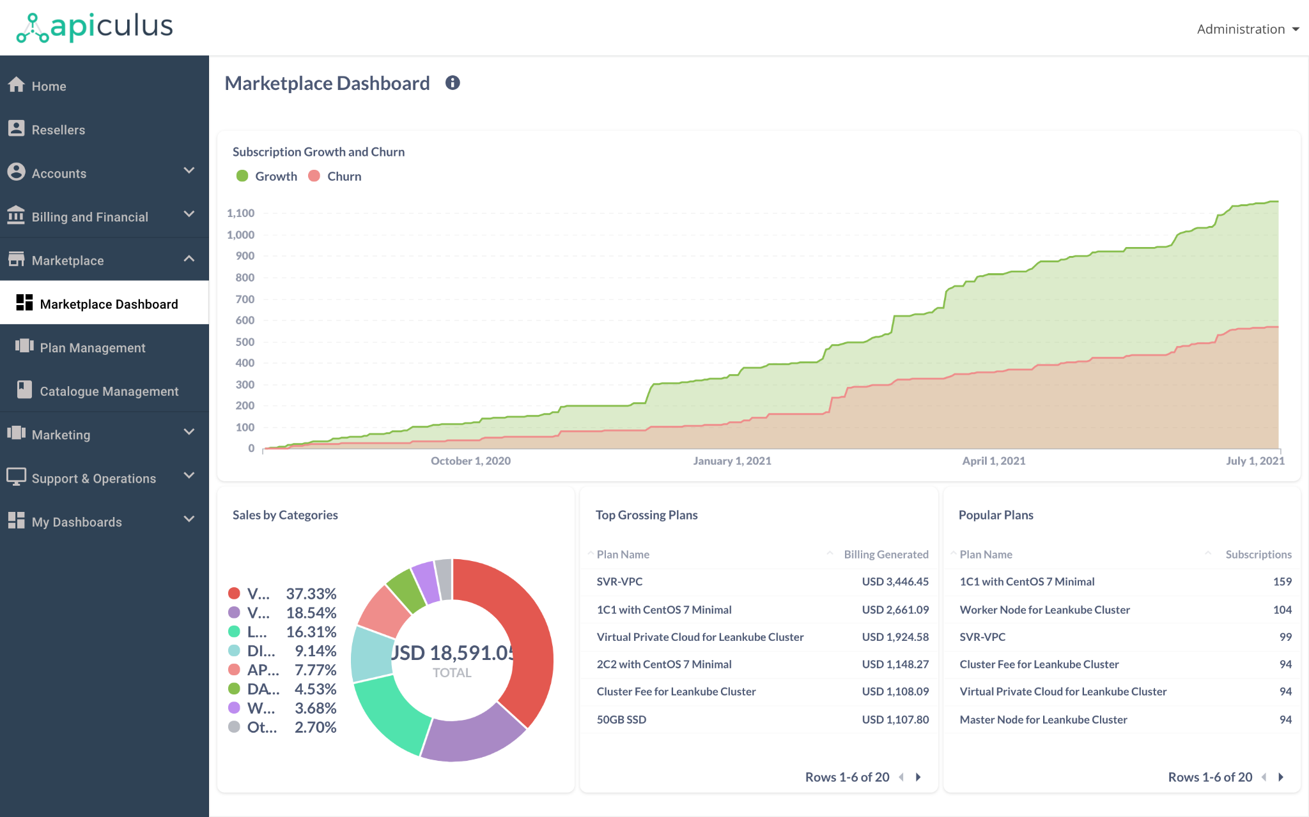

# 

# Plan Management

Plan management on apiculus Admin Console allows administrators and users with product manager roles to create SKU bundles. A plan consists of the following macro aspects:

* Plan details
* Components
* Integration properties

| *It is important to note that creating a plan successfully requires knowledge of the underlying provisioning systems. While apiculus offers a guided method for creating and publishing plans, the method can result in errors if adequate care is not taken.* |
| --- |

## Viewing Plans

All plans can be viewed by navigating to **Marketplace > Plan Management**. The list can be switched between enabled, disabled and draft by using the dropdown on top-left.

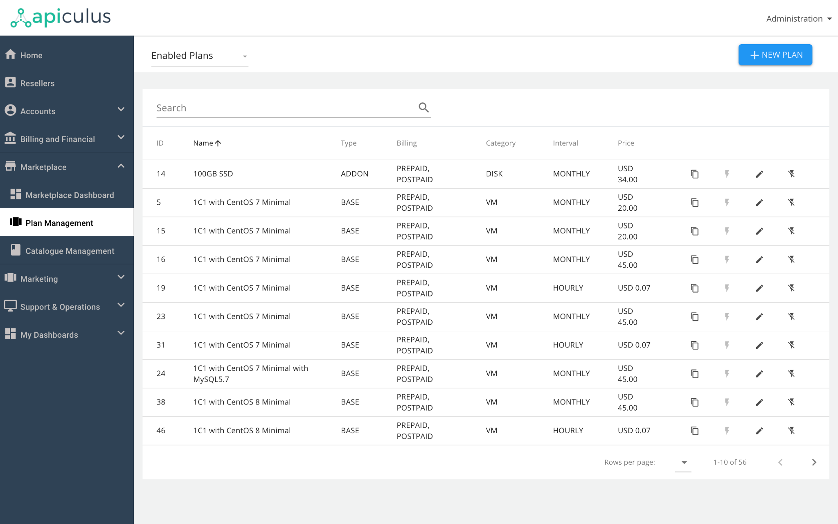

The following actions are available on each plan view:

* All plans can be edited (using the *pencil* icon)
* Enabled plans can be disabled (using the *flash off* icon)
* Disabled plans can be enabled (using the *flash on* icon)
* All plans can be duplicated (using the *copy* icon)
* Draft plans can be deleted (using the *dustbin* icon)

## Creating Plans

New plans can be created by clicking on the **+ New Plan** button on top-right. This will open up a view with the following sections for creating the plan:

1. **Plan Details:** This section includes categorisation and classification details for the plan to be created.
   1. **Category**: choosing the correct plan category is the first step to creating a plan. This also applies the correct template to the subsequent sections for ease of adding information. *Please note that the BACKUP_QUOTA and BACKUP_FEATURE categories require Ahsay as the backup service provider.*
   2. **Name and Description**: these are used for defining the title and description when the plan is shown on the marketplace. Existing names and descriptions can be chosen, or new ones can be added while creating a plan.
   3. **Interval**: this is the billing interval for the plan. apiculus supports hourly, daily, weekly, monthly, quarterly, half-yearly and annual billing intervals, with hourly and monthly being the most commonly used intervals.
   4. **Currency**: if multiple currencies are set up on your deployment, then choosing any one currency will only make the plan available to your customers who are tagged on that currency. For single-currency deployments, this doesn’t make any difference.
   5. **Billing Type**: to make the plan available for retail customers, choose Prepaid. For enterprise, choose Postpaid. This determines the default catalogue(s) that this plan will be published to.
   6. **Region**: for deployments across multiple regions, you can choose which regions you want this plan to be available in.
   7. **Subscription Type**: this lets you choose whether this is a fair use, fixed or usage based subscription. Typically, monthly billing intervals will be defined as fixed subscription type, while hourly billing intervals will be defined as usage-based subscriptions.
   8. **Proration**: you can specify whether subscribing to (entry) or unsubscribing from (exit) this plan should have a proration effect. Enabling proration will automatically adjust the unused days of a month during bill run.
   9. **Type**: for all IaaS plans, choose IaaS. For any other type of plan, choose BaaS.
   10. **Network Type**: any plan can be specified as a default plan, which means the subscription will be applied to all accounts. Basic plans are usually used for EC or Basic networking zones, while Advanced plans are usually used for VPC or Advanced networking zones.
   11. **Plan Type**: allows you to specify whether the plan is a base or an addon. Certain plans require a base subscription before any other can be added on.
   12. **Subscribable**: if set to false, this plan will be available for provisioning, but not to the customer. Currently, configuring non-subscribable plans is disabled on apiculus.
   13. **Account**: plans are made available to all accounts. Overrides or individual visibility can be controlled using catalogues.
   14. **Profiles**: this is the service provider profile that’s configured for your deployment. This will typically be listed as your organisation’s name.

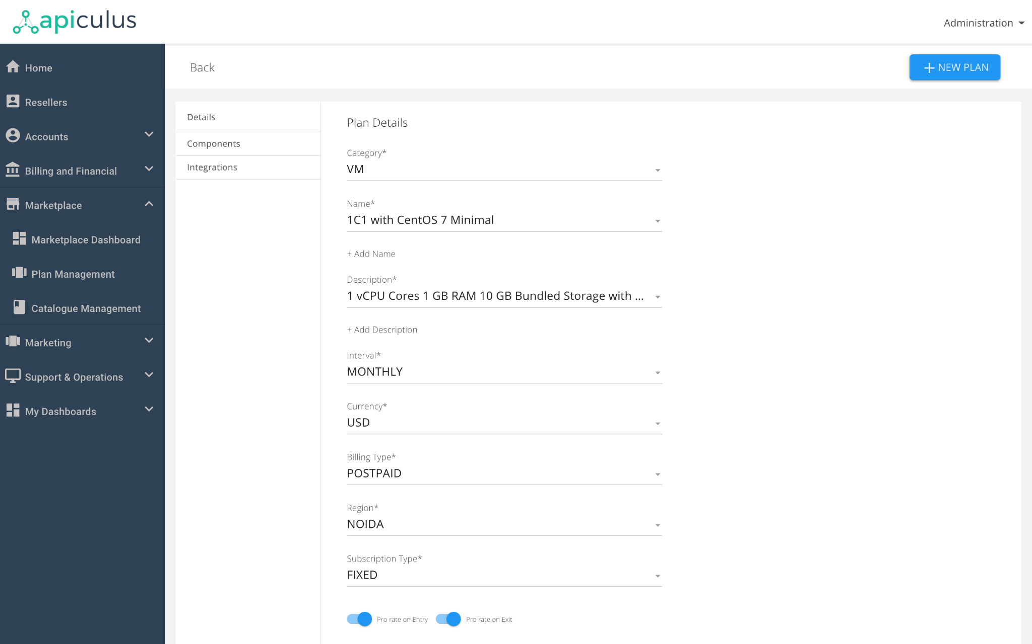

1. **Plan Components:** Each plan consists of further components that are used for actual rating and defining the SKU breakdown. Choosing a Category under Plan Details will automatically show the relevant components. *Please note that the* ***+ Add Components*** *function should only be used if any of the components got deleted by accident.* Components can be edited for the following:
   1. **Type**: this allows you to choose the correct component type based on the plan category. E.g., RAM.
   2. **Name and Description**: this allows you to specify a display name for the component, which will be shown on the marketplace as well as on the invoice line items. Existing names and descriptions can be used or new ones can be added.
   3. **Measurement Unit**: this will automatically show the most relevant units based on the component type chosen above. E.g., GB of RAM.
   4. **Units**: this allows you to specify the number of units of this component to be bundled in the plan. E.g., 4 GB of RAM.
   5. **Rate**: this lets you specify the rate for the bundled component. E.g., 4 GB of RAM at USD 10.

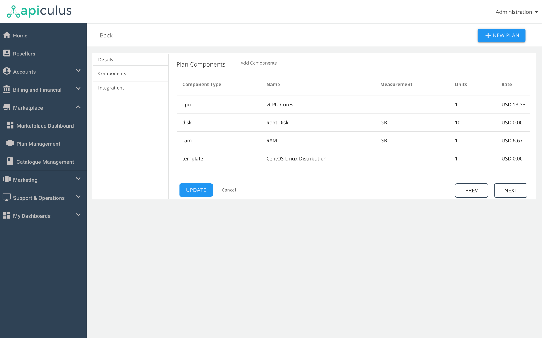

1. **Integration Properties:** For each plan to talk to the underlying provisioning system, it requires certain key-value pairs that allow the handshake. Further, these integration properties are also used to define certain billing entities like taxation logic, charge type etc. For ease of use, apiculus shows all relevant integration properties as pre-filled fields. Only external information (e.g., compute offering name on CloudStack) needs to be specified.

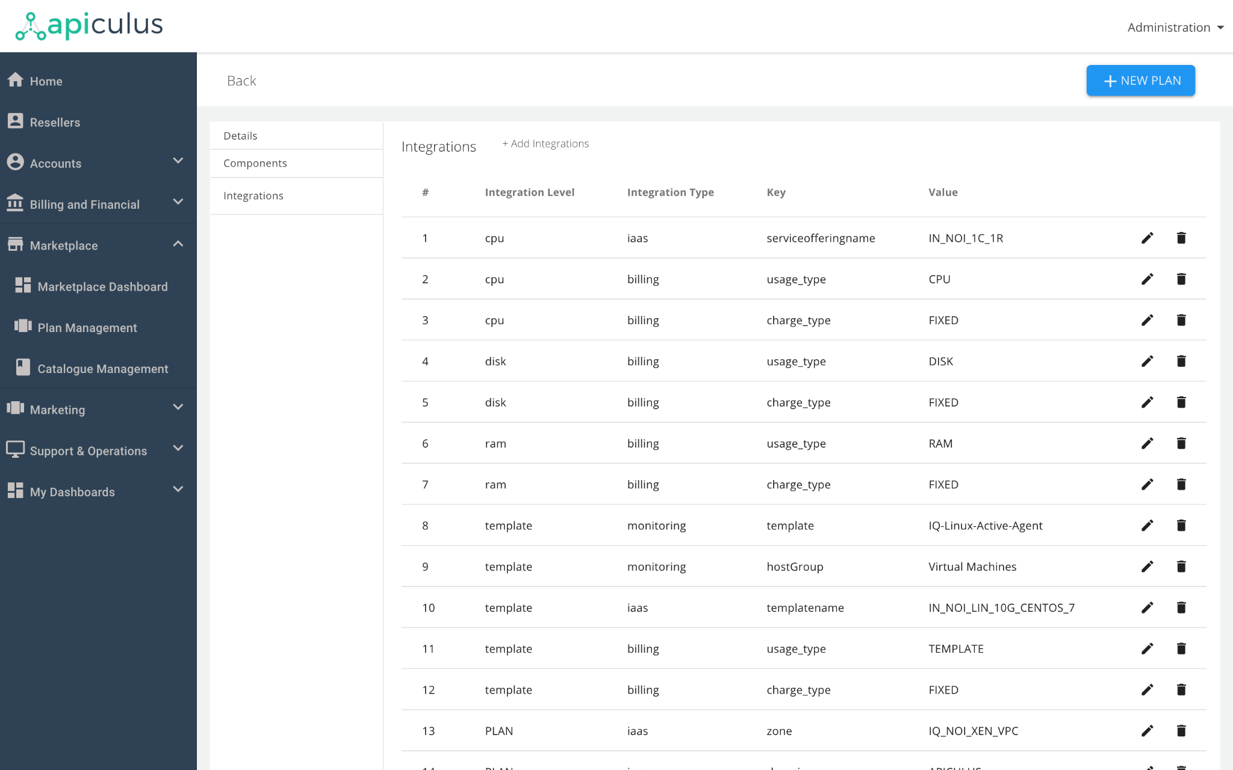

| *A complete mapping of category-wise list of components and integration properties is available on* [am1a-planComponentsIntegrations](https://docs.google.com/spreadsheets/d/1Pwuy9JPjsZBGfftGsnKspxULN6UBF7DtNUoG1kuVeNo/edit?usp=sharing)*(click to open the file in a new browser window/tab)* |
| --- |

## 

## Publishing Plans

All plans go into the default retail and enterprise catalogue(s). Publishing a plan on the marketplace requires the following steps:

1. Fill up the plan creation forms (details, components and, integration properties)
2. Click on **Publish** or **Update** button at the bottom. This will enable the plan for publishing.
3. Navigate to **Marketplace > Catalogue Management** and click on **Sync Catalogues**. This will sync all the plans and catalogues and reflect any changes on the marketplace.

# 

# Catalogue Management

Catalogue management on apiculus Admin Console allows administrators and users with product manager roles to create custom price books based on one or more distribution criteria. A catalogue consists of the following macro aspects:

* Catalogue details
* Included plans
* Integration properties

Rules defined in a catalogue override the same rules defined for the included plans, if any. This includes prices, regions, billing type and currency.

## Viewing Catalogues

All catalogues can be viewed by navigating to **Marketplace > Catalogue Management**. The list can be switched between enabled, disabled and draft by using the dropdown on top-left.

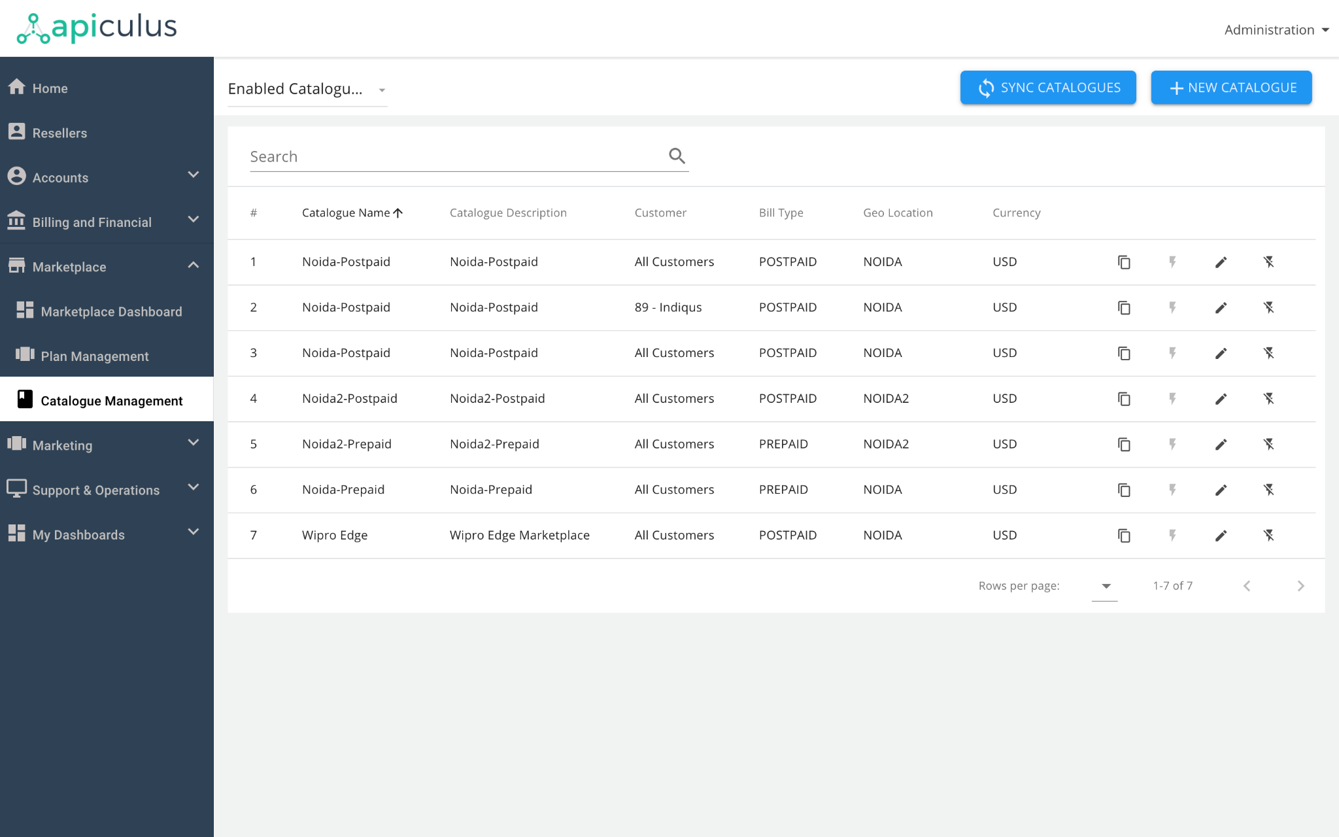

The following actions are available on each plan view:

* All catalogues can be edited (using the *pencil* icon)
* Enabled catalogues can be disabled (using the *flash off* icon)
* Disabled catalogues can be enabled (using the *flash on* icon)
* All catalogues can be duplicated (using the *copy* icon)
* Draft catalogues can be deleted (using the *dustbin* icon)

## Creating Catalogues

New catalogues can be created by clicking on the **+ New Catalogue** button on top-right. This will open up a view with the following sections for creating the catalogue:

1. **Catalogue Details:** This section includes categorisation and classification details for the catalogue to be created.

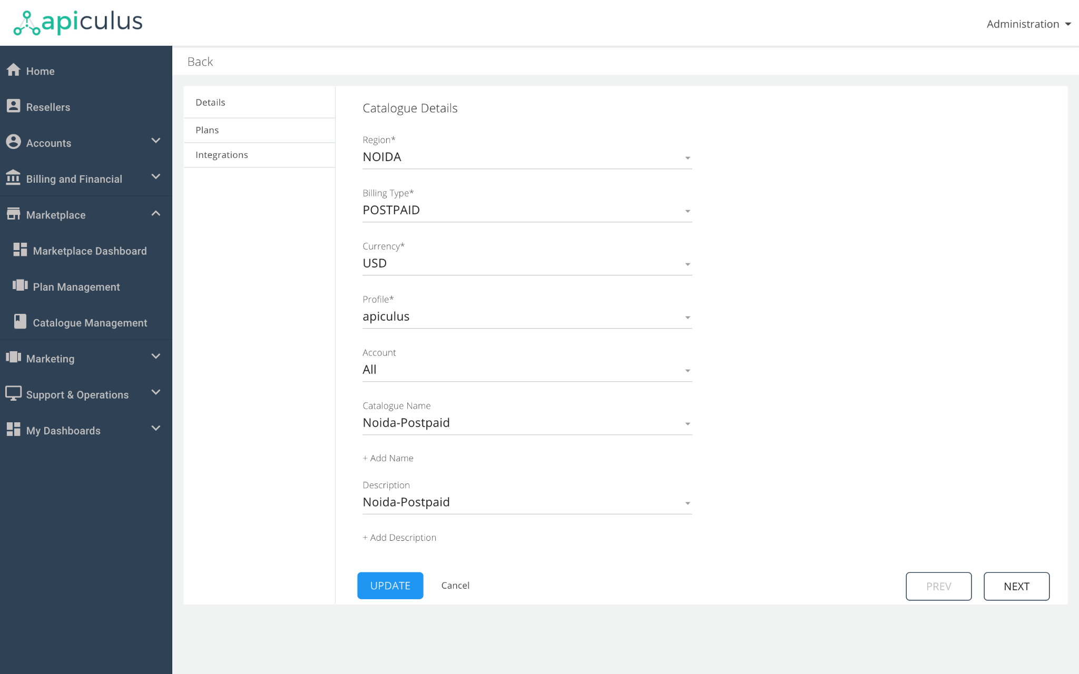

* 1. **Region**: choosing one or more regions will make the catalogue available in the selected region(s).
  2. **Name and Description**: these are used for identifying the catalogue. Existing names and descriptions can be chosen, or new ones can be added while creating a catalogue.
  3. **Billing Type**: to make the catalogue available for retail customers, choose Prepaid. For enterprise, choose Postpaid. This determines the default catalogue(s) that this plan will be published to.
  4. **Currency**: if multiple currencies are set up on your deployment, then choosing any one currency will only make the catalogue available to your customers who are tagged on that currency. For single-currency deployments, this doesn’t make any difference. *It is important to note that in case of multiple currencies available on the deployment, choosing different currencies at the plan and catalogue levels will convert the plan’s pricing to the catalogue’s currency.*
  5. **Account**: catalogues can be made available to all accounts or individually selected accounts. This is useful when you want to offer special prices and offerings for individual customers.
  6. **Profiles**: this is the service provider profile that’s configured for your deployment. This will typically be listed as your organisation’s name.

1. **Included Plans:** Each catalogue consists of a custom selection of plans. Plans can be added to a catalogue by using the **+ Add More Plans** function. This will let you choose from all available plans to add to the catalogue. Once added, a custom price can be defined for the added plans.

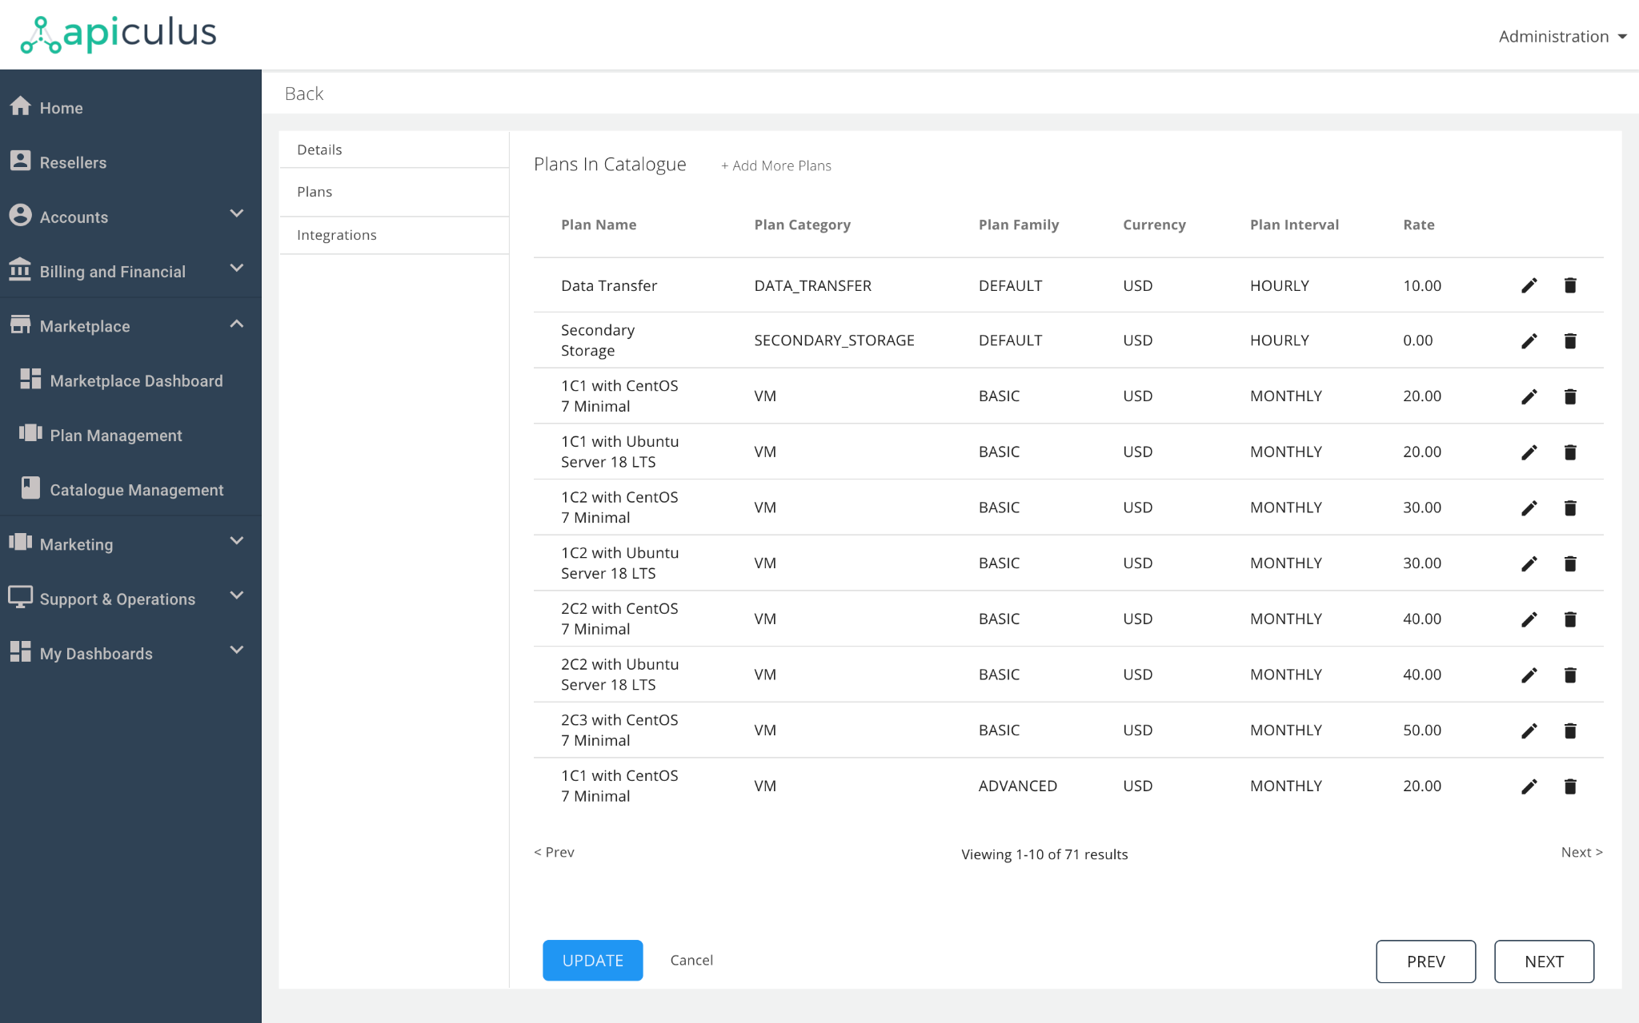

1. **Integration Properties:** Like plans, catalogues also require integration with the underlying billing system. This, in most cases, follows the same logic and integration property values from any existing catalogue can be copied to new ones.

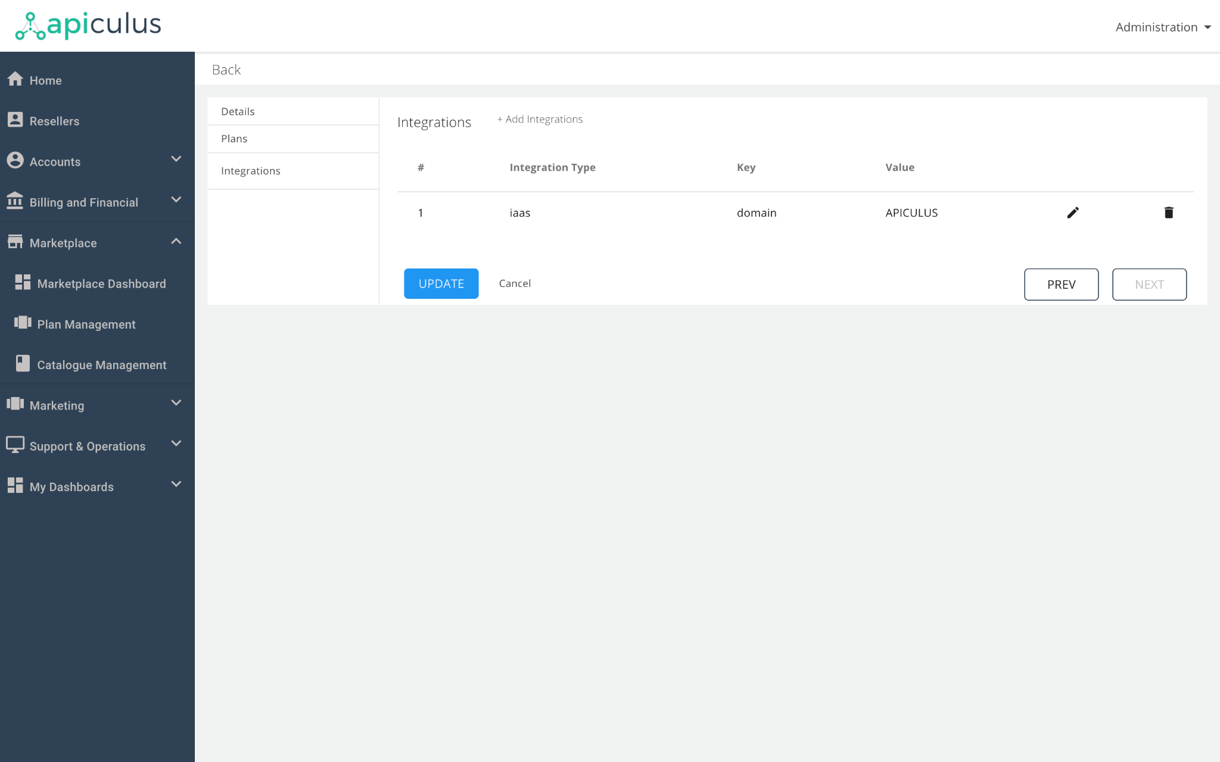

## Publishing Catalogues

All plans go into the default retail and enterprise catalogue(s). Publishing a plan on the marketplace requires the following steps:

1. Fill up the catalogue creation forms (details, plans and, integration properties)
2. Click on **Publish** or **Update** button at the bottom. This will enable the catalogue for publishing.
3. On the catalogues list, click on **Sync Catalogues**. This will sync all the plans and catalogues and reflect any changes on the marketplace.

# 

# Tips, Tricks and Best Practices

The current feature set for creating plans and catalogues is restrictive and an upgraded system is being developed. To use the existing system, the following pointers should be considered:

1. It is recommended that existing plans and catalogues be duplicated and updated with new values, rather than creating from scratch.
2. Catalogues intended for individual conditions (e.g., individual region, individual customer etc.) supersede those defined for ‘all’ conditions.
3. Each different classification on a plan requires a new plan to be created. E.g., the same VM configuration having monthly and hourly prices requires separate plans to be created.
4. For any plan or catalogue creation request, contact [support@indiqus.net](mailto:support@indiqus.net).
5. Category-wise list of plan components and integration properties is available on [am1a-planComponentsIntegrations](https://docs.google.com/spreadsheets/d/1Pwuy9JPjsZBGfftGsnKspxULN6UBF7DtNUoG1kuVeNo/edit?usp=sharing) (click to open the file in a new browser window/tab).