apiculus® User Manual

CloudConsole  
Overview

IndiQus Technologies Pvt. Ltd.

**Table of Contents**

**About apiculus CloudConsole** **3**

**Understanding the Interface** **3**

**Dashboard** **5**

# 

# About apiculus CloudConsole

The apiculus CloudConsole is a single interface from where you can manage day 1 and day 2 technical operations, as well as billing, ticketing, user management and many more. The apiculus CloudConsole has been designed to give you a delightful cloud experience via a simple and intuitive interface. All options and elements have been laid out keeping simplicity in mind and apiculus urges you to explore the CloudConsole UI and experience it yourself.

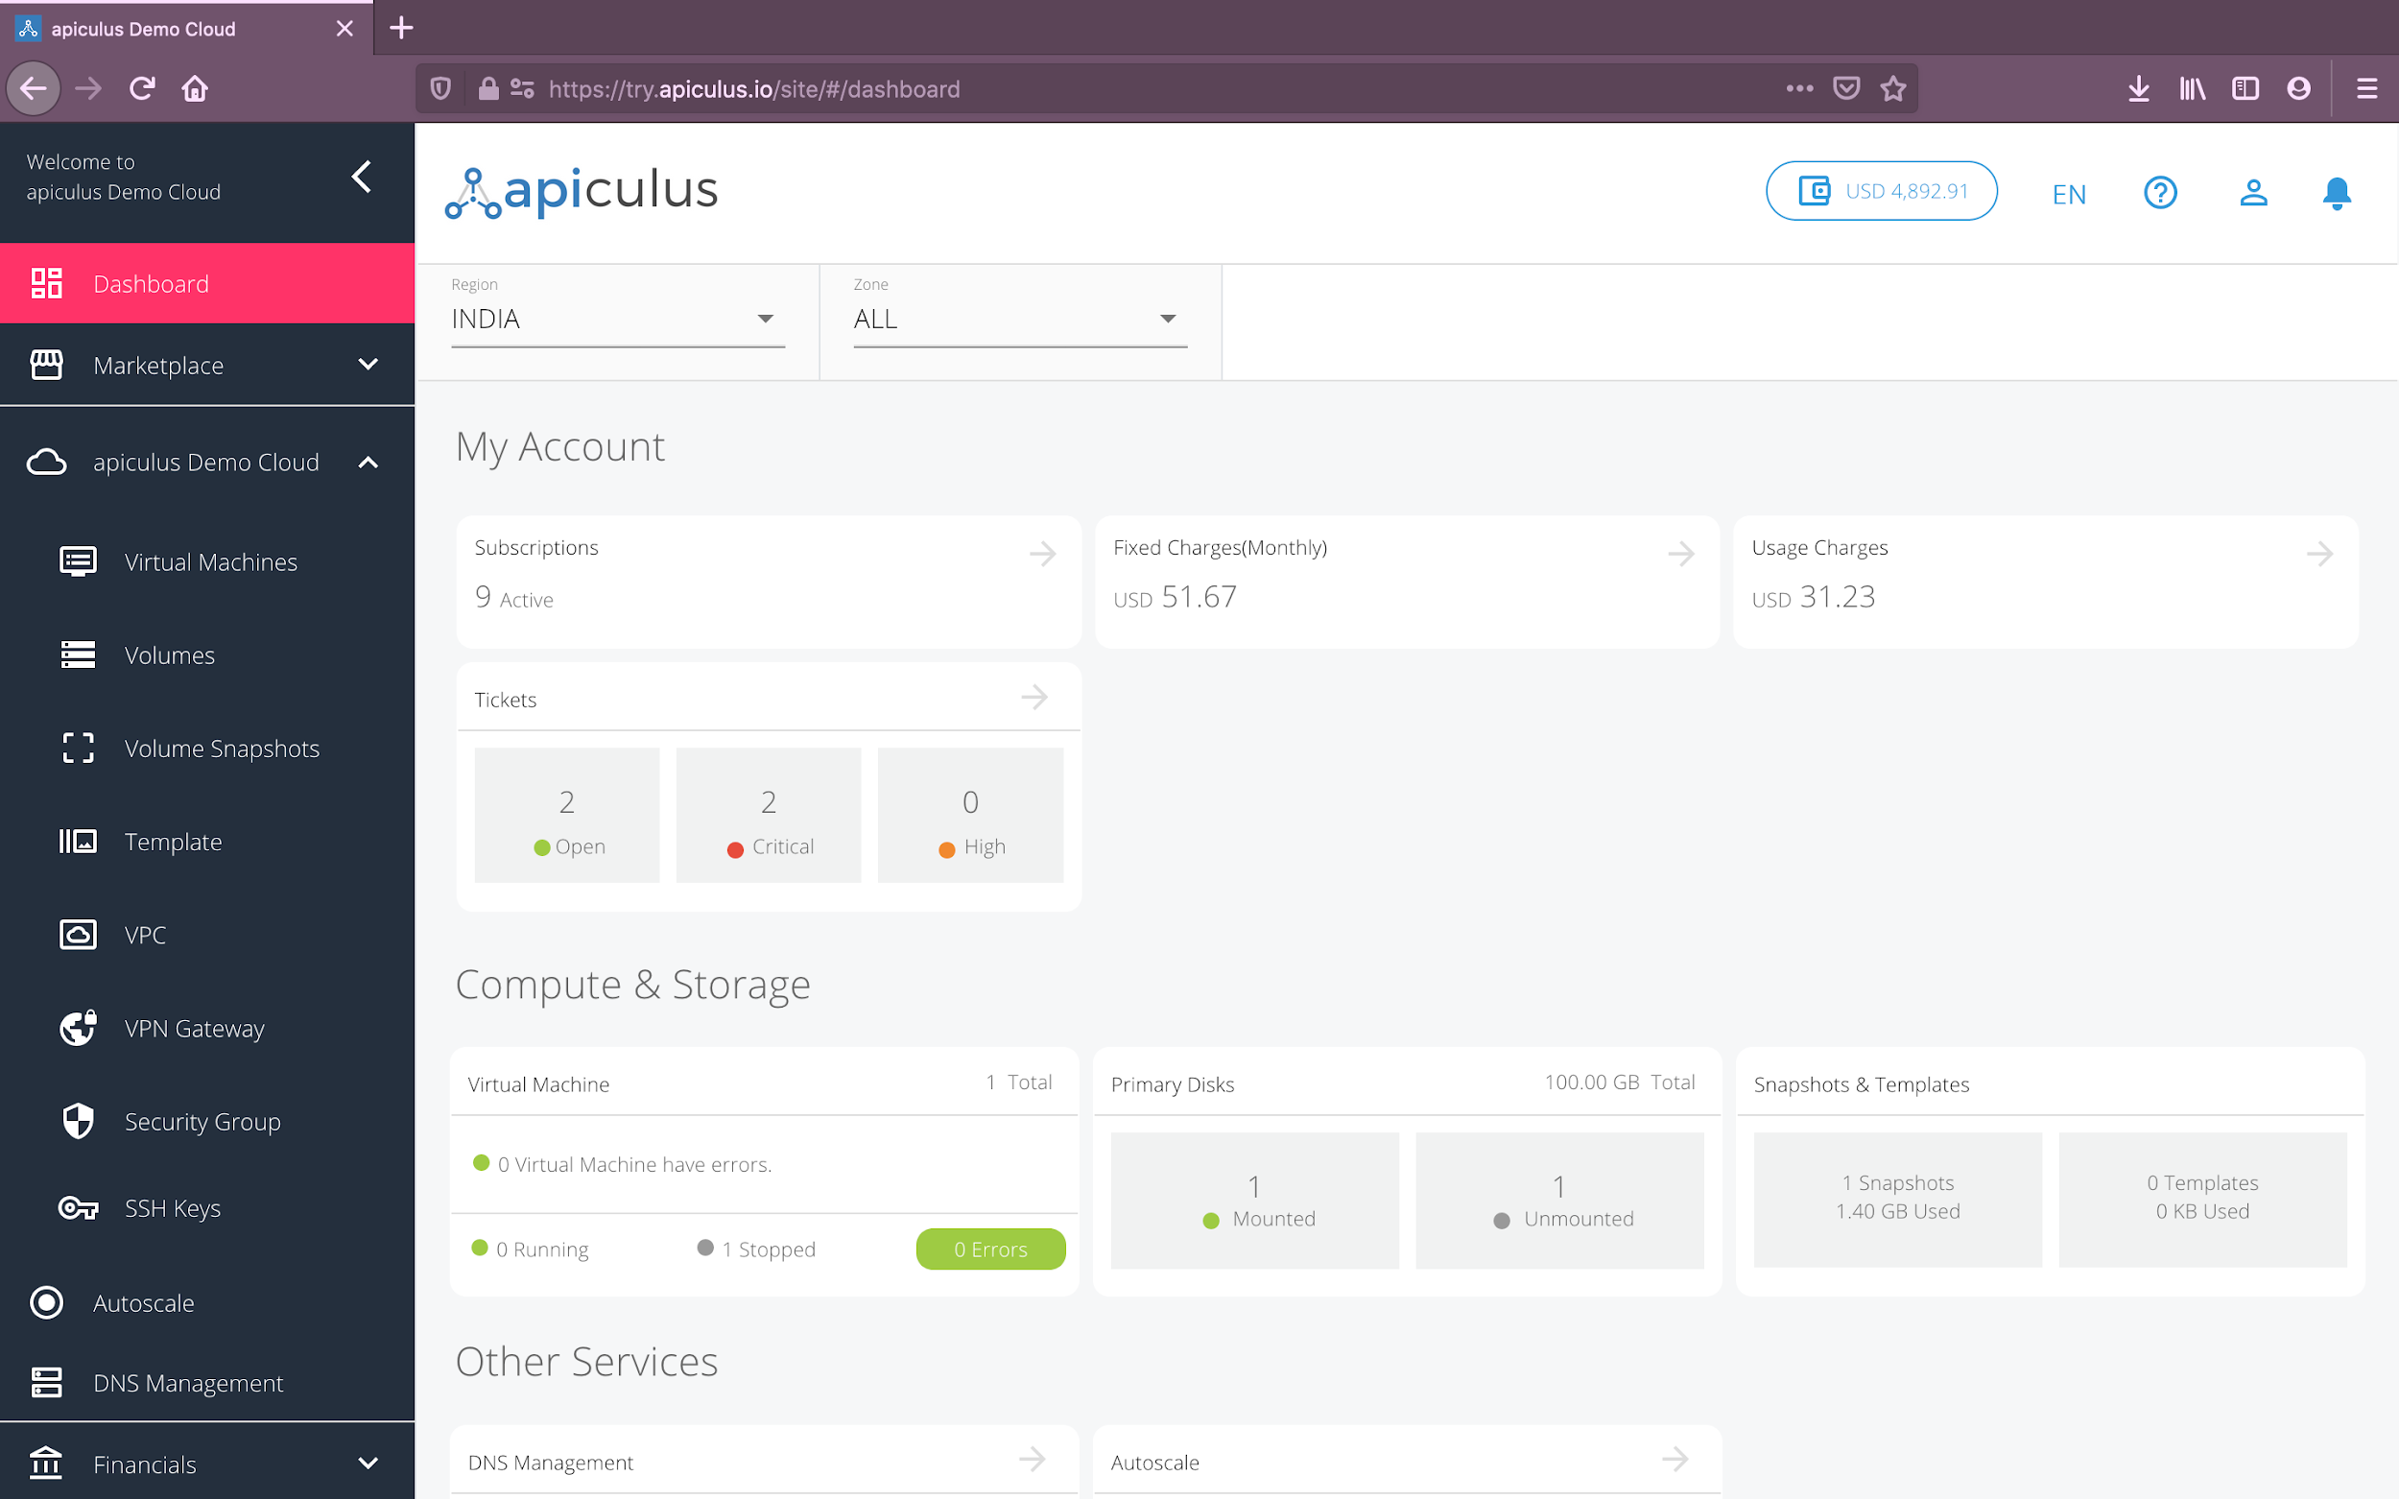

# Understanding the Interface

The apiculus CloudConsole interface can be viewed as made up of the following elements:

1. **Navigation Panel -** This acts as the primary navigation interface.
2. **Top Helper Bar -** This shows the current wallet balance, language selection, activity progress indicators, help menu and access to other administrative sections within your account.
3. **Notifications Panel -** This panel can be called out using the notification ‘bell’ icon in the top helper bar and shows the activity history and current progress on any ongoing tasks.
4. **Quick Actions Panel -** This panel can be called out from the help menu on the top helper bar and can be used as a shortcuts menu.
5. **Information Area -** This is the context section where technical and billing operations management information can be viewed and corresponding actions can be performed.

The navigation structure on apiculus CloudConsole is very flat and does not include multi-level menus or page drilldowns. Any and all information can be accessed with a maximum of two clicks, and going back and forth on the interface is possible from any section.

For all actions (provisioning, operations etc.), apiculus CloudConsole follows a ‘single form’ paradigm, wherein most configurations can be achieved via simple one-page forms that don’t take you out of context.

# 

# Dashboard

The apiculus Cloud dashboard has been designed to give you a quick overview of how your team is using the cloud account. The dashboard gives information on your monthly cloud costs, status of support tickets and resource utilisation widgets, all in one place.

Information on the dashboard is visually colour-coded to grab your attention where it is needed. While most of your day 1, day 2 and billing operations will happen on the other sections of the CloudConsole, the dashboard is a quick way to see whether everything is working fine.