apiculus® User Manual

Marketplace

IndiQus Technologies Pvt. Ltd.

**Table of Contents**

**About Marketplace** **3**

**Navigating the Marketplace** **3**

**Service Activation and Provisioning** **5**

**Unsubscribing from a Service** **6**

# 

# About Marketplace

The apiculus Cloud Marketplace is a one-stop shop for purchasing and provisioning cloud services and resources being offered by apiculus. The apiculus Cloud Marketplace offers virtual compute, storage, network and value added services.

# Navigating the Marketplace

The apiculus Cloud Marketplace can be accessed by clicking on the **Marketplace** menu item in the main navigation panel. There are three sections in the Marketplace:

1. **Network Services -** This section lists all VPC virtual routers and IP addresses that can be purchased and provisioned.

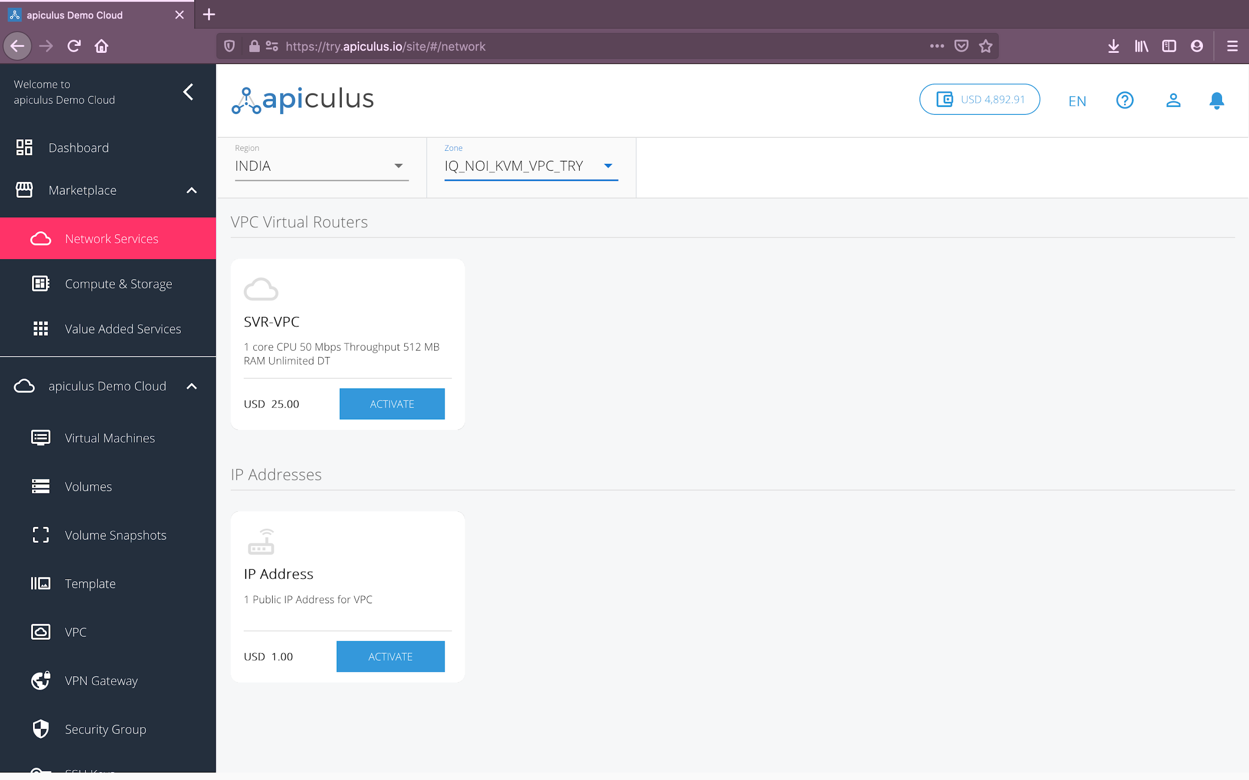

1. **Compute and Storage -** This section lists all virtual machines and addon disks that can be purchased and provisioned.

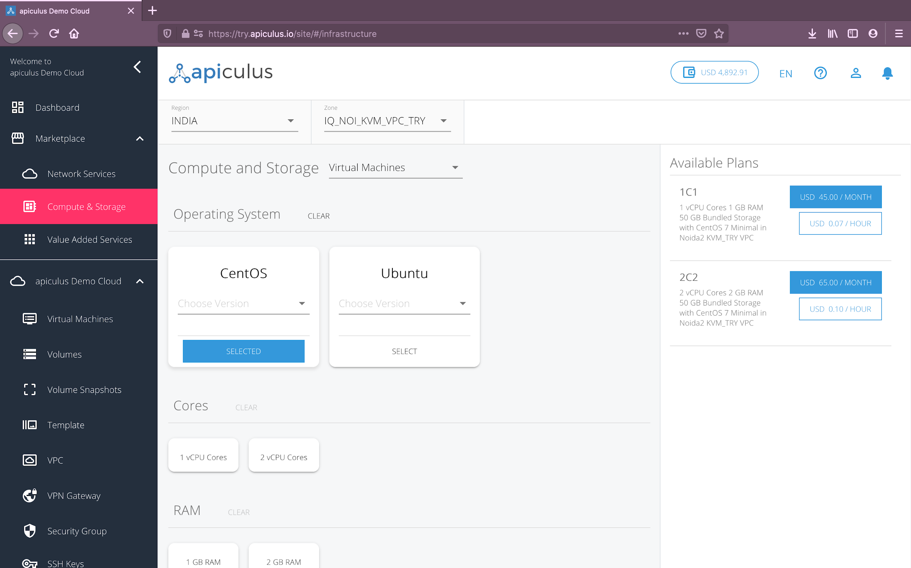

1. **Value Added Services -** This section lists various other services, e.g., quotas for data transfer and snapshot storage, autoscale service, DNS management etc. Additionally, this section also includes any other software services that apiculus is offering as a purchasable entity.

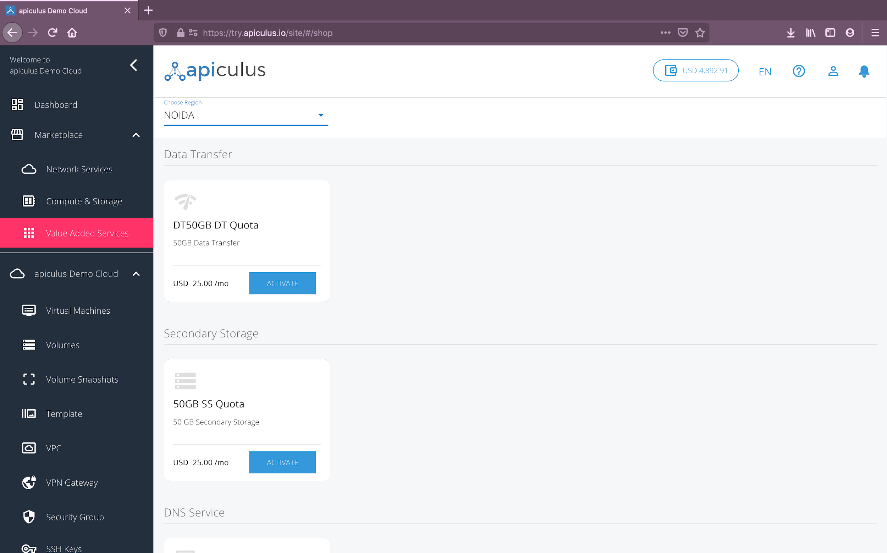

All services and resources show their corresponding subscription rates, which could be hourly, monthly, quarterly, half-yearly, yearly and/or one-time.

*Please note that the availability and prices for certain services might differ depending on the Region and Zone selected from the top dropdowns (wherever available).*

# Service Activation and Provisioning

There are two types of activations on a service listed on the apiculus Cloud Marketplace:

* **Automated Provisioning:** These are services that can be purchased and provisioned directly from the marketplace without any intervention needed from apiculus. All of compute, storage, network and most of value added services fall under this category
* **Activation Requests:** Certain services might need an approval, more information or an offline delivery from apiculus. These services can not be directly activated without intervention from apiculus, but only raised as activation requests.

To make a direct purchase, or send a service activation request, choose the required service or resource and fill up the corresponding form that opens up.

Clicking on **Confirm Purchase** with any required information will initiate the provisioning or request action.

* Automated provisioning might take up to 3-5 minutes. You may use the CloudConsole during this time, but it is advised that you do not refresh the browser window.
* Activation requests might take up to 72 hours for approval or confirmation by apiculus.

In both cases, once the service has been enabled, you’ll be notified of the status on your email address on record. The corresponding menu item on the main navigation panel will also be enabled and will become available for use.

# Unsubscribing from a Service

There are two ways of unsubscribing from a service:

1. **Resource-based subscriptions** (virtual machines, disks, IP addresses, VPC virtual routers etc.) can be deactivated by deleting the resource from their individual item menus.
2. **Service-based subscriptions** (quotas, DNS, autoscale, multi-cloud etc.) can be deactivated from the list of subscriptions that can be found on the **Financials > Subscriptions** section, by clicking on the **Unsubscribe** link next to the subscription line item.

For both types of subscriptions, you can choose to automatically cancel subscription renewal (scheduled deactivation), or remove the subscription immediately (instant deactivation). Scheduled deactivations can be cancelled from the **Scheduled for Deletion** tab in the **Financials > Subscriptions** section.

Upon subscription deactivation, you’ll receive an email notification on your registered email address and you will no longer be charged for the deactivated service, except for the part of the billing cycle that you’ve used the service for. Once deactivated, the same resource or service can not be used again and any configurations, settings or usage needs to be specified or defined afresh.