apiculus® User Manual

Configuring  
Autoscale

IndiQus Technologies Pvt. Ltd.

**Table of Contents**

**Purchasing an Autoscale Pack** **3**

**Understanding the Autoscale Landing Page** **4**

**Autoscale Console** **5**

**Adding and Configuring an Autoscale Rule** **6**

Triggers and Actions **7**

**Publishing, Updation and Deletion** **11**

About Instance Actions **11**

**Unsubscribing from Autoscale** **12**

# 

# Purchasing an Autoscale Pack

To get started with configuring autoscale rules, you need to first purchase an Autoscale Pack subscription from the marketplace. Autoscale Pack can be purchased from the **Value Added Services** section of the marketplace and can be accessed from the **Marketplace** menu on the main navigation panel.

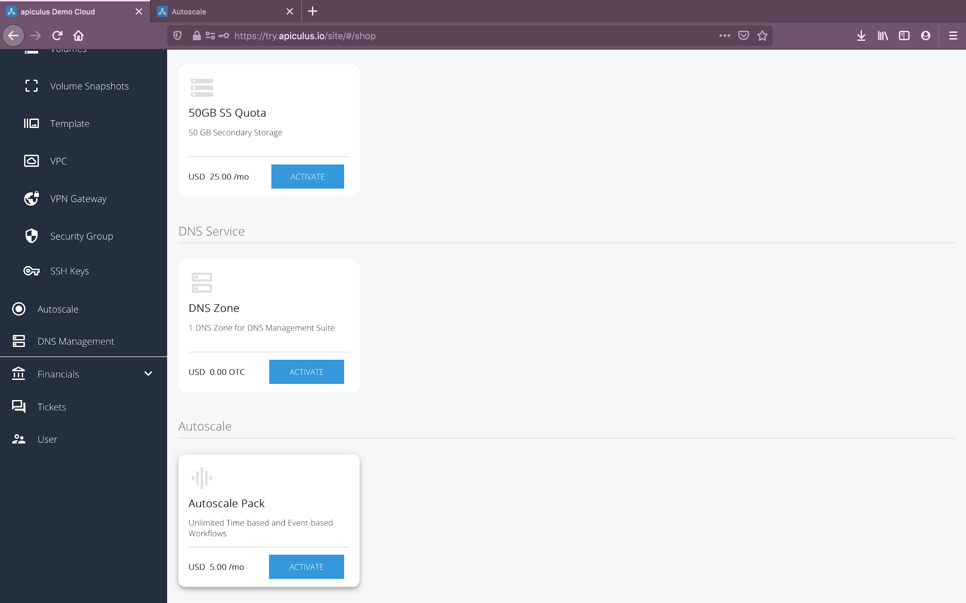

Once you’ve chosen the desired plan, you’ll be asked for a confirmation along with the following information:

* If there are **promo/discount codes** available for this purchase, you’ll be shown those options.

Clicking on **Confirm Purchase** with the above information will create an Autoscale Pack subscription.

Please note that this might take up to 3-5 minutes. You may use the CloudConsole during this time, but it is advised that you do not refresh the browser window.

Once ready, you’ll be notified of this purchase on your email address on record. The **Autoscale** menu item on the main navigation panel will also be enabled and will become available for use.

*Please note that autoscale currently works only within a VPC. Virtual machines created as part of an EC zone will not work with autoscale.*

# Understanding the Autoscale Landing Page

Clicking on **Autoscale** in the main navigation menu will open up the Autoscale landing page on **apiculus Cloud**. Here, you’ll find the following information:

* A list of autoscale rules and policies that exist in your account.
* Rule type for each policy.
* A count of triggers and actions for each policy.
* Last run time of each rule.

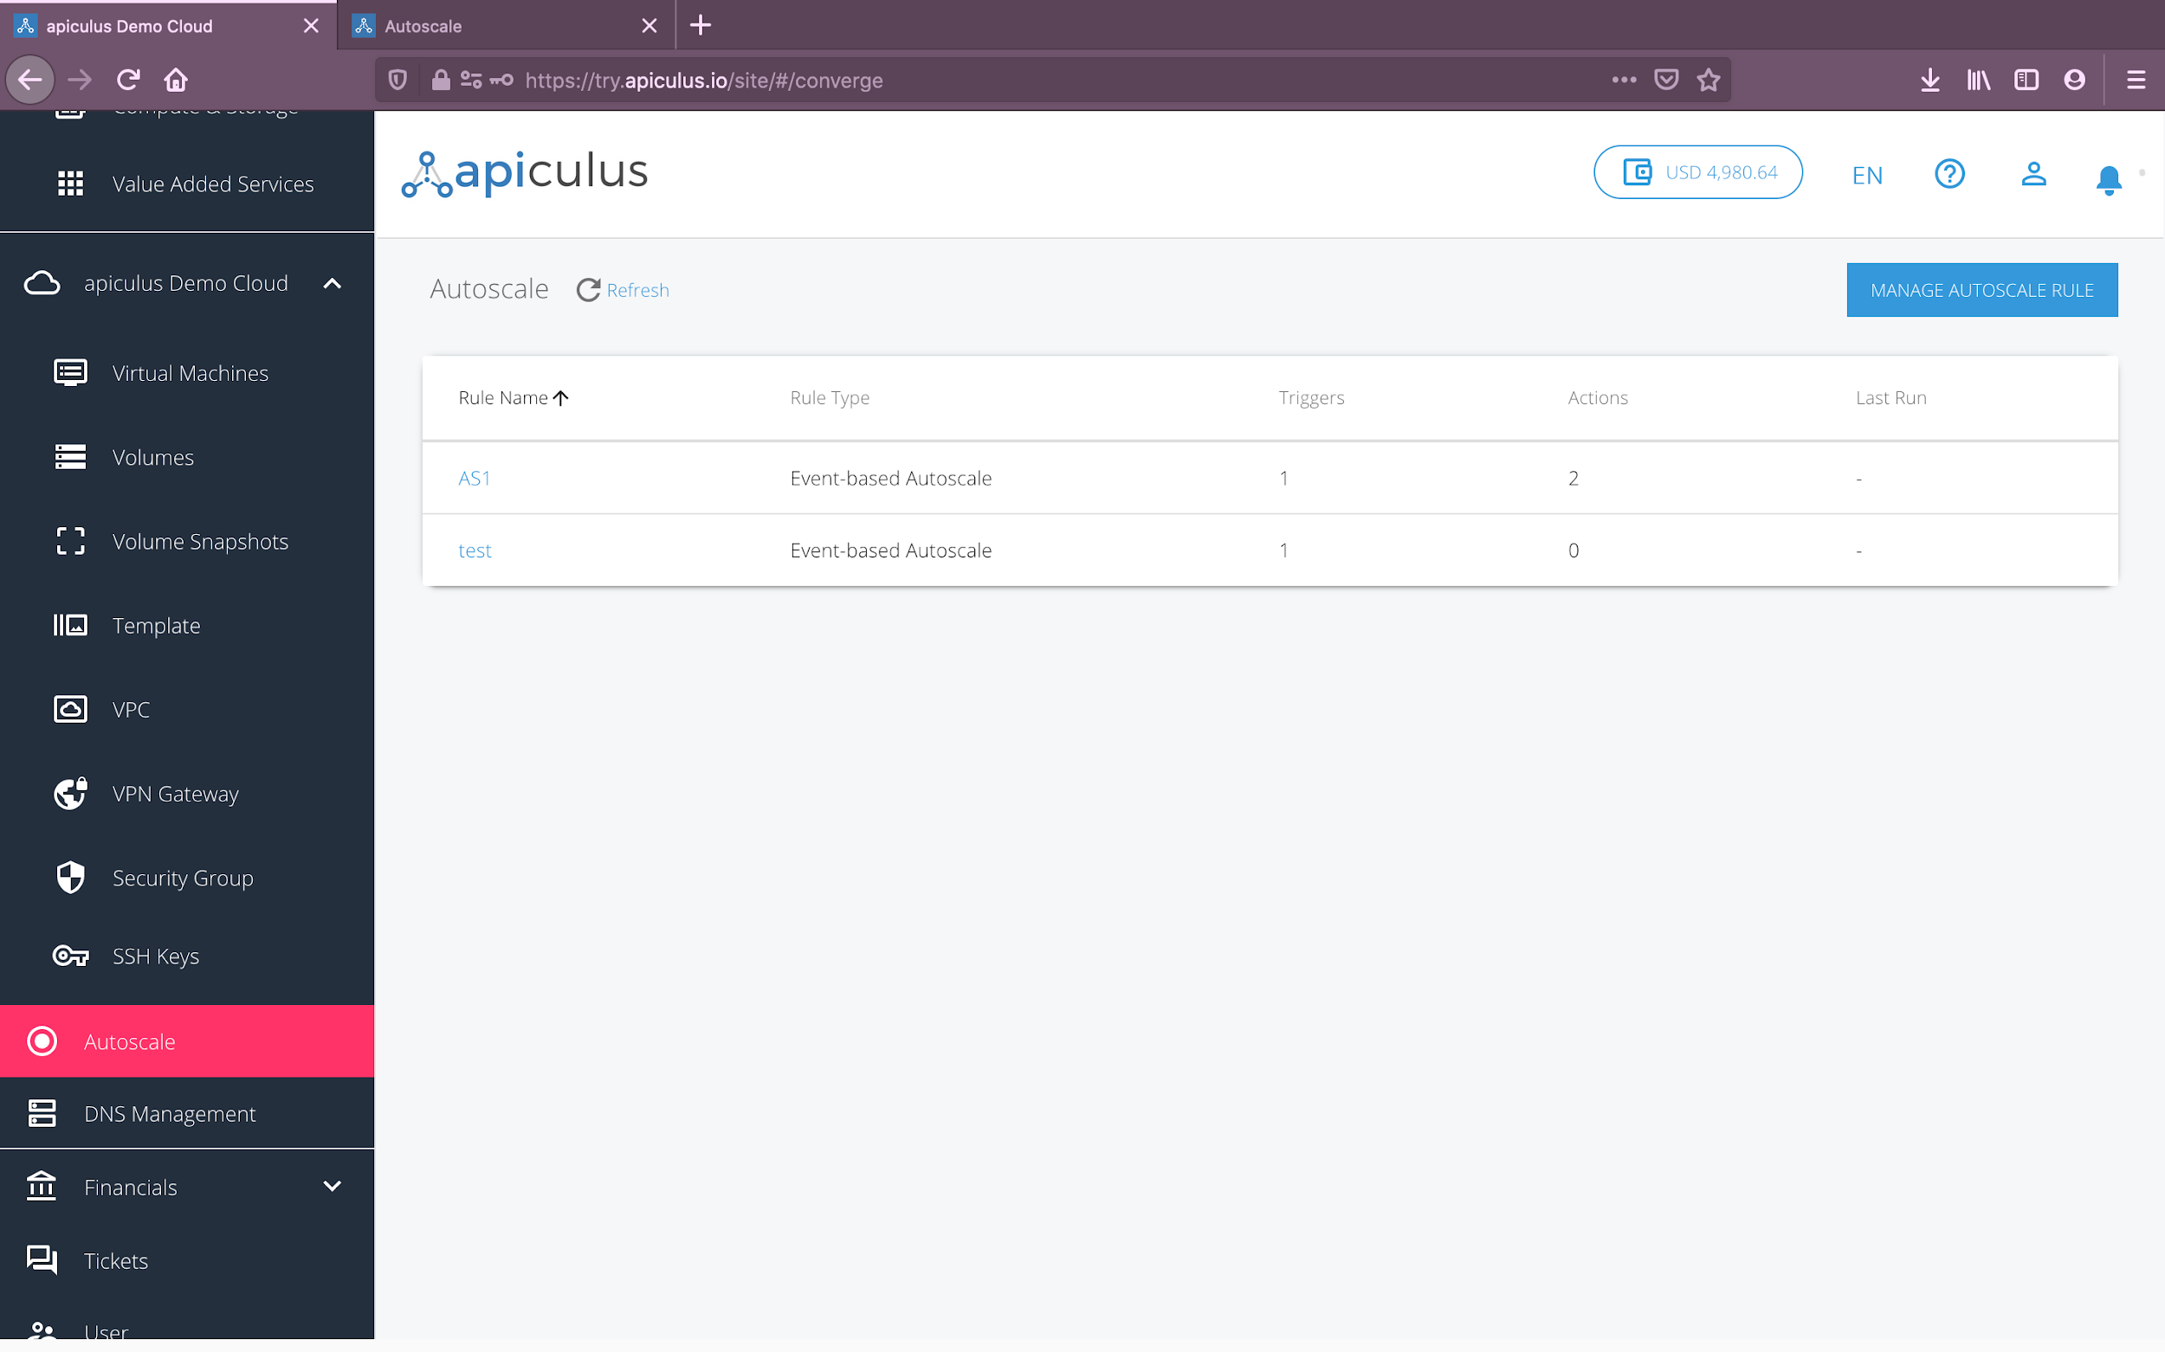

The Autoscale landing page also has an access point to the Autoscale console, which can be accessed by clicking on the **Manage Autoscale Rules** button.

*Please note that this will open the Autoscale console in a new tab.*

# Autoscale Console

The Autoscale configuration console shows a list of all autoscale rules and policies that exist in your account. Each policy shows the following information:

1. Name of the autoscale rule.
2. Type of rule.
3. Count of triggers and actions.
4. Switch to enable or disable the rule.

*Please note that a green-coloured switch indicates that the rule is enabled and active. A grey-coloured switch indicates that the rule is disabled and inactive.*

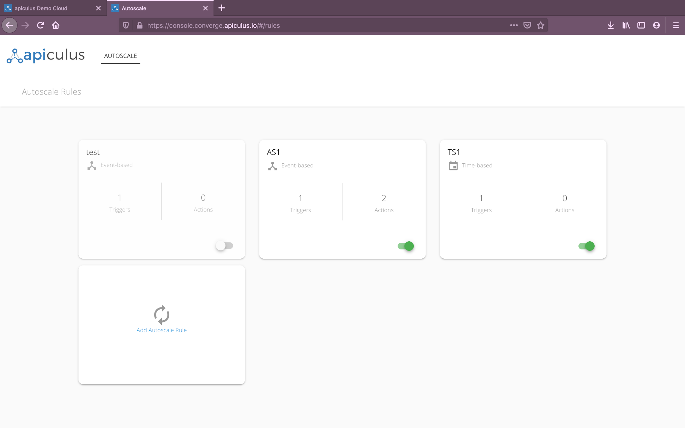

Clicking on a rule name will open up the rule configuration section, which will be explained in the upcoming sections.

You can also create a new autoscale rule using the **Add Autoscale Rule** ‘box’.

# Adding and Configuring an Autoscale Rule

New autoscale rules can be added by clicking the **Add Autoscale Rule** box in the Autoscale console. To add a new rule, you need to specify the following:

* Name of the rule to be created.
* Type of rule:
  + A **time-based autoscale** rule presents options to create schedules, and is useful when the trigger points are known in advance.
  + An **event-based autoscale** rule presents options to define dynamic conditions to take actions on, and is useful when trigger points are not known in advance.

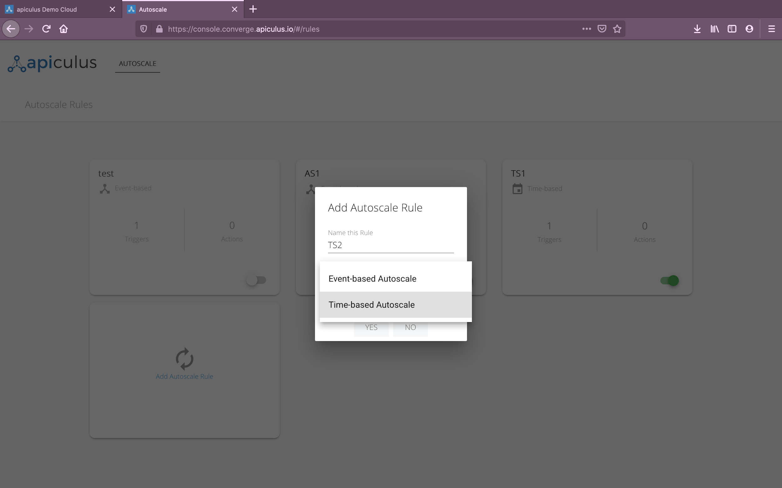

Once a new rule has been added, you’ll be navigated to the autoscale rule configuration section with the following interface elements:

* Left panel to **add** triggers and actions.
* Right panel to **define** trigger and action settings.

## 

# Triggers and Actions

On apiculus Cloud, autoscale works using a combination of triggers and actions.

* **Triggers** are conditional checks that the autoscale system listens to. A new trigger can be added by using the **+ Add Trigger** button on the left panel in the rule configuration section. Triggers vary depending on whether the autoscale rule is time-based or event-based.
  + **Time-based triggers -** These include the following parameters:
    - **Schedule -** Option to set a once, daily, weekly or monthly schedule. Each schedule requires a different ‘detail’, which will be revealed when a schedule is chosen:
      * **Once:** will ask for the specific date and time.
      * **Daily:** will only ask for time of day.
      * **Weekly:** will ask for day of week and time of day.
      * **Monthly:** will ask for day of month and time of day.
    - **Timezone -** Option to define what time zone to trigger this schedule on.

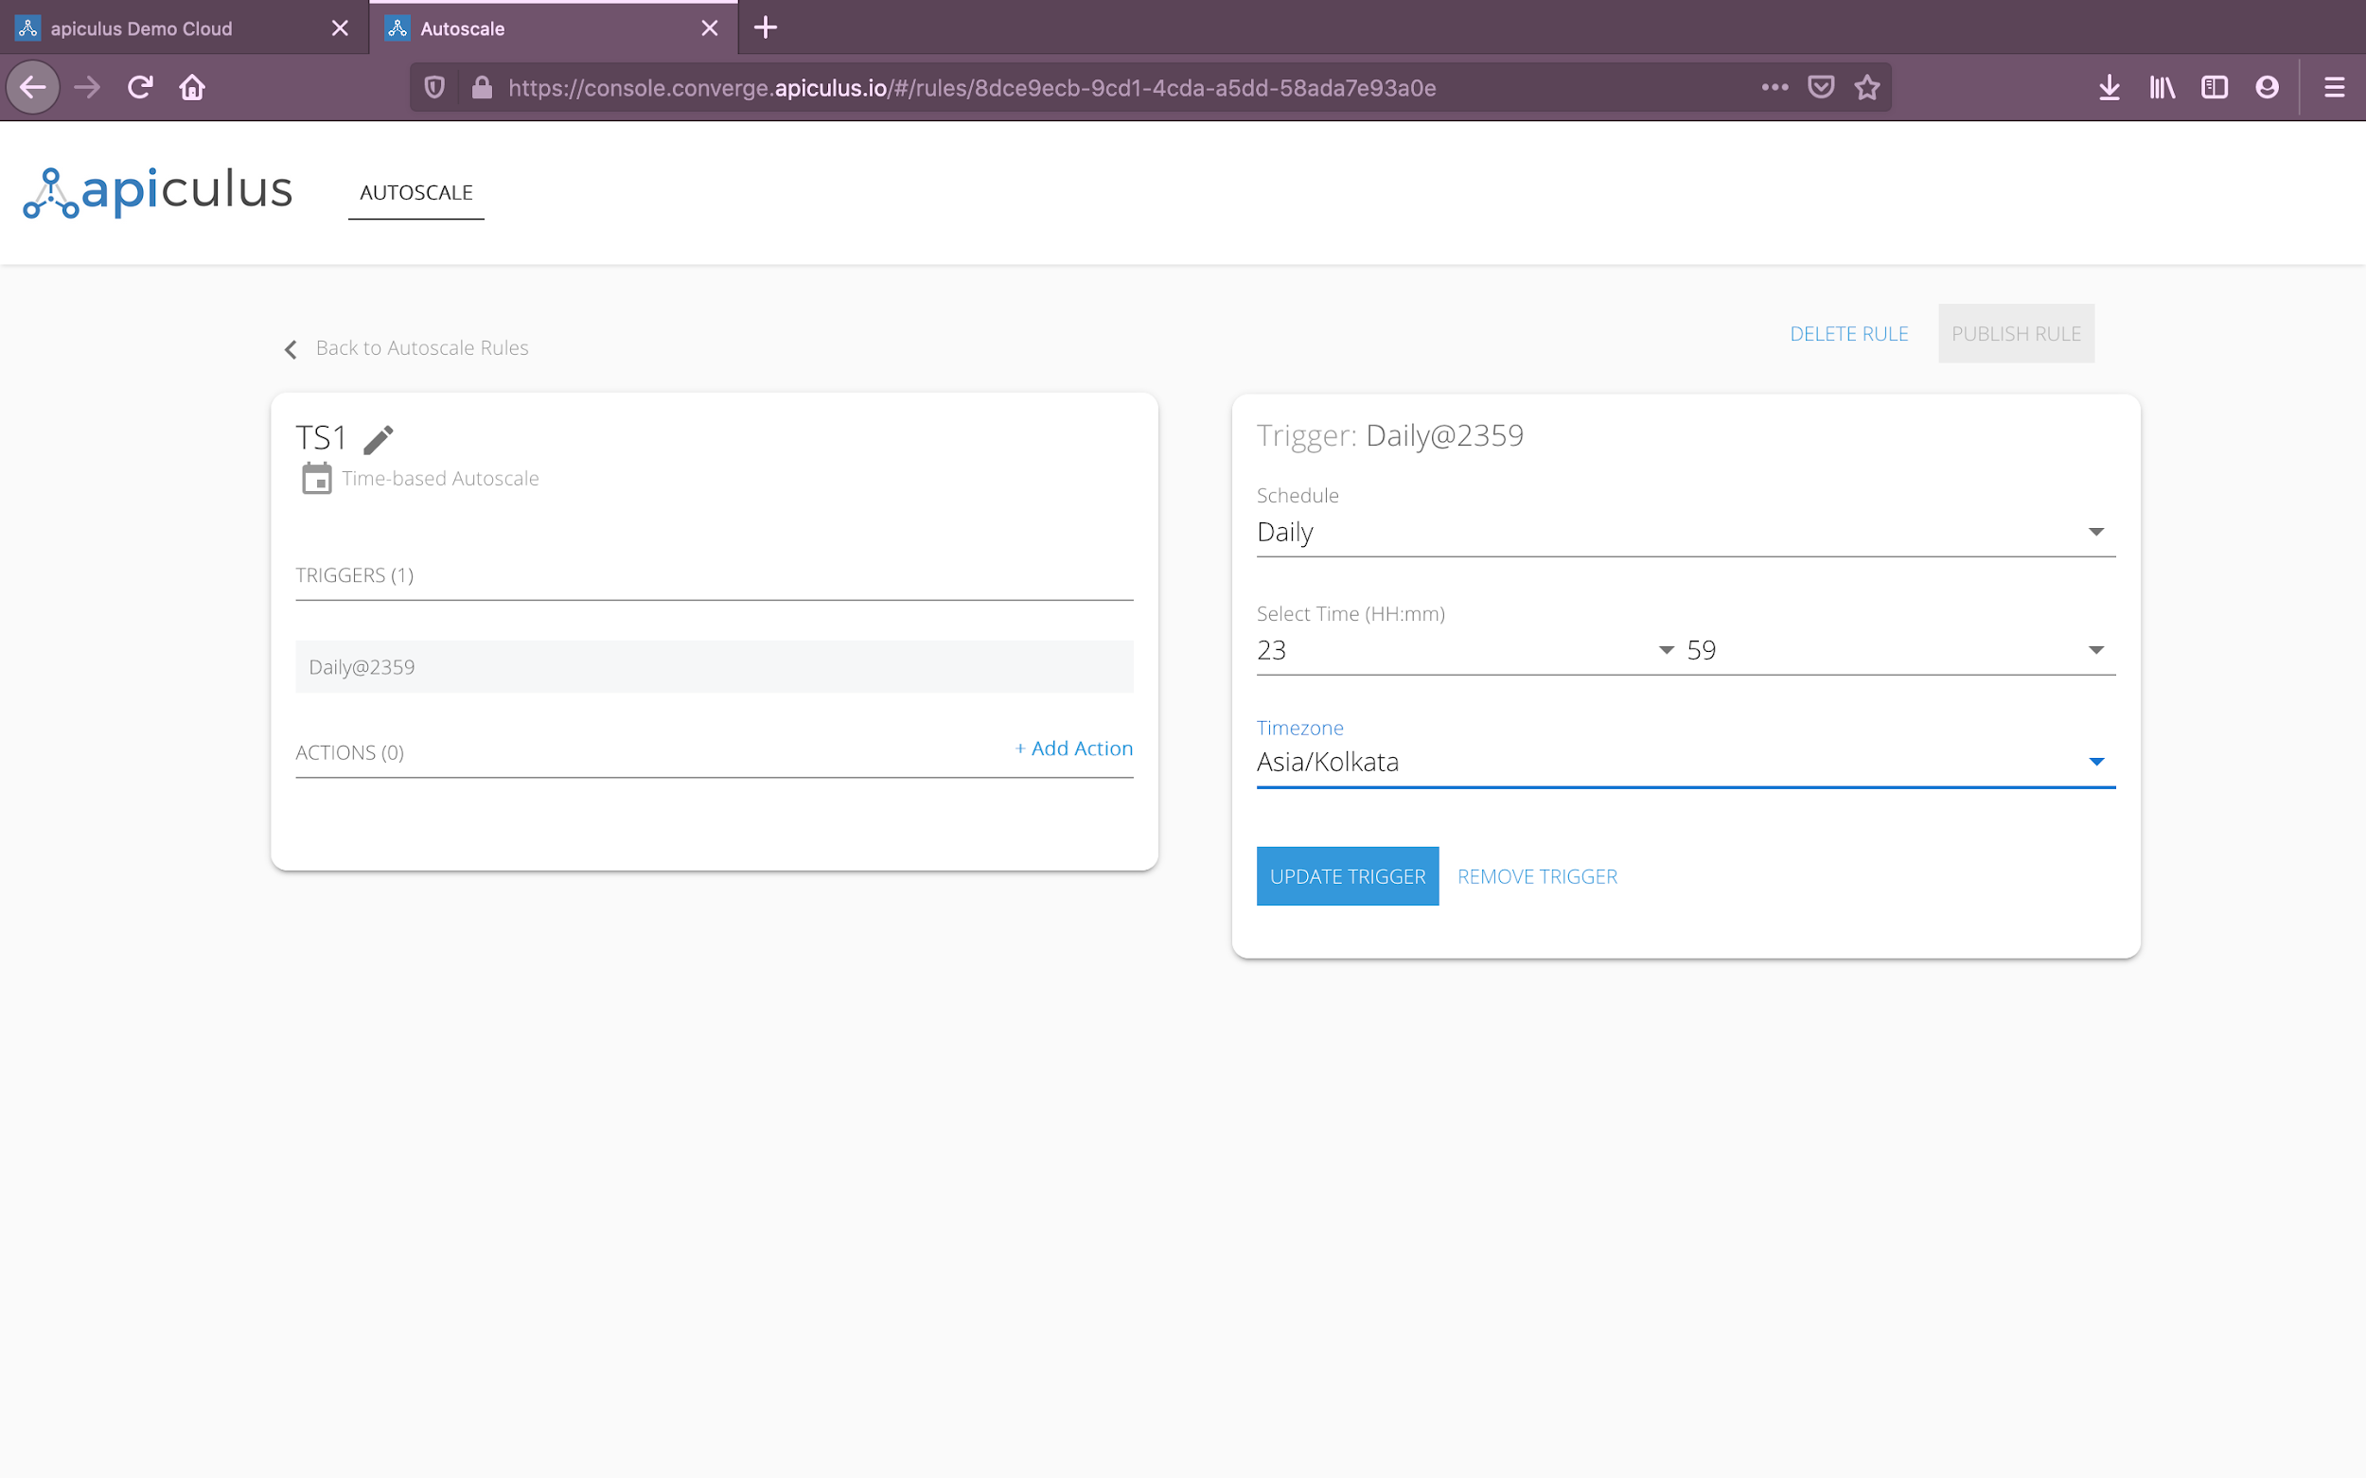

* + **Event-based triggers -** These include the following parameters:
    - **Instance Group -** This option will allow you to create an autoscale ‘group’ by choosing which instances (or virtual machines) to trigger on. *You may choose multiple instances here, depending on how your VPC and load balancing have been configured.*
    - **Parameter -** This option will allow you to define what parameter needs to be monitored to trigger the role. *Currently, apiculus Cloud only support CPU and RAM utilisation parameters.*
    - **Breach Conditions -** This set of options lets you define whether to trigger above or below a custom value, and the reading value itself.
    - **Reading Duration -** This option lets you define the breach window, i.e., the duration for which the breach has to be consistent so as to trigger the event.

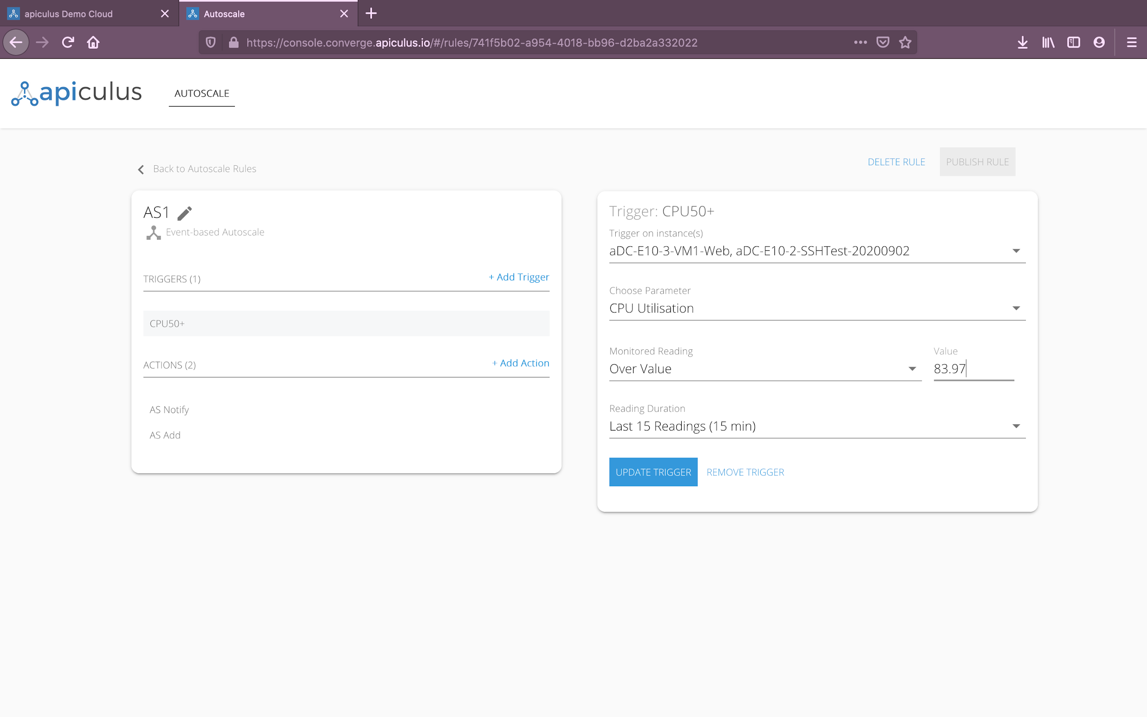

* **Actions** are the automation that needs to be performed when the trigger condition(s) is/are met. A new action can be added by using the **+ Add Action** button on the left panel in the rule configuration section.
  + Action options do not vary based on rule type, and are of the following types:
    - **Notify -** This will send a notification to the specified email IDs (comma-separated for multiple) when the trigger condition is met. *Please note that for time-based rules, notifications send a utilisation report; while for event-based rules, notifications send a breach notification.*
    - **Start Instance -** This will start a specified stopped instance when the trigger condition is met. *Please note that if the specified instance is running, this action will not do anything.*
    - **Stop Instance -** This will stop a specified running instance when the trigger condition is met. *Please note that if the specified instance is stopped, this action will not do anything.*
    - **Autoscale Instance -** This will add a new instance to the autoscale group to distribute the workload across an additional instance, and load-balance based on the VPC configuration. To define an autoscale add action, the following information is needed:
      * **Instance to Replicate -** This will let you define which instance from the instance group should be cloned when the trigger condition is met. *Please note that you can choose only one instance to clone or replicate.*
      * **Template to Apply -** A newly cloned VM will always be created using the base OS template for that configuration. If, however, you have already created a custom/golden instance image as a template in your account, you can instruct the autoscale action to create the clone using that template.
      * **Load Balancing -** This will let you choose what load balancer to add the cloned instance to.
      * **Scaleback -** This option lets you define a ‘reverse’ condition, i.e., to define when to remove the cloned instance after the load has been balanced and normalised. To define scaleback, the following information is required:
        + **Parameter(s) to scale back on -** if more than one triggers have been defined in this autoscale rule, you can choose one or more parameters to scale back on.
        + **Normalisation value -** this will let you define the ‘reverse breach’ or the value at which you consider the load to be balanced or normalised.
  + All actions have a **cooldown minutes** option, which lets you choose how long you want the system to wait until the autoscale rule is run again.

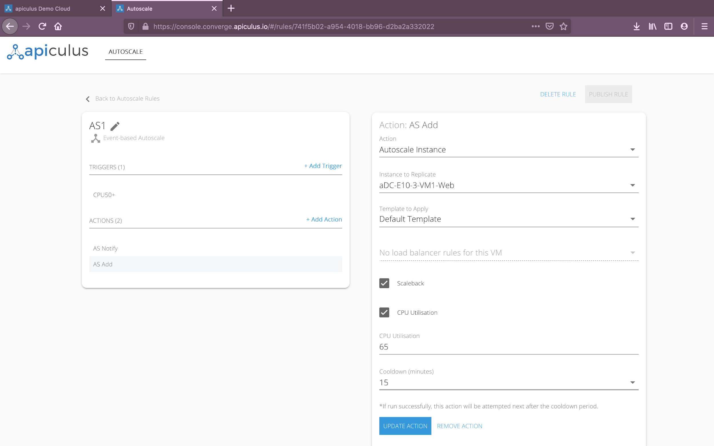

If an autoscale rule has multiple triggers and multiple actions, then the rule will be executed when **all** the trigger conditions are met, and **all** actions will be performed.

*To create autoscale rules that work if* ***either*** *condition is met, it is advisable to create separate autoscale rules.*

# 

# Publishing, Updation and Deletion

Triggers and actions can be **updated** or **removed** from the details pane on the right. Clicking on a trigger or an action on the left pane will open up the details pane for that trigger or action, and the options to update or remove the trigger or action will be available at the bottom of the right pane. Triggers and actions can be updated only when all required details have been filled up.

The autoscale rule can be deleted by using the **Delete Rule** button on top. This will delete all triggers and actions and is not reversible.

To activate an autoscale rule, it needs to be published by using the **Publish Rule** button on top. An autoscale rule can be published only when all the required details for triggers and actions are available.

Autoscale rules can also be renamed by using the rename option (**pencil icon**) on top of the left pane.

# About Instance Actions

All instance actions (start, stop, autoscale) have an impact on your account on apiculus Cloud. The following events will occur when any of these actions is performed:

1. Instance start and stop actions will generate a virtual machine start or stop notification on the main notifications panel on the apiculus Cloud console.
   1. On the apiculus Cloud console, navigating to **apiculus Cloud > Virtual Machines** will list the target virtual machines as running or stopped, depending on the action.
2. Autoscale instance action will create a new virtual machine with the following characteristics:
   1. A new instance with a numbered -clone suffix added to the name of the instance chosen for replication can be found under **apiculus Cloud > Virtual Machines**.
   2. You’ll receive a new subscription creation email for the newly created instance or virtual machine.
   3. The newly created virtual machine will always have an hourly subscription.
   4. On the main notification panel on apiculus Cloud, you’ll see notifications on new virtual machine creation and load balancer rule addition (if a load balancer rule was chosen as part of the action).
   5. Navigating to **apiculus Cloud > VPC** and viewing the target load balancer details will show the newly added virtual machine included in the load balancer rule.

# Unsubscribing from Autoscale

You can unsubscribe from your Autoscale Pack subscription by navigating to **Financials > Subscriptions** and clicking on the **Unsubscribe** link next to the Autoscale Pack subscription in the list. You can choose to automatically cancel subscription renewal, or remove the subscription immediately. Upon subscription deactivation, you’ll receive an email notification on your registered email address and you will no longer be charged for the autoscale service. You will also no longer be able to manage your autoscale rules. To use autoscale on apiculus Cloud, you’ll have to purchase the Autoscale Pack subscription again.

