apiculus® User Manual

DNS Management

IndiQus Technologies Pvt. Ltd.

**Table of Contents**

**About DNS Management** **3**

**Activating the DNS Management Service** **3**

**Adding and Updating DNS Records** **5**

**Deactivating the DNS Management Service** **6**

# 

# About DNS Management

apiculus Cloud ships as an authoritative name server for your DNS requirements. Using the DNS management features on apiculus Cloud, you can bring your own domains and use them with apiculus’s virtual compute, storage and networking services.

# Activating the DNS Management Service

The DNS Management Service can be activated from the **Marketplace**. Service activation is per DNS zone file, which is, in turn, mapped to a domain that you own (have purchased from a domain registrar).

To activate the DNS Management Service for a domain, the following steps are needed:

1. Navigate to **Marketplace > Value Added Services**.
2. Select a plan listed under **DNS Management** by clicking on **Activate**.
3. In the dialog box that opens, specify the **domain name** that you own and want to use, for which the DNS zone file will be created.

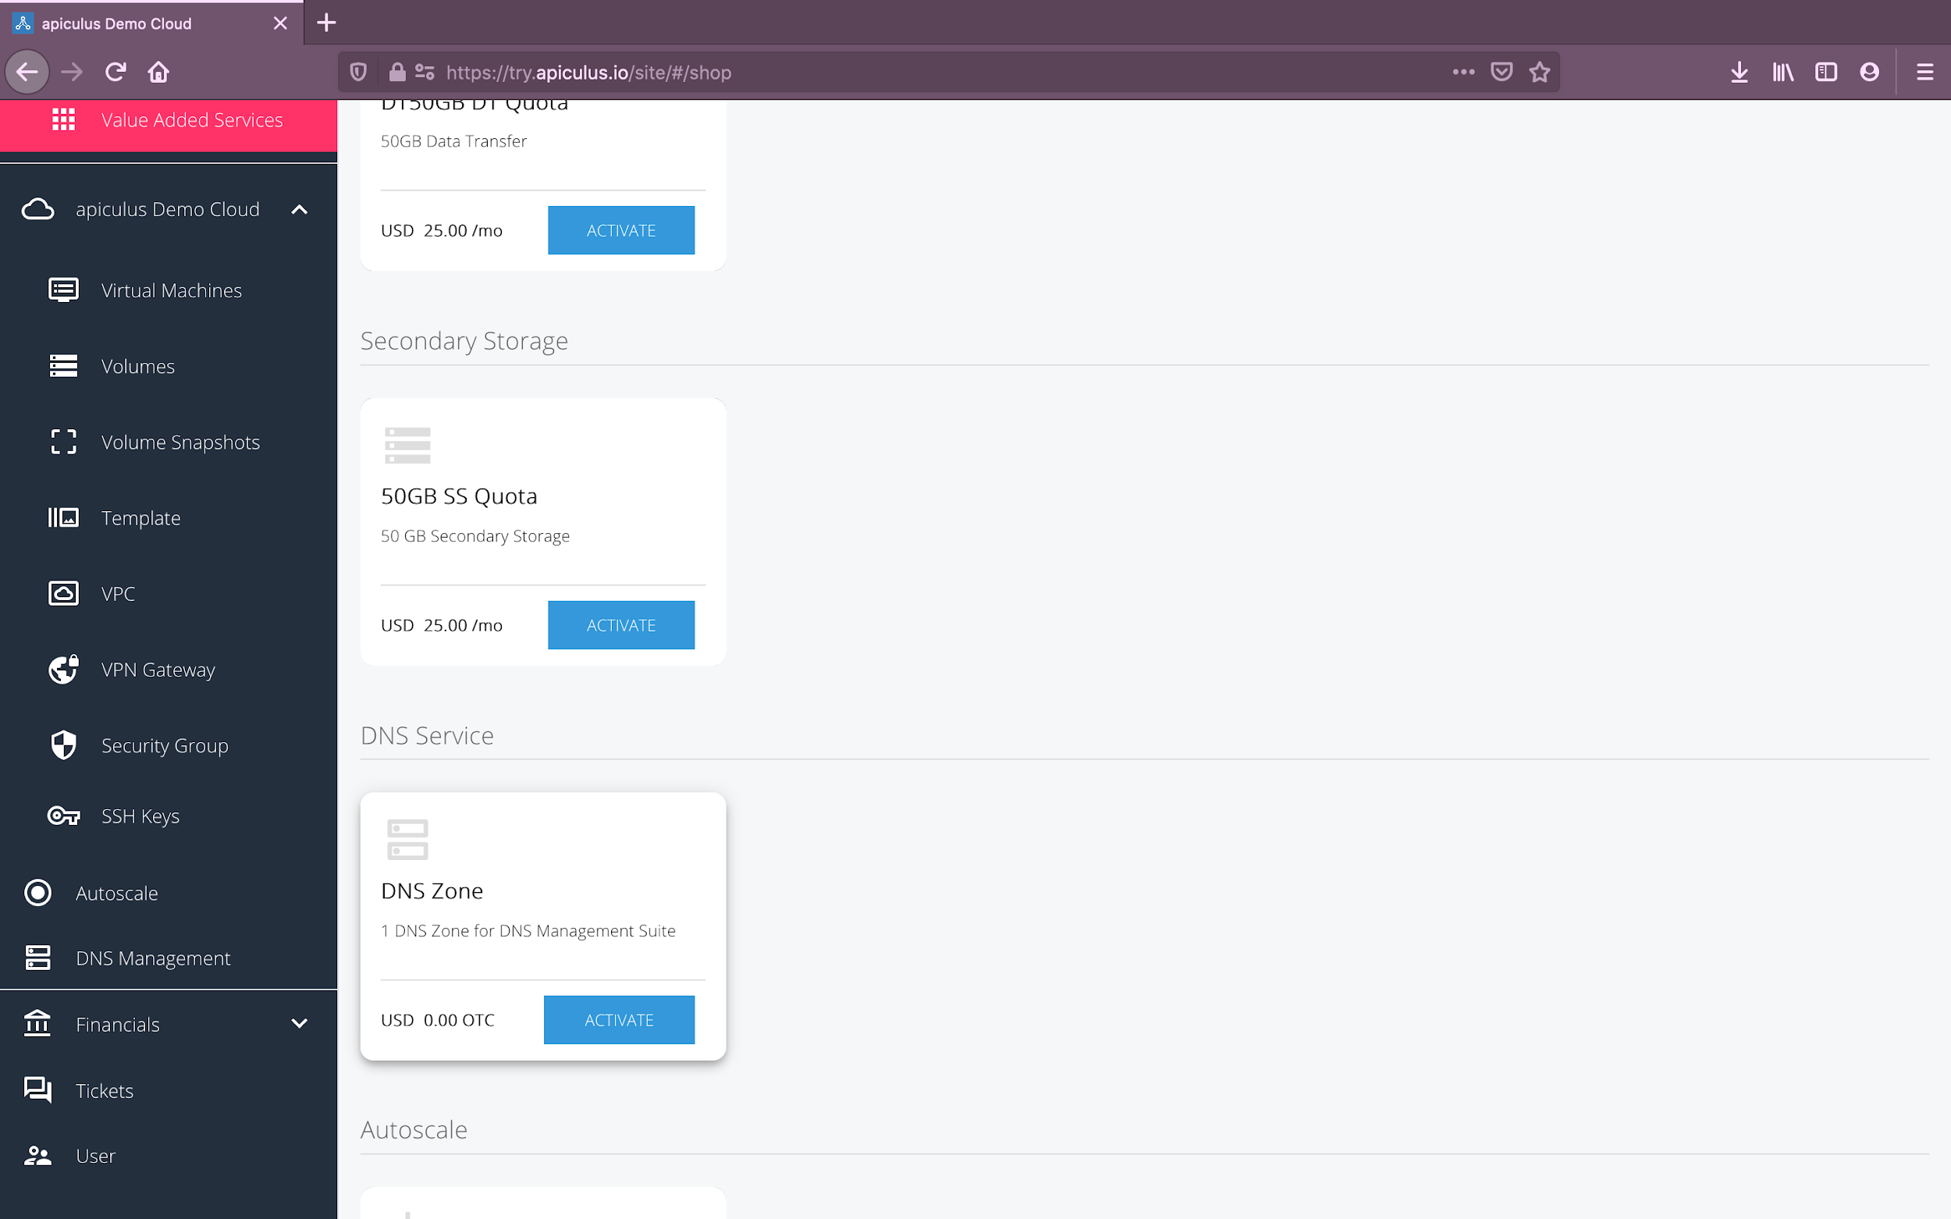

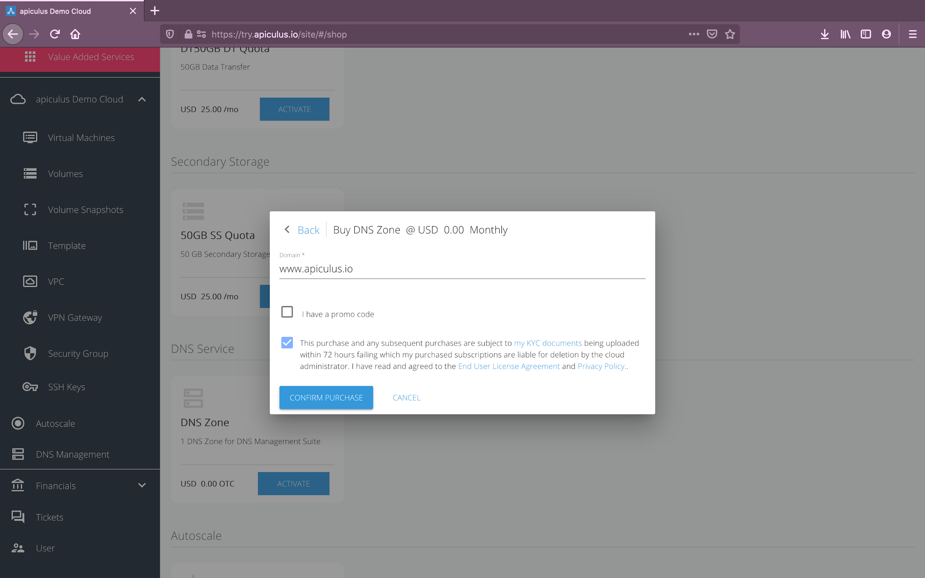

Clicking on **Confirm Purchase** with the above information will activate the DNS Management Service in your account.

Please note that this might take up to 5-8 minutes. You may use the CloudConsole during this time, but it is advised that you do not refresh the browser window.

Once ready, you’ll be notified of this purchase on your email address on record. The newly created DNS zone file can be accessed from **DNS Management** on the main navigation panel, and the corresponding subscription can be seen in the **Financials > Subscriptions** section.

To start using the DNS Management Service, you’ll need to link your domain name (on the registrar’s site) with apiculus’s authoritative name server. The details of these can be found by clicking the **Nameserver Details** button on the top-right on the DNS Management landing page.

*Please note that to use multiple domains with the DNS Management Service on apiculus Cloud, you’ll need to activate a DNS zone for each domain that you own.*

*Please note that since apiculus Cloud only provides an authoritative DNS service and is different from the lookup service provided by your ISP, you’ll need to validate ownership of your domain(s) by mapping them to apiculus’s name servers.*

# Adding and Updating DNS Records

DNS records can be managed on the **DNS Management** section on apiculus Cloud. The section lists all the active zone files and their corresponding DNS records that have been configured.

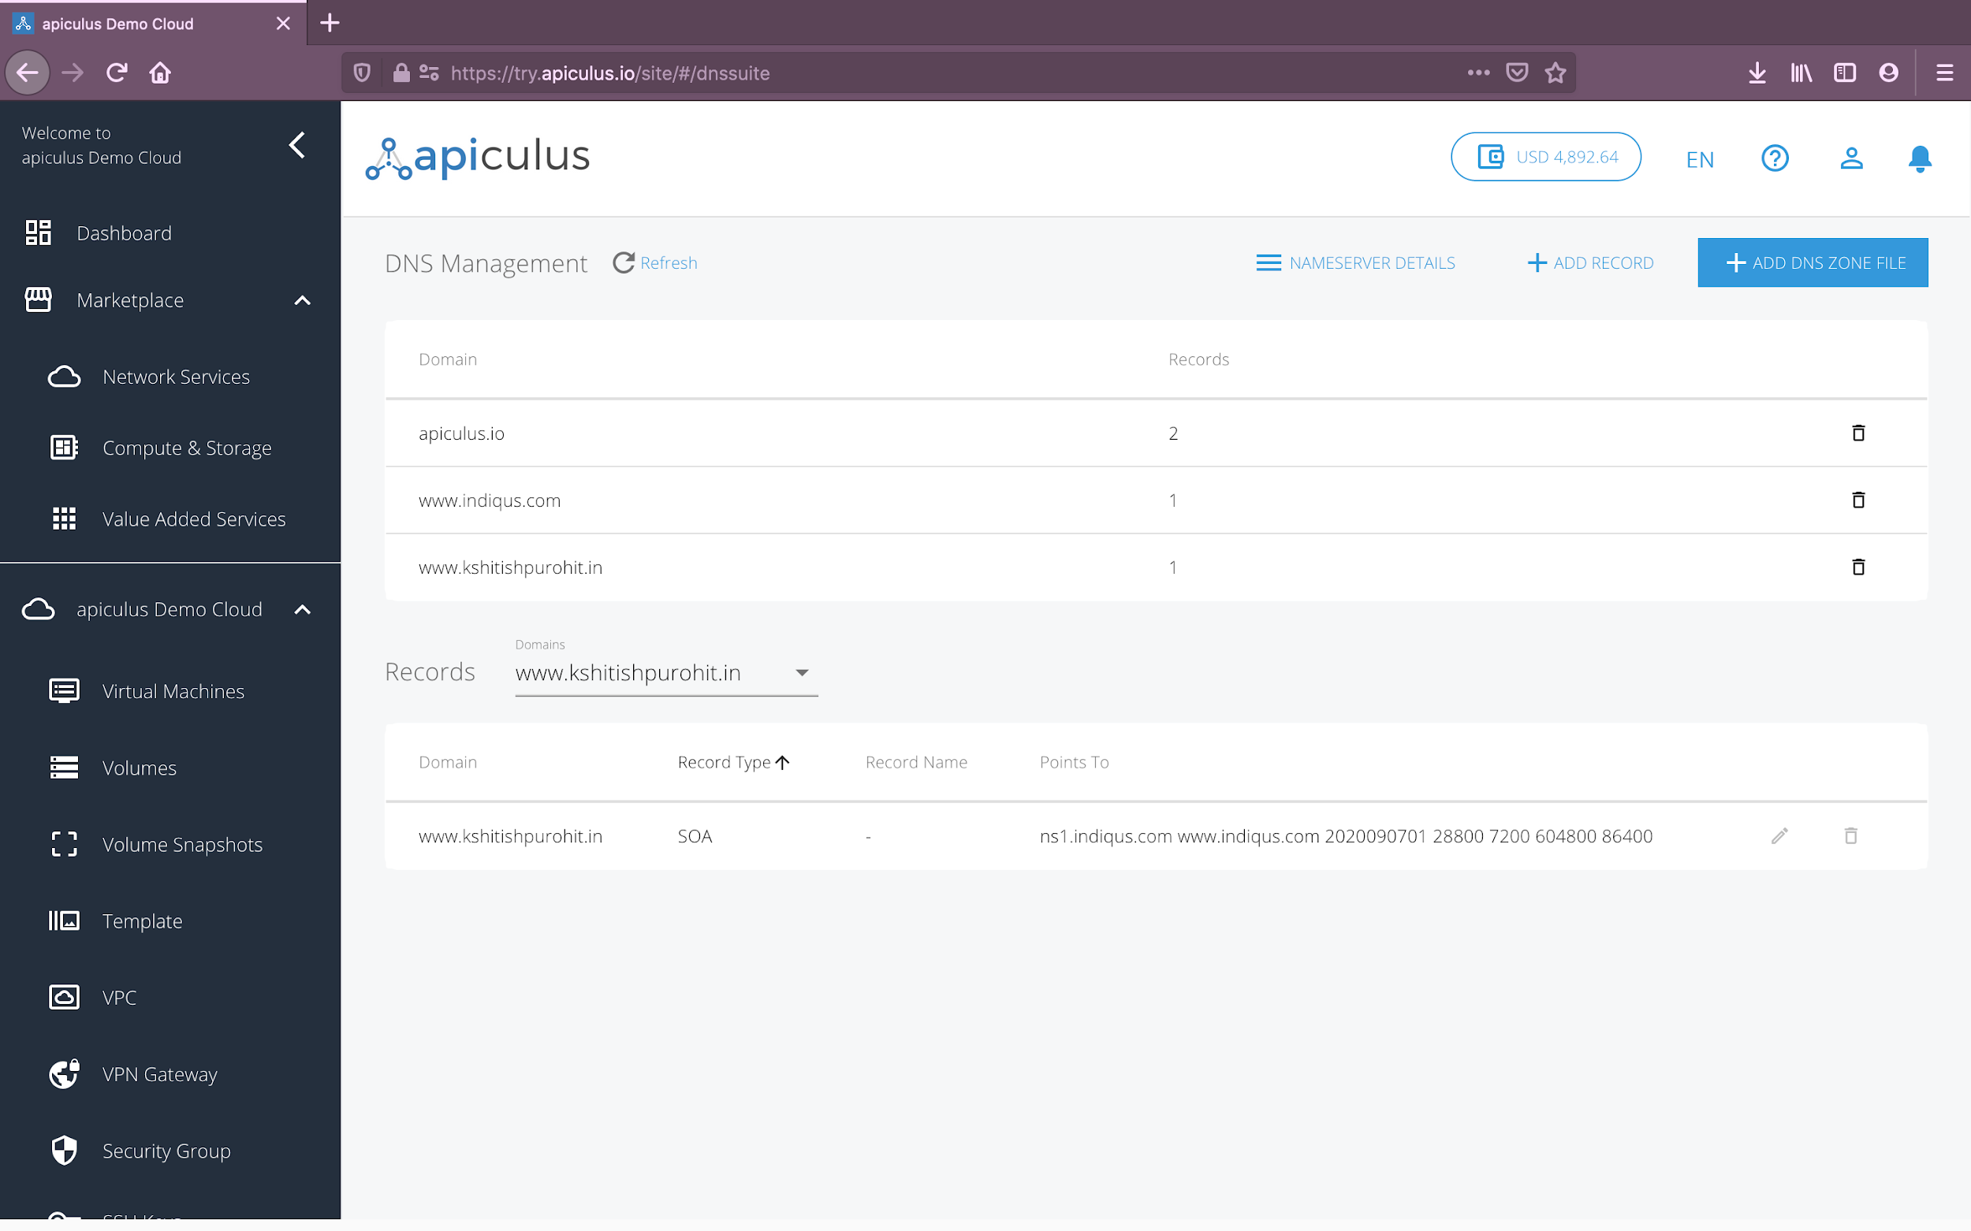

To add a new record, click on the **Add Record** button on the top-right on the DNS Management landing page. This will open up a dialog asking for the record details:

* **Domain:** the domain or the zone in which to create the new record.
* **Record Type:** you can choose from the following types of records:
  + A
  + CNAME
  + TXT
  + MX
  + SRV
  + PTR
  + ALIAS
* **Record Name:** this is the complete record name along with the domain name (e.g., recordname.domainname.com)
* **TTL:** set to 86400 as default, you can specify the TTL as per your requirement.
* **Points To:** the single IP or reverse IP range that you want the record to point to.

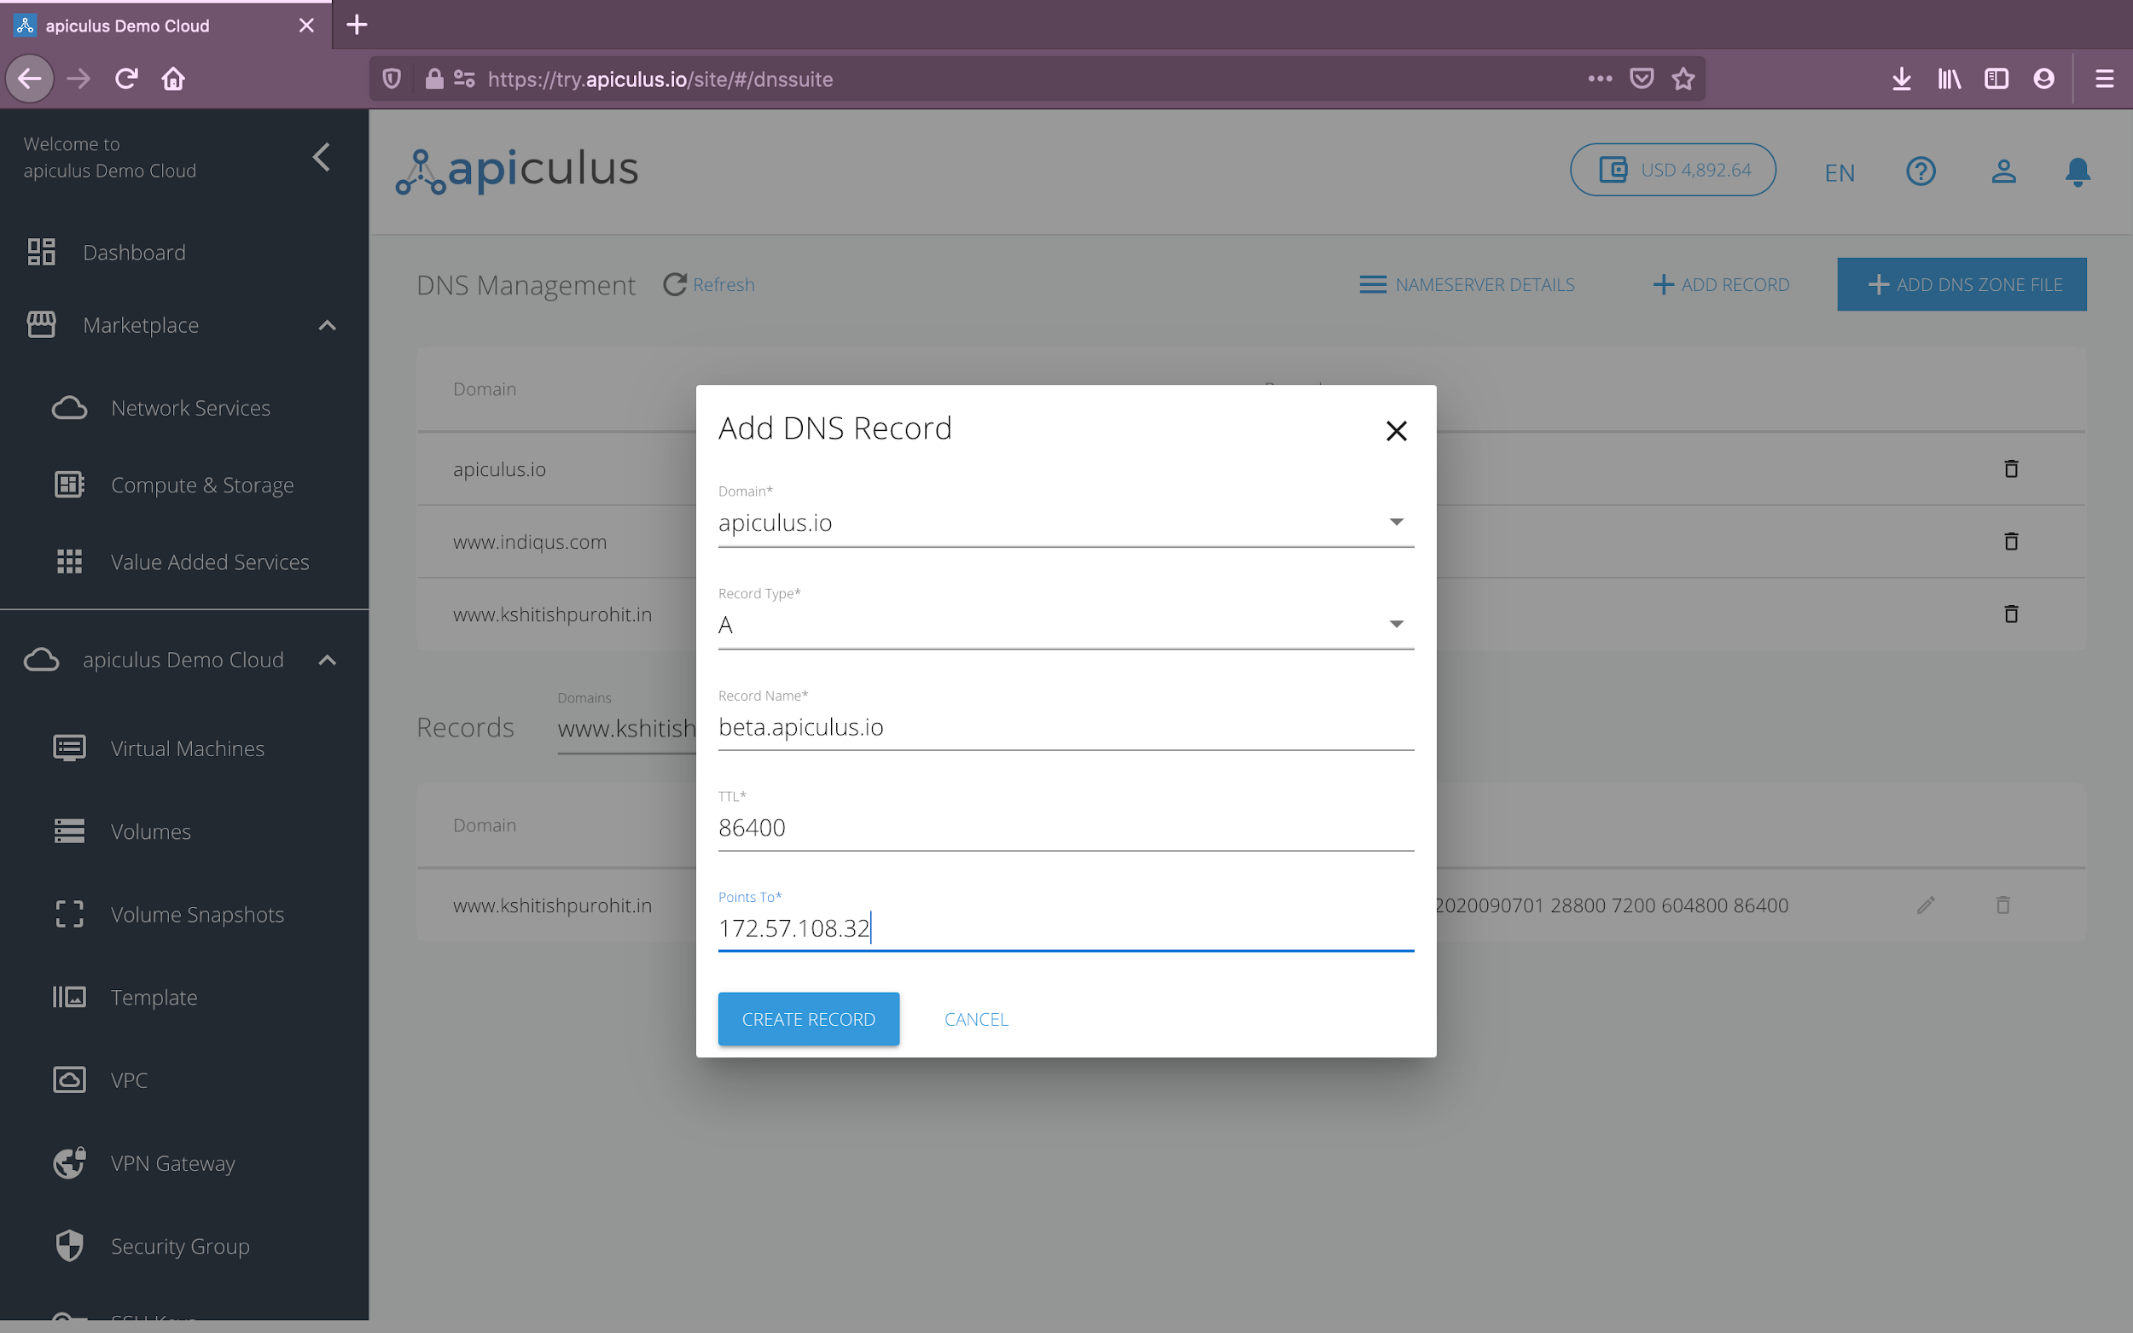

Once created, you can view, edit and delete the record from the records listing.

# Deactivating the DNS Management Service

To deactivate the DNS Management Service, simply delete the zone file(s). You may choose to delete the zone file instantly, or wait for the renewal cycle to complete and then delete the zone file.

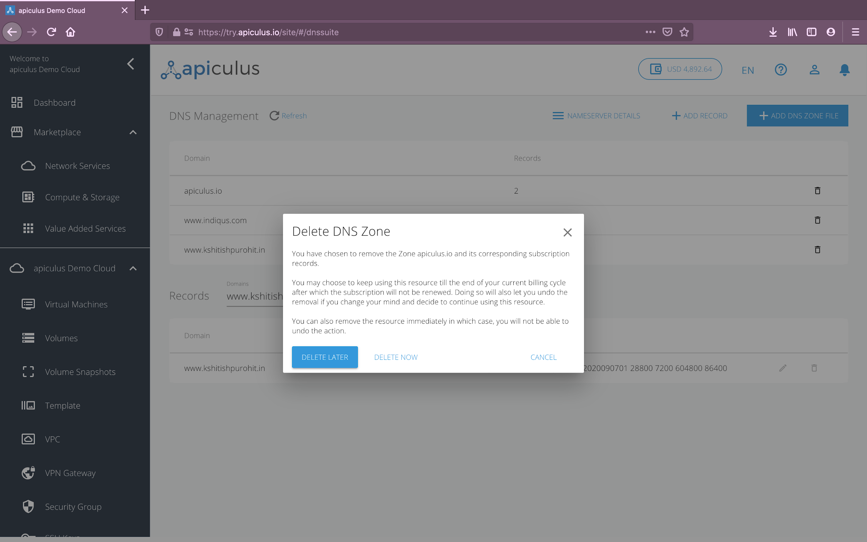

Upon deactivation, you’ll receive a notification on your email ID on record informing you of the service deactivation.