apiculus® User Manual

Billing and Financials

IndiQus Technologies Pvt. Ltd.

**Table of Contents**

**About Billing and Financials** **3**

**Billing Concepts on apiculus Cloud** **3**

**Subscriptions** **4**

**Unbilled Charges** **6**

**Invoices and Statements** **7**

**Service Balance and Transactions** **8**

**Making a Payment** **9**

# 

# About Billing and Financials

Billing on apiculus Cloud works in a subscription fashion. In line with modern-day apps and services, subscription billing models are an efficient way to deliver service value as a pay-as-you-go license. This not only eliminates heavy upfront costs for any service purchase, but also gives you the flexibility to cancel any time and pay for only the amount or duration of use.

# Billing Concepts on apiculus Cloud

To understand the various billing and financial aspects of apiculus Cloud, it is essential to be aware of certain billing concepts:

* **Billing Cycle:** By default, apiculus Cloud follows a monthly billing cycle from the 1st to the 31st (or 30th or 28th) of each month. Any resource or service purchased during the billing cycle will be invoiced in the next month.
* **Billing Frequency:** Services can have their own billing or renewal frequencies. This is essentially the time period for which the resource or service is rated and billed for. These can be:
  + Hourly (mainly for virtual machines and disks)
  + Monthly (for most of the available services)
  + Weekly
  + Quarterly
  + Half-yearly
  + Yearly
  + One-time
* **Billing Model:** apiculus Cloud follows a billing model determined by a credit limit that your account has been offered. This credit limit is a value that you can purchase services and resources up to, without running the risk of account restriction, disablement or termination. Credit limits can be enhanced by apiculus based on your usage and payment track records.
* **Service Balance:** In simple terms, the service balance is your current purchase capacity on apiculus Cloud. The service balance includes your credit limit, payments that you have made and all charges that you have incurred on your subscriptions and is denoted using a ‘wallet’ metaphor.

All billing records related to your account on apiculus Cloud can be accessed from the respective sections under **Financials** in the main navigation panel.

# Subscriptions

A subscription is a record that gets created whenever a new resource is purchased or a service is activated. In other words, a subscription is a financial ‘agreement’ that links the item that has been purchased, its value and its renewal frequency.

Subscriptions have the following characteristics:

* By default, all subscriptions are set to renew automatically at the end of their billing durations.
* By default, all subscriptions are set to prorate on entry as well as on exit. This means that subscriptions created or deleted in the middle of a billing cycle will only be charged partly and not for the whole billing month.
* Subscriptions can be cancelled (or deactivated) at any time. However, while cancelling, you’ll have the option to delete the subscription immediately (instant deletion) or just cancel automatic renewal (scheduled deletion).

apiculus Cloud supports the following types of subscriptions:

* **Fixed recurring -** These have a fixed charge for a fixed period and are automatically renewed with the same fixed charges.
* **Usage -** These are metered (mostly) in an hourly fashion and are billed on the number of usage hours.
* **Fixed non-recurring -** These have a fixed one-time charge and do not require renewal.

Subscriptions can be accessed by clicking on **Financials > Subscriptions** in the main navigation panel. This section shows the following information:

1. **Active Subscriptions -** a tabulated list of all subscriptions that are currently active in your account. *Please note that subscriptions for data transfer and secondary storage are always enabled by default.*
2. **Inactive Subscriptions -** a tabulated list of all subscriptions that were active in the past. This includes all removed subscriptions.
3. **Scheduled for Deletion -** a tabulated list of all subscriptions that are set to not renew automatically.

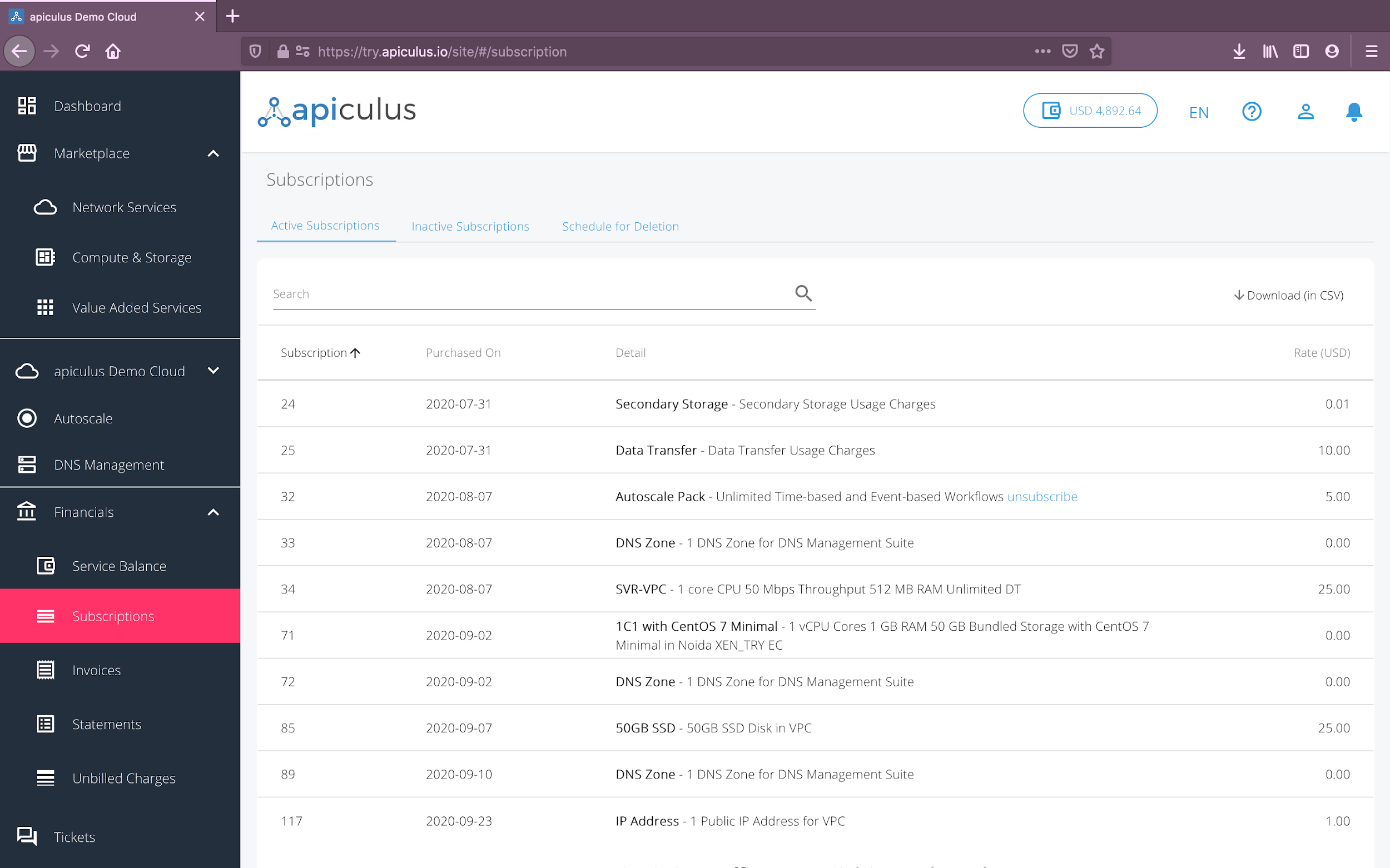

# 

# Unbilled Charges

All subscriptions incur prorated charges during an account’s billing cycle. These incurred charges are also known as unbilled charges and can be accessed from the **Financials > Unbilled Charges** section on the main navigation panel.

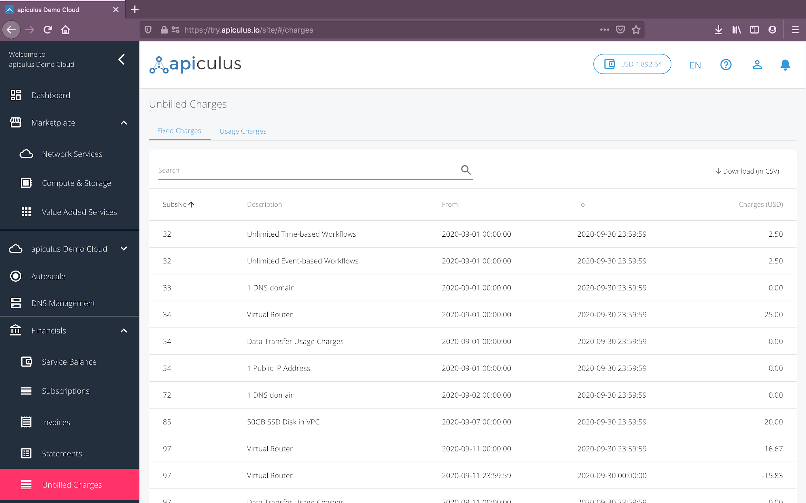

Unbilled charges for fixed (recurring or non-recurring) subscriptions are prorated daily by default. Unbilled charges for usage subscriptions show the actual incurred charges till the last hour.

# 

# Invoices and Statements

Invoices are generated at the end of each billing cycle for the services consumed during the billing cycle. Invoices can be accessed from the **Financials > Invoices** section on the main navigation panel.

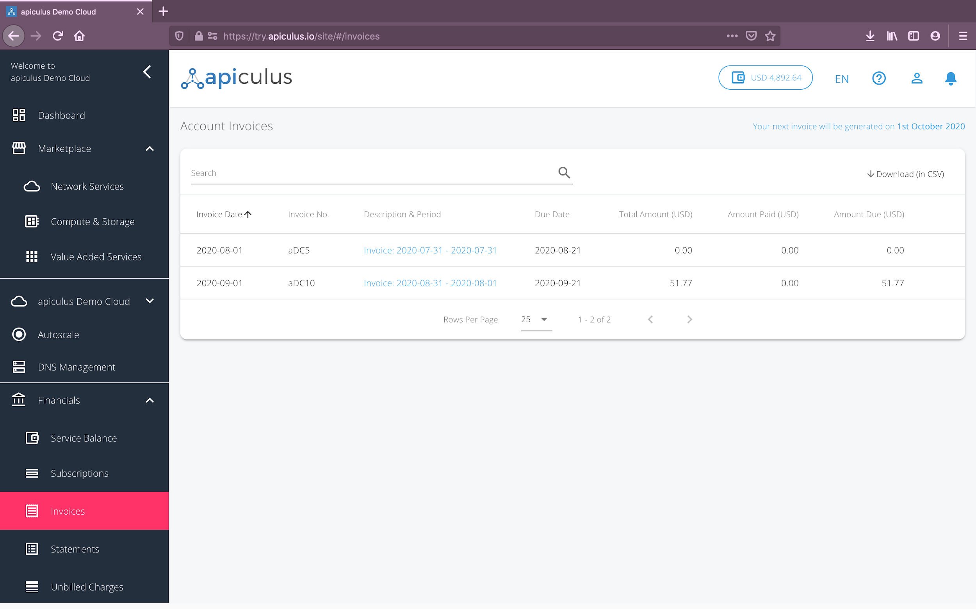

If apiculus Cloud takes online payments, then payments against individual invoices can be made by clicking on the wallet/payment icon next to the invoice. Doing so will navigate to the payment gateway page where you can use any of the supported modes of payment. *Please note that apiculus Cloud does not store any card or bank account information and the same is handled solely by the payment gateway provider.*

Similar to invoices, billing statements are also generated at the end of each billing cycle. These can be accessed from the **Financials > Statements** section on the main navigation panel. A billing statement is an overall summary of opening balance, total credits, total charges and closing balance for a billing cycle.

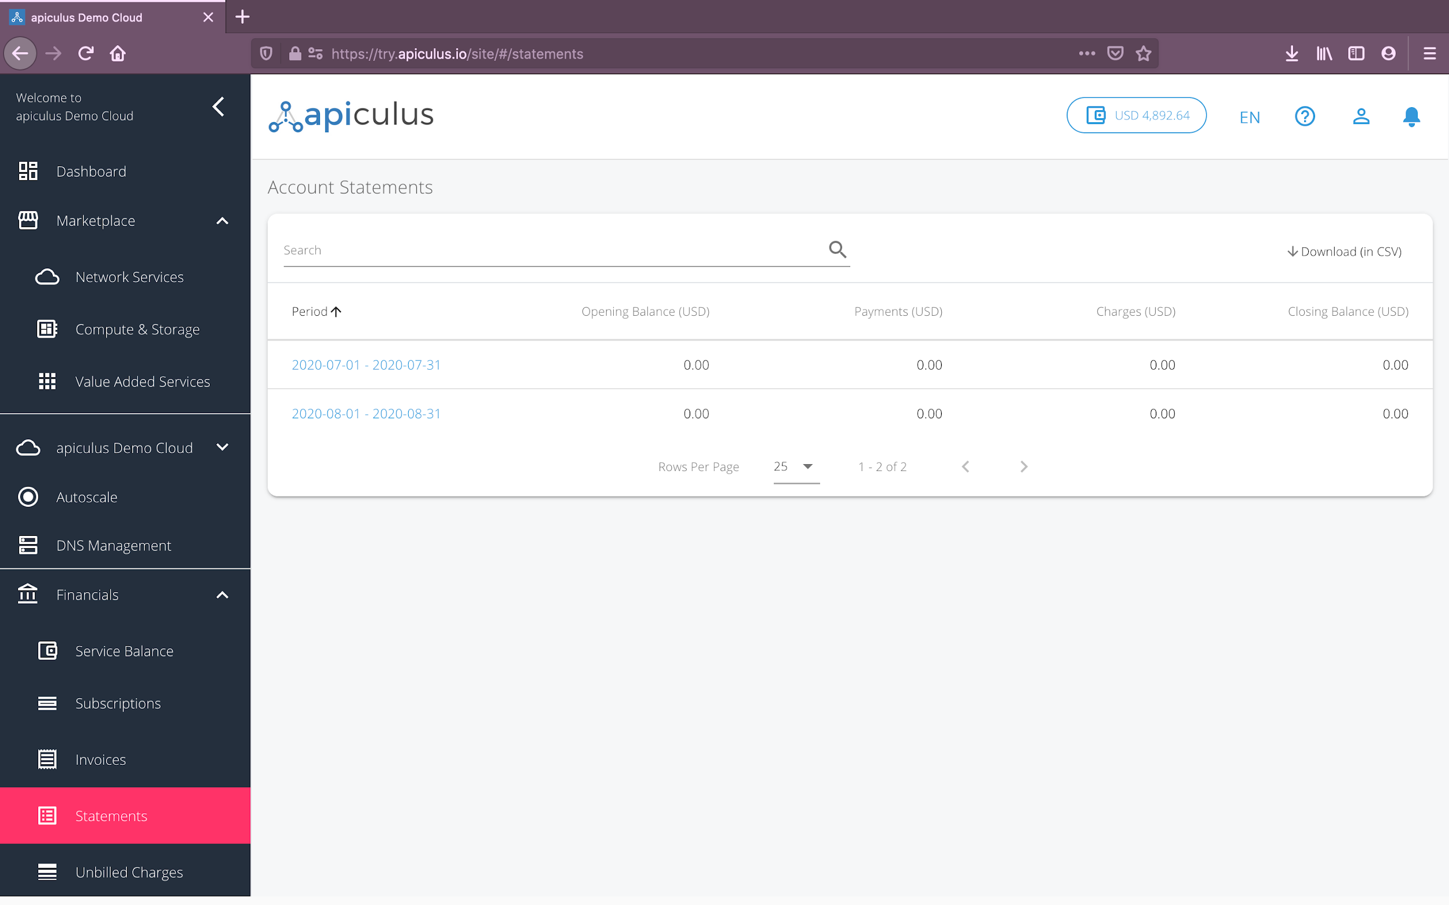

# Service Balance and Transactions

For all practical purposes, the service balance acts as your wallet balance or purchase capacity at any given point of time. The service balance is an aggregation of your credit limit, total payments made and the total charges incurred on your account. Your service balance is always displayed on the top helper bar, and gets updated in real time when a transaction or a charge is recorded.

The service balance and transactions listing can also be accessed from the **Financials > Service Balance** section on the main navigation panel. This section lists all the transactions that have been made towards your service balance, along with providing a means to add money to your wallet.

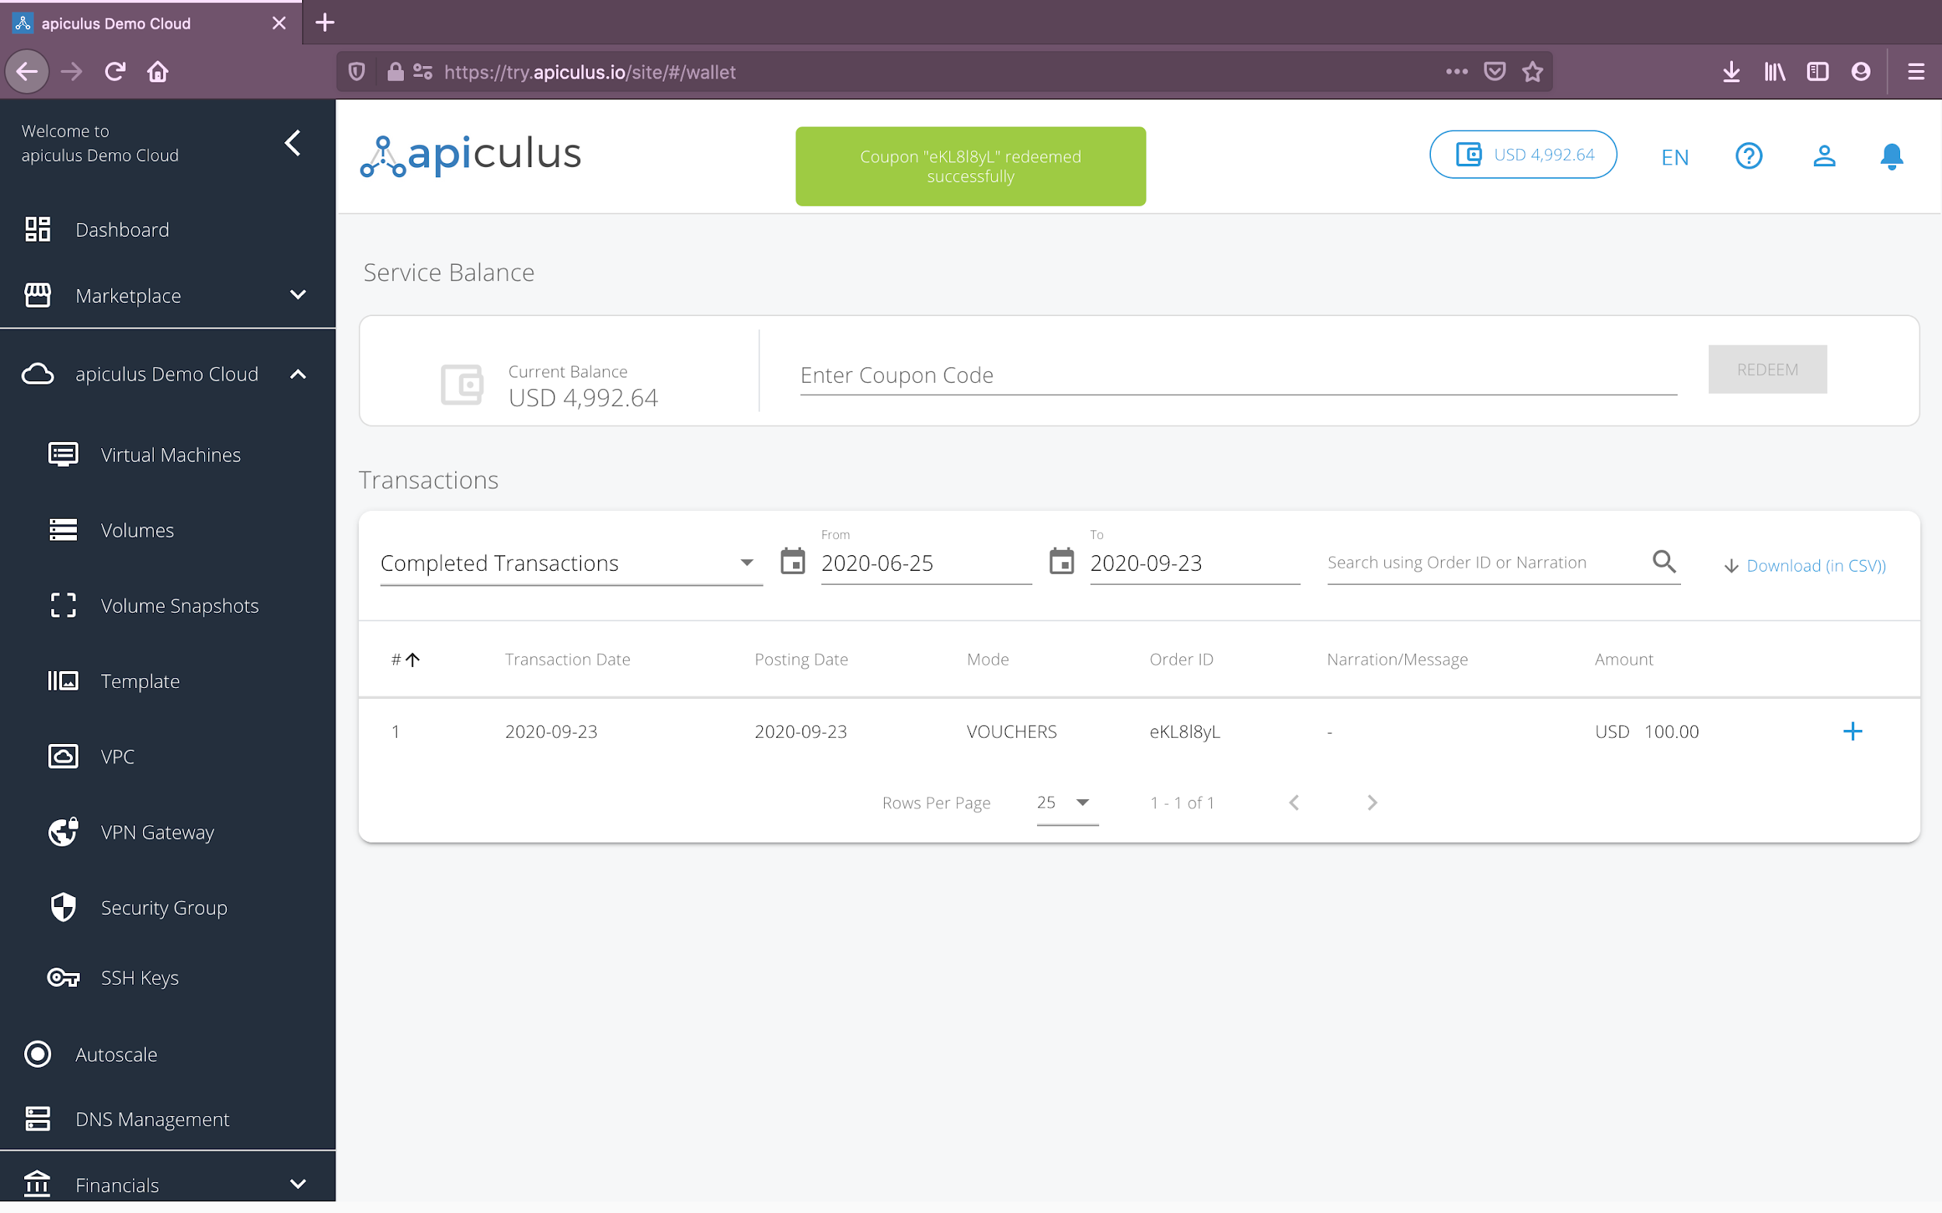

# Making a Payment

apiculus Cloud supports three ways of making payments or adding money to the wallet:

1. **Payment Gateway -** On the service balance section, if apiculus Cloud supports receiving direct online payments, you’ll see an input field asking for the amount to pay. Using this feature, you can specify the amount and also distribute the amount against outstanding invoices or settle as advance amounts. The actual payment will be via the supported payment gateway.
2. **Cash Voucher -** Time and again, {service provide name} may send you cash vouchers as part of a marketing campaign or for any other reason. The service balance can be topped up using cash vouchers by entering the coupon code as received from apiculus.
3. **Offline Payments -** In the event that an online payment failed to get recorded, or if you wish to pay offline (using cheque, direct bank transfer or any other payment method), the apiculus admin will record it as an offline settlement from the backend administration console within 48-72 hours of receiving the payment. This will get reflected as a transaction in your account.