apiculus® User Manual

Account Profile and  
Child User Management

IndiQus Technologies Pvt. Ltd.

**Table of Contents**

**Account Profile** **3**

**Child Users** **3**

# 

# Account Profile

Using the **Profile** section, you can manage your organisation account profile on apiculus Cloud. The profile management section can be accessed from the top helper bar by clicking on the user icon. Account profiles include the following:

1. **Details -** These are the basic demographic details of your organisation. All editable fields can be updated any time.
2. **Billing -** These are the billing details for your organisation, viz., billing address, taxation ID etc.
3. **People -** These are the details for billing and technical contacts in your organisation. *Please note that these contacts are not child users, and do not get login credentials.*
4. **Documents -** This section can be used to upload various organisational documents, e.g., company registration information, taxation ID documents, proofs of address etc. *Please note that apiculus might require these documents to allow continued usage of the cloud services.*

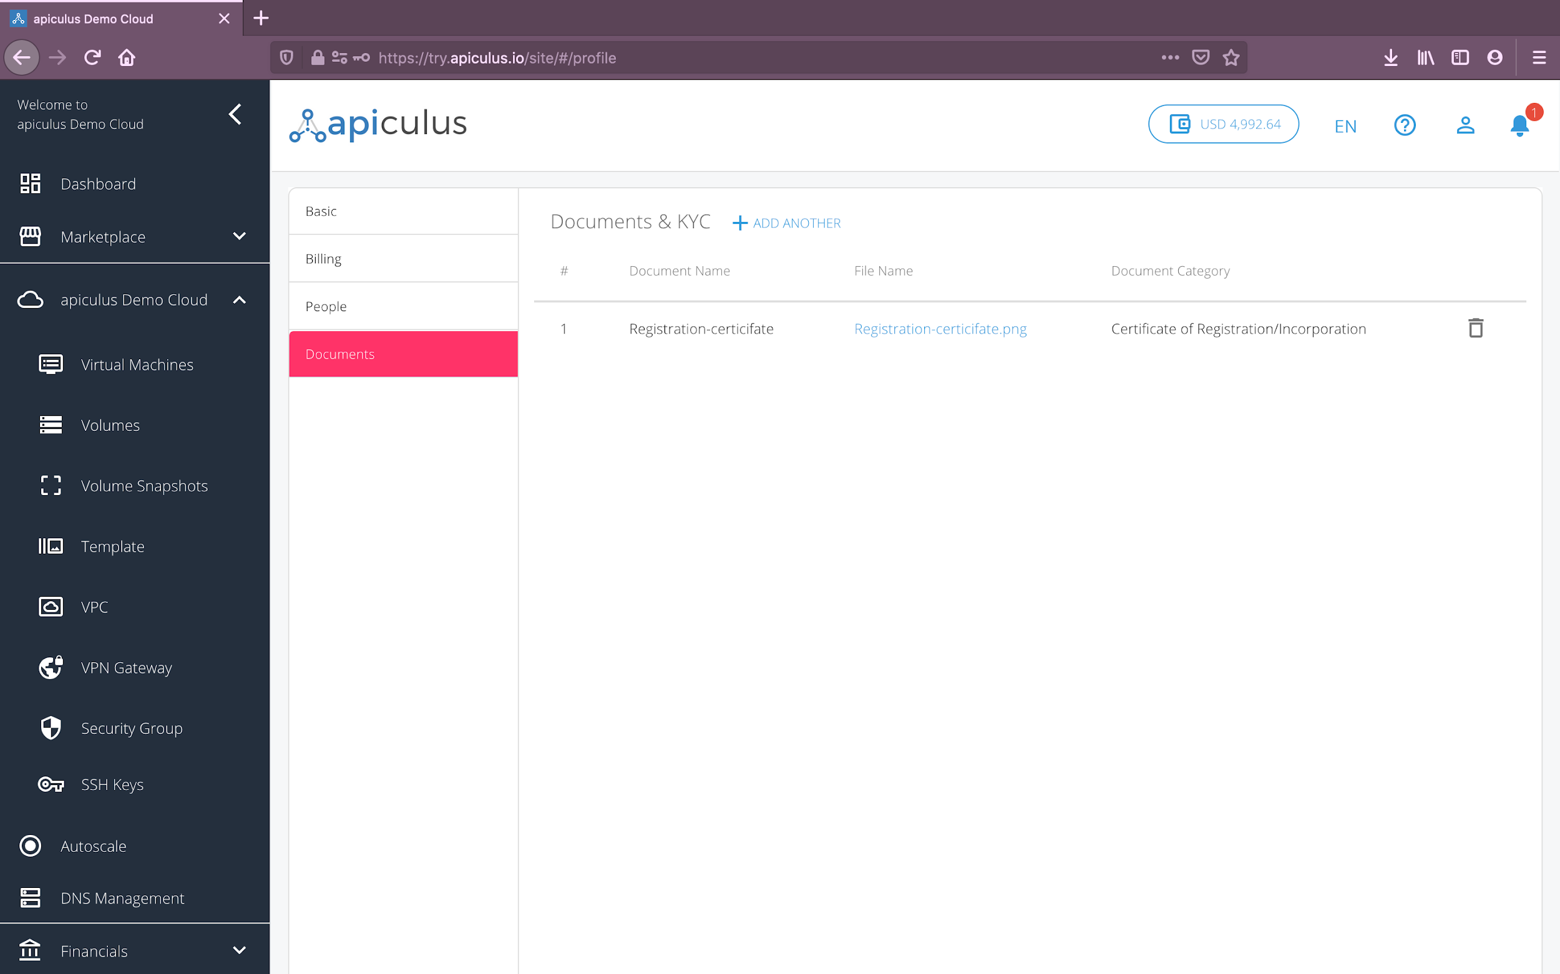

# 

# Child Users

Child users can be onboarded using the **Users** section in the main navigation panel. apiculus Cloud allows you to add billing, technical or other admin users who can log in to your account and perform operations.

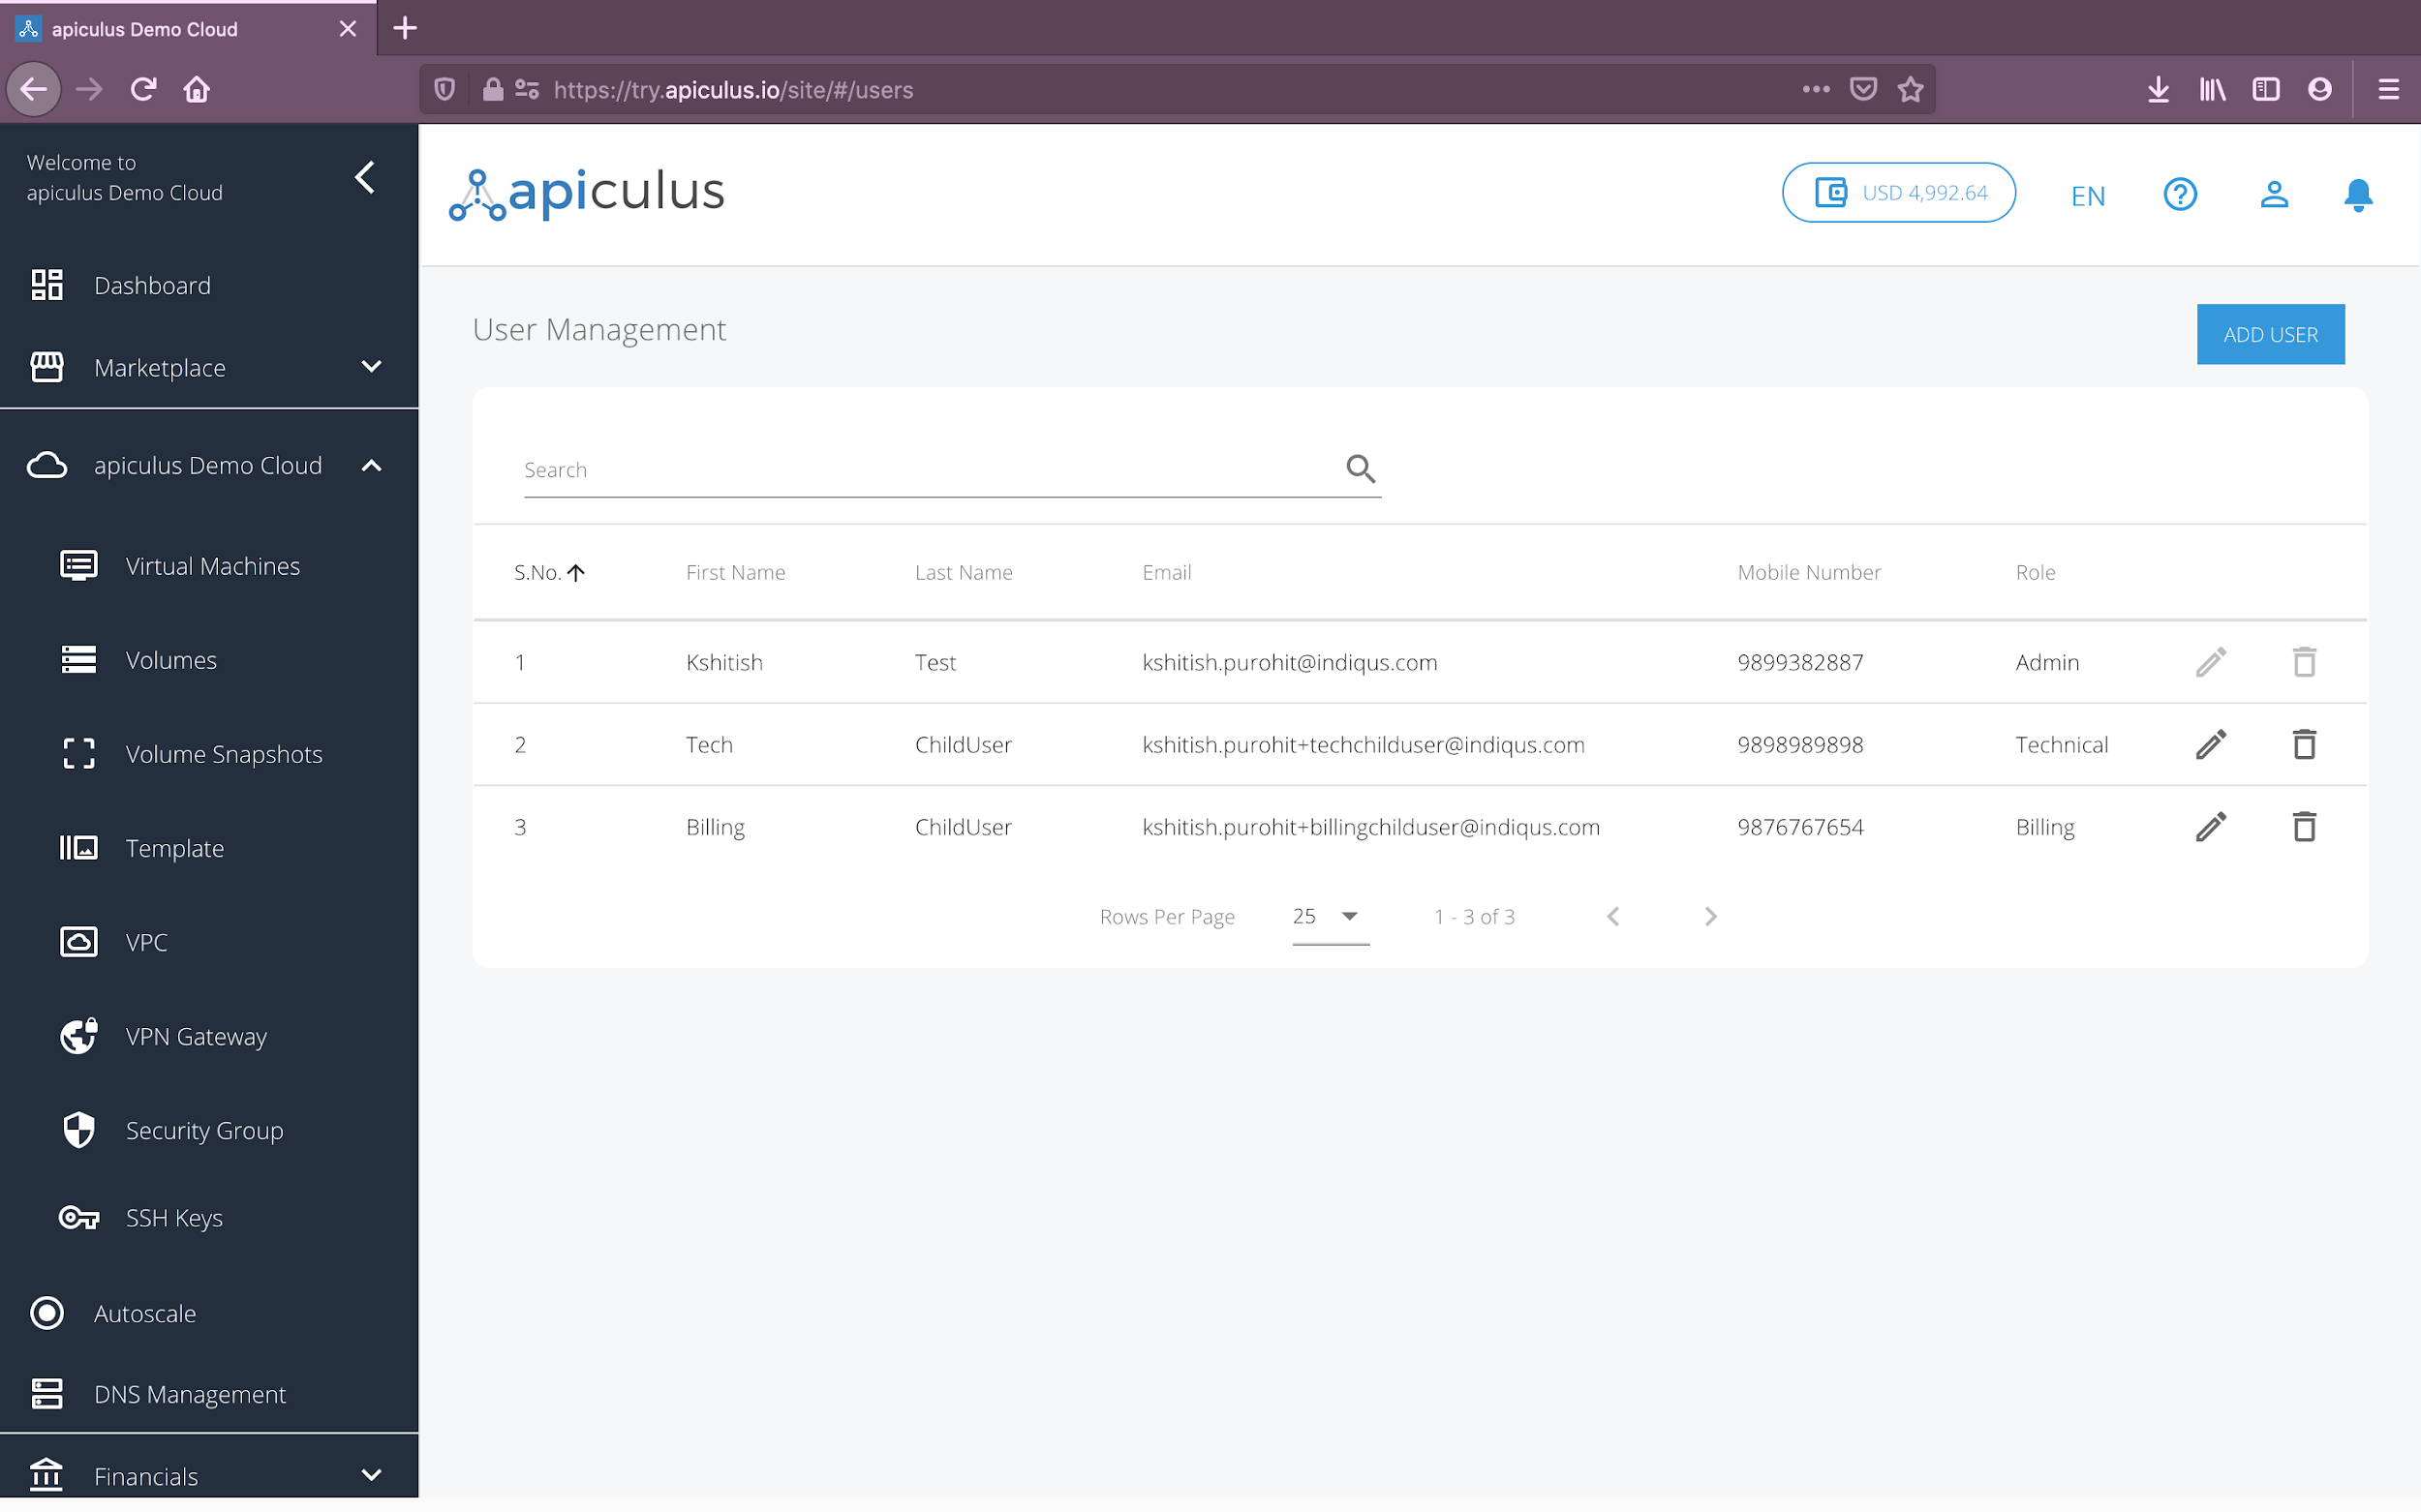

To add a child user, click on the **Add User** button on the top-right. This will open up a dialog box with the following information requirements:

* **User Details -** name, email, country, phone number etc. for the child user.
* **Password -** a password to begin with. Please note that the child user can reset the password from the apiculus CloudConsole.
* **Group -** role for the child user. These can be:
  + **Admin -** gets access to all functionalities.
  + **Billing -** gets permissions to perform billing actions and read-only for other actions.
  + **Technical -** gets permissions to perform technical actions and read-only for other actions.

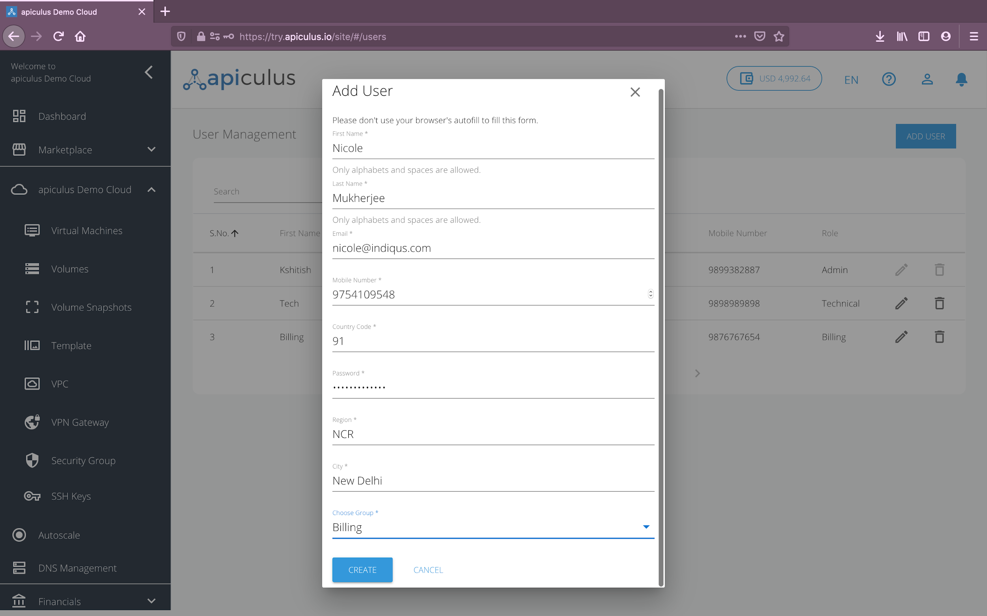

The child user will get notified over the email provided in the form of their account being created. They can then log in and use the apiculus CloudConsole based on the role assigned to them. *Please note that the first/default user will supersede all other admin users, which means that while admin users can edit or remove other users, only the default user can delete other admin users.*