Google Data Analytic Capstone Project - Case Study - Cyclistic Bikeshare
Mesula Korsa - PhD (Veterinary Science) — Health Data Scientist (Portfolio Case Study)
Version: Portfolio Final (No Asterisks) | Date: 18 Jan 2026

1. Executive Summary
Why this matters - Annual members are more profitable than casual riders. My goal was to understand how behavior differs so Bikeshare can convert casuals to members and improve service where it counts.
What results show - Members account for roughly 64% of trips. Usage peaks in July–August and dips in January. Casual riders cluster on weekends (leisure), while members show a weekday commute pattern (notably a Tuesday spike). Classic & electric bikes dominate; docked bikes are rarely used by members.
What to do – Bikeshare needs to focus on conversion during Mar–Aug: a Summer Pass → Annual ladder, a Weekend‑Only pilot to capture leisure demand, and a Commute bundle that rewards weekday streaks. Operationally, increase e‑bike availability and tighten rebalancing around weekend/summer surges; reassess the role of docked bikes in member‑dense areas.

2. Data & Method
Data - 12 monthly CSVs (Jan–Dec 2023). The data was combined into one dataset within Power Query, enforced types, handled nulls, information not required for analysis as well as outliers have been checked and removed before modeling.
Modeling - A simple star schema: a Trips fact table plus Calendar and Station dimensions. DAX measures summarize member share, seasonality, day‑of‑week, and bike‑type mix.
Assumptions & limitations - The case‑study dataset lacks pricing and demographics and does not include weather. Findings reflect usage patterns rather than lifetime value or price sensitivity.

2.1 Data Analysis workflow and transformations
Figure 1. Data analysis workflow.
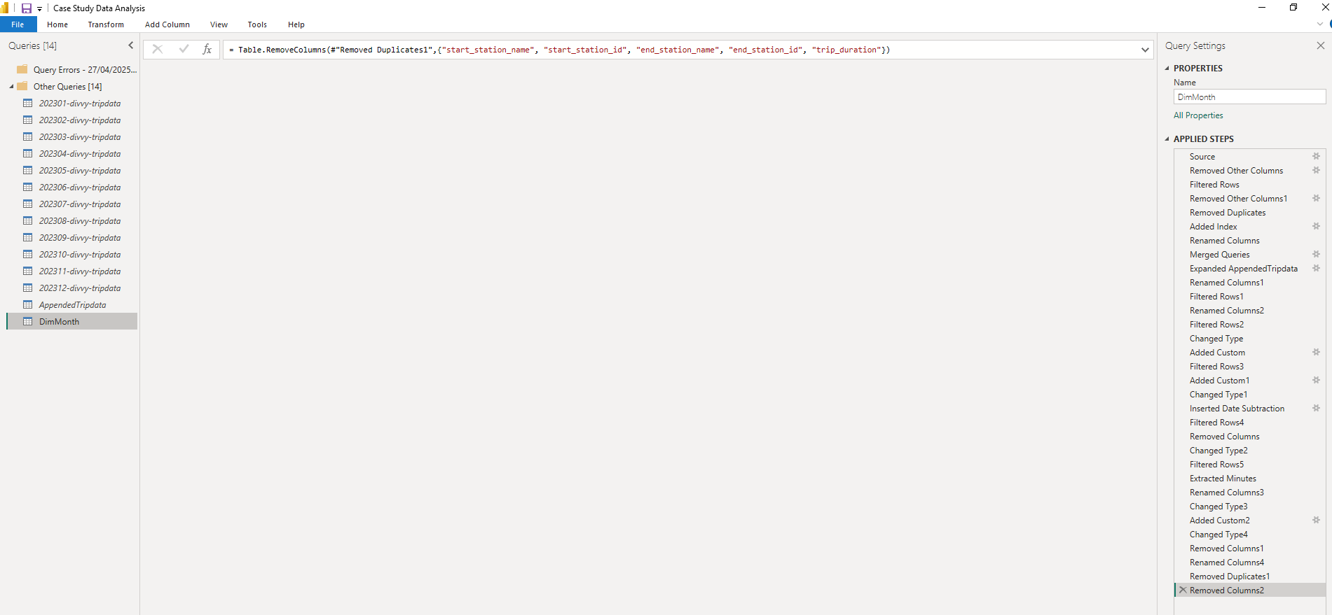
Figure 2. Power Query cleaning and transformation steps.

3. Findings
3.1 Membership mix (see Figure 3). Members are the majority and create a reliable base for membership focused growth.
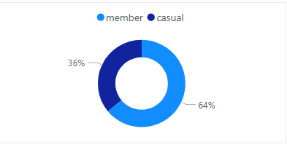
Figure 3. Share of total trips: members ~64% vs casual ~36%.
Why it matters - With most trips already from members, conversion efforts should target high‑propensity casuals rather than broad new‑user acquisition.
3.2 Bike type preference (see Figure 4). Classic & electric bikes dominate; docked usage is minimal among members.
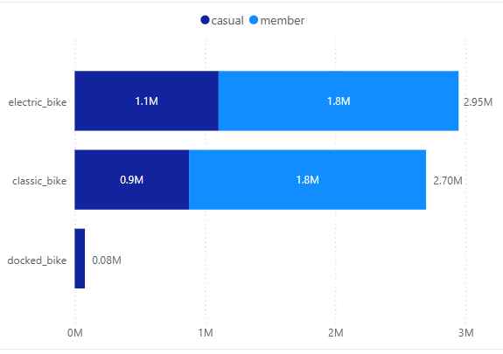
Figure 4. Bike type distribution by rider type.
Why it matters - Allocate more e‑bikes where commuters and weekend riders overlap; consider repurposing or phasing down docked bikes in member‑heavy areas.
3.3 Monthly seasonality (see Figure 5). Demand rises in spring, peaks mid‑summer, and dips sharply in winter.
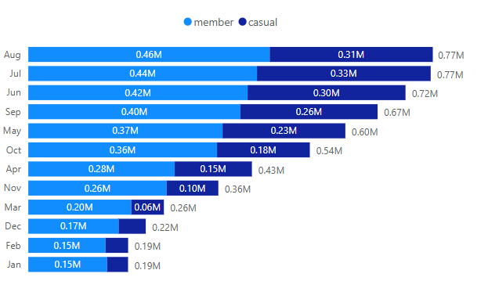
Figure 5. Monthly trips: peak in July–August; trough in January.
Why it matters - Concentrate campaigns in Mar–Aug; schedule maintenance and battery programs before the surge; ensure staffing and rebalancing plans match the curve.
3.4 Day‑of‑week patterns (see Figure 6). Casual: Fri–Sun (leisure); Members: weekday commute signal (Tue spike, Wed dip).
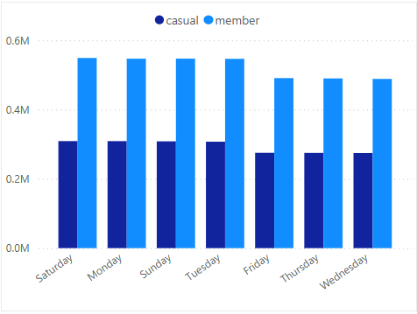
Figure 6. Day‑of‑week trips by rider type.
Why it matters — Offer weekend‑only pricing to capture leisure demand, while weekday bundles reinforce commuting habits.
3.5 Member vs casual trends (see Figure 7).
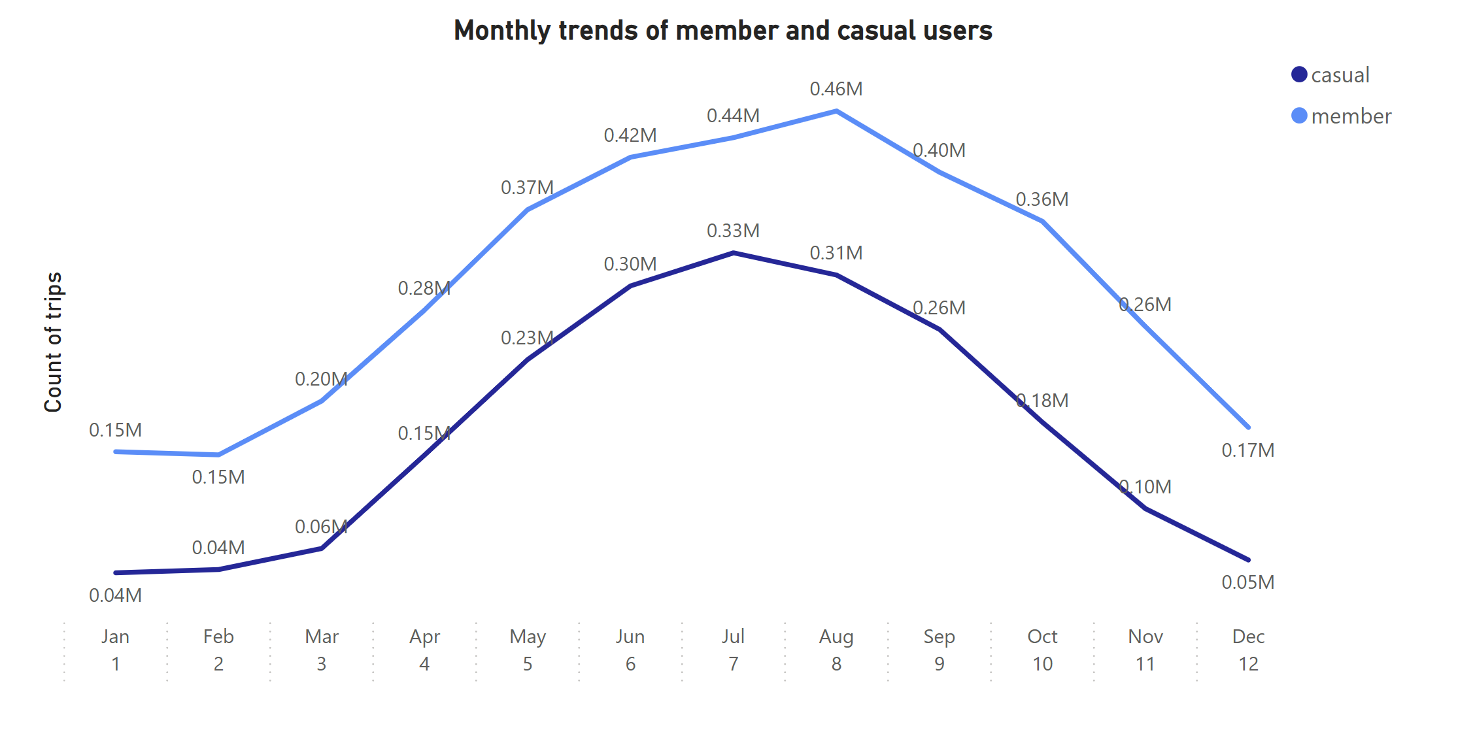
Figure 7. Monthly trend comparison by rider type.
3.6 Dashboard snapshot (2023) (see Figure 8).
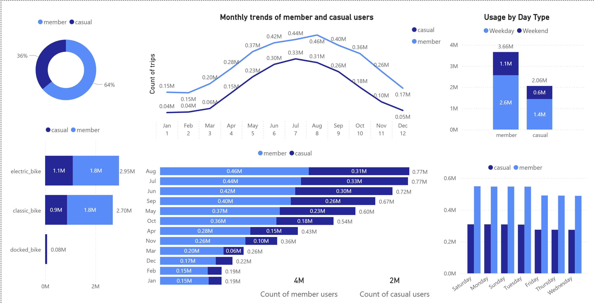
Figure 8. Consolidated dashboard view, 2023.

4. Discussion
Leisure vs. commute — Casuals behave like weekend leisure users; members behave like commuters. Designing pricing and availability around these rhythms reduces friction and boosts perceived value.
Inventory fit — Docked bikes under‑serve commuters. Keep classic/e‑bikes as the default in corridors with strong member presence; test docked repurposing (e.g., tourist bundles) in leisure zones.
Ops alignment — Concentrate rebalancing where and when it matters: Fri PM/Sat AM for leisure hotspots; weekday AM/PM for commuter stations.

5. Recommendations
A) Marketing & Pricing (Mar–Aug focus)
Summer Pass → Annual — A 90‑day pass that auto‑credits toward the annual plan after N rides (e.g., 10–12). In‑app meter shows progress and savings.
Weekend‑Only membership (pilot) — Lower price for Fri–Sun access. After repeated weekend rides, prompt a 1‑tap upgrade to full membership.
Commute bundle — Reward AM/PM streaks (e.g., 8 weekday rides/month) with credits or partner perks to reinforce habits.
B) Service & Operations
Targeted rebalancing SLAs — Fri evening/Sat morning for leisure nodes; weekday AM/PM for commuter corridors.
E‑bike allocation — Raise e‑bike share in summer and at stations with repeated stock‑outs; run a pre‑season battery‑health and maintenance sprint (Mar–Apr).
Contextual nudges - On a rider’s 3rd ride in 30 days, show: “You’d have saved $X with membership.” On Fri–Sun, highlight the Weekend‑Only tier.
C) Measurement & Experiments
Primary KPI – Casual → Member conversion rate (seasonal + overall).
Secondary - Station availability SLA and ride frequency per member; North‑star — 12‑month retention/LTV (requires pricing).
Experiments - A/B price framing; thresholds for the Weekend‑Only upgrade; station‑level docked strategy trials; difference‑in‑differences across matched stations.

6. Ethics & Portfolio Notes
This public case uses the Cyclistic capstone dataset. No PHI or customer identifiers were used. For health projects, follow HIPAA de‑identification (Safe Harbor/Expert Determination) and FAIR data practices on the portfolio site.

