Sample Course Name

Sample Course Module Name

Author: Asst. Prof. Dr. Uğur CORUH

## Microsoft

### Week-1 (Microsoft Excel)

#### Spring Semester, 2022-2023

Download [DOC](week-1.en.md_doc.pdf), [SLIDE](week-1.en.md_slide.pdf), [PPTX](week-1.en.md_slide.pptx)

### Outline

* ‣ Shortcuts ‣ Formulas (Functions/Functions) ‣ Pivot Table ‣ Conditional formatting ‣ Data Validation ‣ Arrangement ‣ Filter ‣ Advanced Filter ‣ Wildcards ‣ Graphics ‣ Quick Reload ‣ Find and Replace ‣ Convert Text to Columns ‣ Get External Data ‣ VBA (Macro)

## ** ► SHORTCUTS**

### ► PIVOT TABLE

* **What is PIVOT TABLE?**

We use this feature if we have a large table and we want to create summary tables according to the fields you want from this table. Although it is very simple to use, it allows us to perform a very powerful and fast data analysis and reporting. If you have a table like this, you can extract many summary reports from this table. If we have a historical field in our table, then you can prepare reports for all historical processes on an annual, quarterly, monthly, weekly and daily basis.

### PIVOT TABLE-1

* **What is PIVOT TABLE?** From the table below, what are the total quantities and amounts on the basis of company, import number or product reference? Again, according to the same fields, what are the total amounts and amounts on annual, quarterly, monthly, weekly basis? You can get many reports such as.

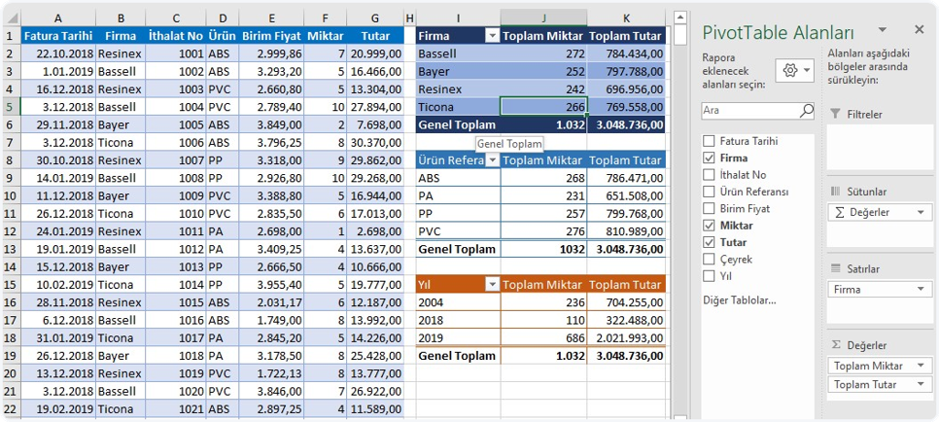

center h:300px

### ► FUNCTIONS (FUNCTIONS / FORMULAS)-2

* **What is FUNCTIONS?** There are many menus in the section where the menus we call the ribbon in Excel are, and there are many features in each menu that are related or not related to that menu name. But the Formulas menu is complete and only related to Formulas. It’s a pretty broad topic. That’s why Microsoft has created a separate menu for this topic.

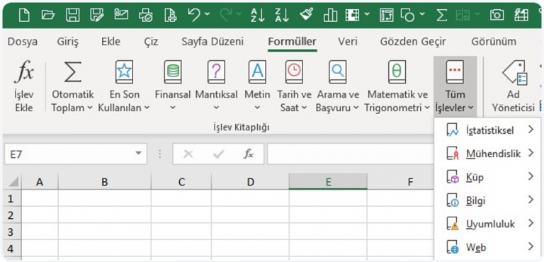

bg right:50% h:300px

### ► CONDITIONAL FORMATTING-3

* **What is CONDITIONAL FORMATTING?** Here are some ready-made conditions that we can use. When the ready conditions are not enough for us, you can create our own rules with formulas and format the cells that comply with those rules. Of course, for this, you need to master the formulas first.When we choose Conditional Formatting, we can see the rules given to us as follows. We can easily format according to numerical, textual and historical data.

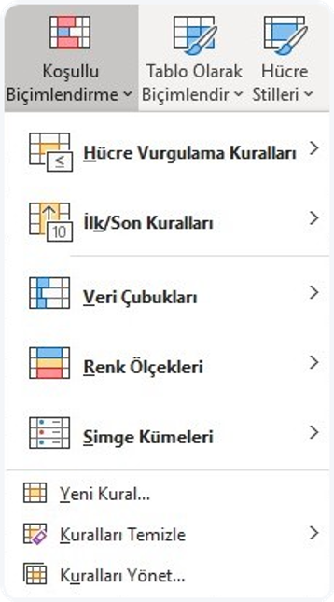

bg left:50% h:500px

### ► DATA VERIFICATION-4

* **What is DATA VERIFICATION?** It is a feature that prevents entering only the data that is desired to be entered into a cell or a range of cells, and prevents any other data entry. It is located in the Data Tools group in the Data menu.

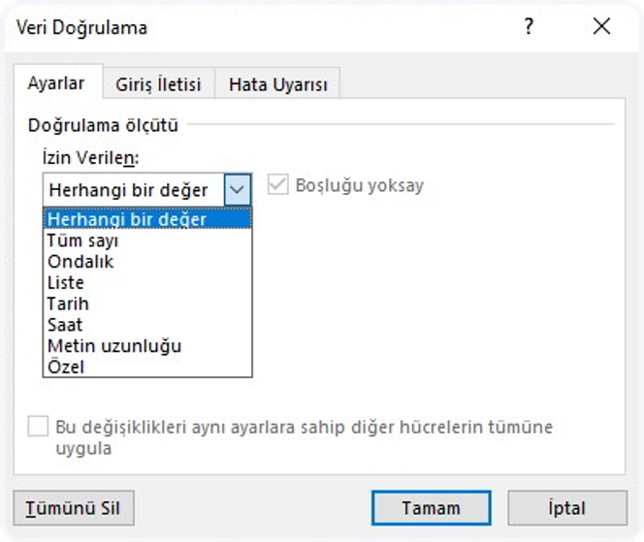

bg h:400px

### ► RANKING-5

* **What is RANKING?** When entering data one after another after writing our headings in our tables, or in a table that comes to us ready, the data may not always be in alphabetical, numerical and historical order, and we feel the need to sort our data according to one or more fields, here is where Excel’s Sorting feature comes to our aid. . 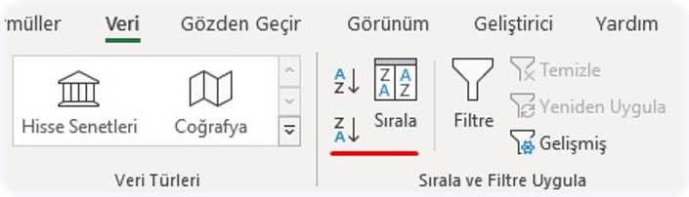 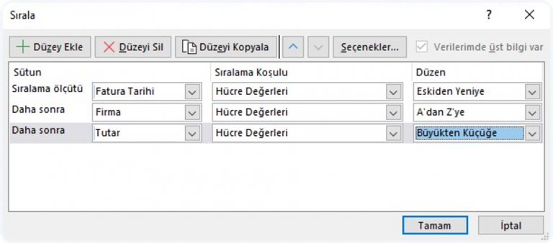 — ## References -https://peakup.org/blog -https://ucoruh.github.io/ce103-algorithms-and-programming-I