# Assignment 3 - AD688

This analysis of the Lightcast job postings dataset reveals several key trends in the U.S. job market for data professionals. Compensation varies significantly by industry, with the finance and information sectors offering the highest salaries. While the provided dataset was heavily skewed towards a single occupation, it clearly shows that advanced degrees and hybrid work arrangements correlate with higher pay, whereas onsite roles encompass the widest range of salaries, including the lower end of the spectrum.

## 1. Analysis of Salary Distribution by Industry (Box Plot)

This box plot reveals the range of starting salaries across various industries, highlighting significant variation. The "Information" and "Finance and Insurance" sectors demonstrate the highest median salaries and the greatest spread, indicating a wide range of compensation within those fields.

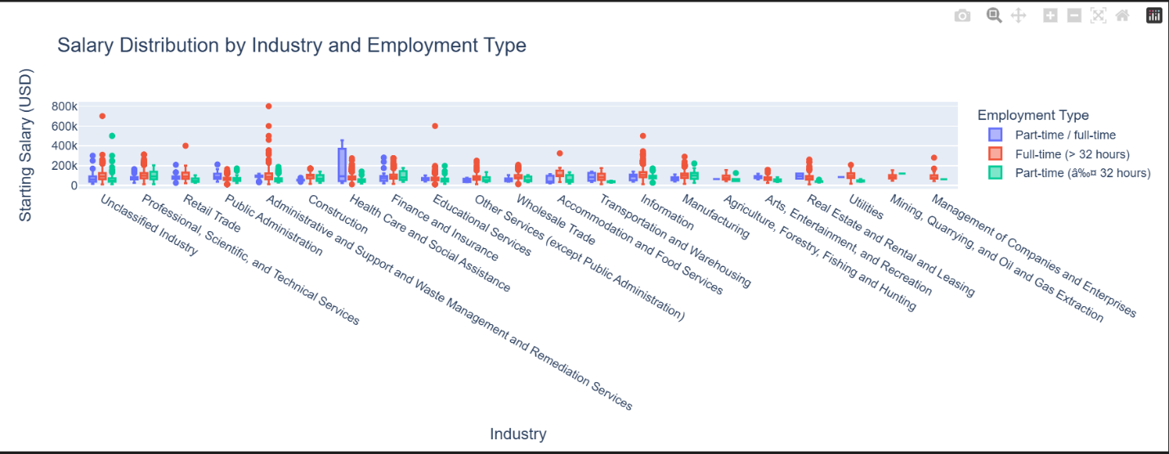

## 2. Analysis of Salary by ONET Occupation (Bubble Chart)

The bubble chart accurately reflects the contents of the provided dataset, which contains job postings for only a single ONET occupation: "Business Intelligence Analysts." This indicates that the dataset is a specific sample focused on one job role rather than a broad representation of the job market.

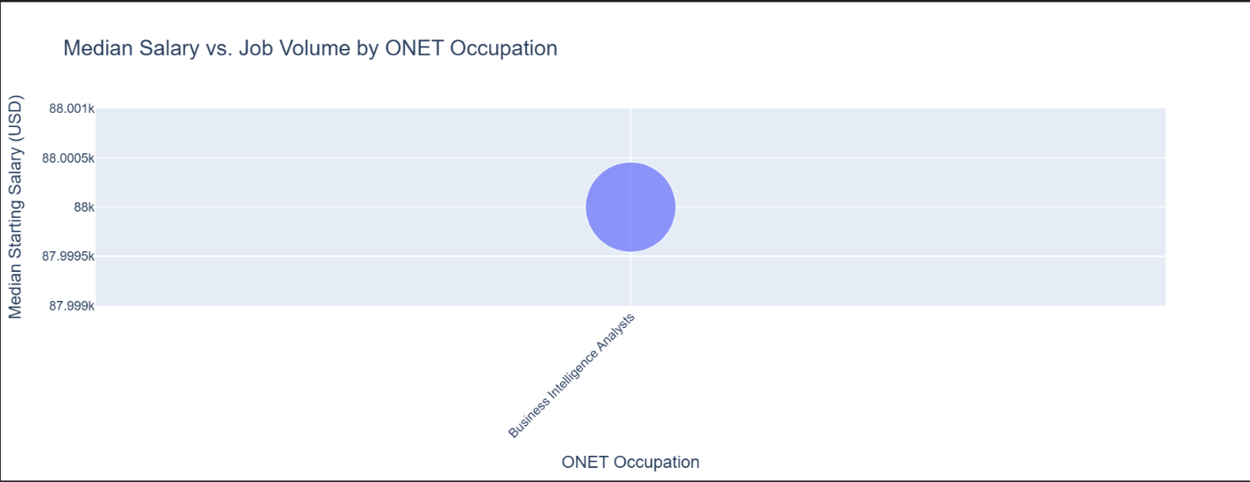

## 3. Analysis of Salary by Education Level

The data shows a clear financial benefit to higher education. The salary distribution for individuals with a Master's degree or PhD is shifted significantly higher than for those with a Bachelor's degree or lower. Furthermore, while salary generally increases with experience for all groups, the trend is more pronounced and starts from a higher baseline for those with advanced degrees.

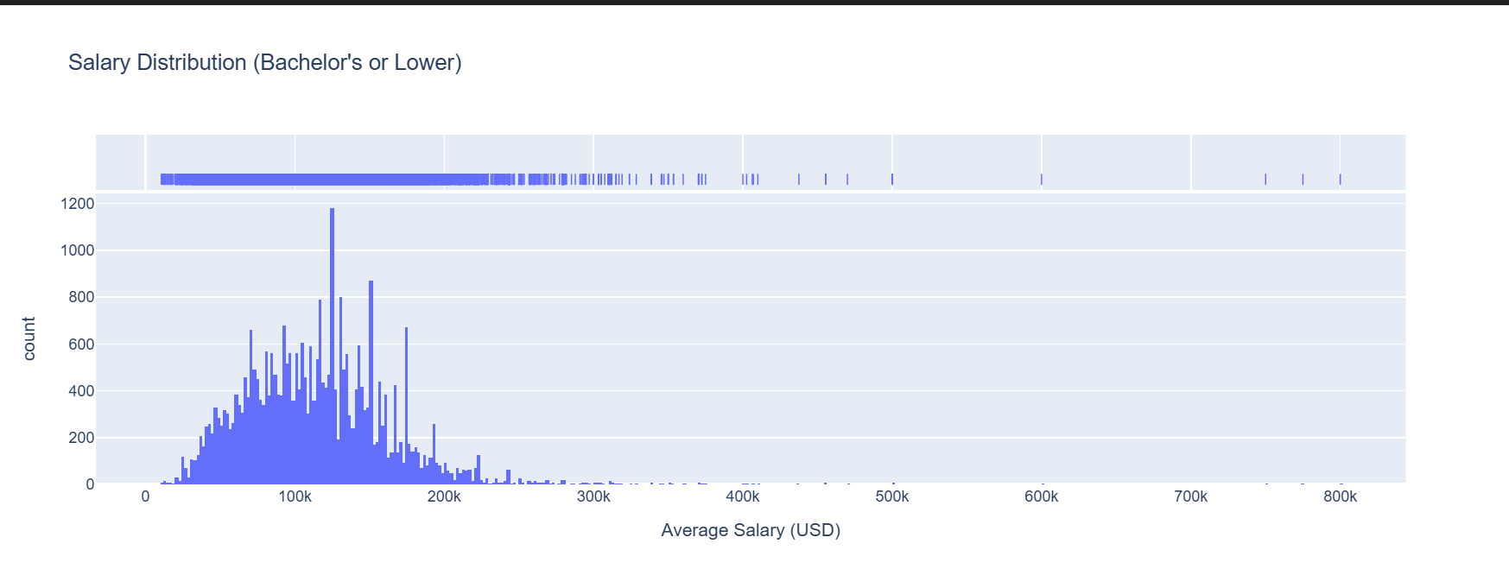

## 4. Analysis of Salary by Remote Work Type

Onsite roles encompass the widest variety of occupations and experience levels, resulting in a salary distribution that is heavily skewed towards the lower end of the pay scale. In contrast, Hybrid and Remote roles appear to have a higher concentration of jobs in the mid-to-high professional salary ranges. This suggests that while all types of jobs can be found onsite, higher-paying specialized roles are more likely to offer flexible work arrangements.

