Assignment 04

Dakota Alder

October 5, 2025

WARNING: Using incubator modules: jdk.incubator.vector  
Using Spark's default log4j profile: org/apache/spark/log4j2-defaults.properties  
Setting default log level to "WARN".  
To adjust logging level use sc.setLogLevel(newLevel). For SparkR, use setLogLevel(newLevel).  
25/10/09 01:29:58 WARN NativeCodeLoader: Unable to load native-hadoop library for your platform... using builtin-java classes where applicable

[Stage 2:===========================================================(1 + 0) / 1]

+------------------------+  
|EMPLOYMENT_TYPE_NAME |  
+------------------------+  
|Part-time / full-time |  
|Part-time (â‰¤ 32 hours)|  
|Full-time (> 32 hours) |  
|NULL |  
+------------------------+

+------+--------+--------------------+--------------------+----------------+-------------+  
|SALARY|DURATION|MIN_YEARS_EXPERIENCE|EMPLOYMENT_TYPE_NAME|REMOTE_TYPE_NAME|IS_INTERNSHIP|  
+------+--------+--------------------+--------------------+----------------+-------------+  
|NULL |6.0 |2 |Full-Time |On-site |false |  
|NULL |18.0 |3 |Full-Time |Remote |false |  
|NULL |35.0 |5 |Full-Time |On-site |false |  
|NULL |48.0 |3 |Full-Time |On-site |false |  
|92500 |15.0 |NULL |Flexible |On-site |false |  
+------+--------+--------------------+--------------------+----------------+-------------+  
only showing top 5 rows

+------+--------------------+--------------------+----------------+--------+-------------+  
|SALARY|MIN_YEARS_EXPERIENCE|EMPLOYMENT_TYPE_NAME|REMOTE_TYPE_NAME|DURATION|IS_INTERNSHIP|  
+------+--------------------+--------------------+----------------+--------+-------------+  
|92962 |2 |Full-Time |On-site |18.0 |0 |  
|107645|10 |Full-Time |On-site |18.0 |0 |  
|192800|6 |Full-Time |On-site |55.0 |0 |  
|125900|12 |Full-Time |On-site |18.0 |0 |  
|170000|6 |Full-Time |On-site |18.0 |0 |  
+------+--------------------+--------------------+----------------+--------+-------------+  
only showing top 5 rows

+------+-----------------------------------+-----------------------------------------+  
|SALARY|features |poly_features |  
+------+-----------------------------------+-----------------------------------------+  
|92962 |[2.0,18.0,0.0,1.0,0.0,1.0,0.0,1.0] |[2.0,4.0,18.0,0.0,1.0,0.0,1.0,0.0,1.0] |  
|107645|[10.0,18.0,0.0,1.0,0.0,1.0,0.0,1.0]|[10.0,100.0,18.0,0.0,1.0,0.0,1.0,0.0,1.0]|  
|192800|[6.0,55.0,0.0,1.0,0.0,1.0,0.0,1.0] |[6.0,36.0,55.0,0.0,1.0,0.0,1.0,0.0,1.0] |  
|125900|[12.0,18.0,0.0,1.0,0.0,1.0,0.0,1.0]|[12.0,144.0,18.0,0.0,1.0,0.0,1.0,0.0,1.0]|  
|170000|[6.0,18.0,0.0,1.0,0.0,1.0,0.0,1.0] |[6.0,36.0,18.0,0.0,1.0,0.0,1.0,0.0,1.0] |  
+------+-----------------------------------+-----------------------------------------+  
only showing top 5 rows

25/10/09 01:30:53 WARN SparkStringUtils: Truncated the string representation of a plan since it was too large. This behavior can be adjusted by setting 'spark.sql.debug.maxToStringFields'.

[Stage 40:> (0 + 1) / 1]

Intercept: 93601.3920  
Coefficients:  
 MIN_YEARS_EXPERIENCE: 6634.9052  
 DURATION: -92.9847  
 IS_INTERNSHIP: -249.3155  
 EMPLOYMENT_TYPE_NAME_0: 1197.4797  
 EMPLOYMENT_TYPE_NAME_1: -5523.5492  
 EMPLOYMENT_TYPE_NAME_2: -8522.4530  
 REMOTE_TYPE_NAME_0: -5444.3124  
 REMOTE_TYPE_NAME_1: 249.3158

---Regression Model Summary---

[Stage 46:> (0 + 1) / 1]

Coefficient Standard Errors: ['81.4106', '23.5643', '1381781.9942', '2058.8730', '2616.5750', '1566.2595', '1637.0408', '1381781.9942', '1381784.4002']  
T Values: ['81.4993', '-3.9460', '-0.0002', '0.5816', '-2.1110', '-5.4413', '-3.3257', '0.0002', '0.0677']  
P Values: ['0.0000', '0.0001', '0.9999', '0.5608', '0.0348', '0.0000', '0.0009', '0.9999', '0.9460']

[Stage 49:> (0 + 1) / 1]

Null Deviance: 35794690345776.1094  
Residual DF Null: 18965  
Deviance: 26420287047212.9453  
Residual DF: 18957

[Stage 50:> (0 + 1) / 1]

AIC: 453167.5668

Length of feature names: 9  
Length of coefficients: 9  
Length of standard errors: 9  
Length of t-values: 9  
Length of p-values: 9

|  | Feature | Estimate | Std Error | t-stat | p-Value |
| --- | --- | --- | --- | --- | --- |
| 0 | Intercept | 93601.3920 | 81.4106 | 81.4993 | 0.0000 |
| 1 | MIN_YEARS_EXPERIENCE | 6634.9052 | 23.5643 | -3.9460 | 0.0001 |
| 2 | DURATION | -92.9847 | 1381781.9942 | -0.0002 | 0.9999 |
| 3 | IS_INTERNSHIP | -249.3155 | 2058.8730 | 0.5816 | 0.5608 |
| 4 | EMPLOYMENT_TYPE_NAME_vec_Full-Time | 1197.4797 | 2616.5750 | -2.1110 | 0.0348 |
| 5 | EMPLOYMENT_TYPE_NAME_vec_Part-Time | -5523.5492 | 1566.2595 | -5.4413 | 0.0000 |
| 6 | REMOTE_TYPE_NAME_vec_On-site | -8522.4530 | 1637.0408 | -3.3257 | 0.0009 |
| 7 | REMOTE_TYPE_NAME_vec_Remote | -5444.3124 | 1381781.9942 | 0.0002 | 0.9999 |
| 8 | IS_INTERNSHIP_vec_0 | 249.3158 | 1381784.4002 | 0.0677 | 0.9460 |

+------+-----------------------------------------+  
|SALARY|new_poly_features |  
+------+-----------------------------------------+  
|92962 |[2.0,4.0,18.0,0.0,1.0,0.0,1.0,0.0,1.0] |  
|107645|[10.0,100.0,18.0,0.0,1.0,0.0,1.0,0.0,1.0]|  
|192800|[6.0,36.0,55.0,0.0,1.0,0.0,1.0,0.0,1.0] |  
|125900|[12.0,144.0,18.0,0.0,1.0,0.0,1.0,0.0,1.0]|  
|170000|[6.0,36.0,18.0,0.0,1.0,0.0,1.0,0.0,1.0] |  
+------+-----------------------------------------+  
only showing top 5 rows

[Stage 65:> (0 + 1) / 1]

Intercept: 82664.5758  
Coefficients:  
 MIN_YEARS_EXPERIENCE: 12841.9186  
 MIN_YEARS_EXPERIENCE_SQ: -458.5495  
 DURATION: -90.7714  
 IS_INTERNSHIP: 2021.1601  
 EMPLOYMENT_TYPE_NAME_0: -1126.1755  
 EMPLOYMENT_TYPE_NAME_1: -6690.5657  
 EMPLOYMENT_TYPE_NAME_2: -8295.2198  
 REMOTE_TYPE_NAME_0: -5060.6739  
 REMOTE_TYPE_NAME_1: -2021.1598

---Polynomial Regression Model Summary---

Coefficient Standard Errors: ['292.1367', '20.7488', '23.2672', '1364347.4552', '2035.6125', '2584.1001', '1546.5315', '1616.4788', '1364347.4552', '1364349.9168']  
T Values: ['43.9586', '-22.1000', '-3.9013', '0.0015', '-0.5532', '-2.5891', '-5.3638', '-3.1307', '-0.0015', '0.0606']  
P Values: ['0.0000', '0.0000', '0.0001', '0.9988', '0.5801', '0.0096', '0.0000', '0.0017', '0.9988', '0.9517']

Null Deviance: 35794690345776.1094  
Residual DF Null: 18965  
Deviance: 25756421776048.0586  
Residual DF: 18956

[Stage 75:> (0 + 1) / 1]

AIC: 452686.9167

Length of feature names: 10  
Length of coefficients: 10  
Length of standard errors: 10  
Length of t-values: 10  
Length of p-values: 10

|  | Feature | Estimate | Std Error | t-stat | p-Value |
| --- | --- | --- | --- | --- | --- |
| 0 | Intercept | 82664.5758 | 292.1367 | 43.9586 | 0.0000 |
| 1 | MIN_YEARS_EXPERIENCE | 12841.9186 | 20.7488 | -22.1000 | 0.0000 |
| 2 | MIN_YEARS_EXPERIENCE_SQ | -458.5495 | 23.2672 | -3.9013 | 0.0001 |
| 3 | DURATION | -90.7714 | 1364347.4552 | 0.0015 | 0.9988 |
| 4 | IS_INTERNSHIP | 2021.1601 | 2035.6125 | -0.5532 | 0.5801 |
| 5 | EMPLOYMENT_TYPE_NAME_vec_Full-Time | -1126.1755 | 2584.1001 | -2.5891 | 0.0096 |
| 6 | EMPLOYMENT_TYPE_NAME_vec_Part-Time | -6690.5657 | 1546.5315 | -5.3638 | 0.0000 |
| 7 | REMOTE_TYPE_NAME_vec_On-site | -8295.2198 | 1616.4788 | -3.1307 | 0.0017 |
| 8 | REMOTE_TYPE_NAME_vec_Remote | -5060.6739 | 1364347.4552 | -0.0015 | 0.9988 |
| 9 | IS_INTERNSHIP_vec_0 | -2021.1598 | 1364349.9168 | 0.0606 | 0.9517 |

Length of feature names: 8  
Length of importances: 8

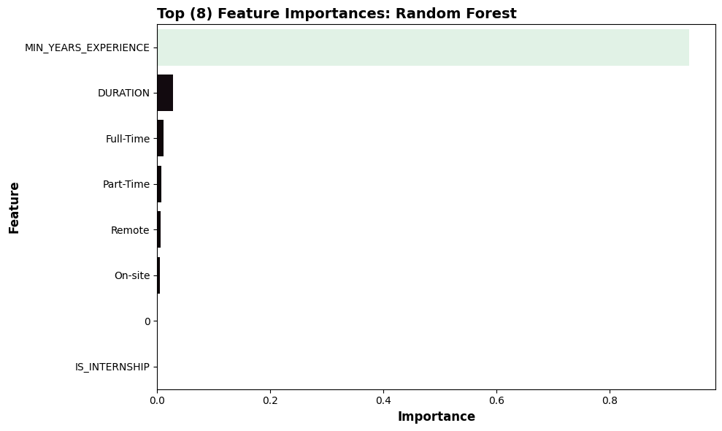

|  | SALARY | Model | Predicted |
| --- | --- | --- | --- |
| 0 | 15860.0 | GLR | 76364.272870 |
| 1 | 22440.0 | GLR | 104756.726135 |
| 2 | 22880.0 | GLR | 82069.331370 |
| 3 | 23179.0 | GLR | 90743.038366 |
| 4 | 23585.0 | GLR | 78595.904958 |

