Assignment 04

Gavin Boss

October 4, 2025

Table of contents

# 1. Load the Dataset

Setting default log level to "WARN".  
To adjust logging level use sc.setLogLevel(newLevel). For SparkR, use setLogLevel(newLevel).  
25/10/08 00:51:57 WARN NativeCodeLoader: Unable to load native-hadoop library for your platform... using builtin-java classes where applicable  
25/10/08 00:51:58 WARN Utils: Service 'SparkUI' could not bind on port 4040. Attempting port 4041.  
[Stage 0:> (0 + 1) / 1] [Stage 1:> (0 + 1) / 1]

# 2. Feature Engineering

[Stage 2:> (0 + 1) / 1] [Stage 5:> (0 + 1) / 1] 25/10/08 00:52:32 WARN SparkStringUtils: Truncated the string representation of a plan since it was too large. This behavior can be adjusted by setting 'spark.sql.debug.maxToStringFields'.  
[Stage 9:> (0 + 1) / 1] [Stage 12:> (0 + 1) / 1]

+------+--------------------------------------+--------------------------------------+  
|SALARY|features |features_poly |  
+------+--------------------------------------+--------------------------------------+  
|192800|(9,[0,1,4,7],[6.0,55.0,1.0,1.0]) |(9,[0,1,4,7],[6.0,55.0,1.0,1.0]) |  
|125900|(9,[0,1,4,7],[12.0,18.0,1.0,1.0]) |(9,[0,1,4,7],[12.0,18.0,1.0,1.0]) |  
|118560|[5.0,20.0,0.0,1.0,0.0,1.0,0.0,1.0,0.0]|[5.0,20.0,0.0,1.0,0.0,1.0,0.0,1.0,0.0]|  
|192800|(9,[0,1,4,7],[6.0,55.0,1.0,1.0]) |(9,[0,1,4,7],[6.0,55.0,1.0,1.0]) |  
|116500|(9,[0,1,4,7],[12.0,16.0,1.0,1.0]) |(9,[0,1,4,7],[12.0,16.0,1.0,1.0]) |  
+------+--------------------------------------+--------------------------------------+  
only showing top 5 rows  
  
Training Data Count: 11604  
Testing Data Count: 2812

# 3. Train/Test Split

[Stage 15:> (0 + 1) / 1] [Stage 18:> (0 + 1) / 1]

Training Data Count: 11604  
Testing Data Count: 2812

* I chose the 80/20 split that was discussed during class, the data set is large enough that this split should be fine, and should account for enough of the data.

# 4. Regression_DF

+------+--------------------+--------------------+--------+-------------+-------------------+----------------+----------------------+------------------------------------------------------------------------------------+  
|SALARY|MIN_YEARS_EXPERIENCE|MAX_YEARS_EXPERIENCE|DURATION|IS_INTERNSHIP|COMPANY_IS_STAFFING|REMOTE_TYPE_NAME|EMPLOYMENT_TYPE_NAME |EDUCATION_LEVELS_NAME |  
+------+--------------------+--------------------+--------+-------------+-------------------+----------------+----------------------+------------------------------------------------------------------------------------+  
|131100|2 |2 |11 |false |false |[None] |Full-time (> 32 hours)|[\n "Bachelor's degree"\n] |  
|136950|3 |3 |28 |false |false |Remote |Full-time (> 32 hours)|[\n "Bachelor's degree",\n "Master's degree",\n "Ph D or professional degree"\n]|  
|136950|3 |3 |28 |false |false |Remote |Full-time (> 32 hours)|[\n "Bachelor's degree",\n "Master's degree",\n "Ph D or professional degree"\n]|  
|104000|3 |3 |8 |false |false |[None] |Full-time (> 32 hours)|[\n "Bachelor's degree"\n] |  
|80000 |3 |3 |37 |false |false |[None] |Full-time (> 32 hours)|[\n "Bachelor's degree"\n] |  
+------+--------------------+--------------------+--------+-------------+-------------------+----------------+----------------------+------------------------------------------------------------------------------------+  
only showing top 5 rows

# 5. Linear Regression Model (OLS)

[Stage 22:> (0 + 1) / 1] [Stage 25:> (0 + 1) / 1]

+------+---------------------------------------+  
|SALARY|features |  
+------+---------------------------------------+  
|131100|(10,[0,1,2,5,8],[2.0,2.0,11.0,1.0,1.0])|  
|136950|(10,[0,1,2,6,8],[3.0,3.0,28.0,1.0,1.0])|  
|136950|(10,[0,1,2,6,8],[3.0,3.0,28.0,1.0,1.0])|  
|104000|(10,[0,1,2,5,8],[3.0,3.0,8.0,1.0,1.0]) |  
|80000 |(10,[0,1,2,5,8],[3.0,3.0,37.0,1.0,1.0])|  
+------+---------------------------------------+  
only showing top 5 rows

[Stage 29:> (0 + 1) / 1] [Stage 32:> (0 + 1) / 1] [Stage 35:> (0 + 1) / 1]

(2243, 14)  
(1848, 14)  
(395, 14)

[Stage 38:> (0 + 1) / 1]

Intercept: 75819.4000  
Coefficients:   
 Feature 1: 4215.6844  
 Feature 2: 4215.6844  
 Feature 3: -23.7725  
 Feature 4: -23942.2288  
 Feature 5: -98.6466  
 Feature 6: 6430.6643  
 Feature 7: 16463.9439  
 Feature 8: 655.1948  
 Feature 9: -9251.7034  
 Feature 10: -12761.7200

---Regression Summary---  
Coefficient Standard Errors: ['57432.0320', '57432.0320', '40.9532', '12518.4270', '1651.7511', '5327.5134', '5421.5678', '6892.7578', '7503.5432', '8182.7045', '9011.3793']  
T-values: ['0.0734', '0.0734', '-0.5805', '-1.9126', '-0.0597', '1.2071', '3.0367', '0.0951', '-1.2330', '-1.5596', '8.4137']  
P-values: ['0.9415', '0.9415', '0.5617', '0.0559', '0.9524', '0.2275', '0.0024', '0.9243', '0.2177', '0.1190', '0.0000']

[Stage 39:> (0 + 1) / 1]

[Stage 42:> (0 + 1) / 1] [Stage 43:> (0 + 1) / 1]

nullDeviance: 2728391925894.5732  
Residual DF Null: 2232  
Residual DF: 2232  
AIC: 52299.8485  
Deviance: 1738269402130.5212  
Explained Variance (from deviance): 0.3628960027212421

Length of features: 11  
Length of coefficients: 11  
Length of standard errors: 11  
Length of t-values: 11  
Length of p-values: 11

|  | Features | Estimate | Std. Error | t value | P-value |
| --- | --- | --- | --- | --- | --- |
| 0 | Intercept | 75819.4000 | 57432.0320 | 0.0734 | 0.9415 |
| 1 | MIN_YEARS_EXPERIENCE | 4215.6844 | 57432.0320 | 0.0734 | 0.9415 |
| 2 | MAX_YEARS_EXPERIENCE | 4215.6844 | 40.9532 | -0.5805 | 0.5617 |
| 3 | DURATION | -23.7725 | 12518.4270 | -1.9126 | 0.0559 |
| 4 | IS_INTERNSHIP | -23942.2288 | 1651.7511 | -0.0597 | 0.9524 |
| 5 | COMPANY_IS_STAFFING | -98.6466 | 5327.5134 | 1.2071 | 0.2275 |
| 6 | REMOTE_TYPE_NAME_vec_[None] | 6430.6643 | 5421.5678 | 3.0367 | 0.0024 |
| 7 | REMOTE_TYPE_NAME_vec_Remote | 16463.9439 | 6892.7578 | 0.0951 | 0.9243 |
| 8 | REMOTE_TYPE_NAME_vec_Hybrid Remote | 655.1948 | 7503.5432 | -1.2330 | 0.2177 |
| 9 | EMPLOYMENT_TYPE_NAME_vec_Full-time (> 32 hours) | -9251.7034 | 8182.7045 | -1.5596 | 0.1190 |
| 10 | EMPLOYMENT_TYPE_NAME_vec_Part-time (â‰¤ 32 hours) | -12761.7200 | 9011.3793 | 8.4137 | 0.0000 |

# 6. Generalized Linear Regression Summary

Based on the features, two significant predictors of salary include remote type name, and employment type name (part time). This makes sense when looking at the data, as remote work tends to pay higher than in person work, so jobs that are broken up by remote, hybrid, or onsite will have different pay scales, while employment type names will be broken up differently because of the difference in salary between part time and full time work. The coefficients have two features that have significant predictors, feature 6 is a positive predictor while feature 10 is a negative predictor. Other features do not have meaningful impacts on the target. The model performance is moderate and could be improved. - Performance - Based on the Explained Variance this model is calculated to have a ~36% of the varience in salary which indicates that there is a moderate performance, but there is still room for improvement. - Other Features - Years of experience, Internships, Full time employment are not significant predictors of salary in this model. This does not mean that they do not have significant impacts on salary as a whole, it just means that in terms of this model that there is not a trend that indicates that these features have a significant impact on salary.

# 7. Polynomical Regression

+------+---------------------------------------------+  
|SALARY|features_poly |  
+------+---------------------------------------------+  
|131100|(11,[0,1,2,3,6,9],[2.0,4.0,2.0,11.0,1.0,1.0])|  
|136950|(11,[0,1,2,3,7,9],[3.0,9.0,3.0,28.0,1.0,1.0])|  
|136950|(11,[0,1,2,3,7,9],[3.0,9.0,3.0,28.0,1.0,1.0])|  
|104000|(11,[0,1,2,3,6,9],[3.0,9.0,3.0,8.0,1.0,1.0]) |  
|80000 |(11,[0,1,2,3,6,9],[3.0,9.0,3.0,37.0,1.0,1.0])|  
+------+---------------------------------------------+  
only showing top 5 rows

[Stage 45:> (0 + 1) / 1] [Stage 48:> (0 + 1) / 1] [Stage 51:> (0 + 1) / 1]

(2243, 16)  
(1848, 16)  
(395, 16)

[Stage 54:> (0 + 1) / 1]

Intercept: 75819.4000  
Coefficients:   
 Feature 1: 4215.6844  
 Feature 2: 4215.6844  
 Feature 3: -23.7725  
 Feature 4: -23942.2288  
 Feature 5: -98.6466  
 Feature 6: 6430.6643  
 Feature 7: 16463.9439  
 Feature 8: 655.1948  
 Feature 9: -9251.7034  
 Feature 10: -12761.7200  
  
---Regression Summary---  
Coefficient Standard Errors: ['57432.0320', '57432.0320', '40.9532', '12518.4270', '1651.7511', '5327.5134', '5421.5678', '6892.7578', '7503.5432', '8182.7045', '9011.3793']  
T-values: ['0.0734', '0.0734', '-0.5805', '-1.9126', '-0.0597', '1.2071', '3.0367', '0.0951', '-1.2330', '-1.5596', '8.4137']  
P-values: ['0.9415', '0.9415', '0.5617', '0.0559', '0.9524', '0.2275', '0.0024', '0.9243', '0.2177', '0.1190', '0.0000']

[Stage 55:> (0 + 1) / 1]

[Stage 58:> (0 + 1) / 1] [Stage 59:> (0 + 1) / 1]

nullDeviance: 2728391925894.5732  
Residual DF Null: 2232  
Residual DF: 2232  
AIC: 52299.8485  
Deviance: 1738269402130.5212  
Explained Variance (from deviance): 0.3628960027212421

Length of features: 11  
Length of coefficients: 11  
Length of standard errors: 11  
Length of t-values: 11  
Length of p-values: 11

|  | Features | Estimate | Std. Error | t value | P-value |
| --- | --- | --- | --- | --- | --- |
| 0 | Intercept | 75819.4000 | 57432.0320 | 0.0734 | 0.9415 |
| 1 | MIN_YEARS_EXPERIENCE | 4215.6844 | 57432.0320 | 0.0734 | 0.9415 |
| 2 | MAX_YEARS_EXPERIENCE | 4215.6844 | 40.9532 | -0.5805 | 0.5617 |
| 3 | DURATION | -23.7725 | 12518.4270 | -1.9126 | 0.0559 |
| 4 | IS_INTERNSHIP | -23942.2288 | 1651.7511 | -0.0597 | 0.9524 |
| 5 | COMPANY_IS_STAFFING | -98.6466 | 5327.5134 | 1.2071 | 0.2275 |
| 6 | REMOTE_TYPE_NAME_vec_[None] | 6430.6643 | 5421.5678 | 3.0367 | 0.0024 |
| 7 | REMOTE_TYPE_NAME_vec_Remote | 16463.9439 | 6892.7578 | 0.0951 | 0.9243 |
| 8 | REMOTE_TYPE_NAME_vec_Hybrid Remote | 655.1948 | 7503.5432 | -1.2330 | 0.2177 |
| 9 | EMPLOYMENT_TYPE_NAME_vec_Full-time (> 32 hours) | -9251.7034 | 8182.7045 | -1.5596 | 0.1190 |
| 10 | EMPLOYMENT_TYPE_NAME_vec_Part-time (â‰¤ 32 hours) | -12761.7200 | 9011.3793 | 8.4137 | 0.0000 |

# 8. Poly Regression Summary

This data has similar impacts to the Linear regression model, Remote_TYPE_NAME having a positive impact and Employment_TYPE_NAME (part time) have a negative impact which are significant predictors of salary according to this model. While other features are not significant predictors. The model performance is the same based on the explained varience which is at 36%.

# 9. Random Forest Regression

[Stage 60:> (0 + 1) / 1] [Stage 61:> (0 + 1) / 1] [Stage 62:> (0 + 1) / 1] [Stage 64:> (0 + 1) / 1] [Stage 68:> (0 + 1) / 1] [Stage 70:> (0 + 1) / 1] 25/10/08 00:55:23 WARN DAGScheduler: Broadcasting large task binary with size 1546.5 KiB  
[Stage 72:> (0 + 1) / 1] 25/10/08 00:55:24 WARN DAGScheduler: Broadcasting large task binary with size 2.7 MiB  
[Stage 74:> (0 + 1) / 1][Stage 75:> (0 + 1) / 1] WARNING: An illegal reflective access operation has occurred  
WARNING: Illegal reflective access by org.apache.spark.util.SizeEstimator$ (file:/opt/spark-3.5.6-bin-hadoop3/jars/spark-core_2.12-3.5.6.jar) to field java.nio.charset.Charset.name  
WARNING: Please consider reporting this to the maintainers of org.apache.spark.util.SizeEstimator$  
WARNING: Use --illegal-access=warn to enable warnings of further illegal reflective access operations  
WARNING: All illegal access operations will be denied in a future release  
[Stage 76:> (0 + 1) / 1] [Stage 77:> (0 + 1) / 1]

Random Forest RMSE: 24624.2976  
Random Forest R²: 0.4558  
Feature Importances: (10,[0,1,2,3,4,5,6,7,8,9],[0.4790147073653835,0.3444487354194342,0.09395909200951295,0.0014699100208343343,0.019885592865900418,0.015141883605094464,0.030348076324909136,0.0036327841559004475,0.006208999364022691,0.005890218869007941])

# 10. Feature Importance Plot

/tmp/ipykernel_3052/4249483686.py:19: FutureWarning:  
  
  
  
Passing `palette` without assigning `hue` is deprecated and will be removed in v0.14.0. Assign the `y` variable to `hue` and set `legend=False` for the same effect.

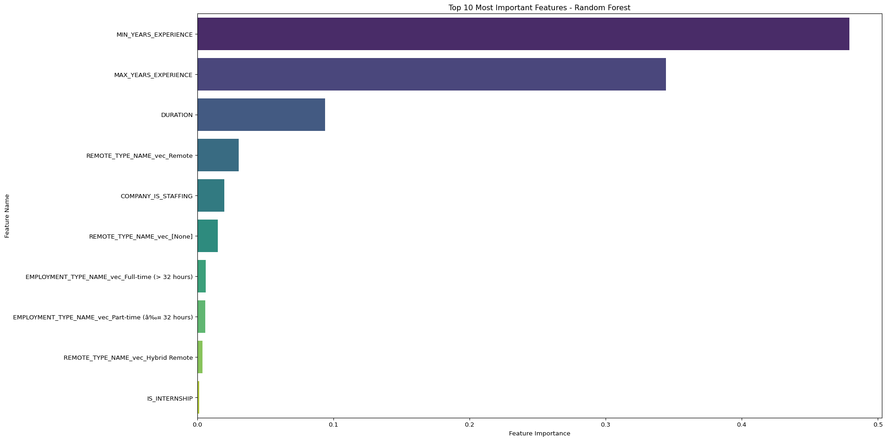

|  | Feature | Importance |
| --- | --- | --- |
| 0 | MIN_YEARS_EXPERIENCE | 0.479015 |
| 1 | MAX_YEARS_EXPERIENCE | 0.344449 |
| 2 | DURATION | 0.093959 |
| 6 | REMOTE_TYPE_NAME_vec_Remote | 0.030348 |
| 4 | COMPANY_IS_STAFFING | 0.019886 |
| 5 | REMOTE_TYPE_NAME_vec_[None] | 0.015142 |
| 8 | EMPLOYMENT_TYPE_NAME_vec_Full-time (> 32 hours) | 0.006209 |
| 9 | EMPLOYMENT_TYPE_NAME_vec_Part-time (â‰¤ 32 hours) | 0.005890 |
| 7 | REMOTE_TYPE_NAME_vec_Hybrid Remote | 0.003633 |
| 3 | IS_INTERNSHIP | 0.001470 |

# 11. Compare 3 Models - GLR, Polynomial, RF

[Stage 78:> (0 + 1) / 1] [Stage 79:> (0 + 1) / 1] [Stage 80:> (0 + 1) / 1] [Stage 81:> (0 + 1) / 1] [Stage 84:> (0 + 1) / 1] [Stage 87:> (0 + 1) / 1] [Stage 90:> (0 + 1) / 1] [Stage 91:> (0 + 1) / 1] [Stage 92:> (0 + 1) / 1]

Model Comparison Metrics:  
 Model RMSE AIC BIC  
0 GLR 27838.376618 52299.848476 45995.361481  
1 Polynomial GLR 27838.376618 52299.848476 45995.361481  
2 Random Forest 24624.297584 NaN 8047.865121

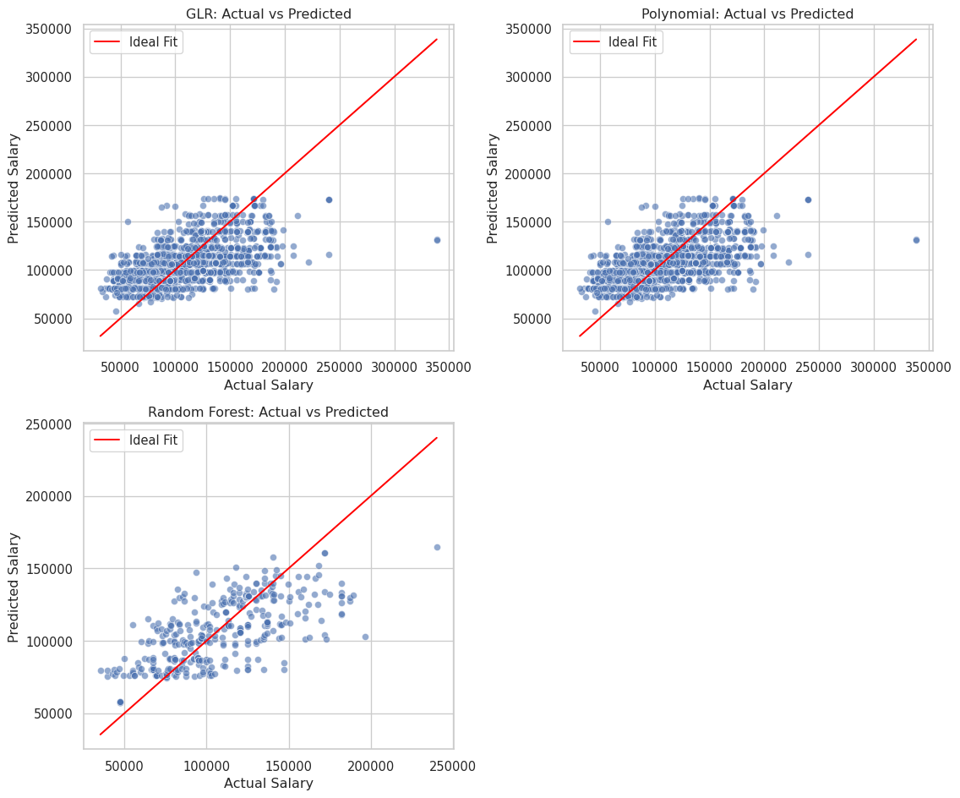

# 12. Calcutlating Log-Likelihood and BIC for Pyspark Models

[Stage 93:> (0 + 1) / 1] [Stage 96:> (0 + 1) / 1]

GLR BIC: 52360.7468  
Polynomial GLR BIC: 52360.7468