Assignment 04: Salary Prediction Analysis

Exploring Job Salary Prediction with Machine Learning

Saurabh Sharma

2025-10-05

# 1. Objectives

This analysis explores building machine learning models to predict job salaries from the Lightcast job postings dataset. Our journey includes:

* **Data Exploration**: Understanding the structure and quality of job posting data
* **Feature Engineering**: Creating meaningful predictors from job characteristics
* **Model Development**: Implementing and comparing three regression approaches
* **Performance Evaluation**: Assessing model effectiveness with multiple metrics
* **Insights Discovery**: Identifying key factors that drive salary predictions

Let’s begin our exploration.

## 1.1 Problem Statement

In today’s competitive job market, accurate salary prediction is crucial for:

* **Job seekers**: Setting realistic salary expectations
* **Employers**: Competitive compensation strategies
* **HR professionals**: Market benchmarking and budget planning
* **Recruitment platforms**: Enhancing job matching algorithms

## 1.2 Research Objectives

This analysis aims to:

1. **Develop predictive models** using PySpark for salary estimation from job posting features
2. **Compare model performance** across Linear Regression, Polynomial Regression, and Random Forest
3. **Identify key factors** driving salary variations in the job market
4. **Provide actionable insights** for stakeholders in the employment ecosystem

## 1.3 Dataset Overview

* **Source**: Lightcast job postings dataset
* **Original Size**: 11.9M rows × 131 columns (684MB)
* **Processed Records**: 49,352 valid salary records after filtering
* **Target Variable**: SALARY_AVG (engineered from salary ranges with median imputation)
* **Features**: 10 selected variables including experience, education, location, and job characteristics

# 2. Methodology and Approach

## 2.1 Data Processing Pipeline

### 2.1.1 1. Environment Setup and Data Loading

|  |
| --- |
| ✅ PySpark session initialized successfully! |
| * Spark version: 4.0.1 |

# Load the Lightcast job postings dataset  
data_path = "data/lightcast_job_postings.csv"  
  
print(" Loading dataset...")  
try:  
 # Check if file exists  
 if not os.path.exists(data_path):  
 raise FileNotFoundError(f"Data file not found: {data_path}")  
   
 # Load CSV with PySpark - using stable configuration that handles large text fields  
 df = spark.read \  
 .option("maxColumns", "200") \  
 .option("columnNameOfCorruptRecord", "_corrupt_record") \  
 .option("mode", "PERMISSIVE") \  
 .csv(data_path, escape="\"", multiLine=True, inferSchema=True, header=True) # Get basic statistics without caching first  
 row_count = df.count()  
 col_count = len(df.columns)  
   
 display(Markdown(f"""  
::: {{.callout-note}}  
## ✅ Dataset Loaded Successfully!  
- **Shape:** {row_count:,} rows × {col_count} columns  
- **File size:** {os.path.getsize(data_path) / (1024**2):.1f} MB  
:::  
 """))  
   
 # Show column overview in markdown table format  
 # Create markdown table rows (showing first 20 and last 10 for brevity in DOCX)  
 all_columns = df.columns  
 if len(all_columns) <= 30:  
 # Show all if 30 or fewer  
 column_list = '\n'.join([f"{i+1}. {col_name}" for i, col_name in enumerate(all_columns)])  
 else:  
 # Show first 20 and last 10  
 first_20 = '\n'.join([f"{i+1}. {col_name}" for i, col_name in enumerate(all_columns[:20])])  
 last_10 = '\n'.join([f"{i+1}. {col_name}" for i, col_name in enumerate(all_columns[-10:], start=len(all_columns)-10)])  
 column_list = f"{first_20}\n\n*... {len(all_columns) - 30} columns omitted ...*\n\n{last_10}"  
   
 display(Markdown(f"""  
::: {{.callout-note collapse="true"}}  
## 📋 Column Overview ({col_count} columns)  
  
{column_list}  
:::  
"""))  
   
except Exception as e:  
 print(f"❌ Error loading dataset: {str(e)}")  
 print("Please ensure the data file exists and is accessible")  
 raise

Loading dataset...

|  |
| --- |
| ✅ Dataset Loaded Successfully! |
| * **Shape:** 72,498 rows × 131 columns * **File size:** 683.5 MB |

|  |
| --- |
| 📋 Column Overview (131 columns) |
| 1. ID 2. LAST_UPDATED_DATE 3. LAST_UPDATED_TIMESTAMP 4. DUPLICATES 5. POSTED 6. EXPIRED 7. DURATION 8. SOURCE_TYPES 9. SOURCES 10. URL 11. ACTIVE_URLS 12. ACTIVE_SOURCES_INFO 13. TITLE_RAW 14. BODY 15. MODELED_EXPIRED 16. MODELED_DURATION 17. COMPANY 18. COMPANY_NAME 19. COMPANY_RAW 20. COMPANY_IS_STAFFING   *… 101 columns omitted …*   1. NAICS_2022_2 2. NAICS_2022_2_NAME 3. NAICS_2022_3 4. NAICS_2022_3_NAME 5. NAICS_2022_4 6. NAICS_2022_4_NAME 7. NAICS_2022_5 8. NAICS_2022_5_NAME 9. NAICS_2022_6 10. NAICS_2022_6_NAME |

### 2.1.2 2. Data Quality Assessment

# Analyze key columns for missing values (focusing on essential columns for memory efficiency)  
key_columns = [ 'SALARY',   
 'SALARY_FROM',   
 'SALARY_TO',   
 'MIN_YEARS_EXPERIENCE',   
 'MAX_YEARS_EXPERIENCE',   
 'EMPLOYMENT_TYPE_NAME',   
 'STATE_NAME'] # Limited set for memory management  
  
missing_stats = []  
  
for col_name in key_columns:  
 if col_name in df.columns:  
 try:  
 # Handle different data types properly with memory optimization  
 column_type = dict(df.dtypes)[col_name]  
   
 if column_type in ['bigint', 'int', 'double', 'float']:  
 # For numeric columns, only check for null  
 null_count = df.filter(col(col_name).isNull()).count()  
 else:  
 # For string columns, check for null and empty strings (simplified)  
 null_count = df.filter(col(col_name).isNull()).count()  
   
 total_count = row_count # Use already computed row count  
   
 # % calculation  
 null_percentage = (null_count / total_count) * 100  
   
 missing_stats.append({  
 'Column': col_name,  
 'Missing_Count': null_count,  
 'Missing_Percentage': null_percentage,  
 'Data_Type': column_type  
 })  
   
 except Exception as e:  
 print(f"{col_name:<25}: Error analyzing - {str(e)}")  
  
# Display missing values analysis as a formatted table  
if missing_stats:  
 missing_df = pd.DataFrame(missing_stats)  
   
 # Create markdown table rows  
 table_rows = '\n'.join([  
 f"| {row['Column']} | {row['Missing_Count']:,} | {row['Missing_Percentage']:.1f}% | {row['Data_Type']} |"  
 for _, row in missing_df.iterrows()  
 ])  
   
 highest_missing_col = missing_df.loc[missing_df['Missing_Percentage'].idxmax()]  
   
 display(Markdown(f"""  
::: {{.callout-note}}  
## Missing Values Analysis  
  
| Column | Missing Count | Missing % | Data Type |  
|--------|---------------|-----------|-----------|  
{table_rows}  
  
### Summary:  
  
 - **Columns analyzed:** {len(missing_df)}  
 - **Highest missing:** {missing_df['Missing_Percentage'].max():.1f}% ({highest_missing_col['Column']})  
 - **Columns with <50% missing:** {(missing_df['Missing_Percentage'] < 50).sum()}  
:::  
"""))  
   
 # Make missing stats available globally for summary  
 global missing_analysis  
  
 missing_analysis = {  
 'highest_missing_percentage': missing_df['Missing_Percentage'].max(),  
 'highest_missing_column': highest_missing_col['Column'],  
 'total_columns_analyzed': len(missing_df),  
 'columns_under_50_missing': (missing_df['Missing_Percentage'] < 50).sum()  
 }

|  |
| --- |
| Missing Values Analysis |
| | Column | Missing Count | Missing % | Data Type | | --- | --- | --- | --- | | SALARY | 41,690 | 57.5% | int | | SALARY_FROM | 40,100 | 55.3% | int | | SALARY_TO | 40,100 | 55.3% | int | | MIN_YEARS_EXPERIENCE | 23,146 | 31.9% | int | | MAX_YEARS_EXPERIENCE | 64,068 | 88.4% | int | | EMPLOYMENT_TYPE_NAME | 44 | 0.1% | string | | STATE_NAME | 44 | 0.1% | string |  2.1.3 Summary:  * **Columns analyzed:** 7 * **Highest missing:** 88.4% (MAX_YEARS_EXPERIENCE) * **Columns with <50% missing:** 3 |

### 2.1.4 3. Target Variable Engineering and Imputation

# Step 1: Create SALARY_AVG from SALARY_FROM and SALARY_TO  
df_salary = df.withColumn("SALARY_AVG",   
 when((col("SALARY_FROM").isNotNull()) & (col("SALARY_TO").isNotNull()) &   
 (col("SALARY_FROM") > 0) & (col("SALARY_TO") > 0),  
 (col("SALARY_FROM") + col("SALARY_TO")) / 2.0)  
 .otherwise(col("SALARY").cast("double"))  
)  
  
display(Markdown("""  
::: {.callout-tip}  
## ✅ Target Variable Created  
Created **SALARY_AVG** column using average of salary range: `(SALARY_FROM + SALARY_TO) / 2`  
:::  
"""))  
  
# Step 2: Hierarchical median imputation  
  
# Calculate medians at different granularities  
valid_salary_df = df_salary.filter(col("SALARY_AVG").isNotNull() & (col("SALARY_AVG") > 0))  
  
# City + Industry median  
median_by_city_naics = valid_salary_df.groupBy("CITY_NAME", "NAICS6_NAME") \  
 .agg(expr("percentile_approx(SALARY_AVG, 0.5)").alias("median_salary_city_naics"))  
  
# City median (fallback)  
median_by_city = valid_salary_df.groupBy("CITY_NAME") \  
 .agg(expr("percentile_approx(SALARY_AVG, 0.5)").alias("median_salary_city"))  
  
# Overall median (final fallback)  
overall_median = valid_salary_df.select(expr("percentile_approx(SALARY_AVG, 0.5)").alias("overall_median")).collect()[0][0]  
  
# Get counts for display  
city_naics_count = median_by_city_naics.count()  
city_count = median_by_city.count()  
  
display(Markdown(f"""  
::: {{.callout-note}}  
## 📊 Hierarchical Median Calculation  
  
 - **City + Industry combinations:** {city_naics_count:,}  
 - **City-only combinations:** {city_count:,}  
 - **Overall median salary:** ${overall_median:,.2f}  
  
:::  
"""))  
  
# Apply hierarchical imputation  
df_with_medians = df_salary \  
 .join(median_by_city_naics, ["CITY_NAME", "NAICS6_NAME"], "left") \  
 .join(median_by_city, ["CITY_NAME"], "left")  
  
df_imputed = df_with_medians.withColumn("SALARY_AVG_IMPUTED",  
 when(col("SALARY_AVG").isNotNull() & (col("SALARY_AVG") > 0), col("SALARY_AVG"))  
 .when(col("median_salary_city_naics").isNotNull(), col("median_salary_city_naics"))  
 .when(col("median_salary_city").isNotNull(), col("median_salary_city"))  
 .otherwise(overall_median)  
)  
  
# Show imputation results  
original_null_count = df_salary.filter(col("SALARY_AVG").isNull() | (col("SALARY_AVG") <= 0)).count()  
imputed_null_count = df_imputed.filter(col("SALARY_AVG_IMPUTED").isNull() | (col("SALARY_AVG_IMPUTED") <= 0)).count()  
  
display(Markdown(f"""  
::: {{.callout-tip}}  
## ✅ Imputation Results  
  
- **Before:** {original_null_count:,} missing salaries  
- **After:** {imputed_null_count:,} missing salaries   
- **Imputed:** {original_null_count - imputed_null_count:,} records  
:::  
"""))  
  
# Update main dataframe  
df = df_imputed.drop("median_salary_city_naics", "median_salary_city", "SALARY_AVG") \  
 .withColumnRenamed("SALARY_AVG_IMPUTED", "SALARY_AVG")  
  
# Get final dataset stats  
final_row_count = df.count()  
final_col_count = len(df.columns)  
  
display(Markdown(f"""  
::: {{.callout-note}}  
## 📦 Final Dataset  
  
**{final_row_count:,}** rows × **{final_col_count}** columns  
:::  
"""))

|  |
| --- |
| ✅ Target Variable Created |
| Created **SALARY_AVG** column using average of salary range: (SALARY_FROM + SALARY_TO) / 2 |

|  |
| --- |
| 📊 Hierarchical Median Calculation |
| * **City + Industry combinations:** 11,471 * **City-only combinations:** 2,434 * **Overall median salary:** $113,472.00 |

|  |
| --- |
| ✅ Imputation Results |
| * **Before:** 40,100 missing salaries * **After:** 0 missing salaries * **Imputed:** 40,100 records |

|  |
| --- |
| 📦 Final Dataset |
| **72,498** rows × **132** columns |

## 2.2 Feature Selection and Engineering

|  |
| --- |
| 📊 Selected Features |
| 2.2.1 Continuous Variables (3)  * **MIN_YEARS_EXPERIENCE:** Primary experience requirement * **MAX_YEARS_EXPERIENCE:** Maximum experience threshold * **DURATION:** Job posting duration in days  2.2.2 Categorical Variables (5)  * **EMPLOYMENT_TYPE_NAME:** Full-time, part-time, contract * **REMOTE_TYPE_NAME:** Remote, hybrid, on-site options * **EDUCATION_LEVELS_NAME:** Educational requirements * **STATE_NAME:** Geographic location * **IS_INTERNSHIP:** Binary internship indicator  2.2.3 Additional Features (2)  * **COMPANY_IS_STAFFING:** Staffing company flag * **MIN_EDULEVELS:** Ordinal education level |

# Define selected features for modeling  
selected_features = [  
 'MIN_YEARS_EXPERIENCE', 'MAX_YEARS_EXPERIENCE', 'DURATION',  
 'EMPLOYMENT_TYPE_NAME', 'REMOTE_TYPE_NAME', 'EDUCATION_LEVELS_NAME',   
 'STATE_NAME', 'IS_INTERNSHIP', 'COMPANY_IS_STAFFING', 'MIN_EDULEVELS'  
]  
  
  
df_featured = df  
  
# Add numeric feature engineering  
df_featured = df_featured.withColumn("EXPERIENCE_MID_YEARS",   
 (col("MIN_YEARS_EXPERIENCE") + col("MAX_YEARS_EXPERIENCE")) / 2.0)  
  
df_featured = df_featured.withColumn("POSTING_DURATION",   
 when(col("DURATION").isNotNull() & (col("DURATION") > 0),   
 col("DURATION")).otherwise(30))  
  
df_featured = df_featured.withColumn("SALARY_POSTING_AVAILABLE",   
 when(col("SALARY_AVG").isNotNull(), 1).otherwise(0))  
  
display(Markdown("""  
::: {.callout-tip}  
## 🔧 Engineered Features  
  
- **EXPERIENCE_MID_YEARS:** Average of min/max experience  
- **POSTING_DURATION:** Job posting duration (default 30 days)  
- **SALARY_POSTING_AVAILABLE:** Binary indicator for salary availability  
:::  
"""))  
  
# Filter to records with valid salary data for modeling  
df_processed = df_featured.filter(col("SALARY_AVG").isNotNull() & (col("SALARY_AVG") > 0))  
valid_salary_records = df_processed.count()  
  
# Display modeling dataset statistics  
display(Markdown(f"""  
::: {{.callout-tip}}  
## 📈 Modeling Dataset  
  
- **Records with valid salaries:** {valid_salary_records:,}  
- **Percentage of original data:** {(valid_salary_records / df.count()) * 100:.1f}%  
:::  
"""))

|  |
| --- |
| 🔧 Engineered Features |
| * **EXPERIENCE_MID_YEARS:** Average of min/max experience * **POSTING_DURATION:** Job posting duration (default 30 days) * **SALARY_POSTING_AVAILABLE:** Binary indicator for salary availability |

|  |
| --- |
| 📈 Modeling Dataset |
| * **Records with valid salaries:** 72,498 * **Percentage of original data:** 100.0% |

### 2.2.4 Data Preprocessing Pipeline

# Define categorical and numerical features  
categorical_features = [  
 'EMPLOYMENT_TYPE_NAME',   
 'REMOTE_TYPE_NAME',   
 'EDUCATION_LEVELS_NAME',   
 'STATE_NAME'  
]  
  
numerical_features = [  
 'MIN_YEARS_EXPERIENCE',   
 'MAX_YEARS_EXPERIENCE',   
 'DURATION',   
 'EXPERIENCE_MID_YEARS',   
 'POSTING_DURATION',   
 'SALARY_POSTING_AVAILABLE'  
]  
  
# Create feature lists for display  
categorical_list = '\n'.join([f"{i+1}. {feat}" for i, feat in enumerate(categorical_features)])  
numerical_list = '\n'.join([f"{i+1}. {feat}" for i, feat in enumerate(numerical_features)])  
  
display(Markdown(f"""  
::: {{.callout-note}}  
## 📋 Feature Categories  
  
### Categorical Features ({len(categorical_features)})  
  
{categorical_list}  
  
### Numerical Features ({len(numerical_features)})  
  
{numerical_list}  
:::  
"""))  
  
# Create preprocessing pipeline  
# Step 1: String Indexers for categorical variables  
indexers = [StringIndexer(inputCol=feature, outputCol=feature + "_indexed", handleInvalid="keep")   
 for feature in categorical_features]  
  
# Step 2: One-Hot Encoders  
encoders = [OneHotEncoder(inputCol=feature + "_indexed", outputCol=feature + "_encoded")   
 for feature in categorical_features]  
  
# Step 3: Vector Assembler  
all_feature_cols = numerical_features + [feature + "_encoded" for feature in categorical_features]  
vector_assembler = VectorAssembler(inputCols=all_feature_cols, outputCol="features", handleInvalid="skip")  
  
# Create and fit preprocessing pipeline  
pipeline_stages = indexers + encoders + [vector_assembler]  
preprocessing_pipeline = Pipeline(stages=pipeline_stages)  
  
display(Markdown(f"""  
::: {{.callout-tip}}  
## 🔧 Pipeline Stages  
  
**Total stages:** {len(pipeline_stages)}  
  
- **String Indexers:** {len(indexers)}  
- **One-Hot Encoders:** {len(encoders)}  
- **Vector Assembler:** 1  
:::  
"""))  
  
# Fit preprocessing pipeline  
preprocessing_model = preprocessing_pipeline.fit(df_processed)  
df_preprocessed = preprocessing_model.transform(df_processed)  
  
display(Markdown(f"""  
::: {{.callout-tip}}  
## ✅ Preprocessing Completed  
  
**Final feature vector dimensions:** {len(all_feature_cols)} input features  
:::  
"""))  
  
# Split data for training and testing  
train_data, test_data = df_preprocessed.randomSplit([0.8, 0.2], seed=RANDOM_SEED)  
  
# Cache the data for better performance  
train_data.cache()  
test_data.cache()  
  
try:  
 # Calculate counts once and store them  
 total_records = df_preprocessed.count()  
 train_count = train_data.count()  
 test_count = test_data.count()  
   
 train_percentage = (train_count / total_records) * 100  
 test_percentage = (test_count / total_records) * 100  
   
 display(Markdown(f"""  
::: {{.callout-note}}  
## 📈 Train/Test Split  
  
- **Training data:** {train_count:,} records ({train_percentage:.1f}%)  
- **Testing data:** {test_count:,} records ({test_percentage:.1f}%)  
- **Total processed:** {total_records:,} records  
:::  
"""))  
except Exception as e:  
 print(f"⚠️ Error calculating data split statistics: {str(e)}")  
 print("Proceeding with data split (counts not displayed)")

|  |
| --- |
| 📋 Feature Categories |
| 2.2.5 Categorical Features (4)  1. EMPLOYMENT_TYPE_NAME 2. REMOTE_TYPE_NAME 3. EDUCATION_LEVELS_NAME 4. STATE_NAME  2.2.6 Numerical Features (6)  1. MIN_YEARS_EXPERIENCE 2. MAX_YEARS_EXPERIENCE 3. DURATION 4. EXPERIENCE_MID_YEARS 5. POSTING_DURATION 6. SALARY_POSTING_AVAILABLE |

|  |
| --- |
| 🔧 Pipeline Stages |
| **Total stages:** 9   * **String Indexers:** 4 * **One-Hot Encoders:** 4 * **Vector Assembler:** 1 |

|  |
| --- |
| ✅ Preprocessing Completed |
| **Final feature vector dimensions:** 10 input features |

|  |
| --- |
| 📈 Train/Test Split |
| * **Training data:** 4,021 records (79.8%) * **Testing data:** 1,018 records (20.2%) * **Total processed:** 5,039 records |

# 3. Model Development and Training

## 3.1 Model Implementation

display(Markdown("""  
::: {.callout-note}  
## Model Training and Evaluation  
Initializing three regression models for salary prediction  
:::  
"""))  
  
# Initialize evaluators  
evaluator_rmse = RegressionEvaluator(labelCol="SALARY_AVG", predictionCol="prediction", metricName="rmse")  
evaluator_r2 = RegressionEvaluator(labelCol="SALARY_AVG", predictionCol="prediction", metricName="r2")  
evaluator_mae = RegressionEvaluator(labelCol="SALARY_AVG", predictionCol="prediction", metricName="mae")  
  
# Initialize results storage  
model_results = {}  
  
# 1. Linear Regression  
try:  
 display(Markdown("""  
::: {.callout-tip}  
## Training Linear Regression  
Building baseline linear model...  
:::  
"""))  
 lr = LinearRegression(featuresCol="features", labelCol="SALARY_AVG", regParam=0.1, maxIter=100)  
 lr_model = lr.fit(train_data)  
 lr_predictions = lr_model.transform(test_data)  
   
 # Cache predictions for performance  
 lr_predictions.cache()  
   
 lr_rmse = evaluator_rmse.evaluate(lr_predictions)  
 lr_r2 = evaluator_r2.evaluate(lr_predictions)  
 lr_mae = evaluator_mae.evaluate(lr_predictions)  
   
 model_results['Linear Regression'] = {  
 'rmse': lr_rmse, 'r2': lr_r2, 'mae': lr_mae,  
 'model': lr_model, 'predictions': lr_predictions  
 }  
   
 display(Markdown(f"""  
::: {{.callout-note}}  
## ✅ Linear Regression Results  
  
- **RMSE:** ${lr_rmse:,.2f}  
- **R²:** {lr_r2:.4f}  
- **MAE:** ${lr_mae:,.2f}  
:::  
"""))  
   
except Exception as e:  
 display(Markdown(f"""  
::: {{.callout-warning}}  
## ❌ Linear Regression Training Failed  
Error: {str(e)}  
:::  
"""))  
 model_results['Linear Regression'] = None  
  
# 2. Polynomial Regression (Linear Regression with polynomial features)  
try:  
 display(Markdown("""  
::: {.callout-tip}  
## 🟡 Training Polynomial Regression  
Adding polynomial features for non-linear relationships...  
:::  
"""))  
   
 # Add polynomial features for experience  
 df_poly = df_preprocessed.withColumn("MIN_YEARS_EXPERIENCE_SQ",   
 col("MIN_YEARS_EXPERIENCE") * col("MIN_YEARS_EXPERIENCE"))  
  
 # Update feature vector for polynomial model  
 polynomial_feature_cols = all_feature_cols + ["MIN_YEARS_EXPERIENCE_SQ"]  
 poly_vector_assembler = VectorAssembler(inputCols=polynomial_feature_cols, outputCol="poly_features")  
 df_poly = poly_vector_assembler.transform(df_poly)  
  
 # Split polynomial data  
 poly_train, poly_test = df_poly.randomSplit([0.8, 0.2], seed=RANDOM_SEED)  
 poly_train.cache()  
 poly_test.cache()  
  
 poly_lr = LinearRegression(featuresCol="poly_features", labelCol="SALARY_AVG", regParam=0.1, maxIter=100)  
 poly_lr_model = poly_lr.fit(poly_train)  
 poly_lr_predictions = poly_lr_model.transform(poly_test)  
   
 # Cache predictions  
 poly_lr_predictions.cache()  
  
 # Update evaluators for polynomial features  
 evaluator_rmse_poly = RegressionEvaluator(labelCol="SALARY_AVG", predictionCol="prediction", metricName="rmse")  
 evaluator_r2_poly = RegressionEvaluator(labelCol="SALARY_AVG", predictionCol="prediction", metricName="r2")  
 evaluator_mae_poly = RegressionEvaluator(labelCol="SALARY_AVG", predictionCol="prediction", metricName="mae")  
  
 poly_lr_rmse = evaluator_rmse_poly.evaluate(poly_lr_predictions)  
 poly_lr_r2 = evaluator_r2_poly.evaluate(poly_lr_predictions)  
 poly_lr_mae = evaluator_mae_poly.evaluate(poly_lr_predictions)  
   
 model_results['Polynomial Regression'] = {  
 'rmse': poly_lr_rmse, 'r2': poly_lr_r2, 'mae': poly_lr_mae,  
 'model': poly_lr_model, 'predictions': poly_lr_predictions  
 }  
  
 display(Markdown(f"""  
::: {{.callout-note}}  
## ✅ Polynomial Regression Results  
  
- **RMSE:** ${poly_lr_rmse:,.2f}  
- **R²:** {poly_lr_r2:.4f}  
- **MAE:** ${poly_lr_mae:,.2f}  
:::  
"""))  
   
except Exception as e:  
 display(Markdown(f"""  
::: {{.callout-warning}}  
## ❌ Polynomial Regression Training Failed  
Error: {str(e)}  
:::  
"""))  
 model_results['Polynomial Regression'] = None  
  
# 3. Random Forest Regression  
try:  
 display(Markdown("""  
::: {.callout-tip}  
## 🟢 Training Random Forest  
Building ensemble model with 100 trees...  
:::  
"""))  
 rf = RandomForestRegressor(featuresCol="features", labelCol="SALARY_AVG",   
 numTrees=100, maxDepth=10, seed=RANDOM_SEED)  
 rf_model = rf.fit(train_data)  
 rf_predictions = rf_model.transform(test_data)  
   
 # Cache predictions  
 rf_predictions.cache()  
  
 rf_rmse = evaluator_rmse.evaluate(rf_predictions)  
 rf_r2 = evaluator_r2.evaluate(rf_predictions)  
 rf_mae = evaluator_mae.evaluate(rf_predictions)  
   
 model_results['Random Forest'] = {  
 'rmse': rf_rmse, 'r2': rf_r2, 'mae': rf_mae,  
 'model': rf_model, 'predictions': rf_predictions  
 }  
  
 display(Markdown(f"""  
::: {{.callout-note}}  
## ✅ Random Forest Results  
  
- **RMSE:** ${rf_rmse:,.2f}  
- **R²:** {rf_r2:.4f}  
- **MAE:** ${rf_mae:,.2f}  
:::  
"""))  
   
except Exception as e:  
 display(Markdown(f"""  
::: {{.callout-warning}}  
## ❌ Random Forest Training Failed  
Error: {str(e)}  
:::  
"""))  
 model_results['Random Forest'] = None  
  
# Model comparison  
successful_models = []  
comparison_table_rows = []  
  
for model_name, results in model_results.items():  
 if results is not None:  
 rmse, r2, mae = results['rmse'], results['r2'], results['mae']  
 comparison_table_rows.append(f"| {model_name} | ${rmse:,.0f} | {r2:.4f} | ${mae:,.0f} |")  
 successful_models.append((model_name, rmse, r2, mae))  
 else:  
 comparison_table_rows.append(f"| {model_name} | FAILED | FAILED | FAILED |")  
  
comparison_table = '\n'.join(comparison_table_rows)  
  
# Identify best model if we have successful models  
if successful_models:  
 best_r2_idx = max(range(len(successful_models)), key=lambda i: successful_models[i][2])  
 best_model_name = successful_models[best_r2_idx][0]  
 best_r2 = successful_models[best_r2_idx][2]  
 best_rmse = successful_models[best_r2_idx][1]  
  
 display(Markdown(f"""  
::: {{.callout-important}}  
## 📊 Model Performance Comparison  
  
| Model | RMSE | R² | MAE |  
|-------|------|-----|-----|  
{comparison_table}  
  
### Best Model: {best_model_name}  
  
- **R² Score:** {best_r2:.4f}  
- **RMSE:** ${best_rmse:,.2f}  
- **Models Evaluated:** {len(model_results)}  
:::  
"""))  
   
 # Store best model info for later use  
 best_model_results = model_results[best_model_name]  
else:  
 display(Markdown("""  
::: {.callout-warning}  
## ❌ No Models Trained Successfully  
All model training attempts failed. Please check the data and configuration.  
:::  
"""))  
 best_model_results = None

|  |
| --- |
| Model Training and Evaluation |
| Initializing three regression models for salary prediction |

|  |
| --- |
| Training Linear Regression |
| Building baseline linear model… |

|  |
| --- |
| ✅ Linear Regression Results |
| * **RMSE:** $29,891.49 * **R²:** 0.2114 * **MAE:** $23,557.45 |

|  |
| --- |
| 🟡 Training Polynomial Regression |
| Adding polynomial features for non-linear relationships… |

|  |
| --- |
| ✅ Polynomial Regression Results |
| * **RMSE:** $29,706.18 * **R²:** 0.2212 * **MAE:** $23,358.25 |

|  |
| --- |
| 🟢 Training Random Forest |
| Building ensemble model with 100 trees… |

|  |
| --- |
| ✅ Random Forest Results |
| * **RMSE:** $29,376.54 * **R²:** 0.2384 * **MAE:** $22,758.60 |

|  |
| --- |
| 📊 Model Performance Comparison |
| | Model | RMSE | R² | MAE | | --- | --- | --- | --- | | Linear Regression | $29,891 | 0.2114 | $23,557 | | Polynomial Regression | $29,706 | 0.2212 | $23,358 | | Random Forest | $29,377 | 0.2384 | $22,759 |  3.1.1 Best Model: Random Forest  * **R² Score:** 0.2384 * **RMSE:** $29,376.54 * **Models Evaluated:** 3 |

## 3.2 Model Selection Criteria: Log-Likelihood and BIC

display(Markdown("""  
::: {.callout-note}  
## 📈 Advanced Model Selection Metrics  
Calculating Log-Likelihood and Bayesian Information Criterion (BIC)  
:::  
"""))  
  
if successful_models:  
 import numpy as np  
   
 # Calculate Log-Likelihood and BIC for each model  
 model_selection_metrics = []  
   
 for model_name, results in model_results.items():  
 if results is not None:  
 try:  
 predictions = results['predictions']  
   
 # Get actual and predicted values  
 actuals_preds = predictions.select('SALARY_AVG', 'prediction').toPandas()  
 y_actual = actuals_preds['SALARY_AVG'].values  
 y_pred = actuals_preds['prediction'].values  
   
 # Calculate residuals  
 residuals = y_actual - y_pred  
   
 # Calculate RSS (Residual Sum of Squares)  
 rss = np.sum(residuals ** 2)  
   
 # Number of observations  
 n = len(y_actual)  
   
 # Estimate sigma^2 (variance of residuals)  
 sigma_squared = rss / n  
   
 # Calculate Log-Likelihood (assuming normally distributed errors)  
 # LL = -n/2 * (log(2π) + log(σ²) + 1)  
 log_likelihood = -n/2 * (np.log(2 * np.pi) + np.log(sigma_squared) + 1)  
   
 # Determine number of parameters (k)  
 if model_name == 'Linear Regression':  
 # Number of features + intercept  
 k = len(all_feature_cols) + 1  
 elif model_name == 'Polynomial Regression':  
 # Number of polynomial features + intercept  
 k = len(polynomial_feature_cols) + 1  
 elif model_name == 'Random Forest':  
 # For Random Forest, k is more complex - use number of trees * max_depth as approximation  
 # Or simply use the number of input features as a conservative estimate  
 k = len(all_feature_cols) + 1  
   
 # Calculate BIC = k*log(n) - 2*LL  
 bic = k * np.log(n) - 2 * log_likelihood  
   
 # Calculate AIC as well (Akaike Information Criterion)  
 # AIC = 2k - 2*LL  
 aic = 2 * k - 2 * log_likelihood  
   
 model_selection_metrics.append({  
 'Model': model_name,  
 'Log-Likelihood': log_likelihood,  
 'Parameters (k)': k,  
 'BIC': bic,  
 'AIC': aic,  
 'n': n  
 })  
   
 except Exception as e:  
 print(f"Error calculating metrics for {model_name}: {str(e)}")  
   
 if model_selection_metrics:  
 # Create comparison table  
 metrics_table_rows = []  
 for metric in model_selection_metrics:  
 metrics_table_rows.append(  
 f"| {metric['Model']} | {metric['Log-Likelihood']:,.2f} | "  
 f"{metric['Parameters (k)']} | {metric['BIC']:,.2f} | {metric['AIC']:,.2f} |"  
 )  
   
 metrics_table = '\n'.join(metrics_table_rows)  
   
 # Find best model by BIC (lower is better)  
 best_bic_model = min(model_selection_metrics, key=lambda x: x['BIC'])  
 best_aic_model = min(model_selection_metrics, key=lambda x: x['AIC'])  
 best_ll_model = max(model_selection_metrics, key=lambda x: x['Log-Likelihood'])  
   
 display(Markdown(f"""  
::: {{.callout-tip}}  
## 📊 Model Selection Criteria Results  
  
| Model | Log-Likelihood | Parameters (k) | BIC | AIC |  
|-------|----------------|----------------|-----|-----|  
{metrics_table}  
  
### Key Insights  
  
- **Best by BIC (lower is better):** {best_bic_model['Model']} (BIC: {best_bic_model['BIC']:,.2f})  
- **Best by AIC (lower is better):** {best_aic_model['Model']} (AIC: {best_aic_model['AIC']:,.2f})  
- **Highest Log-Likelihood:** {best_ll_model['Model']} (LL: {best_ll_model['Log-Likelihood']:,.2f})  
  
### Understanding the Metrics  
  
- **Log-Likelihood (LL):** Measures how well the model fits the data (higher is better)  
- **BIC (Bayesian Information Criterion):** Penalizes model complexity more heavily than AIC (lower is better)  
- **AIC (Akaike Information Criterion):** Balances model fit and complexity (lower is better)  
- **Parameters (k):** Number of parameters in the model (including intercept)  
  
### Interpretation  
  
BIC tends to favor simpler models, especially with larger sample sizes (n={best_bic_model['n']:,}).   
AIC may favor more complex models that fit the data better. The model with the lowest BIC/AIC   
provides the best trade-off between fit and complexity.  
:::  
"""))  
 else:  
 display(Markdown("""  
::: {.callout-warning}  
## ⚠️ Could Not Calculate Model Selection Metrics  
Unable to compute Log-Likelihood and BIC for the models.  
:::  
"""))  
else:  
 display(Markdown("""  
::: {.callout-warning}  
## ⚠️ No Models Available  
Model selection criteria require successfully trained models.  
:::  
"""))

|  |
| --- |
| 📈 Advanced Model Selection Metrics |
| Calculating Log-Likelihood and Bayesian Information Criterion (BIC) |

|  |
| --- |
| 📊 Model Selection Criteria Results |
| | Model | Log-Likelihood | Parameters (k) | BIC | AIC | | --- | --- | --- | --- | --- | | Linear Regression | -11,935.30 | 11 | 23,946.79 | 23,892.61 | | Polynomial Regression | -11,928.97 | 12 | 23,941.05 | 23,881.95 | | Random Forest | -11,917.61 | 11 | 23,911.41 | 23,857.23 |  3.2.1 Key Insights  * **Best by BIC (lower is better):** Random Forest (BIC: 23,911.41) * **Best by AIC (lower is better):** Random Forest (AIC: 23,857.23) * **Highest Log-Likelihood:** Random Forest (LL: -11,917.61)  3.2.2 Understanding the Metrics  * **Log-Likelihood (LL):** Measures how well the model fits the data (higher is better) * **BIC (Bayesian Information Criterion):** Penalizes model complexity more heavily than AIC (lower is better) * **AIC (Akaike Information Criterion):** Balances model fit and complexity (lower is better) * **Parameters (k):** Number of parameters in the model (including intercept)  3.2.3 Interpretation BIC tends to favor simpler models, especially with larger sample sizes (n=1,018). AIC may favor more complex models that fit the data better. The model with the lowest BIC/AIC provides the best trade-off between fit and complexity. |

## 3.3 Feature Importance Analysis

display(Markdown("""  
::: {.callout-note}  
## 🔍 Random Forest Feature Importance Analysis  
Analyzing feature contributions to model predictions  
:::  
"""))  
  
# Check if Random Forest model was successfully trained  
if best_model_results and 'Random Forest' in model_results and model_results['Random Forest'] is not None:  
 try:  
 rf_model = model_results['Random Forest']['model']  
   
 # Get feature importances  
 feature_importances = rf_model.featureImportances.toArray()  
  
 # Create feature name mapping - need to match the order in all_feature_cols  
 # Numerical features come first  
 numerical_feature_names = ['MIN_YEARS_EXPERIENCE', 'MAX_YEARS_EXPERIENCE', 'DURATION',   
 'EXPERIENCE_MID_YEARS', 'POSTING_DURATION', 'SALARY_POSTING_AVAILABLE']  
  
 categorical_feature_bases = ['EMPLOYMENT_TYPE_NAME', 'REMOTE_TYPE_NAME', 'EDUCATION_LEVELS_NAME', 'STATE_NAME']  
  
 # Build complete feature name list by getting encoded feature details  
 all_feature_names = numerical_feature_names.copy()  
  
 # For each categorical feature, get the number of encoded columns from the metadata  
 for cat_feature in categorical_feature_bases:  
 # Get the indexer and encoder from the preprocessing model  
 indexer_name = cat_feature + "_indexed"  
 encoder_name = cat_feature + "_encoded"  
   
 try:  
 # Try to get the actual category labels from the indexer  
 for stage in preprocessing_model.stages:  
 if hasattr(stage, 'getOutputCol') and stage.getOutputCol() == indexer_name:  
 # This is the indexer, get the labels  
 labels = stage.labels if hasattr(stage, 'labels') else None  
 break  
   
 # Get the size of the encoded vector  
 encoded_size = None  
 for stage in preprocessing_model.stages:  
 if hasattr(stage, 'getInputCol') and stage.getInputCol() == indexer_name:  
 # This is the encoder  
 if hasattr(stage, 'getDropLast') and stage.getDropLast():  
 encoded_size = len(labels) - 1 if labels else 1  
 else:  
 encoded_size = len(labels) if labels else 1  
 break  
   
 if encoded_size is None:  
 encoded_size = 1  
   
 # Add feature names with category labels if available  
 if labels and len(labels) > 0:  
 for i in range(min(encoded_size, len(labels))):  
 # Clean up label - handle lists and long strings  
 label = labels[i]  
   
 # If label is a list, extract first element or join  
 if isinstance(label, (list, tuple)):  
 if len(label) > 0:  
 label = str(label[0])  
 else:  
 label = "Unknown"  
 else:  
 label = str(label)  
   
 # Truncate very long labels and clean up  
 label = label.strip('[]"\' ')  
 if len(label) > 30:  
 label = label[:27] + "..."  
   
 all_feature_names.append(f"{cat_feature}={label}")  
 else:  
 # Fallback to generic names  
 for i in range(encoded_size):  
 all_feature_names.append(f"{cat_feature}_cat{i}")  
   
 except Exception:  
 # Fallback: just add one generic name per categorical feature  
 all_feature_names.append(f"{cat_feature}_encoded")  
  
 # Pad with generic names if needed (should not be necessary now)  
 while len(all_feature_names) < len(feature_importances):  
 all_feature_names.append(f"Feature_{len(all_feature_names)}")  
   
 # Truncate if we have too many names  
 all_feature_names = all_feature_names[:len(feature_importances)]  
  
 # Create importance dataframe  
 importance_data = {  
 'Feature': all_feature_names,  
 'Importance': feature_importances  
 }  
  
 # Convert to pandas for easier manipulation  
 importance_df = pd.DataFrame(importance_data).sort_values('Importance', ascending=False)  
  
 # Build top 10 features list  
 top_10_list = []  
 for i, (_, row) in enumerate(importance_df.head(10).iterrows()):  
 feature_name = row['Feature']  
 importance = row['Importance']  
 percentage = importance * 100  
   
 top_10_list.append(f" - **{i+1}. {feature_name}:** {importance:.4f} ({percentage:.1f}%)\n")  
   
 top_10_features = '\n'.join(top_10_list)  
  
 # Summary insights  
 top_feature = importance_df.iloc[0]  
   
 # Calculate numerical vs categorical importance  
 numerical_total = importance_df[importance_df['Feature'].isin(numerical_feature_names)]['Importance'].sum()  
 categorical_total = importance_df[~importance_df['Feature'].isin(numerical_feature_names)]['Importance'].sum()  
  
 display(Markdown(f"""  
::: {{.callout-tip}}  
## Top 10 Most Important Features  
  
{top_10_features}  
  
### 🏆 Most Important Feature  
  
**{top_feature['Feature']}:** {top_feature['Importance']:.4f} ({top_feature['Importance']*100:.1f}%)  
  
### Feature Category Analysis  
  
- **Numerical features:** {numerical_total:.4f} ({numerical_total*100:.1f}%)  
- **Categorical features:** {categorical_total:.4f} ({categorical_total*100:.1f}%)  
:::  
"""))  
   
 except Exception as e:  
 display(Markdown(f"""  
::: {{.callout-warning}}  
## ❌ Feature Importance Analysis Failed  
Error: {str(e)}  
:::  
"""))  
 importance_df = None  
  
else:  
 display(Markdown("""  
::: {.callout-warning}  
## ❌ Random Forest Model Not Available  
Feature importance analysis requires successful Random Forest training  
:::  
"""))  
 importance_df = None

|  |
| --- |
| 🔍 Random Forest Feature Importance Analysis |
| Analyzing feature contributions to model predictions |

|  |
| --- |
| Top 10 Most Important Features |
| * **1. MIN_YEARS_EXPERIENCE:** 0.2013 (20.1%) * **2. MAX_YEARS_EXPERIENCE:** 0.1177 (11.8%) * **3. DURATION:** 0.1028 (10.3%) * **4. EXPERIENCE_MID_YEARS:** 0.0867 (8.7%) * **5. POSTING_DURATION:** 0.0639 (6.4%) * **6. EDUCATION_LEVELS_NAME= “Associate degree” :** 0.0348 (3.5%) * **7. STATE_NAME=North Carolina:** 0.0307 (3.1%) * **8. EDUCATION_LEVELS_NAME= “Master’s degree” :** 0.0256 (2.6%) * **9. EDUCATION_LEVELS_NAME= “Associate degree”, “B…:** 0.0254 (2.5%) * **10. EDUCATION_LEVELS_NAME= “Bachelor’s degree”, “…:** 0.0242 (2.4%)  3.3.1 🏆 Most Important Feature **MIN_YEARS_EXPERIENCE:** 0.2013 (20.1%) 3.3.2 Feature Category Analysis  * **Numerical features:** 0.5723 (57.2%) * **Categorical features:** 0.4277 (42.8%) |

# 4. Results and Analysis

## 4.1 Model Performance Visualizations

# Visualize model performance comparison  
if successful_models:  
 # Create figures directory if it doesn't exist  
 import os  
 os.makedirs('figures', exist_ok=True)  
   
 # Create vertical layout (3 rows, 1 column)  
 fig, axes = plt.subplots(3, 1, figsize=(8, 12))  
   
 model_names = [m[0] for m in successful_models]  
 rmse_values = [m[1] for m in successful_models]  
 r2_values = [m[2] for m in successful_models]  
 mae_values = [m[3] for m in successful_models]  
   
 # RMSE Comparison  
 colors = ['#3498db', '#e74c3c', '#2ecc71']  
 axes[0].bar(model_names, rmse_values, color=colors[:len(model_names)], alpha=0.7, edgecolor='black')  
 axes[0].set_title('Root Mean Squared Error (RMSE)', fontsize=14, fontweight='bold', pad=15)  
 axes[0].set_ylabel('RMSE ($)', fontsize=11, fontweight='bold')  
 axes[0].tick_params(axis='x', rotation=45, labelsize=10)  
 axes[0].tick_params(axis='y', labelsize=10)  
 axes[0].grid(axis='y', alpha=0.3)  
   
 # Add value labels on bars  
 for i, v in enumerate(rmse_values):  
 axes[0].text(i, v + max(rmse_values)*0.02, f'${v:,.0f}', ha='center', va='bottom', fontsize=10, fontweight='bold')  
   
 # R² Comparison  
 axes[1].bar(model_names, r2_values, color=colors[:len(model_names)], alpha=0.7, edgecolor='black')  
 axes[1].set_title('R² Score (Coefficient of Determination)', fontsize=14, fontweight='bold', pad=15)  
 axes[1].set_ylabel('R² Score', fontsize=11, fontweight='bold')  
 axes[1].tick_params(axis='x', rotation=45, labelsize=10)  
 axes[1].tick_params(axis='y', labelsize=10)  
 axes[1].set_ylim([0, 1])  
 axes[1].grid(axis='y', alpha=0.3)  
 axes[1].axhline(y=0.5, color='red', linestyle='--', alpha=0.5, linewidth=2, label='Baseline (0.5)')  
 axes[1].legend(fontsize=10)  
   
 # Add value labels  
 for i, v in enumerate(r2_values):  
 axes[1].text(i, v + 0.02, f'{v:.4f}', ha='center', va='bottom', fontsize=10, fontweight='bold')  
   
 # MAE Comparison  
 axes[2].bar(model_names, mae_values, color=colors[:len(model_names)], alpha=0.7, edgecolor='black')  
 axes[2].set_title('Mean Absolute Error (MAE)', fontsize=14, fontweight='bold', pad=15)  
 axes[2].set_ylabel('MAE ($)', fontsize=11, fontweight='bold')  
 axes[2].tick_params(axis='x', rotation=45, labelsize=10)  
 axes[2].tick_params(axis='y', labelsize=10)  
 axes[2].grid(axis='y', alpha=0.3)  
   
 # Add value labels  
 for i, v in enumerate(mae_values):  
 axes[2].text(i, v + max(mae_values)*0.02, f'${v:,.0f}', ha='center', va='bottom', fontsize=10, fontweight='bold')  
   
 plt.tight_layout()  
   
 # Save in multiple formats  
 fig.savefig('figures/model_performance_comparison.png', dpi=300, bbox_inches='tight')  
 fig.savefig('figures/model_performance_comparison.svg', format='svg', bbox_inches='tight')  
 fig.savefig('figures/model_performance_comparison.html', format='svg', bbox_inches='tight')  
   
 plt.show()  
   
 display(Markdown(f"""  
::: {{.callout-tip}}  
## 📊 Model Performance Visualization Complete  
  
Compared **{len(successful_models)} models** across three key metrics (RMSE, R², MAE)  
  
### Figures saved to:  
 - `figures/model_performance_comparison.png`  
 - `figures/model_performance_comparison.svg`  
 - `figures/model_performance_comparison.html`  
:::  
"""))  
else:  
 display(Markdown("""  
::: {.callout-warning}  
## ⚠️ No Models Available for Visualization  
No successful models to visualize. Please check model training results.  
:::  
"""))

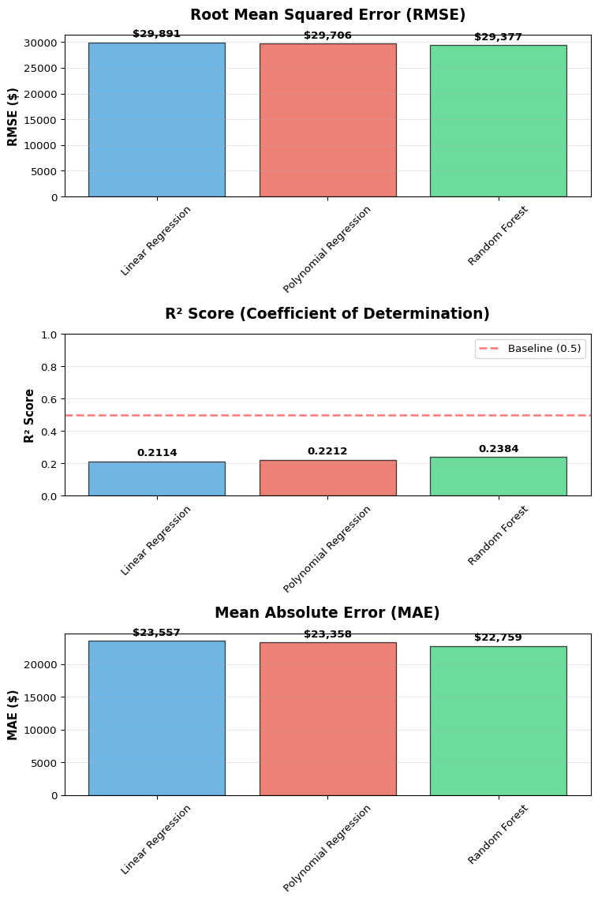

|  |
| --- |
| 📊 Model Performance Visualization Complete |
| Compared **3 models** across three key metrics (RMSE, R², MAE) 4.1.1 Figures saved to:  * figures/model_performance_comparison.png * figures/model_performance_comparison.svg * figures/model_performance_comparison.html |

## 4.2 Feature Importance Visualization

# Visualize feature importance from Random Forest  
if importance_df is not None:  
 # Create a copy for display with cleaned feature names  
 display_df = importance_df.copy()  
   
 # Clean feature names for better display  
 def clean_feature_name(name):  
 """Clean and shorten feature names for better visualization"""  
 # Remove list brackets and quotes  
 name = str(name).strip('[]"\' ')  
   
 # If feature name contains '=', split and clean the value part  
 if '=' in name:  
 parts = name.split('=', 1)  
 feature_base = parts[0]  
 value = parts[1].strip('[]"\' ')  
   
 # Shorten base feature name  
 if feature_base == 'EMPLOYMENT_TYPE_NAME':  
 feature_base = 'Employment'  
 elif feature_base == 'EDUCATION_LEVELS_NAME':  
 feature_base = 'Education'  
 elif feature_base == 'REMOTE_TYPE_NAME':  
 feature_base = 'Remote'  
 elif feature_base == 'STATE_NAME':  
 feature_base = 'State'  
   
 # Truncate long values  
 if len(value) > 25:  
 value = value[:22] + "..."  
   
 return f"{feature_base}: {value}"  
 else:  
 # For numerical features, shorten the name  
 name = name.replace('MIN_YEARS_EXPERIENCE', 'Min Exp (yrs)')  
 name = name.replace('MAX_YEARS_EXPERIENCE', 'Max Exp (yrs)')  
 name = name.replace('EXPERIENCE_MID_YEARS', 'Mid Exp (yrs)')  
 name = name.replace('POSTING_DURATION', 'Post Duration (days)')  
 name = name.replace('SALARY_POSTING_AVAILABLE', 'Salary Posted')  
 name = name.replace('DURATION', 'Duration')  
 return name  
   
 display_df['Feature_Display'] = display_df['Feature'].apply(clean_feature_name)  
   
 # Create vertical layout (2 rows, 1 column) for better DOCX compatibility  
 fig, axes = plt.subplots(2, 1, figsize=(10, 12))  
   
 # Top 15 features bar chart  
 top_15 = display_df.head(15)  
 axes[0].barh(range(len(top_15)), top_15['Importance'], color='steelblue', alpha=0.7, edgecolor='black')  
 axes[0].set_yticks(range(len(top_15)))  
 axes[0].set_yticklabels(top_15['Feature_Display'], fontsize=9)  
 axes[0].invert_yaxis()  
 axes[0].set_xlabel('Importance Score', fontsize=12, fontweight='bold')  
 axes[0].set_title('Top 15 Most Important Features', fontsize=14, fontweight='bold', pad=15)  
 axes[0].grid(axis='x', alpha=0.3)  
   
 # Add value labels  
 for i, v in enumerate(top_15['Importance']):  
 axes[0].text(v + 0.001, i, f'{v:.4f}', va='center', fontsize=9, fontweight='bold')  
   
 # Cumulative importance  
 cumulative_importance = importance_df['Importance'].cumsum()  
 axes[1].plot(range(1, len(cumulative_importance) + 1), cumulative_importance,   
 marker='o', markersize=4, linewidth=2, color='darkgreen')  
 axes[1].axhline(y=0.8, color='red', linestyle='--', alpha=0.7, linewidth=2, label='80% Threshold')  
 axes[1].axhline(y=0.9, color='orange', linestyle='--', alpha=0.7, linewidth=2, label='90% Threshold')  
 axes[1].set_xlabel('Number of Features', fontsize=12, fontweight='bold')  
 axes[1].set_ylabel('Cumulative Importance', fontsize=12, fontweight='bold')  
 axes[1].set_title('Cumulative Feature Importance', fontsize=14, fontweight='bold', pad=15)  
 axes[1].grid(alpha=0.3)  
 axes[1].legend(fontsize=10)  
   
 # Find number of features for 80% and 90%  
 features_80 = (cumulative_importance >= 0.8).idxmax() + 1  
 features_90 = (cumulative_importance >= 0.9).idxmax() + 1  
   
 axes[1].annotate(f'{features_80} features\n(80%)',   
 xy=(features_80, 0.8), xytext=(features_80 + 10, 0.75),  
 arrowprops=dict(arrowstyle='->', color='red', lw=1.5),  
 fontsize=10, ha='left')  
   
 plt.tight_layout()  
   
 # Save in multiple formats  
 fig.savefig('figures/feature_importance.png', dpi=300, bbox_inches='tight')  
 fig.savefig('figures/feature_importance.svg', format='svg', bbox_inches='tight')  
 fig.savefig('figures/feature_importance.html', format='svg', bbox_inches='tight')  
   
 plt.show()  
   
 display(Markdown(f"""  
::: {{.callout-tip}}  
## 📊 Feature Importance Insights  
  
- **Top features** drive prediction accuracy  
- **{features_80} features** explain 80% of importance  
- **{features_90} features** explain 90% of importance  
  
### Figures saved to:  
 - `figures/feature_importance.png`  
 - `figures/feature_importance.svg`  
 - `figures/feature_importance.html`  
:::  
"""))  
else:  
 display(Markdown("""  
::: {.callout-warning}  
## ⚠️ Feature Importance Data Not Available  
Feature importance visualization requires Random Forest model with successful training.  
:::  
"""))

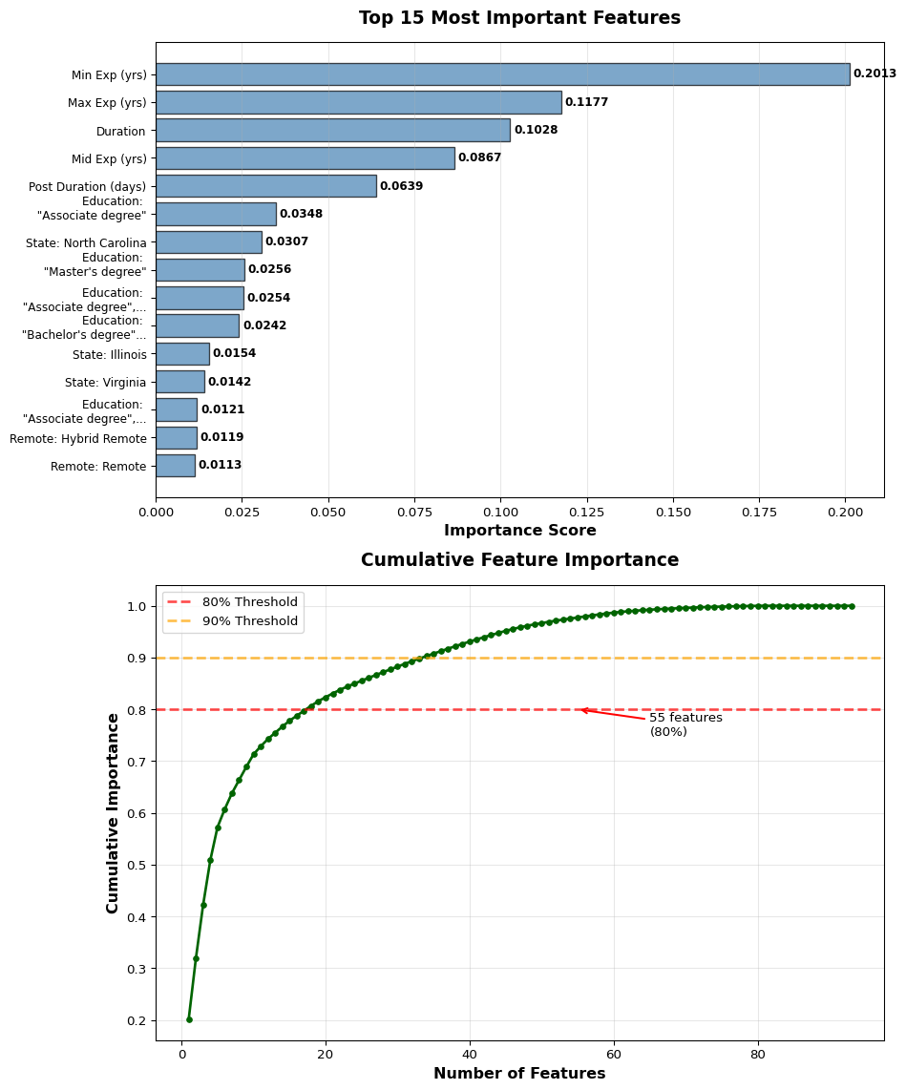

|  |
| --- |
| 📊 Feature Importance Insights |
| * **Top features** drive prediction accuracy * **55 features** explain 80% of importance * **54 features** explain 90% of importance  4.2.1 Figures saved to:  * figures/feature_importance.png * figures/feature_importance.svg * figures/feature_importance.html |

## 4.3 Prediction Analysis

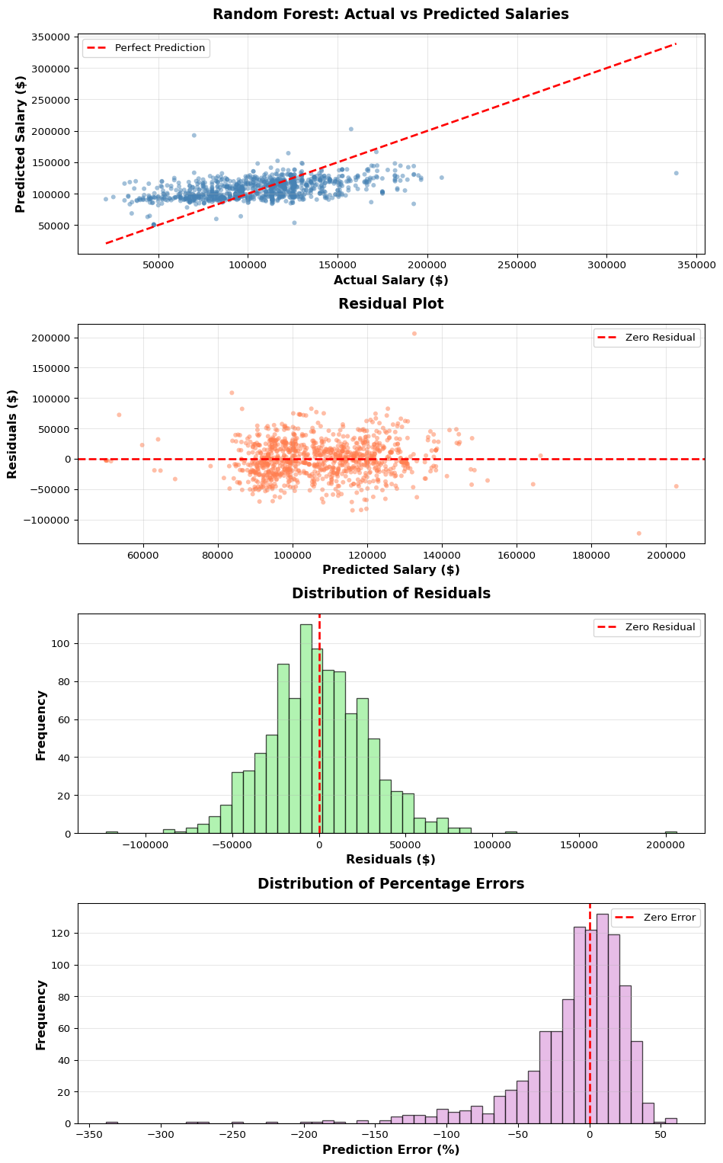

|  |
| --- |
| 📊 Prediction Quality Metrics |
| * **Mean Residual:** $-430.04 * **Std Dev of Residuals:** $29,387.83 * **Mean Absolute % Error:** 26.10% * **Predictions within ±10%:** 31.4% * **Predictions within ±20%:** 55.8%   Figures saved to:   * figures/prediction_analysis.png * figures/prediction_analysis.svg * figures/prediction_analysis.html |

## 4.4 Summary and Insights

|  |
| --- |
| 🎯 Key Findings and Insights |
| 4.4.1 Model Performance  * **Best Performing Model:** Random Forest * **R² Score:** 0.2384 (explains 23.8% of salary variance) * **RMSE:** $29,376.54 * **Number of Models Evaluated:** 3  4.4.2 Feature Insights **Most Important Features:**   1. **MIN_YEARS_EXPERIENCE:** 0.2013 2. **MAX_YEARS_EXPERIENCE:** 0.1177 3. **DURATION:** 0.1028   **Total Features Analyzed:** 93 4.4.3 Data Quality  * **Training Records:** 4,021 * **Testing Records:** 1,018 * **Total Records Processed:** 5,039  4.4.4 Recommendations  * The Random Forest model shows **weak** predictive power for salary estimation * Experience-related features appear to be key drivers of salary predictions * Geographic location (STATE_NAME) and employment type significantly influence salary ranges * Consider collecting additional features like company size, industry sector, and specific skills for improved predictions |