VIETNAM NATIONAL UNIVERSITY, HANOI
HANOI SCHOOL OF BUSINESS AND MANAGEMENT

FINAL PROJECT REPORT
HSB2006 - DEVELOPING BUSINESS APPLICATIONS

OFFICESTOCK
Office Stationery Inventory and Internal Issuance Management System

Project Information | Value
Semester / Academic Year | Semester 2 - Academic Year 2024-2025
Class | MET4
Project | OfficeStock
Production Architecture | Vercel Frontend -> PHP API -> Online MySQL/MariaDB
Roles | ADMIN_MANAGER / WAREHOUSE / EMPLOYEE
Team members | Đăng - Trung - Huyền - Duy - Vinh
GitHub Repository | [TO BE UPDATED - ACTUAL GITHUB URL]
Project Board | [TO BE UPDATED - ACTUAL PROJECT BOARD URL]
Live Frontend | [TO BE UPDATED - ACTUAL VERCEL URL]
Backend API | [TO BE UPDATED - ACTUAL PHP API URL]
Database Provider | [TO BE UPDATED - ACTUAL ONLINE DATABASE PROVIDER]

Important evidence rule: public URLs, screenshots and PASS/FAIL results must be inserted only after real production deployment and execution.

Report Content
- 1. Executive Summary
- 2. Business Problem
- 3. Project Scope, Users, Assumptions and Limitations
- 4. Objectives
- 5. Functional and Non-functional Requirements
- 6. User Stories and Acceptance Criteria
- 7. Project Management, Project Board and Team Contribution
- 8. System Diagrams
- 9. Application Architecture and Technology Stack
- 10. Database Schema and Data Dictionary
- 11. Implementation Evidence
- 12. UI/UX Design Workflow
- 13. Authentication and Authorization
- 14. Core Business Workflow
- 15. Search, Filter, Sort and Reporting
- 16. Validation and Error Handling
- 17. Security Controls
- 18. Testing, Results and Defects
- 19. Deployment and Setup Guide
- 20. Test Accounts and Demo Scenario
- 21. Requirement-to-Evidence Traceability Matrix
- 22. Third-party Assets and Licenses
- 23. AI/Tool-use Declaration
- 24. Limitations and Future Development
- 25. Viva / Demo Preparation
- 26. Final Submission Checklist

1. Executive Summary
OfficeStock is a database-driven business web application that manages office-supply master data, inventory quantities, internal stationery requests, managerial approval and warehouse issuance. The production architecture separates the public frontend from the PHP business backend: a responsive frontend is prepared for Vercel, a PHP 8.x JSON API contains authentication, authorization and business rules, and all operational data is stored in an online MySQL/MariaDB database.
The final academic scope intentionally contains exactly three roles: ADMIN_MANAGER, WAREHOUSE and EMPLOYEE. The central demonstrable workflow is Employee Request -> Manager Approval -> Warehouse Issue -> Automatic Inventory Update -> Transaction History. Warehouse issuance uses a database transaction and row-level locking so an insufficient item causes the entire issuance to roll back rather than partially deduct stock.
The source package has been refactored and statically verified for PHP syntax, JavaScript syntax and the frontend production build. Public hosting URLs and production runtime test results remain evidence items that must be supplied by the team after connecting real hosting/database accounts. This report therefore does not invent production URLs, screenshots or PASS results.

2. Business Problem
- Office-supply quantities can become inconsistent when receipts and issues are recorded in separate spreadsheets or messages.
- Employees may not have a standardized channel to submit and track stationery requests.
- Approval and warehouse issuance can be difficult to trace when responsibility is not recorded in one system.
- Low-stock products may be noticed late, increasing the risk of unavailable everyday office supplies.
- Transaction reporting becomes time-consuming when records are fragmented.
- Different user responsibilities require server-side access control rather than a shared unrestricted interface.

2.1 Product Idea
OfficeStock provides a focused internal workflow rather than a large ERP scope. It connects product/supplier master data, inventory, employee request, manager approval, warehouse issue and reporting in one database-driven application.

2.2 Business Value
- Improved traceability of who requested, reviewed and issued stationery.
- Consistent current-stock visibility after every inventory-changing transaction.
- A clear status lifecycle: PENDING, APPROVED/REJECTED and ISSUED.
- Low-stock visibility based on quantity compared with minimum_stock.
- A reporting source based on inventory transaction records rather than manually consolidated files.

3. Project Scope, Users, Assumptions and Limitations

3.1 In Scope / Out of Scope
In Scope | Out of Current MVP
Authentication + exactly 3 roles | ERP / accounting
Product CRUD | Payment gateway
Supplier CRUD | CRM
Inventory + low-stock detection | AI demand forecasting
Stock In / Stock Out | Multi-company tenancy
Employee multi-item request | Multi-warehouse transfer
Manager approve/reject | Barcode hardware
Warehouse issue + automatic stock update | Email/SMS production notifications
Search / Filter / Sort / Reporting | Commercial SLA / high-availability design
Production deployment-ready architecture | Native mobile application

3.2 Users and Responsibilities
Role | Responsibilities
ADMIN_MANAGER | Dashboard; Product/Supplier CRUD; inventory view; request approve/reject; reports; users; transaction history.
WAREHOUSE | Dashboard; product/inventory view; Stock In/Out; view approved requests; issue request; transaction history.
EMPLOYEE | Dashboard; active stationery catalog; create multi-item request; view/cancel own PENDING request.

3.3 Assumptions
- The academic MVP represents one organization and one logical warehouse.
- Inventory quantities are stored as non-negative integers.
- Each employee belongs to a department so issued requests can be attributed to that department.
- The assessment database contains non-sensitive sample data and dedicated test accounts.
- The public frontend, PHP backend and database are separate production resources connected over the Internet.

3.4 Limitations
- No MFA/SSO.
- No automatic procurement/replenishment order.
- No multi-warehouse transfer.
- No production notification service.
- Backups, monitoring and high availability depend on the selected hosting/database provider.

4. Project Objectives
- Translate an office-supply management problem into a secure database-driven business web application.
- Digitize the request -> approval -> issue process.
- Maintain consistent stock quantity after stock in, stock out and approved-request issuance.
- Provide role-appropriate interfaces for manager, warehouse and employee users.
- Provide search/filter/sort/reporting features using live database data.
- Prepare a production architecture with a public frontend, public PHP API and online relational database.
- Provide evidence that is explainable and verifiable during demonstration/viva.

5. Functional and Non-functional Requirements
ID | Functional Requirement
FR01 | Authenticate users and revoke application sessions on logout.
FR02 | Implement exactly three server-side roles.
FR03 | Provide database-derived role dashboards.
FR04 | Product create/read/update/deactivate/restore.
FR05 | Supplier create/read/update/deactivate/restore.
FR06 | Inventory search/filter/sort and low-stock detection.
FR07 | Warehouse multi-item Stock In.
FR08 | Warehouse direct Stock Out with negative-stock prevention.
FR09 | Employee creates a multi-item stationery request.
FR10 | Employee views and cancels only own PENDING requests.
FR11 | Admin/Manager approves or rejects PENDING requests.
FR12 | Warehouse issues only APPROVED requests.
FR13 | Issue transaction atomically reduces inventory and changes request to ISSUED.
FR14 | Transaction history is available to authorized operational roles.
FR15 | Manager report filters by transaction type/date and returns a database summary.
FR16 | Manager can create and lock/unlock assessment users.

ID | Non-functional Requirement
NFR01 | Responsive pages with consistent navigation, forms, validation messages and status feedback.
NFR02 | PHP 8.x backend with PDO connection to MySQL/MariaDB.
NFR03 | Relational schema with PK, FK, unique constraints and transaction integrity.
NFR04 | Prepared statements for user-controlled query values.
NFR05 | Hashed passwords and protected application sessions.
NFR06 | Server-side authorization on privileged endpoints.
NFR07 | Secrets supplied using environment variables and excluded from source control.
NFR08 | Frontend prepared for Vercel and backend prepared for Docker web hosting.
NFR09 | No static/fake business data used to simulate backend features.
NFR10 | Production test results must be based on actual execution.

6. User Stories and Acceptance Criteria
ID | User Story | Acceptance Criteria
US01 | As an Employee, I want to sign in so that I can access my own stationery workflow. | Given valid Employee credentials, when I sign in, then the Employee dashboard is displayed and manager/warehouse actions are not authorized.
US02 | As an Employee, I want to request multiple stationery items in one request. | A request requires a reason and at least one unique product with quantity > 0; successful submission creates PENDING header/detail records.
US03 | As an Employee, I want to track my requests. | The request list returns only records whose requester_id is the current user.
US04 | As an Admin/Manager, I want to approve or reject PENDING requests. | Only PENDING requests can be reviewed; rejection requires a note; reviewer and timestamp are stored.
US05 | As Warehouse Staff, I want to issue an approved request. | Only APPROVED requests are issuable; every item must have sufficient stock; success stores transaction/detail rows, decreases inventory and marks request ISSUED.
US06 | As Warehouse Staff, I want to receive stock. | A multi-item IN transaction increases each inventory quantity and stores a transaction record.
US07 | As Warehouse Staff, I want to prevent over-issue. | If any OUT/ISSUE quantity exceeds current stock, the entire database transaction rolls back.
US08 | As an Admin/Manager, I want to manage products and suppliers. | Create/update data persists; deactivate is a soft state change; restore reactivates the record.
US09 | As an operational user, I want to find inventory quickly. | Search/filter/sort return database-derived results and low-stock status is calculated from quantity <= minimum_stock.
US10 | As an Admin/Manager, I want a transaction report. | The report supports type/date filters and returns transaction rows plus summary counts.

7. Project Management, Project Board and Team Contribution
The project should be managed through a GitHub repository created during the examination period with meaningful, progressive commits. The final repository must not appear as a single bulk upload. Each technical change should be reviewed before being committed.
Member | Responsibility / Evidence Ownership
Đăng - Lead | Requirements, scope, architecture, repository coordination, deployment coordination, integration and final report.
Trung | PHP backend and database review; SQL schema; data integrity; API/database evidence.
Huyền | Frontend/UI/UX review; responsive layout; screenshots and design-workflow evidence.
Duy | Business workflow verification; Use Case, Activity and Sequence diagrams; end-to-end demo flow.
Vinh | Testing, security review, defect tracking, production test evidence and final test report.

7.1 Project Board
[TO BE UPDATED - PROJECT BOARD LINK]
Insert the actual GitHub Project Board or approved project-board link and capture a screenshot showing task status and ownership.

7.2 Progressive Commit Plan
- Initial production project structure
- Refactor PHP backend into JSON API
- Add database-backed authentication sessions
- Implement Product and Supplier CRUD
- Implement inventory Stock In / Stock Out
- Implement Employee request
- Implement Manager approval/rejection
- Implement Warehouse issue + atomic inventory update
- Add Vercel-ready frontend and API integration
- Add search/filter/sort/reporting
- Configure backend Docker deployment
- Configure Vercel build
- Add production test plan
- Fix production defects
- Update README and final report evidence

8. System Diagrams
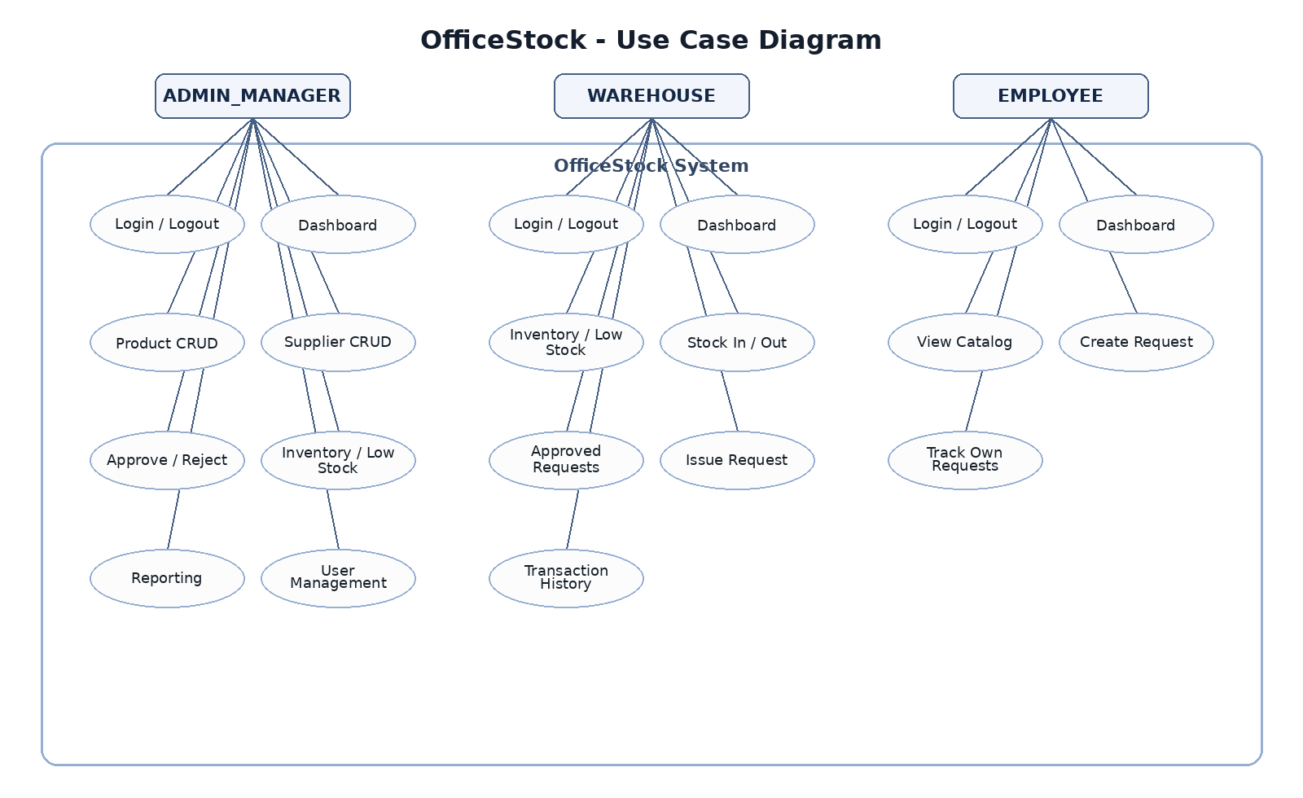
Figure 1. Use Case Diagram - exactly three actors and implemented OfficeStock functions.
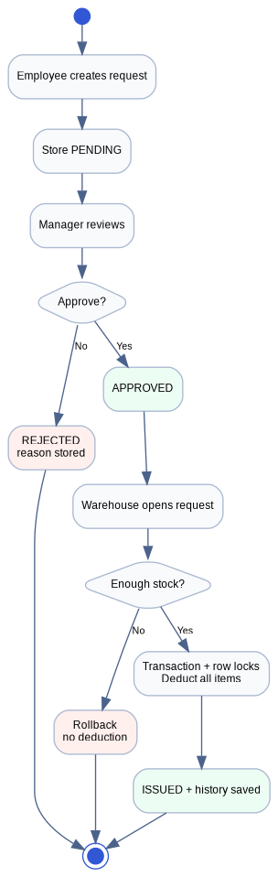
Figure 2. Activity Diagram - request, approval, stock validation, issue and rollback path.
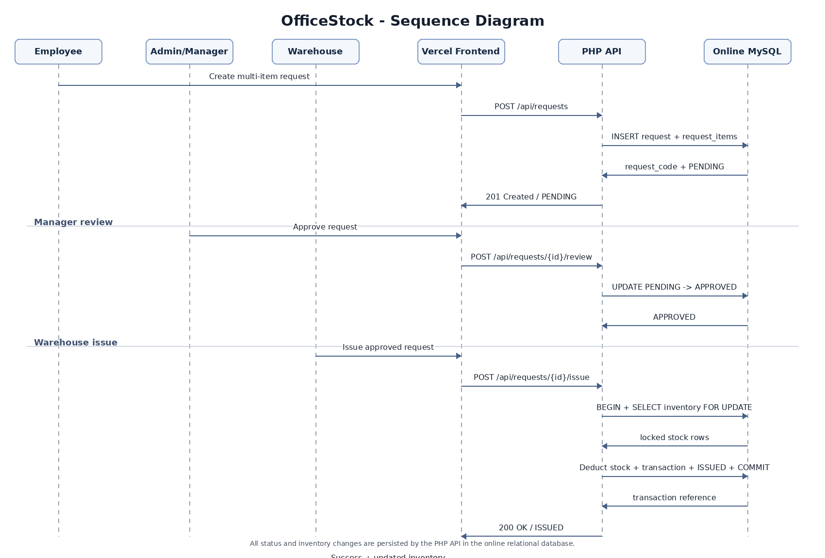
Figure 3. Sequence Diagram - Vercel frontend calls PHP API, which persists workflow changes in the online database.
The diagrams are based on the refactored source package. Before submission, the team must re-check them against any production code change made during deployment debugging.

9. Application Architecture and Technology Stack

9.1 Production Architecture
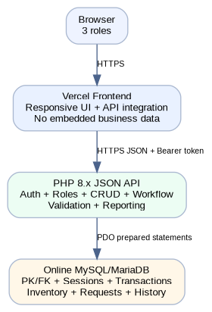
Figure 4. OfficeStock production application architecture.
The frontend and backend are deployed independently. The frontend is a responsive browser application prepared for Vercel. It calls the PHP API over HTTPS. The PHP backend owns authentication, authorization, validation, CRUD, workflow and reporting. PDO connects to the online relational database using hosting environment variables.

9.2 Deployment Architecture
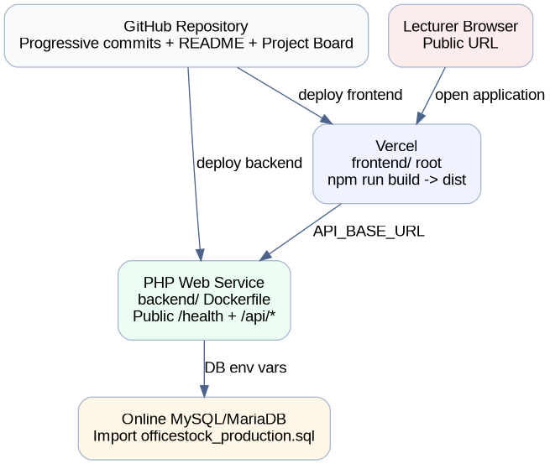
Figure 5. Deployment architecture and repository-to-hosting flow.

9.3 Technology Stack
Layer | Technology | Purpose
Frontend | HTML5 / CSS3 / ES Modules | Responsive business UI, forms, navigation and API integration.
Frontend Build | Node.js built-in build script | Generates static dist and injects API_BASE_URL without third-party runtime packages.
Frontend Hosting | Vercel | Public frontend URL.
Backend | PHP 8.x | Authentication, authorization, CRUD, workflow, validation and reporting.
Database Access | PDO / pdo_mysql | Prepared statements and database transactions.
Backend Hosting | Docker-compatible PHP web service | Public PHP API and /health endpoint.
Database | Online MySQL/MariaDB | Relational master/transaction data and application sessions.
Version Control | GitHub | Progressive commits, README and Project Board.

10. Database Schema and Data Dictionary
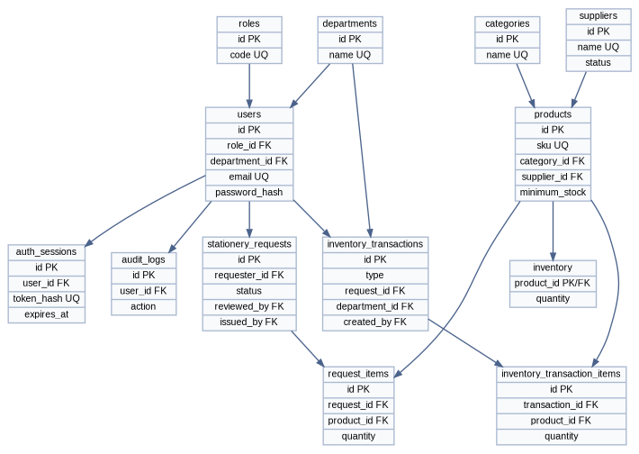
Figure 6. OfficeStock logical ERD based on backend/database/officestock_production.sql.
The database separates master data, current inventory, request workflow, inventory transaction history, application sessions and audit evidence. The schema includes primary keys, foreign keys, unique constraints, check constraints and indexes relevant to workflow queries.
Table | Field | Type | Definition
roles | id | INT PK | Role identifier.
roles | code | VARCHAR UNIQUE | ADMIN_MANAGER / WAREHOUSE / EMPLOYEE.
departments | id | INT PK | Department identifier.
departments | name | VARCHAR UNIQUE | Department name.
users | id | INT PK | User identifier.
users | email | VARCHAR UNIQUE | Login identifier.
users | password_hash | VARCHAR | Hashed password; plaintext is never stored.
users | role_id | INT FK | References roles.
users | department_id | INT FK NULL | Employee department.
users | status | ENUM | ACTIVE or LOCKED.
auth_sessions | id | BIGINT PK | Application session identifier.
auth_sessions | user_id | INT FK | Session owner.
auth_sessions | token_hash | CHAR(64) UNIQUE | SHA-256 hash of random bearer session token.
auth_sessions | expires_at | DATETIME | Server-side session expiry.
categories | id | INT PK | Product category identifier.
categories | name | VARCHAR UNIQUE | Category name.
suppliers | id | INT PK | Supplier identifier.
suppliers | name | VARCHAR UNIQUE | Supplier name.
suppliers | status | ENUM | ACTIVE/INACTIVE soft state.
products | id | INT PK | Product identifier.
products | sku | VARCHAR UNIQUE | Product SKU.
products | category_id | INT FK | Product category.
products | supplier_id | INT FK NULL | Preferred supplier.
products | minimum_stock | INT | Low-stock threshold.
products | unit_cost | DECIMAL | Reference unit cost.
products | status | ENUM | ACTIVE/INACTIVE soft state.
inventory | product_id | INT PK/FK | One current-stock row per product.
inventory | quantity | INT | Current non-negative quantity.
stationery_requests | id | INT PK | Request identifier.
stationery_requests | request_code | VARCHAR UNIQUE | Human-readable request code.
stationery_requests | requester_id | INT FK | Employee who submitted.
stationery_requests | status | ENUM | PENDING/APPROVED/REJECTED/ISSUED/CANCELLED.
stationery_requests | reviewed_by | INT FK NULL | Manager reviewer.
stationery_requests | issued_by | INT FK NULL | Warehouse issuer.
request_items | id | INT PK | Request line identifier.
request_items | request_id | INT FK | Request header.
request_items | product_id | INT FK | Requested product.
request_items | quantity | INT > 0 | Requested quantity.
inventory_transactions | id | INT PK | Transaction header identifier.
inventory_transactions | reference_code | VARCHAR UNIQUE | Transaction reference.
inventory_transactions | type | ENUM | IN / OUT / REQUEST_ISSUE.
inventory_transactions | request_id | INT FK NULL | Related request when issued.
inventory_transactions | created_by | INT FK | Warehouse user who executed transaction.
inventory_transaction_items | transaction_id | INT FK | Transaction header.
inventory_transaction_items | product_id | INT FK | Transaction product.
inventory_transaction_items | quantity | INT > 0 | Moved quantity.
audit_logs | id | BIGINT PK | Audit row identifier.
audit_logs | user_id | INT FK NULL | Actor where available.
audit_logs | action | VARCHAR | LOGIN, CREATE_REQUEST, ISSUE_REQUEST, etc.

11. Implementation Evidence
Module | Implemented Behavior | Source Evidence
Authentication | Login, application session token, logout revocation, current user. | backend/app/Core/Auth.php; backend/public/index.php
Authorization | Role checks on privileged services/endpoints. | Auth::requireRole calls in Services and router.
Product CRUD | Create/read/update/deactivate/restore + search/sort. | CatalogService.php + /api/products endpoints.
Supplier CRUD | Create/read/update/deactivate/restore + search/filter. | CatalogService.php + /api/suppliers endpoints.
Inventory | Current stock, low stock, Stock In/Out, negative-stock prevention. | InventoryService.php
Employee Request | Multi-item PENDING request and own-request restriction. | RequestService::create/list/cancelOwn
Manager Review | Approve/reject only PENDING; rejection reason required. | RequestService::review
Warehouse Issue | APPROVED-only; transaction, locks, deduction, ISSUED. | RequestService::issue
Reporting | Transaction rows with type/date filters and summary. | InventoryService::transactions/reportSummary
Frontend | Role navigation, forms, status feedback, API integration. | frontend/src/js/app.js; styles.css

11.1 Production Screenshot Evidence
[TO BE UPDATED - PUBLIC VERCEL URL]
Browser address bar and working OfficeStock login page.

[TO BE UPDATED - EMPLOYEE DASHBOARD]
Authenticated Employee dashboard loaded from production database.

[TO BE UPDATED - EMPLOYEE REQUEST]
Submitted PENDING request with 10 pens + 5 notebooks.

[TO BE UPDATED - MANAGER APPROVAL]
Manager request queue and approval evidence.

[TO BE UPDATED - WAREHOUSE ISSUE]
Approved request issued successfully.

[TO BE UPDATED - INVENTORY UPDATED]
Inventory quantities after issue.

[TO BE UPDATED - TRANSACTION HISTORY]
REQUEST_ISSUE transaction and product lines.

[TO BE UPDATED - LOW STOCK]
Low-stock badge/filter evidence.

[TO BE UPDATED - REPORTING]
Manager report filters and transaction summary chart.

[TO BE UPDATED - RESPONSIVE VIEW]
Mobile-width production frontend.

12. UI/UX Design Workflow
Step | Design Decision | Evidence
1. Role tasks | Start from the actions each role must perform. | ROLE_PERMISSION_MATRIX.md
2. Navigation | Show only modules relevant to the signed-in role. | frontend/src/js/app.js
3. Information hierarchy | Dashboard cards surface product, inventory, low-stock and request metrics. | Dashboard UI
4. Form design | Labels, required fields, numeric minimums and clear action buttons. | Product/request/stock forms
5. Status feedback | PENDING/APPROVED/REJECTED/ISSUED and LOW/NORMAL badges. | Frontend status badges
6. Error handling | API errors are surfaced as toast/error panels. | api.js + ui.js
7. Responsiveness | Sidebar collapses and grids adapt to tablet/mobile widths. | styles.css media queries
8. Evidence capture | Production desktop/mobile screenshots inserted before submission. | Final report screenshots

The frontend deliberately uses no static business dataset. Interface tables, dashboard metrics, requests, inventory and reports are rendered from API responses.

13. Authentication and Authorization

13.1 Login and Application Session
- Frontend sends email/password to POST /api/auth/login over HTTPS.
- PHP looks up the account using a prepared statement and verifies the password hash.
- PHP generates a cryptographically random session token and stores only its SHA-256 hash in auth_sessions.
- Frontend stores the returned token in sessionStorage and sends it in the Authorization header.
- Protected endpoints resolve the current user from the database session row and enforce expiry.
- Logout deletes the server-side session row, making the token unusable.

13.2 Role Authorization
Frontend navigation improves usability but is not treated as a security boundary. Server-side service methods call Auth::requireRole before privileged business operations. An Employee cannot approve requests by directly calling the manager endpoint, and a Manager cannot issue warehouse requests unless the account has the WAREHOUSE role.

14. Core Business Workflow
The central workflow is the most important implementation path for demonstration. It is fully represented in the PHP backend and relational database model.
- Employee creates a request with a reason and multiple unique product items.
- The backend inserts stationery_requests with status PENDING and request_items inside one transaction.
- Admin/Manager reads PENDING requests and selects Approve or Reject.
- Approve changes status to APPROVED and records reviewer/time. Reject changes status to REJECTED and requires a reason.
- Warehouse sees APPROVED requests and selects Issue.
- The backend locks the request and inventory rows using SELECT ... FOR UPDATE.
- Every requested quantity is validated against current stock.
- If any item is insufficient, the transaction rolls back and no quantity is deducted.
- If every item is available, the backend inserts a REQUEST_ISSUE transaction and detail rows, decreases inventory, updates request to ISSUED and commits.
- Inventory, transaction history and dashboard/report metrics then reflect the database changes.

15. Search, Filter, Sort and Reporting
Function | Implementation
Product Search | SKU/name text query.
Product Sort | Allow-listed sort columns including name, SKU, quantity and minimum stock.
Supplier Search/Filter | Name/email/phone search and ACTIVE/INACTIVE filter.
Inventory Search | SKU/name search.
Inventory Filter | Low stock or normal stock.
Inventory Sort | Name/SKU/quantity/minimum with allow-listed SQL expressions.
Request Filter | Status-based request list, additionally constrained by role.
Transaction Report | Type/date filters and summary count by transaction type.
Report Visualization | Frontend transaction-volume bar chart generated from API summary.

16. Validation and Error Handling
- Required strings are trimmed and maximum lengths are checked.
- Email addresses use server-side format validation.
- Product IDs and quantities must be positive integers.
- Minimum stock and unit cost must be non-negative.
- Duplicate products are rejected inside one request/transaction payload.
- Rejecting a request requires a rejection reason.
- Only known status/sort values are accepted through allow-lists.
- Over-issue raises a business-rule error and rolls back the database transaction.
- Frontend forms add usability validation, while the PHP backend remains authoritative.
- API errors use structured JSON codes such as VALIDATION_ERROR, FORBIDDEN and BUSINESS_RULE_ERROR.

17. Security Controls
Control | Implementation / Evidence
Password protection | password_hash() for seed/runtime user passwords and password_verify() during login.
Prepared statements | PDO prepared statements; emulated prepares disabled.
Application-session protection | Random 256-bit token; hash stored server-side; expiry; revocation on logout.
Authorization | Backend Auth::requireRole checks.
Input validation | Validator allow-lists and numeric/string validation.
Inventory integrity | Transactions + SELECT FOR UPDATE; rollback on failure.
CORS | Exact allowed frontend origin(s) from CORS_ALLOWED_ORIGINS.
Secrets | Database/API production settings use environment variables; .env ignored.
Error disclosure | Production returns generic unexpected-server error unless APP_DEBUG explicitly enabled.
Security headers | nosniff, DENY framing, referrer and permissions headers.

Cookie-based CSRF is not used as the authentication mechanism in the separated-domain production architecture. The session credential is explicitly attached to requests as a bearer authorization header, so conventional ambient-cookie CSRF does not apply. The production frontend origin is still restricted by the backend CORS allow-list.

18. Testing, Results and Unresolved Defects
Static verification has been performed on the generated production source package. Runtime production tests remain NOT RUN until the team deploys real public resources. This distinction prevents fabricated PASS results.
Verification | Result
PHP syntax lint for all backend PHP files | PASS
JavaScript syntax check for frontend modules | PASS
Frontend production build with API_BASE_URL | PASS
Exactly three seeded roles by SQL inspection | PASS
Workflow transaction/locking logic by source inspection | PASS
Public frontend URL | NOT RUN
Public PHP API database connectivity | NOT RUN
TC01-TC20 end-to-end production execution | NOT RUN

ID | Test | Expected | Actual | Status
TC01 | Login Admin/Manager | Manager dashboard opens | [TO BE UPDATED] | NOT RUN
TC02 | Login Warehouse | Warehouse dashboard opens | [TO BE UPDATED] | NOT RUN
TC03 | Login Employee | Employee dashboard opens | [TO BE UPDATED] | NOT RUN
TC04 | Wrong password | Login rejected safely | [TO BE UPDATED] | NOT RUN
TC05 | Role authorization | Forbidden operation returns 403 | [TO BE UPDATED] | NOT RUN
TC06 | Product CRUD | Create/update/deactivate/restore persists | [TO BE UPDATED] | NOT RUN
TC07 | Supplier CRUD | Create/update/deactivate/restore persists | [TO BE UPDATED] | NOT RUN
TC08 | Search/filter/sort | Results match query | [TO BE UPDATED] | NOT RUN
TC09 | Employee create request | PENDING request + two items stored | [TO BE UPDATED] | NOT RUN
TC10 | Manager approve | PENDING -> APPROVED | [TO BE UPDATED] | NOT RUN
TC11 | Manager reject | REJECTED + reason stored | [TO BE UPDATED] | NOT RUN
TC12 | Warehouse issue | ISSUED + transaction saved | [TO BE UPDATED] | NOT RUN
TC13 | Inventory update | Stock decreases exactly | [TO BE UPDATED] | NOT RUN
TC14 | Over-issue rejection | Rollback/no partial deduction | [TO BE UPDATED] | NOT RUN
TC15 | Low-stock alert | LOW state displayed | [TO BE UPDATED] | NOT RUN
TC16 | Dashboard | Metrics match production DB | [TO BE UPDATED] | NOT RUN
TC17 | Reporting | Type/date report works | [TO BE UPDATED] | NOT RUN
TC18 | Logout | Old token returns 401 | [TO BE UPDATED] | NOT RUN
TC19 | Validation | Invalid input is rejected | [TO BE UPDATED] | NOT RUN
TC20 | Security | Secrets/CORS/auth/SQL controls verified | [TO BE UPDATED] | NOT RUN

18.1 Unresolved Defects
[TO BE UPDATED - DEFECT LOG]
After production tests, list only real unresolved defects with severity, reproduction steps, owner and workaround.

19. Deployment and Setup Guide

19.1 Production Deployment
- Create/finalize the GitHub repository and push meaningful progressive commits.
- Provision an online MySQL/MariaDB database and import backend/database/officestock_production.sql.
- Create a Docker PHP web service using backend/Dockerfile.
- Set backend environment variables: application mode, allowed frontend origin and database credentials.
- Deploy the backend and verify /health reports the database as connected.
- Create a Vercel project using frontend/ as the root directory.
- Set API_BASE_URL to the public PHP API origin.
- Build with npm run build and deploy dist.
- Update backend CORS_ALLOWED_ORIGINS to the exact final Vercel origin and redeploy if necessary.
- Run the full production test plan through the public frontend.

19.2 Developer Verification Without Production Secrets
The source package can be syntax-checked and the frontend can be built without exposing production credentials. Database-dependent behavior requires a compatible MySQL/MariaDB database. Production credentials must remain in hosting environment variables.

19.3 Environment Variables
Component | Variable | Purpose
Backend | APP_ENV | Production mode.
Backend | APP_DEBUG | Keep false for production.
Backend | APP_URL | Public PHP API URL.
Backend | CORS_ALLOWED_ORIGINS | Exact Vercel origin(s).
Backend | SESSION_TTL_HOURS | Application-session expiry.
Backend | DB_HOST / DB_PORT / DB_NAME / DB_USER / DB_PASSWORD | Online database connection.
Frontend | API_BASE_URL | Public PHP API base URL used by build script.

20. Test Accounts and Demo Scenario
Role | Email | Assessment Password
ADMIN_MANAGER | manager@officestock.demo | Manager@2026
WAREHOUSE | warehouse@officestock.demo | Warehouse@2026
EMPLOYEE | employee@officestock.demo | Employee@2026

These passwords are assessment-only sample credentials. The SQL stores password hashes, not plaintext passwords.

20.1 Recommended Demonstration
- Open the public Vercel frontend.
- Login as Employee.
- Create a request for 10 Blue Ballpoint Pens and 5 A5 Notebooks.
- Verify the request is PENDING.
- Login as Admin/Manager and approve the request.
- Login as Warehouse and issue the APPROVED request.
- Open Inventory and verify the two quantities decreased.
- Open Transaction History and verify the REQUEST_ISSUE reference.
- Login as Admin/Manager and show updated dashboard/report values.
- Show a negative test: attempt an unauthorized action or over-issue and demonstrate safe rejection.

21. Requirement-to-Evidence Traceability Matrix
Exam Area | OfficeStock Implementation | Required Evidence
Project management + requirements | Requirements, user stories, Project Board, member roles | docs/REQUIREMENTS.md; PROJECT_BOARD.csv; GitHub evidence
Use Case / Activity / Sequence | Diagrams based on implemented roles/workflow | docs/diagrams/*.png
UI/UX + responsive | Role navigation, forms, badges, errors, media queries | frontend/src + production screenshots
Database + PHP connection | MySQL schema and PDO connection | backend/database + Database.php
Authentication + roles | Hashed passwords, application sessions, exactly 3 roles | Auth.php + roles seed
CRUD | Product/Supplier endpoints and UI | CatalogService.php + frontend
Complete business workflow | Request -> Approval -> Issue -> Inventory update | RequestService.php + DB evidence
Search/filter/sort/report | Product/inventory filters and transaction reports | CatalogService/InventoryService + frontend
Security | Prepared statements, authorization, session, CORS, env secrets | backend Core/Services
Testing/results | TC01-TC20 + actual production results | PRODUCTION_TEST_PLAN.md
Packaging/setup | README, Dockerfile, Vercel config, SQL | repository package
Live demo | Public frontend/backend/database | [TO BE UPDATED - REAL URLs]

22. Third-party Assets and Licenses
The production frontend is intentionally dependency-light. It uses browser-standard HTML, CSS and JavaScript modules and does not require a third-party UI template. The backend uses the official PHP runtime image for container deployment and built-in PHP/PDO functionality. Graphviz was used during documentation generation to render diagrams. The final repository README should list any additional library, icon, image or template added by the team after this report is generated.
[TO BE UPDATED - THIRD-PARTY ASSET LIST]
Add the exact source/license of any asset or library introduced during final UI/deployment changes.

23. AI / Tool-use Declaration
Field | Declaration
AI/tool name(s) | [TEAM TO CONFIRM ACTUAL AI/TOOLS USED]
Purpose of use | Architecture refactoring, code drafting, validation review, documentation, test-plan drafting and report preparation.
Main parts assisted | PHP API structure, frontend/API integration, database review, deployment configuration, diagrams and report drafting.
How output was verified | PHP syntax lint, JavaScript syntax checks, frontend build, team review, production tests after deployment, and ability to explain/modify the work.

The team remains responsible for correctness, security, licensing, originality and the ability to explain or modify the submitted work during the demonstration/viva.

24. Limitations and Future Development

24.1 Current Limitations
- One organization / one logical warehouse.
- No automatic procurement workflow.
- No MFA or enterprise SSO.
- No email/SMS notification integration.
- No native mobile application.
- Public monitoring/backups depend on the selected hosting/database provider.

24.2 Future Development
- Multiple warehouses and transfer transactions.
- Purchase-order and replenishment workflow.
- Department budget/spending limits.
- Notification service for approvals and low-stock events.
- Report export and richer analysis.
- Demand forecasting only after sufficient historical data is available.

25. Viva / Demo Preparation
Question | Short Answer
Why is the PHP backend retained? | The examination explicitly requires PHP connection/backend evidence; PHP also owns the real business rules and database access.
How many roles are implemented? | Exactly three: ADMIN_MANAGER, WAREHOUSE and EMPLOYEE.
Where are passwords stored? | Only password hashes are stored in users.password_hash.
How is SQL injection mitigated? | PDO prepared statements are used and emulated prepares are disabled.
How is a logged-in session protected? | A random token is issued; only its SHA-256 hash is stored server-side with expiry and revocation.
Why can an Employee not approve a request? | The PHP review service requires ADMIN_MANAGER before updating a request.
How can one request contain multiple products? | stationery_requests is the header and request_items contains product/quantity detail rows.
What happens after approval? | Status becomes APPROVED; Warehouse can then see and issue it.
How do you prevent negative stock? | Inventory rows are locked inside a DB transaction and quantities are validated before update.
What if one item is insufficient? | The entire issue transaction rolls back; no partial stock deduction is committed.
Where is issue history stored? | inventory_transactions and inventory_transaction_items.
How is low stock detected? | quantity <= minimum_stock.
How is Employee data privacy enforced? | Request queries add requester_id=current authenticated user.
Where is validation performed? | Both frontend usability validation and authoritative PHP Validator/business rules.
Why is conventional cookie CSRF not the main control? | The separated frontend uses an explicit bearer authorization header rather than an ambient authentication cookie.
What does CORS do? | The backend accepts browser API requests only from configured production frontend origins.
What is the main deployment architecture? | Vercel frontend -> PHP API -> online MySQL/MariaDB.
What results have actually been verified now? | Static PHP/JS/build checks; production URL/database workflow tests remain NOT RUN until hosting is connected.
Why are some report fields placeholders? | The report does not invent URLs, screenshots or PASS results without real production evidence.
What is the most important demo flow? | Employee Request -> Manager Approve -> Warehouse Issue -> Inventory Update -> Transaction History.

26. Final Submission Checklist
☐ Application starts successfully from the public frontend instructions.
☐ Online database contains the submitted schema and sufficient sample data.
☐ GitHub repository has visible progressive history.
☐ README includes purpose, features, technology, deployment, database, test accounts and limitations.
☐ All public links are accessible to the lecturer.
☐ Exactly three role accounts work.
☐ Employee -> Manager -> Warehouse workflow works on production.
☐ Report and diagrams match implemented source/database.
☐ Production screenshots are inserted and annotated.
☐ TC01-TC20 have real Actual Result and PASS/FAIL values.
☐ No production password, private API key or personal data is committed.
☐ Third-party assets/libraries are disclosed.
☐ AI/tool-use declaration reflects actual team use.
☐ File names are changed to the lecturer-required naming format.

Final Evidence Status
Source refactoring and static verification are complete in the generated package. Public deployment, public URLs, production screenshots and end-to-end runtime results must be completed by the team using real hosting/database accounts before this report is treated as submission-final.

