Bootstrap Programming- Assignments

Session 1

Duration (3 hrs)

**Assignment 1:**

Using div and bootstrap classes, create below GRID layout for large size screen.

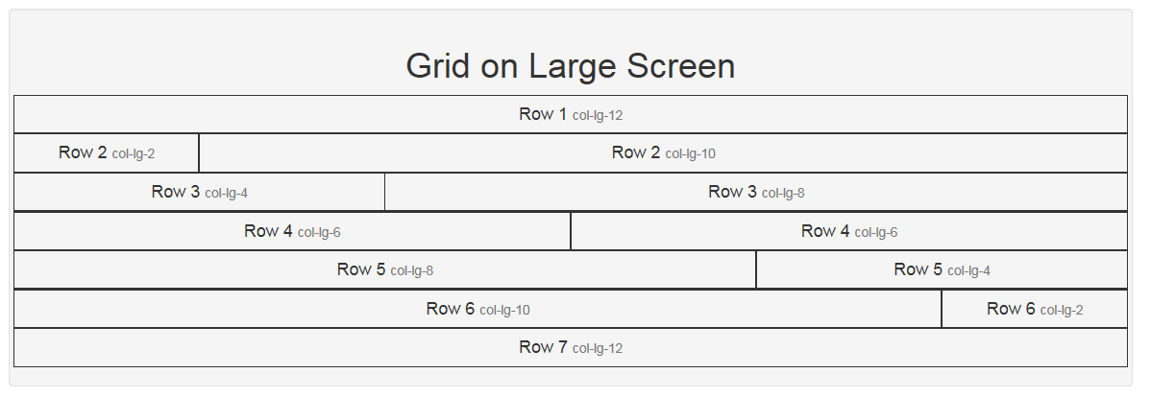

**Assignment 2:**

Use grid layout given in assignment 1 and make it responsive for all type of devices. Column width ratio must be responsive as defined below:

|  |  |  |  |  |  |  |  |  |
| --- | --- | --- | --- | --- | --- | --- | --- | --- |
| **Row #** | **Large Device** | | **Medium Device** | | **Small Device** | | **Extra Small** | |
| **Col 1** | **Col 2** | **Col 1** | **Col 2** | **Col 1** | **Col 2** | **Col 1** | **Col 2** |
| **Row 1** | 12 | | 12 | | 12 | | 12 | |
| **Row 2** | 2 | 10 | 4 | 8 | 6 | 6 | 12 | 12 |
| **Row 3** | 4 | 8 | 6 | 6 | 6 | 6 | 12 | 12 |
| **Row 4** | 6 | 6 | 6 | 6 | 6 | 6 | 12 | 12 |
| **Row 5** | 8 | 4 | 6 | 6 | 6 | 6 | 12 | 12 |
| **Row 6** | 10 | 2 | 8 | 4 | 6 | 6 | 12 | 12 |
| **Row 7** | 12 | | 12 | | 12 | | 12 | |

Expected o/p of large screen

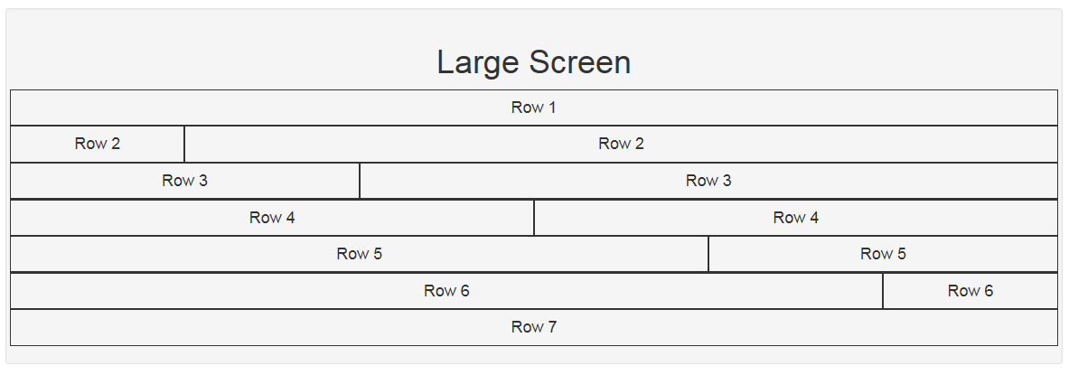

Expected o/p of medium screen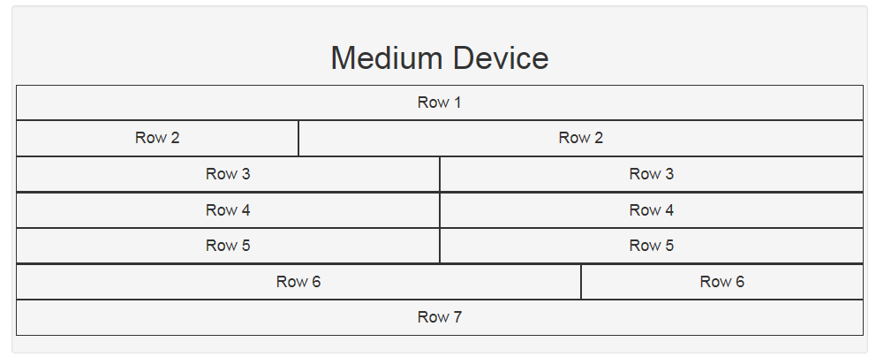

Expected o/p of small screen

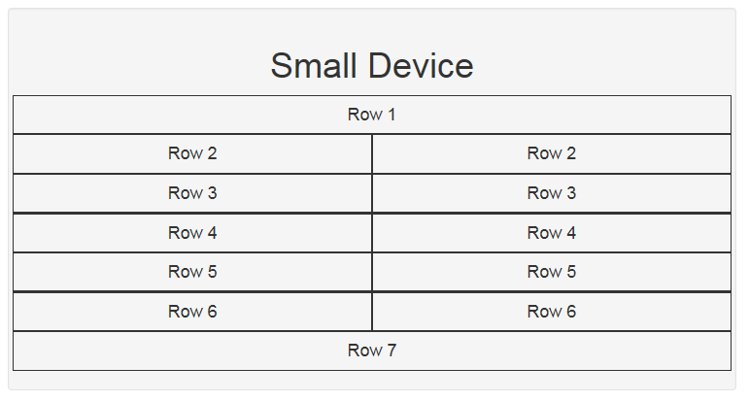

Expected o/p of extra small screen

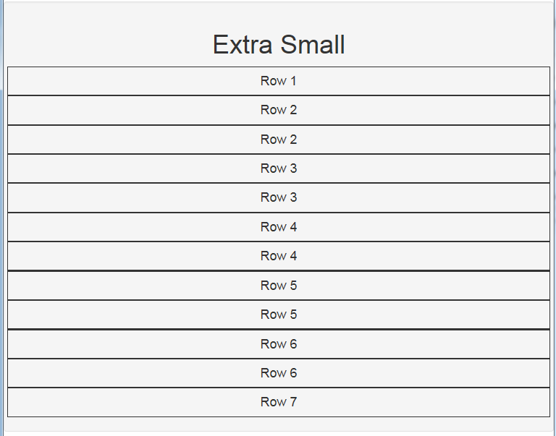

**Assignment 3:**

Use assignment 2, add some dummy text and apply following formatting on text using bootstrap.

|  |  |  |
| --- | --- | --- |
| **Row #** | **Formatting** | |
| **Row 1** | Center aligned your name in heading 1 format. | |
| **Row 2** | Primary text with italic. | |
| **Row 3** | Danger text in center alignment. | |
| **Row 4** | Muted small text. | |
| **Row 5** | Right aligned strong warning text. | |
| **Row 6** | Strong success text. | |
| **Row 7** | left aligned informative content. | |