**Solution of the Day 1 Assignment** - Testing Fundamental and STLC

**Exercise 1.1** -

Important questions we should ask-

Q1- the constraint or validation given are client side or server side , in the database?

For this assignment we are considering the constraints are html constraints.

Existing Constraints on Fields which needs to verify from BA :

| **Name of Fields having invalid constraints** | **Constraints Existing** | **Required Constraints** |
| --- | --- | --- |
| Account name/Age/Gender | Not Mandatory field | Be Mandatory field |
| First name | not greater than 30 characters | Be greater than 30 characters |
| Age field | > 0 and <=2 | (> 18 and <= 60) |
| Source picklist | TV, Internet, Newspaper, Hoardings. | Search Engine,Google Ads,Facebook Ads,Youtube Ads,Other paid social media advertising,Facebook post/group,Twitter post,Instagram post/story,Other social media,Email,Radio,TV,Newspaper,Word of mouth,Other with text box to specify other source. |
| "Submit" button message display | "Thank You" | We can provide a descriptive message. |
|  |  |  |
|  |  |  |
|  |  |  |

We’ll be Updating the UI of the page to make it more user friendly.

| **Field Names** | **Updated label/text box Designs/changes/validations** | **Updated Field Names** |
| --- | --- | --- |
| Layout format/color/background | We can follow any standard form layout for better visuals and irregular starting of field names and ending. Color and theme of the UI should be according to the bank color and significance. |  |
| Account Data | Right / left /center alignment with start /end of property fields, according to the layout followed. | Please fill the form to create your account. |
| * | It should be at the end of the text of all the text fields |  |
| First name | Why is it not bold? | First Name |
| Account Name | Please correct the span of label length. |  |
| Account No. |  | Account Number |
| Account Type | Please correct the span of label length.  We can create a pickList(please refer the next page for the same) |  |
| Active | Please correct the span of label length.  We can create a pickList(please refer the next page for the same)  What is active? |  |
| City | Why is it not bold? |  |
| State | The picklist box should have the same length as the text boxes for alignment. Also for a default value place the “-Please select-”. Why is it not bold? |  |
| Zip code or postal code | Zip code should accept digits only.  Why is it not bold? | Zip Code |
| Country | Please reduce the length of the text box. |  |
| Phone Number | Only digits Fixed length according to the country  Why is it not bold? |  |
| Age | Please correct the span of label length. |  |
| Gender | Refer below table for picklist.  Please correct the span of label length. |  |
| Where did you first learn of this opportunity and/or see this position advertised? | Proper alignment and text wrap. | How Did You Hear About Us?  Or How Did you find us? |
| Source | Radio buttons / check boxes will be more approachable.  Label is not required |  |
| Submit | Text inside the button should be aligned to center |  |
| Reset | Text inside the button should be aligned to center |  |
|  |  |  |

We are going to create the PICKLIST for the fields mentioned

| **PickList** | **PickList Options** |
| --- | --- |
| Account Type | please select |
| Active | Default |
| Gender | Please select |
|  |  |

Additional Fields should be added according to requirement, discussed with BA.

| Occupation/salary should be included as this is bank opening account form |
| --- |
| Email |
| DOB instead of AGE |
| Last Name is missing |
|  |

**Exercise 1.2: Create requirements for the report card generation system.**

**Example - List of fields, Mandatory Fields, etc.**

**System Design**

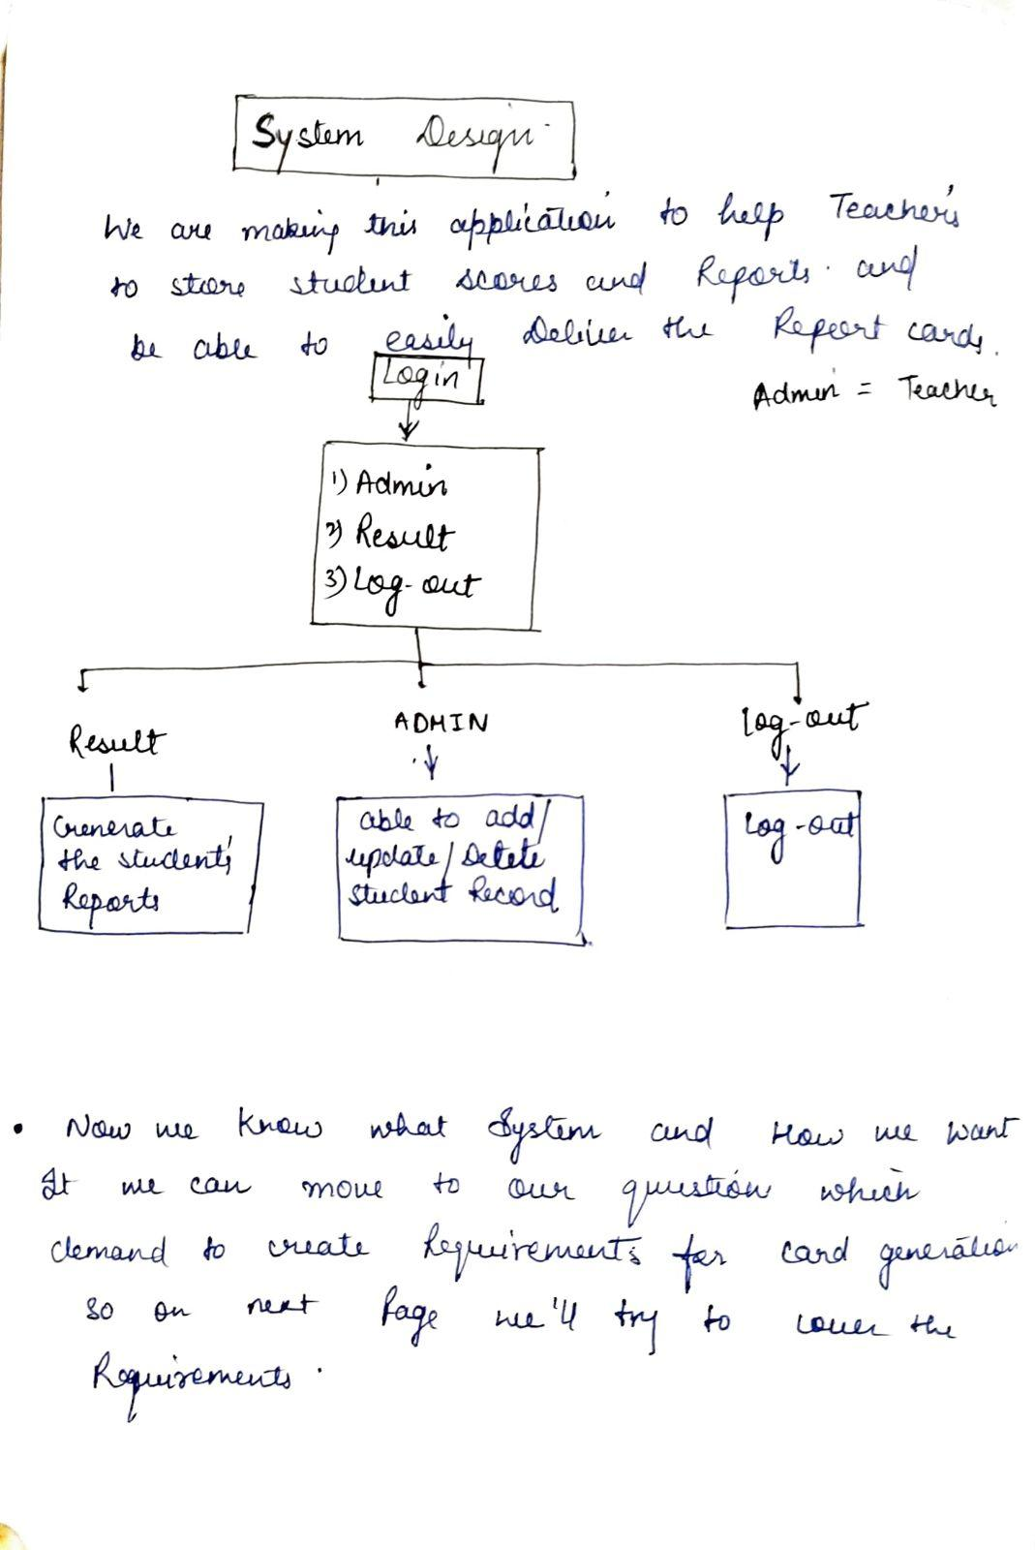

**UI references**

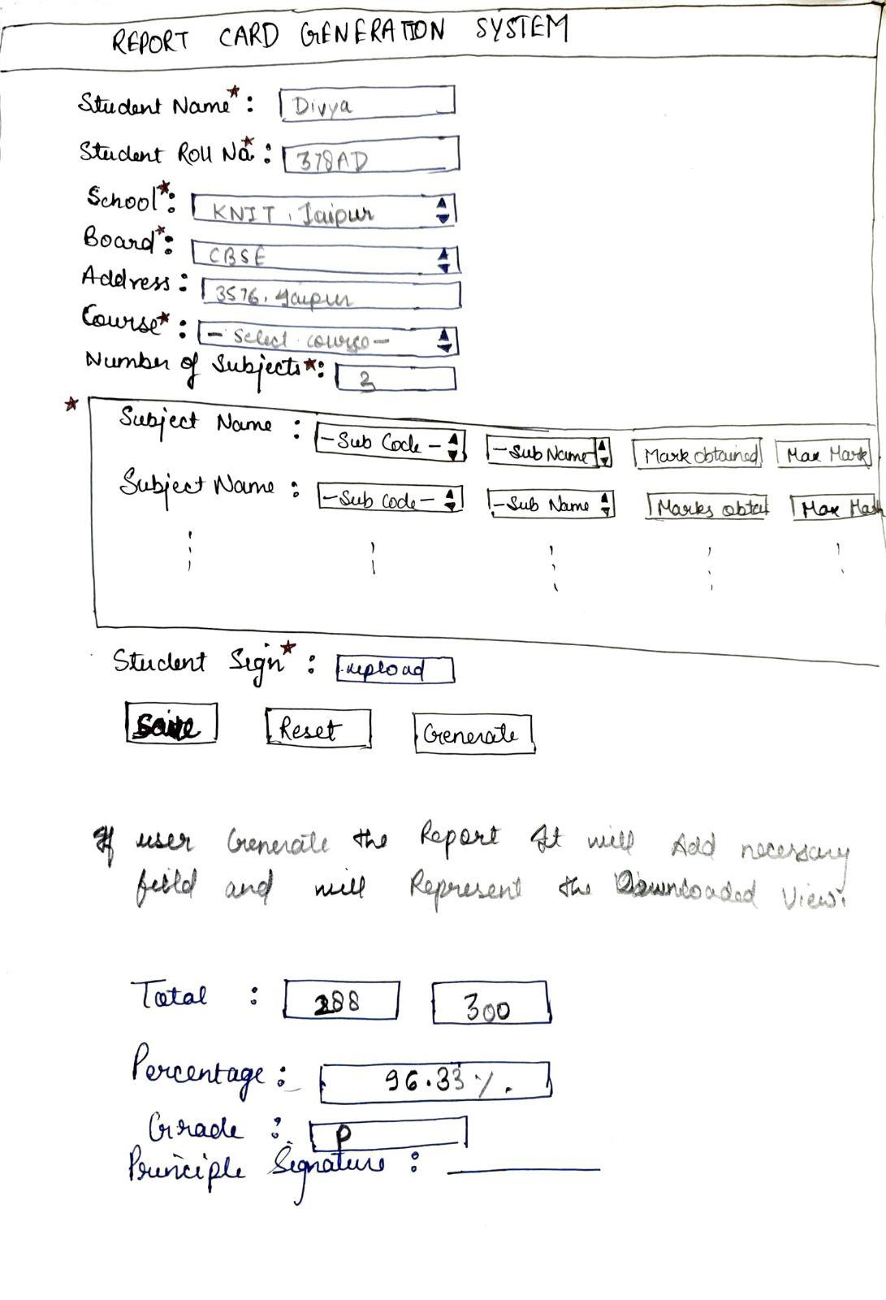

**Field requirement**

| **Fields** | **Constraints** |
| --- | --- |
| **Student Name** | * Alphabets (A-Z a-z) only * Not exceed 30 char * Should not accept numbers and special char * mandatory |
| **Student Roll Number** | * String type * Should not accept special char * Specified length * Unique * mandatory |
| **School** | * Dropdown list of all schools * Other for the schools which aren’t available in lists * mandatory |
| **Board** | * Dropdown list of recognized boards. * mandatory |
| **Address** | * Address can be of any length * String value |
| **Subject code** | * This dropdown field is dependent on the course selected * Contain unique subject code for specific subject in reference with the code * Only Alphabet and numbers(A-Z 0-9) * No special character are accepted * mandatory |
| **Subject Name** | * Key value pair will auto select the values field and will reflect the subject name * Alphabets (A-Z a-z) only * Should not accept numbers and special char * mandatory |
| **Marks Obtained** | * Contain numeric value * <=100 * mandatory |
| **Maximum Marks** | * =100 * mandatory |
| **Grade** | * Contain only(F,P) * Numeric and special character not accepted * If percentile is in range 31-100 show grade =P Otherwise( 1-30 ) show grade = F |
| **Total** | * Total marks scored by student in each subject * mandatory |
| **Total max marks** | * = Sum of all max marks column |
| **Percentage** | * 0< percentage<100 * mandatory |
| **Student Signature** | * Contain image of signed copy of principle and student * <5mb * Clear and scanned * mandatory |