**Exercise 3: Answer below questions using Equivalence Partitioning/Boundary Value concepts**

**Scenario: If you take the train before 9:30 am or in the afternoon after 4:00 pm until 7:30 pm**

**('the rush hour'), you must pay full fare. A saver ticket is available for trains between 9:30 am**

**and 4:00 pm, and after 7:30 pm.**

**A. What are the partitions and boundary values to test the train times for ticket types?**

**Partitions -**

Equivalence Class Partition is a test case design technique that involves dividing input test data into separate partitions with similar elements.

Valid Partitions are values that should be accepted by the component or system under test. This partition is called *"Valid Equivalence Partition."*

Invalid Partitions are values that should be rejected by the component or system under test. This partition is called *"Invalid Equivalence Partition."*

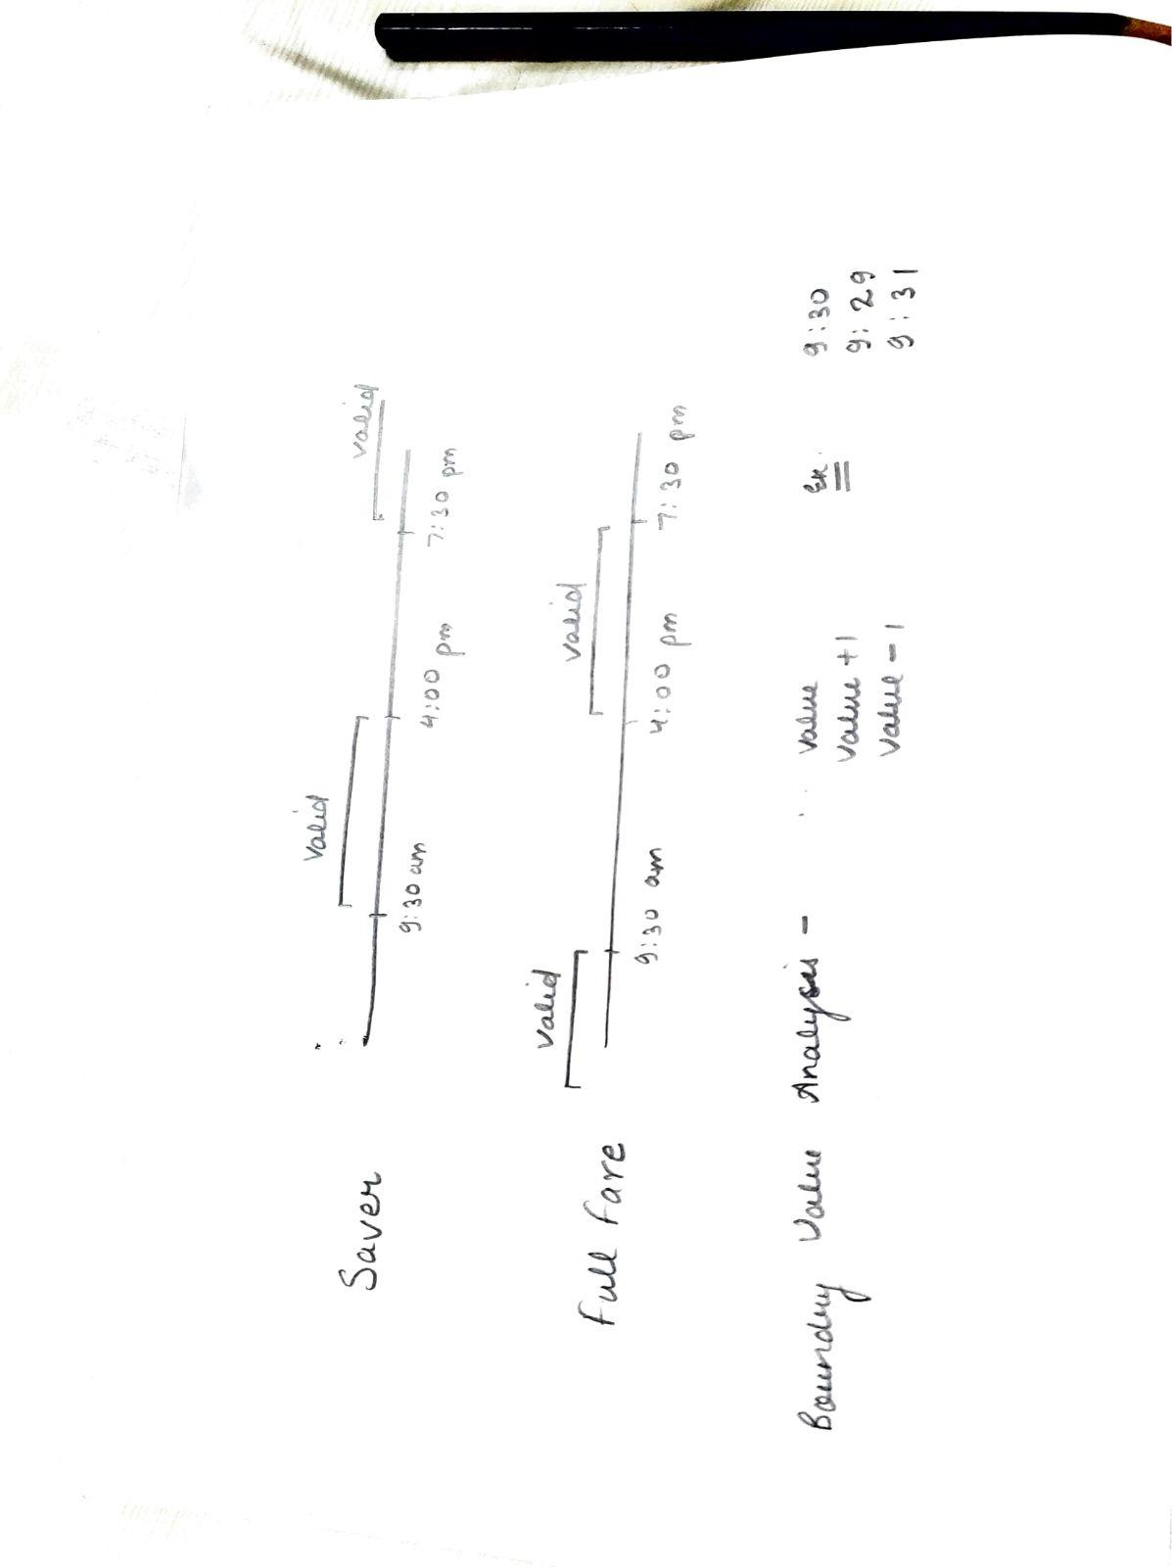

Saver ticket - 4 pm <=ticket bought<=9:30 am >7:30 pm>=7:31

Train left at 11:00 am

Train left at 11 :00 pm

Full fare - 4:00 pm< =ticket bought <=7:30 pm <9:30 am <=9:29 am

Train left at 8:00 am

Train left at 5:00 pm

**Boundary values to test-**

* 9:29 am
* 9:30 am
* 9:31 am
* 3:59 pm
* 4:00 pm
* 4:01 pm
* 7:29 pm
* 7:30 pm
* 7:31 pm

**B. Which are valid partitions and which are invalid partitions? What are the boundary**

**Values?**

**valid partitions and which are invalid partitions**

| **Valid Partitions** | **Invalid Partitions** |
| --- | --- |
| Train left at 9:29 am | Train left at 8:00 am (saver ticket) |
| Train left at 9:30 am | Train left at 5:00 pm (saver ticket) |
| Train left at 9:31 am | Train left at 12:00 pm (full fare ticket) |
| Train left at 3:59 pm | Train left at 10:00 pm (full ticket) |
| Train left at 4:00 pm |  |
| Train left at 4:01 pm |  |
| Train left at 7:29 pm |  |
| Train left at 7:30 pm |  |
| Train left at 7:31 pm |  |

**Boundary Values**

* **9:29 am**
* **9:30 am**
* **9:31 am**
* **3:59 pm**
* **4:00 pm**
* **4:01 pm**
* **7:29 pm**
* **7:30 pm**
* **7:31 pm**

**C. Derive test cases for the partitions and boundaries.**

**test cases for the partitions**

Saver ticket - 4 pm <=ticket bought<=9:30 am >7:30 pm>=7:31

Train left at 11:00 am

Train left at 11 :00 pm

Full fare - 4:00 pm< =ticket bought <=7:30 pm <9:30 am <=9:29 am

Train left at 8:00 am

Train left at 5:00 pm

**boundaries.**

| **Boundary value analysis** | **outcome** |
| --- | --- |
| Train left at 9:29 am | full fare ticket |
| Train left at 9:30 am | saver ticket |
| Train left at 9:31 am | saver ticket |
| Train left at 3:59 pm | saver ticket |
| Train left at 4:00 pm | full fare ticket |
| Train left at 4:01 pm | full fare ticket |
| Train left at 7:29 pm | full fare ticket |
| Train left at 7:30 pm | saver ticket |
| Train left at 7:31 pm | saver ticket |

**Exercise 4: Perform below steps and create test scenarios -**

**A. Open Amazon website (https://www.amazon.in/). Home Page is displayed having**

**Search input textbox**

**● Create test scenarios for Amazon Search input textbox**

| **test scenarios** |  |
| --- | --- |
| Check for the search input box and icon |  |
| Check when the user enter nothing |  |
| Checks when user enter any product name and hit enter |  |
| Check if index searching is being used when the user enter any character |  |
| Check if autocomplete suggestions are working when search string words are typed |  |
| Check when user enter wrong string value |  |
| Check for special characters |  |
| Check for alphanumeric |  |
| Check if autocomplete suggestion is working for any typed string |  |
| Check if we entered the input text and without hit enter we refreshed the page |  |
| Check if the absurd input string is provided |  |
| Check if we provide more than one product names in the search bar |  |
| Check if we provide item that is not sell by amazon |  |
| All UI requirements are applied and fulfilled |  |
| The UI of the page should be responsive in any environment |  |
| The compatibility with different browsers |  |
| Application compatibility ex- IOS and Android |  |
| Network Compatibility, the site should load properly in the different networks 2g, 3g, 4g, 5g. |  |
| Able to handle the error and exceptions on the incompatibility issues with the error message to the user |  |
| The Log out time |  |
| The backward and forward functionality should be working after pressing the forward and backward arrow tab |  |
|  |  |
|  |  |
|  |  |
|  |  |
|  |  |
|  |  |
|  |  |

**B. Enter any search text (for ex. mobile) on the search textbox of Amazon website.**

**● Create test scenarios for the page containing all results / products.**

| **test scenarios** |  |
| --- | --- |
| User is able to provide input |  |
| The search result should contain the products related to search |  |
| The number of results it is showing information line should be visible |  |
| Filters sections is contained |  |
| Check for default filters |  |
| Check if filters are working as per requirement |  |
| Check for extreme case filters |  |
| Check after removing the filters |  |
| Check the number of products it is displaying in a page |  |
| Check if all the cards and information is displayed smoothly |  |
| Check if navigating any specific product leads to its description and details |  |
| Check if sorting with options  Featured Price :Low to High Price :High to Low Avg. Customer Review Newest Arrivals is working fine or not |  |
| Check weather the product price , details and brand and option to add the cart is visible or not |  |
| Check if navigation tab |  |
| Check all the links , tabs and dashboard |  |
| All UI requirements are applied and fulfilled |  |
| The UI of the page should be responsive in any environment |  |
| The compatibility with different browsers |  |
| Application compatibility ex- IOS and Android |  |
| Network Compatibility, the site should load properly in the different networks 2g, 3g, 4g, 5g. |  |
| Able to handle the error and exceptions on the incompatibility issues with the error message to the user |  |
| The Log out time |  |
| The backward and forward functionality should be working after pressing the forward and backward arrow tab |  |

**C. Click on any product (searched in step 2), the Detail Page of that product is opened.**

**● Create test scenarios for verification of the Detail Page of a particular product (ex**

**mobile - Samsung J7).**

| **test scenarios** |  |
| --- | --- |
| User is able to navigate any specific product searched |  |
| User is able to see the detailed view of that product in a new tab |  |
| User is able to see the images of product |  |
| Verify the  price , details,  brand ,  Discounts, Policy, add to cart ,  buy now,  add to wishlist , size,and  A detailed para about the product is available. |  |
| Verify if product is in stock/out of stock |  |
| Verify below if the “products related to items” are available |  |
| Make sure you are able to zoom on the picture of product |  |
| Verify if there is “customer review section “ for the product, along with the recommended products, |  |
| Check for the rating and review stars given to product by the customer is available |  |
| Make sure all the links in the web page is are working |  |
| Verify for all the functionality is working as they are supposed to |  |
| Look for proper UI design and web page is responsive |  |
| Verify if there is section where this product is compared with the other product of same category on the basis of price range |  |
| Check for UI and responsiveness of the page |  |
| All UI requirements are applied and fulfilled |  |
| The UI of the page should be responsive in any environment |  |
| The compatibility with different browsers |  |
| Application compatibility ex- IOS and Android |  |
| Network Compatibility, the site should load properly in the different networks 2g, 3g, 4g, 5g. |  |
| Able to handle the error and exceptions on the incompatibility issues with the error message to the user |  |
| The Log out time |  |
| The backward and forward functionality should be working after pressing the forward and backward arrow tab |  |
|  |  |
|  |  |
|  |  |
|  |  |