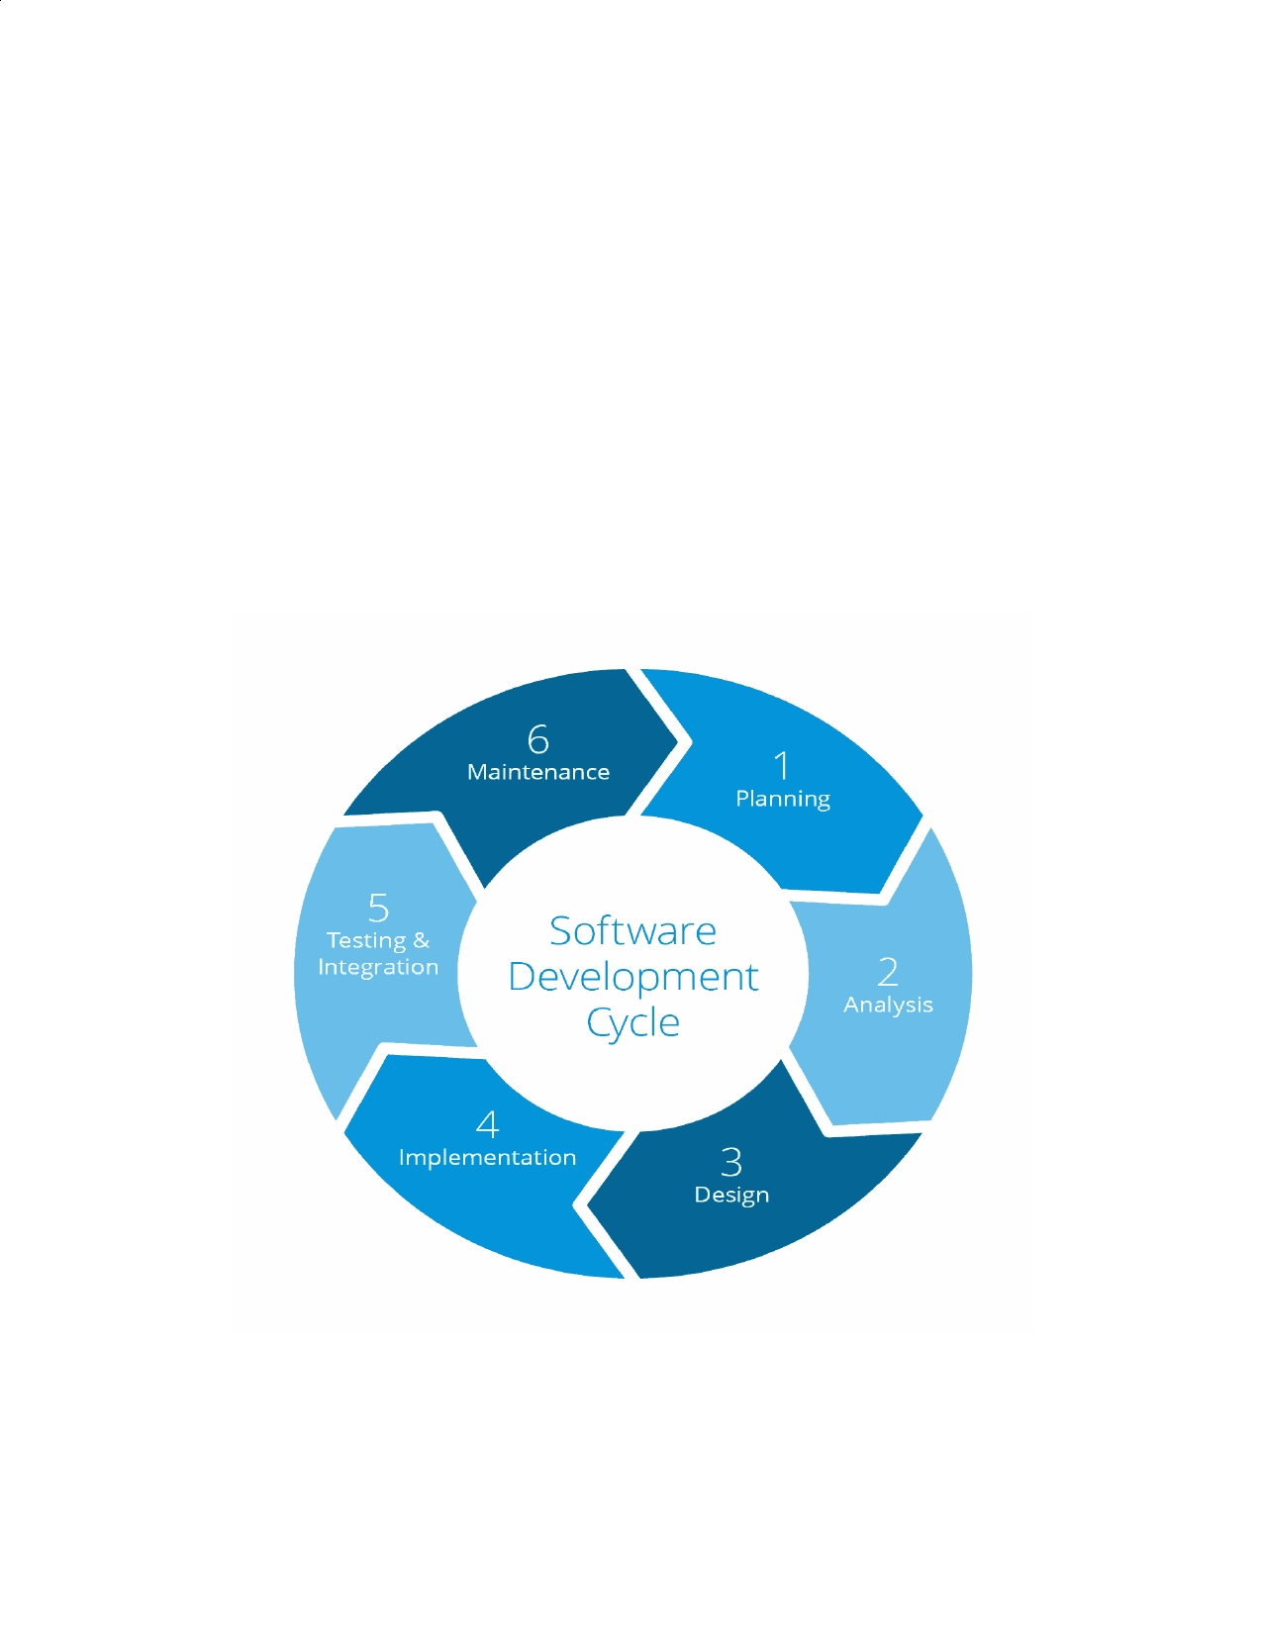
QA Assignment-2

Q1. Which software development technique is good for the systems that have
third party API calls, cron jobs, data exports/imports, etc. ?

Ans. ​TDD(Test Driven Development), as it focuses on how functionality is implemented
rather than focusing on end user needs. Above given applications suit this purpose.

Q2. Where does Test Automation fit in the Software Life Cycle? Explain with a
diagram? Ans.

​Fig: Software Development Life Cycle

Q3. Can we skip the manual testing and why?

Ans. ​No, Automation Testing is just robotic and can't act as a real user prospective.
Manual testing, on the other end, allows the developing program to be used as it would
be upon launch. Any bugs that may pop up when a user handles the program in a certain way are more likely to be caught with manual testing.

Q4. Give the names of the selector?
Ans. Targeting using Ids : -
<input id="email" value="">
#email
Targeting using attributes
<input name="email" value="">
input[name="email"]
Targeting using class names : -
<div class="some-class another-class">...</div>
.some-class.another-class
Targeting using element tag : -
<div class="username">Justin</div>
<span class="username">Justin</span>
div.username
span.username
Targeting using hierarchy : -
<div class="name"> <label>Deekshika</label> </div> .name label
Targeting using ordering : -
<ul class="fruits">
<li>Apple</li>
<li>Banana</li> <li>Coconut</li>
</ul> .fruits li:nth-child(2)
Q5. What is the modular framework?

Ans. ​ Modular framework consists of :-
❏ Driver scripts "drive" test execution.
❏ Interaction with the SUT done by functions in a test library.
❏ The objects are defined once and reusable in all test methods.
❏ Small and to-the-point methods are created for individual functionalities.
❏ The test case is the collection of these small methods and reusable objects.

Q6. Explain the Open source tool.

Ans. ​Open-source tools are software tools that are freely available without a
commercial license. Many different kinds of open-source tools allow developers and
others to do certain things in programming, maintaining technologies or other types of technology tasks.

Q7. What is a Hybrid framework?

Ans. Hybrid Driven Framework is a combination of both the Data-Driven and Keyword-Driven framework. Here, the keywords, as well as the test data, are externalized.

Q8. Write a name of record and replay tool.

Ans. ​Selenium IDE, record and replay approach is a popular approach among
commercial tools. It's very easy to use and needs no programming skills.
Q9. What is the difference between BDD and Cucumber?

Ans. ​BDD (Behavior Driven Development) technique is a software development
technique that defines the user behavior prior to writing test automation scripts or the
functional pieces of code while Cucumber is a framework for writing and executing high

level descriptions of your software's functionality. Cucumber plays a ​central role ​in a
development approach called Behaviour Driven Development (BDD).

Q10. Can we replace the Regression testing from Test automation and how?

Ans. ​The answer to this question depends on the initial testing approach. If the initial
testing approach was manual testing, then the regression testing is usually performed
manually. Conversely, if the initial testing approach was automated testing, then the regression testing is usually performed by automated testing.

Q11. How many 'A's test script has? Explain them.
Ans.
1. ARRANGEMENT or Object Identification We identify objects (buttons, dropdowns etc.) either by their ids, names or by their Window Titles etc. In case of web application, we identify by user ID, or By XPath or By CSS or By Class Name etc. If nothing works, we then identify objects by using mouse coordinates (But it is not a reliable method of object identification).
2. ACTION on the Identified Object When the objects are identified, we perform
some kind of actions on it either by mouse or by keyboard. For example, either we click, or we double-click, or we mouse hover over it or sometimes we drag-drop. Sometimes we write on text boxes. So any kind of action we perform on these objects are covered in this second step.
3. ASSERTION : The assertion is basically checking the object with some expected
result. For example, if we press 2+3 on the calculator, the screen should show 5.

