Assignment-2

**1. Which software development technique is good for the systems that have third party API calls, cron jobs, data exports/imports, etc.?**

Answer:

For systems that have third party API calls, cron jobs, data exports/imports, etc., TDD might be a better solution.

**2. Where does Test Automation fit in the Software Life Cycle? Explain with diagram.**

Answer:

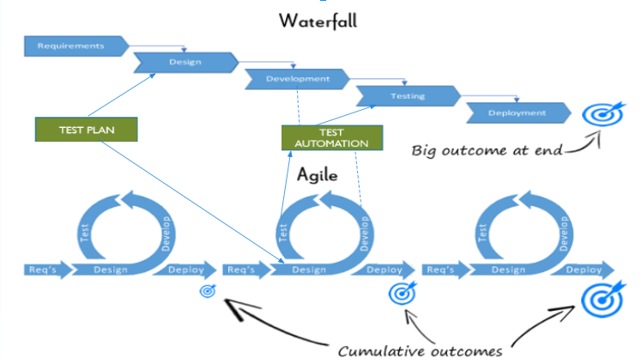

**3. Can we skip the manual testing and why?**

Answer:

No, we cannot skip the manual testing. Even as automated suites become more sophisticated, they still require human drivers. Actually, automated tests are often converted from initially manual efforts.

Reference: <https://testlio.com/blog/manual-qa-testing-best-practices/>

**4. Give the names of selector?**

Answer:

CSS and XPATH Selector.

**5. What is the modular framework?**

Answer:

* Driver scripts “drive” test execution
* Interaction with the SUT done by functions in a test library
* The objects are defined once and reusable in all test methods.
* Small and to-the-point methods are created for individual functionalities
* The test case is the collection of these small methods and reusable objects

**6. Explain the Open source tool?**

Answer:

* Large variety
  + Some are great—others not so
* Normally easy to integrate with other tools
* Free, as in beer, is good
  + Everyone can use freely
* Free, as in speech, is good
  + Can be customize freely
  + Can never really die

**7. What is Hybrid framework?**

Answer:

* Use the combination of two or more of the techniques, taking from their strengths and minimizing their weaknesses.
* The framework can use the modular approach along with either data-driven or keyword-driven framework.
* The framework can use scripts to perform some tasks that might be too difficult to implement in a pure keyword driven approach.

**8. Write a name of record and replay tool.**

Answer:

* Selenium IDE
* Katalon Studio
* Watir
* TestingWhiz,
* Ranorex,
* Rapise,
* Sahi.

**9. What is the difference between BDD and Cucumber?**

Answer:

Behavior-driven design (BDD) is a way to write code based on tests. Cucumber is a BDD tool.

**10. Can we replace the Regression testing from Test automation and how?**

Answer:

The words “automated” and “regression testing” go hand-in-hand. When companies first consider how they can maximize their QA teams’ potential through automation, they look to regression tests.

This is because regression tests are naturally good candidates for automation. In general, automated test cases should be:

* Stable
* Repeated frequently
* Simple
* Worth maintaining

Reference: <https://testlio.com/blog/regression-testing-automated/>

**11. How many ‘A’s test script has? Explain them.**

Answer:

Test Script is basically about three ‘A’s:

* ARRANGEMENT/Object Identification
* ACTION
* ASSERTION