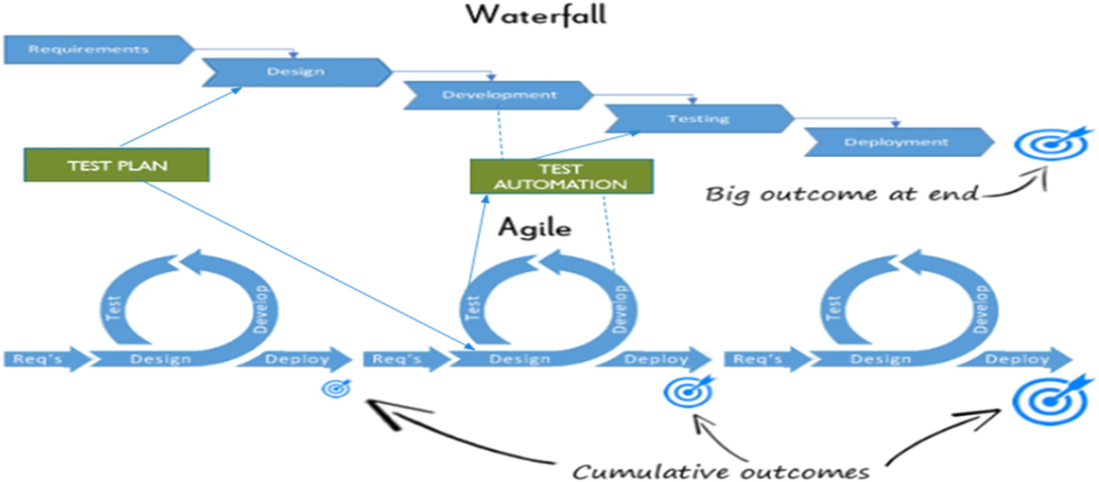
QA-Session 4

Ques1 Which software development technique is good for the systems that have third party API calls, cron jobs, data exports/imports, etc.,

Ans1 For systems that have third party API calls, cron jobs, data exports/imports, etc., TDD might be a better solution. TDD is a software development technique that involves writing automated test cases prior to writing functional pieces of the code. This is popular in agile methodologies as it drives delivering a shippable product at the end of a sprint. This process can be divided into multiple steps:
- A developer, based on requirement documents, writes an automated test c ase.
- The development team runs these automated test scripts against what is c urrently developed and the tests fail, as they should since none of the features have been implemented yet.
- Development team functional code to ensure the automated test script gives them a green light.
- The development team can then refactor and organize the code to produce a tested deliverable at the end of the sprint.

Ques2 Where does Test Automation fit in the Software Life Cycle? Explain with diagram.

Ans 2 Software Development Life Cycle (SDLC) is not a new term but crucial for every beginner who wants to enter to the software industry. It could be explained as a process used to plan, develop, maintain and replace (if needed) a particular software product or project. Thus so, every software project member is required to follow this procedure to achieve a high-quality product as well as meet customer expectations within a feasible timeline at the lowest cost. Test automation goes hand-in-hand with going agile—it’s necessary in a fast-paced environment and shortens the turnaround cycle. It also allows businesses to test more with better efficiency.

Ques3 Can we skip the manual testing and why?

Ans 3 No we cannot skip manual testers because-
- Usability testing can’t be automated.
Automating usability tests is just not possible. Usability testing requires a human. You can’t train a computer to identify “good” usability vs “bad” usability.
- Automated testing only tests what is predictable.
Automation focuses on functionality that already exists. Its coverage is vast, but it is not deep. Automated testing is great for regression tests, especially when resources are limited. But only doing automated testing is sure to introduce some failures and holes in your testing process.
- Exploratory Testing.
This “choose your own path” type of testing is not possible with automation. Exploratory testing allows us to take areas of our application and peel back the l ayers to uncover things automated tests will never find. It enables us to ask questions like “what if I do it this instead?”. Exploratory testing is a manual process, and there’s no changing that.
- Automated tests can contain bugs/errors.
If you write automated tests with bugs, you’re going to have false positives.The human element of manual testing can identify these errors and make sure you’re testing properly.
- Technical limitations can come into play.
Some test scenarios are just too complicated or downright impossible to automate. A common argument is “automated testing is cheaper”. But it is not
hard to spend a ton of time and money on elaborate automation. Take for example, testing a variety of touch screen devices. How to automate the experience of a “tap” and a “swipe”. You can’t do that in a way that is equivalent to human usage.

Ques4 Give the names of selector? Ans 4 Selectors are:
- Universal selector
- Type selectors
- Descendant selectors
- Child selectors
- Adjacent sibling selectors
- Attribute selectors
- ID selectors

Ques 5 What is the modular framework?
Ans 5 In the modular testing framework, testers create test scripts on module wise by breaking down the complete application under test into smaller, independent tests. In simple words, testers divide the application into multiple modules and create test scripts individually. These individual test scripts can be combined to make larger test scripts by using a master script to achieve required scenarios. This master script is used to invoke the individual modules to run end to end test scenarios. In this framework, testers write function libraries to use it when ever required. This is AKA modularity framework or module-based framework.

Ques 6 Explain the Open source tool.

Ans 6 Open source tools is a phrase used to mean a program -- or tool -- that performs a very specific task, in which the source code is openly published for use and/or modification from its original design, free of charge. Open source tools are typically created as a collaborative effort in which programmers improve upon the code and share the changes within the community, and is usually available at no charge under a license defined by the Open Source Initiative. Open source tools may be viable alternatives to popular closed-source applications and some open source tools offers features or performance benefits that surpass their
commercial counterparts. The phrase open source tools is synonymous with open source utility and similar to open source applications.
Open-source tools stand in contrast to tools that are commercially licensed and available to users for a fee. Well-known examples of open-source tools include many of the software products from the Apache Foundation, such as big-data tool Hadoop and related tools. Most of these are freely available, with the licensing held by a user community, instead of a company making a profit from s oftware.

Ques 7 What is Hybrid framework?

Ans 7 If our framework consist of 2 or more than 2 framework's then it is termed as a Hydrid framework. Hybrid framework is the combination of both keyboard driven and data driven
frameworks. About Implementation of the same at the time of creating of frame work need to take care of all test objects those are not going to be changed in application should be hardcoded and most frequently changing objects should be taken from the data sheet.
Keyword driven framework : It enable the tester to create its own customized keyword which can be used while automating the application.
Data driven framework : It enables the tester to fetch data from an external source such as DB , even from an excel sheet.
The framework which integrate the above two is known as Hybrid framework.

Ques 8 Write a name of record and replay tool.

Ans 8 Record and Replay, otherwise known as codeless automation, is a way to run tests without programming knowledge. This is done using a tool,
like CrossBrowserTesting, that allows you to manually perform actions in the browser and save them as a test.

Ques 9 What is the difference between BDD and Cucumber?

Ans 9 Behavior-driven design (BDD) is a way to write code based on tests. Cucumber is a BDD tool. Cucumber is a framework for writing and executing high level descriptions of your software’s functionality. BDD is really more for developers to
write the story and ensure the proper functionality instead of something most testers would be involved in, other than writing the test.

Ques 10 How many ‘A’s test script has? Explain them.

Ans 10 In test automation, we write scripts. Scripting is basically about three ‘A’s:
- ARRANGEMENT
We identify objects (buttons, dropdowns etc.) either by their ids, names or by their Window Titles etc. In case of web application, we identify by user ID, or By XPath or By CSS or By Class Name etc. If nothing works, we then identify objects by using mouse coordinates (But it is not a reliable method of object identification)

- ACTION
When the objects are identified, we perform some kind of actions on it either by mouse or by keyboard. For example, either we click, or we double-click, or we mouse hover over it or sometimes we drag-drop. Sometimes we write on text boxes. So any kind of action we perform on these objects are covered in this second step.

- ASSERTION
The assertion is basically checking the object with some expected result. For example, if we press 2+3 on the calculator, the screen should show 5. In this case, our expected result is 5.

Ques 11. Can we replace the Regression testing from Test automation and how?

Ans 11 The words “automated” and “regression testing” go hand-in-hand. When companies first consider how they can maximize their QA teams’ potential through automation, they look
to regression tests.

This is because regression tests are naturally good candidates for automation. In general, automated test cases should be:
- Stable
- Repeated frequently
- Simple
- Worth maintaining

