Moving to an Internet of Value:
Chapter 1, Blockchain Fundamentals for the “Internet of Value”

- At a high level, how does the “Internet of Information” work?
- What is a trusted third party (TTP)? What truth attestations do TTPs perform? What are examples of TTPs?
- Who invented Bitcoin? What do we know about the creator?
- What metaphor does Bitcoin use to describe its money supply?
- After the white paper, how did Bitcoin become a live network? When did Bitcoin go live? In other words, what day was the Genesis block released?
- Define the double spend problem, and how Bitcoin solves it.
- Define the bookkeeping problem, and how Bitcoin solves it.
- Define the medium of exchange problem, and how Bitcoin solves it.
- Money provides what three functions?
- How does Bitcoin mitigate cybersecurity threats?
- Identity five limitations of Bitcoin.
- What do public blockchain (BC) communities value?
- What do private BC communities value?
- What is the difference between permissionless and permissioned blockchains?
- What do boundary spanners believe will ultimately happen with public and private BCs?
Blockchain Landscape:
Chapter 2, Blockchain Fundamentals for the “Internet of Value”

Cryptocurrencies:
- What are altcoins? How are they created? What are two early examples of altcoins?
- What are privacy coins? What are two early examples of privacy coins?
- What are stable coins? How are they created? What are four examples of stable coins?
- Go to https://www.coinbase.com/price/tether. Does tether always equal exactly $1.00? Why or why not?
- How is the market capitalization of the cryptocurrency market calculated?
- Go to https://coinmarketcap.com/ How many cryptocurrencies are listed? From May 1st 2019 to May 1st 2020, in what month and year was the market capitalization for the entire cryptocurrency market the highest?
- Go to https://coinmarketcap.com/ Compare the top six cryptocurrencies by market value today compared to the six reported in Chapter 2: Are the same six still at the top? Has the order changed?
- Go to https://coinmarketcap.com/currencies/bitcoin/markets/; What dates were the high and low values May 1st 2019 to May 1st 2020? What were those values?

Blockchain Investment:
- According to Chapter 2, which BC company received the most venture capital?
- What is an Initial Coin Offering (ICO)? How is it different from an Initial Public Offering (IPO)?
- Which were the first two ICOs?
- In general, how has ICO investment dollars changed over the past three years?
- Go to https://www.icodata.io/ICO/active. How many ICOs are active? What does this number tell you about the popularity of ICOs now?
- Go to https://www.icodata.io/ICO Sort by ‘Ended’, Search for 2019. What were the top 3 ICOs in 2019 by US dollars raised?

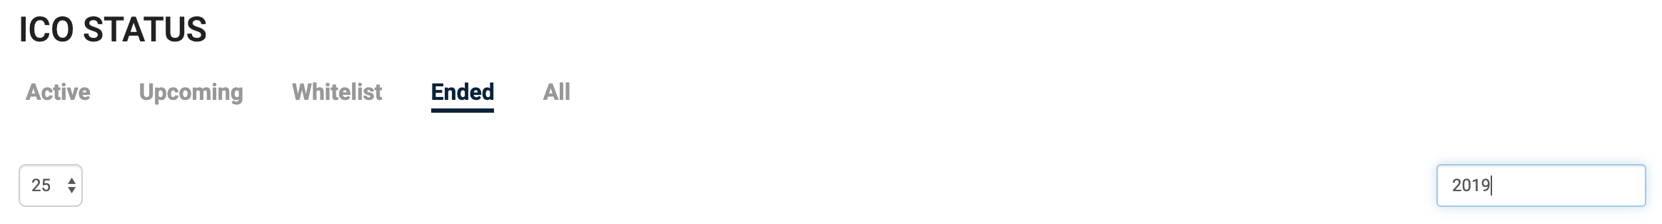

- What are IEOs?
- Go to https://ieo.tokens-economy.com/country.html How many IEOs does Estonia now have? Which industries are raising the most money in Estonia?
- What are STOs?
- Go to https://stoscope.com/ About how many STOs are listed? Which industry has the most?
- Compare and contrast ICOs, STOs, and IEOs in terms of who manages the fund raising, who is allowed to invest, who performs the prescreening, and the relative risk to investors.

Blockchain Players:
- According to Chapter 2, about how many blockchain startups were there as of January 2020?
- Go to https://angel.co/blockchains How may blockchain startups are reported compare to January 2020? What is their average valuation?
- What is a crypto-exchange? Are they considered TTPs? Which were the first two exchanges? What are three popular exchanges today?
- The BC news sites CoinTelegraph, Coindesk, and Bitcoin News are rated among the top ten blockchains by Rise.global based on what criteria?
- Which two industries are most active in exploring blockchain technologies?
- According to Forbes, traditional enterprises are building on which four platforms most frequently? (see Figure 2.5)
- As of 2020, how many major blockchain consortia are there? Which industry has the most BC consortia?
- At a high level, be aware of the focus and aims of R3, HLP, B3i, EEA, DIF, BiTA, and OOC. Which of these BC consortia is focused on financial services? On insurance? On transportation? On oil and natural gas?
- Why do we need BC standards? Why can’t we just use existing standards?
- List six standards-making bodies that are developing BS standards
- Which regulation combats financial terrorism, requiring companies to report suspicious activity?
- List the pro and cons of regulations
- How does the US SEC evaluate ICOs?
- What is the Howey Test? What are the four criteria of the Howey Test?
- What is a BitLicense? Which US state requires it?
- Which US State is emerging as the most pro-crypto in terms of welcoming legislation?
- How does China view BC technologies?
- Which country has award more BC patents—the US or China?
- What is the purpose of a US corporate earnings report? In general, what do US corporate earnings reports indicate about BCs?

Blockchain Hype Cycle:
- What are the five phases of Gartner’s Technology Hype Cycle?
- Which phase are blockchains in as of September 2019?
- What three points are made about Gartner’s Technology Hype Cycle?

The Blockchain Application Framework:

Chapter 3, Blockchain Fundamentals for the “Internet of Value”

Trade before and after a blockchain:
- What is meant by “immutability”? “data provenance”? “brute force cybersecurity defense”?
- Should blockchains replace all centralized systems?
- List the major advantages and disadvantages of centralized trading systems and TTPs.
- List the major advantages and disadvantages of distributed trading systems with BCs.
- What business value is promised by BCs compared to centralized systems? (transact directly with trading partners; lower transaction costs; one version of truth means no need for reconciliations; faster settlement times; instant status; data provenance; execute agreements without monitoring; security that is fault tolerant, resilient, and available)
- What social value is promised?

BLOCKCHAIN APPLICATION FRAMEWORK

- Name the four components of a BC application according to Lacity’s blockchain application framework.
- What is a protocol?

1. PROTOCOLS

Digital Ledgers:
- Define a ledger. Define a distributed ledger.
- List three ways BC distributed digital ledgers are structured.
- How does Bitcoin structure its distributed ledger?
- What is the first block in a chain of blocks called?
- Let’s explore the Bitcoin ledger. Go to https://btc.com/ How many transactions were in block 400000? When was the Bitcoin genesis block created? Find Block 57035, the first ‘real’ transaction for 2 Papa John Pizzas. How much was paid? When did that transaction occur? What is that worth in today’s dollars?
- Let’s explore the Ethereum ledger. Go to https://eth.btc.com/ Find the most current Ethereum block: What is the block number? How many transactions are there in the block? Find Ethereum’s Genesis Block. When was it released? Find Ethereum block 400000. What was the mining reward in ether?
- How does Ripple and Stellar structure their distributed ledgers?
- Examine Ripple’s network at https://xrpcharts.ripple.com/#/ What is the current ledger number?
- Examine Ripple’s live transactions https://xrpcharts.ripple.com/#/transactions what types of transactions do you see? Observe the live ledger until you witness THREE types of transactions.
- Examine Ripple’s current validator nodes at https://xrpcharts.ripple.com/#/validators
- How many Ripple nodes are on the Unique Node List (UNL)?
- In a tangle, a new transaction must validate how many previous transactions?
- Observe IOTA’s tangle at http://tangle.glumb.de/ Click on a circle. What information is displayed?
- Which is more secure, a chain of blocks or a tangle?
- Which is faster, a chain of blocks or a tangle?
Rights of Participation and Validation:
- What are rights of participation? What are the two types of rights of participation?
- What are rights of validation? What are the two types of rights of validation?
- Identity three public-permissionless blockchains.
- Identity two public-permissioned blockchains.

Watch four short videos to get an overview of the use cases:
- MediLedger overview: https://www.youtube.com/watch?v=Cxkjntn6F10
- IBM Food Trust overview: https://youtu.be/QWijlTDHLMQ
- Tradelens overview: https://youtu.be/0O2E9bCpKDk
- EY WineChain: https://www.youtube.com/watch?v=ABd3VPdwVhA

- Identify three private-permissioned blockchains.
- Describe a (Virtual) private-permissionless blockchain; Which company is leading an open source movement to transmit private transactions on a permissionless network?

Native Digital Assets:
- Identify five functions of digital assets as defined by your textbook (Lacity)
- Why do we need a standard native digital asset taxonomy?
- What are ERC20 and ERC721 tokens?
- What is the Token Taxonomy Initiative? What are fungible vs. non-fungible? Singletons vs. Sub-divisible? Transferable vs. non-transferable?

Your textbook is lacking a discussion of the rules typically specified for a digital asset, such as total money supply and how coins are released. Please know the data in the slide below.

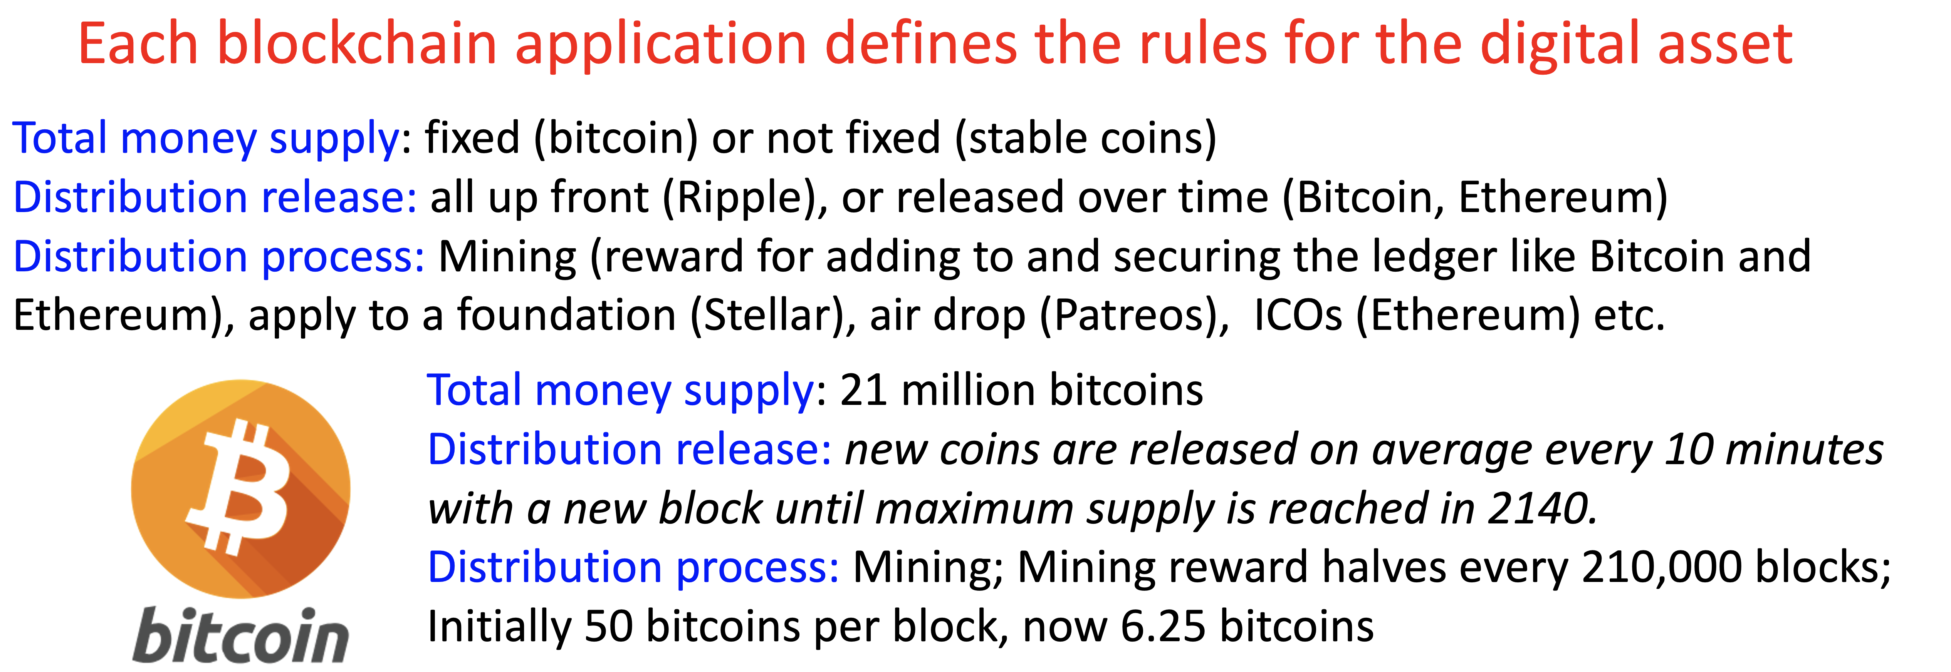
- Go to https://www.bitcoinblockhalf.com/ . What date will the Bitcoin reward drop to 3.125 coins per block?

Cryptography:
- Define cryptography
- What base is hexadecimal notation? Why is it used?
- What is a hash function?
- Why are hash functions called “one-way” functions?
- What is SHA-256? Who invented it? How many bytes are contained in its output?
- Go to https://passwordsgenerator.net/sha256-hash-generator/ Generate a hash of your first and last name concentrated together in the form: JohnSmith

Next, add a space between your first and last name in the form: John Smith
How much did the hash value change?

- On a single Bitcoin block, name all the places hashed are used in the header and in transactions:

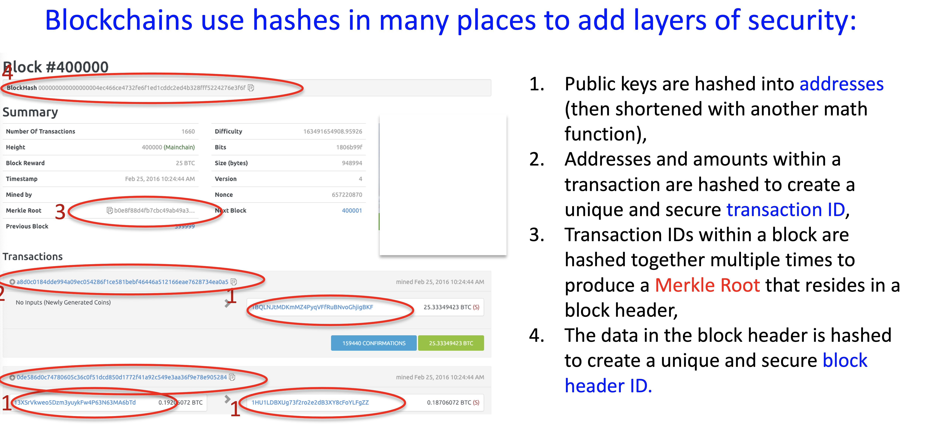
What is a Merkle Root? Why is it so secure?
- Go to https://passwordsgenerator.net/sha256-hash-generator/ Generate a Merkle Root for John and James;
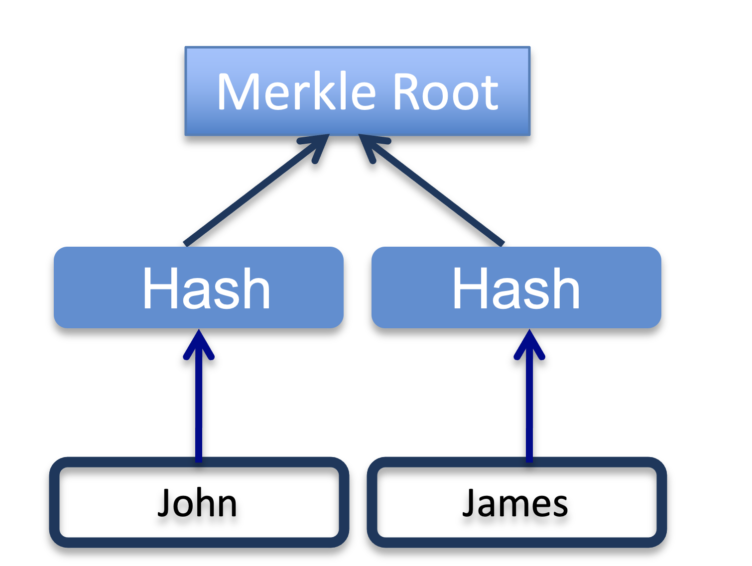

You should have generated this Merkle Root:
376EEE70A0D5FC54EE253B108DF6F220D9CD06C468EFF68CB40F4FAF80E9A99D

- What two keys comprise a digital signature?
- Where are private keys stored?
- Where are public keys stored?
- How does a public key become an address we see on the Bitcoin ledger?
- If I want to send Bitcoin to someone, what do they need to provide to me—the public or private key?

Consensus Protocols:
- Define consensus.
- How can a distributed network of computer nodes agree on a decision, if some of the nodes are likely to fail or to act dishonestly? This is the fundamental question of the so-called Byzantine Generals’ problem, which gave birth to the concept of Byzantine fault tolerance.
- Watch: Byzantine fault tolerance https://www.youtube.com/watch?v=VWG9xcwjxUg
- When was the Proof-of-Work protocol invented?
- Why did Nakamoto (2008) adopt Proof-of-Work? For what purposes?
- What is Proof-of-Work? Which node gets to validate transactions and add them to the blockchain? How are nodes incentivized?
- Watch Bitcoin mining: https://www.youtube.com/watch?v=iyq4od8MBoE
- How has bitcoin’s mining difficulty changed over time? Why does the price of Bitcoin affect the mining difficulty?
- How does technology advances in mining equipment affect the mining difficulty?
- A Bitcoin miner’s computer is busy away trying to find the next block number before everyone else—what specific numbers must the miner’s computer use as inputs to finding the next block number? (See Glossary entry “Proof-of-Work” or VoiceThread for answer).
- Which is the only number that is allowed to vary in the miner’s computation for the next block header? (See Glossary entry “Proof-of-Work” or VoiceThread for answer).
- What’s the point of having a mining difficulty number? (See Glossary entry “Proof-of-Work” for answer).
- What is Proof-of-Stake? What different rules have blockchain protocols used to select the next validator? How are validators incentivized? What are the advantages and disadvantages of PoS over PoW?
- Watch Pow vs. PoS: https://youtu.be/-C19r0UsYws
- How does EOS’ delegated Proof-of-stake work?
- Go to https://bloks.io/vote: Where are the current 21 block producers located?
- What is Practical Byzantine Fault Tolerance (PBFT)? How do nodes reach consensus? How do Hyperledger Fabric, Ripple, and Stellar allow participants to select validator nodes? As a general rule, what percentage of nodes need to agree before consensus is considered safe?
- Be able to identify all the data fields on a bitcoin blockheader and on the first two transactions. How is each data field generated?

Smart Contract:
- Define a smart contact.
- Who invented smart contracts? When?
- Which was the first blockchain application with a “Turing Complete” smart contract?
- What are the downsides of a smart contract? The upsides?
- What are deterministic vs. non-deterministic smart contracts?
- What is an “oracle”—why is it needed?
- Go to https://etherscan.io/ Find the CryptoKitties smart contract. What is the hash of the contact code? How many transfers has the smart contract processed?

2. CODE BASES:
- Which online repository posts many blockchain code bases?
- When were R3 Corda, Quorum, Fabric first released?

3. BLOCKCHAIN APPLICATION USE CASES:
- List five examples of blockchain applications (use cases from Figure 3.14).

4. BLOCKCHAIN APPLICATION INTERFACE:
- What is an API? Application Programming Interface
- Go to: https://developer.bitcoin.org/reference/rpc/index.html What types of APIs do you see for Bitcoin? About how many APIs are there?

- What are best practices for keeping a digital wallet secure?

Map Bitcoin to the BC Application Framework

Quiz II Study Guide
- Name four permissions needed in Multichain to grant full participation
- T/F: Unlike Bitcoin, Multichain allows for the creation of multiple currencies in one blockchain.
- What are the default settings for Multichain: public or private? Permissionless, permissioned?
Private and permissioned
- What is the configuration file used in Multichain to change default permissions and characteristics
of blocks is called?
- Upon which source code is Multichain is built on top of?
Bitcoin Core
- How often does Bitcoin write a block?
Every 10 Minutes
- What is the consensus mechanism of Bitcoin?
Proof-Of-Work
- How does bitcoin prevent the double spend problem?
Miners verify what the nodes see and will invalidate a transaction that wasn’t in the block it proceses
- How do bitcoin wallet addresses get created?
Hashed from private key and then by public key so that it can only be linked to the original private key
- How does a miner verify a bitcoin transaction?
Solves a complex cryptographic puzzle to verify
- What is a 51 percent takeover attack?
51% of the Validating nodes verify a malicious block
- What are some major 51 percent takeover attacks?
ETC Classic
- What is the difference between performance and scalability?
Performance relates to performance to the end user while scalability refers to performance under a data load.
- What is sharding?
Splitting a blockchain into smaller portions known as shards.
- Why is quantum computing considered a threat to blockchain security?
Quantum computers may soon be able to solve elliptical curve encryption.
- Why is it more accurate to call Bitcoin and Ethereum “Pseudo-anonymous” rather than “anonymous”?
Transactions are public and can be seen on explorers
- How can identities be deduced on the Bitcoin blockchain?
KYC and linking to exchanges
- What are zero knowledge proofs? Which coin uses zero knowledge proofs?
Z-Cash among others, Proves the transaction without revealing any direct information
Ripple:
- Who founded Ripple? When was it founded? Was it a consortium, private startup, or not-for-profit?
Jeb McCaleb, 2012, Private Startup
- What type of application is it? What are its three major services?
It’s a currency exchange system for banks utilizing blockchain.
- Why is the application called “Ripple”?
Named after the open-source protocol its built on top of
- Describe the money supply and distribution of Ripple’s native digital asset; Is the currency inflationary or deflationary?
100,000,000, Inflationary at a max of 1 billion per month, Distributed to mostly the team and banks
- Which consensus algorithm does Ripple use?
Private consensus on bank servers that verify transactions
Stellar:
- Who founded Stellar? When was it founded? Was it a consortium, private startup, or not-for-profit?
Jeb McCaleb, 2014, Open source not for profit
- What type of application is it?
Digital currency Protocol
- What is the role of the Stellar Foundation?
Support development of the stellar blockchain
- Describe the money supply and distribution of Stellar’s native digital asset
100,000,000,000, approx. 46% to investors and team members
Chapter 5: Business Applications for Supply Chains
- How large is the global food supply chain in terms of US dollars?
- List three challenges with the global food supply chain networks of today. How may people become ill each year?
- Which types of food are most frequently recalled?
- When did Walmart and IBM start working on what was to become the IBM Food Trust?
- What three services does the IBM Food Trust provide?
- Can IBM view all of the data stored on the platform?

ESSAY: Pick ONE blockchain application from chapter 5, 6, or 7. (a) Analyze the extent to which this application is a good blockchain use case based on our two major criteria, which are: Do trading partners need an immutable record of multi-party transactions? Is there a compelling reason why trading partners prefer not to rely on a TTP?. If this application relies on a trusted third party, describe the services it provides and how those services compare with the roles of TTPs BEFORE using the application. In your own words, analyze the extent to which you think the application delivers business and/or social value.

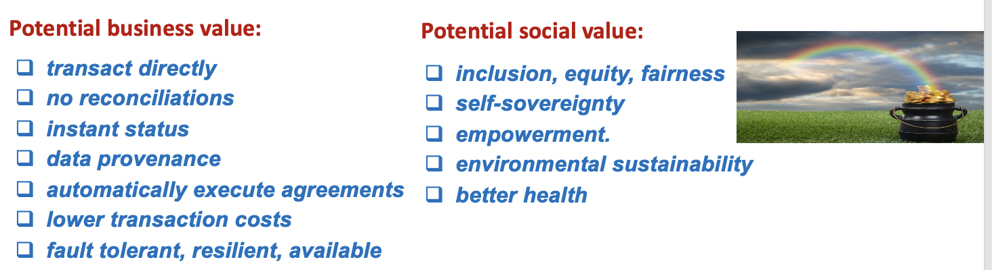

Chapter 7: Business Applications for Credentials
- What is the trust triangle? What are the roles of issuers, verifiers and subjects?
- According to Alex Preukschat and Drummond Reed, authors of Decentralized Digital Identity and Verifiable Credentials: Self-Sovereign Identity, what are three adoption challenges to SSI?
- Name three talent acquisition problems with the use of platforms like CareerBuilder, Indeed, LinkedIn, and Monster.
Chapter 8: Technical Challenges and Emerging Solutions
- Go to https://digiconomist.net/bitcoin-energy-consumption; Compare the electricity cost to mining 1 bitcoin to the number of VISA transactions that can be processed and the number of hours of watching YouTube videos.
Security:
- Which security attacks happen most frequently?
- What happened at Mt. Gox?
- When are blockchain code bases considered most vulnerable?
- At a high level, what are Heisenbugs, Mandelbugs, and Schrödinbugs? Who are they named after and what theories are they associated with? (See Glossary)
- Concerning the DAO hack on Ethereum in 2016, why did the Ethereum community fight over its resolution? Was Ethereum or Ethereum Classic the “fork followers’?
- Why is quantum computing considered a threat to blockchain security?
Performance & Scalability:
- What is the difference between performance and scalability?
Performance= length of time it takes for a transaction to be processed in a system
Scalability= Throughput (how many transactions can be processed per second)

- On average, how many TPS can Bitcoin process? Ethereum? Paypal? Visa?
Bitcoin= 5 tps; Ethereum= 30 tps; Paypal= 193 tps; Visa; Approx. 1,700 tps
- Why does network congestion increase transaction fees?
When a network gets congested, miners prioritize
- What is SegWit? Why is it called that? When was it implemented? What fork did it prompt?
Segregated Witness. Implemented in 2017. SegWit moved Bitcoin senders’ digital signatures into its own block, which increased block size. It prompted a soft-fork.
- Watch What is SegWit? Segregated Witness Explained Simply: https://youtu.be/f3CFUbeehc8
From the video:
- What is transaction malleability?
  - The possibility for a hacker to alter a digital signature before it is added to a block. This changes transaction ID.
- What are the main benefits of SegWit?
  - Solves transaction malleability, more transactions fit in a 1MB block
- Was SegWit launched as a hard or soft fork? Why?
  - Soft fork. Non-segwit adopters could still mine Bitcoin
- What do SegWit Computers receive that non-SegWit computers do not?
  - Witness data
- What is the difference between “height” and “weight”?
- If you as a bitcoin holder want to adopt SeqWit, what must you do?
- What is sharding? Which BC is considering adoption?
Sharding segments the validation process so that not every node validates every transaction.
- What is the Lightning Network? The Raiden network?
Lightning Network takes intermediate BTC transactions off-chain, only posting the values of the initial credit and final account. Unclutters the blockchain.
Raiden Network is an Ethereum L2 that tracks micropayments between users off-chain
- How do private blockchains solve for performance and scalability? What is FastFabric?
They solve for P & S by limiting the number of nodes needed to validate transactions and by allowing private messaging and channels among trading partners. FastFabric improved the throughput of Hyperledger Fabric from 3,000 to 20,000 tps.

Anonymity:
- How can identities be deduced on the Bitcoin blockchain?
When transactions are funded with multiple addresses, patterns can emerge where one party tracks another party’s transactions.
- What are zero knowledge proofs?
Method for one party to verify possession of information without actually revealing the information.
- What is the difference between challenge-response and non-interactive ZKPs?
Challenge-Response= ZKP coordinated between known parties
Non-Interactive ZKP= Party can prove possession of information to the public
- Which blockchains uses zero knowledge proofs?
ZCash, MediLedger, Quorum
- What is the purpose of EY’s Nightfall?
EYN allows parties to exchange tokens on a public blockchain while masking the sender, receiver, and amount of the exchange.
- What is a ring signature? Which coin uses them?
Monero uses ring signatures to hide the sender’s address
- What is the purpose of a key image?
Hide’s the sender’s address
- How does Monero prevent a double spend if so much data is obfuscated?
Miners just need to make sure the key image isn’t found anywhere else in the blockchain. If the key image isn’t there, then the private key must have never been used before in the blockchain, which verifies that there is no double spend

Confidentiality:
- How do permissioned blockchains improve confidentiality? No open-source code and permissioned access to data assigned to each user
- How does Hyperledger Fabric protect confidentiality? Permissioned Blockchain, No cryptocurrency Incentive, Wildly different consensus methods

Interoperability:
- What is an atomic swap?
Exchange of two crypto’s from separate blockchains; no intermediary
- What are three ways to connect blockchains?
  - One-time asset pass
  - Cross-chain oracle
  - Cross-chain transaction processing
- What is a one-way peg? Two-way peg?
1waypeg= one chain reads data from another chain
2waypeg= a single asset can be used by at least two chains
- What is a Proof-of-Burn?
Consesus mech. based on burning coins to validate transactions.
- What are two examples of Cross-Chain Oracles? Coinbase, Chainlink
- What is the difference between a single notary and a multiple notary? Provide one example of each. Also called single sig or multi sig. Single notary connects two blockchains through exactly one TTP (i.e. any centralized exchange). Multiple notary is like single sig but the centralization is more of an oligarchy (i.e. BitGo).
- How does Accenture’s Interoperability Node work?
- Which type of interoperability solution uses a Multisig wallet?
Previously topics from Exam I and Exam II should be considered
- Name four permissions needed in Multichain to grant full participation
- T/F: Unlike Bitcoin, Multichain allows for the creation of multiple currencies in one blockchain.
- What are the default settings for Multichain: public or private? Permissionless, permissioned?
Private and permissioned
- What is the configuration file used in Multichain to change default permissions and characteristics of blocks is called?
multichain.conf
- Upon which source code is Multichain is built on top of?
Bitcoin Core
- How often does Bitcoin write a block?
Every 10 Minutes
- What is the consensus mechanism of Bitcoin?
Proof-Of-Work
- How does bitcoin prevent the double spend problem?
Miners verify what the nodes see and will invalidate a transaction that wasn’t in the block it processes
- How do bitcoin wallet addresses get created?
Hashed from private key and then by public key so that it can only be linked to the original private key
- How does a miner verify a bitcoin transaction?
Solves a complex cryptographic puzzle to verify
- What is a 51 percent takeover attack?
51% of the Validating nodes verify a malicious block
- What are some major 51 percent takeover attacks?
ETC Classic
- What is the difference between performance and scalability?
Performance relates to performance to the end user while scalability refers to performance under a data load.
- Why is quantum computing considered a threat to blockchain security?
Quantum computers may soon be able to solve elliptical curve encryption.
- Why is it more accurate to call Bitcoin and Ethereum “Pseudo-anonymous” rather than “anonymous”?
Transactions are public and can be seen on explorers but aren’t linked to a real world identity
- How can identities be deduced on the Bitcoin blockchain?
KYC and linking to exchanges
- What are zero knowledge proofs? Which coin uses zero knowledge proofs?
Z-Cash among others, Proves the transaction without revealing any direct information
- How do permissioned blockchains improve confidentiality?
Only certain users have access to see any data moved on chain and any details of the exchange
- What is KYC, AML, and GDPR?
KYC- Know your customers, AML- Anti Money Laundering, GDPR- General Data Protection Regulation
- What does Metamask provide?
Wallet embedded in browser extension
- What is a testnet?
A mirror of a main blockchain used as a testing environment
- How do we get ETH for our ERC-20 development?
We use a faucet to get testnet ETH
- What is an ERC-20 token? Give an example of a method in the API.
Token Symbol, Name, Supply, Decimals, Owner Account
- How does Chainlink work?
Network of nodes connected to off-chain sources relaying information to on-chain applications
- Why do we need Oracles? Give an example of an application that might benefit from Oracle services.
Decentralized exchanges such as Tinyman or Uniswap need to connect to an oracle to get current and accurate price data when users exchange tokens.
- What are action principles? practices identified by our research that produced desirable results in real world implementation
- What are the three phases to BC adoption?
- What action principles are helpful in Phase I?
- What action principles are helpful in Phase II?
- What action principles are helpful in Phase III?

The blockchain mindset:
- What is coopetition? When was this term first used?
- How has the auto industry used coopetition? Where did they cooperate? Where did they compete?
- A blockchain governance model must specify the decision-making rights for many aspects of a blockchain; what questions must be answered pertaining to:
- Data policies
- Rights of participation
- Rights of validation
- Rights of overrides
- Rights of ownership
- Compliance
- Software update control
- Governance residence
- Funding model
- What are the main advantages of centralized governance?
Accountability and traceability of attacks, Fast decision making
- What are the main advantages of decentralized governance?
Safety and distribution, inclusivity, freedom
- What is a benevolent dictator? What other labels are used to describe benevolent dictators? Which blockchains are governed by this model?
A benevolent dictator is an individual who controls all of the parameters of a governance protocol.

