Assignment 3-4

- Which software development technique is good for the systems that have third party API calls, cron jobs, data exports/imports, etc.
TDD(Test Driven Development), as it focuses on how functionality is implemented rather than focusing on end user needs. Above given applications suits this purpose.

- Where does Test Automation fit in the Software Life Cycle? Explain with diagram.

Test automation appear in software life cycle during the development and testing phase.
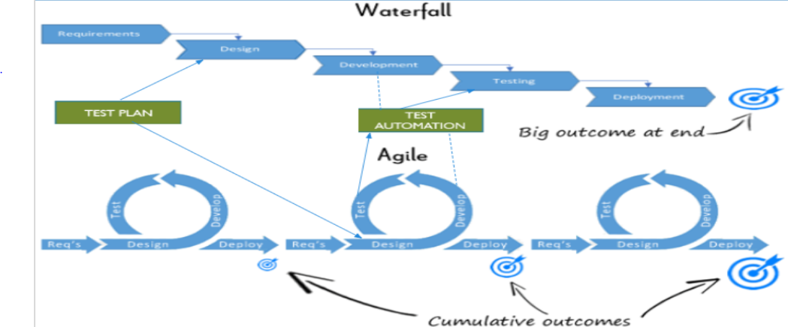

- Can we skip the manual testing and why?
No, Automation Testing are just robotic and can’t act as a real user prospective. Manual testing, on the other end, allows the developing program to be used as it would be upon launch. Any bugs that may pop up when a user handles the program in a certain way are more likely to be caught with manual testing. Machines are great for running regression tests. Humans are great for finding new defects.
(This answer may change when machine learning and AI develop more in future)

- Give the names of selector?
- Using ID
  - eg:- <input id="email" value="">
#email

- Using Attributes
  - eg:- <input name="email" value="">
[name="email"]
  - eg:- <a href="www.google.com">Edit User</a>
a[href="www.google.com"]

- Using Class names
  - eg:- <div class="some-class-name">...</div>
. some-class-name
[class="some-class-name"]

- Using Element tag
  - eg:- <div class="username">Rachna</div>
<span class="username">Rachna</span>
div . Username

- Using Hierarchy
  - eg:- <div class="name">
<label>Justin</label>
</div>
.name label

- Using Ordering
  - eg:- <ul class="fruits">
<li>Apple</li>
<li>Orange</li>
</ui>
.fruits li:nth-child(2)

- Using Text contents
  - eg:- <a href="www.gmail.com">Gmail</a>
//a[text()="Gmail"]

- What is the modular framework?
- Driver scripts “drive” test execution
- Interaction with the SUT done by functions in a test library
- The objects are defined once and reusable in all test methods.
- Small and to-the-point methods are created for individual functionalists
- The test case is the collection of these small methods and reusable objects

- Explain the Open source tool.
Open source tools is a phrase used to mean a program – or tool -- that performs a very specific task, in which the source code is openly published for use and/or modification from its original design, free of charge. Open source tools are typically created as a collaborative effort in which programmers improve upon the code and share the changes within the community, and is usually available at no charge under a license defined by the Open Source Initiative.

- What is Hybrid framework?
- Use the combination of two or more of the above-mentioned techniques(record and playback, linear, modular, data driven,keyword driven ), taking from their strengths and minimizing their weaknesses.
- The framework can use the modular approach along with either data-driven or keyword-driven framework.
- The framework can use scripts to perform some tasks that might be too difficult to implement in a pure keyword driven approach.

- Write a name of record and replay tool.
Selenium IDE, record and replay approach is popular approach among commercial tools. Its very easy to use and need no programming skills.

- What is the difference between BDD and Cucumber?
BDD (Behavior Driven Development) technique is a software development technique that defines the user behavior prior to writing test automation scripts or the functional pieces of code.
While, Cucumber is a framework for writing and executing high level descriptions of your software's functionality.
Cucumber plays a central role in a development approach called Behavior Driven Development (BDD)

- Can we replace the Regression testing from Test automation and how?
The answer to this question depends on the initial testing approach. If the initial testing approach was manual testing, then the regression testing is usually performed manually. Conversely, if the initial testing approach was automated testing, then the regression testing is usually performed by automated testing.

- How many ‘A’s test script has? Explain them.
- ARRANGEMENT or Object Identification:-
  - We identify objects (buttons, drop-downs etc.) either by their ids, names or by their Window Titles etc. In case of web application, we identify by user ID, or By Xpath or By CSS or By Class Name etc. If nothing works, we then identify objects by using mouse coordinates (But it is not a reliable method of object identification).
- ACTION on the Identified Object:-
  - When the objects are identified, we perform some kind of actions on it either by mouse or by keyboard. For example, either we click, or we double-click, or we mouse hover over it or sometimes we drag-drop. Sometimes we write on text boxes. So any kind of action we perform on these objects are covered in this second step.
- ASSERTION:-
  - The assertion is basically checking the object with some expected result. For example, if we press 2+3 on the calculator, the screen should show 5.

