1. MEMBERS

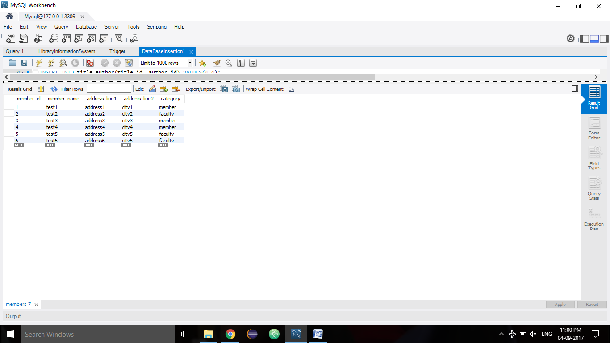

1. BOOKS

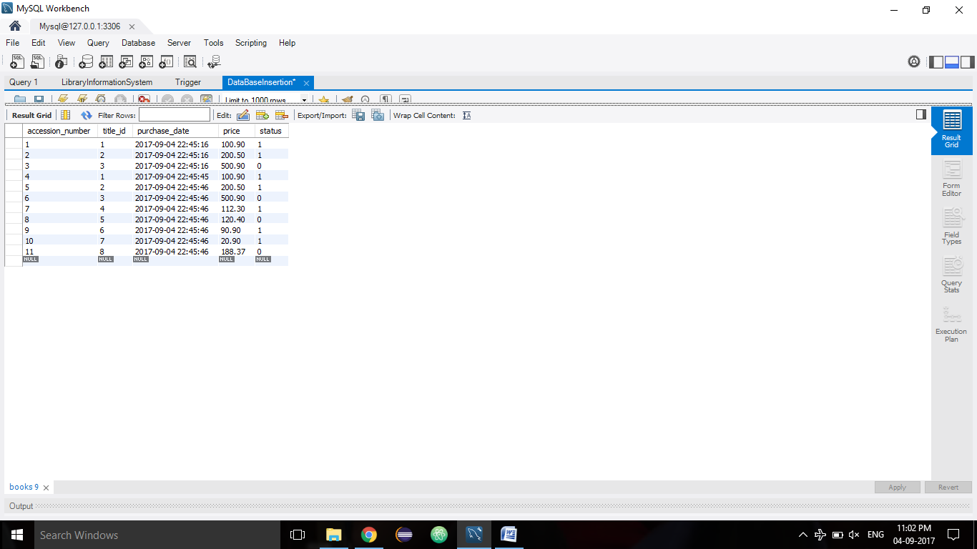

1. PUBLISHERS

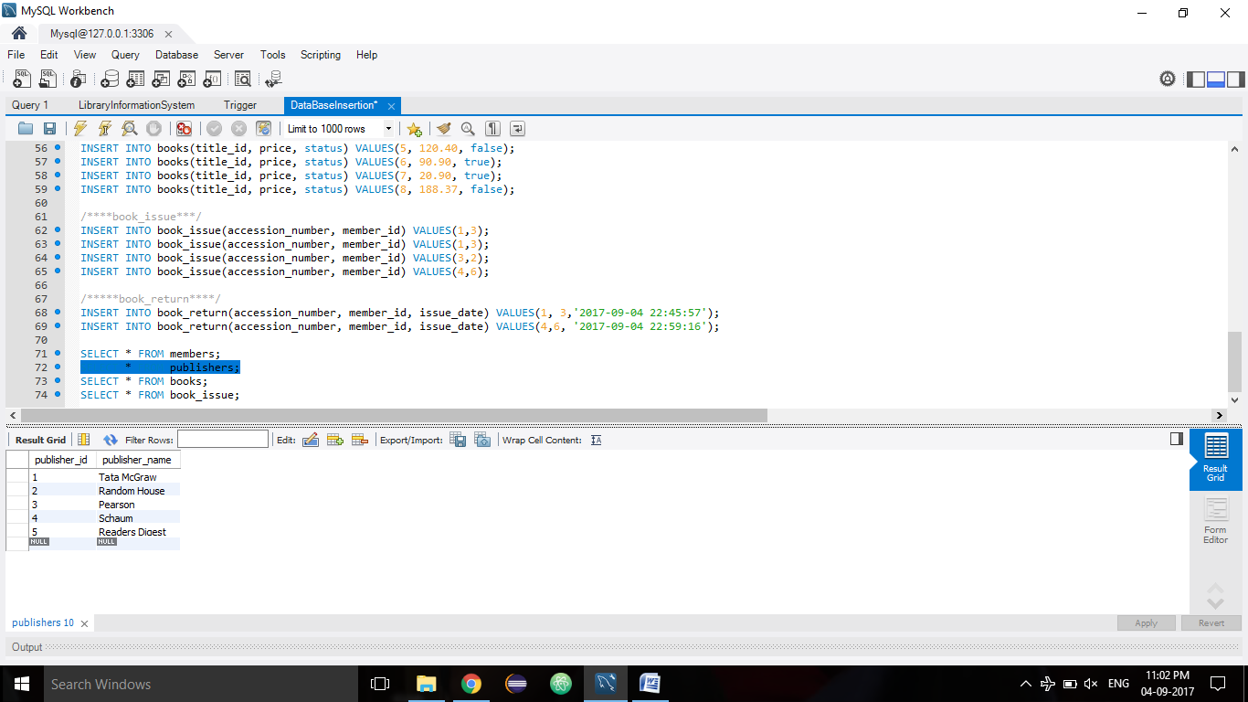

1. AUTHORS

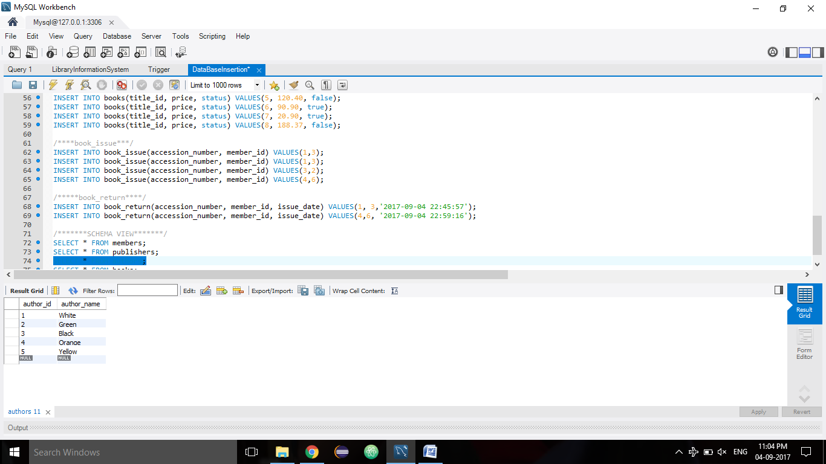

1. TITLES

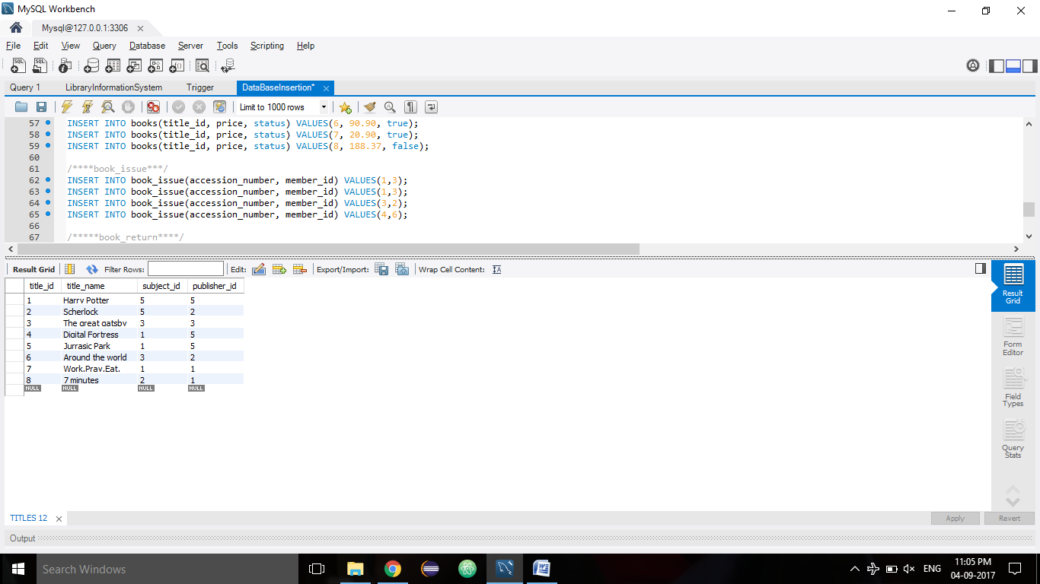

1. BOOK_ISSUE

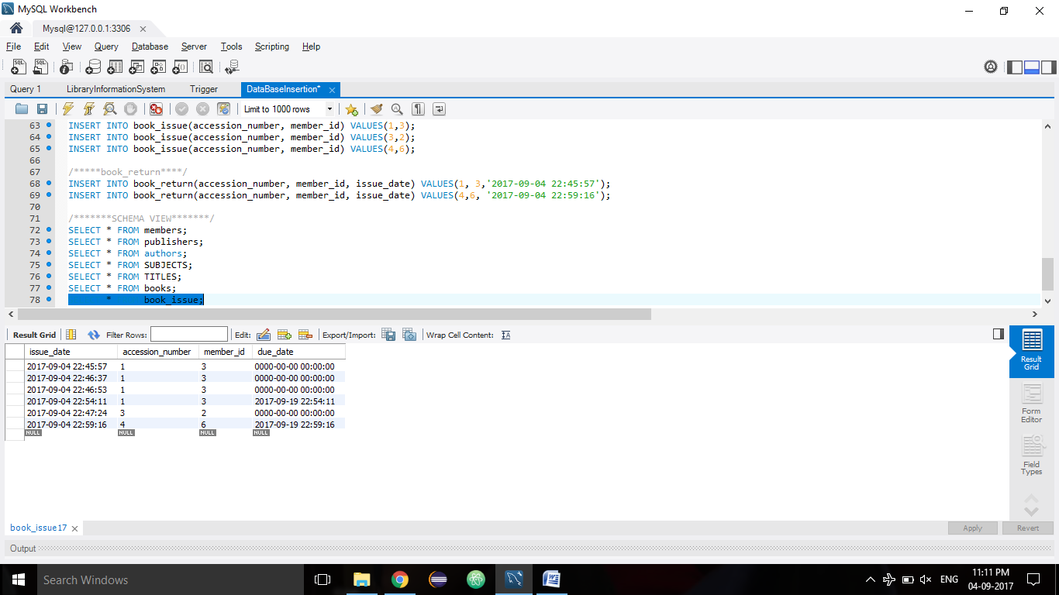

1. SUBJECTS

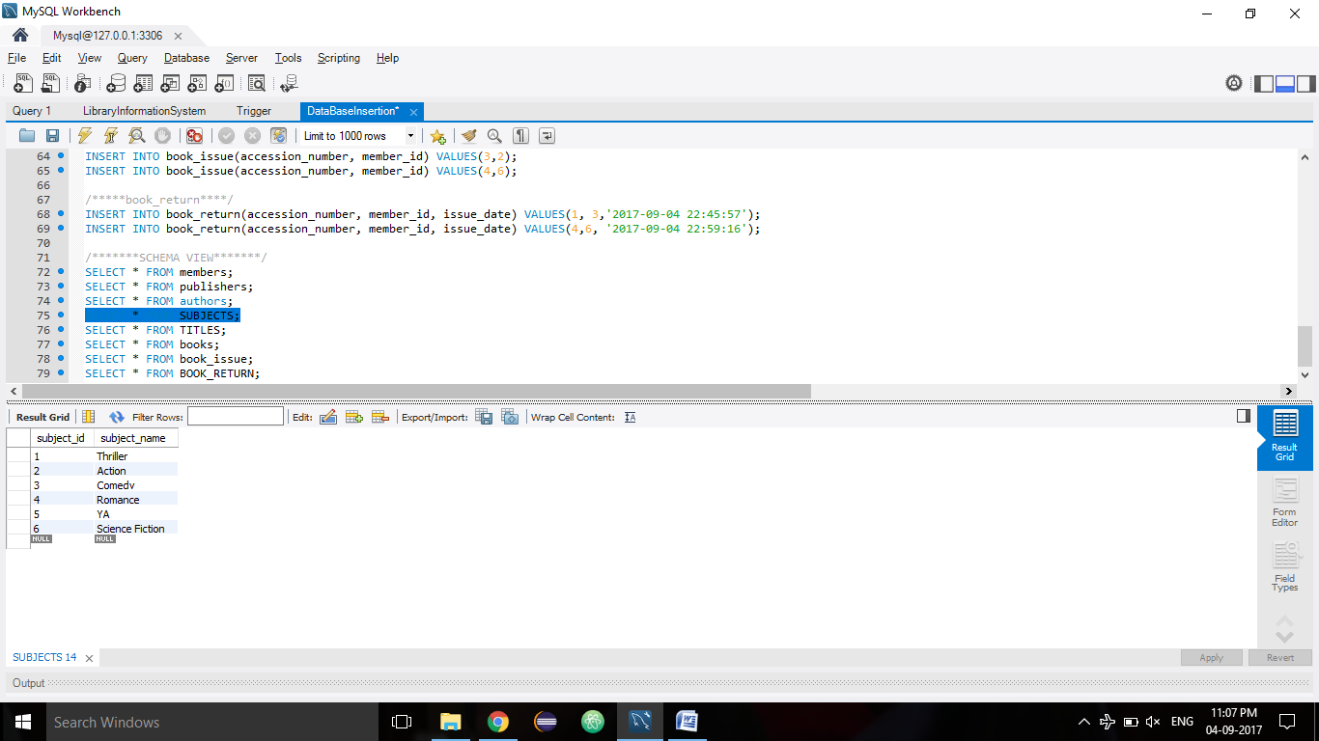

1. TITLE_AUTHOR

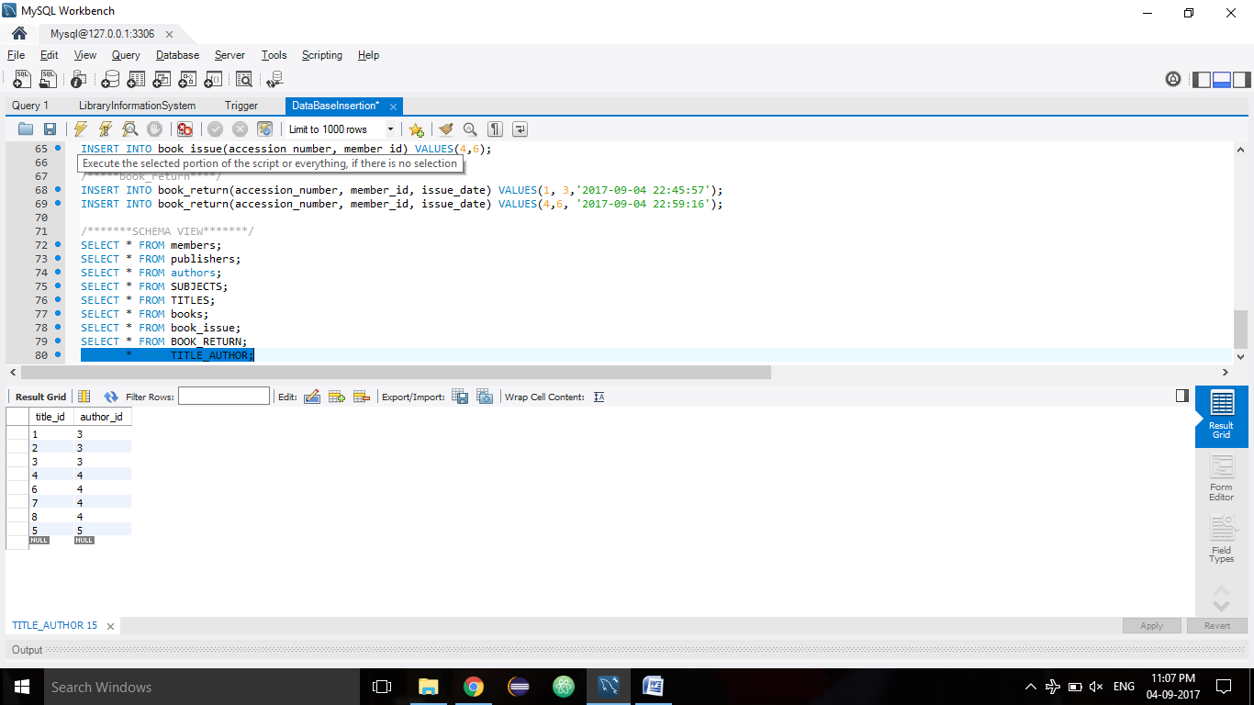

1. BOOK_RETURN

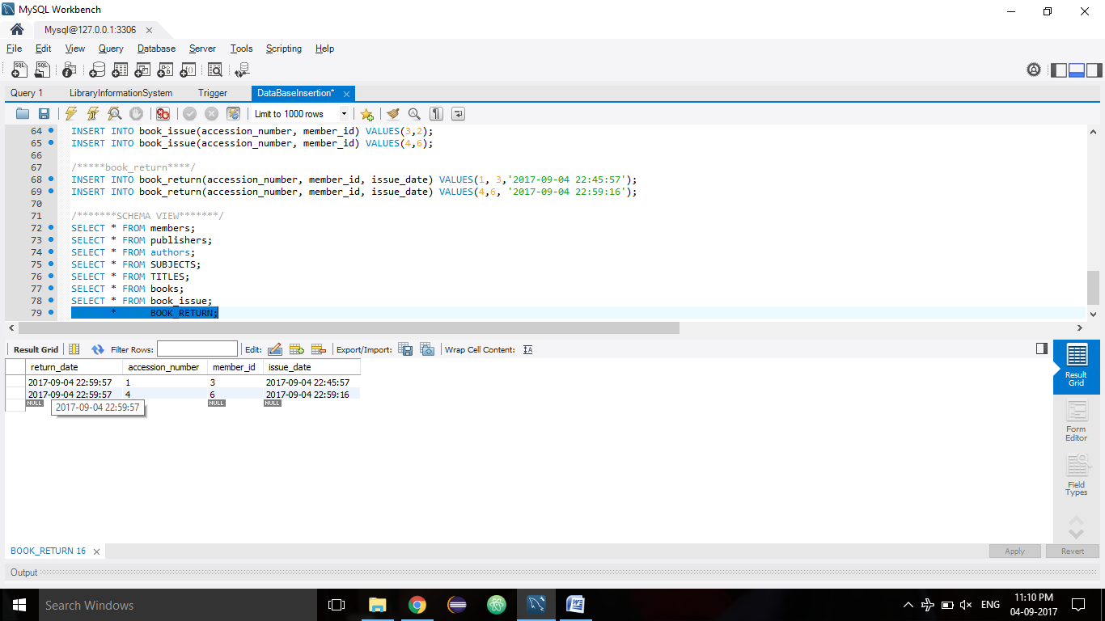

**ASSIGNMENT 2**

1. SHOW TABLES

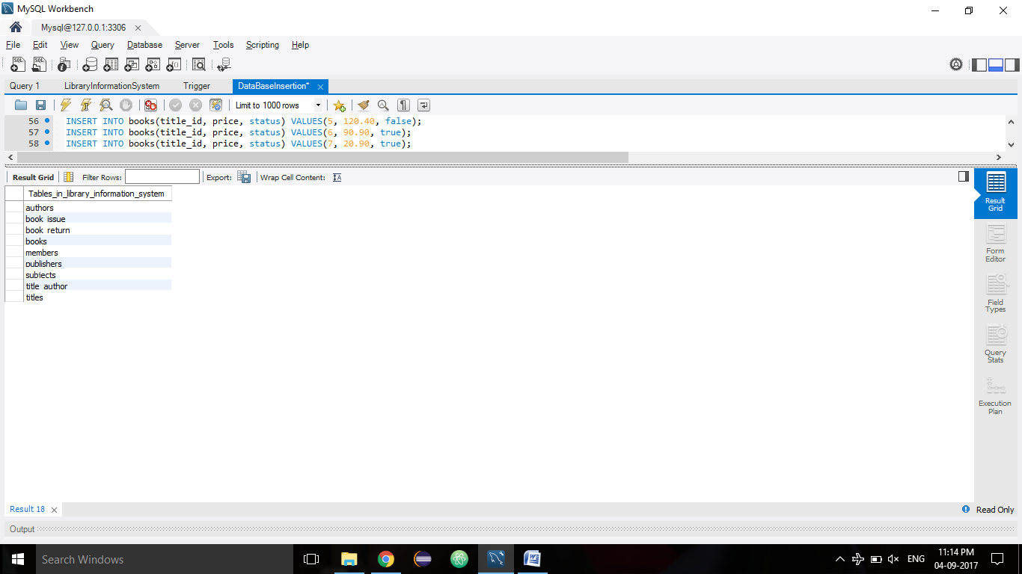

1. TRIGGER RETURN_DATE UP FOR AFTER 15 DAYS

DELIMITER $$

CREATE TRIGGER return_date_15days

BEFORE INSERT ON `book_issue` FOR EACH ROW

BEGIN

SET NEW.due_date = now() + INTERVAL 15 DAY;

END;

$$

DELIMITER ;

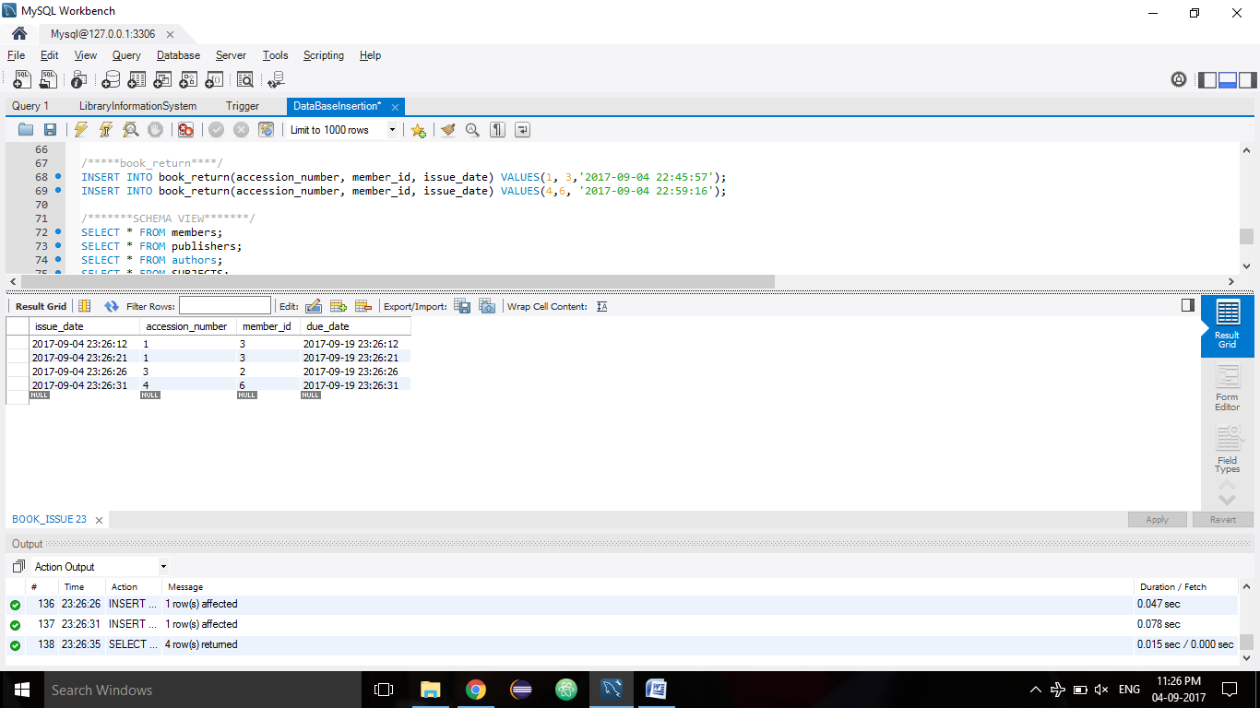

1. SET @@foreign_key_checks = 0;

DROP table library_information_system.members;

SET @@foreign_key_checks = 1;

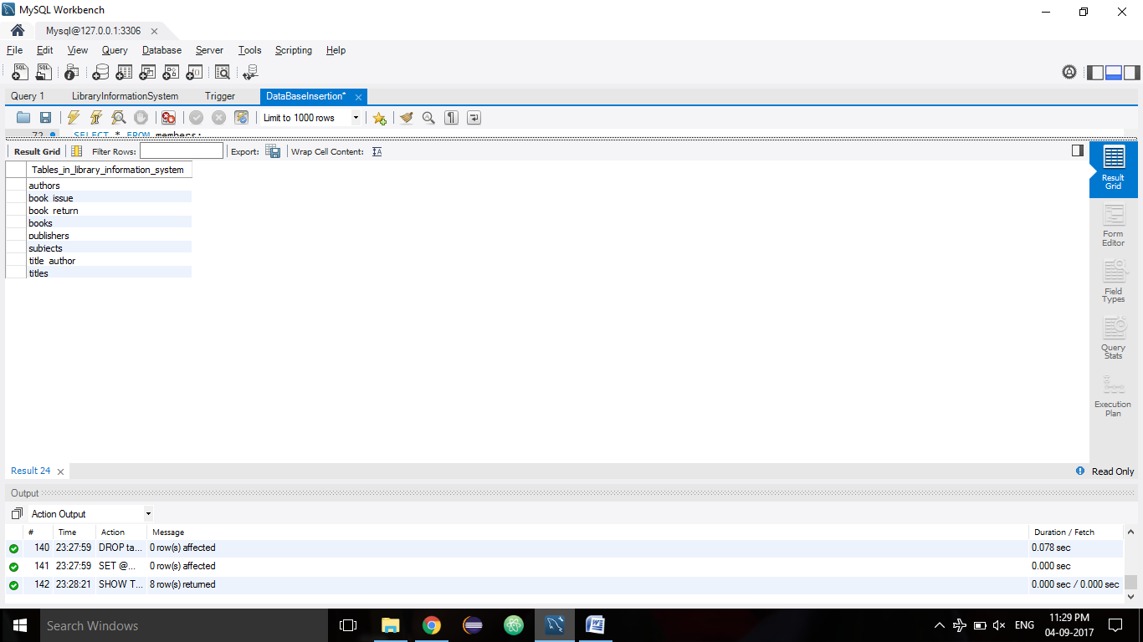

1. Delete members table:

CREATE TABLE IF NOT EXISTS members(

member_id INT NOT NULL AUTO_INCREMENT,

member_name CHAR(20) NOT NULL,

address_line1 VARCHAR(30),

address_line2 VARCHAR(30),

category CHAR(20),

PRIMARY KEY (member_id)

);

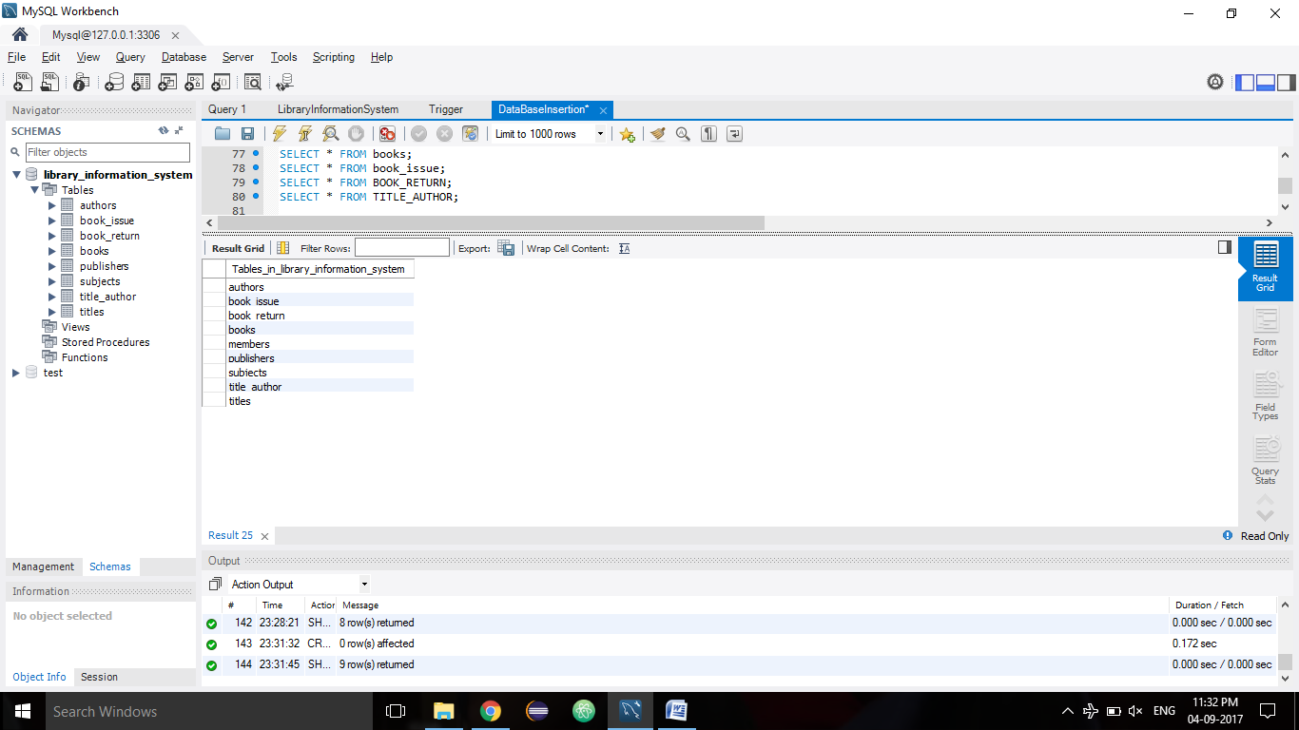

ASSIGNMENT 3

1. INSERT SAMPLE DATA

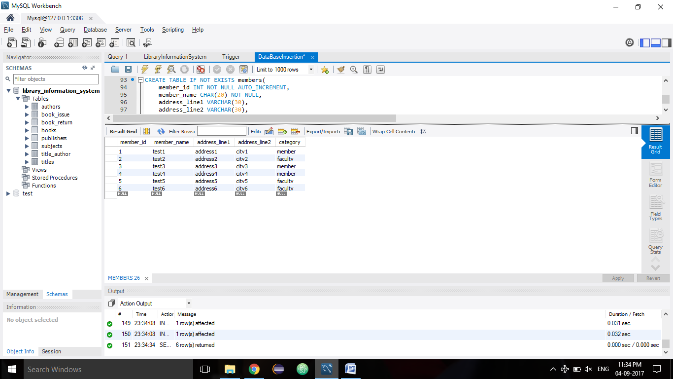

1. SET SQL_SAFE_UPDATES = 0;

UPDATE members SET address_line2 = 'jaipur';

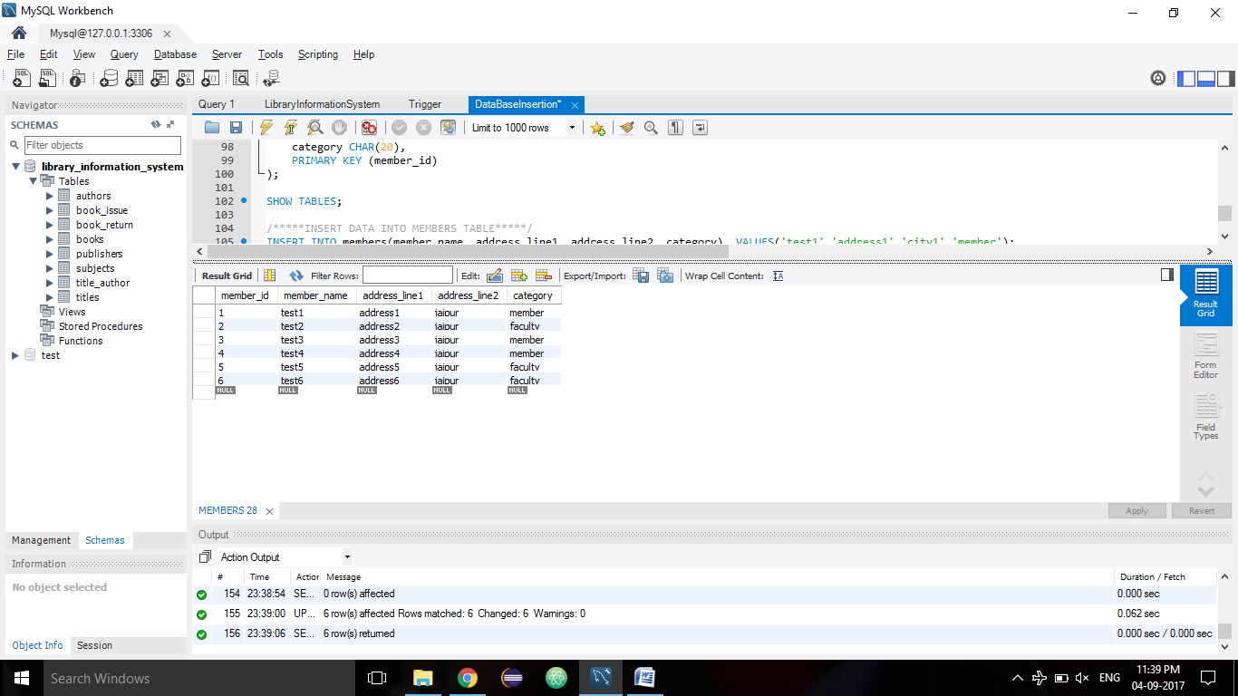

1. UPDATE members SET address_line1 = 'EPIP, Sitapura' WHERE category = 'faculty';

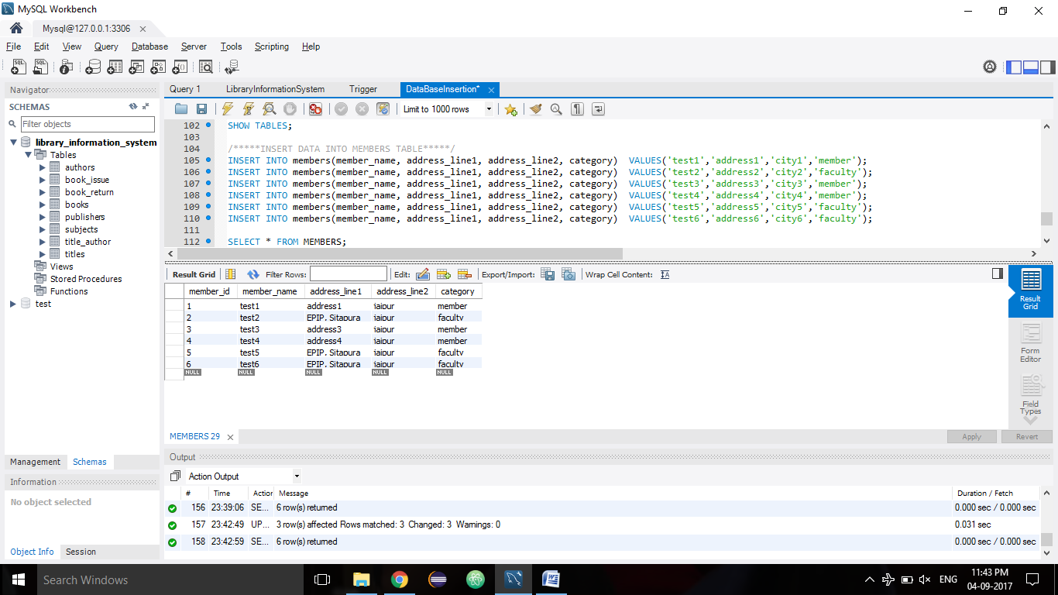

1. DELETE FROM publishers;

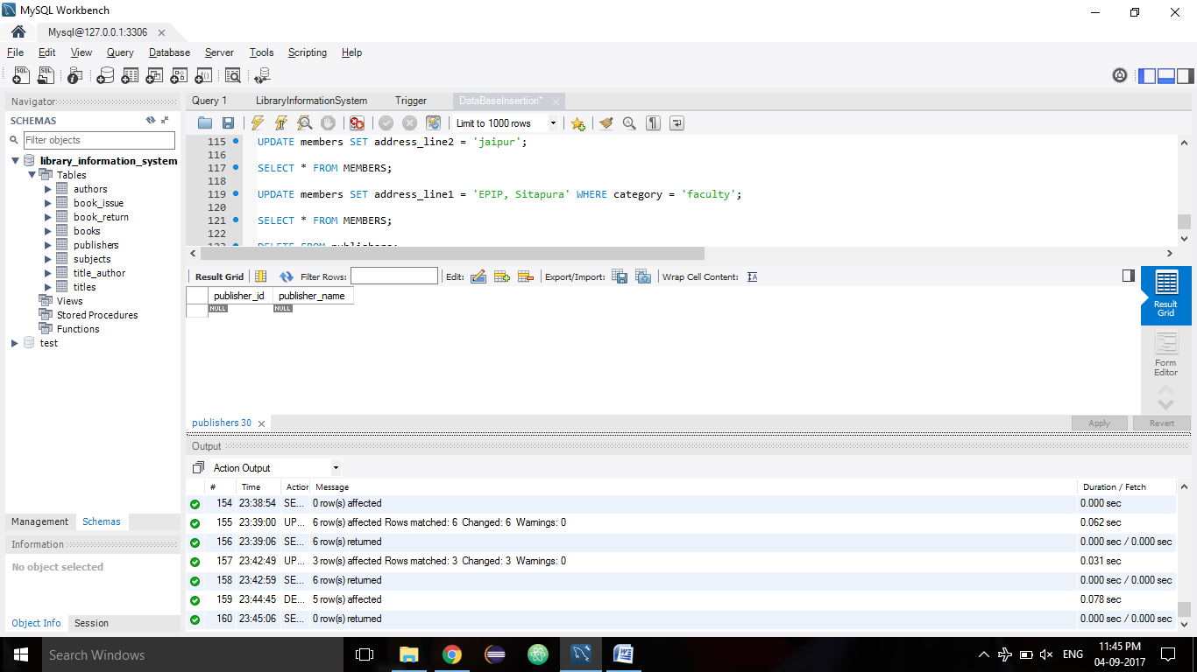

5.

ALTER TABLE publishers AUTO_INCREMENT = 1;

SET @publisher_1 = 'Tata McGraw';

INSERT INTO publishers(publisher_name) VALUES(@publisher_1);

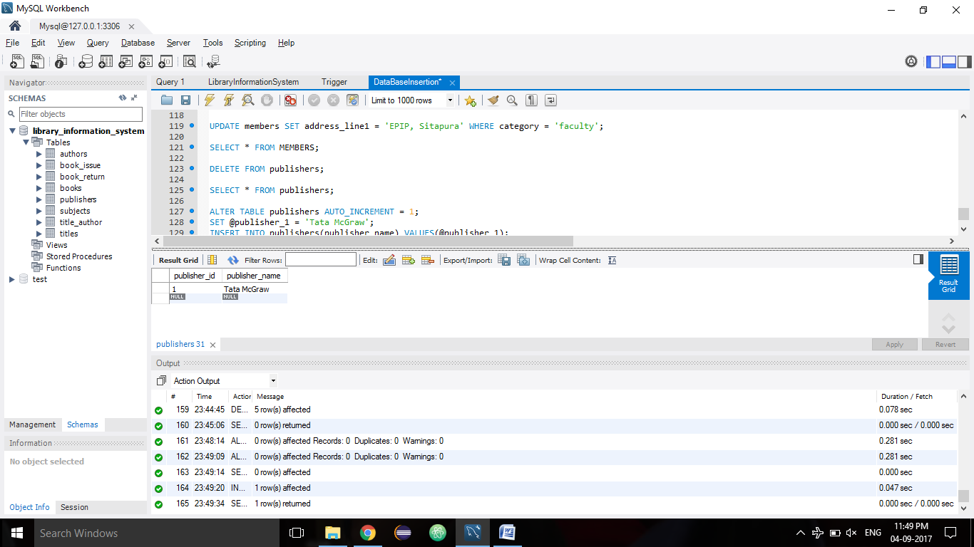

6.

DELETE FROM titles WHERE publisher_id = 1;

