**Assignment 1:**

1. Get book details for books that have not been returned before 2 months.

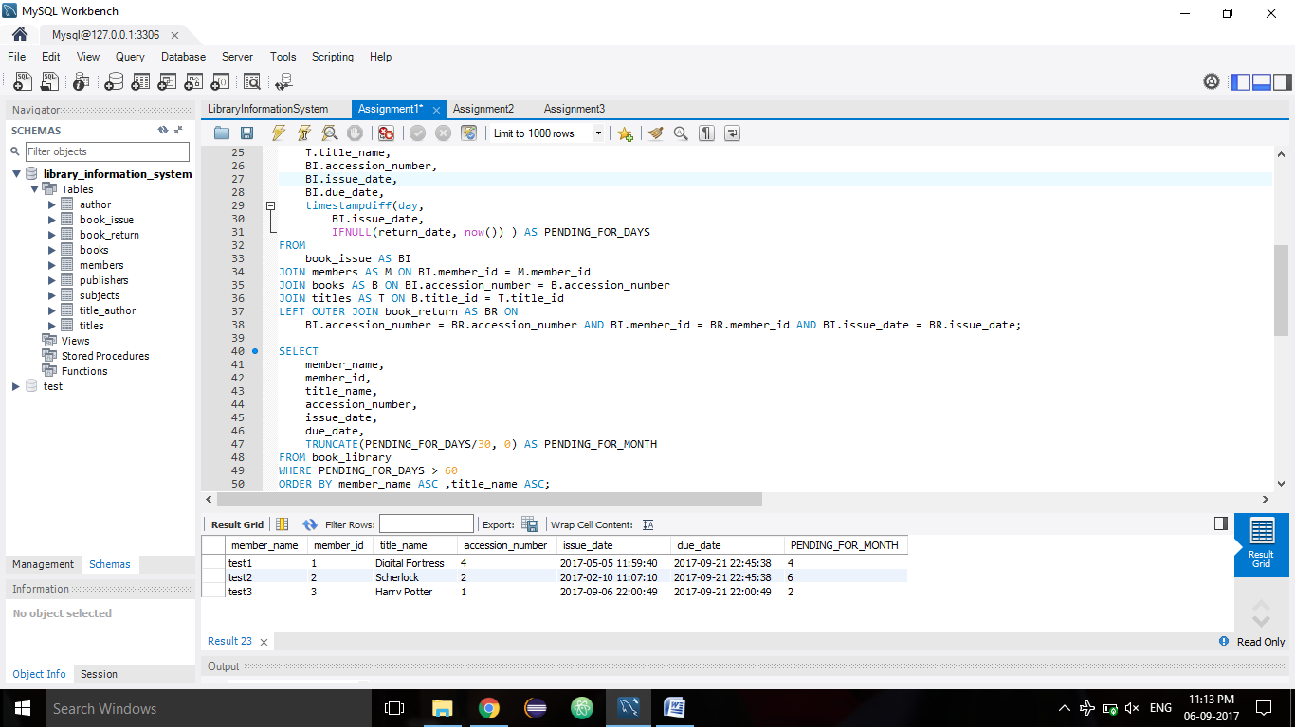

1. Find the maximum length name in data entries and its length.

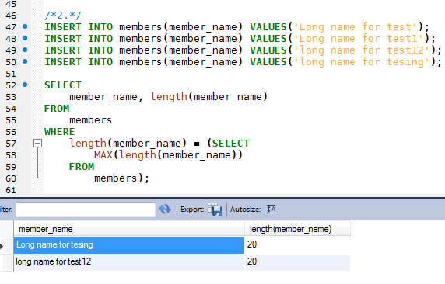

1. Total books issued so far.

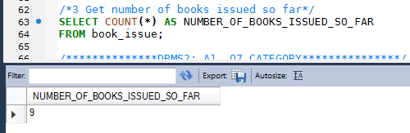

**ASSIGNMENT 2:**

1. Total books purchased and their subject domain

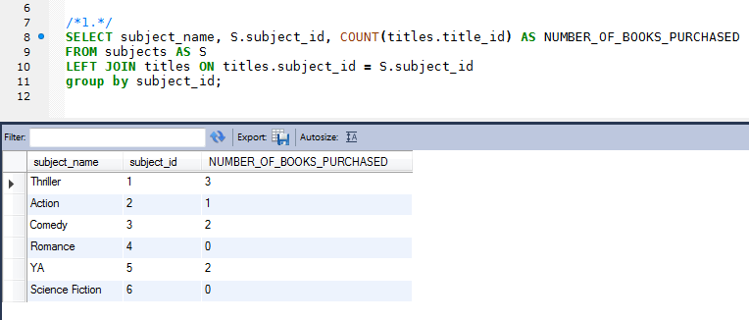

1. If book is not returned AND due_date() - issue_date > 60 days

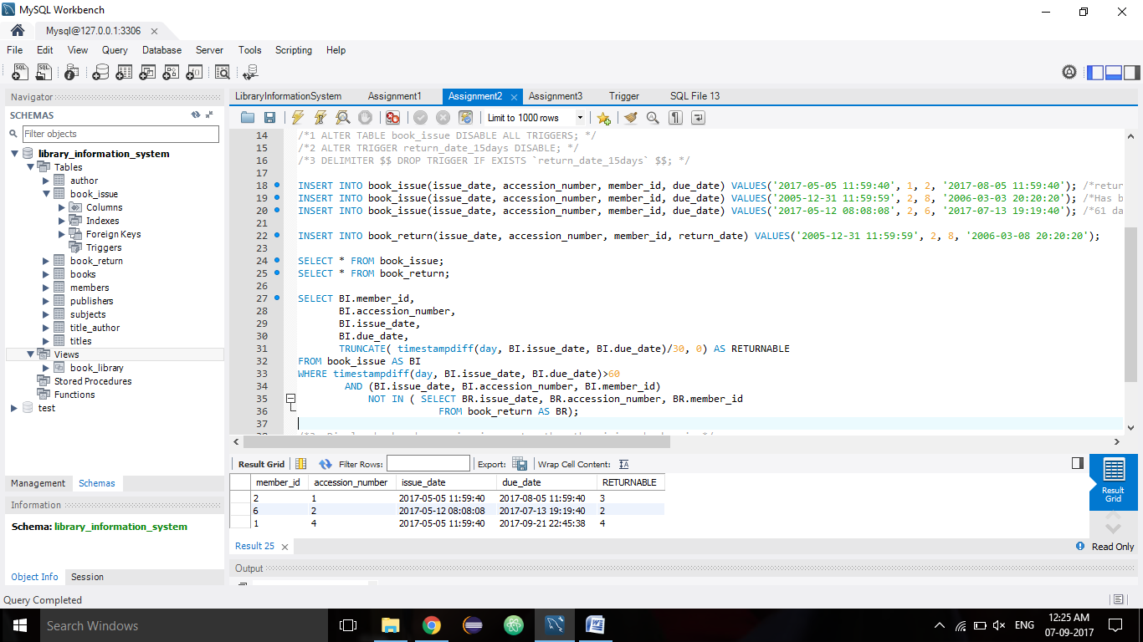

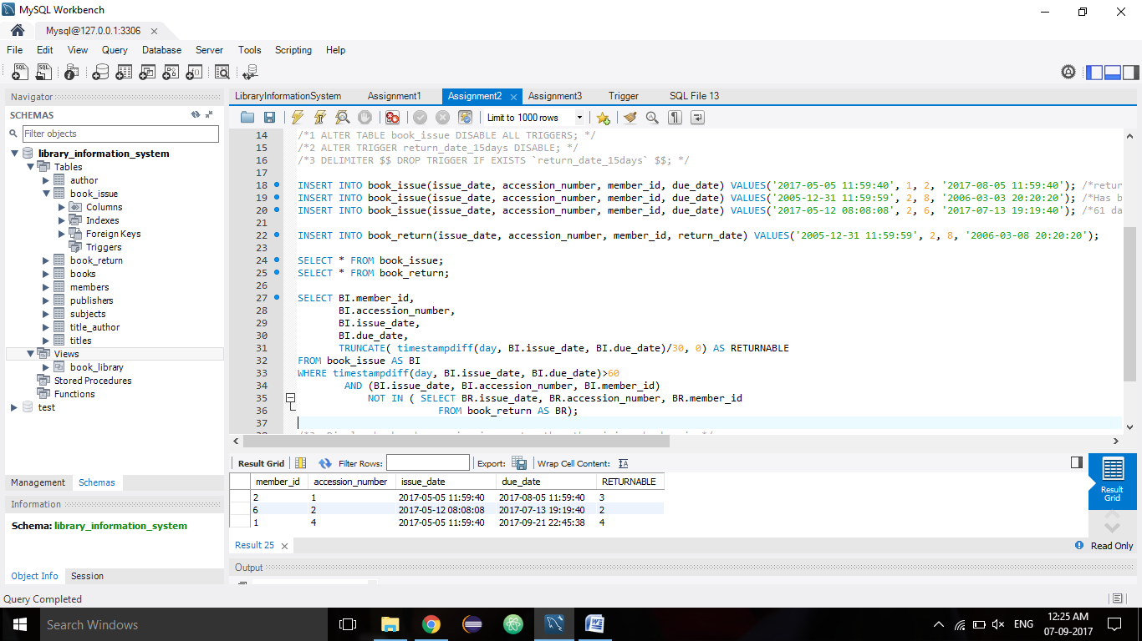

1. Display books whose price is greater than the minimum book price.

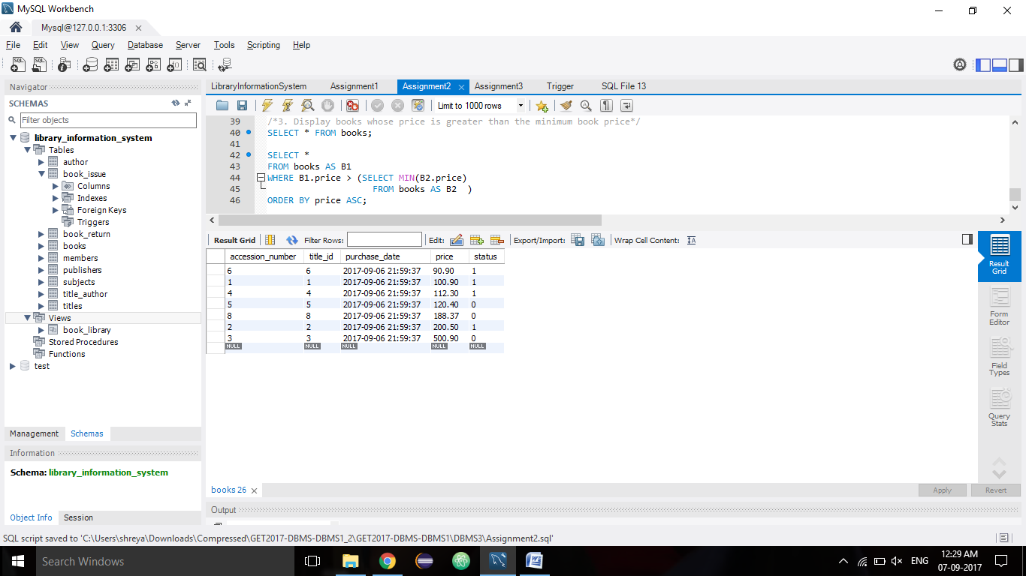

**ASSIGNMENT 3:**

1. Display total number of faculty, total number of members and total of others.

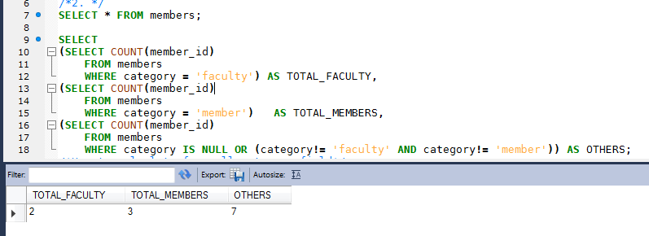

1. Titles issued more than 2 times.

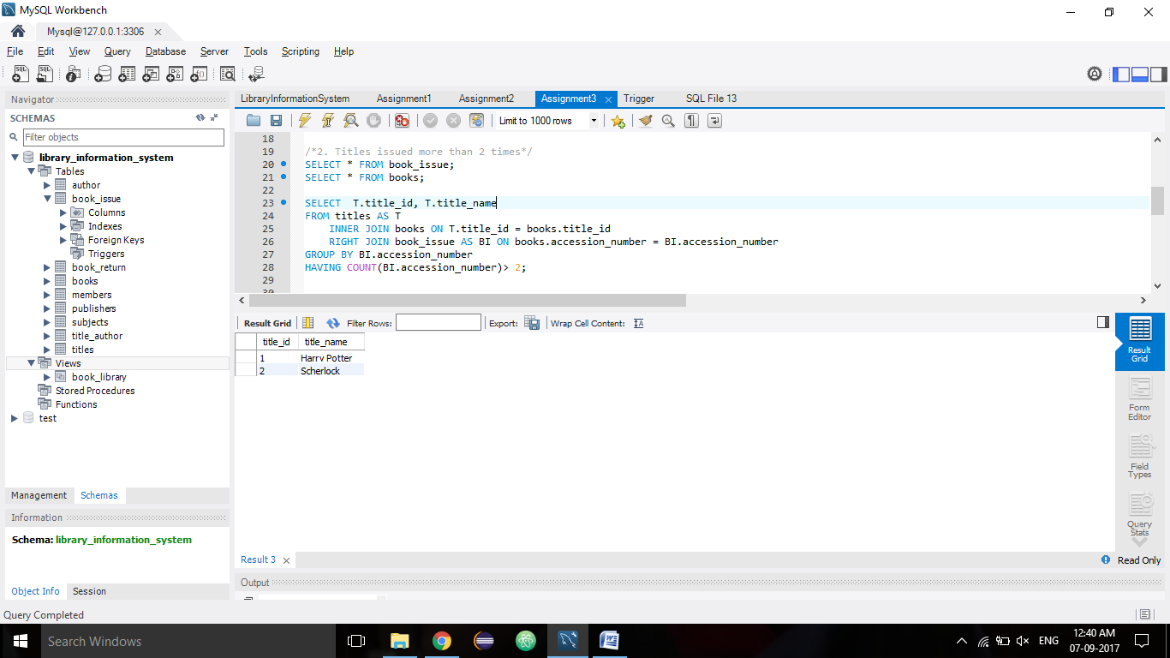

1. Info about book issued to members of category other than 'faculty'.

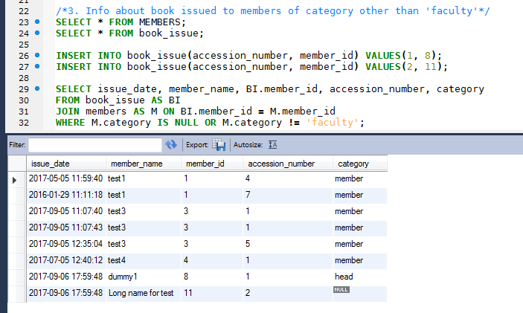

1. Author details for authors whose at least 1 book has been purchased

