**Assignment 1:**

1. Write a SELECT command to display name of those members

who belong to the category as to which member

“Jon Snow” belongs.

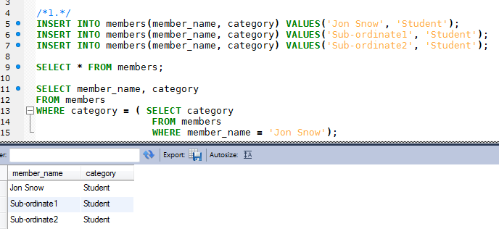

2. Write a SELECT command to display information on the books

that have not been returned till date. The information should

include book issue date, title, member name and due date.

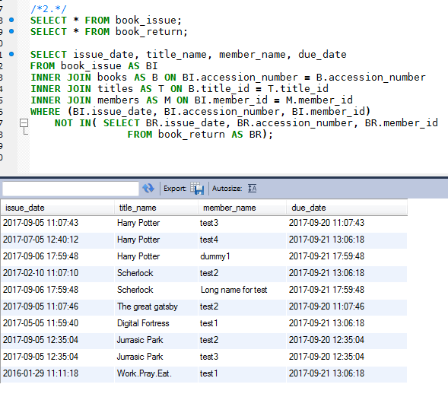

3. Write a SELECT command to display information on the books

that have been returned after their due dates. The information

should include book issue date, title, member name and due

date.

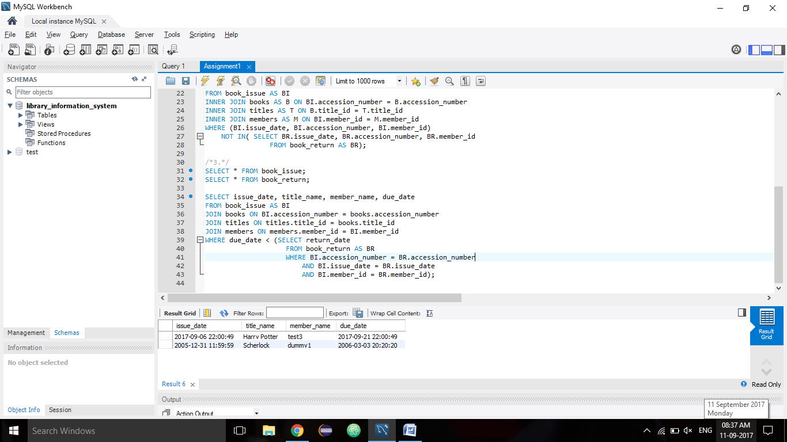

4. Write a SELECT command to display information of those books

whose price is equal to the most expensive book purchased so far.

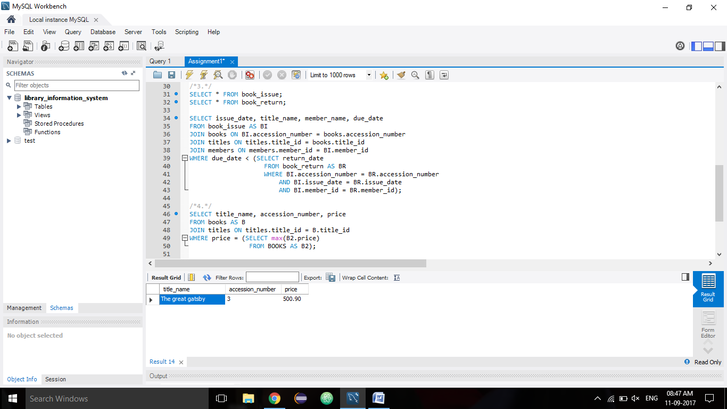

5. Write a SELECT command to display the second maximum price

of a book.

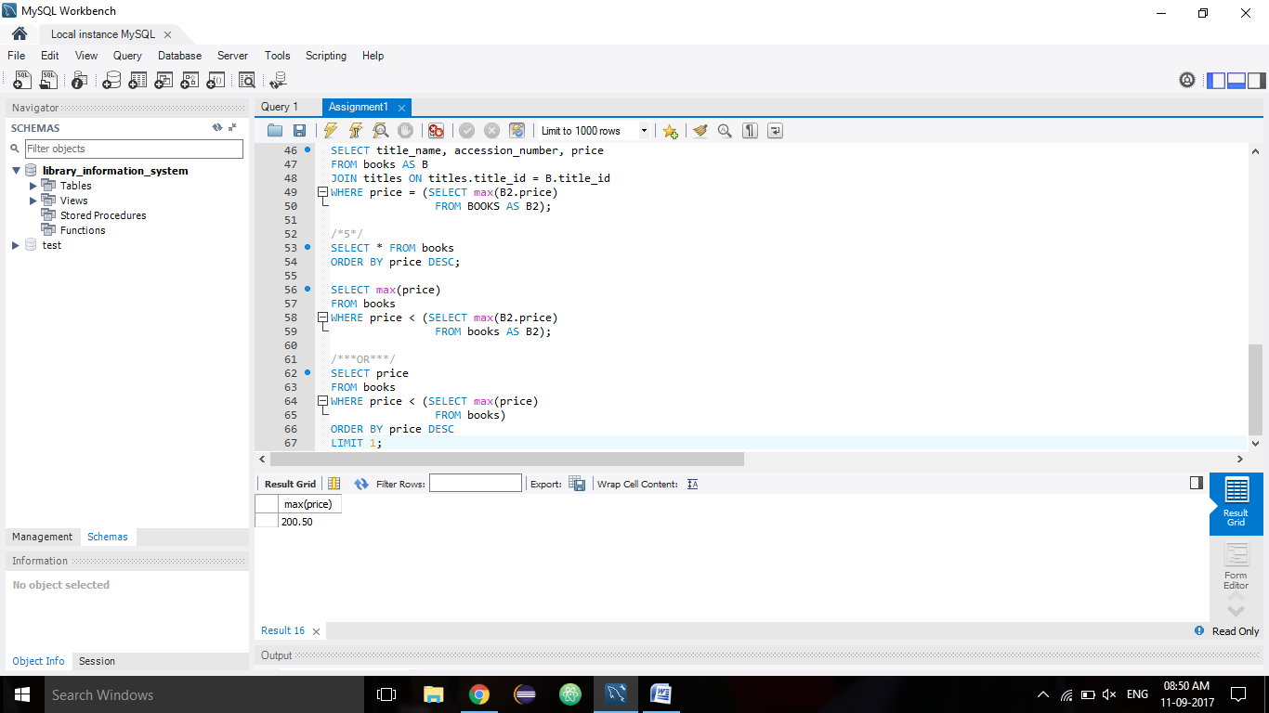

**ASSSIGNMENT 2:**

1. Create a View which can be used to display member name and all issue details of the member using a simple SELECT command.

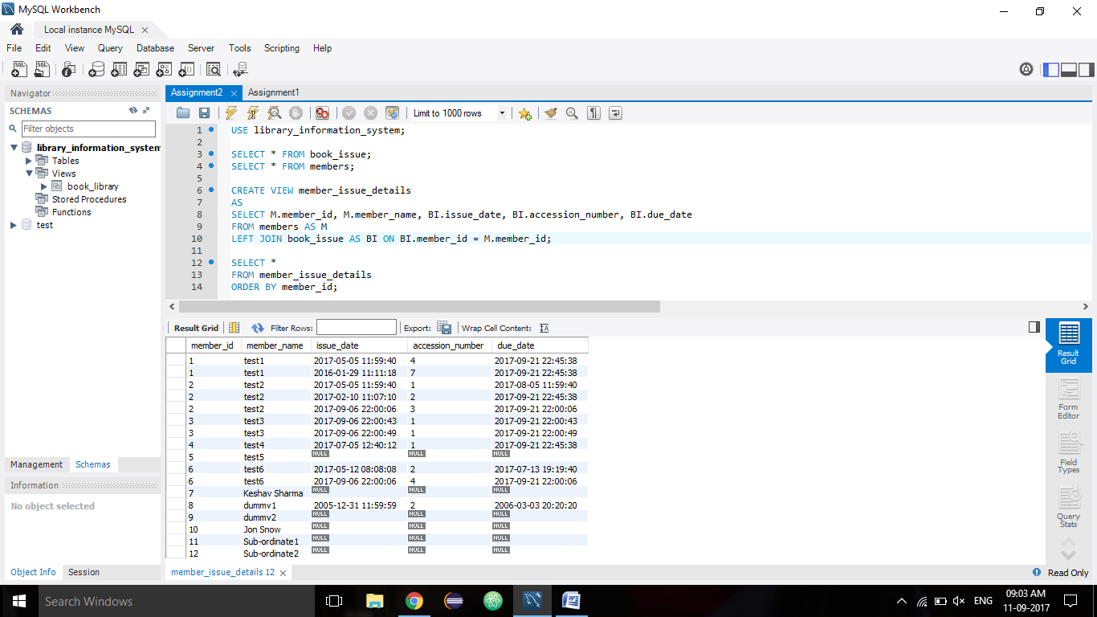

2. Create a View which contains three columns, member name,

member id and full description of category, i.e., Faculty, Students

and Others instead of F,S and O.

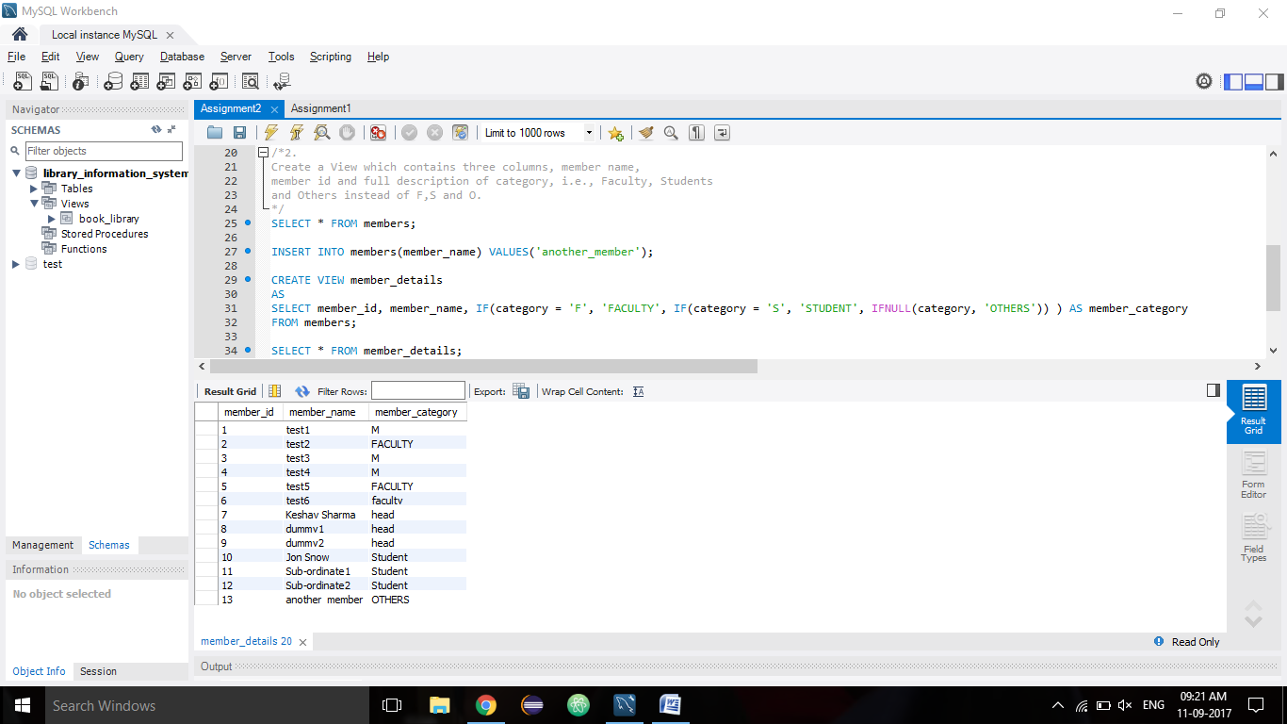

3. Create a View which contains the information – subject name,

title, member name, category, issue date, due date and return

date. If the books have not been returned, NULL should be

displayed instead of return date.

