**JavaScript Session 1 Assignment 1: Link pages through JS**

1. Open Home.html

The UI looks like this:

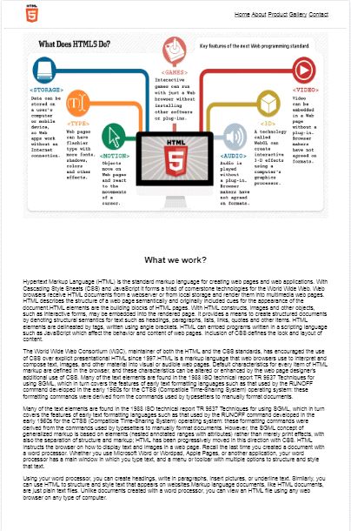

2. In the header tab,

The navigation bar contains the links

On click, ContactUs page is loaded.



**JavaScript Session 1 Assignment 2: Validate Form**

1. Open Home.html

The UI looks like this:



2. In the header tab,

The navigation bar contains the links

On click, ContactUs page is loaded.



3. The name field only accepts alphabets upto 20 characters.

i. Long name attribute

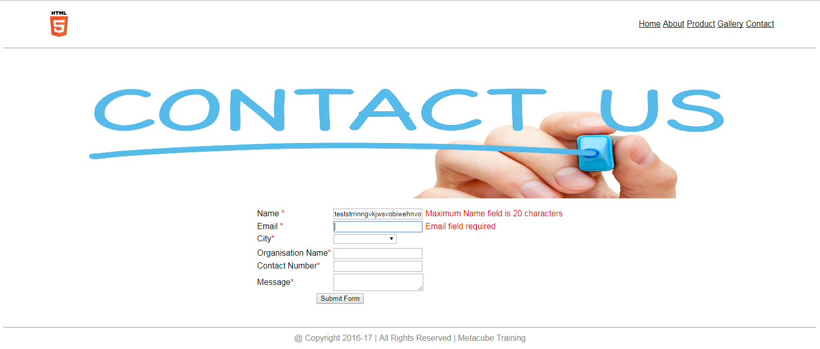

ii. Numeric values

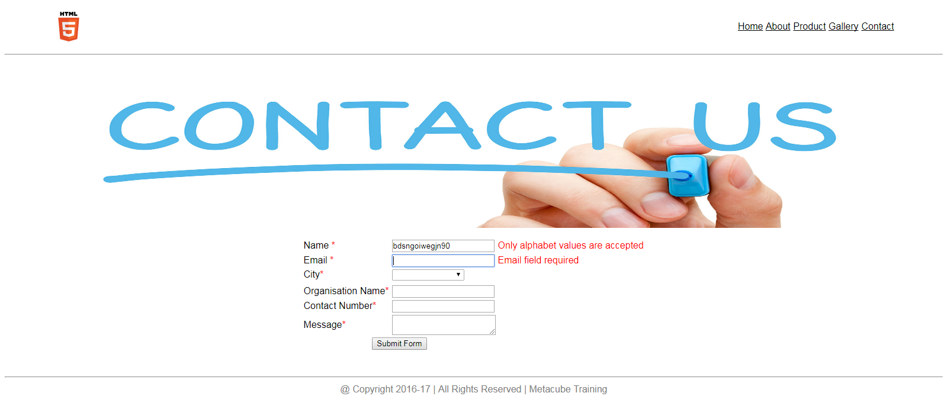

iii. Valid name entry

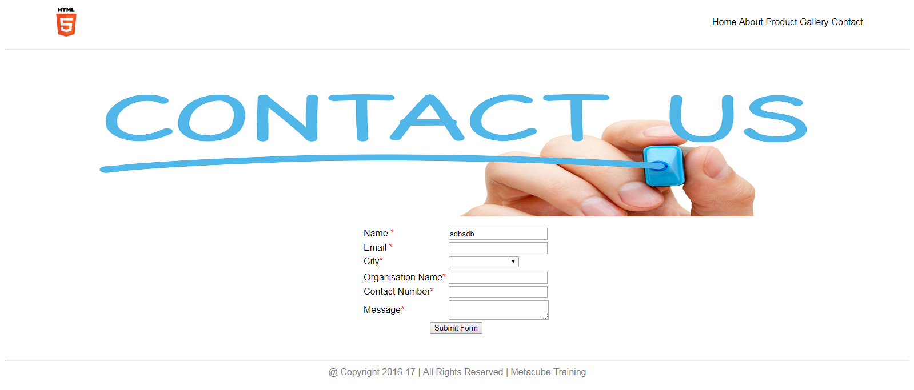

4. Email field accepts only alphabets _ and .

Followed by @

And then alphabets and numbers

Followed by .

And then alphabets

i. Invalid entry

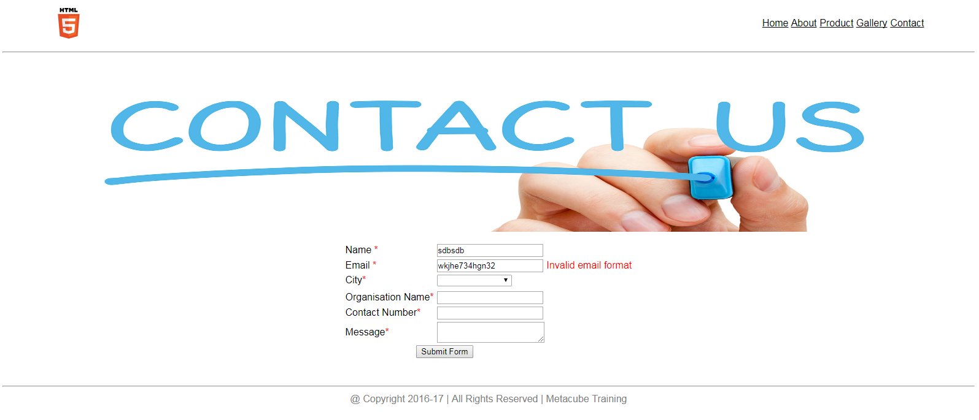

ii. Valid Entry

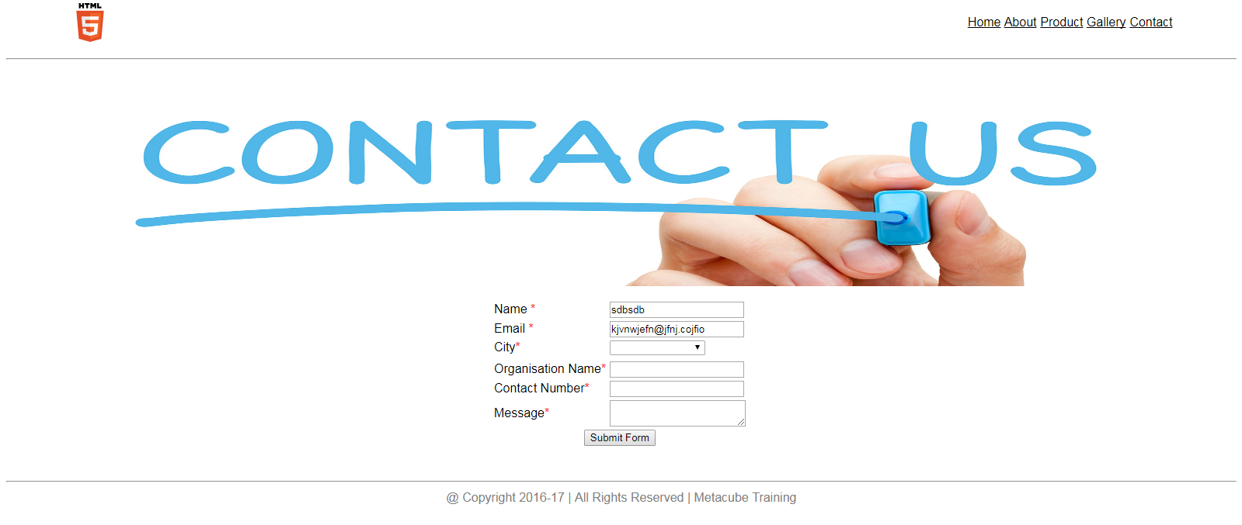

5. Selected city is displayed into a disabled textbox

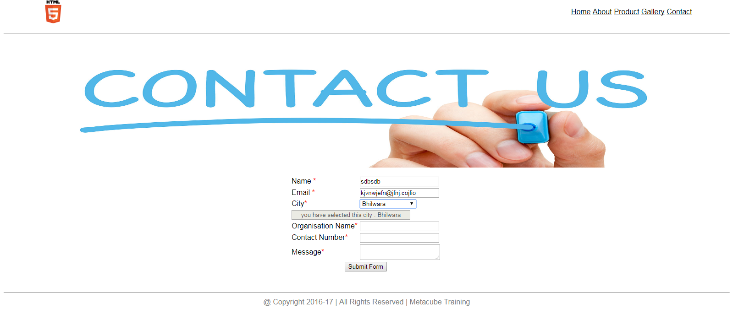

6. Organisation name accepts only alphabets (no name length)

i. Invalid entry

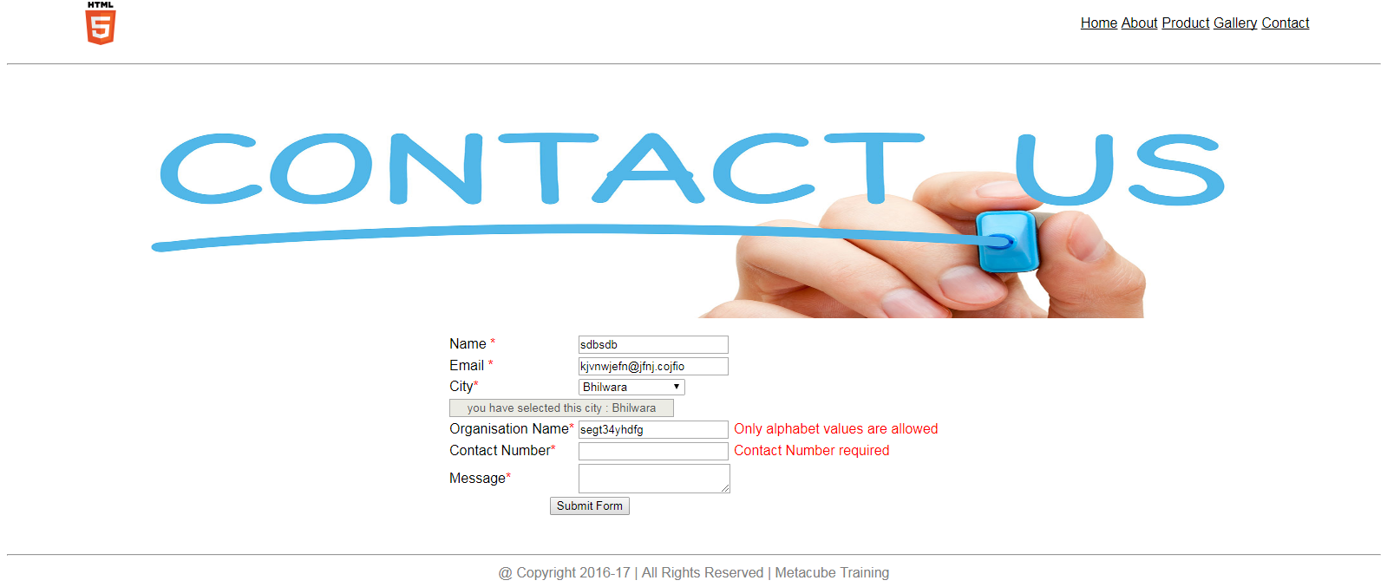

ii. Valid Entry

7. All fields are required. Cannot leave any entry empty.

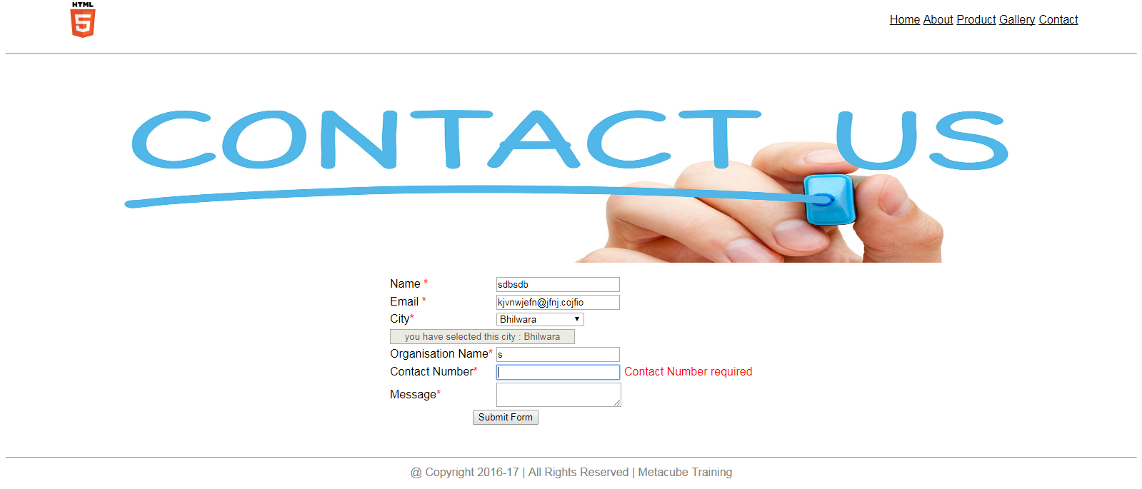

8. Contact details only accepts numeric values (length limit is 10 numbers)

i. Valid entry

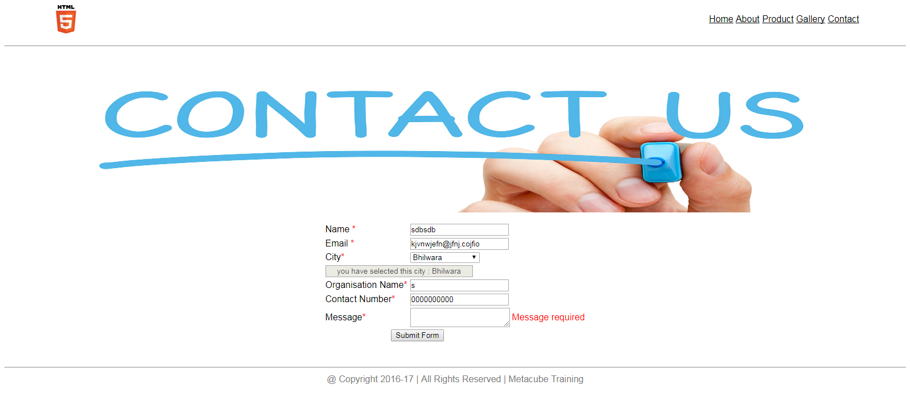

ii. Invalid entry

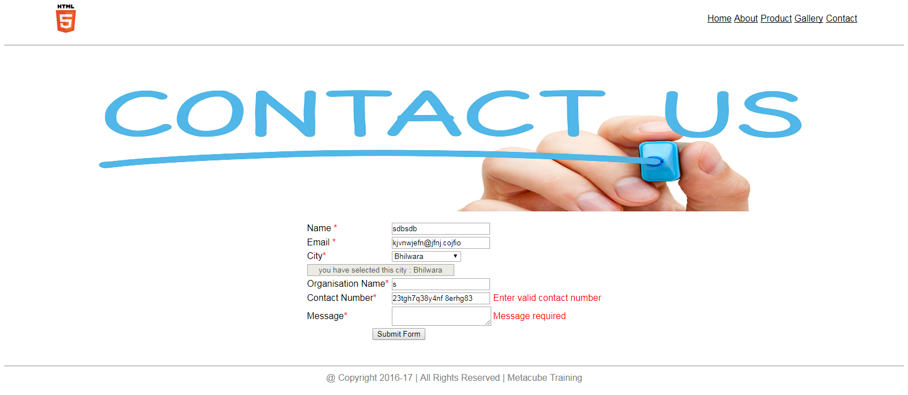

9. Message field is required.

All UNICODE charaters are accepted.

Field limit is 250 words.

i. Message greater than 250 words.

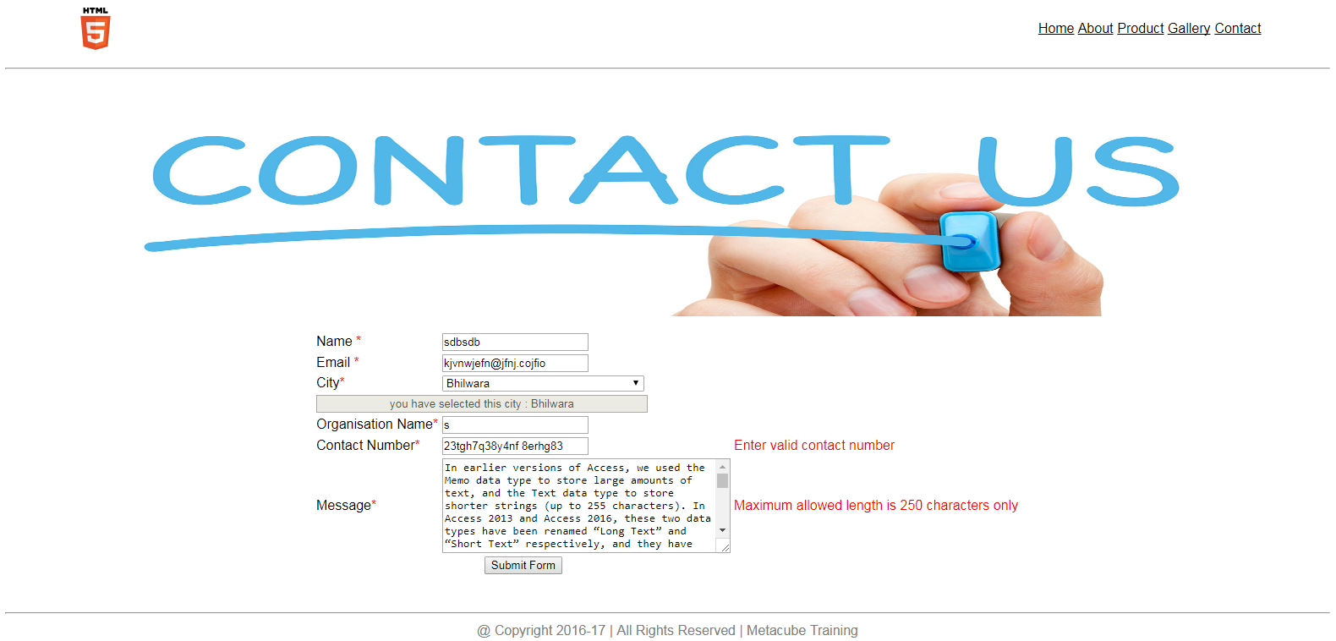

ii. Valid entry

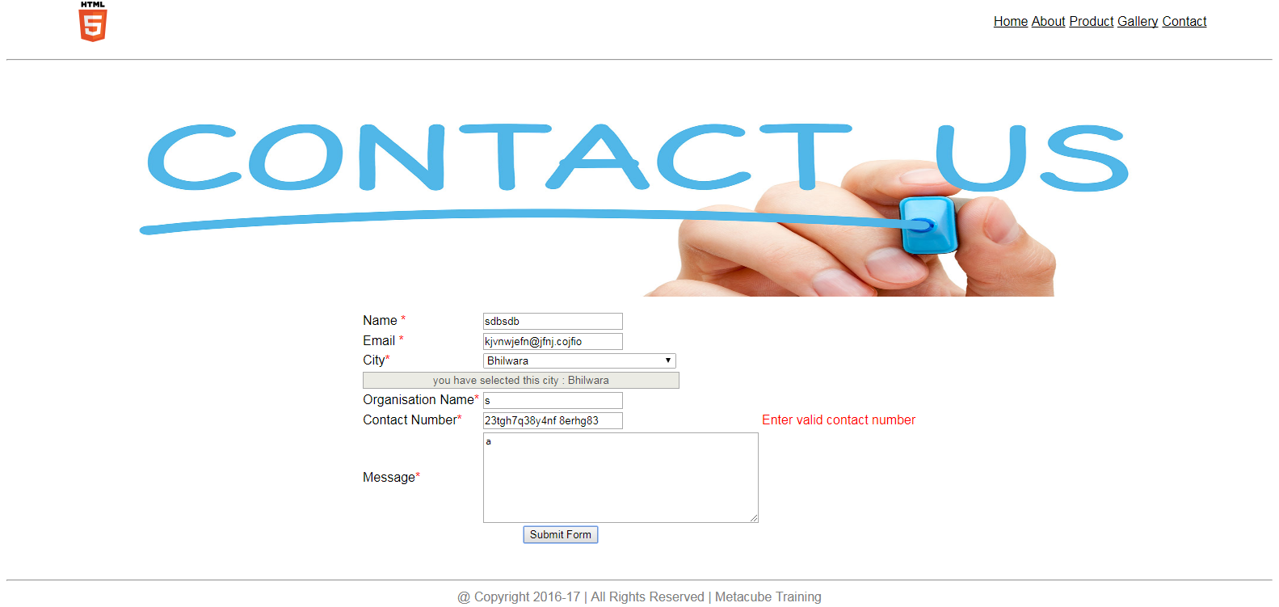

10. Form is not submitted until all valid enteries are entered.

