ASSIGNMENT 1
1. Display columns of members table.
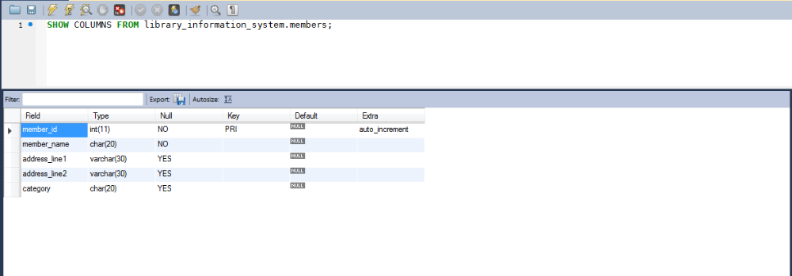

2. Display data from members table.
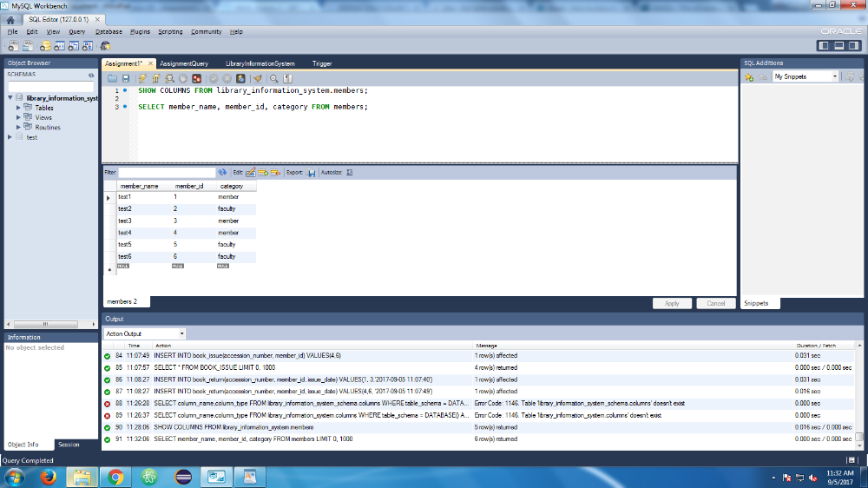
3. Display members belonging to FACULTY.
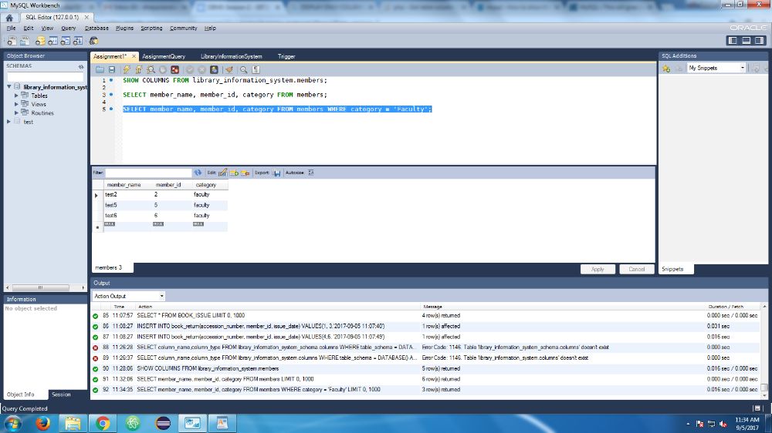
4. get types of members
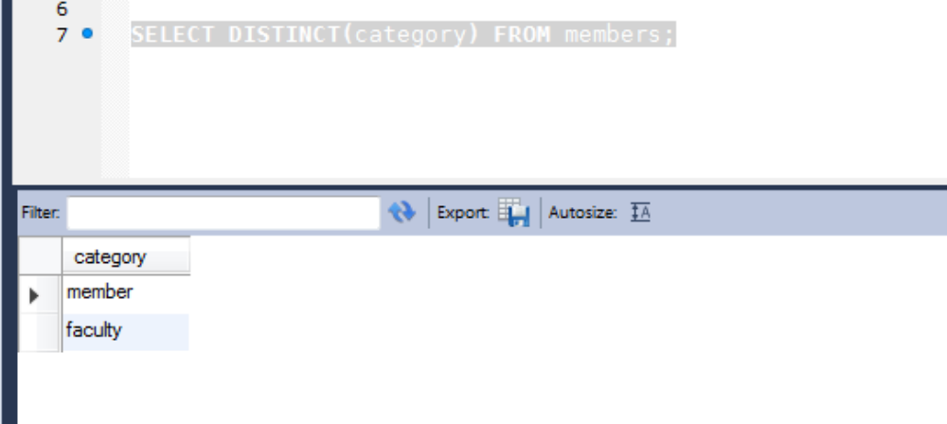
5. Reverse print the members by their name.
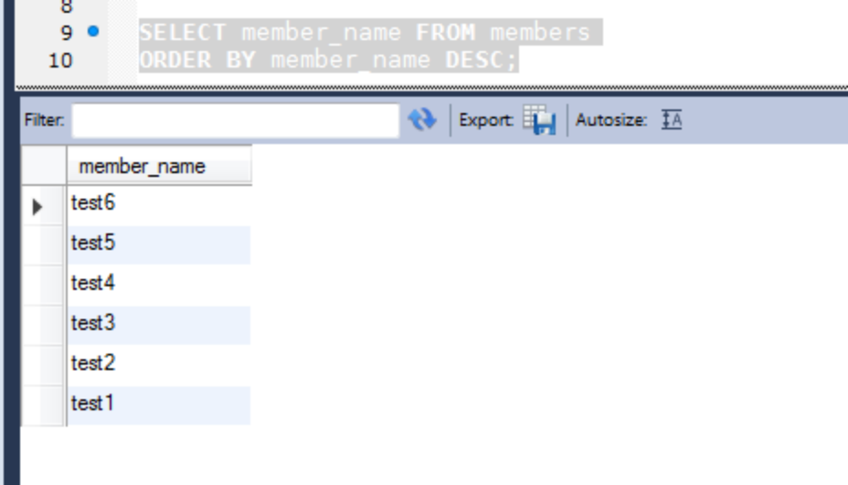
6. Display associated subject name and publisher of book for said title of book
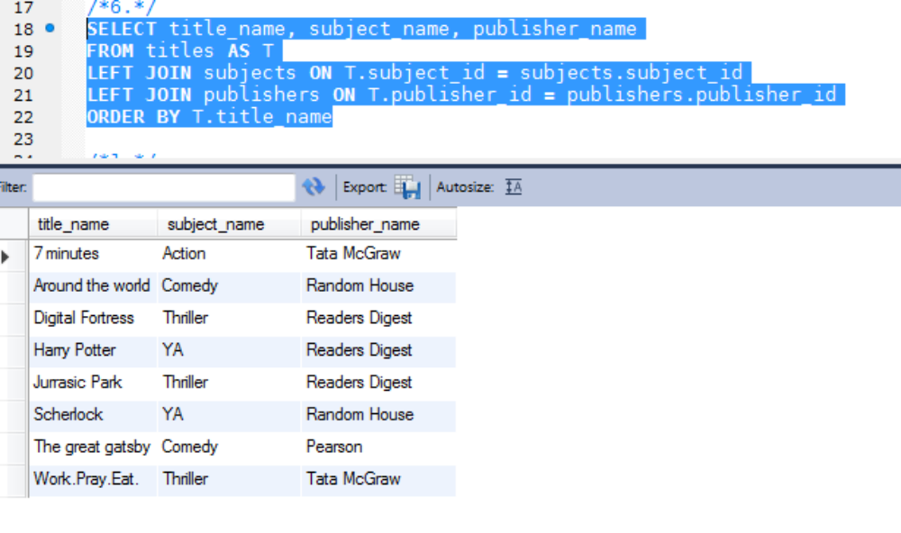
7. Count by category type
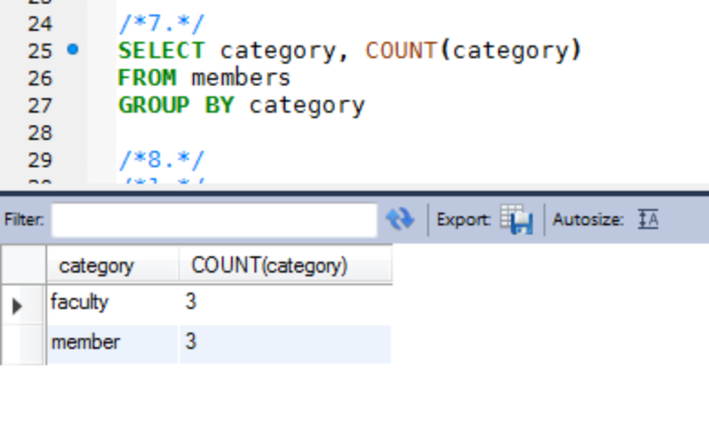
8. Get members of the same category as 'Keshav Sharma' category.
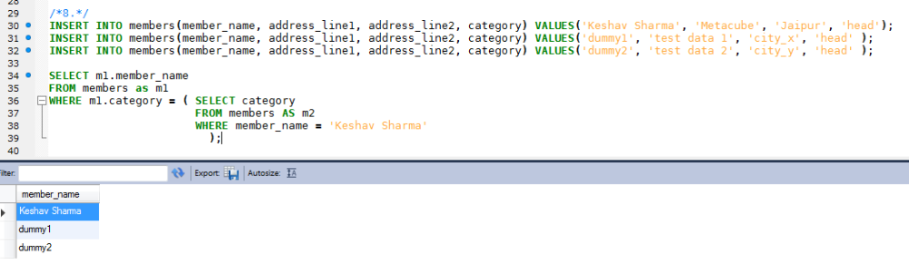

9. Get book issued details and whether these books have been returned (get return date) or if due (display null)
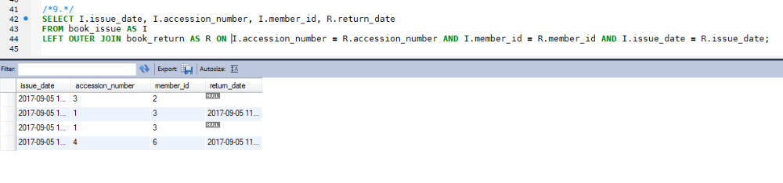
ASSIGNMENT 2
Order by issue date then by member name (Ascending order)
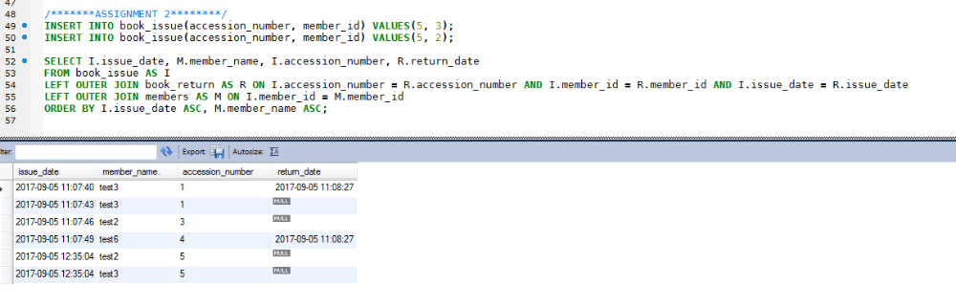

ASSIGNMENT 3
Retrieve category and parent category name. Sort by parent category name.

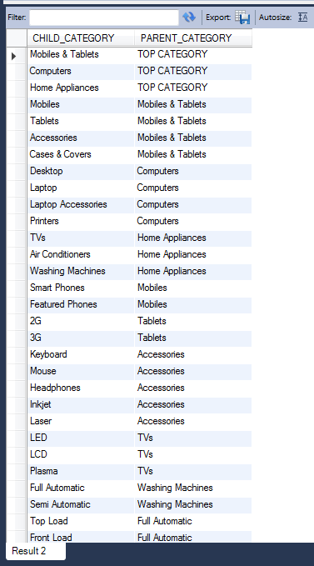

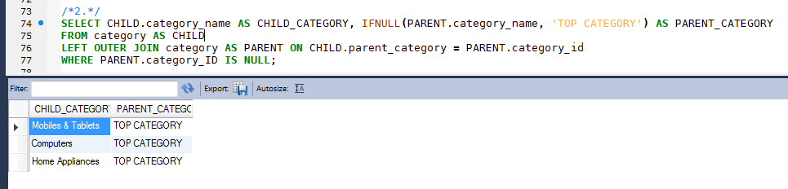
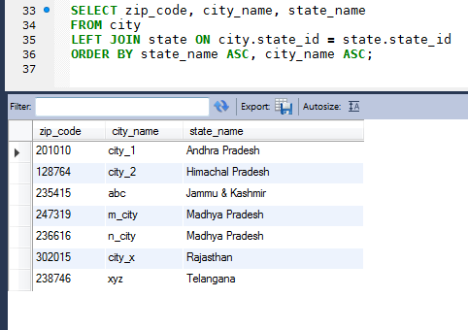
ASSIGNMENT 4:
Return result set ordered by state name and city name

