Bootstrap Assignment 1

- Web View
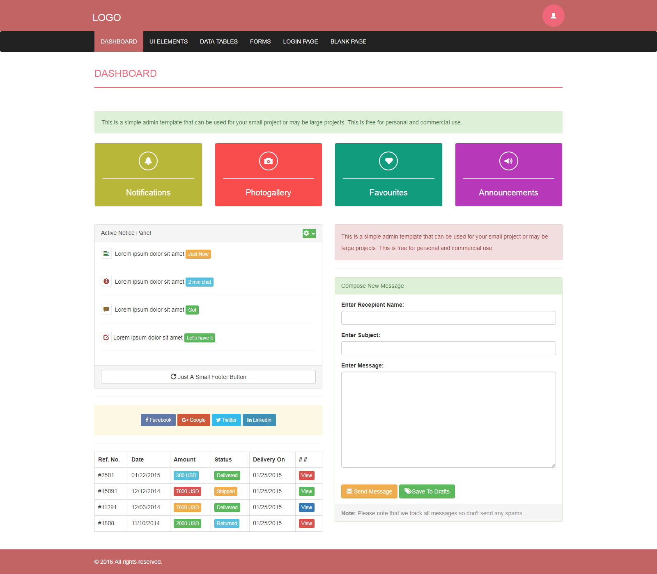

- Tablet View
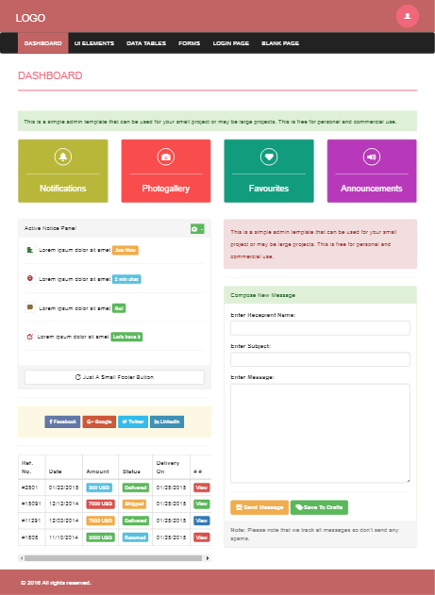

- Mobile View
