- Which software development technique is good for the systems that have third party API calls, cron jobs, data exports/imports, etc.,

The best options are Service-Oriented Architecture (SOA) and Microservices Architecture. They allow:
- Loose coupling: Simple integration with external APIs.
- Independent deployment: Fits well with systems that have scheduled tasks or cron jobs.
- Asynchronous processing: Perfect for tasks involving the import and export of data.

In such dynamic, integration-heavy environments, agile development combined with CI/CD practices also performs well.

- Where does Test Automation fit in the Software Life Cycle? Explain with a diagram.
In order to provide continuous validation, test automation is integrated throughout DevOps/CI-CD Pipelines and falls under the Software Development Life Cycle (SDLC) Testing Phase.
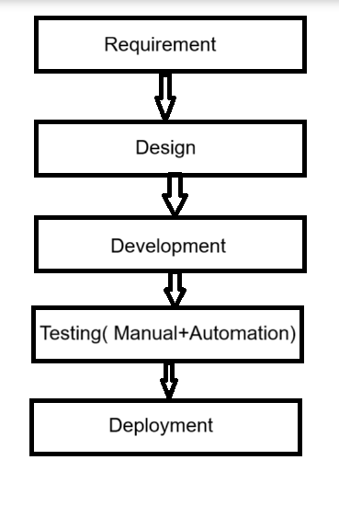

3. Can we skip the manual testing and why?

No, manual testing shouldn't be entirely disregarded for the following reasons:
- Human insight is necessary for exploratory testing.
- Human judgment is needed for look and feel, usability, and UI/UX feedback.
- Stable builds for automation are lacking in early-stage development.
- Only stable and repetitive test cases benefit from automation.

4. Give the names of the selector(locators)?
Answer:Common Web Element Selectors / Locators:
- ID
- Name
- Class Name
- Tag Name
- CSS Selector
- Link Text

5. Describe the Modular Framework.
The application being tested is divided into distinct modules using a modular testing framework, and test scripts are created separately for each module.

Benefits:
- Code reusability
- Simple upkeep
- Structure that is scalable

6. Explain the Open source tool.
Software that has source code that is openly accessible for use, alteration, and distribution is known as an open source tool.

- Test-related examples include:
- Web automation with Selenium
- Performance testing with JMeter
- Postman: Testing APIs
- Frameworks for unit tests: TestNG and JUnit

7. What is a Hybrid framework?
In response, a hybrid testing framework combines two or more frameworks, usually:
- Partially
- Driven by Data
- Driven by Keywords
Benefits
- Adaptability
- Reusability
- Increased scalability

8. Give the Record and Replay Tool a name.
The popular record and replay tool is the Selenium IDE.

Additional instances:
- Studio Katalon
- Test Project
- The Ranorex

9. What distinguishes Cucumber from BDD?

Behavior Driven Development | BDDA cucumber
An approach to development | An instrument that facilitates BDD
emphasizes teamwork while utilizing simple language | Gherkin syntax to executable code conversion
promotes using the Given-When-Then format when creating user stories. | uses step definitions to put those stories into practice.

In conclusion, Cucumber is a tool that aids in the implementation of BDD, which is a methodology.

10. Can we replace the Manual Regression testing effort from Test automation and how?

Yes, a significant amount of manual regression testing can be replaced by test automation by:

- Performing repetitive tests in a timely and reliable manner
- Minimizing human error
- In long-term projects, saving time

However, some UI/UX regressions still require manual testing; not all regressions can be automated.

11. How many ‘A’s test script has? Explain them.

Answer: A test script follows the "AAA Pattern," which consists of three A's:
- Arrange the state of the data to set it up for testing.
- Act on the data through some method that performs an action.
- Assert that the result from acting on that data is what we expect it to be
This pattern guarantees that tests are clear, understandable, and organized.

