*Дубкова Валерия КС-26*

**13-ая лабораторная работа**

**Задание**

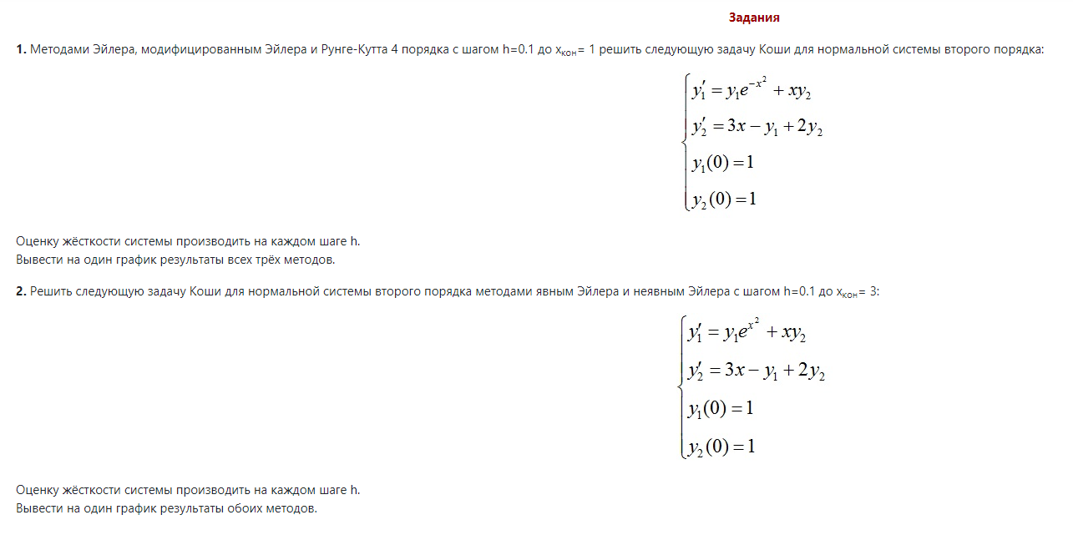

**Код**

Lab13z1.m

clear all; clc

f1=@(x, y1, y2)y1*exp(-x^2) + x*y2;

f2=@(x, y1, y2)3*x - y1 + 2*y2;

x0 = 0; xk = 1;

y10 = 1; y20 = 1;

h = 0.1;

x = x0:h:xk;

len = abs((x0-xk)/h);

fprintf('Жесткость системы на каждом шаге:\n');

for i=1:(len+1)

A=[exp(-x(i)^2) x(i); -1 2];

Liambda = eig(A);

S(i) = max(real(Liambda))/min(real(Liambda));

fprintf('\tx = %f; s = %f\n', x(i), S(i));

end

% Метод Эйлера

fprintf('\nРезультаты решения методом Эйлера:\n');

y1(1) = y10;

y2(1) = y20;

fprintf('\tx = %f; y1 = %f; y2 = %f\n', x(1), y1(1), y2(1));

for i=1:len

y1(i+1) = y1(i) + h*f1(x(i), y1(i), y2(i));

y2(i+1) = y2(i) + h*f2(x(i), y1(i), y2(i));

fprintf('\tx = %f; y1 = %f; y2 = %f\n', x(i+1), y1(i+1), y2(i+1));

end

plot3(x, y1, y2, '-*r');

% Модифицированный метод Эйлера

y1(1) = y10;

y2(1) = y20;

for i=1:len

ty1 = y1(i) + h*f1(x(i), y1(i), y2(i));

ty2 = y2(i) + h*f2(x(i), y1(i), y2(i));

y1(i+1) = y1(i) + 0.5*h*(f1(x(i), y1(i), y2(i)) + f1(x(i+1), ty1, ty2));

y2(i+1) = y2(i) + 0.5*h*(f2(x(i), y1(i), y2(i)) + f2(x(i+1), ty1, ty2));

end

fprintf('\nРезультаты решения методом модифицированным Эйлера:\n');

for i=1:(len+1)

fprintf('\tx = %f; y1 = %f; y2 = %f\n', x(i), y1(i), y2(i));

end

hold on

plot3(x, y1, y2, '-*b');

% Метод Рунге-Кутта

y1(1) = y10;

y2(1) = y20;

for i=1:len

x1 = x(i) + 0.5*h;

x2 = x(i) + h;

k1 = h*f1(x(i), y1(i), y2(i));

l1 = h*f2(x(i), y1(i), y2(i));

k2 = h*f1(x1, y1(i)+0.5*k1, y2(i)+0.5*l1);

l2 = h*f2(x1, y1(i)+0.5*k1, y2(i)+0.5*l1);

k3 = h*f1(x1, y1(i)+0.5*k2, y2(i)+0.5*l2);

l3 = h*f2(x1, y1(i)+0.5*k2, y2(i)+0.5*l2);

k4 = h*f1(x2, y1(i)+k3, y2(i)+l3);

l4 = h*f2(x2, y1(i)+k3, y2(i)+l3);

deltaY1 = (k1 + 2*k2 + 2*k3 + k4)/6;

deltaY2 = (l1 + 2*l2 + 2*l3 + l4)/6;

y1(i+1) = y1(i) + deltaY1;

y2(i+1) = y2(i) + deltaY2;

end

fprintf('\nРезультаты решения методом Рунге-Кутта:\n');

for i=1:(len+1)

fprintf('\tx = %f; y1 = %f; y2 = %f\n', x(i), y1(i), y2(i));

end

hold on

plot3(x, y1, y2, '-oblack');

[x,y] = ode15s(@func,[0 1],[1 1]);

y = y';

fprintf('\nРезультаты решения с помощью функции ode15s:\n');

for i=1:length(y)

y1(i) = y(1, i);

y2(i) = y(2, i);

fprintf('\tx = %f; y1 = %f; y2 = %f\n', x(i), y1(i), y2(i));

end

hold on

plot3(x, y1, y2, '-*m');

grid on

title('Графики');

xlabel('x'); ylabel('y1'); zlabel('y2');

legend('Эйлера', 'Мод. Эйлера', 'Рунге-Кутта 4-го пор.', 'ode15s');

legend('Location', 'northwest');

legend('boxoff');

figure;

p1 = plot(x, y1, '-*g');

hold on

p2 = plot(x, y2, '-*b');

grid on

title('ode15s');

xlabel('x'); ylabel('y');

legend([p1, p2], {'y1', 'y2'});

Lab13z2.m

clear all; clc

f1=@(x, y1, y2)y1*exp(-x^2) + x*y2;

f2=@(x, y1, y2)3*x - y1 + 2*y2;

x0 = 0; xk = 3;

y10 = 1; y20 = 1;

h = 0.1;

x = x0:h:xk;

len = abs((x0-xk)/h);

fprintf('Жесткость системы на каждом шаге:\n');

for i=1:(len+1)

A=[exp(x(i)^2) x(i); -1 2];

Liambda = eig(A);

S(i) = max(real(Liambda))/min(real(Liambda));

fprintf('\tx = %f; s = %f\n', x(i), S(i));

end

% Метод Эйлера

y1(1) = y10;

y2(1) = y20;

for i=1:len

y1(i+1) = y1(i) + h*f1(x(i), y1(i), y2(i));

y2(i+1) = y2(i) + h*f2(x(i), y1(i), y2(i));

% Оценка жесткости системы

A=[exp(x(i)^2) x(i); -1 2];

Liambda = eig(A);

S(i) = max(real(Liambda))/min(real(Liambda));

end

fprintf('\nРезультаты решения явным методом Эйлера:\n');

for i=1:(len+1)

fprintf('\tx = %f; y1 = %f; y2 = %f\n', x(i), y1(i), y2(i));

end

figure;

plot3(x, y1, y2, '-*r');

grid on

title('Явный Эйлера');

xlabel('x'); ylabel('y1'); zlabel('y2');

legend('Явный Эйлера');

legend('Location', 'northwest');

legend('boxoff');

figure;

plot(x, y1, '-*r');

hold on

plot(x, y2, '-*black');

grid on

title('Явный Эйлера');

xlabel('x'); ylabel('y');

legend('y1', 'y2');

% неявный метод Эйлера

y1(1) = y10;

y2(1) = y20;

for i=1:len

% y1(i+1) = y1(i) + h*f1(x(i), y1(i+1), y2) =>

% y1(i+1) = y1(i) + h*(y1(i+1)*exp(x^2) + x*y2 =>

% y1(i+1) = y1(i) + h*y1(i+1)*exp(x^2) + h*x*y2 =>

% y1(i+1) - h*y1(i+1)*exp(x^2) = y1(i) + h*x(i+1)*y2 =>

% y1(i+1)(1 - h*exp(x(i+1)^2)) = y1(i) + h*x(i+1)*y2 =>

y1(i+1) = (y1(i) + h*x(i)*y2(i))/(1 - h*exp(x(i)^2));

% y2(i+1) = y2(i) + h*(3*x - y1(i+1) + 2*y2(i+1)) =>

% y2(i+1) = y2(i) + h*3*x - h*y1(i+1) + h*2*y2(i+1) =>

% y2(i+1) - h*2*y2(i+1) = y2(i) + h*3*x - h*y1(i+1) =>

% y2(i+1)*(1 - h*2) = y2(i) + h*3*x - h*y1(i+1) =>

y2(i+1) = (y2(i) + h*(3*x(i) - y1(i+1)))/(1 - 2*h);

end

fprintf('\nРезультаты решения неявным методом Эйлера:\n');

for i=1:(len+1)

fprintf('\tx = %f; y1 = %f; y2 = %f\n', x(i), y1(i), y2(i));

end

figure;

plot3(x, y1, y2, '-*black');

grid on

title('неявный метод Эйлера');

xlabel('x'); ylabel('y1'); zlabel('y2');

legend('неявный метод Эйлера');

legend('Location', 'northwest');

legend('boxoff');

figure;

plot(x, y1, '-*r');

hold on

plot(x, y2, '-*black');

grid on

title('неявный метод Эйлера');

xlabel('x'); ylabel('y');

legend('y1', 'y2');

[x,y] = ode15s(@func,[0 3],[1 1]);

figure;

for i=1:(length(x))

hold on

p1 = plot (x(i), y(i, 1), '-*g');

end

for i=1:(length(x))

p2 = plot (x(i), y(i, 2), '-*b');

hold on

end

hold on

plot(x, y, '-black');

grid on

title('ode15s');

xlabel('x'); ylabel('y');

legend([p1, p2], {'y1', 'y2'});

func.m

function dy = func(x,y)

dy = zeros(2,1);

dy(1) = y(1) * exp(-x.^2) + x * y(2);

dy(2) = 3*x - y(1) + 2*y(2);

end

**Результат выполнения программы**

Lab13z1.m

*Жесткость системы на каждом шаге:*

*x = 0.000000; s = 2.000000*

*x = 0.100000; s = 1.714957*

*x = 0.200000; s = 1.435182*

*x = 0.300000; s = 1.000000*

*x = 0.400000; s = 1.000000*

*x = 0.500000; s = 1.000000*

*x = 0.600000; s = 1.000000*

*x = 0.700000; s = 1.000000*

*x = 0.800000; s = 1.000000*

*x = 0.900000; s = 1.000000*

*x = 1.000000; s = 1.000000*

*Результаты решения методом Эйлера:*

*x = 0.000000; y1 = 1.000000; y2 = 1.000000*

*x = 0.100000; y1 = 1.100000; y2 = 1.100000*

*x = 0.200000; y1 = 1.219905; y2 = 1.240000*

*x = 0.300000; y1 = 1.361913; y2 = 1.426009*

*x = 0.400000; y1 = 1.529162; y2 = 1.665020*

*x = 0.500000; y1 = 1.726070; y2 = 1.965108*

*x = 0.600000; y1 = 1.958752; y2 = 2.335522*

*x = 0.700000; y1 = 2.235541; y2 = 2.786752*

*x = 0.800000; y1 = 2.567568; y2 = 3.330548*

*x = 0.900000; y1 = 2.969398; y2 = 3.979901*

*x = 1.000000; y1 = 3.459685; y2 = 4.748941*

*Результаты решения модифицированным методом Эйлера:*

*x = 0.000000; y1 = 1.000000; y2 = 1.000000*

*x = 0.100000; y1 = 1.109953; y2 = 1.120000*

*x = 0.200000; y1 = 1.242267; y2 = 1.286251*

*x = 0.300000; y1 = 1.400393; y2 = 1.506322*

*x = 0.400000; y1 = 1.589178; y2 = 1.789011*

*x = 0.500000; y1 = 1.815308; y2 = 2.144435*

*x = 0.600000; y1 = 2.087858; y2 = 2.584097*

*x = 0.700000; y1 = 2.418903; y2 = 3.120899*

*x = 0.800000; y1 = 2.824196; y2 = 3.769084*

*x = 0.900000; y1 = 3.323878; y2 = 4.544099*

*x = 1.000000; y1 = 3.943203; y2 = 5.462333*

*Результаты решения методом Рунге-Кутта:*

*x = 0.000000; y1 = 1.000000; y2 = 1.000000*

*x = 0.100000; y1 = 1.110369; y2 = 1.121041*

*x = 0.200000; y1 = 1.243262; y2 = 1.288696*

*x = 0.300000; y1 = 1.402201; y2 = 1.510612*

*x = 0.400000; y1 = 1.592123; y2 = 1.795673*

*x = 0.500000; y1 = 1.819826; y2 = 2.154084*

*x = 0.600000; y1 = 2.094515; y2 = 2.597436*

*x = 0.700000; y1 = 2.428421; y2 = 3.138708*

*x = 0.800000; y1 = 2.837469; y2 = 3.792211*

*x = 0.900000; y1 = 3.341989; y2 = 4.573432*

*x = 1.000000; y1 = 3.967440; y2 = 5.498767*

*Результаты решения с помощью функции ode15s:*

*x = 0.000000; y1 = 1.000000; y2 = 1.000000*

*x = 0.017889; y1 = 1.018437; y2 = 1.018994*

*x = 0.035777; y1 = 1.037518; y2 = 1.039295*

*x = 0.053666; y1 = 1.057270; y2 = 1.060967*

*x = 0.113206; y1 = 1.127664; y2 = 1.142707*

*x = 0.172747; y1 = 1.206013; y2 = 1.240991*

*x = 0.232287; y1 = 1.293172; y2 = 1.357660*

*x = 0.291828; y1 = 1.390087; y2 = 1.494566*

*x = 0.391828; y1 = 1.577910; y2 = 1.775221*

*x = 0.491828; y1 = 1.803025; y2 = 2.128348*

*x = 0.591828; y1 = 2.074459; y2 = 2.565482*

*x = 0.691828; y1 = 2.404245; y2 = 3.099538*

*x = 0.791828; y1 = 2.808053; y2 = 3.744727*

*x = 0.891828; y1 = 3.305585; y2 = 4.516383*

*x = 1.000000; y1 = 3.978348; y2 = 5.512385*

Lab13z2.m

*Жесткость системы на каждом шаге:*

*x = 0.000000; s = 2.000000*

*x = 0.100000; s = 1.677418*

*x = 0.200000; s = 1.257187*

*x = 0.300000; s = 1.000000*

*x = 0.400000; s = 1.000000*

*x = 0.500000; s = 1.000000*

*x = 0.600000; s = 1.000000*

*x = 0.700000; s = 1.000000*

*x = 0.800000; s = 1.000000*

*x = 0.900000; s = 1.000000*

*x = 1.000000; s = 1.000000*

*x = 1.100000; s = 1.000000*

*x = 1.200000; s = 1.123800*

*x = 1.300000; s = 2.046155*

*x = 1.400000; s = 2.971473*

*x = 1.500000; s = 4.207508*

*x = 1.600000; s = 5.952325*

*x = 1.700000; s = 8.488947*

*x = 1.800000; s = 12.258170*

*x = 1.900000; s = 17.966907*

*x = 2.000000; s = 26.770714*

*x = 2.100000; s = 40.590511*

*x = 2.200000; s = 62.671894*

*x = 2.300000; s = 98.588380*

*x = 2.400000; s = 158.068843*

*x = 2.500000; s = 258.378084*

*x = 2.600000; s = 430.669060*

*x = 2.700000; s = 732.109127*

*x = 2.800000; s = 1269.401700*

*x = 2.900000; s = 2245.154844*

*x = 3.000000; s = 4050.791732*

*Результаты решения явным методом Эйлера:*

*x = 0.000000; y1 = 1.000000; y2 = 1.000000*

*x = 0.100000; y1 = 1.100000; y2 = 1.100000*

*x = 0.200000; y1 = 1.222106; y2 = 1.240000*

*x = 0.300000; y1 = 1.374104; y2 = 1.425789*

*x = 0.400000; y1 = 1.567228; y2 = 1.663537*

*x = 0.500000; y1 = 1.817686; y2 = 1.959522*

*x = 0.600000; y1 = 2.149057; y2 = 2.319657*

*x = 0.700000; y1 = 2.596267; y2 = 2.748683*

*x = 0.800000; y1 = 3.212468; y2 = 3.248793*

*x = 0.900000; y1 = 4.081610; y2 = 3.817305*

*x = 1.000000; y1 = 5.342675; y2 = 4.442605*

*x = 1.100000; y1 = 7.239226; y2 = 5.096858*

*x = 1.200000; y1 = 10.227543; y2 = 5.722307*

*x = 1.300000; y1 = 15.230955; y2 = 6.204014*

*x = 1.400000; y1 = 24.291864; y2 = 6.311722*

*x = 1.500000; y1 = 42.421093; y2 = 5.564880*

*x = 1.600000; y1 = 83.503838; y2 = 2.885746*

*x = 1.700000; y1 = 191.984597; y2 = -4.407488*

*x = 1.800000; y1 = 536.679153; y2 = -23.977446*

*x = 1.900000; y1 = 1902.704830; y2 = -81.900850*

*x = 2.000000; y1 = 8920.692394; y2 = -287.981503*

*x = 2.100000; y1 = 57568.426265; y2 = -1237.047043*

*x = 2.200000; y1 = 530921.000749; y2 = -7240.669078*

*x = 2.300000; y1 = 7243851.532019; y2 = -61780.242969*

*x = 2.400000; y1 = 150906674.677897; y2 = -798520.754765*

*x = 2.500000; y1 = 4939713132.854789; y2 = -16048891.653507*

*x = 2.600000; y1 = 260819176210.082820; y2 = -513229982.519688*

*x = 2.700000; y1 = 22760048423395.223000; y2 = -26697793599.251911*

*x = 2.800000; y1 = 3358398843646305.000000; y2 = -2308042194657.814500*

*x = 2.900000; y1 = 856459850246708610.000000; y2 = -338609534998219.000000*

*x = 3.000000; y1 = 385557615159988390000.000000; y2 = -86052316466668736.000000*

*Результаты решения неявным методом Эйлера:*

*x = 0.000000; y1 = 1.000000; y2 = 1.000000*

*x = 0.100000; y1 = 1.111111; y2 = 1.111111*

*x = 0.200000; y1 = 1.248308; y2 = 1.270350*

*x = 0.300000; y1 = 1.421685; y2 = 1.485227*

*x = 0.400000; y1 = 1.646385; y2 = 1.763236*

*x = 0.500000; y1 = 1.945184; y2 = 2.110897*

*x = 0.600000; y1 = 2.352839; y2 = 2.532017*

*x = 0.700000; y1 = 2.923844; y2 = 3.024540*

*x = 0.800000; y1 = 3.747227; y2 = 3.574772*

*x = 0.900000; y1 = 4.977108; y2 = 4.146326*

*x = 1.000000; y1 = 6.901721; y2 = 4.657693*

*x = 1.100000; y1 = 10.117791; y2 = 4.932392*

*x = 1.200000; y1 = 16.039012; y2 = 4.573114*

*x = 1.300000; y1 = 28.702046; y2 = 2.578636*

*x = 1.400000; y1 = 63.392963; y2 = -4.213325*

*x = 1.500000; y1 = 216.512165; y2 = -31.805677*

*x = 1.600000; y1 = 4133.439895; y2 = -555.874583*

*x = 1.700000; y1 = -13776.402028; y2 = 1027.807025*

*x = 1.800000; y1 = 17016.324290; y2 = -841.644255*

*x = 1.900000; y1 = -10856.914137; y2 = 305.733948*

*x = 2.000000; y1 = 4004.599695; y2 = -117.695027*

*x = 2.100000; y1 = -892.651531; y2 = -34.787342*

*x = 2.200000; y1 = 124.527958; y2 = -58.262673*

*x = 2.300000; y1 = -9.591379; y2 = -70.804419*

*x = 2.400000; y1 = 1.373894; y2 = -87.814760*

*x = 2.500000; y1 = 0.641020; y2 = -108.948577*

*x = 2.600000; y1 = 0.523533; y2 = -135.313663*

*x = 2.700000; y1 = 0.406478; y2 = -168.217889*

*x = 2.800000; y1 = 0.309242; y2 = -209.298516*

*x = 2.900000; y1 = 0.230394; y2 = -260.601945*

*x = 3.000000; y1 = 0.168113; y2 = -324.685945*

**Графики**

Lab13z1.m

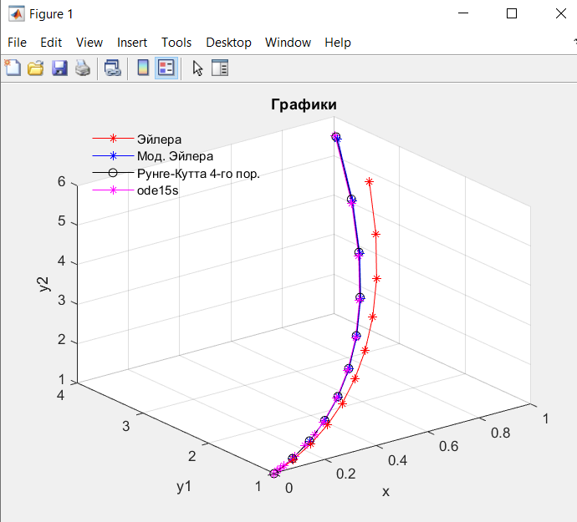

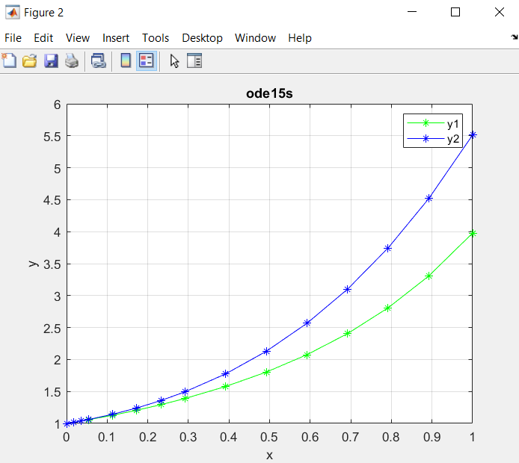

Lab13z2.m

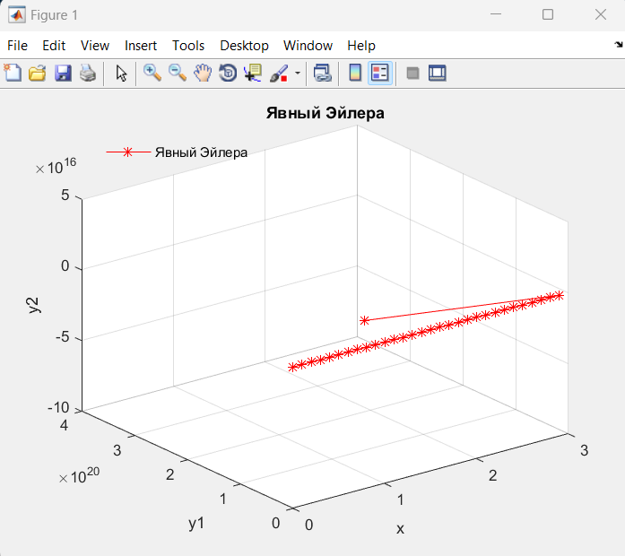 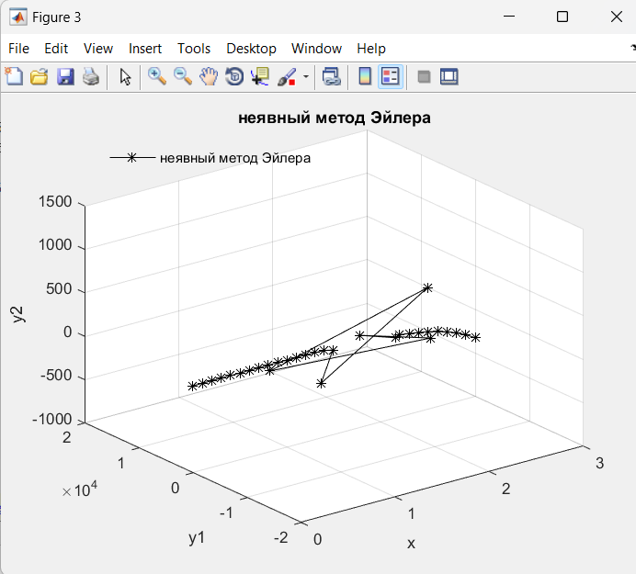

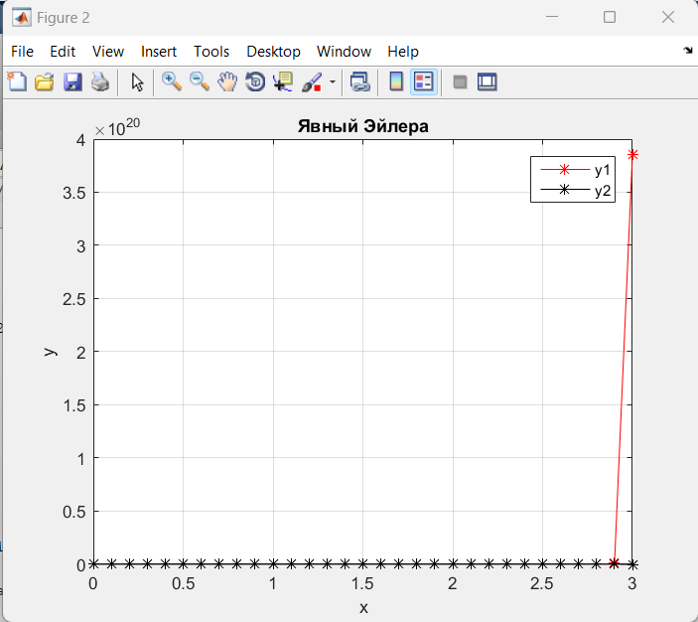 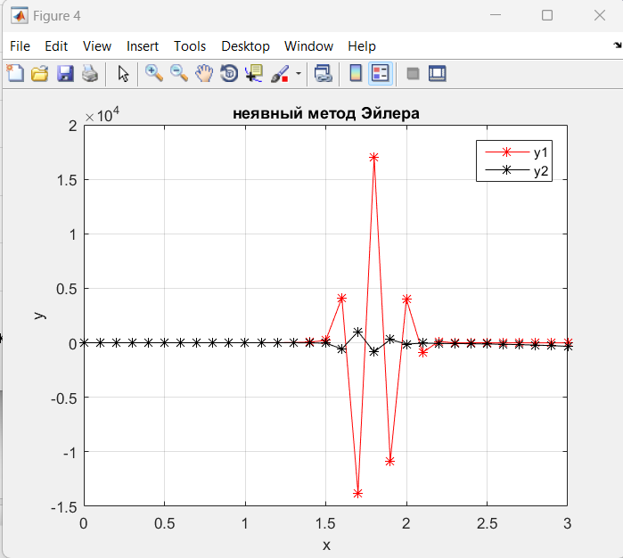

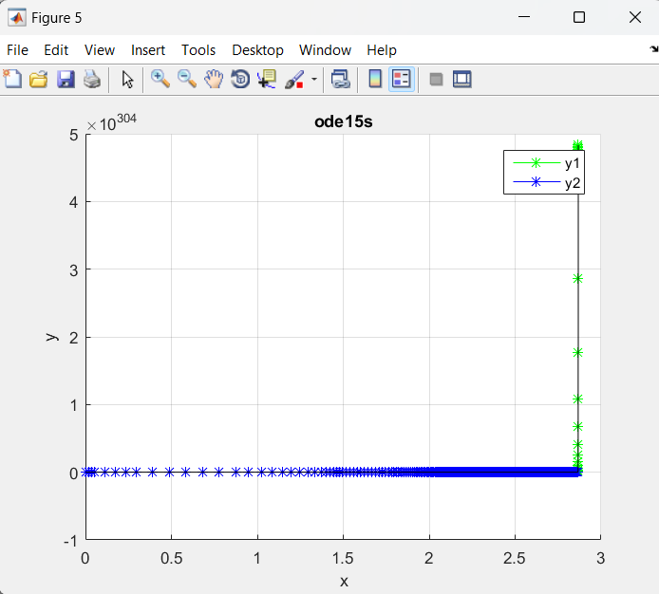

**Выводы**

Обычный метод Эйлера не так точно находит решение по сравнению с модифицированным (Эйлера-Коши), а также со стандартным, это видно по сходству с графиком Рунге-Кутта.

Явный метод Эйлера совсем не подходит для решения жёстких задач, поэтому то, что он вывел и кажется странным, явные методы в принципе не заточены для таких примеров, чего не скажешь о неявных методах. Неявный метод Эйлера тому подтверждение. В данной задаче очень высокая жесткость, поэтому даже неявный метод показывает неидеальный график, но во всяком случае намного лучше, чем любой явный (использованный стандартный метод – явный).