**Getting Started**

1. Download the latest release of [SLA](https://github.com/syjgino/SLA/releases) from Github and extract the zip file. To run it, simply find the SLA_V***.exe file and open it. (A prompt command window will open together with the GUI window. Please do not close the prompt window.)
2. To convert wiff file to mzml file, you need to download and install MSconvertGUI from [Proteowizard](http://proteowizard.sourceforge.net/download.html). Important: You should use the MSconvertGUI version downloadable in our Github entry, as minor formatting change may occur in new versions that create errors in SLA function.
3. A spreadsheet program must be installed on the control computer (i.e. Excel or LibreOffice).
4. Download Analyst method files and dictionary files. Copy all Analyst method files to the “Acquisition Methods” folder under the project folder you created with Analyst.
   * [KeyV1](https://github.com/syjgino/SLA/blob/v1.3/doc/KeyV1) for LWM version.
   * [KeyV3](https://github.com/syjgino/SLA/blob/v1.3/doc/KeyV3) for our extended version using Sciex Lipidyzer standard kit.
   * KeyV4 for new version using Avanti SplashOne as standard.

**Tuning**

**Instrument Setup**

1. This protocol assumes that users are utilizing a Sciex Lipidyzer with the 100ul sample loop installed in the Shimadzu Autosampler.
2. Prior to Tuning/Sample Run, make sure that the instrument is topped off with appropriate solvents and solutions. The pump system should be supplied with running buffer (50/50% Methanol/Dichloromethane with 10mM ammonium acetate). The auto-sampler wash should be topped off with 2-propanol. The SelexION should be supplied with 1-propanol as modifier.
3. Tuning solution is prepared by diluting EquiSPLASH™ LIPIDOMIX® (Avanti, 330731-1EA) 1 to 20 with running buffer. The syringe pump should be loaded with .5-1mL of this tuning solution and connected to the electrode (the autosampler output is disconnected from the mass spec for this step).
4. Load a sample vial containing running buffer in Position 1 in sample rack. This will be utilized in the Tuning and Suitability steps.

**Tuning Run**

1. It is recommended that you create a new project or subproject for each experiment in order to avoid confusion in appropriately tuned methods. In Analyst: Tools → Project → Create Project
2. Copy all Analyst method files from provided method folder to the current project “Acquisition Method” folder.
3. “Hardware Config” → Activate “Lipidyzer” profile
4. Acquire → Ready Instrument
5. Purge Modifier and wait 30min for instrument to warm up
6. While waiting, set up batches. Negative and positive infusion batches should each contain three repeats of the same respective method.
7. For Positive Batch: Build Acquisition Batch → add batch name(e.g. “Tune – *Date* – 1”) and add 3 samples named “POS1/2/3” (all drawing from vial position 1) → submit
8. For Negative Batch: Build Acquisition Batch → add batch name(e.g. “Tune – *Date* – 2”) and add 3 samples named “NEG1/2/3” (all drawing from vial position 1) → submit
9. Start syringe pump 3-5min before sample run start

**Tuning Analysis:**

1. Following the run, find and copy both sets of .WIFF files to a new folder in a location of your choice. Convert to mzml with MSConvertGUI. (Use the default setting in MSConvertGUI)
2. To read Tuning data with SLA, select the **Tuning** tab.
3. Click Import POS/Import NEG and choose the corresponding mzml files. (We recommend using the last one among the 3 replicates.)
4. Click Import Tune Dict to import the Tuning_spname_dict_xxx.xlsx file. If you need to make changes to the tuning mrm list, please read the “**Build New Method**” section.
5. The default settings on this tab are set for the provided tune method (v1, v3, v4) and don’t need to be changed. If you have created your own tuning method, you will need to select the starting value of COV and the ramp up step size appropriate to your method.
6. Choose peak finding method from drop down list. We recommend “Con9”.
   1. Max1: the maximum point
   2. Max3: the median of top 3 points
   3. Con5: the median of the maximum set of consecutive 5 values
   4. Con9: the median of the maximum set of consecutive 9 values
7. Hit the “Run” button, the auto selected peak results will be printed to the Result window and plots will pop out. (The Group column in the POS and NEG tab in Tuning_spname_dict_***.xlsx file are corresponding to the items listed under the Export area. You can customize it by editing the Group column.)
8. Fill in COV values in the Export area. You can copy and paste the recommended values from results to Export boxes. Alternatively, you can manually choose COV values. You can use your mouse to point at a different peaks in the plots. The x shown on the bottom right corner of the plot is the COV value. Hit ExportResult button when finished. Result will be saved to a .xlsx file in the same folder with Mzml files. (The excel file will be open automatically. A command prompt may pop-up. You can close it after the excel file is open.)
9. For V3: Note that most tuning mixes have a single LPC and LPE species and yet these subclasses have two different COV values for shorter and longer chain species. The calculation for the offset between these is provided on the tab.

[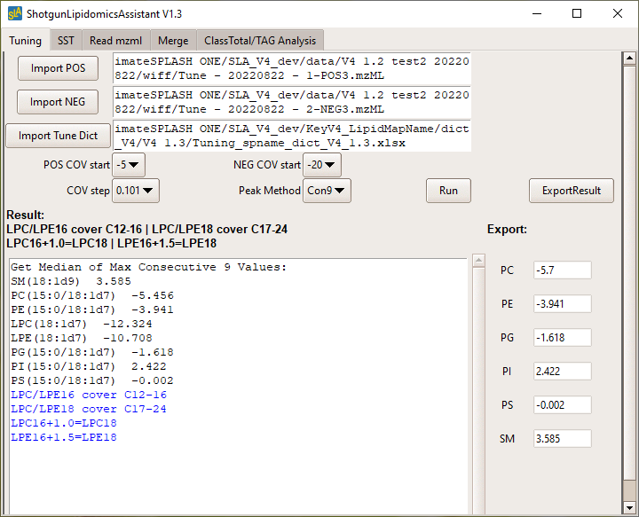](https://github.com/syjgino/SLA/blob/v1.3/doc/screeshot/Tune1.PNG) [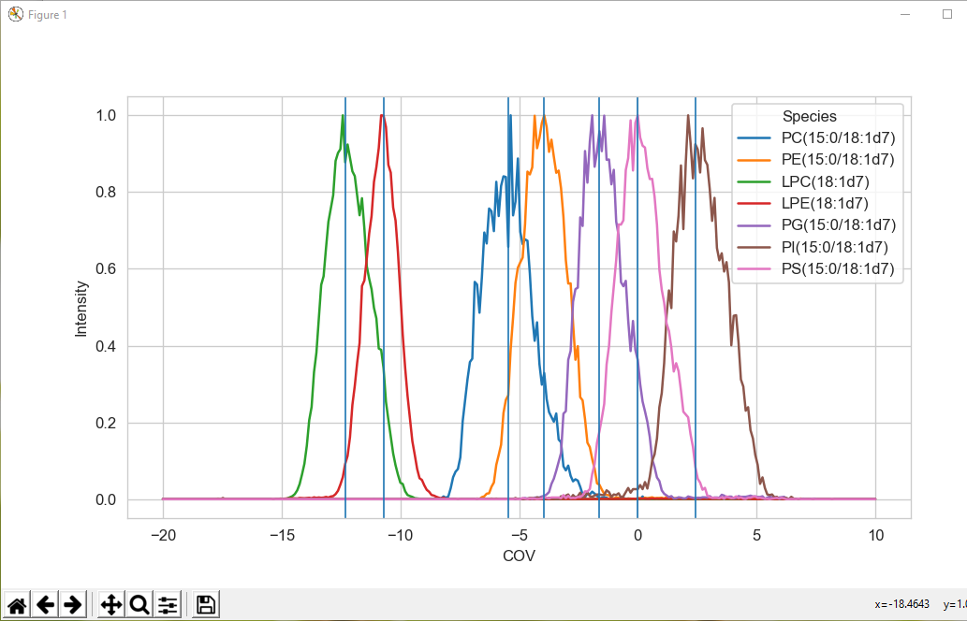](https://github.com/syjgino/SLA/blob/v1.3/doc/screeshot/Tune2.PNG) [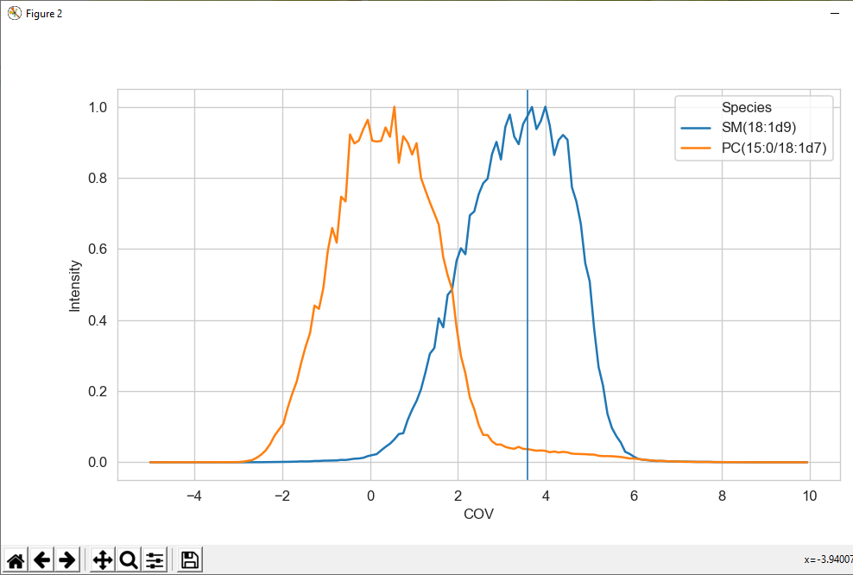](https://github.com/syjgino/SLA/blob/v1.3/doc/screeshot/Tune3.PNG)

1. Copy/paste the volt column to the corresponding Analyst method COV column. The “POS” and “NEG” tabs correspond to the respective experiments in “Method 1”. The SST tab contains COV values for both positive and negative experiments in the SST method. Save the respective files after this modification.

[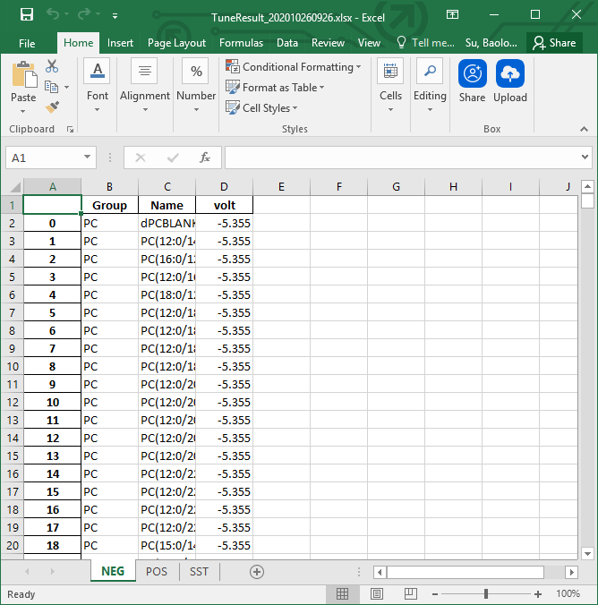](https://github.com/syjgino/SLA/blob/v1.3/doc/screeshot/Tune4.PNG)

**Suitability Test**

**Setup**

(Note: The Suitability Test is not required but is recommended to ensure that the instrument is in good working order and that the previous tuning step was carried out properly. The Suitability Test mix should be prepared fresh on a regular basis. Baseline results for the suitability test should be established and significant decreases should be troubleshot appropriately.)

1. The suitability test mix is prepared by diluting EquiSPLASH™ LIPIDOMIX® (Avanti, 330731-1EA) 1:100 with running buffer. It is recommended that a 1mL stock be prepared with 10μl of EquiSPLASH being diluted with 990µl of running buffer and used for 3-4 suitability tests.
2. Add suitability test mix in a robovial and place in the 105 position in the sample rack. Make sure there is sufficient volume of running buffer in the position 1 vial.
3. Reconnect the autosampler output to the source.

**SST Run**

1. If instrument was set to standby, a modifier purge and 30 minute warm up will be required before starting. If instrument remained ready after tune, you may proceed immediately to the suitability test.
2. Build batch using the “SST v3” method under the batch name “SST – *Date* - 1”. Create 2 samples in the batch: a “buffer” in vial 1 and a “LOD” in vial 105.
3. Submit and Run batch.

**SST Analysis**

1. Find and copy .WIFF files to a working folder. Extract to Mzml format with MSConverterGUI.
2. To read the Suitability Test results with the SLA, select the **SST** tab.
3. Import the Mzml file with the SST result (the “LOD” file above).
4. Import the Tuning_spname_dict_xxx.xlsx file.
5. Hit Run and the result will be saved to an xlsx file under the same directory with the Mzml file.
6. Compare results with previous suitability tests.

[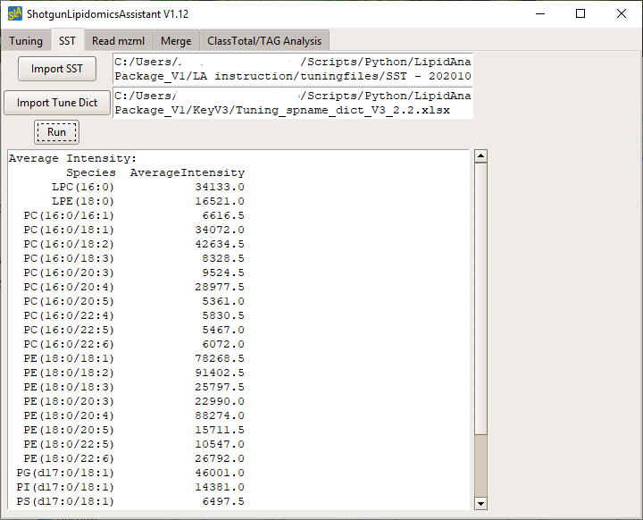](https://github.com/syjgino/SLA/blob/v1.3/doc/screeshot/SST1.PNG)

**Standard Preparation**

Note: These instructions describe the preparation of standards that matches the v4 Standard Dictionary posted here on Github. This formulation can be modified/optimized to specific user applications. In general, this standard formulation is roughly equivalent to the one quarter the amount of original amount of Lipidyzer standard and is ideal for the analysis of 25µl of plasma/serum. The concentration and amount of each standard to be added to a sample before extraction can be modified on the “StdInfo” tab of the standard dictionary excel file.

1. Acquire 6 Avanti standard products: Ultimate SplashOne (330820), dFA 18:1 (861809), dCer d18:0/13:0 (330726), Glu Cer(d18:1-d7/15:0) (330729), dLacCER d18:1/15:0 (330727), 15:0-18:1-d7-PA (791642).
2. Resuspend the four powdered products into DCM/methanol solution:
   1. dFA 18:1 (Avanti 861809)(10mg) – Resuspend and dilute to 10mL, creating a 1mg/mL stock. Using 1mL of the 1mg/mL stock, 10mL of a .1mg/mL stock can be prepared.
   2. dCer d18:0/13:0 (Avanti 330726)(1mg) – Resuspend and dilute in 10mL, creating a .1mg/mL stock. Then use 1mL of the .1mg/mL stock to create 10mL of .01mg/mL stock.
   3. Glu Cer(d18:1-d7/15:0) (Avanti 330729)(1mg) – Resuspend and dilute in 5mL, creating a .2mg/mL stock.
   4. dLacCER d18:1/15:0 (Avanti 330727)(1mg) – Resuspend and dilute in 10mL, creating a .1mg/mL stock.
3. Combine these six standards to create a cocktail to add to standards. Users will most likely want dry down this mixture and resuspend in a volume that can more consistently added to each sample (i.e. 25µl or 100µl) with solvents matching those used in the extraction. Alternatively, users performing a DCM/methanol based extraction can simply dilute the cocktail in DCM/methanol to obtain a more convenient volume. Here is an example of a cocktail prepared for 40 samples.

|  |  |  |  |  |
| --- | --- | --- | --- | --- |
|  | Avanti # | Con (mg/mL) | ul/sample | 40 samples |
| Ultimate SplashOne | 330820 | various | 2.5 | 100 |
| dFA 18:1 | 861809 | 0.1 | 1 | 40 |
| dCer d18:0/13:0 | 330726 | 0.01 | 1 | 40 |
| Glu Cer(d18:1-d7/15:0) | 330729 | 0.2 | 1 | 40 |
| dLacCER d18:1/15:0 | 330727 | 0.1 | 1 | 40 |
| 15:0-18:1-d7-PA | 791642 | 1 | 0.1 | 4 |
| **Total** |  |  | **6.6** | **264** |

1. Aliquot standards into samples and carry out extraction.

**Sample Run**

1. Lipid extracts are dried down, resuspended in 275ul and transferred to a robovial. Samples should be assigned numbers that are utilized in the batch setup. These numbers should be filled into the Sample Map (the first column) along with sample information.
2. These samples should be placed in the auto-sampler sample rack in appropriate order.
3. Prior to starting the run, make sure all solvents and running buffer are topped off.
4. If the instrument has been on standby before starting the sample run, a modifier purge and 30 minute warm up will be needed.
5. If you are performing a large experiment (60+ samples), it may be worthwhile to run Method 1 and Method 2 batches separately. This allows you to check over the samples and correct any plumbing problems before doing a second injection of precious samples.
6. Build batch:
   1. When creating a batch/set, the name should follow the format “name - date – method”. For example, “Lipidomics – 20220101 – 1” for a batch using method 1.
   2. Add sample: in this section, leave the Prefix blank for both “Sample name” and “Data file”.

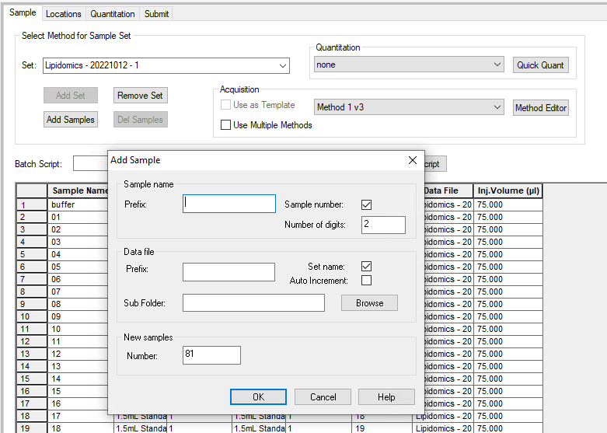

* 1. Fill in sample info: Each batch should be filled with the sample numbers assigned above in step 1. Each sample should be assigned with the correct vial positions.

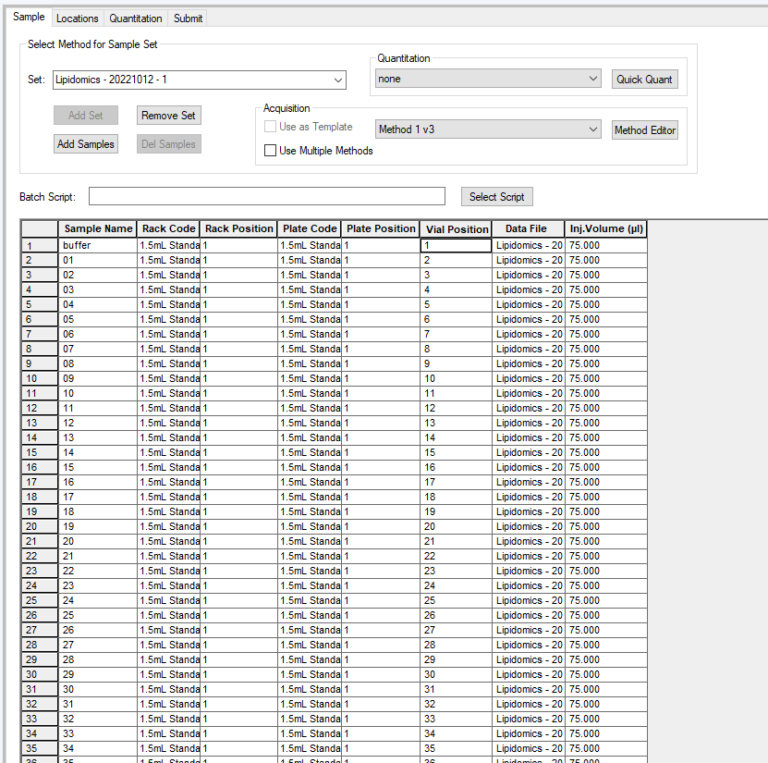

1. Note that all samples to be analyzed must be assigned with unique names. We recomend using 01 through 99 as sample names (01, 02... instead of 1, 2...), and names containing letters or symbols as controls (i.e. “buffer”, “QC”, “QCSpike”, etc.). These names should be in the same order to the first column in the map file and assigned sample information. (In the map file you can use 1, 2... instead of 01, 02...) Avoid using special characters here.

[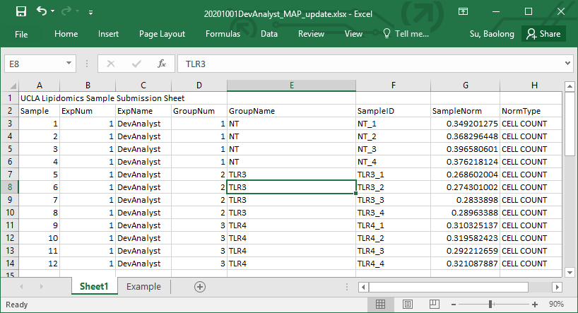](https://github.com/syjgino/SLA/blob/v1.3/doc/screeshot/Map.PNG)

1. Submit and run the batch. After completing both Method batches, proceed with data analysis.

**Data Analysis**

**Analysis Setup**

1. You will need a Species Name Dictionary (spname_dict_xxx.xlsx) and a Standard Dictionary (standard_dict_xxx.xlsx) to perform the data analysis step. Make sure these match the Analyst methods utilized in your sample run.
2. There is a **Mute** column in spname_dict_xxx. You can mute a species from the output by setting the value to TRUE and select “**Yes**” under the “**Mute Species**” dropdown menu in SLA. (Internal Standards and species end with “_2” are always muted from output.)
3. In our current dictionary, species names ending with "_2" denote for extra MRMs acquired for isotope correction, which are not included in the output. If you want to export these data, change “_2” to something else and put “TURE” in **Mute**. Please read the “**Build New Method”** instruction before making any changes to these dictionary files.

| **Q1** | **Q3** | **Mute** | **Name** |
| --- | --- | --- | --- |
| -700 | 200 | FALSE | dPCBLANK |
| -706.5 | 225.2 | FALSE | PC(12:0/14:1) |
| -736.5 | 255.2 | FALSE | PC(16:0/12:0) |
| -734.5 | 253.2 | FALSE | PC(12:0/16:1) |

1. To update internal standard information, open the “standard_dict_xxx.xlsx” file and go to sheet **StdInfo**. Make sure that the appropriate standards are listed, that the actual concentrations and volumes used match the standards you prepared. If you are using a different amount/type of sample than 0.025ml plasma, please adjust the SampleNorm factor in the map file so the SLA will get the correct normalization in the next step. Do not change the Coef column in the Standard_dict.
2. You will also need the Sample Map (sample submission form) you filled out while setting up the samples. Follow the example on the Sample Map. Make sure that each sample is appropriately demarcated into experiments and groups, and that the normalization values for each sample are correct. You can change it to rearrange them. To exclude samples, such as bad samples/subgroups or blank/QC_spike, you can assign them to a separate experiment, or simply exclude them from the map. For different type of samples, the sample normalization values are:
   * Plasma: volume in ml
   * Tissue: weight in mg
   * Cell: number of cell in 10 million

[](https://github.com/syjgino/SLA/blob/v1.3/doc/screeshot/Map.PNG)

**Read MZML**

1. Find and copy .WIFF files to an appropriate working folder. Convert to mzml format with MSconvertGUI. (Note: the program will read all mzml files in the folder. Please only keep the relevant mzml files there.)
2. Select the **Read mzml** tab on the SLA.
3. Set Directory to the folder of mzml files.
4. Import Standard_dict and spname_dict files.
5. Import isotope correction list if you want to do isotope correction.
6. Select the version of raw data file. (wiff file generated from LWM run or Analyst run)
7. If you want to mute species which you labeled as TRUE in the spname_dict file, chose Yes for Mute Species. Otherwise, all detected species will be reported.
8. Put in your project name. This will be added to the front of the name of exported files. You can also leave it blank.
9. Select the number of 0s/NAs allowed in standards and targets. By default, SLA will removes any MRMs that have more than 2 zeros out of 20 acquisitions. If any standards are found to have more than 2 zeros (or have an average raw intensity below 100), they are removed along with all unknowns that use that standard. Any remaining zeros within the data set are dropped (if any MRM data sets have 1 or 2 zeros) and the remaining values are averaged.
10. Choose Yes/No for isotope correction. If you select Yes, then the “Import iso dict” section must be filled.
11. Select number of scans you chose in Analyst. The default is 20 scans, which is used by the original LWM.
12. Hit Read MZML. Results will be saved under the same folder with the mzml files.

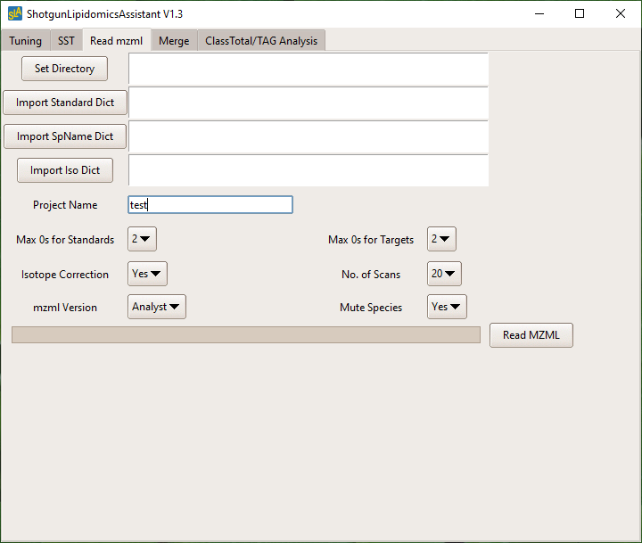

**Merge data with sample map**

1. Select **Merge** tab on SLA.
2. Set directory to where you want to keep the outputs.
3. Import sample map excel file. Then select the sheet name that contains the map.
4. Select output excel files m1&m2 from **Read mzml** session.
   * If you only run method1 or method2, then load the output to “Import Method1” and leave m2&m3 blank.
   * Leave method 3 blank unless you added another method to your experiment. To create a customized method, please read the **“Build New Method”** section.

[m1m2shot](https://github.com/syjgino/SLA/blob/v1.3/doc/screeshot/m1m2output.PNG)

1. Put in your project name or leave it blank.
2. Select if you want to export a csv file which can be uploaded to [ClustVis](https://biit.cs.ut.ee/clustvis/) for analysis.
3. Hit Run Merge. Results will be saved in the directory you selected.

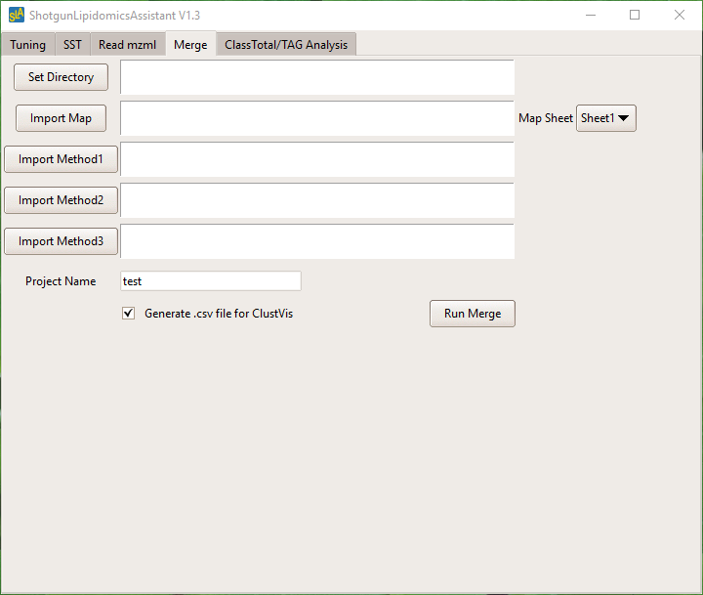

**Further Analysis**

1. Prior to performing the ClassTotal/TAG Analysis, you may want to move the primary data file to a new subfolder (especially if there are multiple data files from multiple demarcated experiments in the batch).
2. Select ClassTotal/TAG Analysis tab.
3. Load the *Exp* file from the Merge session

[expshot](https://github.com/syjgino/SLA/blob/v1.3/doc/screeshot/expfile.PNG)

1. Select if you want to add error bar and data points to the TAG analysis bar plots.
2. Hit Run TAG. Results will be saved under the same folder with your *Exp* file.

[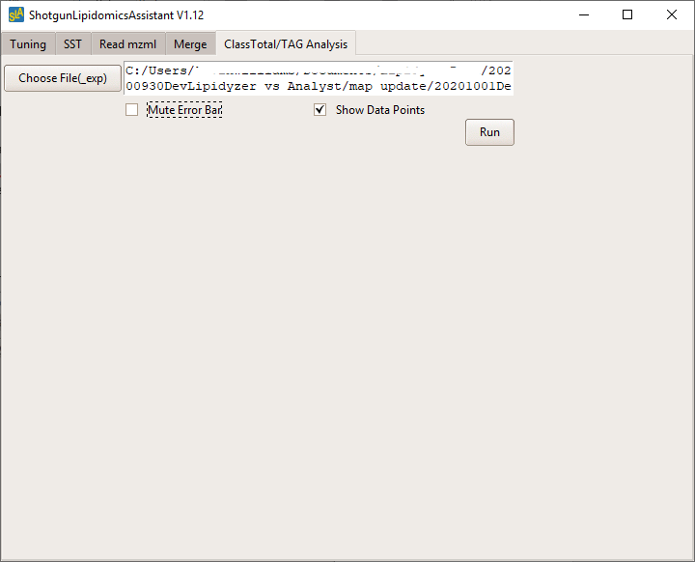](https://github.com/syjgino/SLA/blob/v1.3/doc/screeshot/TAG.PNG)

**Build New Method**

This section is for people who need to build their customized acquisition method. Besides the Analyst method files, there are 4 extra excel files needed: Species List, Standard Dictionary, Isotope Correction Dictionary and Tuning dictionary. All species names must be the same in these files. (Note: Please do not change the sheet's name, column name and column order in these dictionary files.)

**Species List (Spname_dict.xlsx)**

This workbook contains the information of species we scan for. The order of species should be the same as the MRM list in Analyst method, including the ***BLANK entries. These BLANK entries and inserted to give the machine time to adjust COV when using DMS. The Class column is used for class total analysis. The FA1/FA2 columns are used for fatty accid analysis. The Mute column is to label species that you don’t want to include in exported data files.

All species name must be unique in an entire experiment. If you measure the same species in 2 different methods and analyze both together, then you need to name them differently. Note that all species name start with “d” are considered as internal standards and will be automatically dropped in output data. All species name end with “_2” are also automatically dropped as extra scans on alternative tails for isotope correction.

[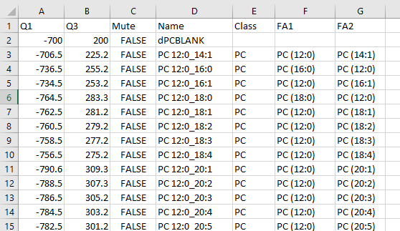](https://github.com/syjgino/SLA/blob/v1.3/doc/screeshot/spname.PNG)

**Standard Dictionary (Standard_dict.xlsx)**

This workbook contains the unknown to standard match dictionary and the standard information sheet. The Method1/Method2 sheets will take information from the **StdInfo** sheet to fill column **MW**, **Con** and **Vol**. These values are then used to compute the **Coef**, which is used to calculate unknown concentration. (We had observed that by rounding the Coef to 1 decimal place, we got the closest approximation to the LWM result. But keeping more decimal places might be better.) The SLA will search for the species name and grab the Coef. Note that all species acquired, including BLANK entries, internal standards and muted “_2” species, must be listed here.

The DupTail column is used to indicate if a species has 2 identical fatty acyl tails (i.e. PC 16:0_16:0). If TURE, then the **Coef** will be divided by 2.

[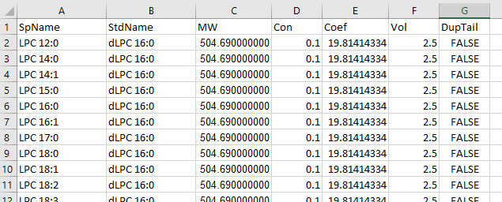](https://github.com/syjgino/SLA/blob/v1.3/doc/screeshot/standardkey.PNG)

The **StdInfo** sheet contains the standard information. The standard name, concentration, volume used and molar weight must be filled in column B-E correspondingly.

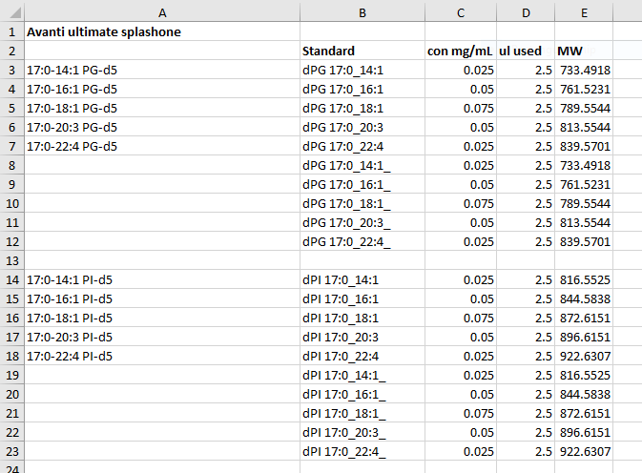

**Isotope Correction Dictionary (ISOcorrectlist.xlsx)**

This workbook contains the information needed to perform isotope correction. The species should be ordered ascendingly by the absolute value of Q1 and Q3.

Q1, Q3, Name: the mrm and name of the target species

P0: natural %abundance of the target species with no isotope

CT*: the name of the source species that could contaminate the target

CT*type: this column is for note, you can keep it blank

Pct*: %abundance of the source species that could contaminate the target

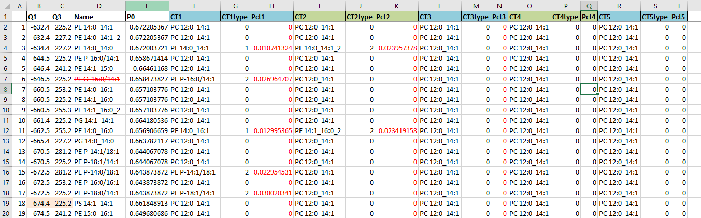

SLA can take up to 5 source of contaminations. Please do not remove or change the column names. All acquired species must be listed here, except the BLANK entries. If a species is not contaminated by multiple sources, simply put 0 in **Pct** and a dummy name in **CT**.

**Tuning Dictionary (Tuning_spname_dict.xlsx)**

This file contains all information needed for tuning and SST.

**Sheet 1/2:**

These 2 sheets contains all species acquired in tuning. Positive mode in sheet 1 and negative mode in sheet 2. All Q1/Q3 input here are in absolute value. Each set of Q1/Q3 must be unique. Each species name must be unique. The order of species in these 2 sheets can be free. They can also include extra species that are not acquired.

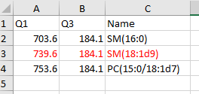

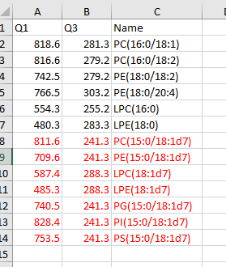

**SST/NEG/POS:**

This sheet contains all species acquired in SST method and species in NEG/POS mode in the actual acquisition method, including BLANK entries. The order of species in these 3 sheets must be the same as the Analyst method files, as you will copy and paste the output COV value into the Analyst method table. Each set of Q1/Q3 must be unique. Each species name must be unique.

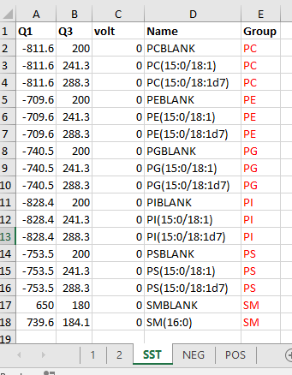

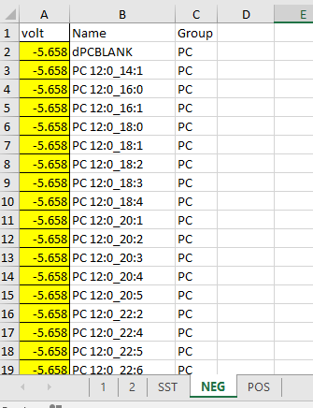

Put 0 in column **volt**.

The **Group** column is used to map the COV values. SLA will first use this column to create COV entry boxes, then it will fill these 3 tables by assigning your input COV to the species in that Group. For example, if you want to separate PC into 2 groups and use 2 different COV, simply put PC1 and PC2 for corresponding PCs in column **Group**.