Guide to DVD Chapter 36: *Andrew Beck*

**Embedded One-Bit Music:**

**Making Microcontrollers Sing**

Running the Random Sequencer on ATmega168

This code uses elements from the Embedded One-Bit Music DVD chapter to create a randomly changing sequencer. It will play a random sequence for a preset amount of time, and then create new parameters that will repeat exactly, creating intense pulsating rhythms of one-bit music.

First you must connect the AVRISP mkII programmer to the ATmega168 microcontroller.

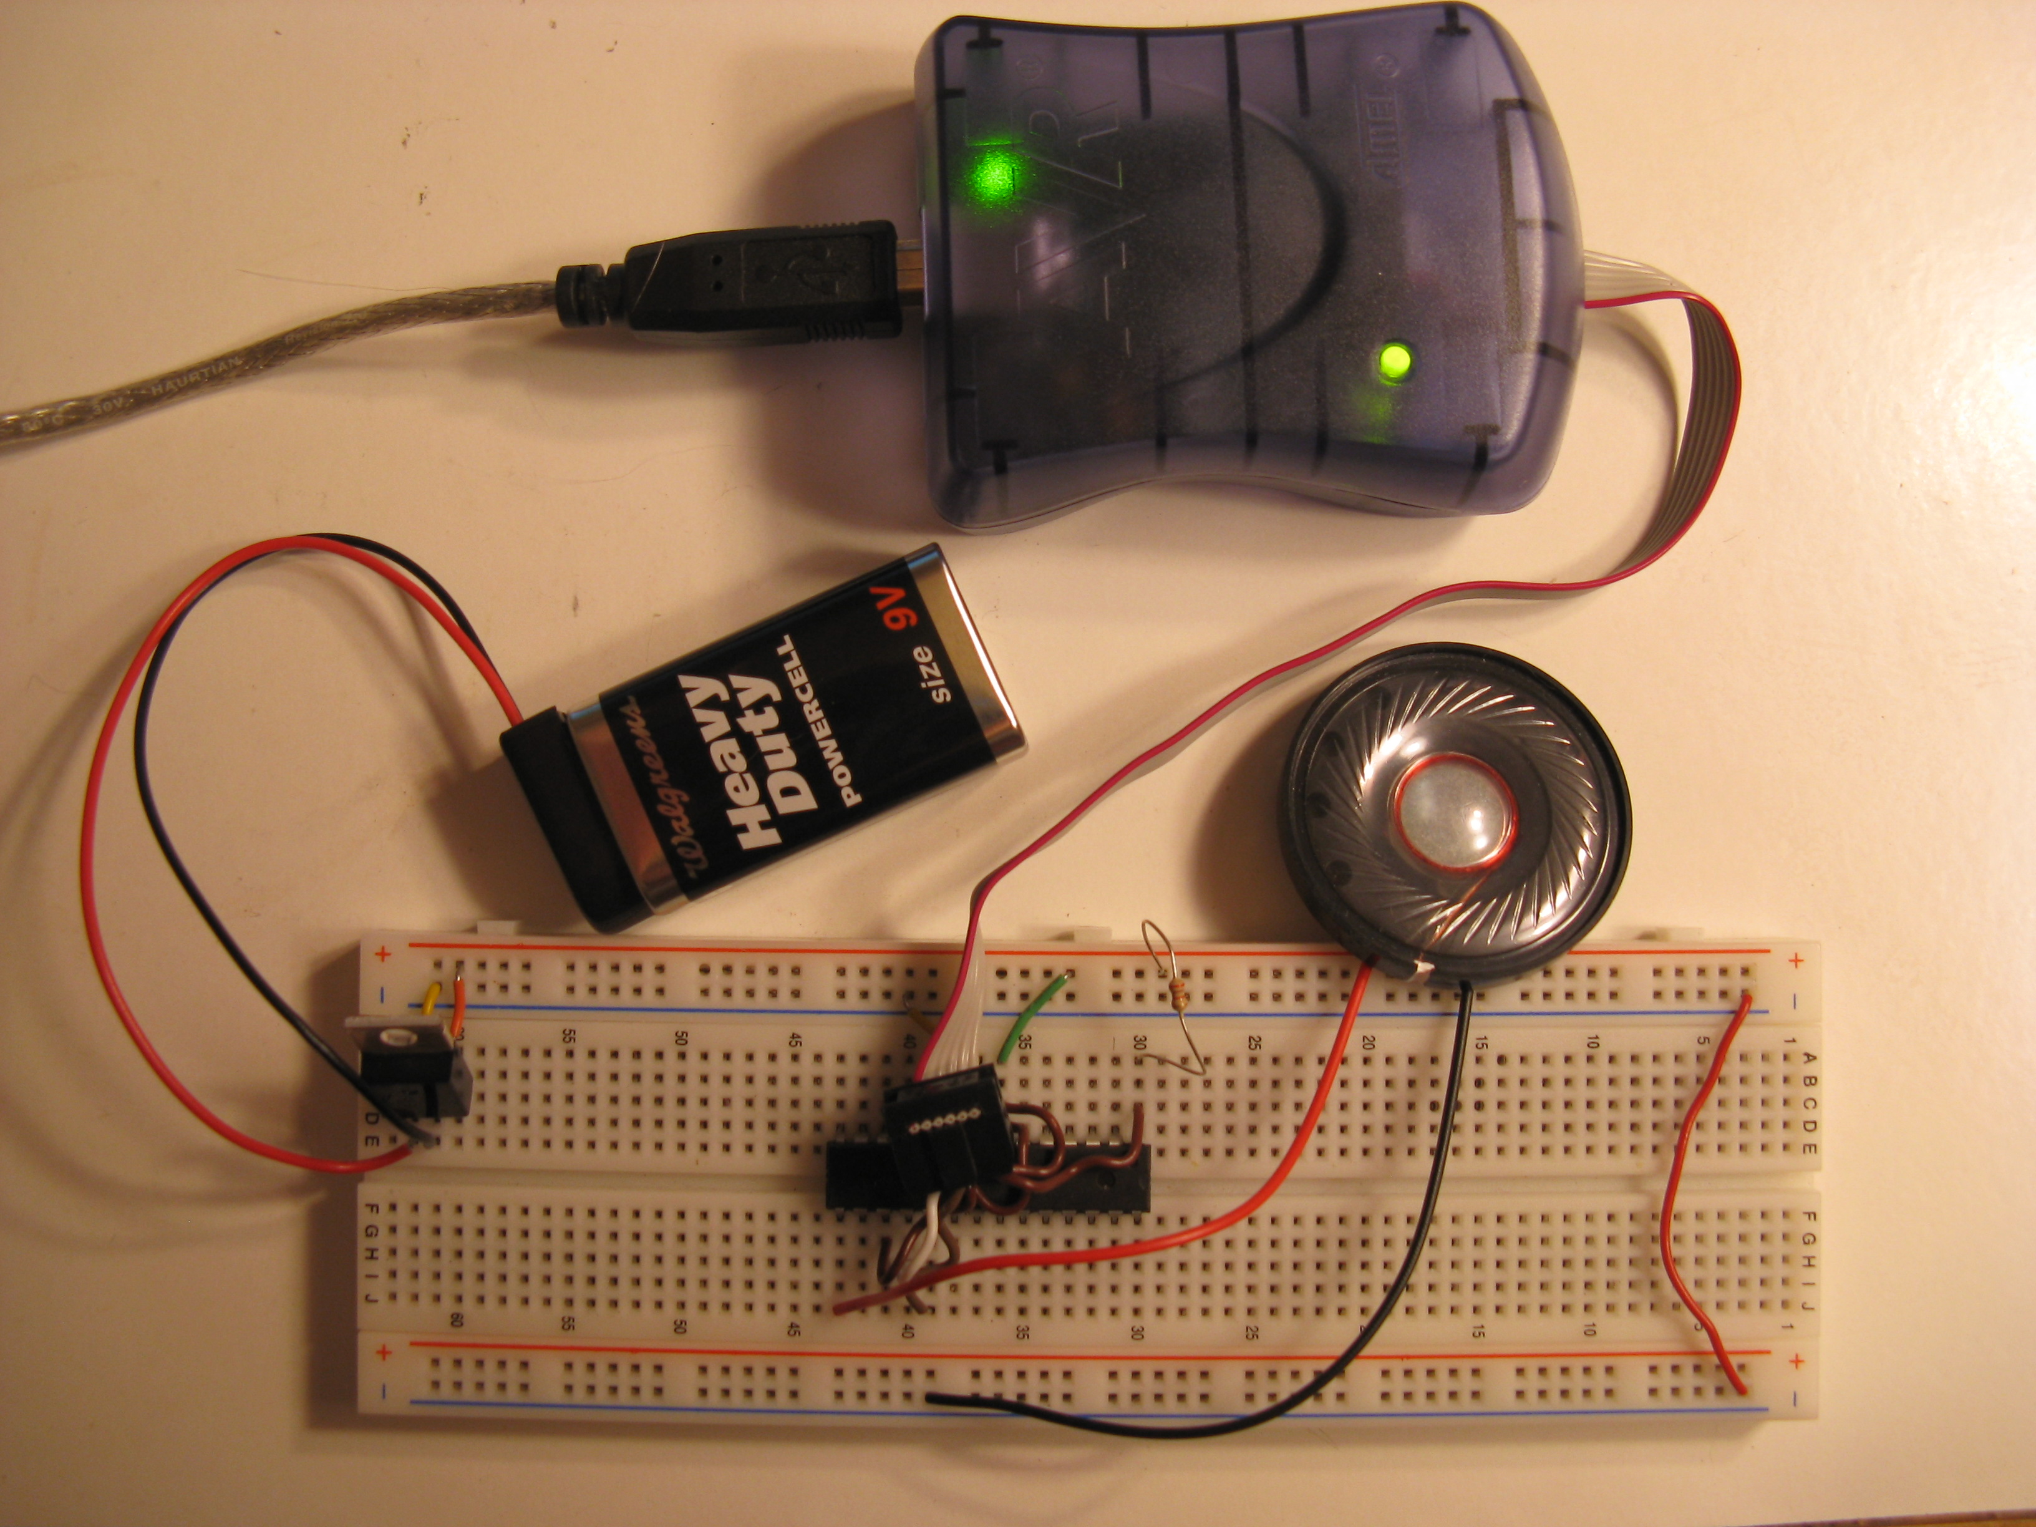

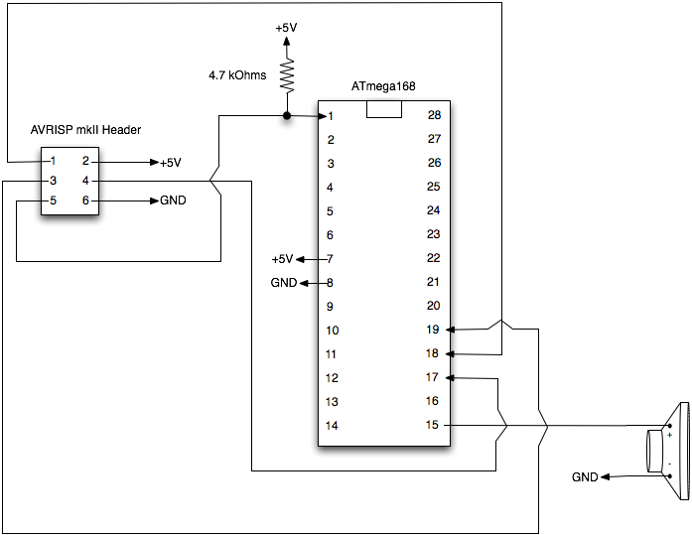

Refer to the chapter for detailed instructions on connecting the programmer.

**Windows**

Install AVR Studio 4 (<http://www.atmel.com/dyn/Products/tools_card.asp?tool_id=2725>) and WinAVR (<http://winavr.sourceforge.net/>).

Open the AVR Studio project file (*SeqExample.aps*) and Click “Build->Build”, then “Tools->Program AVR->Connect” to connect to AVRISP mkII. Under the “Program” tab, choose the output hex file from the “default” directory, then click “Program”.

**OS X**

Install CrossPack for AVR Development (<http://www.obdev.at/products/crosspack/index.html>) which includes the AVR GCC compiler as well as avrdude for connecting to the AVRISP mkII.

From the terminal, set GCC 3 as the default compiler.

avr-gcc-select 3

You can either create a new project and copy the code in:

Create a new AVR project

avr-project SeqExample

Open the MakeFile in SeqExample/firmware/ in a text editor.

Replace

DEVICE = atmega8

with

DEVICE = atmega168

Replace

PROGRAMMER = -c stk500v2 -P avrdoper

with

PROGRAMMER = -c avrisp2 -P usb

Now open *main.c* and copy and paste *SeqExample.c* from the windows examples directory into *main.c*.

Or you can use the example project in the OSX-Linux directory

From the terminal, go to the SeqExample/OSX-Linux/firmware directory, then run

make

Then

make flash

**LINUX**

You’ll need to install avr-libc, avrdude, libusb, and all their dependencies.

Unfortunately I have not used Linux to compile this code so I can’t walk through the details.