Guide to DVD Chapter 20 Examples: Jaeho Chang

Composing Noise

There are three examples of algorithmic sound synthesis written in C++ especially using Xcode. This guide tells you how to run these example projects.

Installing Xcode
Xcode is a full-featured integrated development environment that is part of Mac OS X. You can install Xcode that is included on Mac OS X Install DVD. You can also download and install the latest version of Xcode from the Apple Developer Connection site at: http://developer.apple.com/tools/xcode/

Opening a Project
An Xcode project is not a single file, but consists of a number of files. To open a project, you should locate the file with the extension xcodeproj in the project folder and double-click it.

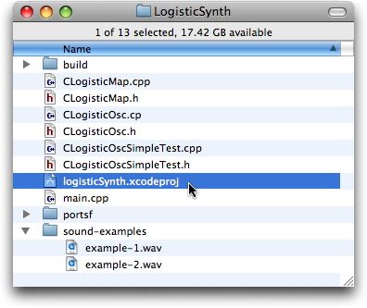

Supplying Arguments
Before running a project, you should supply arguments to the executable of the project. This can be done with just a few clicks as follows:

- Click the triangle button beside the Executables group in the Groups & Files list, and then double-click the executable file.
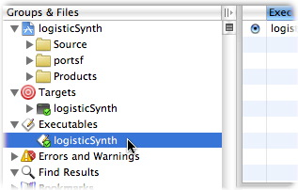
- In the executable inspector, click the Arguments tab.
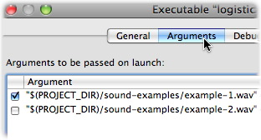
- There are example argument settings you can test. You can choose one by using the checkbox on the left side. After reading the text, you may want to add your own argument settings in this window to explore the example.

Running a Project
To run a project, click 'Build and Go' button on the toolbar, or select 'Build and Go' from the Build menu.

