Guide to DVD Chapter 29 Examples: Andrew Beck

Alternate Controllers: Connecting to HID Devices in Cocoa – HidToOSC

HidToOSC

With this program you can tie each element to a unique OSC message. Whenever the delegate method elementUpdated is called, an OSC message is sent to the address and port given by the user with the OSC name that the user types in the text field and a float value from the element.

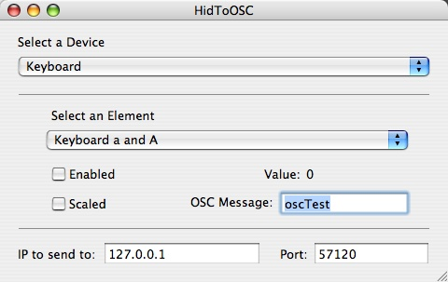

Included with HidToOSC is a Csound file, oscTest.csd, that will generate short notes whenever it receives an OSC message titled “oscTest”.

Using HidToOSC with oscTest.csd.

- Open oscTest.csd in Csound and run it. It will now be listening for OSC messages.
- Run HidToOSC. By default, the IP is set to “127.0.0.1”, also known as the loopback address. This means that we will be sending OSC messages to our own computer. The port number is set to 57120, which is the port we are listening to in the Csound file.
- Select a device, such as keyboard.
- Select an element, such as ‘Keyboard a and A’ (the letter ‘a’ on the keyboard).
- Select ‘Enabled’. When you press ‘a’ you should see the Value change from 0 to 1.
- Type a message in the text field to send an OSC message whenever the value changes. In this case, type “oscTest” since we are waiting for that address in Csound.

