Guide to DVD Chapter 29 Examples: Andrew Beck

Alternate Controllers: Connecting to HID Devices in Cocoa – HidToSound

HidToSound

HidToSound will generate different sounds based on input from a HID device. Under “savedFiles” there are example files that show feedback from the mouse and keyboard. This program will work on joysticks as well, but only keyboard and mouse files are included for compatibility reasons.

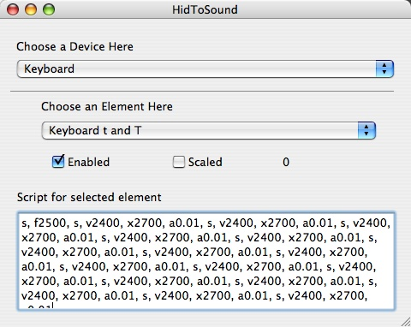

First, try loading some of the example files – these should work with all generic Apple keyboards and mice.
circusMouse.xml – turns your mouse or track pad into strange journey though time and space.

funkyKeyboard.xml – will bring the funk to your keyboard.

keyboardEffects.xml – is like your own mini “Louis and Bebe Barron” inside your computer.

How to Create Your Own Sounds in HidToSound:

At the heart of the program, the user creates a script that will be run for each individual element. The script is run anytime the value is not zero (i.e. for buttons, when they are depressed, but not when they are released).
Select a device, such as “Keyboard”, and select an element, such as “Keyboard a and A”, which corresponds to the ‘a’ button. Click ‘enabled’.
The simplest script will generate a short tone. You can create a sine wave tone by entering a single ‘s’, a square wave by entering a ‘q’, and saw tone by entering ‘w’. Press ‘enter’ to set the script.
After setting a tone, you can edit various parameters by entering new commands. Separate all commands by a comma and a space (“, “). The script is very strict and a comma and space should always be directly followed by a new command. All the commands below work on the last created tone.

‘f’ – Sets the frequency
‘a’ – Sets the amplitude
‘d’ – Sets the duration
‘b’ – Sets the attack time in seconds
‘e’ – Delays the start of the sound by a certain number of seconds
‘h’ – Sets the ending frequency (IE a glissando from frequency to ending frequency over the whole sound)

So for example the script “s, f100” would create a sine wave at 100Hz, “s, 60, q, f140” would create a sine wave at 60Hz and a square wave at 140Hz. “s, e1” would play a sine wave after 1 second, etc. Look at the saved files for more complicated examples.

The following commands require two commands to be run.

‘v’ followed by ‘x’ – Set to a random frequency between two values
‘v’ followed by ‘y’ – Set to a random amplitude between two values
‘v’ followed by ‘z’ – Set to a random duration between two values

For example, “s, v500, x900” would create a sine wave with a random frequency between 500Hz and 900Hz.

‘m’ followed by ‘n’ – Set frequency to element value times ‘m’ plus ‘n’
‘m’ followed by ‘o’ – Set amplitude to element value times ‘m’ plus ‘o’
‘m’ followed by ‘p’ – Set duration to element value times ‘m’ plus ‘p’

Let’s say you have a scaled value between 0 and 1. Running “s, m50, n100” would linearly scale the frequency between 100 and 150.

