Guide to DVD Chapter 34 Examples: Federico Saldorini

Waveshaping: From Csound to Cocoa

To compile the project for this chapter, you will need version 3 or newer of the Apple Developer Tools package for OS X. If you don’t have this package or you have a version prior to 3.0, the latest version can be downloaded, free of charge, from:

http://developer.apple.com/technology/Xcode.html

The only requirement for downloading these tools is that you sign up for a free Apple Developer Connection membership.

Among the many tools included, in this chapter we will use:

- Xcode, an integrated development environment (IDE) that serves as a front end to the gcc toolchain.
- Interface Builder, a visual design tool for creating and testing graphical user interfaces.
- AU Lab, a DAW-like hosting application that is used for testing audio units.
- AUVAL, a command-line tool for validating audio units.

The developer tools package will also install all the necessary frameworks that are required to develop both audio units and Cocoa-based applications.

Polynomial8

The Polynomial8 folder, inside the examples folder, contains the entire project that
this chapter is based on.

Opening the Project

To open the project, double-click on the file Polynomial8.xcodeproj.

Compiling the Project

To compile the project, click the Build icon in Xcode. As explained in section 3 of the tutorial, each time you build the project a new copy of the audio unit (a file named Polynomial8.component) will be installed in your root plug-ins directory. The full path to this directory is /Library/Audio/Plug-Ins/Components/.

Testing the Project

Since an audio unit is a plug-in, it can’t be directly run or debbuged from within Xcode or as a stand-alone application. Instead you need to test the audio unit from within an audio-unit compatible host. Further, to test the audio unit through its Cocoa custom view, the host needs to support Cocoa views. The easiest way to test audio units (including those with Cocoa views) is through AU Lab. This is also the method that Apple recomends for initial testing.

The audio unit for this tutorial has a few parameters to test. So, a convinient way of testing the unit would be by using it to process an audio loop. To test the audio unit in AU Lab in this way, follow these steps:

Make sure you have compiled the project and that there is a copy of the audio unit component in the appropriate folder in your hard-drive, as discussed under Compiling the Project.

Launch AU Lab and create a new document. The document’s default input/output settings should be enough for our purposes. Just make sure that your document has at least one output track. Also, make sure to choose your desired output device from the “Specify the Audio Device” drop-down menu, as in Figure 1:

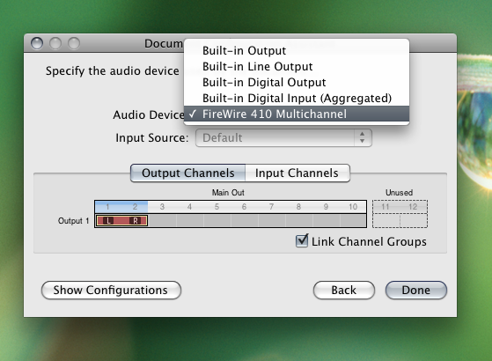

Figure 1 Selecting an audio output device for a new document in AU Lab.

In the newly created document, you need to create a playback device to continuously loop some audio file. The output of this device will be the input to our audio unit. To create the playback device, select “Add Audio Unit Generator…” from the “Edit” menu (Figure 2):

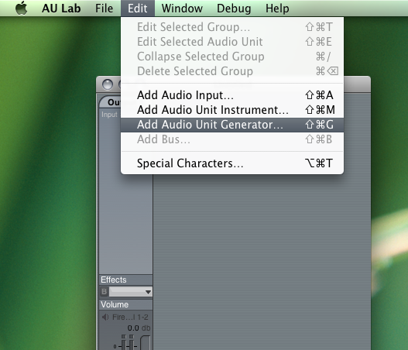

Figure 2 Creating a file playback audio unit in a new AU Lab document.

Make sure the selected generator is of type “AUAudioFilePlayer” and click “OK” to create it. With the new generator track in place, click on the “Audio Files + …” tab inside the generator’s playback list and, when presented with the “Open” dialog box, select an audio file of your choice (Figure 3):

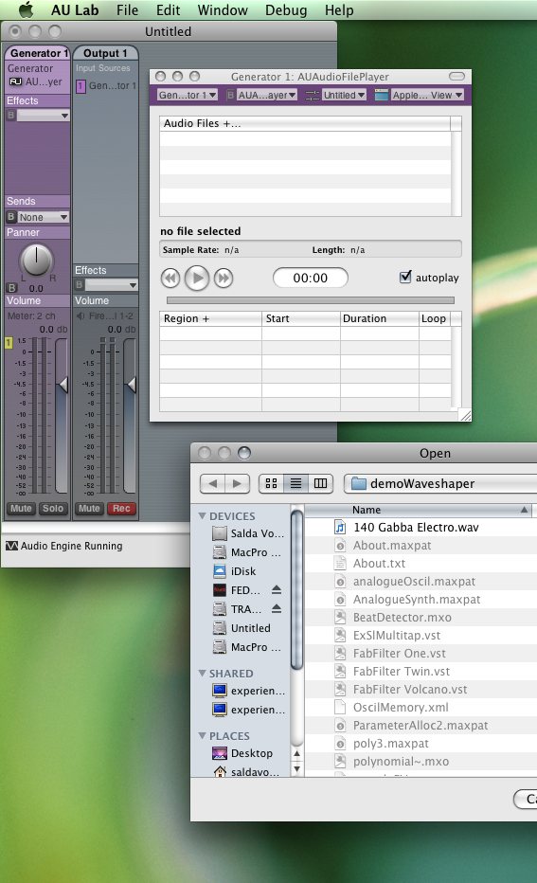

Figure 3 Selecting an audio file to playback in a new AU Lab document.

Also, make sure that the “autoplay” box is checked in the generator’s interface. This checkbox determines whether the selected audio file will continuously loop or not. At this point, you can click the Play button in the generator’s interface and your selected audio file should start playing.

Finally, you need to create an instance of the Polynomial8 audio unit. You do this by clicking on the “Effects” slot in your output track (“Output 1” in Figure 3) and selecting the unit from the drop-down menu (Figure 4):

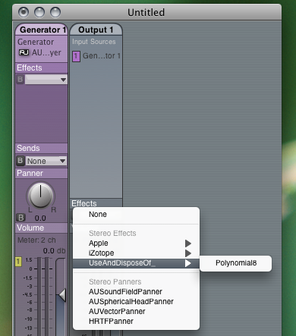

Figure 4 Creating an instance of the Polynomial8 audio unit in AU Lab.

At this point, the audio unit should load and you should see its Cocoa view in Au Lab. To switch between the unit’s Cocoa and generic views, simply select either from the unit’s upper-right drop-down menu (Figure 5):

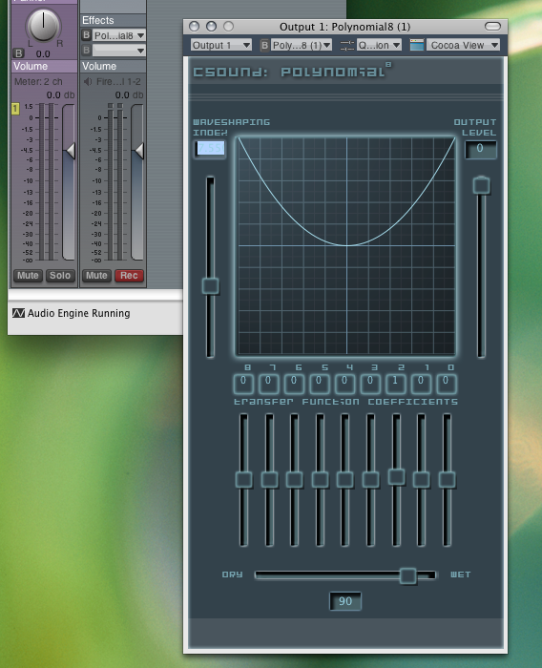

Figure 5 Instantiated Polynomial8 audio unit with Cocoa view in AU Lab.

