Become the

“IndiaMART + Razorpay + Zoho + Udaan” for industrial machinery

High-Impact Features You Should Add

🔎 A. Advanced Filtering & Buyer Intelligence
Add filters like:
- Machine condition (New / Refurbished / Used)
- Power requirement (kW / HP)
- Production capacity per hour
- Automation level (Manual / Semi / CNC / Fully Auto)
- Location (state-wise industrial clustering)
- Lead time
- GST invoice available
- Warranty period
This instantly increases serious buyer trust.

B. Smart Machine Comparison Tool

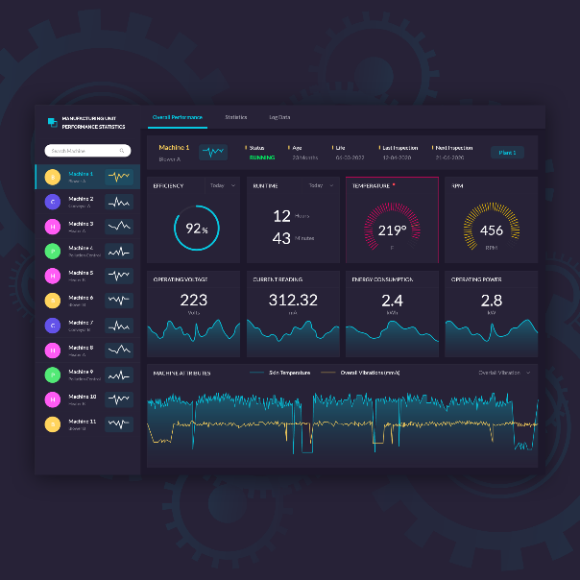

Let buyers:
- Select 3 machines
- Compare:
  - Price
  - Capacity
  - Warranty
  - Power usage
  - After-sales support
  - Spare availability
This builds decision infrastructure.

C. In-App Negotiation Layer
Industrial buying is negotiation-heavy.
Add:
- “Request Best Price”
- Quote system (RFQ module)
- Counter-offer workflow
- Seller response time tracking
- Chat history storage
This makes you sticky.

D. RFQ (Request for Quotation) Broadcast
Very powerful feature:
Buyer posts:
“Need 20 HP Hydraulic Press, Delhi, Budget ₹8–10L”
System:
- Notifies 25 relevant suppliers
- Suppliers submit quotes
- Buyer compares in dashboard
This is how you scale liquidity.

E. Spare Parts & Service Marketplace
Huge gap in India.
Add:
- AMC contracts
- Service technicians
- Spare parts listings
- Machine installation services
You become lifecycle platform, not just marketplace.

F. Payment & Escrow Layer (Future V2)
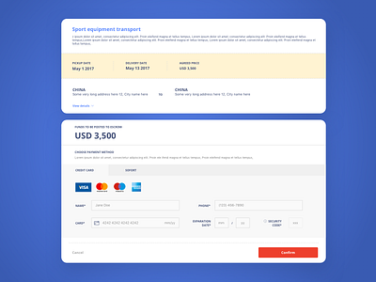

Industrial buyers fear fraud.
Add:
- Escrow payments
- Milestone release
- Inspection-based payment unlock
- GST invoice automation
This builds serious trust.

G. Seller Dashboard Analytics
Give sellers:
- Profile views
- Lead conversion rate
- Response time ranking
- Market demand trends
- Category heatmap
If you want recurring revenue → this is key.

H. Industrial Cluster Intelligence
India is cluster-driven:
- Ludhiana (forging)
- Coimbatore (machinery)
- Rajkot (machine tools)
- Faridabad (fabrication)
- Ahmedabad (textiles)
Add:
- “Browse by Industrial Hub”
- Heatmaps of supply-demand
- Cluster-based vendor ranking
This becomes a moat.

3️⃣ Trust Infrastructure (Critical in India)
Industrial marketplace success = trust.
Add:

✅ Seller Verification Badges
- GST verified
- Factory visit verified
- Years in business
- ISO certification

📸 Real Factory Videos
Video builds credibility faster than text.

📞 Assisted Procurement
Add:
“Talk to Procurement Expert”
Even a basic callback form helps.

4️⃣ Revenue Model Suggestions
Here’s how you can monetize intelligently:

💰 1. Featured Listings
Top placement in category.

💰 2. Verified Seller Subscription
₹3,000–₹15,000 / month tiers.

💰 3. Commission on Closed Deals (future)
0.5%–2% on transactions.

💰 4. RFQ Boosting
Suppliers pay to receive premium RFQs.

💰 5. Data Insights Subscription
Industrial pricing trends for serious buyers.

5️⃣ UX Improvements to Implement
Without seeing your exact UI live here, generally for industrial marketplace:

Make it:
- Dark industrial aesthetic (steel grey, electric blue accents)
- Large specification cards
- Data-heavy, but clean
- Minimal marketing fluff
- High credibility feel

Homepage Should Clearly Say:
Instead of generic marketplace language:
“India’s Industrial Equipment Exchange”
“Buy. Sell. Source. Secure.”
“Verified Machinery Marketplace for Manufacturers.”
Clarity builds authority.

6️⃣ Strategic Long-Term Play
The real moat is:

🧠 Data
If you track:
- Machine demand by region
- Average deal sizes
- Price fluctuations
- Most searched equipment
You can:
- Build pricing index
- Offer demand prediction
- Become industry intelligence provider
That’s where valuation increases.

7️⃣ Expansion Path
Phase roadmap suggestion:

Phase 1
- Listings
- RFQ
- Verified sellers

Phase 2
- Escrow
- Financing partners
- Insurance tie-ups

Phase 3
- Inventory financing
- Equipment leasing
- Export sourcing
- Cross-border trade (Middle East / Africa)

8️⃣ Competitive Angle
IndiaMART is:
- Broad
- Lead spam heavy
- Not machinery-specialized
Your advantage:
- Category depth
- Serious buyers
- Clean UX
- Industrial focus
Stay niche → win trust → then scale.

