AUZAARBAZAAR LANDING PAGE

HERO SECTION
Headline:
India’s Trusted Industrial Equipment Marketplace
Subheadline:
Buy, sell, and source verified machinery with confidence.
Auzaarbazaar connects manufacturers, suppliers, and buyers across India through a secure and transparent procurement platform.
Primary CTA:
🔎 Browse Machinery
Secondary CTA:
🏷 List Your Equipment
Trust Bar:
GST Verified Suppliers | Industrial Buyers Across India | Secure Inquiry System | RFQ Enabled

SECTION 2 — WHAT WE DO
Headline:
Built for India’s Manufacturing Economy
Copy:
Auzaarbazaar is a specialized marketplace designed exclusively for industrial machinery and equipment.
Whether you're a factory owner looking to upgrade production capacity, or a supplier seeking serious buyers, our platform simplifies discovery, negotiation, and procurement.
We focus on:
• CNC Machines
• Fabrication Equipment
• Hydraulic & Mechanical Presses
• Packaging Machinery
• Electrical & Automation Systems
• Industrial Spare Parts & Tools

SECTION 3 — HOW IT WORKS
Headline:
A Smarter Way to Buy & Sell Machinery
For Buyers:
- Search or filter by machine type, capacity, and location
- Compare specifications instantly
- Send inquiries or request custom quotations
- Connect directly with verified suppliers
For Sellers:
- Create a verified supplier profile
- Upload machinery listings with detailed specifications
- Receive qualified buyer inquiries
- Close deals faster

SECTION 4 — TRUST & VERIFICATION
Headline:
Procurement Without Uncertainty
Industrial purchases require trust.
That’s why Auzaarbazaar emphasizes transparency through:
✔ GST-verified suppliers
✔ Detailed machine specifications
✔ Direct supplier communication
✔ RFQ broadcast system
✔ Location-based sourcing
We are building a cleaner, more reliable alternative to fragmented B2B listings.

SECTION 5 — FOR SERIOUS INDUSTRIAL BUYERS
Headline:
Compare. Evaluate. Decide.
Industrial decisions are data-driven.
Our platform enables:
• Specification-based filtering
• Multi-machine comparison
• Region-based sourcing
• Direct quotation requests
• Negotiation transparency
No unnecessary intermediaries. No listing clutter.

SECTION 6 — INDUSTRIAL CLUSTERS (Authority Building)
Headline:
Serving India’s Manufacturing Hubs
From Ludhiana to Coimbatore.
From Rajkot to Faridabad.
From Ahmedabad to Pune.
Auzaarbazaar connects India’s industrial clusters into one digital procurement network.

SECTION 7 — FOR SELLERS
Headline:
Grow Your Industrial Reach
Join a platform built specifically for machinery suppliers.
Gain access to:
• Verified industrial buyers
• RFQ demand broadcasts
• Performance analytics dashboard
• Featured listing upgrades
• Brand credibility through verification

SECTION 8 — FUTURE VISION (Subtle Authority Signal)
Headline:
More Than a Marketplace
Auzaarbazaar is evolving into a complete industrial procurement ecosystem, including:
• Escrow-secured transactions
• Equipment financing partnerships
• Installation & service marketplace
• Industrial demand intelligence
We are building the digital backbone of India’s machinery trade.

FINAL CTA
Headline:
Start Sourcing Smarter Today
Whether you’re expanding production or listing equipment,
Auzaarbazaar helps you move faster and transact with confidence.
[ Browse Machinery ]
[ List Your Equipment ]

Footer Tagline
Auzaarbazaar — India’s Industrial Equipment Exchange.

Below is a complete homepage layout architecture with:
- Visual hierarchy
- Spacing system
- Section flow
- Typography scale
- Industrial aesthetic direction
- Conversion optimization

OVERALL DESIGN DIRECTION

Brand Personality:
Industrial. Structured. Precise. Trustworthy. Data-driven.

Color System:
- Primary: Deep Steel Blue (#0F172A / slate-900 style)
- Accent: Electric Blue (#2563EB)
- Secondary: Industrial Grey (#334155)
- Highlight: Safety Orange (#F97316) for CTAs
- Background: Light Graphite (#F8FAFC)
Avoid “startup gradient” vibes.
Think: Siemens + Caterpillar + Razorpay Enterprise.

PAGE STRUCTURE (Top to Bottom)

1️⃣ NAVIGATION BAR (Height: 80px)
Layout:
Left → Logo
Center → Primary Links
Right → CTA buttons
Menu Items:
- Browse Equipment
- Categories
- RFQ
- Industrial Hubs
- For Sellers
Right Side:
[ Login ]
[ List Equipment ] (Primary CTA button)
Sticky navigation on scroll.

2️⃣ HERO SECTION (Above the Fold)
Height: 85vh
Padding: 120px top, 100px bottom

Layout Grid: 2 Columns (60/40 split)

Left Column:
Large Headline (H1 – 52px weight 700)
India’s Trusted Industrial Equipment Marketplace
Subheading (18–20px)
Then CTA buttons:
[ Browse Machinery ] – Primary
[ Post RFQ ] – Secondary outlined
Below CTAs:
Small trust badges row.

Right Column:
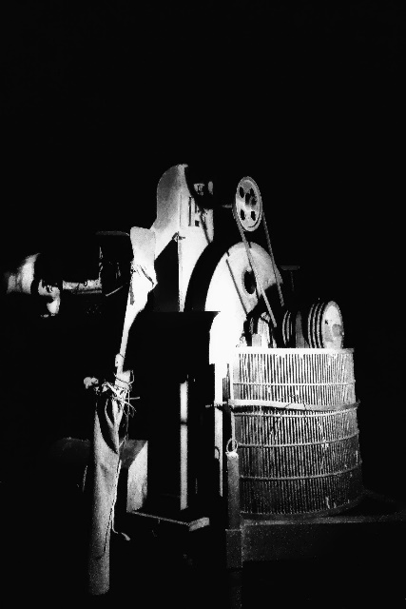
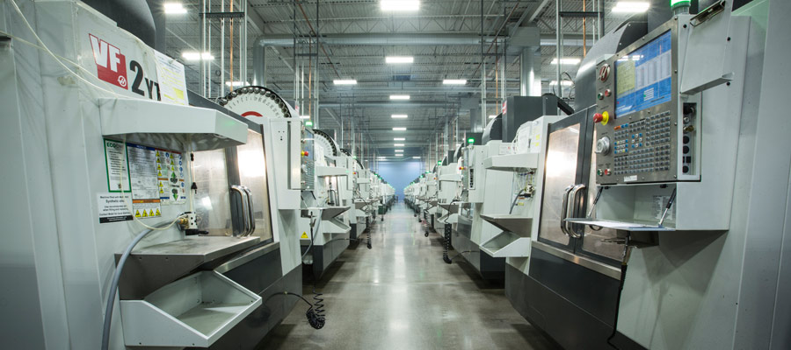
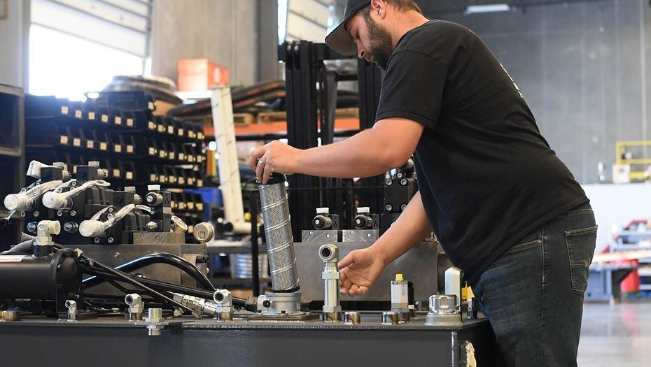
Use:
- Dark industrial image
- Slight blue overlay gradient
- Subtle animated grid pattern background
Optional:
Floating stats card overlay:
“1,200+ Machines Listed”
“300+ Verified Suppliers”

3️⃣ CATEGORY GRID SECTION
Background: White
Padding: 100px top & bottom
Headline center aligned:
“Explore Machinery Categories”
Grid: 3 columns desktop / 2 tablet / 1 mobile
Each Card:
- Icon (minimal line icon)
- Category Name
- Number of listings
- Hover effect → subtle elevation + blue border
Categories example:
- CNC Machines
- Fabrication Equipment
- Hydraulic Systems
- Packaging Machinery
- Electrical & Automation
- Industrial Tools
Spacing between cards: 32px

4️⃣ HOW IT WORKS (Split Section)
Background: Light Grey
Padding: 120px vertical
2 Columns
Left: Minimal icon timeline
Right: Text explanation
Step Design:
Circle number (01, 02, 03, 04)
Short 1-line headline
1 sentence explanation
Keep it compact.

5️⃣ FEATURE HIGHLIGHTS (Trust Infrastructure)
Background: Dark (steel blue)
White text.
Grid layout: 4 columns
Each block:
Minimal icon
Short headline
1-line description
Examples:
✔ Verified Suppliers
✔ Direct Negotiation
✔ RFQ Broadcast
✔ Industrial Clusters
Add subtle vertical separators.

6️⃣ MACHINE COMPARISON PREVIEW SECTION
Background: White
Padding: 120px vertical
Left: Comparison UI mockup (table layout preview)
Right: Text


This visually signals:
“We are not just listings. We are decision infrastructure.”

7️⃣ INDUSTRIAL HUB MAP SECTION
Background: Light neutral
Headline:
“Serving India’s Manufacturing Hubs”
Under it:
Map of India with highlighted nodes:
- Ludhiana
- Rajkot
- Coimbatore
- Faridabad
- Ahmedabad
- Pune


Under map:
Small text:
“Browse suppliers by region.”

8️⃣ FOR SELLERS (Conversion Section)
Background: Deep blue
Left side:
Bullet benefits
Right side:
Strong CTA block
“List Your Equipment Today”
Large orange CTA button.
Add credibility indicators:
- Free basic listing
- GST verification
- Dedicated support

9️⃣ FINAL CTA STRIP
Height: 300px
Dark background
Centered text:
“Ready to Source Smarter?”
Two buttons:
[ Browse Machinery ]
[ Post RFQ ]
Minimal distractions.

🔟 FOOTER
Structured, not cluttered.
4 Columns:
Company
- About
- Contact
- Careers
Marketplace
- Categories
- RFQ
- Seller Guide
Legal
- Terms
- Privacy
Industrial Resources
- Buying Guide
- Safety Standards
- Financing (future)
Bottom line:
Auzaarbazaar — India’s Industrial Equipment Exchange

📏 SPACING SYSTEM
Use consistent spacing scale:
8px base grid.
Section padding:
100–120px desktop
60px tablet
40px mobile
Card padding:
24–32px
Avoid cramped industrial UI. It should breathe.

TYPOGRAPHY HIERARCHY
H1: 48–56px
H2: 32–36px
H3: 20–22px
Body: 16–18px
Small text: 14px
Use:
Inter / Satoshi / IBM Plex Sans
Industrial but modern.

UX Enhancements You Should Add
• Sticky “Post RFQ” button on scroll
• Floating chat support bubble
• Recently viewed machines
• Save for comparison feature
• Skeleton loading states

Conversion Optimization Additions
Add:
- Social proof section (future)
- “Recently closed deals”
- Supplier response time badge
- Machine condition tag (New / Used / Refurbished)

