Git and github
Git is a 'source code management' (SCM) system designed by Linus Torvalds in 2005 (Git, 2014). While it claims to be 'a stupid content tracker' (Torvalds, 2013), in practice git is a highly sophisticated, decentralised and distributed way of write code in groups on scales ranging from an individual to large organisations. Git encourages branching or multiple versions of the same project at the same time, and provides many different ways of merging, tracking, duplicating and integrating code repositories distributed across many developers. It facilitates and encourages copies and variations, as well as tracking and auditing of changes in almost any kind of digital data.
Since 2007, Github.com has served as a largely public host platform for git repositories or 'repos.' It has encouraged software developers and programmers to store, work on and retrieve the source code and associated texts associated with software projects on many scales, ranging from individuals to large organisations. It has augmented the many operations afforded by git with 'social coding' affordances such as 'starring', 'watching, 'the distinctive 'pull-request' mechanism, various more formal organisational arrangements (teams, organisations, etc) and visual descriptive devices (graphs in particular; See Figure 2). Github has grown rapidly since 2007 to become perhaps the most important online code repository, hosting around 10 million projects in total with several million people contributing to them albeit with widely varying levels of activity. We might understand Github as the formal enterprise that organises – and somewhat ironically, centralises – the informal de-centralised organisation of git.
Github itself publishes much data about the growth of repos. The public legibility of platform dynamics is typical of contemporary software-mediated culture: things are made to be readable by many. Github.com also produces and encourages the production of various forms of visualisation and tabulation of what goes on there. To illustrate this legibility, we could choose important or famous repositories on github – the Linux kernel (https://github.com/torvalds/linux), for instance, is a much-vaunted, economically and technically central open source software project, still led by Linus Torvalds – and analyse the flows of meaning, texts and readers/writers connected to that repository. Relatively quickly, individual contributions could be analysed, and we could begin to characterise the composition of the group of people who keep this important software object working and up-to-date. But this work is largely already done by github.com itself (as the screenshot in Figure 1. shows).
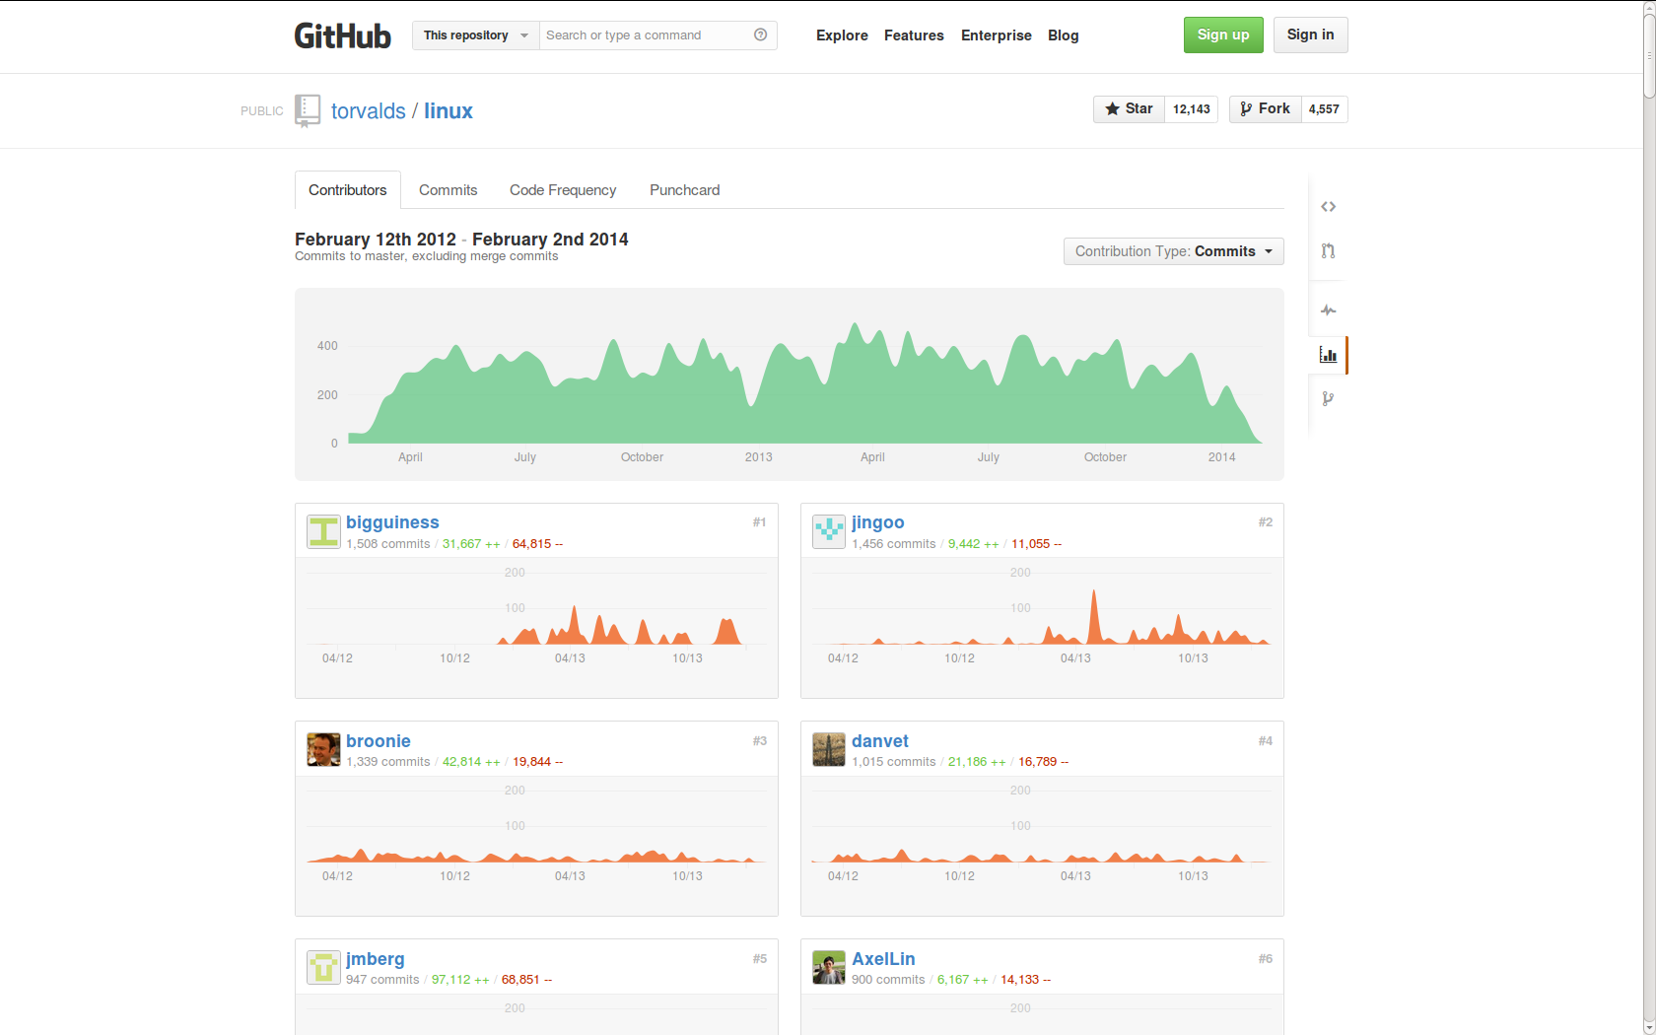

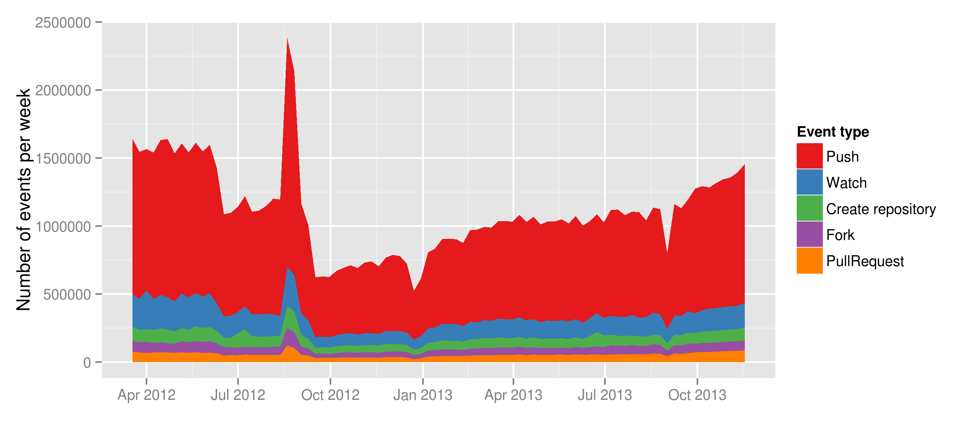
As a typical social media platform, Github also publishes much data about what happens on github.com through its APIs (Application Programmer Interfaces). This data is mainly intended for software applications and web services built around github. But the combination of the Events API endpoint, the API that supplies a more or less 'live' feed of events on the github.com platform (https://api.github.com/events) and the archived copies of events stored since 2011 at the GithubArchive (http://www.githubarchive.org/) means that github can in principal be analysed using 'live methods':
The tools and devices for research craft are being extended by digital culture in a hyper-connected world, affording new possibilities to re-imagine observation and the generation of alternative forms of research data. Part of the promise of live methods is the potential for simultaneity in research and the possibility of re-ordering the relationship between data gathering, analysis and circulation (Back and Puwar, 2012, p. 7)
The scale of the platform (only millions of participants, not hundreds of millions) and the existence of archives means that social researchers can envisage analysing the whole of github, not just one month of data or a selected group.
There are both great potentials and difficulties in doing this. The fact that we have ready access to the github event timeline is testimony to this. But what is most available from that data is a set of pre-formed 18 event types (some of which are shown in Figure 2). These event types subsume much of the traffic around github, but give us little way of deciding what is an important event, and how to elicit from the hundreds of millions of events in the event timeline which ones matter and which ones do not. At the same time, we know from ethnographic and other studies of software that the very detailed and fine-grained tracking of work and activity that is inherent to git means that in principal repos and software projects themselves can be analysed in great depth. Patterns of work, flows of meaning, borrowing and imitation of constructs and practices, shifts in interest and importance should be publicly legible in the repos, and important, in the flow of code between repos. But the possibilities of perceiving these flows and patterns presuppose capacities to filter and select event in the stream that neither confirm the unsurprising importance of certain high profile software projects (Linux, Mozilla, node.js, etc) or overwhelm us with the buzz of transient or emphemeral repositories.

References
Back, L., Puwar, N., 2012. A manifesto for live methods: provocations and capacities. Sociol. Rev. 60, 6–17.
Git, 2014. Git [WWW Document]. URL http://git-scm.com/ (accessed 2.25.14).
Torvalds, 2013. git(1) Manual Page [WWW Document]. URL https://www.kernel.org/pub/software/scm/git/docs/ (accessed 2.25.14).

