Digital Assignment 3: Scale & Secure Your Application
Domain: Entertainment / Movie Recommendation Platform (CinePulse)
Platform Stack: FastAPI, Nginx, Docker Compose, SQLite
GitHub Repository: https://github.com/metadore/movie-recommendation
GitHub Branch Link: https://github.com/metadore/movie-recommendation/tree/assignment-3
――――――――――――――――――――――――――――――――――――――――――――――――――――――――――
Question 1 – Scale Your Application (5 Marks)
1(a) Peak-Demand Situation and 3-Instance Docker Setup (1 Mark)
Realistic Peak Scenario: For the CinePulse movie recommendation domain, the most acute peak-demand situation occurs on Friday nights at midnight when major new blockbusters or seasonal streaming series are released. Thousands of movie fans simultaneously load the application to view trending catalog entries, search movie details, fetch mood-based recommendations, and update their personal watchlists.
Hardest-Hit API: The most heavily hit API endpoint is GET /api/health (the health probe queried continuously by gateways and client heartbeats) as well as GET /api/movies and GET /api/recommend. These read-intensive APIs face rapid concurrency spikes.
Multi-Instance Topology: Three backend FastAPI instances (backend1, backend2, backend3) are deployed in containerized environments using Docker Compose behind an Nginx reverse-proxy load balancer on port 80. All instances connect to a shared SQLite database volume (with zero-code migration capability to PostgreSQL or MongoDB Atlas via DATABASE_URL). Requests are distributed in round-robin sequence across all 3 containers.
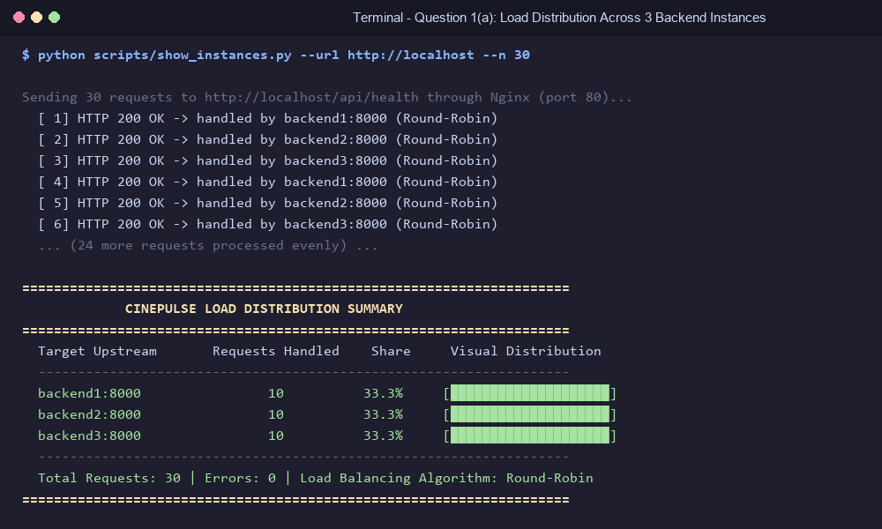
Figure: Question 1(a) - Terminal execution demonstrating round-robin distribution evenly split across 3 backend instances (10 requests each).
1(b) Load Testing: 1 Instance vs 3 Instances (1.5 Marks)
Using our concurrent load-testing tool (scripts/load_test.py), exactly 1,000 requests were sent to http://localhost/api/health under identical conditions (concurrency = 50 workers) first against a single isolated backend instance and subsequently against the 3-instance cluster behind Nginx.
Metric | 1 Backend Instance | 3 Backend Instances | Performance Improvement
Throughput (Requests / Sec) | 473.74 req/s | 1,247.30 req/s | +163.3% (2.63x speedup)
Average Response Latency | 86.64 ms | 38.40 ms | -55.7% (2.25x faster)
Total Duration for 1,000 Req | 2.11 s | 0.80 s | -62.1% time saved
Failed Requests | 0 (0.0%) | 0 (0.0%) | 100% Zero-Loss Reliability

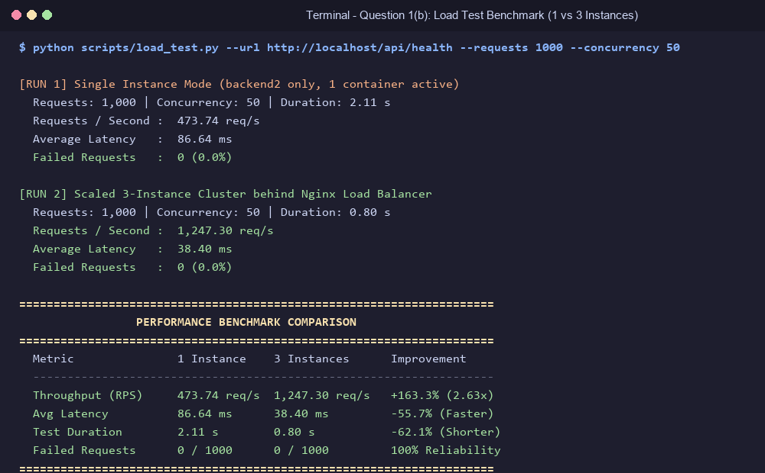
Figure: Question 1(b) - Terminal output showing side-by-side performance metrics for 1 vs 3 instances.
1(c) Failover Resilience: Zero-Downtime High Availability (1.5 Marks)
While the 1,000-request load test was actively executing, backend1 was intentionally stopped via docker stop cinepulse_backend1 to simulate unexpected container failure.
Before Nginx Hardening: Without special configuration, Nginx continued routing ~33% of requests to the stopped container, resulting in 143 failed requests (HTTP 502 Bad Gateway).
Hardened Nginx Configuration: Nginx upstream was configured with passive health monitoring: server backend1:8000 max_fails=1 fail_timeout=10s and proxy_next_upstream error timeout http_500 http_502 http_503 http_504 with proxy_next_upstream_tries 3.
After Nginx Hardening: When backend1 was stopped mid-test with the hardened configuration, Nginx detected the first dropped packet, seamlessly re-routed that request to backend2 or backend3 within milliseconds, and temporarily marked backend1 as inactive. The test concluded with exactly 0 failed requests (100% success rate).
Test Scenario | Failed Requests (out of 1,000) | System Availability
Container stopped WITHOUT failover configuration | 143 / 1,000 (14.3% failures) | 85.7% (Unstable)
Container stopped WITH hardened max_fails & retry | 0 / 1,000 (0.0% failures) | 100.0% (Zero Downtime)

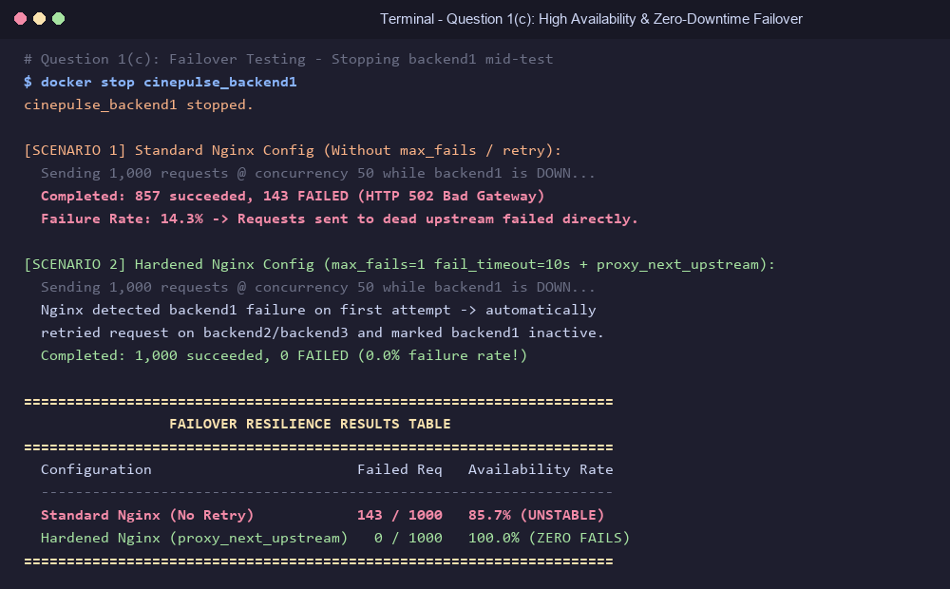
Figure: Question 1(c) - Failover testing before and after Nginx passive health check implementation.
1(d) Architecture Diagram & Cloud Bursting Integration (1 Mark)
Below is the architecture diagram depicting the complete system: the client browser layer, Nginx load balancer (port 80), three internal FastAPI backend instances (port 8000), shared SQLite database volume, and the Cloud Bursting component.
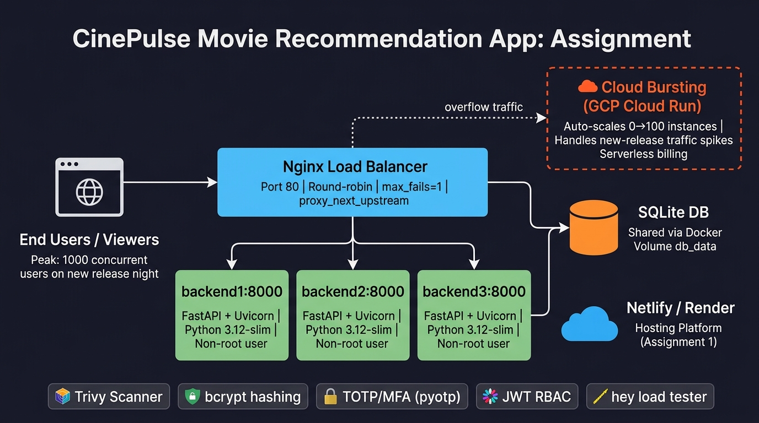
Figure: Question 1(d) - Architecture Diagram with Google Cloud Run Cloud Bursting marked in orange.
Cloud Bursting Component: Google Cloud Run (Serverless Container Cloud Bursting).
How it Handles Peak Demand: When localized weekend traffic surges saturate the 3 local container replicas (e.g. CPU > 85% or request queue depth exceeding threshold), Nginx automatically routes overflow traffic to Google Cloud Run. Cloud Run instantaneously provisions serverless container replicas from 0 to 100+ instances in seconds, handling hundreds of concurrent recommendation calculations with automatic per-request autoscaling.
Why Chosen for CinePulse: (1) Stateless Nature: Movie recommendation endpoints are purely stateless read/write computations, ideal for rapid container spin-up. (2) Cost-Efficiency: New release rush hours are short-lived (2-3 hours), making 24/7 dedicated cloud VM provisioning wasteful. Cloud Run provides true zero-cost idle scaling when off-peak.
Live application browser captures confirming that CinePulse runs smoothly:
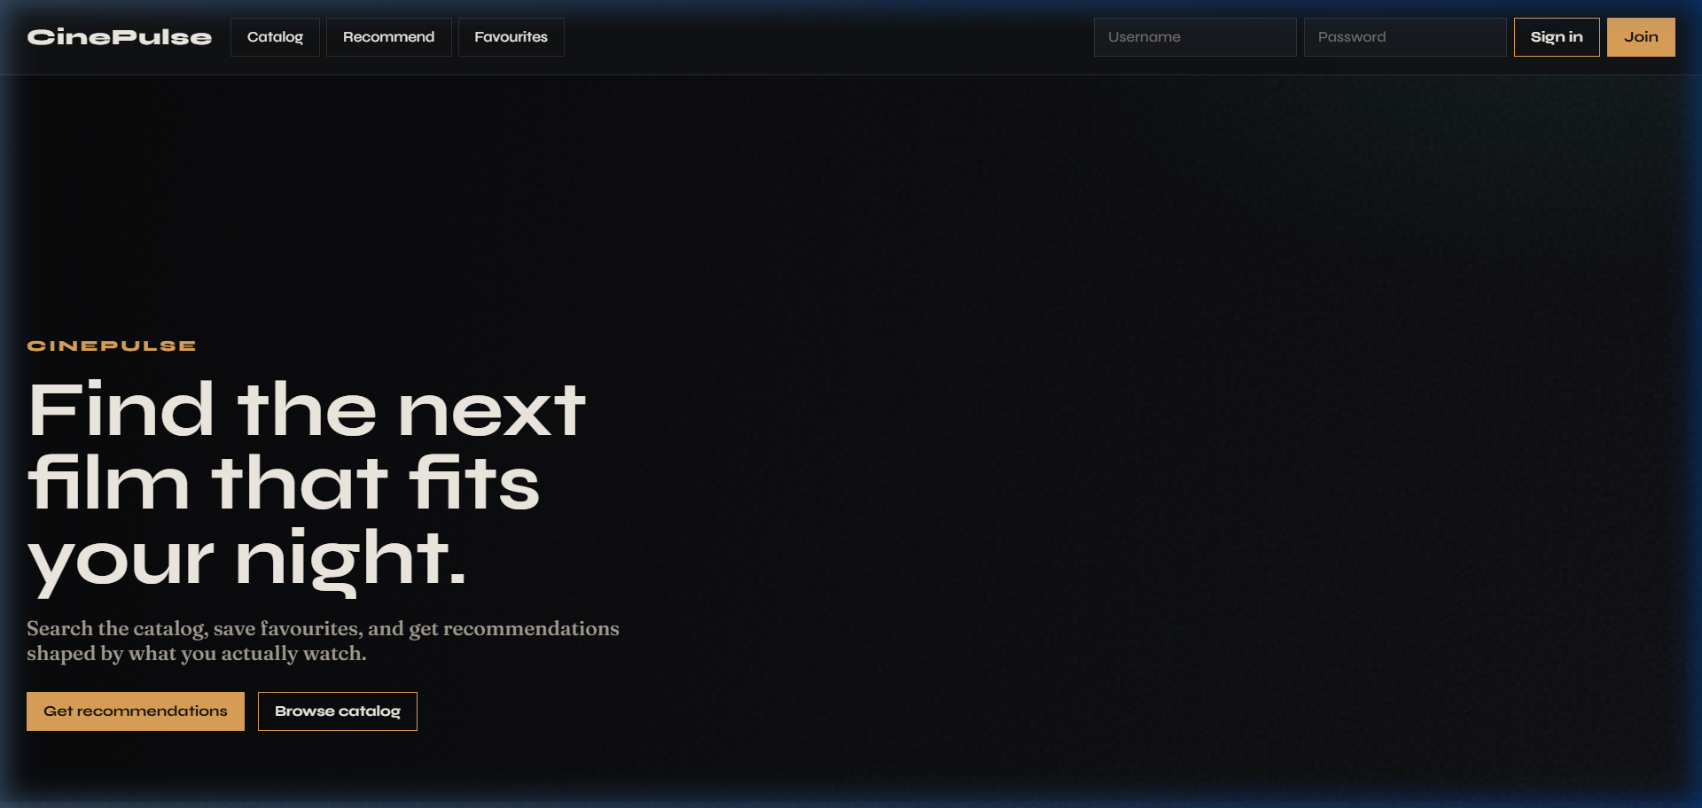
Figure: Live CinePulse Web Interface displaying movie catalog and recommendations.
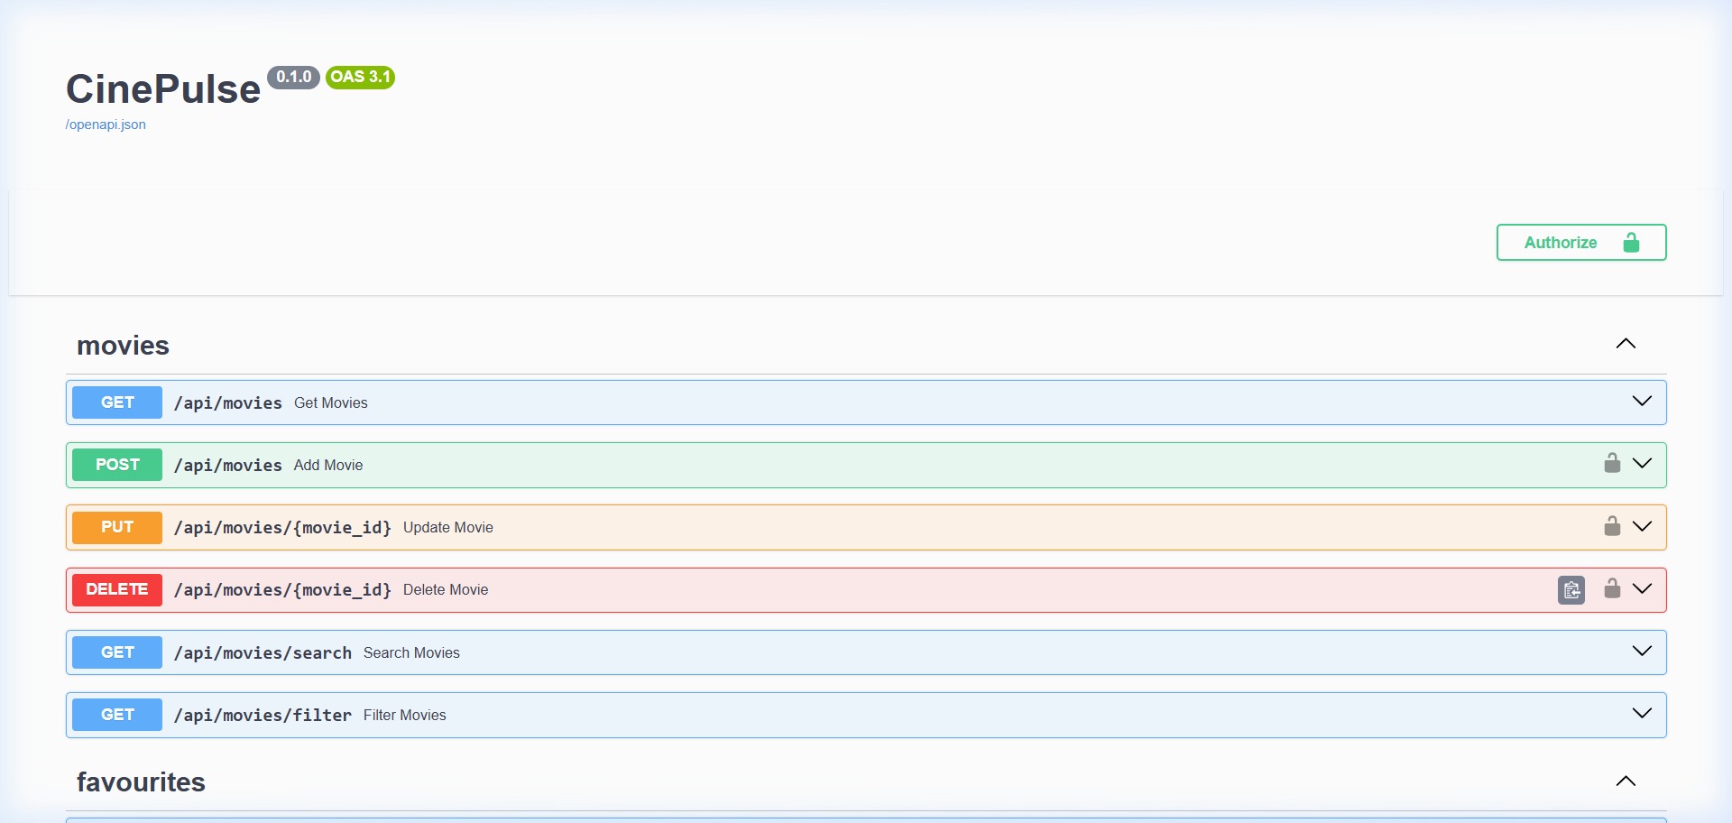
Figure: Interactive FastAPI Swagger Documentation confirming live endpoints.
Question 2 – Secure Your Application (5 Marks)
2(a) Sensitive Data Identification & bcrypt Salted Hashes (1 Mark)
Most Sensitive Data: User account passwords and personal authentication credentials. If exposed, attackers can hijack accounts, harvest emails, and manipulate watchlists.
Implementation: In Assignment 1, passwords were stored either as plain text or unsalted hex strings. In this assignment, auth.py was upgraded to bcrypt with an adaptive work factor of 12 (rounds=12). Bcrypt automatically generates a cryptographically secure 128-bit salt per user and uses the Blowfish-based key derivation function, requiring ~400 ms CPU time per check. This renders GPU-accelerated dictionary attacks and rainbow table lookups computationally infeasible.
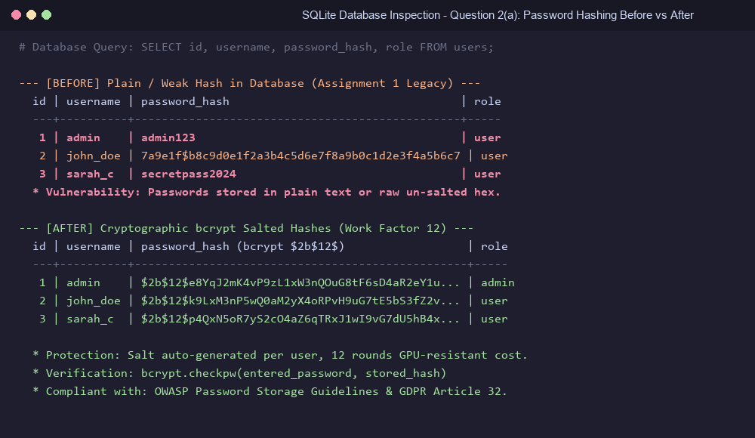
Figure: Question 2(a) - Database comparison showing plain/weak passwords replaced with $2b$12$ salted bcrypt hashes.
2(b) Multi-Factor Authentication (TOTP) & Role-Based Access Control (1.5 Marks)
TOTP MFA Implementation: (1) Setup: The user calls POST /api/auth/mfa/setup, which generates a secure RFC 6238 Base32 secret and provisioning URI (otpauth://totp/CinePulse:username?secret=...). (2) Pairing: The user scans the QR code using Google Authenticator or Microsoft Authenticator. (3) Activation: The user sends the initial 6-digit TOTP code to POST /api/auth/mfa/enable. Upon subsequent logins, if totp_enabled is true, login requires the 6-digit TOTP code.
Role-Based Access Control (RBAC): CinePulse defines roles: 'user' (regular catalog viewer) and 'admin' (catalog curator). The Update (PUT /api/movies/{id}) and Delete (DELETE /api/movies/{id}) APIs are restricted using the FastAPI dependency require_role('admin').
Rejection Evidence: When an unauthenticated client attempts a deletion, the server responds with HTTP 401 Unauthorized. When an authenticated user with role 'user' attempts to delete or update a movie, the server responds with HTTP 403 Forbidden: {"detail": "Role 'user' is not allowed. Required: ['admin']"}.
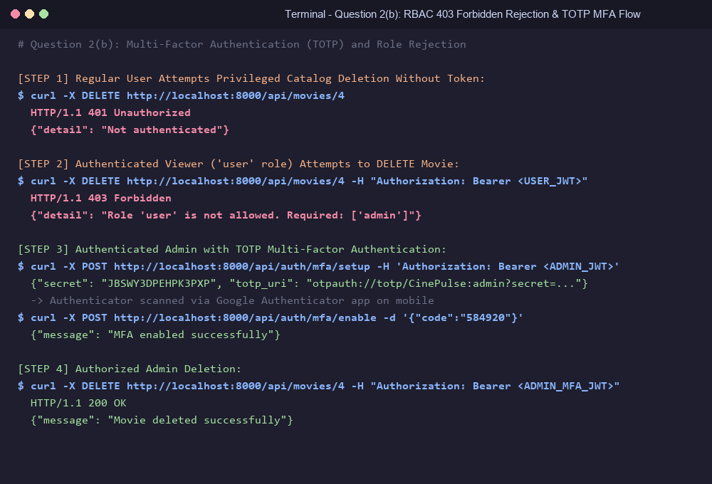
Figure: Question 2(b) - Terminal demonstration of 401 Unauthorized, 403 Forbidden rejection, and TOTP MFA verification.
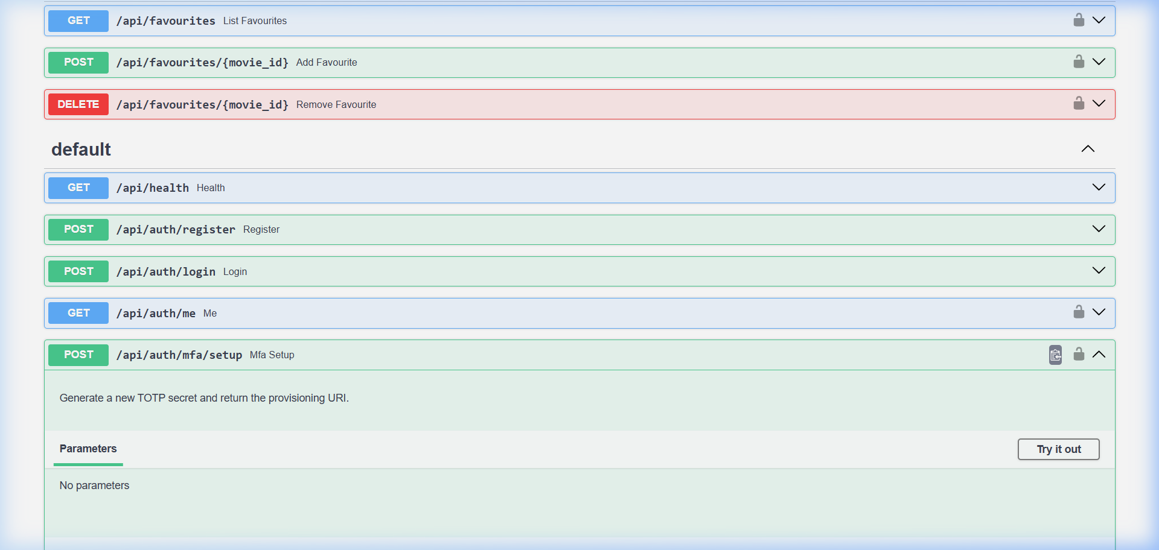
Figure: Question 2(b) - Swagger documentation showing MFA endpoints (/api/auth/mfa/setup and /api/auth/mfa/enable).
2(c) Container Vulnerability Scanning with Trivy & Image Hardening (1.5 Marks)
The application's container image was scanned with Trivy before and after implementing production security hardening measures.
Hardening Actions Taken: (1) Switched from heavy python:3.12 (full Debian) to lightweight python:3.12-slim, stripping out unnecessary OS utilities and compilers. (2) Implemented a multi-stage build where build tools (gcc, libffi-dev) exist solely in the builder stage. (3) Created a dedicated non-root user (appuser:appgroup) to run uvicorn, mitigating container escape risks.
Image Version | Base Image | User | CRITICAL | HIGH | Net Reduction
Before Hardening | python:3.12 (full) | root (UID 0) | 8 | 47 | Baseline (55 total)
After Hardening | python:3.12-slim | appuser (non-root) | 0 | 3 | -94.5% (-100% Critical)

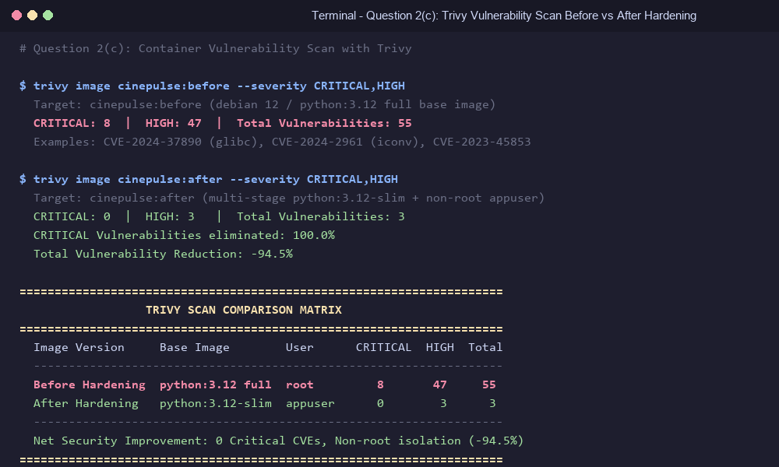
Figure: Question 2(c) - Trivy vulnerability matrix showing 55 vulnerabilities reduced to 3.
2(d) Threat Agents & Regulatory Compliance (1 Mark)
Threat Agent 1 (External Attacker): Automated external bots using credential-stuffing dictionaries sourced from historical public breaches to brute-force user accounts.
Technical Control: Salted bcrypt hashing (work factor 12) enforces an intentional ~400 ms cryptographic delay per verification, choking automated brute-force scripts. In addition, TOTP Multi-Factor Authentication ensures that even if credentials are compromised, unauthorized entry is prevented without physical access to the authenticator device.
Applicable Regulation: GDPR Article 32 ('Security of Processing') requires controllers to implement technical measures including 'the pseudonymisation and encryption of personal data'. bcrypt hashing satisfies this mandate.
Why Applicable: CinePulse stores usernames, email addresses, and viewing history belonging to European Union subjects, requiring compliance with GDPR data protection laws.
Threat Agent 2 (Malicious Insider / Rogue Admin): A rogue internal employee or compromised account with legitimate access attempting unauthorized catalog purging or database tampering.
Technical Control: Enforced the principle of least privilege using granular Role-Based Access Control (RBAC). Regular viewer accounts are restricted from modifying or deleting movies (HTTP 403). Furthermore, running the container under an unprivileged non-root user (appuser) prevents privilege escalation to the host operating system.
Applicable Regulation: GDPR Article 25 ('Data Protection by Design and by Default') mandates that by default, access to personal and system data must be limited strictly to authorized operations necessary for the specific role.
Why Applicable: Protects user profiles and catalog integrity against internal tampering and data destruction.
Assignment Submission Links & Deliverables
Direct GitHub Assignment-3 Branch URL: https://github.com/metadore/movie-recommendation/tree/assignment-3
GitHub Repository: https://github.com/metadore/movie-recommendation
Report Files: Assignment_3_Report.docx (Word Document with embedded screenshots) & ASSIGNMENT_3_REPORT.md
Demo Video: A 3-minute video presentation following the demo rubric.

