MetaHCR v1.0

Administrators Guide

This document is the administrators guide for the Metagenomics on Hydrocarbon Resources (MetaHCR) web application. All users should consult the accompanying Users Guide. The guide also contains a description of the data files used by the Upload functions of MetaHCR.

Note that the pages and examples in this Users Guide are based on the use of a public version of the MetaHCR database.

Overview
MetaHCR is a web application interface to a relational database that stores the inter-relationships amongst Hydrocarbon Resource Samples, their Single Gene and Metagenome Analyses and the Organisms found via these analyses. Ancillary tables provide metadata.
Administrators are users who have “super user” privileges. These privileges allow this user to:
- Create users and changing passwords.
- Create instances of all the tables utilized by MetaHCR.

Accessing MetaHCR and Logging On
Your system administrator will have given you a URL to use to access the web server that is hosting the MetaHCR application. Accessing this URL with a browser will result in the Home page being displayed:

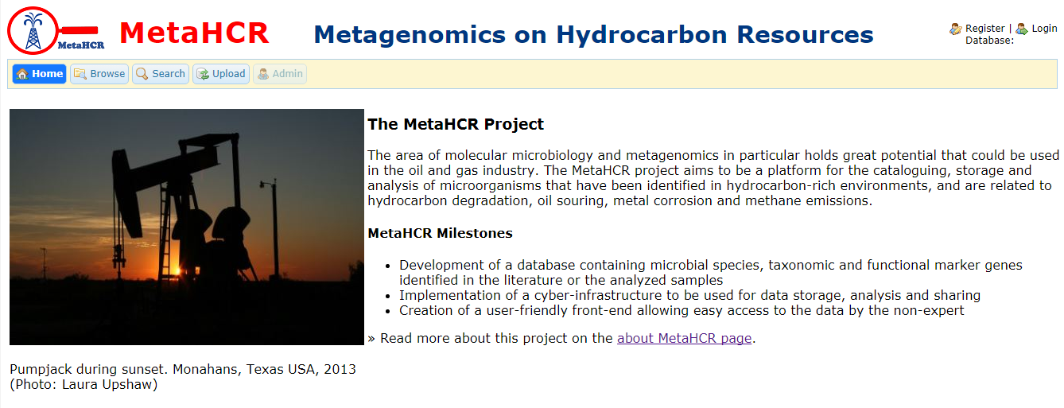

You must login to access MetaHCR's facilities. Click on the Login icon in the upper right-hand corner of the web page. You will be presented with the following dialog:
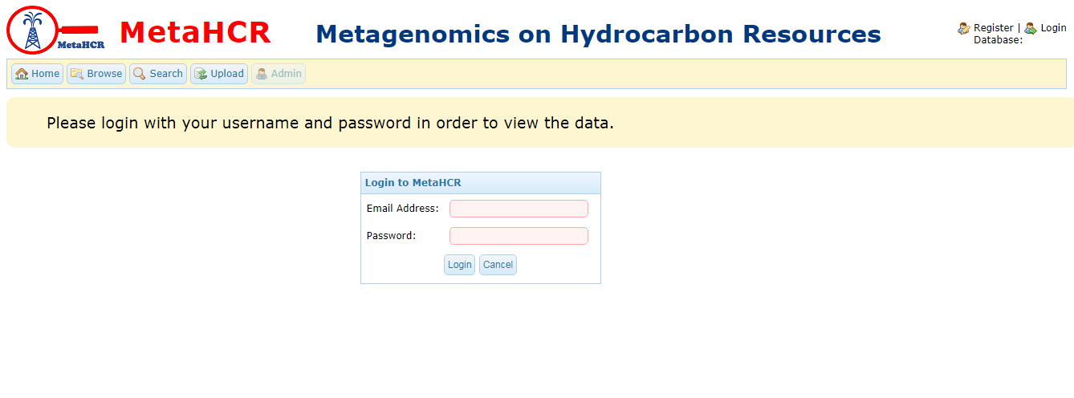
Note if you are using a freshly-installed version of the public database, you should log in with user name of admin and the password of admin.
Enter your email address and password and click on the Login button. If the login is successful the Home page will be re-displayed:

In the upper right hand corner, your user name, organization and the name of the database that you are currently accessing is displayed. In addition, there is an icon for logging out.
After logging in, the administrative functions are reached by clicking on the Admin button at the top of a MetaHCR web page. This button is disabled if you do not have the correct privileges.
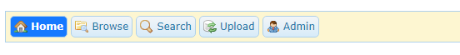

Clicking on the Admin button will take you to the administrators web page. It has a different look and organization than the MetaHCR application pages:

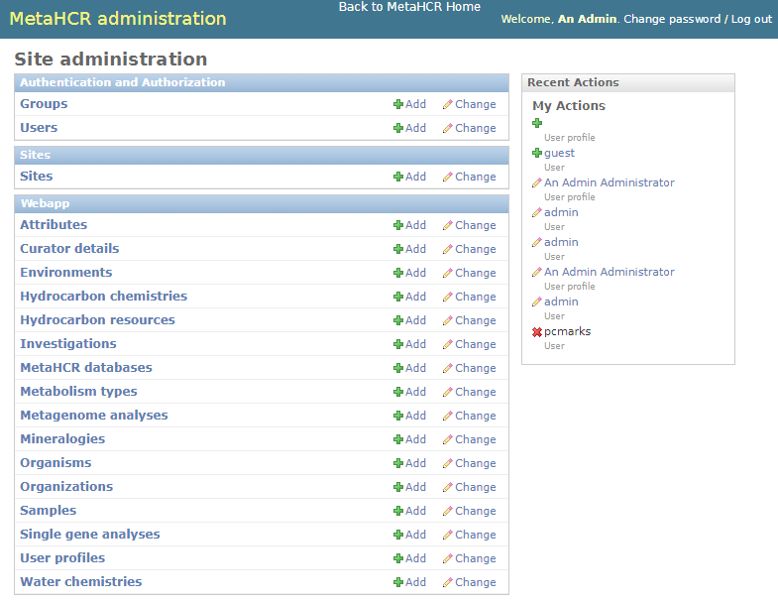

On the left-hand side, under the Authentication and Authorization, are the Groups and Users currently available in MetaHCR. Note that the Django Groups facilities are not utilized in the MetaHCR application. Similarly, for Sites.

Under Webapp are all the data items (tables) whose entries can be created, deleted and modified via general data maintenance.

General Data Maintenance

Any of the data items (tables) listed under Webapp can be clicked on resulting in a page showing a list of the entries (rows) in that table. There is a button on the upper right that allows you to add a new entity to this table. Clicking on one of these entries will show all the data fields in that entry and allow you to also modify the data and save the changes. There is also a Delete button that will delete this entry from its table. A typical maintenance web page – in this case Sample – looks like the following:

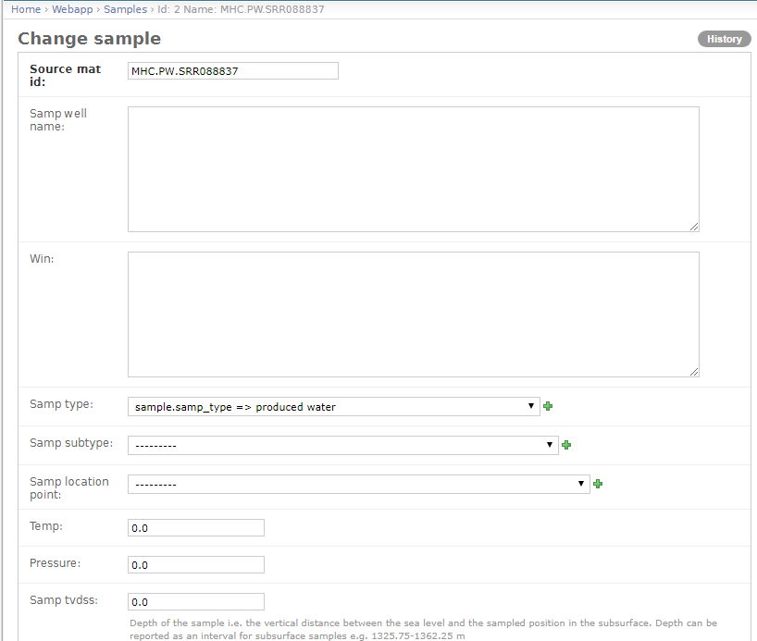
Note the Samp type field. It is example of a field that uses the controlled vocabulary values that can be found in the Attributes table. With a controlled vocabulary the user is limited to entering only valid values. More on Attributes below.

Adding Organizations, Databases, Users and User Profiles

There are relationships and dependencies amongst Organizations, Databases, Users and User Profiles. Users must belong to an Organization and Users must have a User Profile. Moreover, Organizations must specify the name of the database. Typically, the following steps are executed in this order:

- Add an Organization unless the proper one exists.
- Add a MetaHCR database
- Add a User.
- Add a User Profile associating it with a User and a User Profile

Clicking on Organizations under Webapp will display a list of organizations:

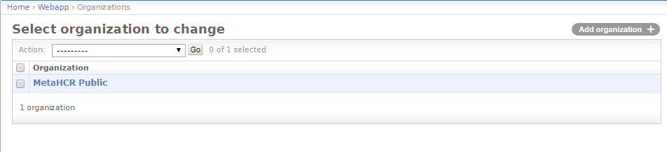
Clicking on an organization will display its fields:
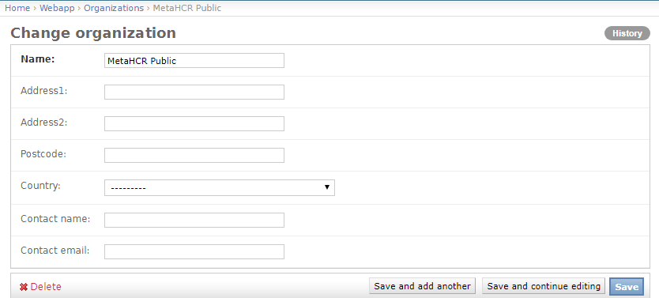

Selecting MetaHCR databases displays the following list:
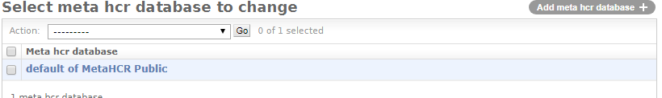

The field values for a database entry are:
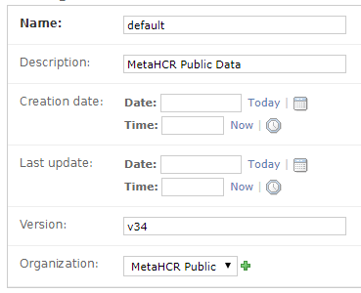
The Name field corresponds to the database name that is specified in the MetaHCR settings.py file (see the section on Settings).

To add a User, click on its + Add button. The following page will be displayed:

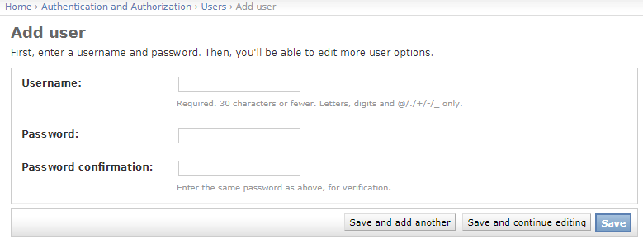
Note that passwords are never saved in plain text.

Finally, to add a User Profile, click on its + Add button. This page will appear:
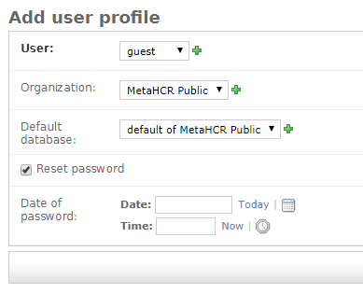

Controlled Vocabulary

MetaHCR employs a controlled vocabulary for many of the field values of its data resources. Each field has associated with it a set of valid values. The entries in the Attribute table can be added, deleted and changed. Similarly for the set of valid values associated with an attribute.

Select the Attributes entry from list under Webapp on the main Maintenance page. A list (partial) of the attributes is shown:
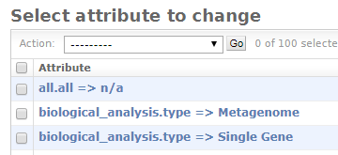

Attributes are identified by table and field names. In the above, the valid values for the type field in the biological_analysis table are Metagenome and Single Gene. You must use the database table and field names that are found in the database's schema. Note the all.all Attribute. These are attributes that can be used across all tables and their fields.

Settings

All Django applications rely on a settings file named setting.py. The file is found in the metahcr/metahcr directory under the top-level directory. It is read when the application starts. It consists of a number of parameters - variables and their values. In general, the parameters in the first part of the file are the ones whose values may need to be changed. In particular, the following are important:

- CATEGORY_CHOICES – a list of pairs of values that specify the names and corresponding attribute display values of all of the tables that contain controlled vocabulary fields.
- DATABASES – these are values specific to the database(s) that are being used. Each database entry is identified by a name – default in the public database. This name is used in the User Profile described earlier in this document. The values within this database record are specific to the type of database being used. MetaHCR is currently configured to use a PostgreSQL database.
- AWS_ACCESS_KEY, AWS_SECRET_ACCESS_KEY, AWS_STORAGE_BUCKET_NAME – these are values that must be supplied if you want upload data files stored in an AWS S3 bucket.

