MetaHCR v1.0

Users Guide

This document is the users guide for the Metagenomics on Hydrocarbon Resources (MetaHCR) web application. Administrators should consult the Administrators Guide.

Note that the pages and examples in this Users Guide are based on the use of a public version of the MetaHCR database.

Overview
MetaHCR is a web application interface to a relational database that stores the inter-relationships amongst Hydrocarbon Resource Samples, their Single Gene and Metagenome Analyses and the Organisms found via these analyses. Ancillary tables provide metadata.

Accessing MetaHCR and Logging On
Your system administrator will have given you a URL to use to access the web server that is hosting the MetaHCR application. Accessing this URL with a browser will result in the Home page being displayed:

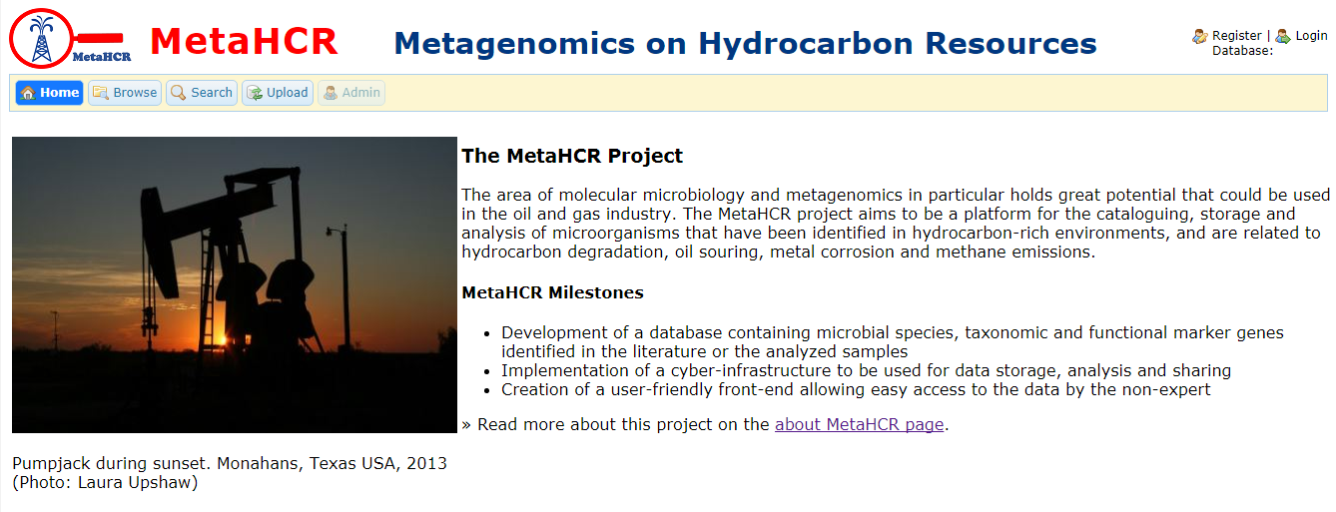

You must login to access MetaHCR's facilities. Click on the Login icon in the upper right-hand corner of the web page. You will be presented with the following dialog:

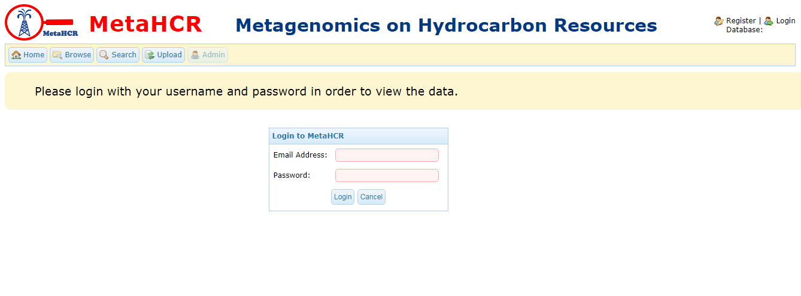
Note if you are using a freshly-installed version of the public database, you should log in with user name of guest and the password of guest.
Enter your email address and password and click on the Login button. If the login is successful the Home page will be re-displayed:

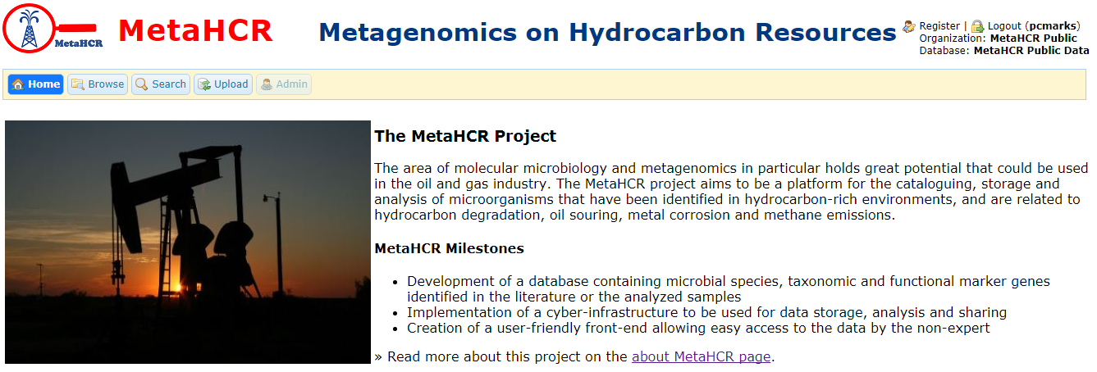
In the upper right hand corner, your user name, organization and the name of the database that you are currently accessing is displayed. In addition, there is an icon for logging out.

MetaHCR's Major Functional Areas

There are four major functional areas in MetaHCR: Browsing, Searching, Uploading and Administration. Each can be reached by selected the corresponding menu item at the top of the page. Each function gives you access to one or more of the following data resources: Investigations, Sample, Analyses (Single Gene and Metagenome), Organisms, and Hydrocarbon Resources. The primary data resource in the MetaHCR database are the following:

- Investigations which contain Samples,
- Samples which contain Analyses, and
- Analyses which contain Organisms

Browsing gives you the ability to examine all the entries in all of the data sources. In addition, various filters can be applied to these data to create subsets.

Searching gives you the ability to search for occurrences of one of the primary data resources and to then follow the relationships listed above. For example, searching for a particular Organism can lead to the Analyses in which it was identified. The Analyses, in turn, could lead to the Samples and ultimately to the Investigation that collected these Samples. Below is a diagram of how you can traverse the primary data resources in MetaHCR.

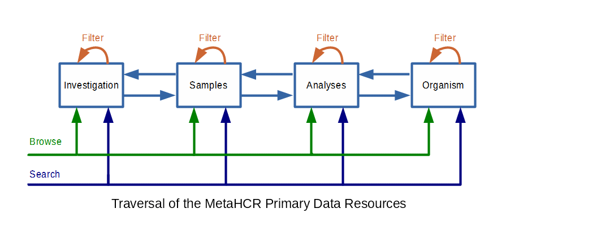
Uploading provide facilities for uploading both Single Genome and Metagenome Analyses associated with a particular Sample. The use of each of the functional areas follows.

For a description of the Administration functions and usage, please consult the MetaHCR Administrators Guide.

Browsing and Filtering

Clicking on the Browse menu button will result in the following page being displayed:

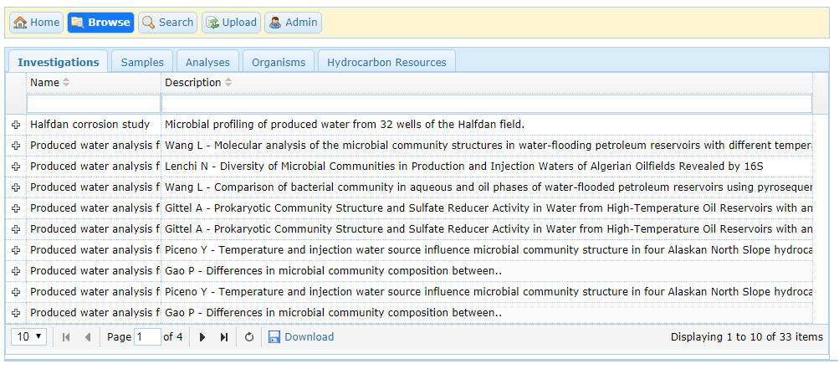
There are five tabs corresponding to Investigations, Samples, Analyses, Organisms, and Hydrocarbon Resources. Selecting any one of these tabs will display a list of all of the entries for that particular data resource. All of the lists provide the following sets of functions: Basic, Infosheets, and Nested Data.

Basic Functions

- The lists may be paged through and the number of entries per page can be changed: (10 – 50).
- The data for each displayed field, for example, Name and Description on the Investigations page, can be sorted by clicking on the up and down arrows next to the field name.
- Below each field name is an area that you can enter characters that will be used as filters. So, for example, typing “water” (without the quotes) into the Name field on an Investigation page will result in a new list of Investigations that contain these characters in their Name field. Note that as you type, each character triggers a search in the database, so you may experience a small “lag” in response.

Nested Data

Clicking on the “plus” sign in the leftmost column – if it is present – will result in the line opening up and displaying information about data that data resource “contains”. For example, clicking on the plus sign of the first Investigation entry will result in the display of two lines describing the two Samples that are part of this Investigation:

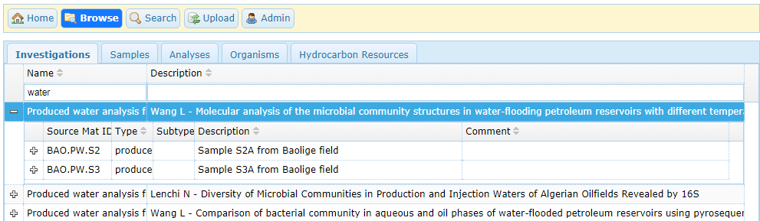
Depending on the data being displayed further plus signs may appear. For Investigations, if the Samples have Analyses associated with them then clicking on the Sample's plus sign will show the analysis(es):

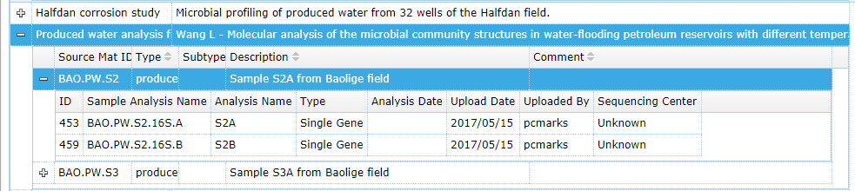

Infosheets

Selecting a list entry will result in an “Infosheet” being displayed at the bottom of the page. An Infosheet will display all of the data fields associated with the list entry:

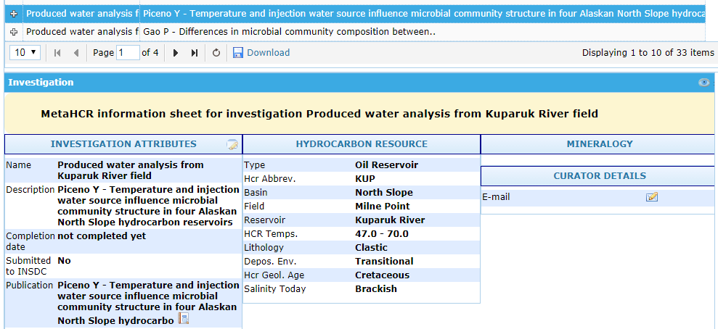
The infosheet can be collapsed or expanded by clicking on the title line containing the name of the data resource. For Investigations, the title line contains “Investigation”; similarly for the other data resources.

On the Infosheet title line, to the far right, is an “eye” icon. Clicking on this icon will toggle between showing the infosheet fields that contain data (the default) to displaying all of the fields, irrespective of their values. Compare the following infosheet with the previous:
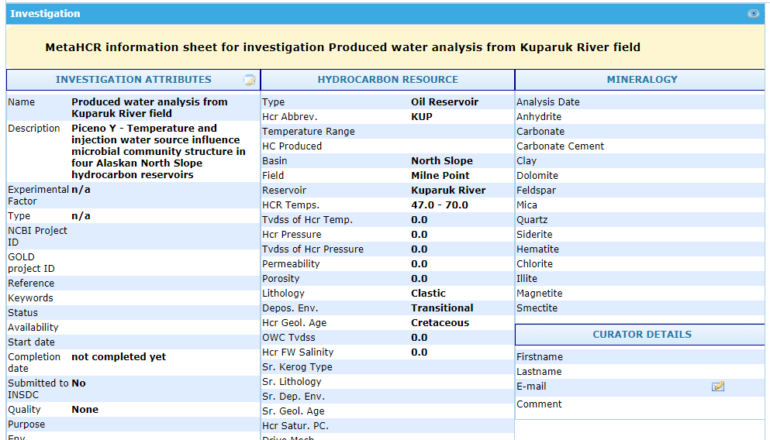

Sample and Analysis Infosheets

The infosheets for Samples and Analyses are the same: it is an accordion display with the following five expandable/collapsible panel. There are two types of Analyses: Single Gene and Metagenome. Since, all analyses need to be associated with a Sample, the Sample's infosheet is available as well in the infosheet area. The panels are:

- Metadata – metadata for the Sample.
- Single Gene Analysis – metadata for the selected Analysis, if present
- Single Gene Analysis Organisms – a list of the Organisms found in the selected Analysis, ordered by abundance.
- Metagenome Analysis – metadata for the selected Analysis, if present
- Metagenome Results – metagenome results. A list of genes and associated data.

An example of a Single Gene Analysis infosheet:

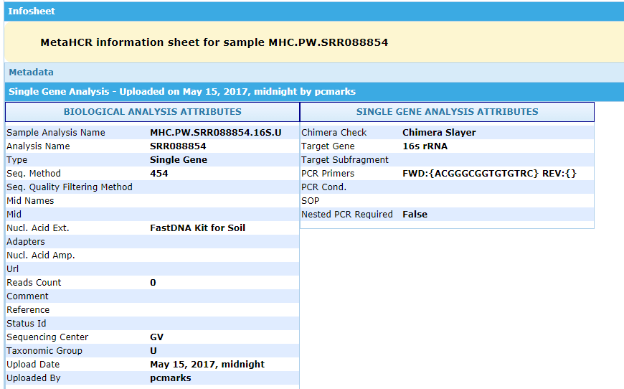

An example of a Single Gene Analysis Organisms infosheet:

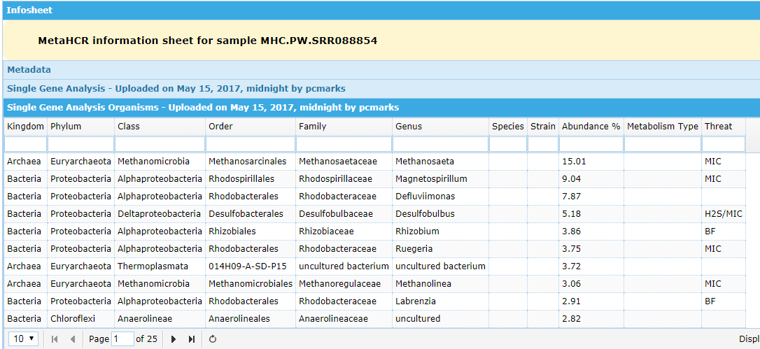
An example of a Metagenome Results infosheet:

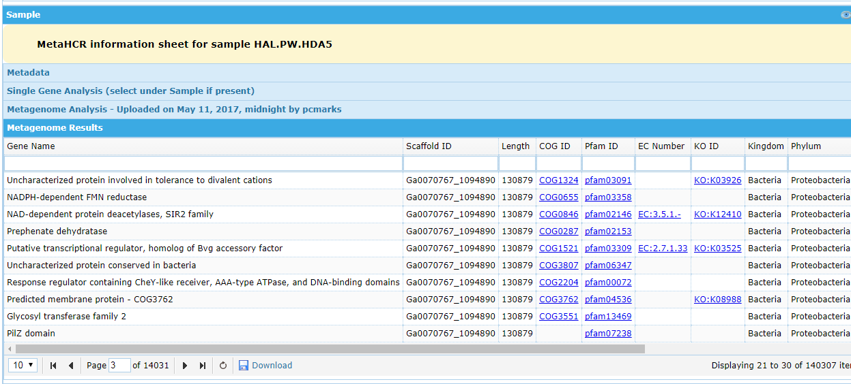

Nested Data

- Clicking on the “plus” sign in the leftmost column – if it is present – will result in the line opening up and displaying information about data that data resource “contains”. For example, clicking on the plus sign of the first Investigation entry will result in the display of two lines describing the two Samples that are part of this Investigation:

- Depending on the data being displayed further plus signs may appear. For Investigations, if the Samples have Analyses associated with them then clicking on the Sample's plus sign will show the analysis(es):

- For all of these types of expansions, the infosheet for the respective data resource that is selected will display at the bottom of the page.

Searching
The search functions give you the ability to follow the relationships between Investigations, Samples and their Analyses, and Organisms. You can search for instances of each of these data resources using various criteria and then display the other data that these instances are part of. For instance, searching for organisms by taxonomy or by their characteristics will result in a list of Organisms. If these Organisms have appeared in any Analyses then these Analyses and their associated Samples and their Investigations may all be displayed. You may search for Investigations which will lead to Samples/Analyses then to Organisms. And, you can search for Samples/Analyses which will lead to their Investigations and Organisms.
The initial page for the Search function is shown below.

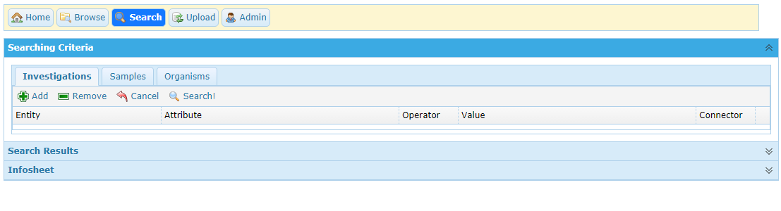
There are three accordion areas entitled Searching Criteria, Search Results, and Infosheet. Each can be collapsed or expanded by clicking on these titles. Searching begins in the Searching Criteria area. There are three tabs corresponding to which data resource will be searched for first. Below each of these tabs are four buttons that allow you to set up the search criteria. The criteria, when they exist, appear below these buttons. Clicking Add will create a new criterion; Remove deletes the currently selected criterion; Cancel cancels the entry of a criterion; and Search! initiates the search. Finally, below these buttons are the search criteria:
- Entity – is one or more data resources, depending on the tab chosen;
- Attributes – the fields associated with the selected data resource;
- Operator – depending on the data type of the Attribute this will be an operator such as '=', 'contains', etc.;
- Value – the particular value to be used in the search;
- Connector – either 'and' (the default) or 'or' which serves to combine two criteria.
A typical search is described in the following paragraphs. You will start with a search for a particular organism, find its Samples/Analyses and their Investigations.

Click on the Organisms tab. Next, click on the Add button – this section of the page should like: the following:
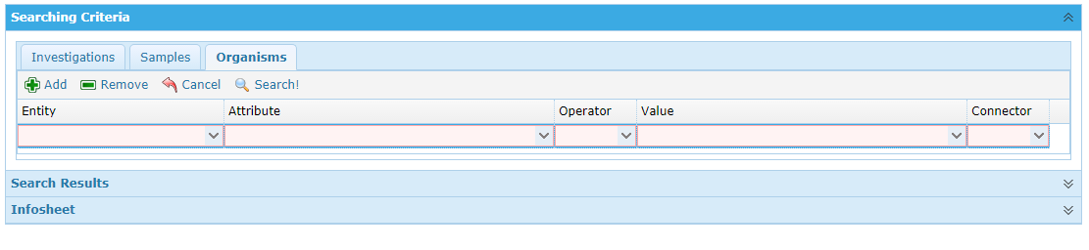
Click on the Entity drop-down menu:
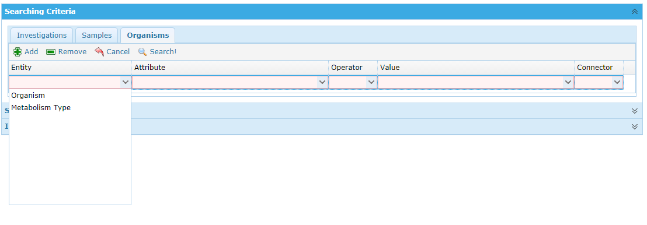
Select Organism for the Entity with which you will begin the search. Next, select the Attribute drop-down menu – it will have changed to match the Entity – Organism - that you selected:
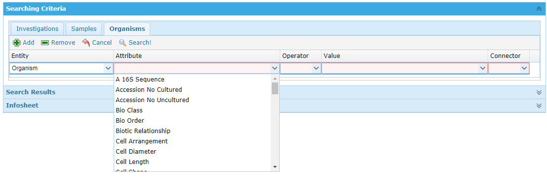

You can either scroll down to the Attribute or begin typing the name of the attributes. Type the single letter 'g' – the drop-down menu for the Attribute becomes:
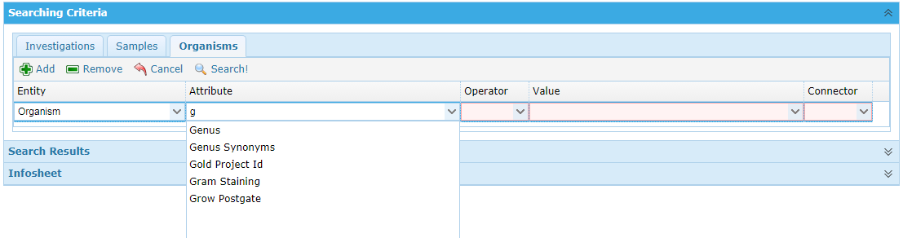
Choose 'Genus' and then click on the Operator drop-down menu. In this menu choose 'contains' which will, for character string attributes, search for the occurrence of the search string within the Attribute's value. Finally, type 'pelobacter' in the Value field. Note, if the Attribute is a Controlled Vocabulary item then the Value field turns into a drop-down menu with the allowable values. Your search criteria should look like this:
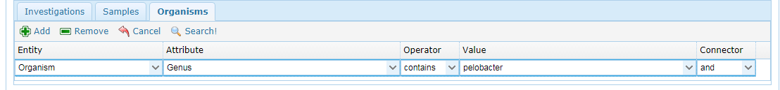
Click on the Search! button just above the search criterion. The search is initiated and if any organisms have the string 'pelobacter' in their genus field, they will displayed in the Search Results area of the page:
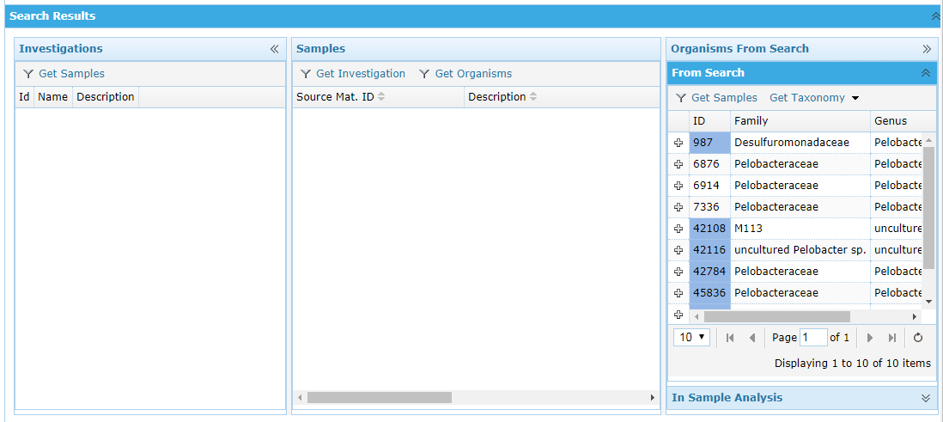
In the right-most column of the Search Results you will see a paginated list of the matching Organisms. Selecting the plus sign will open up the Organism list entry and display the rest of the organism's taxonomy as well as some of its attributes.

Those Organisms that appear in one or more Analyses will have their ID highlighted. Select the first Organism in the list (ID = 987) – this will also result in an Infosheet for this organism to be displayed at the bottom of the page. Next click on the Get Samples button above the list. This action will result in a list of Samples, whose Analyses contain this organism, appearing in the middle column of the Search Results area:
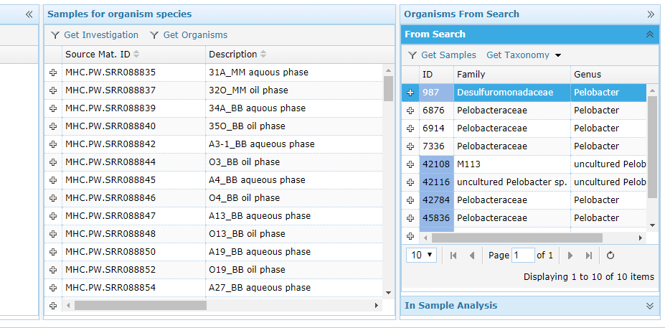
Clicking on the plus sign and/or selecting a Sample or an Analysis exhibits the same behavior as on the Browsing pages. For a more detailed description of this behavior, please see the Browsing section of this document.

In the center list of Samples and Analyses, you can select a Sample and click on the Get Investigations button to display the Investigation that this Sample is associated with. The Investigation will appear in the left-most area of the Search Results:

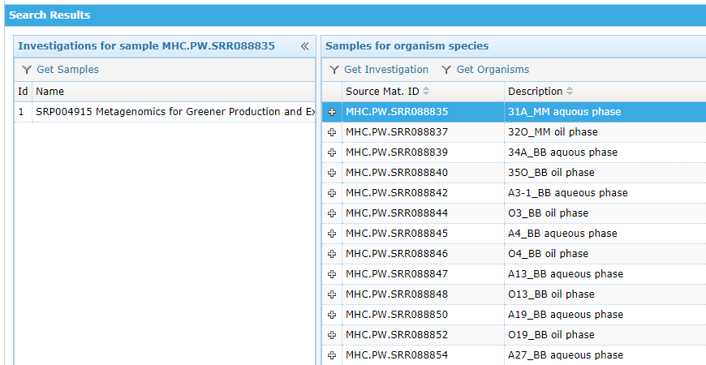
The above describes a search that begins with finding Organisms that have certain characteristics. Similar types of searches can be performed for Investigations and Samples. The results of these searches will appear in the left-most and center columns, respectively. From the Investigations list, you can get its Samples by clicking on the Get Samples button. From the Samples/Analyses list, you can get the Organisms found by an Analysis by clicking on the Get Organisms button.

Uploading

This set of functions can be reached by selecting the Upload menu button at the top of the M2SC page. Uploading allows you to:

- Upload a Single Gene Analyses and associate it with a Sample.
- Upload a Metagenomic Analysis and associate it with a Sample
- Maintain (delete) previously uploaded Analyses

The Uploading page is divided into two areas:
- A list of the Samples in the current database
- An area for Analyses Uploading and Maintenance

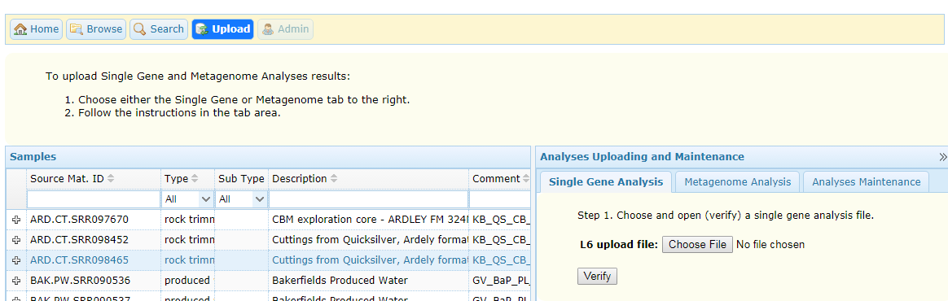
You choose the type of analysis to be uploaded by selecting one of tabs in the right-most column.

Single Gene Analysis Uploading
Single Gene Analysis has been designed to upload so-called “L6” files. A description of this file is located in the Administrator's Guide.

There are three steps involved in uploading Single Gene Analyses:
- Choosing and verifying the analyses file.
- Uploading the analyses file.
- Examining the upload log file

They are outlined in the Single Gene Analysis tab:
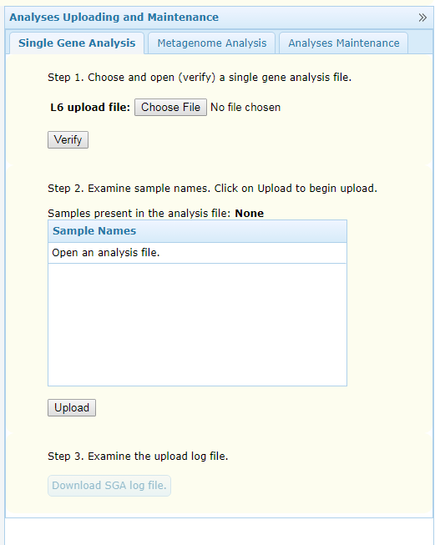

Metagenome Analysis Uploading

Metagenome Analysis uploading has been designed to upload a group of three separate data files: Scaffold file, Gene Function file, and RNA file. Descriptions of these files are located in the Administrator's Guide.

There are three steps involved in uploading Metagenome Analyses:
- Choosing and verifying the three analyses files.
- Uploading the analyses file.
- Examining the upload log file

They are outlined in the Single Gene Analysis tab:

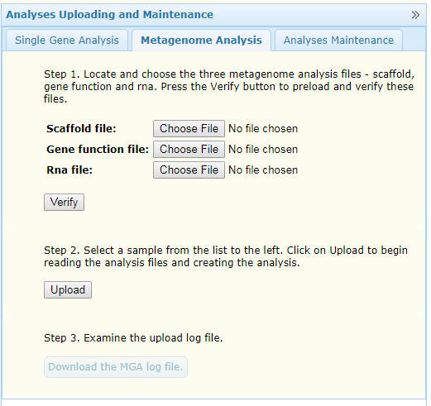

MetaHCR creates a log file for every analysis.
MetaHCR can be configured to upload copies of the analyses files to Amazon's AWS S3 storage. These settings are in the applications settings.py file and description of them is available in the Administrators Guide.

Analyses Maintenance

This part of uploading gives you the ability to delete analyses and to download log files that were created during an upload. This function is accessed by clicking on the Analyses Maintenance tab:

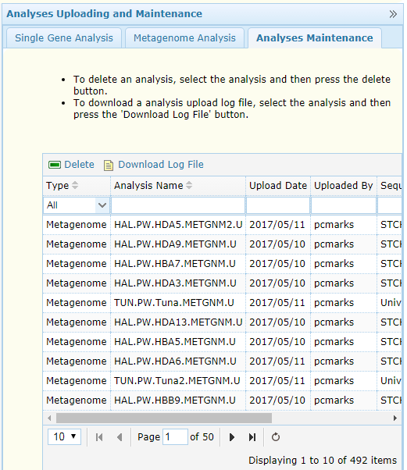

A list of the current Analyses is shown along with instructions for deleting an analysis or downloading the log file for an analysis.

