**Summary of metahit illustrative scenarios**

*Anna Goodman, July 2021*

**SCENARIO 1.1: Illustrative example of cycling scenarios: A mode shift to cycling, modelled in 2 stages**

**Step 1. Model non-cyclists becoming cyclists**

1. Define a current cyclist as someone who i) reported cycling as their usual main mode of travel to work [from Census 2011], or ii) reported doing any cycling in the past week [from NTS travel diary], or iii) reported that they typically cycle three or more times a week [from NTS questionnaire]. The baseline proportion of adults who are current cyclists in England is 7.6%.
2. In the synthetic population of all 43 million adults age 16+, fit an individual-level regression model that estimates the probability of being a cyclist as a function of age, sex, ethnicity, car ownership, economic activity, urban/rural status, region, and hilliness of home area. The results are summarised in Table 2.

Table : Multivariable predictors of being a cyclist, among 43 million adults in England

|  |  |  |  |
| --- | --- | --- | --- |
|  |  | **Log odds** | **Odds ratio** |
| Sex | Male | 0 | 1 |
|  | Female | -0.944 | 0.39 |
| Age | 16-24 | 0 | 1 |
|  | 25-34 | -0.061 | 0.94 |
|  | 35-49 | -0.032 | 0.97 |
|  | 50-64 | -0.340 | 0.71 |
|  | 65-74 | -0.879 | 0.42 |
|  | 75+ | -1.175 | 0.31 |
| Ethnicity | White | 0 | 1 |
|  | Non-white | -0.560 | 0.57 |
| Car ownership | Yes | 0 | 1 |
|  | No | 0.267 | 1.31 |
| Economic | Inactive | 0 | 1 |
| activity | Active | 0.228 | 1.26 |
| Urban/rural status | Rural | 0 | 1 |
|  | Urban | 0.036 | 1.04 |
| Region | North East | 0 | 1 |
|  | North West | 0.008 | 1.01 |
|  | Yorkshire and Humber | 0.195 | 1.22 |
|  | East Midlands | 0.170 | 1.18 |
|  | West Midlands | 0.080 | 1.08 |
|  | East of England | 0.205 | 1.23 |
|  | London | 0.157 | 1.17 |
|  | Southeast | 0.267 | 1.31 |
|  | South West | 0.361 | 1.43 |
| Hilliness of home area | Change per twentieth increase | -0.020 | 0.98 |
| Constant | - | -2.019 | 0.13 |

Using the log odds, the results in Table 2 can also be written out in the form of an equation as shown in Equation 1, where ‘pcyclist’ is the probability of being a cyclist:

Equation 1:

logit (pcyclist) = (-0.944 * female) + (-0.061 * age25to34) + (-0.032 * age35to49) + (-0.340 * age50to64)

+ (-0.879 * age65o74) + (-1.175 * age75+) + (-0.560 * nonwhite) + (0.267 * nocar)

+ (0.228 * ecactive) + (0.036 * urban) + (0.008 * northwest) + (0.195 * Yorkshire)

+ (0.170 * eastmidlands) + (0.080 * westmidlands) + (0.205 * eastofengland)

+ (0.157 *London) + (0.267 * southeast) + (0.361 * southwest)

+ (-0.020 * hilliness20th) + -2.019

pcyclist = exp ([logit (pcyclist)]) / (1 + (exp([logit(pcyclist)])

1. In each local authority, assignsome baseline non-cyclists to become new cyclists, such that the overall proportion of cyclists increases to 15%. People who already were cyclists at baseline are unchanged. Three illustrative versions of this scenario were implemented:
   1. **‘Near market’**: assign non-cyclists to be new cyclists using probabilities directly generated from Equation 1– i.e. fully in line with the baseline probability of being a cyclist.
   2. **‘Age equality’**: assign non-cyclist to be new cyclists using probabilities generated from Equation 1 after excluding the five terms for age. In other words, the probability of becoming a cyclist does not vary by age (effectively because all ages are treated as having the same probability of cycling as 16-24-year-olds), but the probability does still vary by sex, ethnicity etc.
   3. **‘Targeting young, male drivers’:** assign all males aged 16-24 who did any past-week car driving to be new cyclists. Draw the remaining cyclists, up to a total of 15%, from all other groups in line with the probabilities generated from Equation 1.

**Step 2. Model some trips among new** **cyclists being switched to cycling.**

1. Use NTS 2010-2016 data for England to define distance decay functions for cycling a given trip among people who were cyclists at baseline, stratified by age (16-49 vs 50+) and sex. These are shown in Table 3 below:

Table 3: Distance decay functions for cycling a trip among cyclists, by distance, age, and sex

|  |  |  |  |  |
| --- | --- | --- | --- | --- |
| **Distance (km)** | **Male**  **16-49** | **Female 16-49** | **Male**  **50 +** | **Female 50 +** |
| 0 to 1 km | 9.7% | 14.4% | 21.2% | 24.9% |
| 2 to 4 km | 36.1% | 34.4% | 35.2% | 34.0% |
| 5 to 7 km | 37.4% | 31.4% | 26.6% | 25.5% |
| 8 to 12 km | 29.2% | 21.2% | 21.9% | 12.8% |
| 13 to 19 km | 19.2% | 9.2% | 21.8% | 9.2% |
| 20 to 29 km | 13.0% | 5.9% | 17.4% | 3.5% |
| >30 km | 0.0% | 0.0% | 0.0% | 0.0% |

1. Apply these distance decay functions to the trips made in the past week by new cyclists, probabilistically switching some trips in line with the probability of making that trip by bicycle. Trips by people who were already cyclists at baseline are unchanged. Note that some new cyclists may not in fact make any cycle trips in the past week, e.g. if they happened not to travel in the past week or only to make long trips.
2. Trips that are switched are assumed to have the same total trip distance[1], with the average speed of that age and sex group. These average speeds were defined using NTS 2010-2016 data for England as a whole, as shown in Table 4:

Table 4: Average speed of cycling by age and sex

|  |  |  |  |  |
| --- | --- | --- | --- | --- |
|  | **Male**  **16-49** | **Female 16-49** | **Male**  **50 +** | **Female 50 +** |
| Average cycling speed (km / hr) | 14.2 | 11.8 | 13.3 | 10.6 |

1. Note that one could implement this Step differently for different scenarios – e.g. disproportionately switching car trips in a ‘congestion charge’ scenario, or disproportionately switching longer trips in an ‘ebikes’ scenario.

**Results for the local authority of Hartlepool**

Below in Table 5 are selected local authority-level summary statistics for baseline and the various scenarios, in the local authority of Hartlepool [as an example]. These parameters are also available at the trip- or individual-level and would, with additional processing, feed into the health model (see Table 1).

Table : Selected local authority results for Hartlepool

|  |  |  |  |  |  |
| --- | --- | --- | --- | --- | --- |
|  |  | **Baseline** | **Near market** | **Age equity** | **Target young, male drivers** |
| **%** | **individuals who are cyclists** | 6.60% | 15% | 15% | 15% |
| **Cycling** | **Mode share** | 1.4% | 3.4% | 3.3% | 3.4% |
|  | **Duration (mean min/wk)** | 5.7 | 14.0 | 14.0 | 14.8 |
|  | **Distance (mean km / week)** | 1.3 | 3.1 | 3.1 | 3.3 |
| **Walking** | **Mode share** | 23.2% | 22.8% | 22.8% | 22.8% |
|  | **Duration as main mode (mean min/wk)** | 74.9 | 73.3 | 73.4 | 73.4 |
|  | **Duration including stages (mean min/wk)** | 140.2 | 137.7 | 137.8 | 137.8 |
|  | **Distance (mean km / week)** | 5.2 | 5.1 | 5.1 | 5.1 |
| **Car** | **Mode share** | 48.6% | 47.5% | 47.5% | 47.3% |
| **driving** | **Duration (mean min/wk)** | 166.4 | 163.8 | 163.8 | 163.4 |
|  | **Distance (mean km / week)** | 103.9 | 102.8 | 102.8 | 102.5 |

As expected, the scenarios differ considerably with respect to the demographic profile of how cycling has increased and how driving has decreased. Specifically, in the ‘age equity’ scenario a higher proportion of the cycling is among older people, and in the ‘target young, male drivers’ scenario a higher proportion of the driving decrease is among younger people (Figure 1).

Figure : Change in average past-week cycling and driving duration, by age group

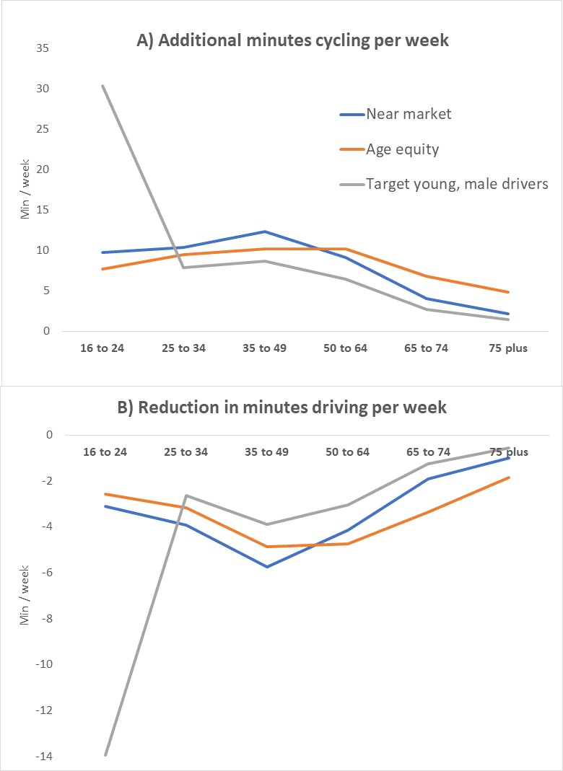

**SCENARIO 1.2: Illustrative example of a 20% reduction in car travel**

* Step 1: Identify a random 20% of car driver or passenger trips, made by household cars or non-household cars : trip_mainmode_det, modes 5 – 8
* Step 2: switch those trips to having zero travel duration and travel distance, with no replacement trips: i.e. they just stay home

1. this is what we did in PCT, I can't completely remember what we did in ICT. An alternative would be to apply average cycling versus walking versus driving detour factors, generating these from e.g. Google.