EMS

Onboarding & User Guide
Setting up a new company on the EMS platform, and how to use every module day-to-day
Audience: Platform Administrators & HR Managers
Version 1.0

Table of Contents

Part 1 — Onboarding a New Institution
This part is a one-time walkthrough for bringing a new company onto EMS, from creating the institution through to having employees, leave rules, and staff accounts in place. Part 2 is a lasting reference for using every module day-to-day once that setup is done.

1. Introduction
This guide walks a Platform Administrator and a company's first HR Manager through everything needed to bring a new institution (company) onto the EMS platform, from creating the company record through to having employees, leave rules, and staff accounts in place.
EMS is multi-tenant: every company (“institution”) is fully isolated from every other institution on the platform. Each institution signs in with its own Company Code, and only a Platform Administrator can create new institutions.

Who does what
- Platform Administrator (superadmin) — creates the institution record and its first HR Manager account. This is a one-time setup step per company.
- HR Manager — signs in with the credentials the Platform Administrator created, then configures leave rules, adds employees, and invites additional staff.
Note: Screenshots in this guide were captured from a live walkthrough on the EMS platform using a sample company, “Bright Horizon Sdn Bhd”, so you can see exactly what each screen looks like in practice.

2. Step 1 — Platform Admin Creates the Institution
Only a Platform Administrator can create a new institution. Platform Administrators sign in by leaving the Company Code field blank.
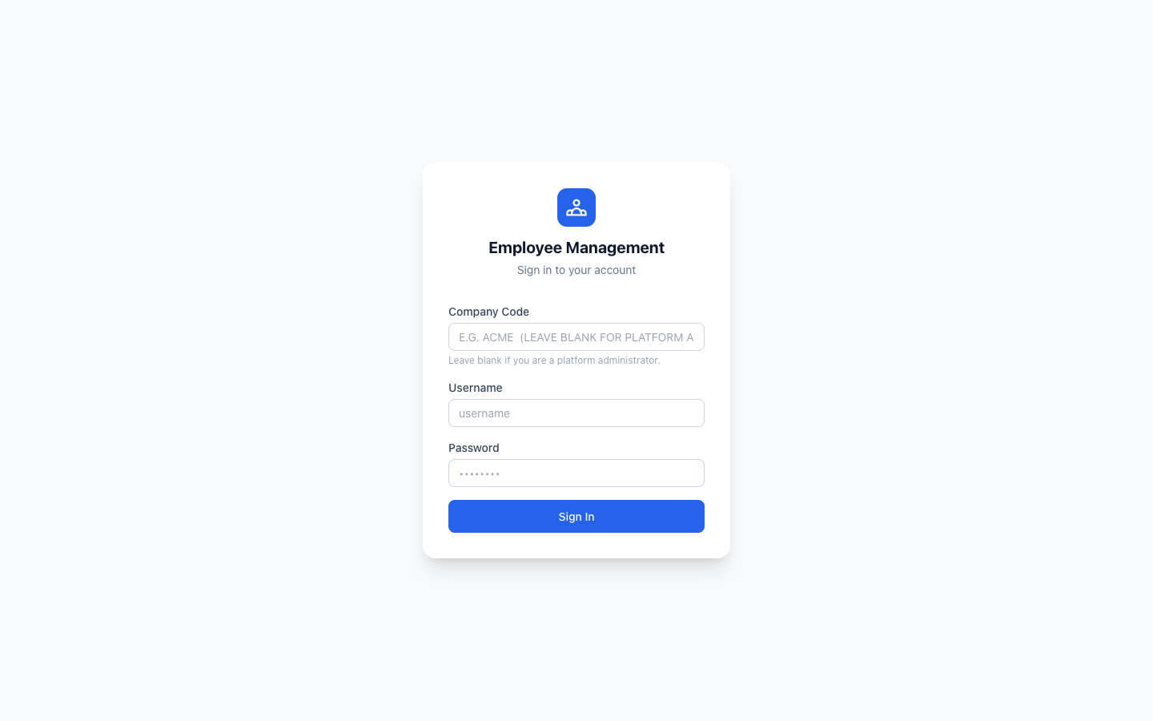
Figure 1. Sign-in screen. Leave Company Code blank to sign in as a Platform Administrator.
Once signed in, open the Institutions page from the sidebar. This lists every company currently on the platform.
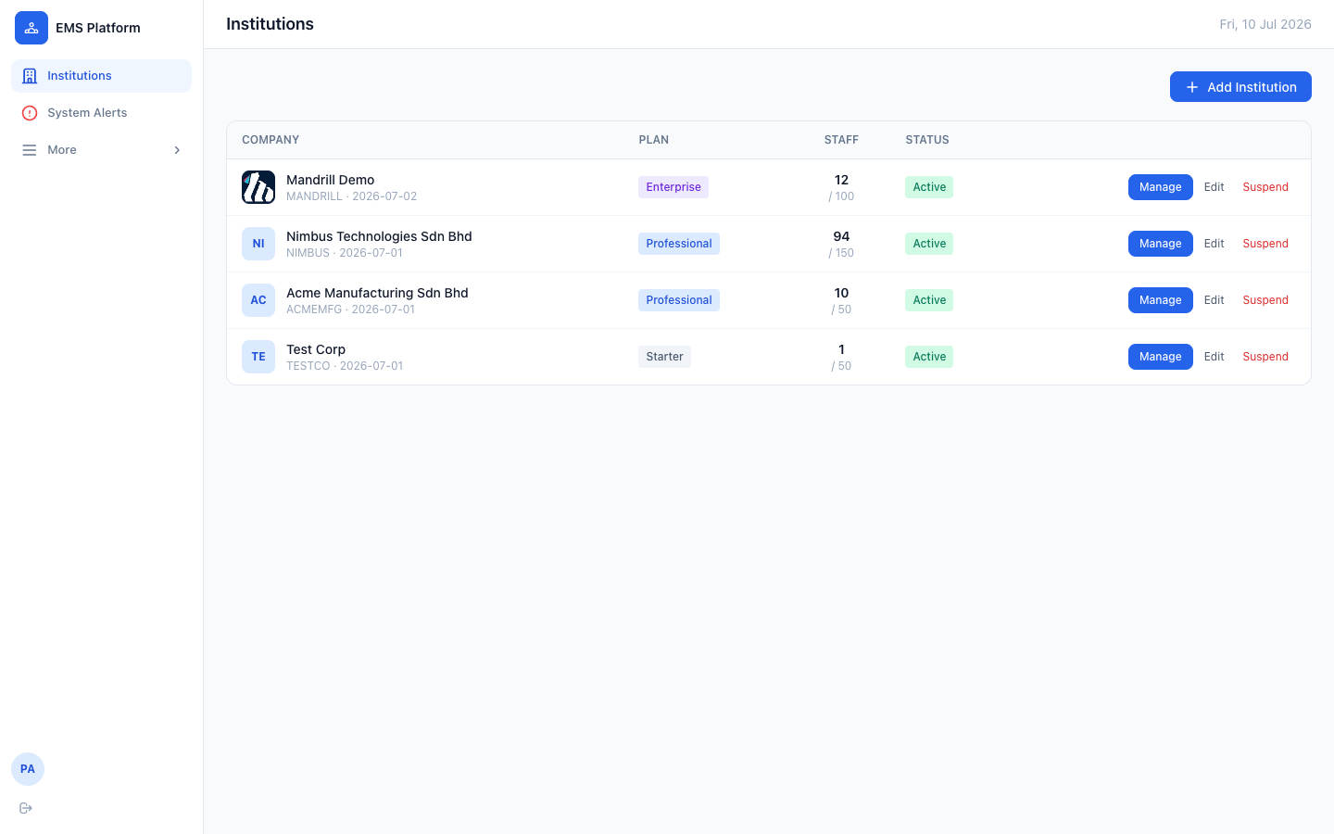
Figure 2. Institutions list, showing existing companies and their plan, staff count, and status.
- Click “+ Add Institution” in the top-right corner.
- Fill in the company details — name, a short unique Company Code, plan, and contact information.
- In the same form, fill in the “Initial HR Manager Account” section — this creates the very first login for the new company.
- Click “Create Institution”.
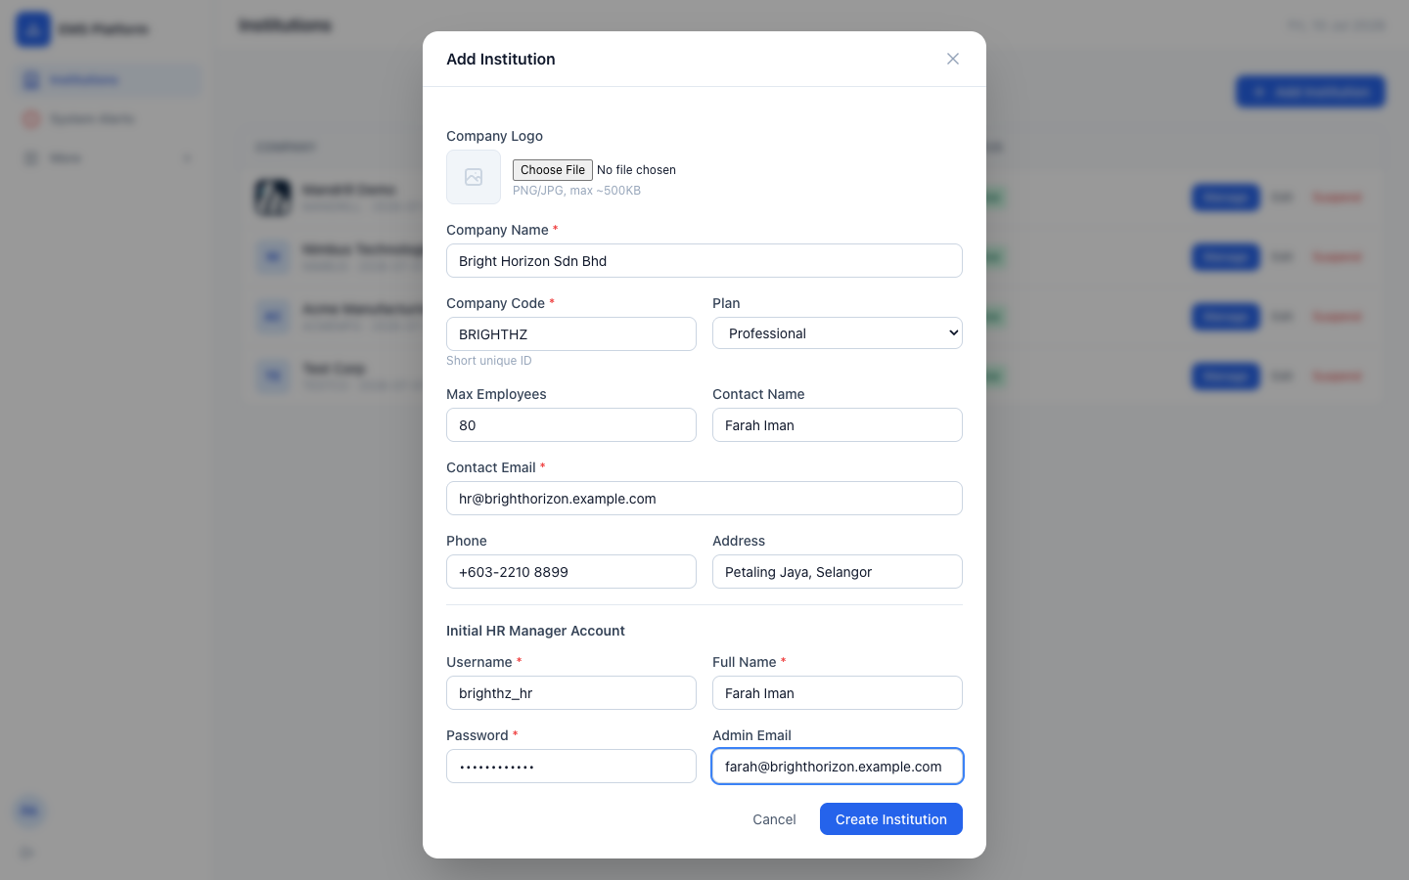
Figure 3. Add Institution form — company details plus the initial HR Manager account, created together in one step.
The fields in this form are:
Field | Description
Company Name | Full legal or trading name of the company.
Company Code | A short, unique identifier (e.g. BRIGHTHZ). Employees will type this on the sign-in screen — keep it short and memorable.
Plan | Starter, Professional, or Enterprise — controls the employee headcount ceiling.
Max Employees | Maximum number of employee records the institution can hold.
Contact Name / Email / Phone / Address | Primary business contact for the account.
Initial HR Manager — Username / Password | Login credentials for the company's first HR Manager. Share these with the HR contact through a secure channel.
Initial HR Manager — Full Name / Email | Display name and notification email for that account.

After creation, the new company appears at the top of the Institutions list, with 0 staff and an Active status.
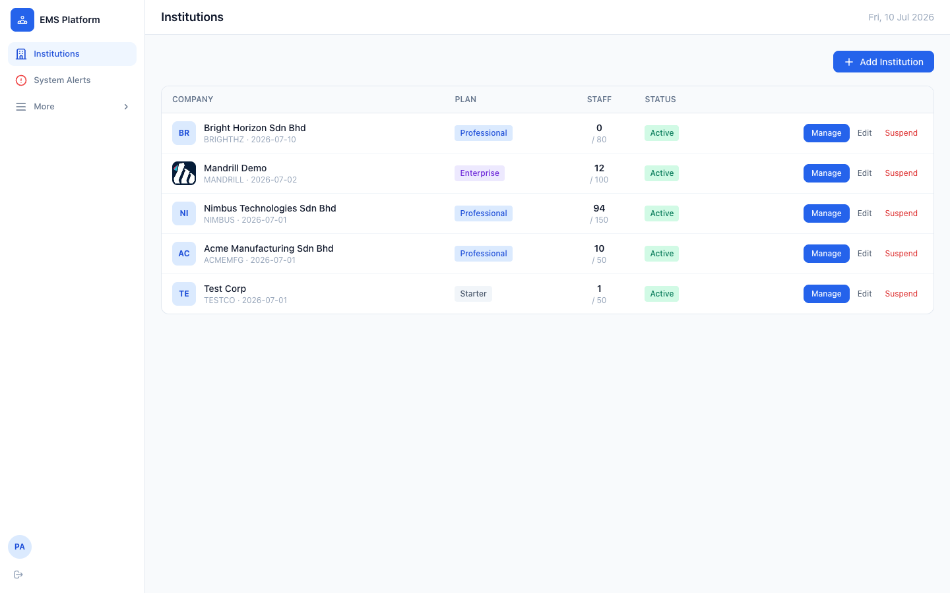
Figure 4. The new institution, Bright Horizon Sdn Bhd, now appears in the Institutions list.
Note: A Platform Administrator can always come back to this list later to Edit a company's details, or Suspend an institution — there is currently no self-service way for an HR Manager to edit their own company profile, so changes to company name, logo, plan, or contact details must go through the Platform Administrator.

3. Step 2 — First Login as HR Manager
Hand the Company Code and the HR Manager username/password to the person who will be administering the account. They sign in the same way as any other user, but with the Company Code filled in this time.
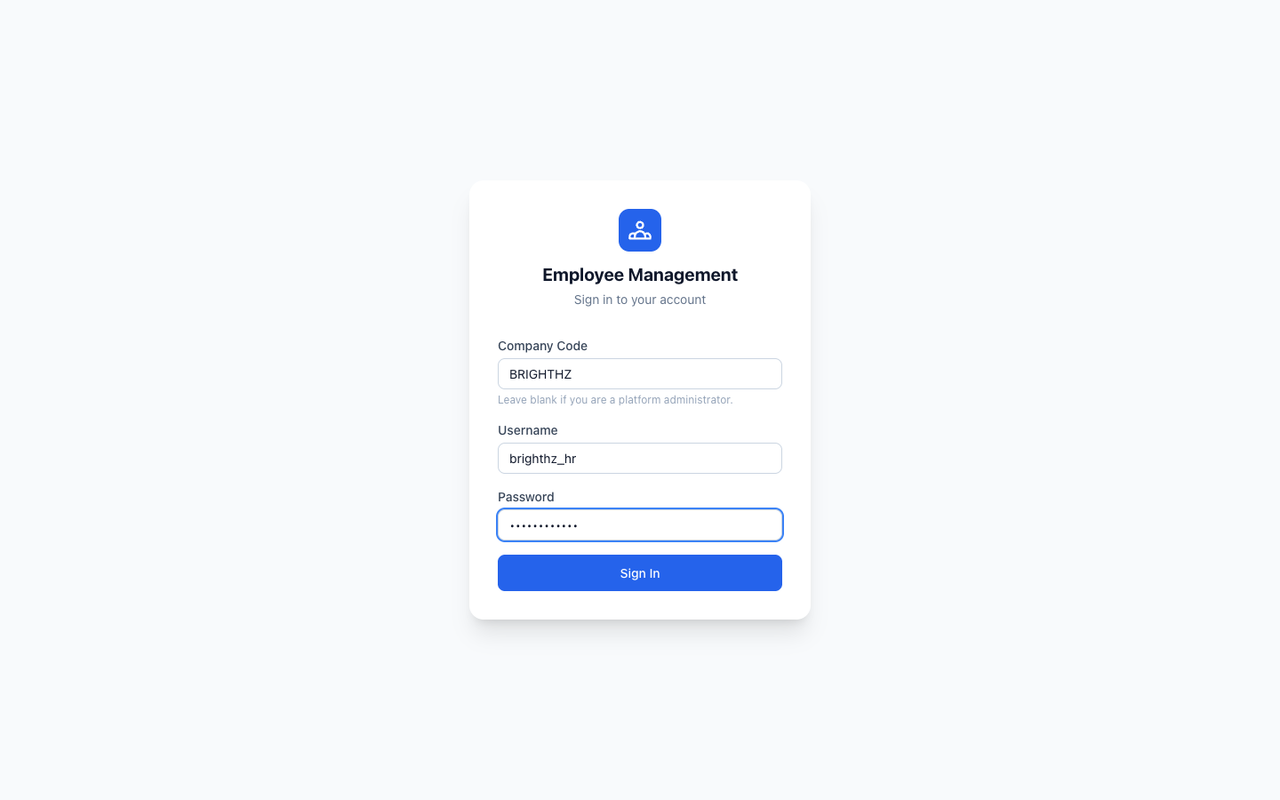
Figure 5. Signing in as the new HR Manager, with the company's own Company Code.
On first login, the dashboard is empty — there are no employees, requisitions, or projects yet. This is expected.
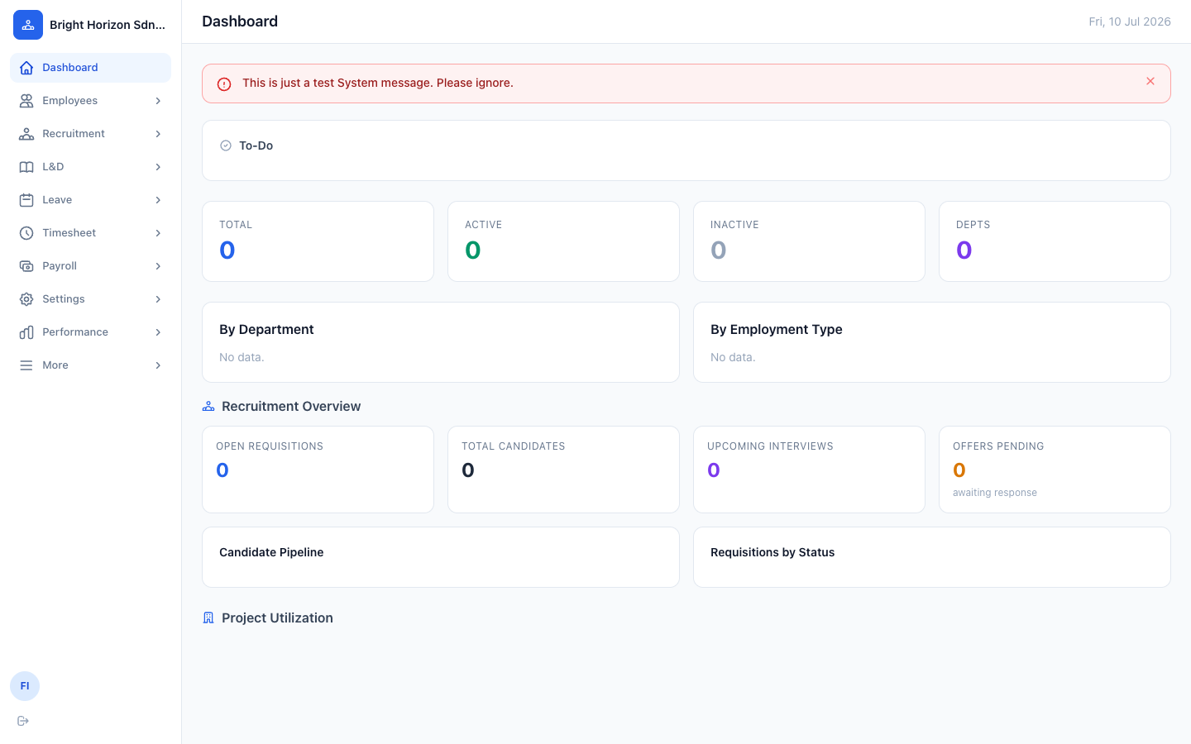
Figure 6. The Dashboard immediately after first login — empty until employees and records are added.

4. Step 3 — Get Familiar with the Sidebar
The sidebar lists every module the HR Manager role has access to. Each group is collapsed by default — click a group's name to expand its sub-menu.
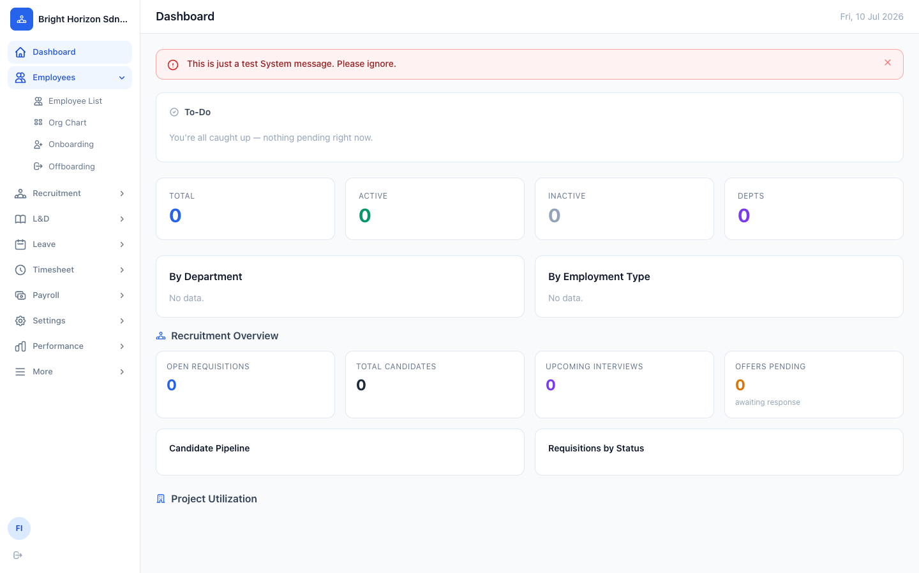
Figure 7. Sidebar navigation, with the Employees group expanded to show Employee List, Org Chart, Onboarding, and Offboarding.
A quick tour of what's available:
- Employees — employee records, org chart, onboarding and offboarding checklists.
- Recruitment — job requisitions, candidates, interviews, and offers.
- L&D — training courses and enrollments.
- Leave — leave applications, approvals, public holidays, and leave type configuration.
- Timesheet — time entries, approvals, and projects.
- Payroll — payroll runs and payslips.
- Settings — bulk employee upload, user accounts, and notifications.
- Performance — goals, appraisals, and review cycles.

5. Step 4 — Add Employees
There are two ways to bring employees into a new institution: adding them one at a time, or uploading a batch via CSV.

5.1 Add an employee manually
From Employees → Employee List, click “+ Add Employee”. The form is split across three tabs — Personal Info, Employment, and Statutory & Payroll.
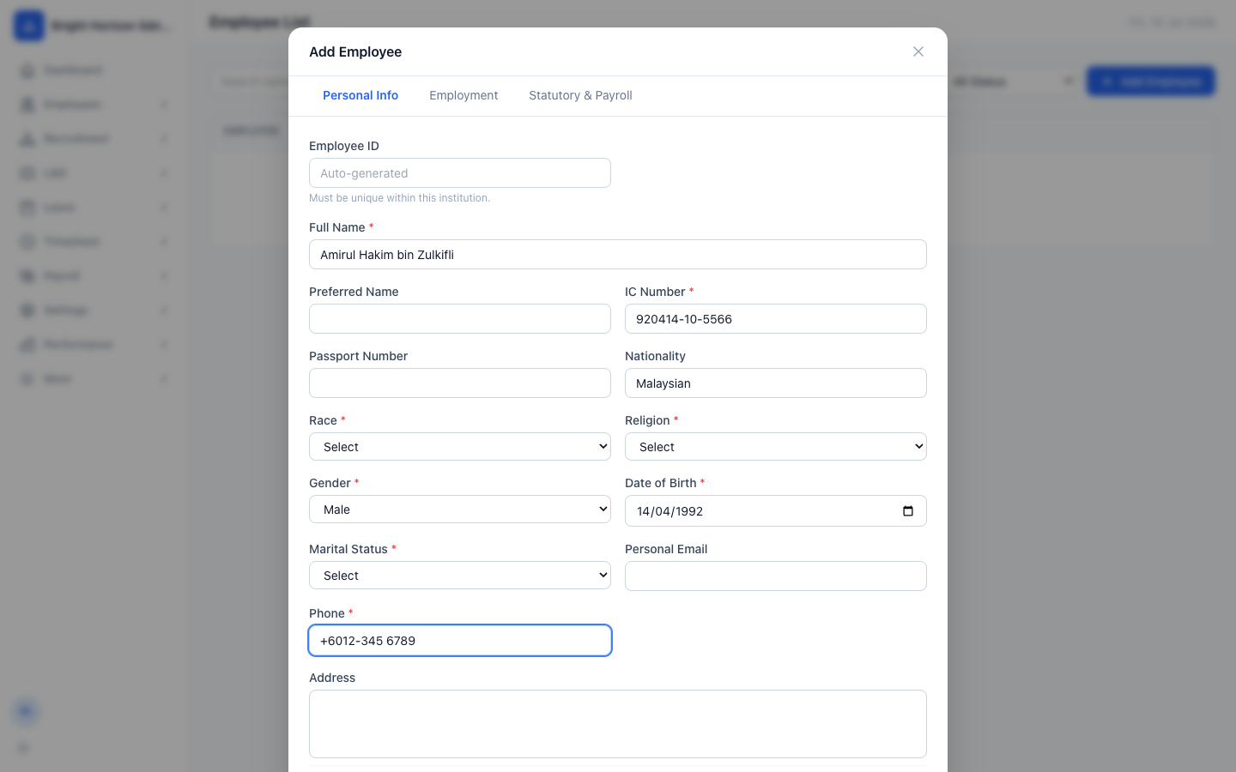
Figure 8. Add Employee form — Personal Info tab. Employee ID is auto-generated unless you set a custom one.
Note: Required fields are marked with a red asterisk. You can save after completing all three tabs — the Next button walks you through each one in order.

5.2 Bulk upload employees
For onboarding many employees at once, use Settings → Bulk Upload. Download the CSV template, fill in one row per employee, and upload it.
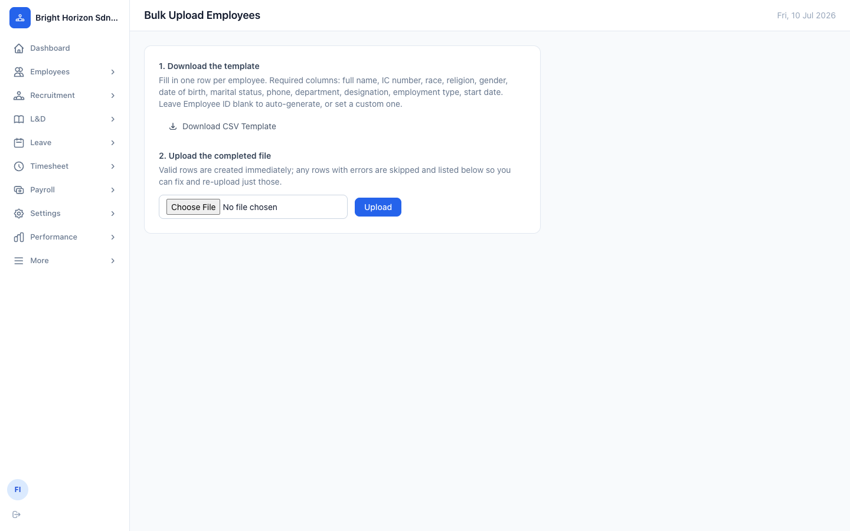
Figure 10. Bulk Upload Employees — download the template, fill it in, then upload. Rows with errors are skipped and listed for correction.
Valid rows are created immediately; any rows with errors are listed below the upload button so you can fix just those and re-upload.

5.3 Employee List
However they're added, all employees show up in the Employee List, searchable by name, ID, IC number, or designation.
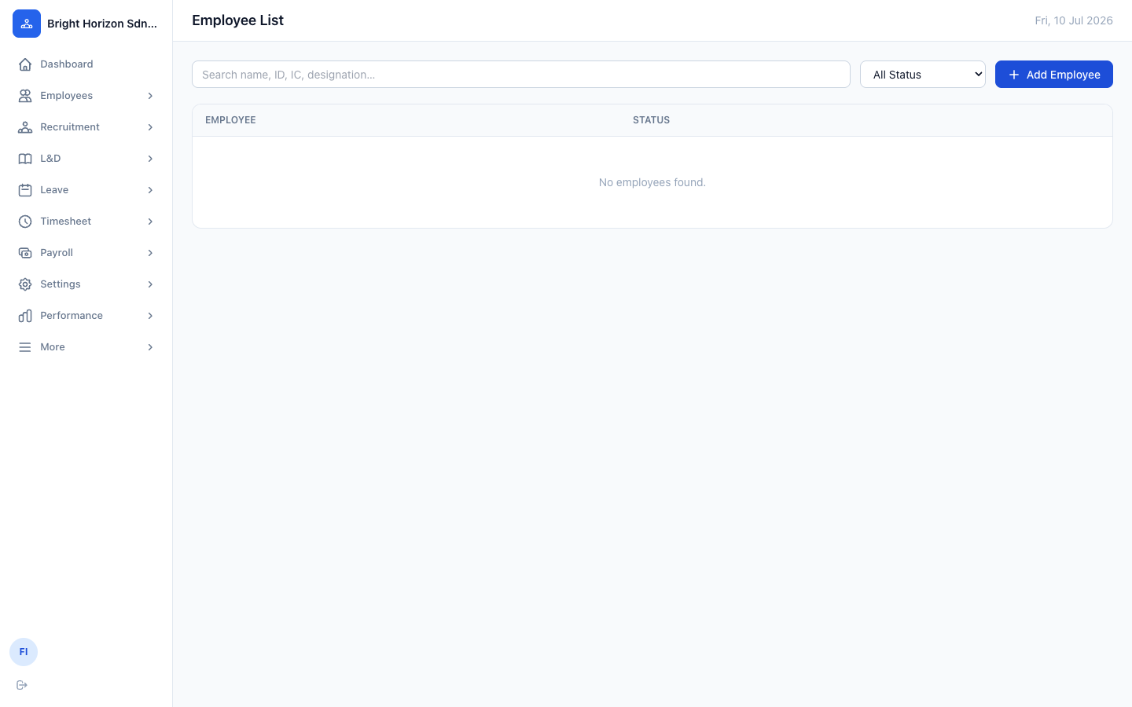
Figure 9. Employee List — empty until the first employee is added.

6. Step 5 — Configure Leave Types & Public Holidays
Before employees can apply for leave, set up the institution's leave types (e.g. Annual, Medical, Unpaid) and its public holiday calendar. Both live on the same page: Leave → Public Holidays.
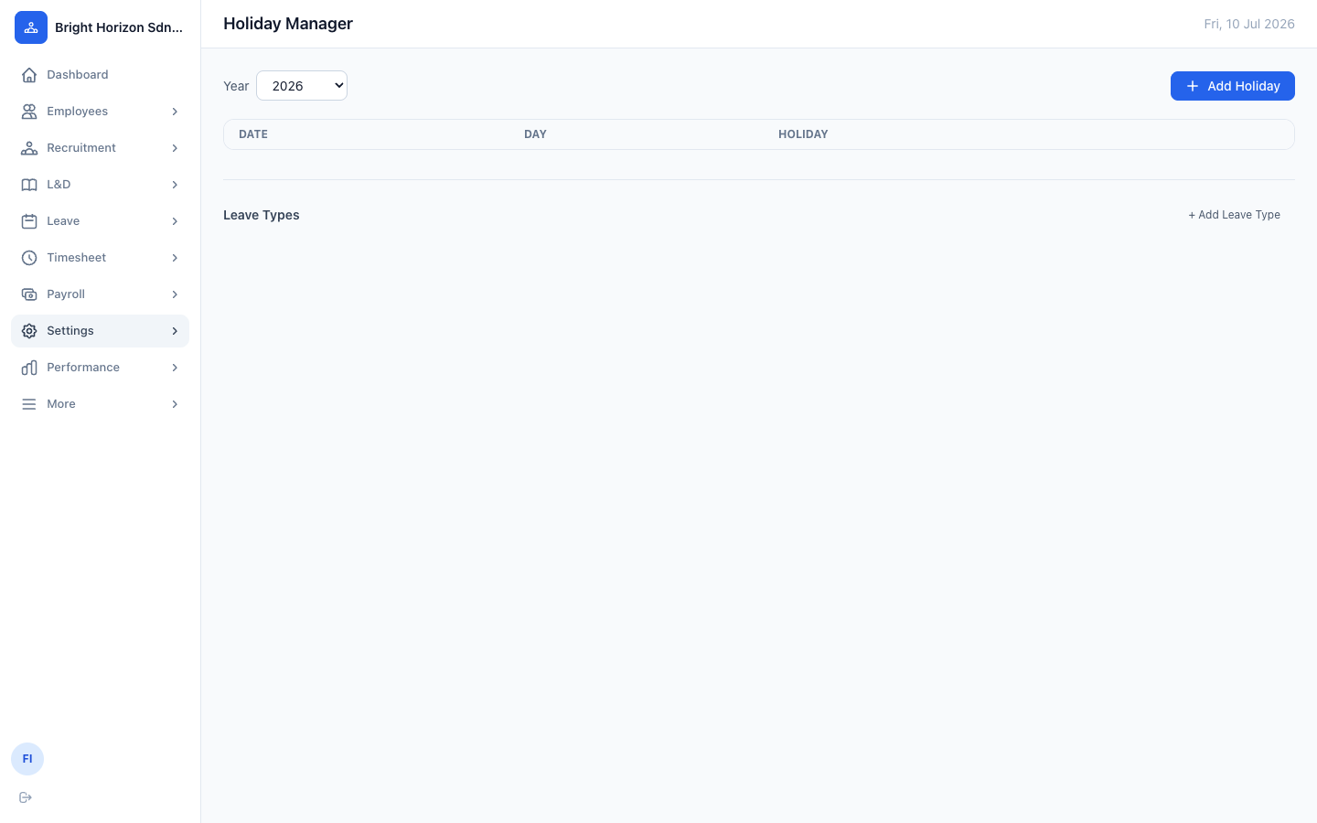
Figure 11. Holiday Manager and Leave Types — configure both from this single page.
- Click “+ Add Holiday” to add each public holiday for the selected year.
- Click “+ Add Leave Type” to define the leave categories your company offers, including whether each is paid.
Note: Leave balances are calculated per employee based on the leave types you configure here, so it's worth setting this up before employees start submitting applications.

7. Step 6 — Set Up the Reporting Structure
As employees are added, use each employee's “Reports To” field (on the Employment tab) to build out the reporting chain. The Org Chart page visualizes this automatically.
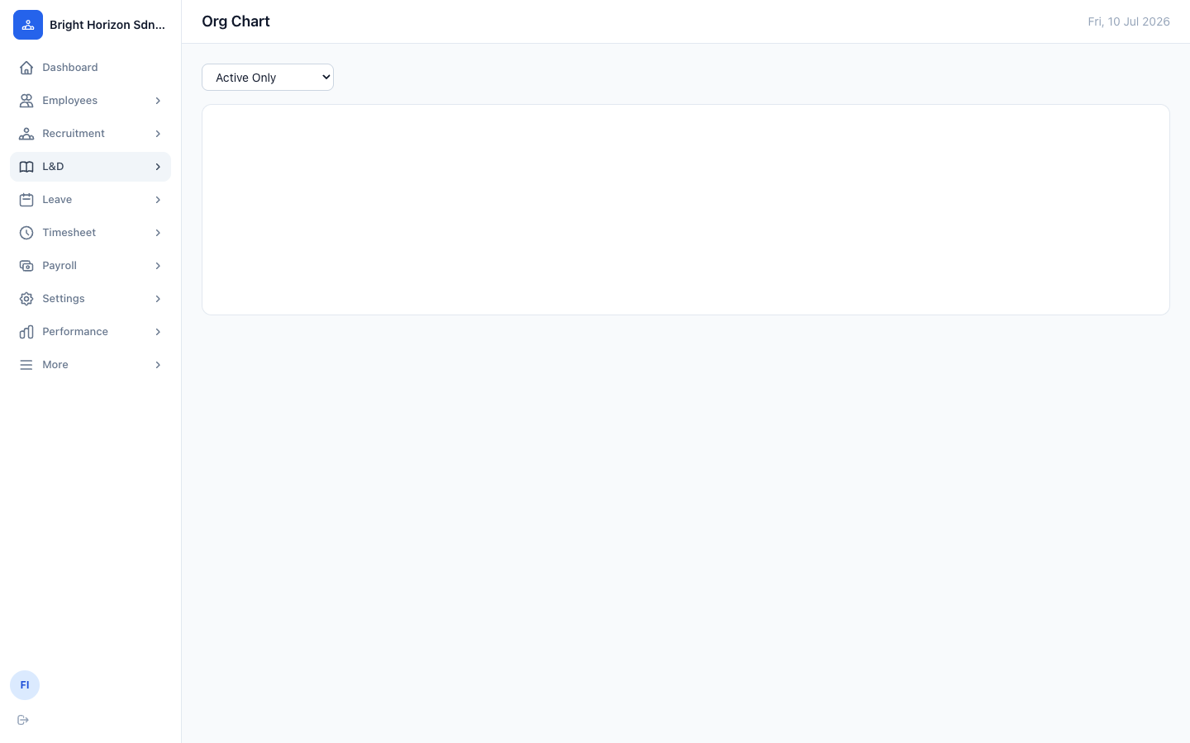
Figure 12. Org Chart — populates automatically as employees are added and reporting lines are set.
Note: The reporting chain isn't just cosmetic — it drives manager-scoped views throughout the platform, including who can approve a given employee's leave and timesheets, and who sees a given appraisal for manager review in the Performance module.

8. Step 7 — Add Additional Staff Accounts
The HR Manager account created during Step 1 is the only login that exists at first. Add accounts for other staff (managers, payroll administrators, additional HR staff) from Settings → Users.
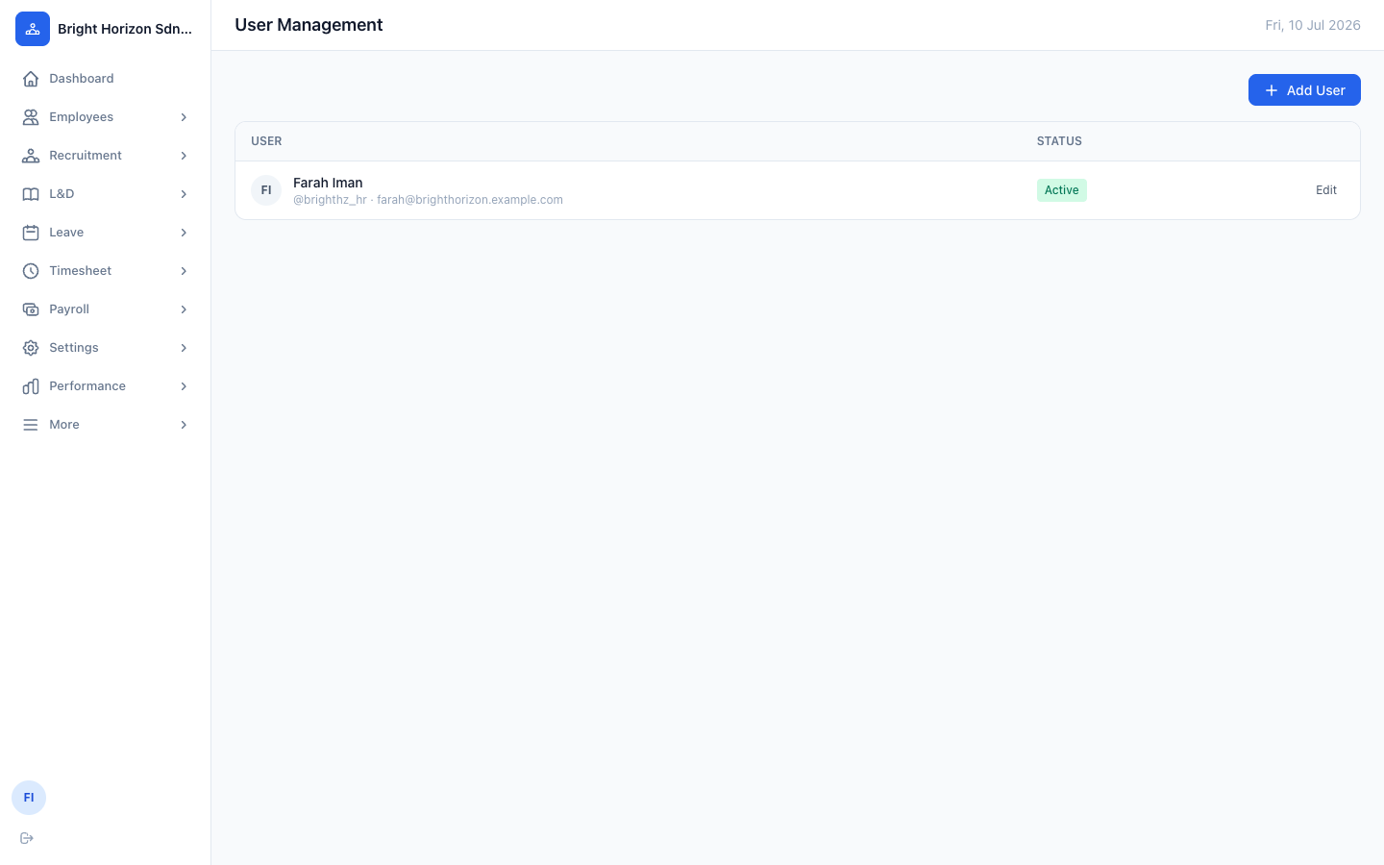
Figure 13. User Management — the initial HR Manager account, with “+ Add User” to create additional logins.
When creating a user, you'll choose a role that determines what they can see and do:
Field | Description
hr_manager | Full administrative access within the institution — employees, payroll, settings, performance, and user management.
hr_admin | Day-to-day HR operations without full settings/user-management access.
manager | Access scoped to their own reporting chain — approvals, team appraisals, team timesheets.
payroll_manager | Payroll runs and payslips.
employee | Self-service only — own profile, leave, timesheet, and payslips.

Note: A single login can be linked to an employee record (via the Employee ID field) so that person also gets self-service access to their own profile, leave, and payslips — this is optional and can be set later.

Part 2 — Module Reference Guide
Part 1 covered the one-time setup of a new institution. This part is a lasting reference for day-to-day use of every module in EMS, once the institution is up and running. Screenshots here are taken from a populated, real-world institution rather than an empty new one, so you can see each feature actually in use.
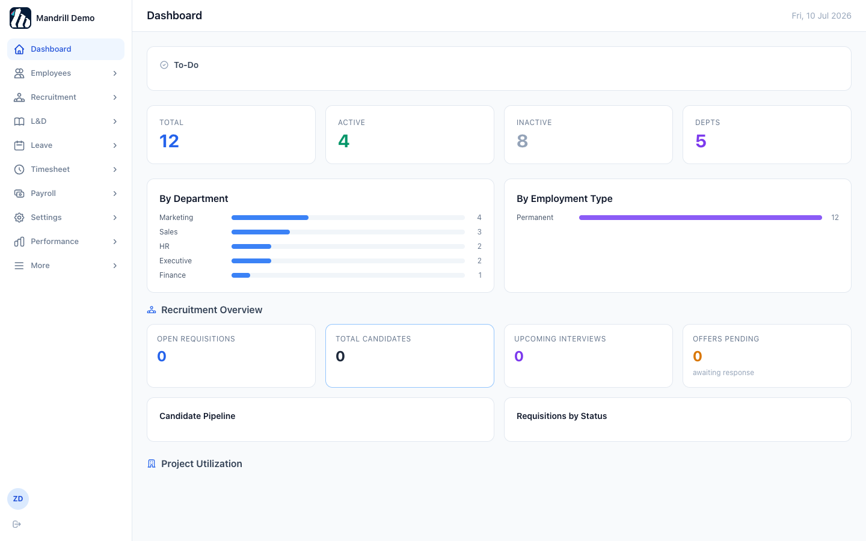
Figure 14. The Dashboard once an institution has real data — headcount, department breakdown, recruitment overview, and project utilization all populate automatically.

9. Employees
The Employees group covers the full employee lifecycle: records, reporting structure, onboarding, and offboarding.

9.1 Employee List
The main directory of every employee in the institution. Search by name, ID, IC number, or designation, and filter by status.
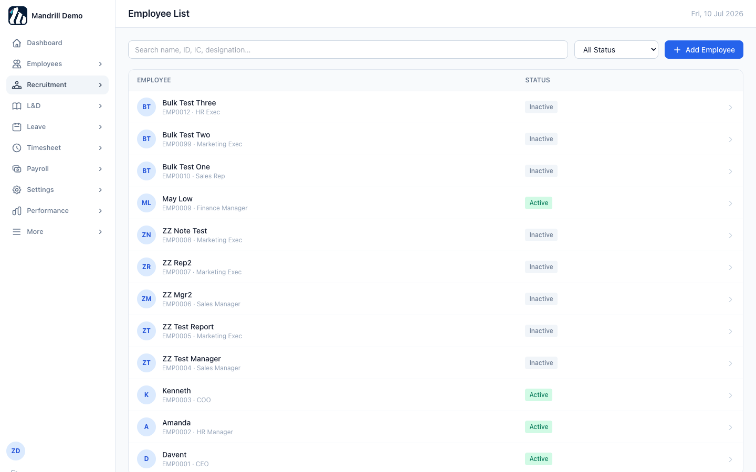
Figure 15. Employee List — every employee, with quick status filtering and search.

9.2 Viewing an employee record
Click any row to open the employee's full record across four tabs: Personal Info, Employment, Statutory & Payroll, and (for hr_manager/hr_admin) a locked HR Notes tab for confidential notes — disciplinary, performance, warnings, or commendations.
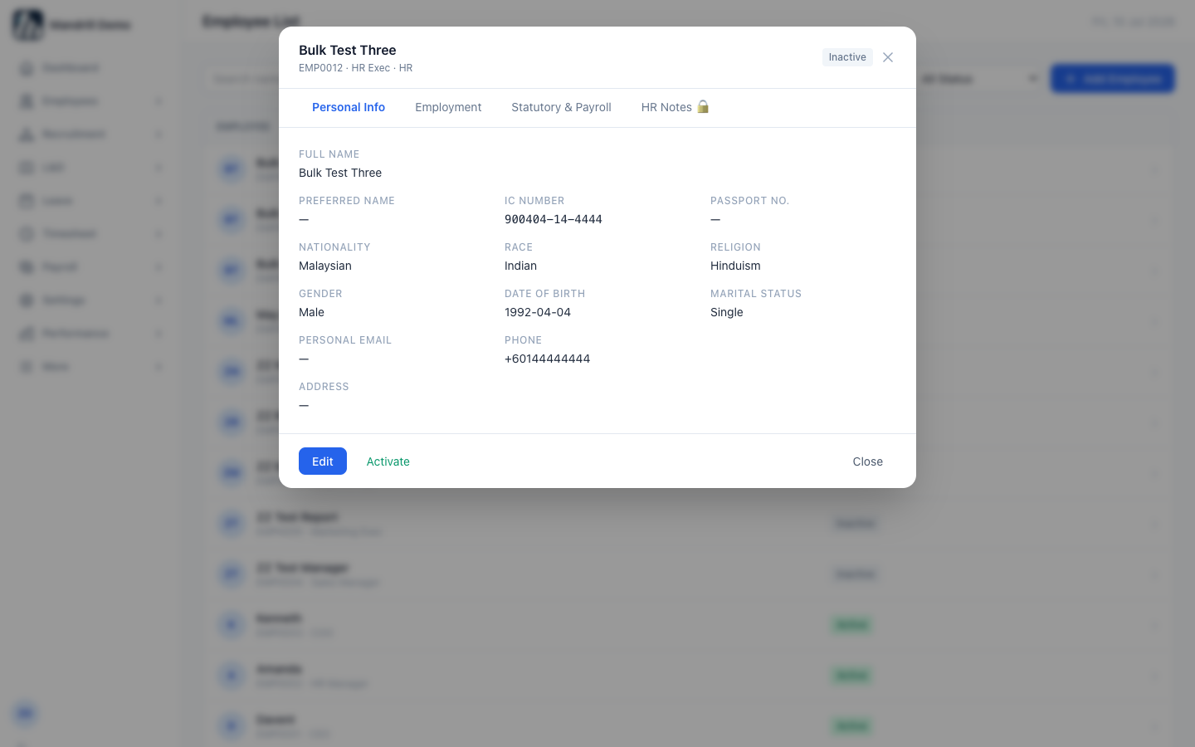
Figure 16. Employee detail view — tabbed record with an Edit button and an Activate/Deactivate toggle.
Note: Employees are never hard-deleted from EMS — set status to Inactive instead. This preserves their historical leave, payroll, and performance records.

9.3 Org Chart
Builds itself automatically from each employee's “Reports To” field — no separate configuration needed. Toggle between Active Only and all employees.
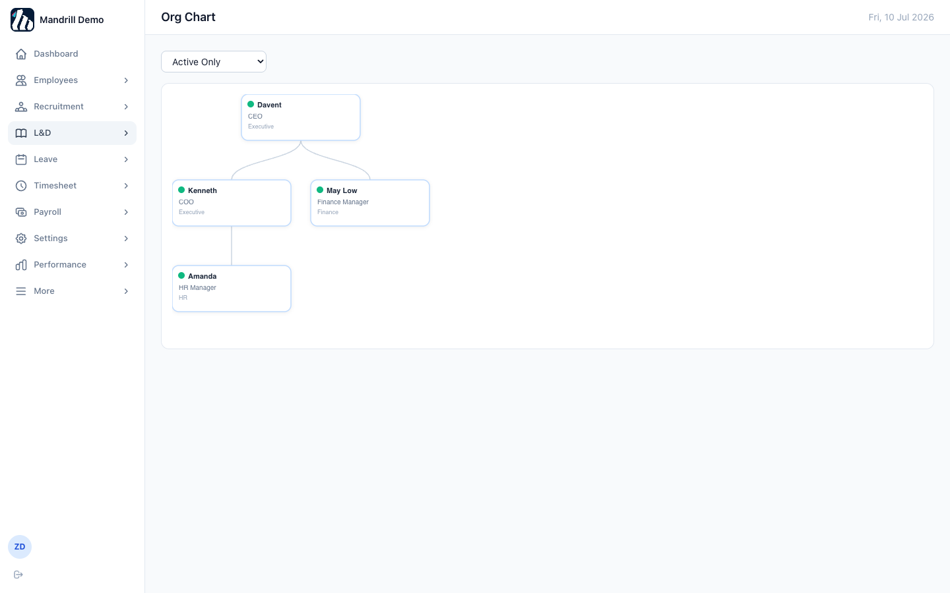
Figure 17. Org Chart — reporting lines drawn automatically from employee data.

9.4 Onboarding
Start a formal onboarding checklist for a new hire from Employees → Onboarding. Checklists are built from templates (manage these via “Manage Templates”), and progress is tracked item-by-item until complete.
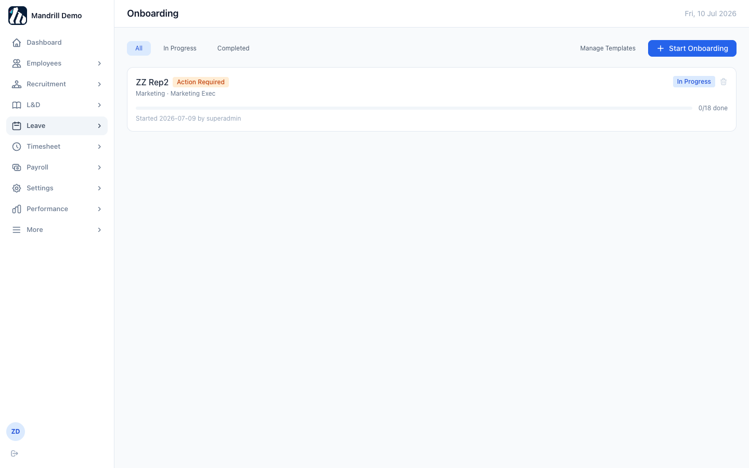
Figure 18. Onboarding — checklist progress for employees currently being onboarded.

9.5 Offboarding
The mirror-image workflow for employees leaving the company — exit checklist items (equipment return, access revocation, final settlement, etc.) tracked the same way as onboarding.
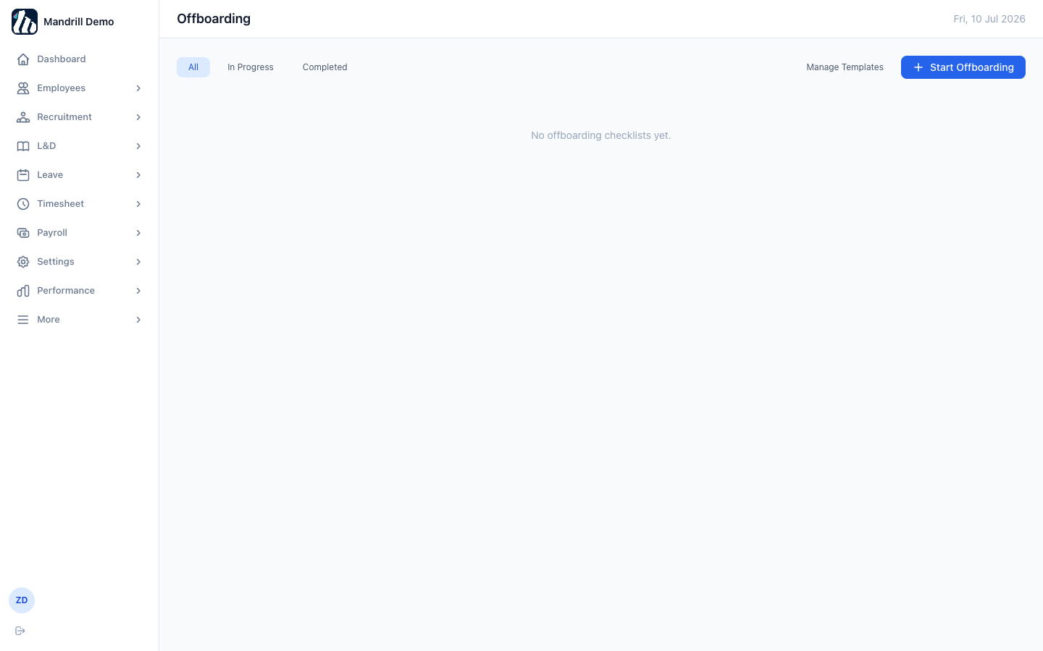
Figure 19. Offboarding — no exits in progress in this example institution.

10. Recruitment
The recruitment pipeline flows in one direction: a Job Requisition is opened and approved, Candidates are added against it, Candidates are scheduled for Interviews, and successful candidates receive an Offer.

10.1 Job Requisitions
- Click “+ New Requisition”.
- Fill in the position title, department, headcount, salary range, and a description.
- Save — the requisition starts in Draft and moves through your institution's approval flow from there.
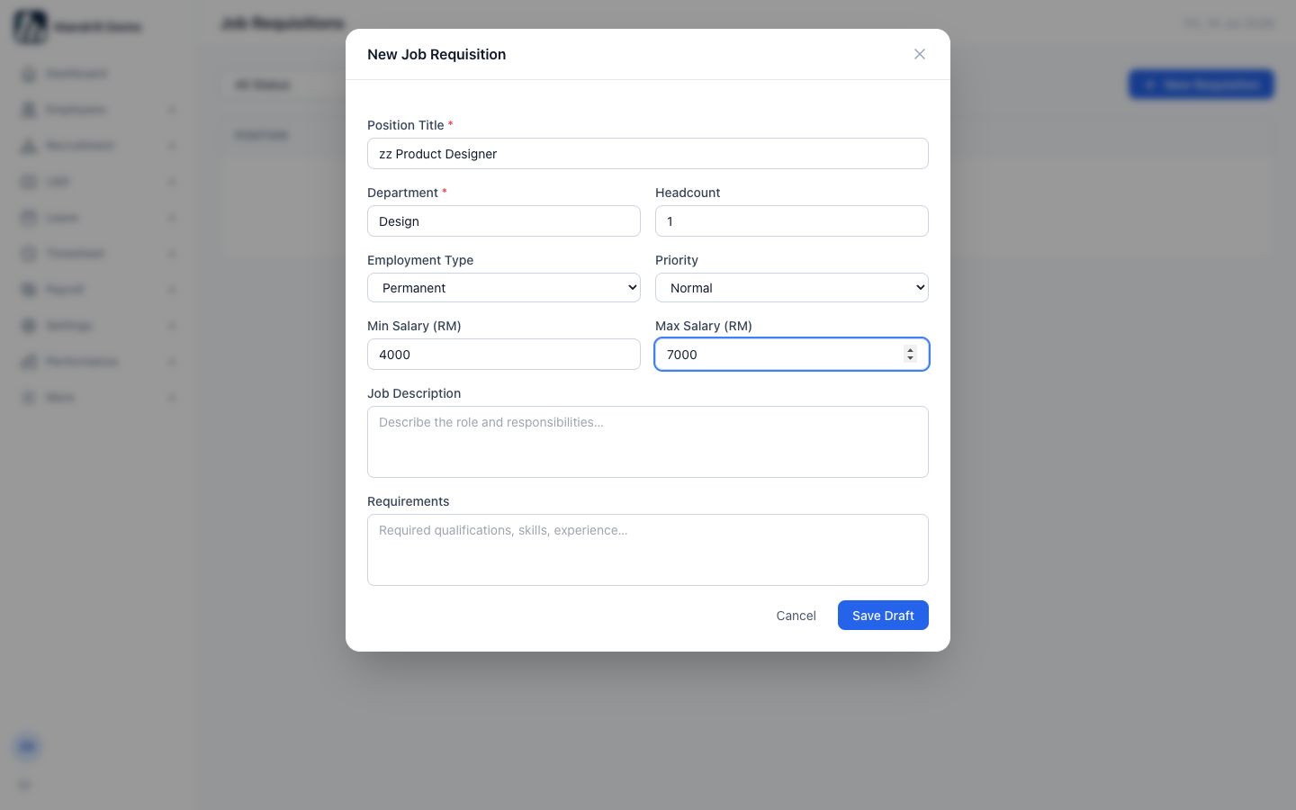
Figure 20. New Job Requisition form.
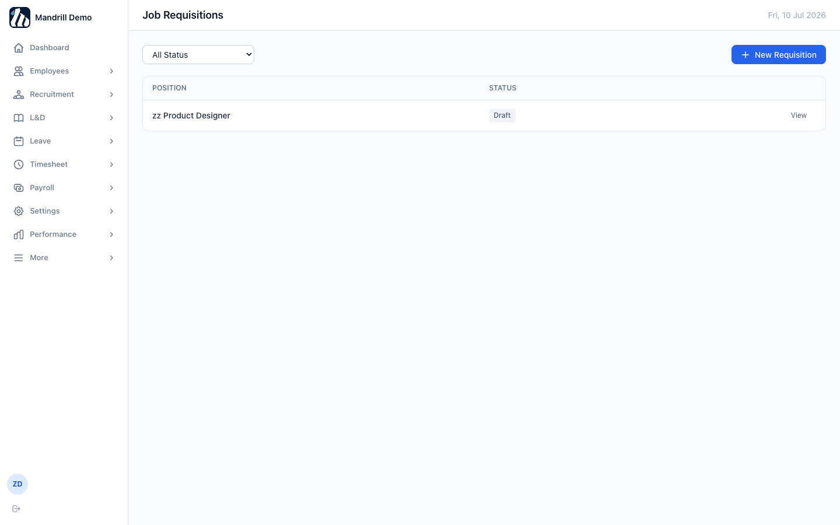
Figure 21. Job Requisitions list — each requisition shows its current status.

10.2 Candidates
Candidates are added against a specific requisition and tracked through the pipeline (Applied → Screening → Interview → Offer → Hired/Rejected).
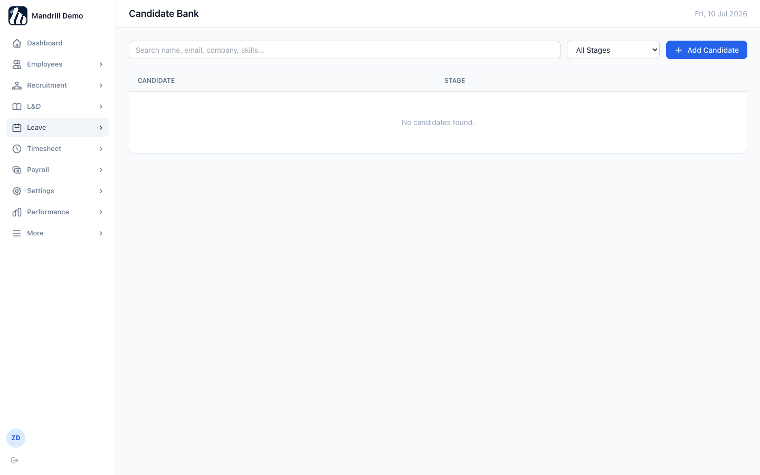
Figure 22. Candidate Bank — empty until candidates are added against an open requisition.

10.3 Interviews
Schedule and score interviews for candidates who've progressed far enough in the pipeline. Multiple interviewers can each submit a score.
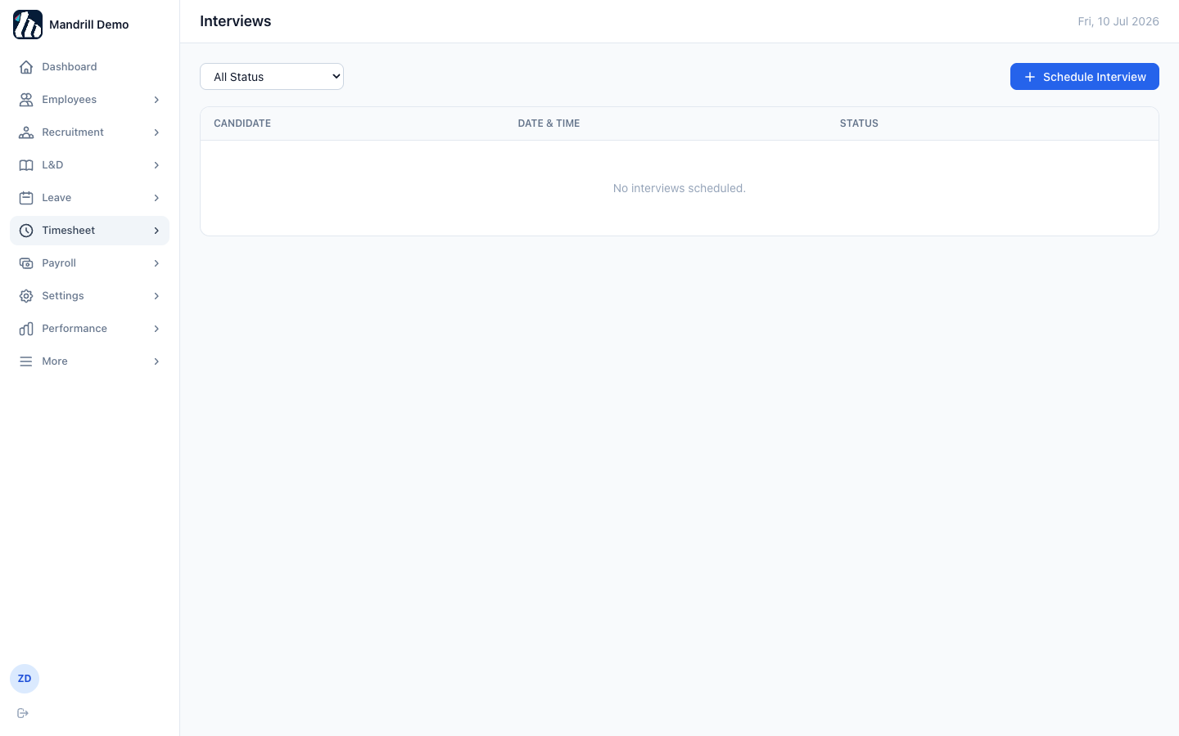
Figure 23. Interviews — scheduled interviews appear here with their scores once submitted.

10.4 Offers
Generate an offer letter for a candidate once a hiring decision is made. Accepting an offer can convert the candidate directly into a new employee record, carrying over their details.
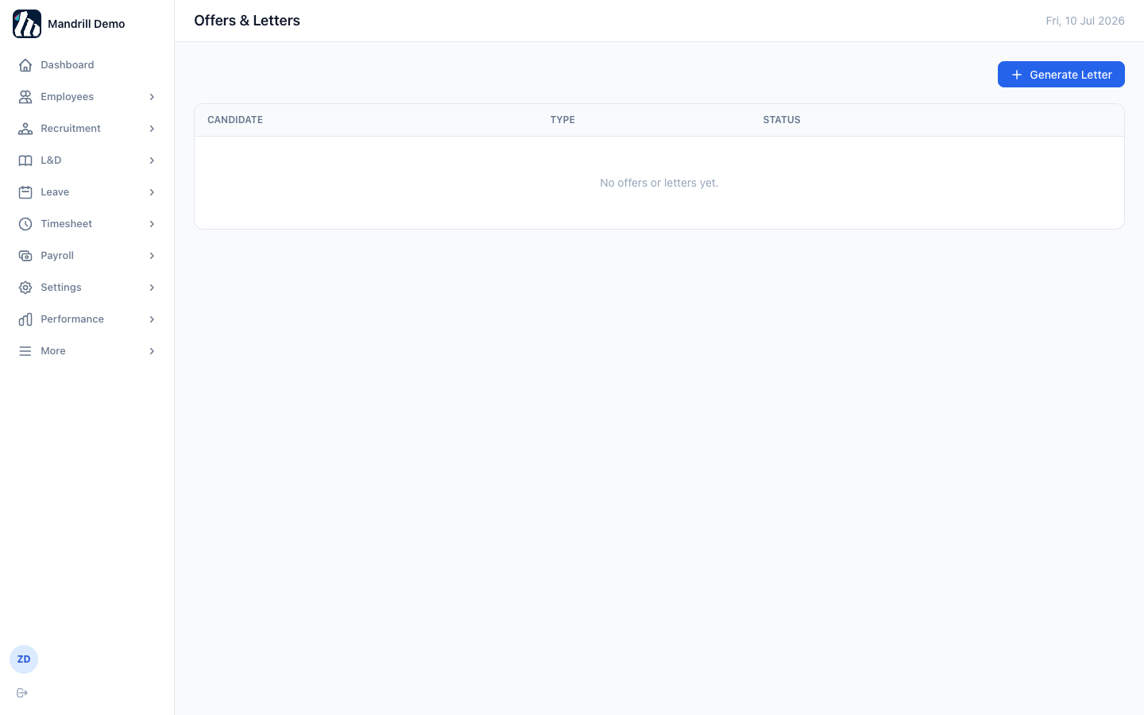
Figure 24. Offers & Letters — tracks offers extended and their acceptance status.

11. Learning & Development (L&D)

11.1 Course Catalog
HR creates courses here — mandatory, professional development, or certification tracks — each with a price (or free) and optional quiz.
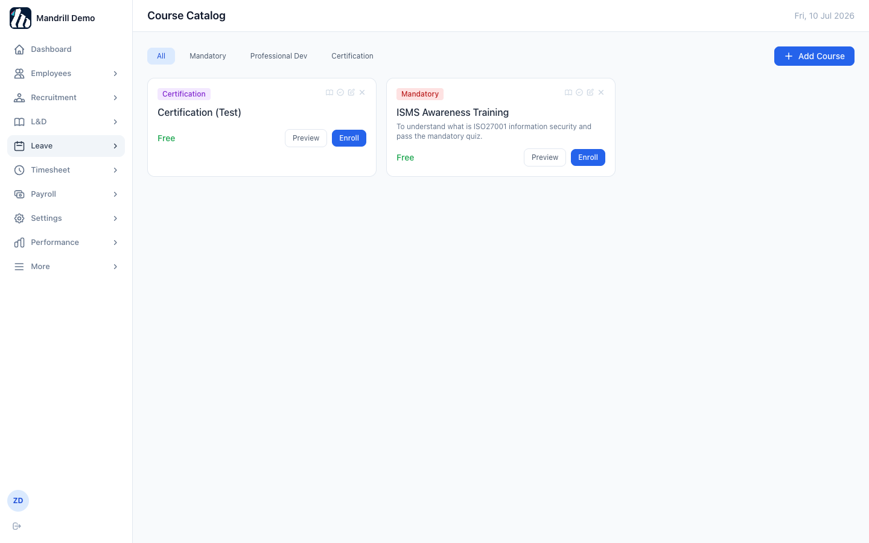
Figure 25. Course Catalog — courses employees can browse and enroll in.

11.2 My Trainings
Every employee's personal enrollment list, showing progress through each course's modules and any quiz attempts.
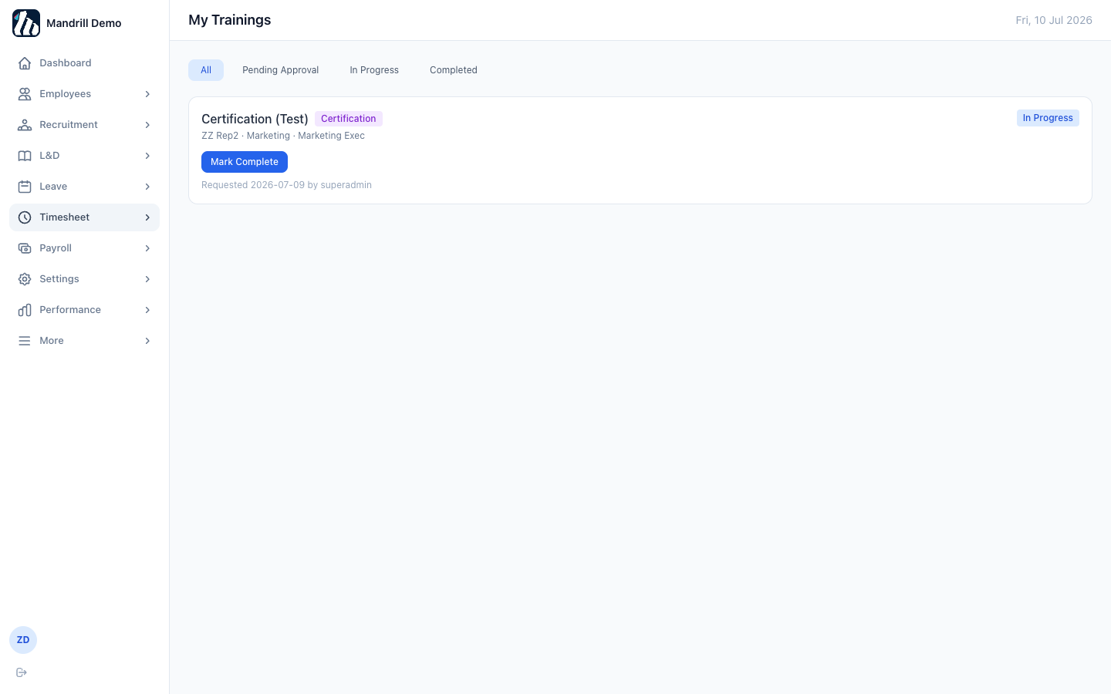
Figure 26. My Trainings — the logged-in user's own enrollments.

12. Leave

12.1 Applying for leave
- Click “+ Apply for Leave” from My Leave.
- Choose the leave type — the form shows your remaining balance for that type immediately.
- Pick start and end dates and, optionally, a reason or supporting attachment.
- Submit — the application goes to your manager for approval.
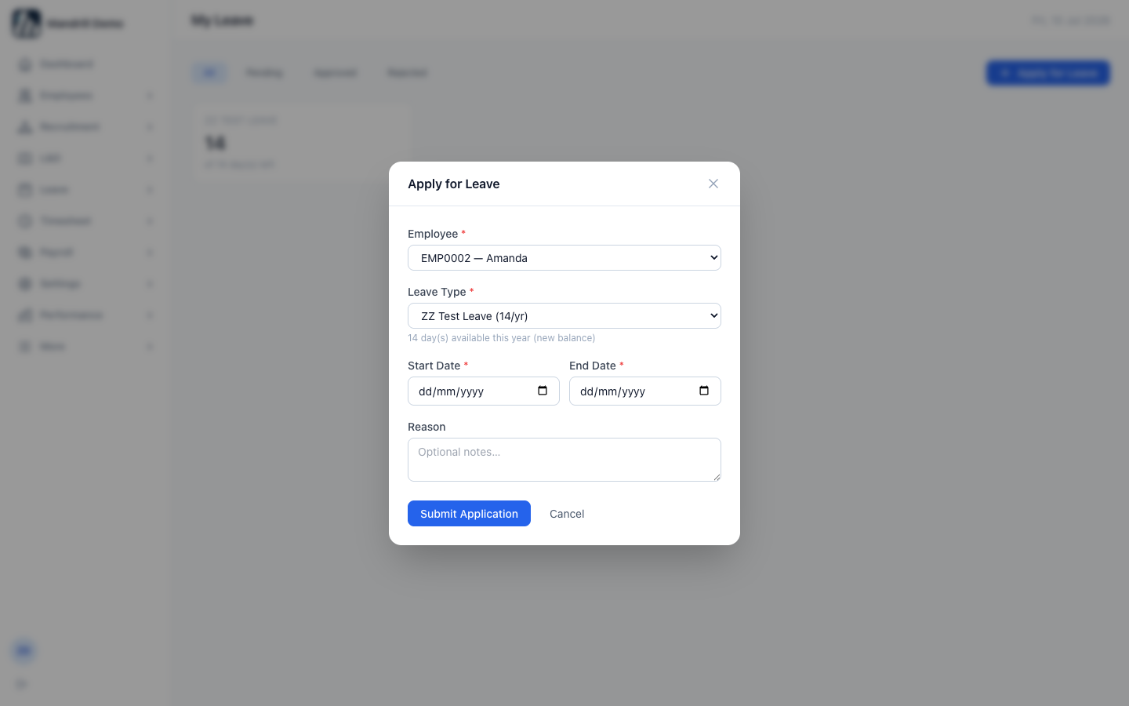
Figure 27. Apply for Leave — balance shown live as soon as a leave type is selected.
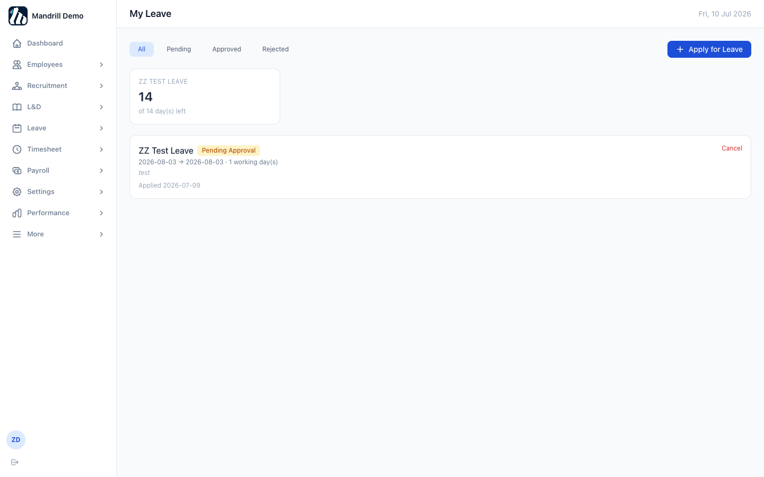
Figure 28. My Leave — a running history of the employee's own applications, filterable by status.

12.2 Leave Approvals
Managers and HR see pending leave requests from their reporting chain here, with one-click Approve/Reject.
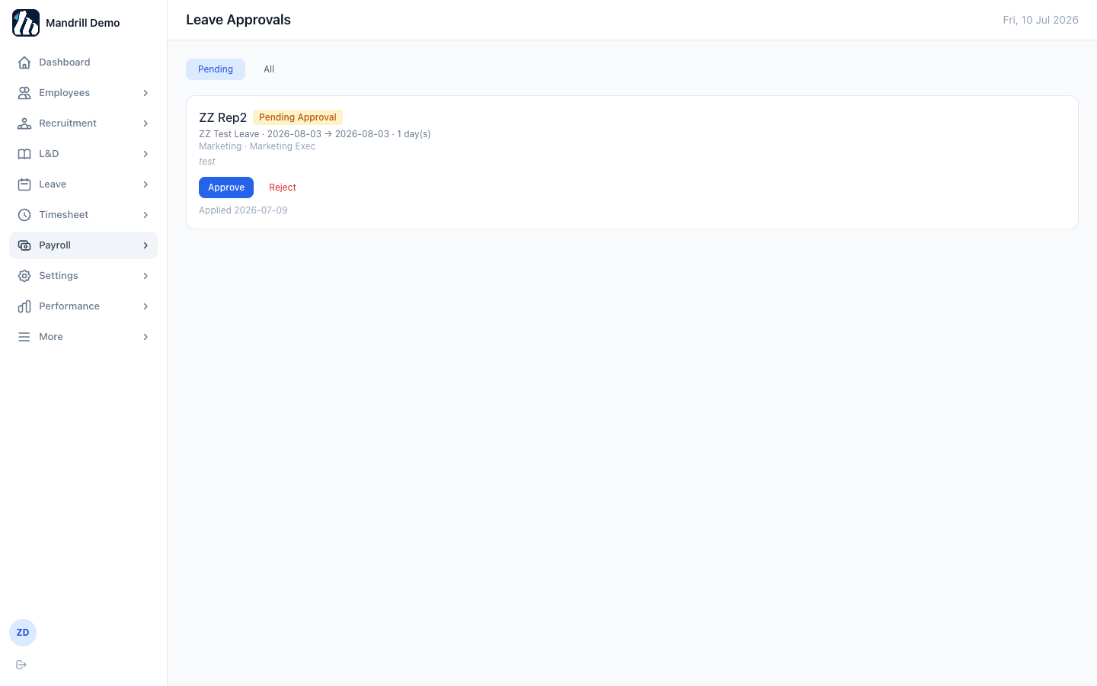
Figure 29. Leave Approvals — a pending request awaiting a decision.
Note: Leave types and the public holiday calendar are configured once, institution-wide, from Leave → Public Holidays (see Part 1, Step 5).

13. Timesheet & Projects

13.1 My Timesheet
Employees log hours against a project and task for each day of the week, then submit the whole week for manager approval.
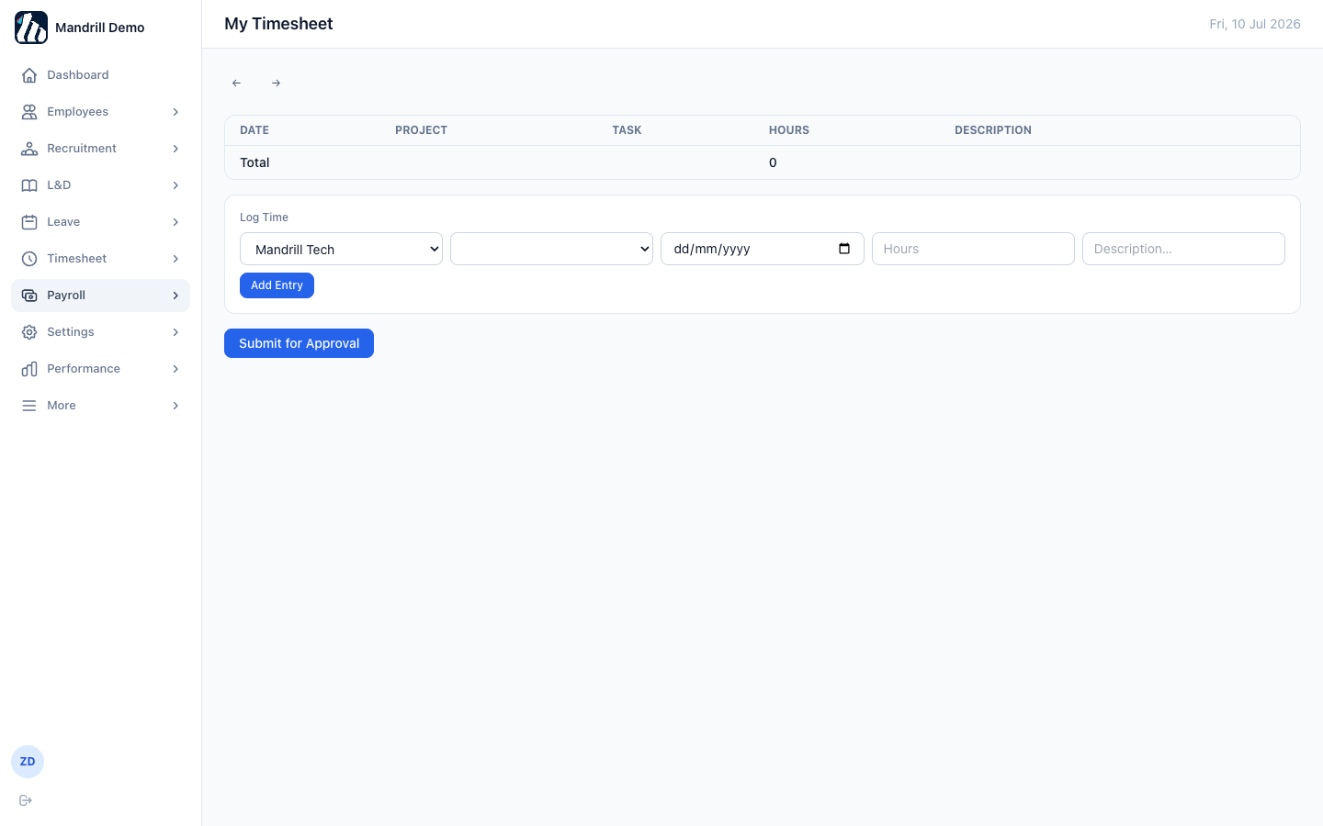
Figure 30. My Timesheet — log time by project and task, then Submit for Approval.

13.2 Timesheet Approvals
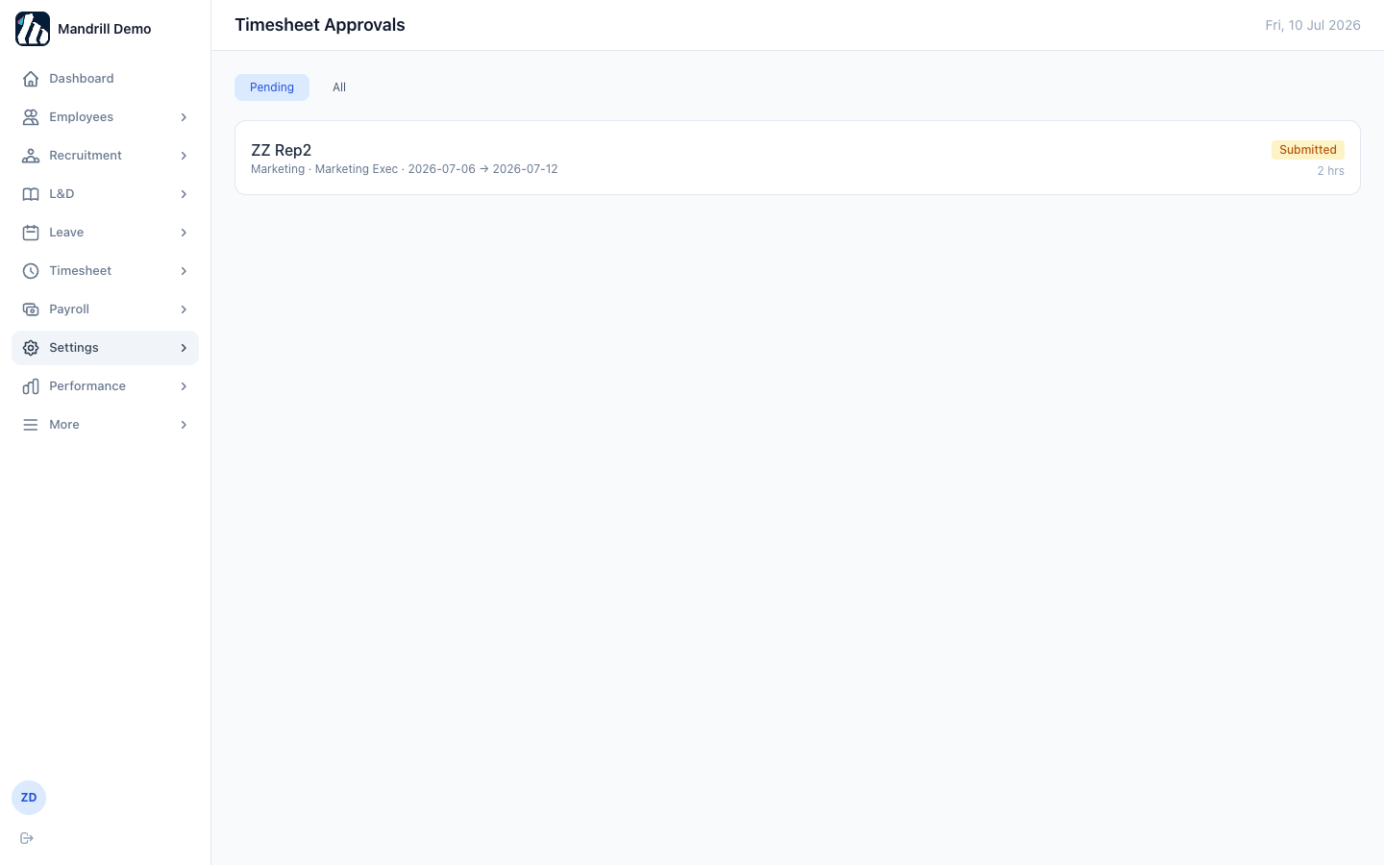
Figure 31. Timesheet Approvals — submitted weekly timesheets awaiting a manager's decision.

13.3 Projects
HR/managers create projects and break them into tasks. Team members are assigned to individual tasks (with an expected start date and duration) so only assigned staff can normally log hours to a task.
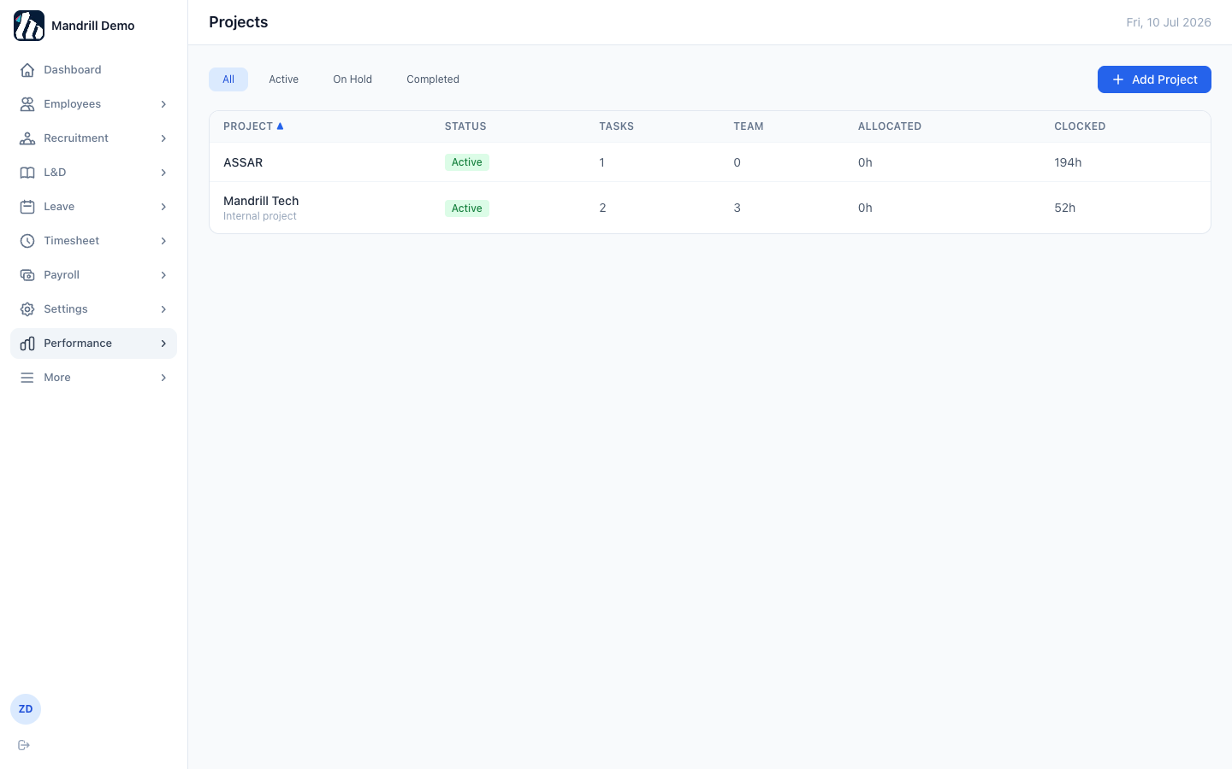
Figure 32. Projects — task and team-clocked-hours summary per project.
Note: A task can be marked “ALL — every employee” instead of assigning specific people, which opens it up so any employee in the institution can clock hours to it — useful for company-wide activities like town halls or all-hands training that don't belong to one team.

14. Payroll

14.1 Payroll Runs
HR (with the payroll_manager role) creates a payroll run for a pay period; EMS computes each employee's EPF, SOCSO, EIS, and PCB automatically based on Malaysian statutory tables.
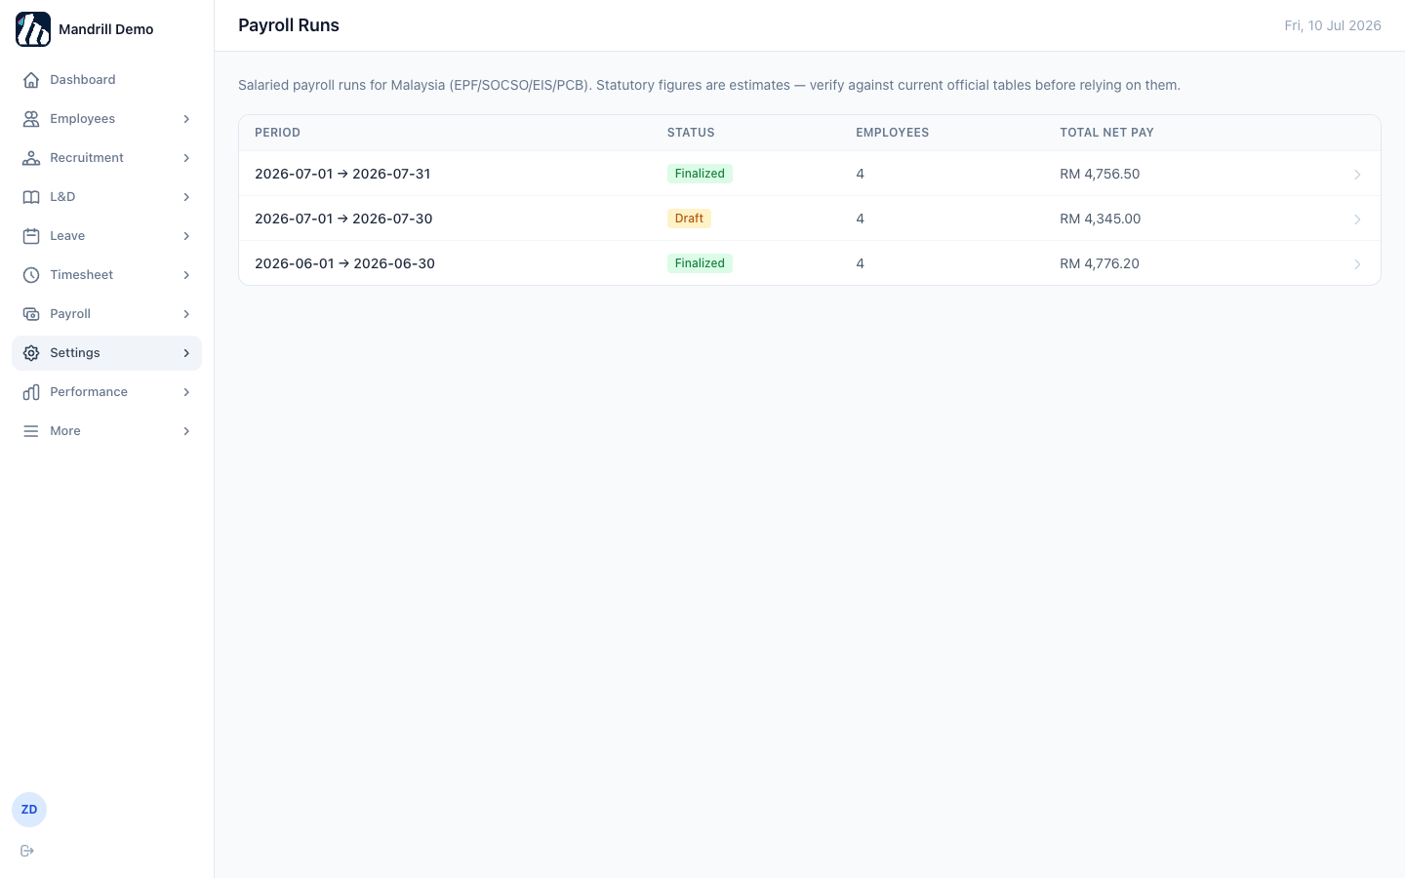
Figure 33. Payroll Runs — Draft runs can still be edited; Finalized runs are locked.
Click into any run to see the full breakdown per employee before finalizing.
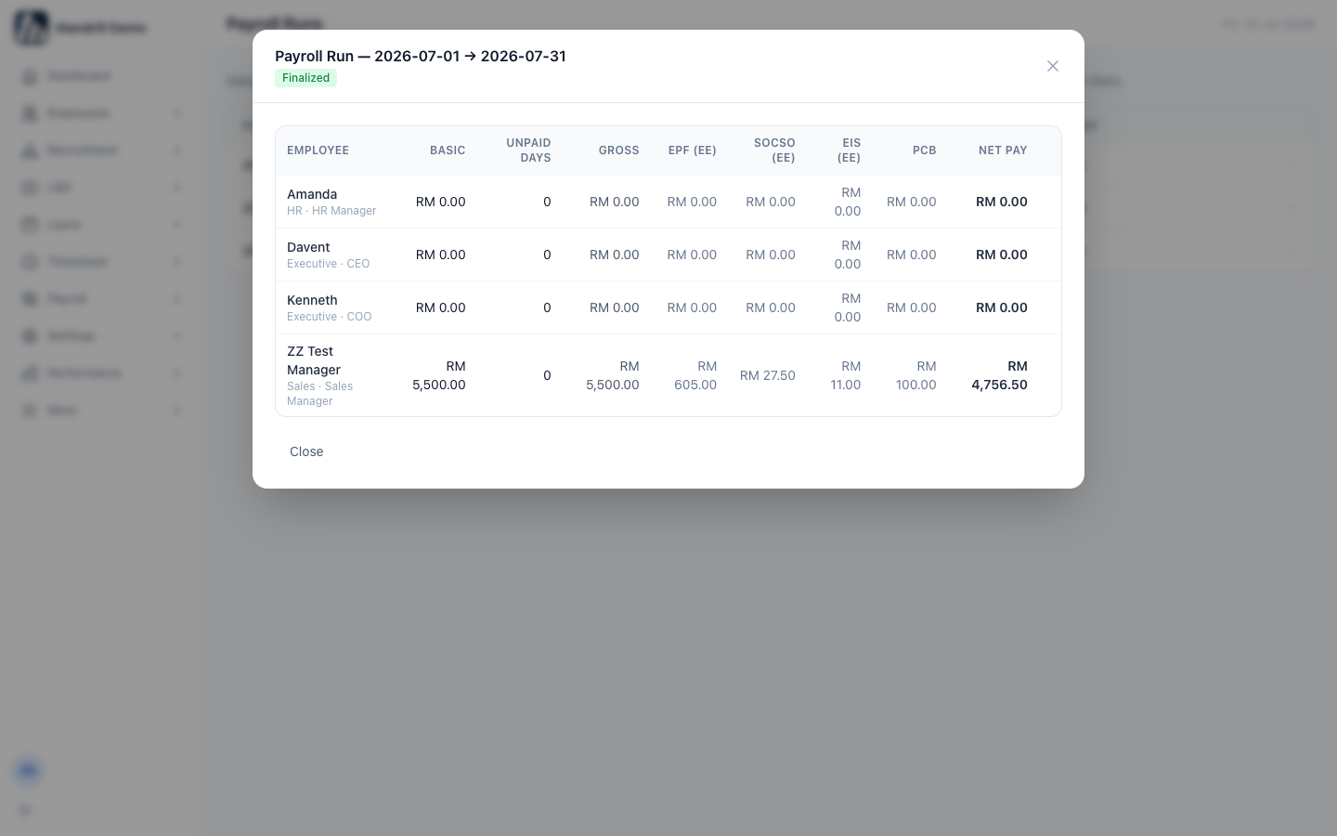
Figure 34. Payroll run detail — basic pay, statutory deductions, and net pay per employee.
Note: Statutory figures are estimates based on built-in rate tables — always verify against the current official EPF/SOCSO/EIS/LHDN tables before relying on them for real payroll.

14.2 My Payslips
Every employee can view and print their own payslips from finalized runs.
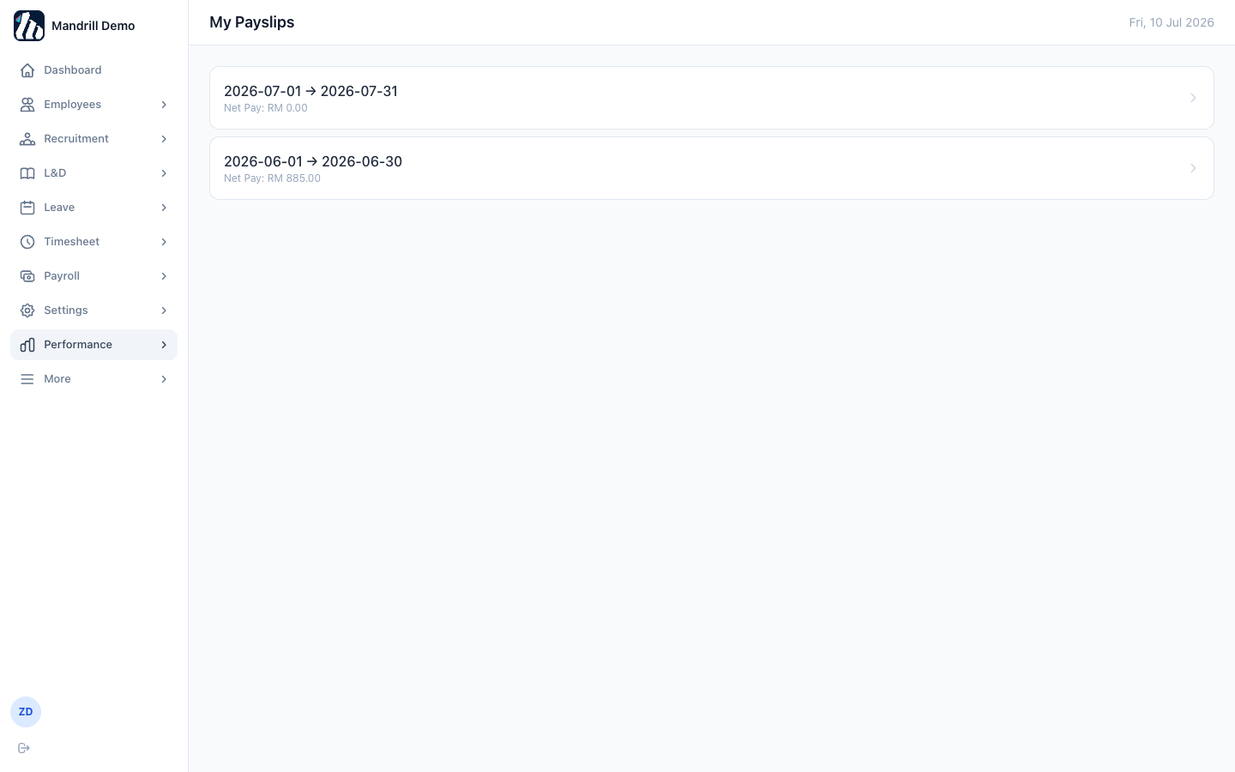
Figure 35. My Payslips — one entry per finalized pay period.

15. Performance
The Performance module runs goal-setting and appraisals through a four-stage cycle: Self-Review → Manager Review → HR Calibration → Finalized.

15.1 Performance Cycles
HR opens a new cycle (e.g. “H1 2026”), which lets employees start setting goals for that period. A cycle must later be moved into Calibration, then Finalized, once all appraisals are complete.
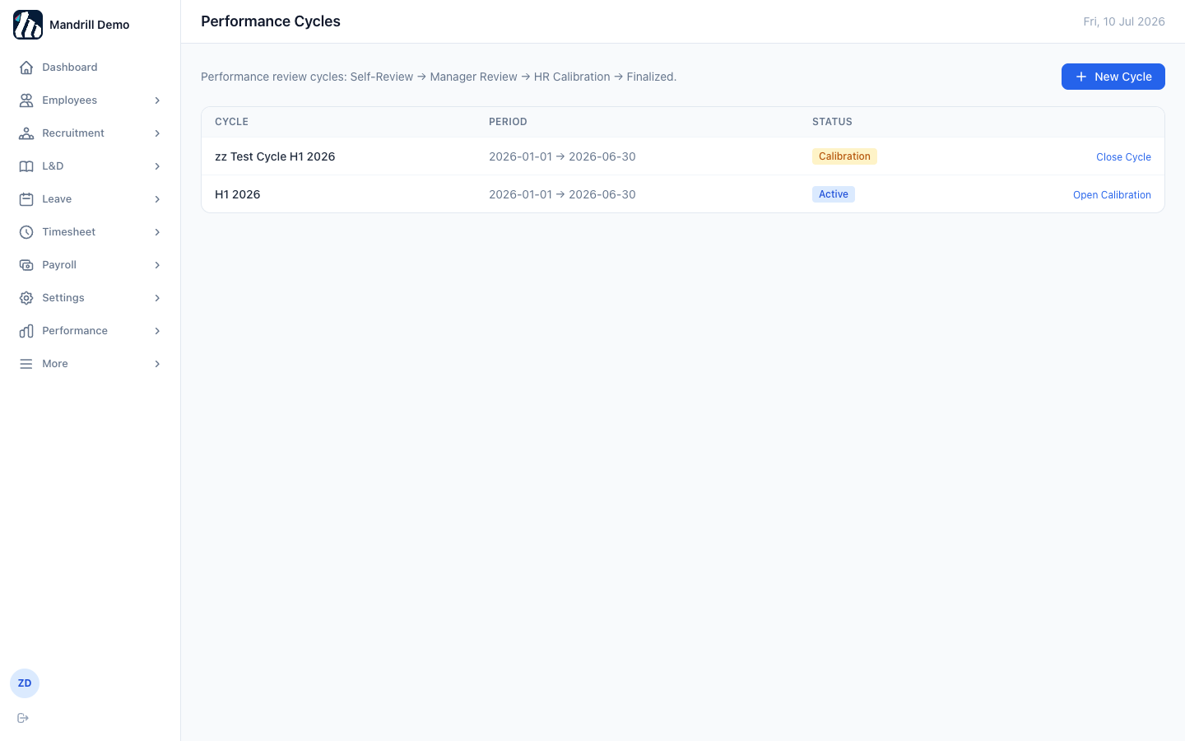
Figure 36. Performance Cycles — the stage-by-stage workflow shown at the top of the page.

15.2 My Goals & Appraisal
Employees add KPI or OKR-style goals against the active cycle, each with a weight. Once the cycle moves to review, each goal is automatically scored out of 5 based on target vs. actual, and self/manager ratings are recorded here too.
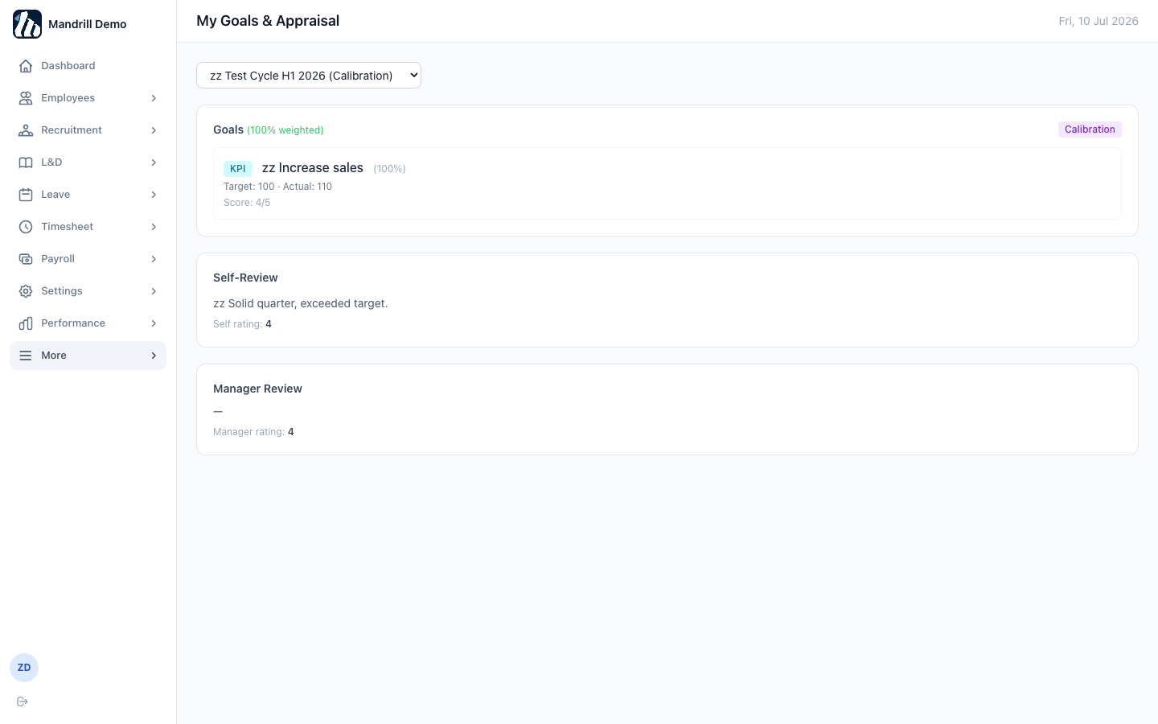
Figure 37. My Goals & Appraisal — a KPI goal, its computed score, and the self/manager review sections.

15.3 Team Appraisals
Managers see their direct and indirect reports' appraisals here and submit manager ratings once an employee has completed their self-review.
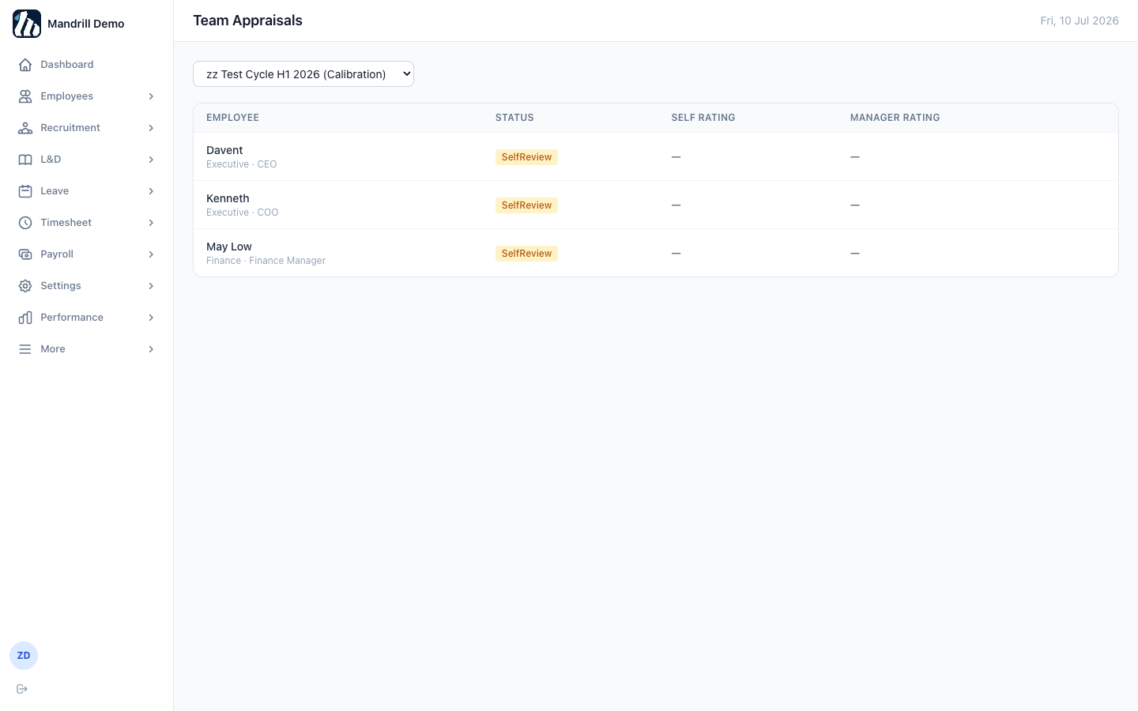
Figure 38. Team Appraisals — each report's appraisal status at a glance.

15.4 Calibration
HR's final pass across all appraisals in a cycle: a rating distribution chart to check for clustering, plus the ability to override any individual rating (with a required note) before finalizing.
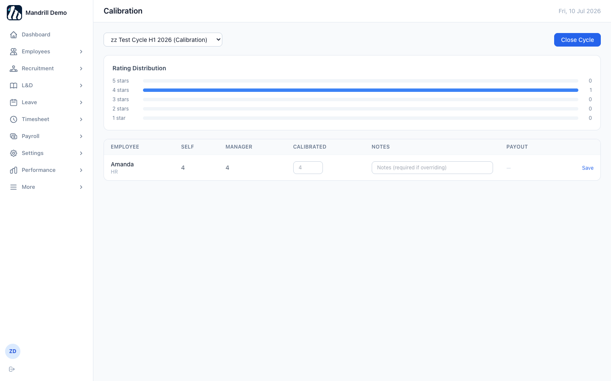
Figure 39. Calibration — rating distribution and per-employee calibration controls.
Note: Once HR closes a cycle from here, every appraisal in it is locked as Finalized and feeds into merit increment / bonus payout decisions in Payroll.

16. Settings — Notifications
Broadcast a dashboard-wide message to every employee for a scheduled time window — useful for maintenance notices, policy reminders, or company announcements. Only one notification can be active at a time.
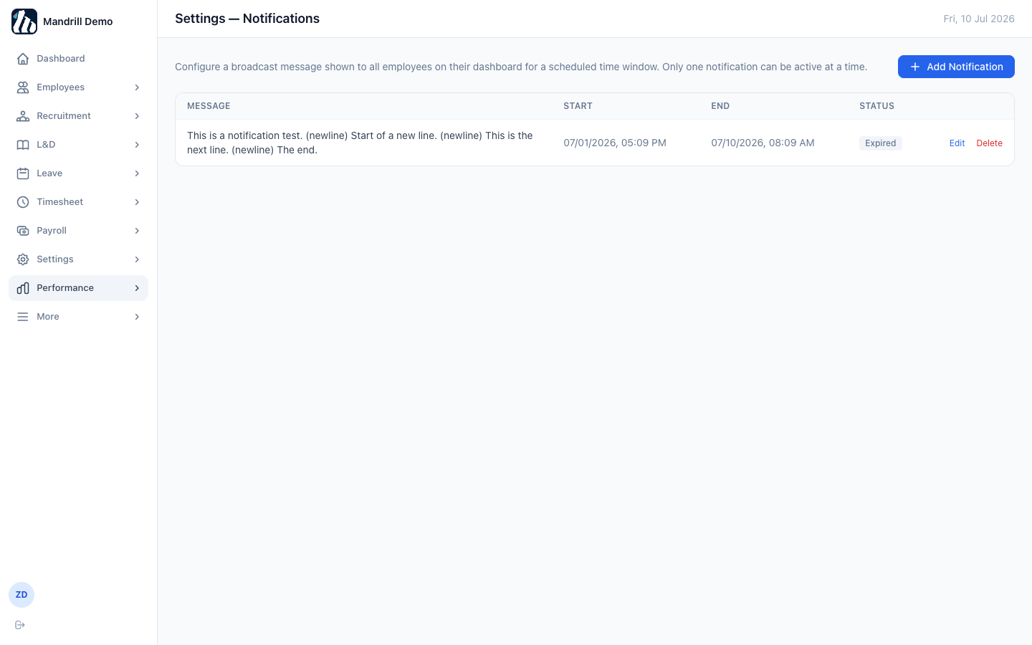
Figure 40. Settings — Notifications — schedule a message with a start and end time.

17. Next Steps Checklist
Once the setup in Part 1 is complete, a new institution is ready for day-to-day use. A few things worth doing next:
- Run a payroll cycle once employees have salary details entered (Payroll → Payroll Runs).
- Set up onboarding checklist templates if you'll be formally onboarding new hires through the platform (Employees → Onboarding).
- Create your first Performance cycle if you plan to run goal-setting and appraisals (Performance → Cycles).
- Add L&D courses if you'll be tracking employee training (L&D → Catalog).
- Open a requisition if you're actively hiring (Recruitment → Requisitions).
Note: That's the full tour. Part 1 gets a new institution off the ground; Part 2 is the reference to come back to as you use each module day-to-day.

