EMS
Onboarding & User Guide
Setting up a new company on the EMS platform, and how to use every area day-to-day
Audience: Platform Administrators, HR Managers, managers and employees
Version 2.1 — for EMS release 1.3 (October 2026): the new navigation, a sitemap, and who-can-use-which leave type
Replaces version 2.0. Version 1.0 describes the menu before release 1.0.
Contents
What’s new in versions 2.1 and 2
Part 1 — Onboarding a New Institution
1. Introduction
2. Step 1 — Platform Admin creates the company
3. Step 2 — First login as HR Manager
4. Step 3 — Get to know the layout
The areas and what is in them
The sitemap
Search and the + New menu
5. Step 4 — Add employees
5.1 Add an employee manually
5.2 Import many employees from a CSV file
5.3 The Directory
6. Step 5 — Configure leave types and public holidays
6.1 Limiting a leave type to the right people (Maternity, Paternity)
7. Step 6 — Set up the reporting structure
8. Step 7 — Add staff accounts
Other settings worth a look now
Part 2 — Reference Guide
9. Home
9.1 Today — Employee
9.2 Today — Manager and HR
9.3 Insights
10. Me
10.1 Overview
10.2 Profile
10.3 Leave
10.4 Time: timesheet, overtime and clock in/out
10.5 Pay: payslips, total rewards, benefits and claims
10.6 Growth: trainings, goals and appraisal, interviews, courses
11. Team
11.1 Approvals
11.2 Requests: leave, timesheets, resignations
11.3 Work: attendance and projects
11.4 Performance
12. People
12.1 Directory
12.2 An employee’s page
12.3 Org chart
12.4 Onboarding and offboarding
12.5 Document compliance
13. Hiring
13.1 Requisitions
13.2 Candidates
13.3 Interviews and offers
14. Pay
14.1 Payroll runs
14.2 Compensation
14.3 Benefits
15. Learning
16. Admin
16.1 Announcements & email
16.2 Roles & permissions
16.3 Approval workflows
16.4 Attendance rules
16.5 Document types and the audit log
16.6 Integrations & AI
17. Using EMS on a phone
18. Quick reference
18.1 Keyboard shortcuts
18.2 Questions people ask
18.3 Where did it go? Old menu to new
18.4 Page by page: who sees what
18.5 Next steps checklist

What’s new in versions 2.1 and 2

New in version 2.1 (release 1.3)
What changed | In short
Leave types can be limited to the right people | A leave type can now be open to everyone, or only to female or male staff, to married staff, or to people with a minimum length of service. Maternity leave can be for women only and paternity leave for married men with a year’s service; nobody else sees them. HR can still make an exception for one named person. See 6.1.
A sitemap of the whole product | A one-page picture of every area and tab, colour-coded by who sees it, in chapter 4, and a page-by-page table of who sees what in 18.4.

New in version 2 (release 1.0)
Version 2 of this guide describes EMS as it works from release 1.0 (October 2026), which replaced the old menu with a new way of finding things. If you used version 1, everything you could do before you can still do; most of it is now one or two clicks nearer. This page lists what changed; the reference chapters in Part 2 cover each area in detail, and the table at the end of the guide shows where every old menu item went.
What changed | In short
A new menu: areas and tabs | The long accordion menu is gone. A short list on the left now shows areas — Home, Me, Team, People, Hiring, Pay, Learning, Admin — and each area has tabs across the top for its pages. Any page is the area, then a tab, then (sometimes) a second row.
Each role sees only its own areas | An Employee sees three, a Manager four, an HR Manager eight. You never see an area you cannot use.
Home is shaped by who you are | Home has two tabs: Today and Insights. Today is different for an Employee (clock-in, task tiles, balances), a Manager (your team today) and HR (everyone today, plus the decisions waiting). Insights holds the dashboards.
Search and commands | Press Ctrl+K (⌘K on a Mac), or use the search box at the top, to jump to any page, find a person, or start an action by typing.
+ New and the clock | A “+ New” button creates things (leave, claim, employee, requisition…) from any page, and a clock button at the top clocks you in or out wherever you are.
One approvals inbox | Team › Approvals gathers leave, timesheets, overtime, claims, requisitions, resignations, training and improvement plans in one list, with the details beside each request.
Me: everything personal in one place | Leave, timesheet, clock-in, payslips, benefits, trainings, goals and your own profile now live under Me, for every role.
The employee record is a page | Opening a person now opens a full page you can bookmark and go Back from, with a new Overview tab and “Needs attention”.
Saved views and bulk actions | The Directory and Candidates lists have saved views (“Probation ending soon”) and a bar for exporting or moving the people you tick.
Works on a phone | A bottom bar replaces the slide-out menu, and the main lists turn into cards.
Tidier Admin | All settings are grouped under Admin: Company, People & access, Attendance rules, Announcements & email, Integrations & AI, Audit log.

Note: Every page keeps its own web address, so bookmarks and links in emails from before the change still work.

Part 1 — Onboarding a New Institution
This part is a one-time walkthrough for bringing a new company onto EMS, from creating the institution through to having employees, leave rules, and staff accounts in place. Part 2 is a lasting reference for using every area day-to-day once that setup is done.

1. Introduction
This guide walks a Platform Administrator and a company’s first HR Manager through everything needed to bring a new institution (company) onto the EMS platform, from creating the company record through to having employees, leave rules, and staff accounts in place.
EMS is multi-tenant: every company (“institution”) is fully isolated from every other company on the platform. Each company signs in with its own Company Code, and only a Platform Administrator can create new companies.

Who does what
- Platform Administrator (superadmin) — creates the company record and its first HR Manager account. This is a one-time setup step per company.
- HR Manager — signs in with the credentials the Platform Administrator created, then configures leave rules, adds employees, and invites additional staff.
Note: Screenshots in this guide were taken from the EMS platform using a sample company, “Bright Horizon Sdn Bhd”, with fictional people and figures. Your own screens will show your own data.

2. Step 1 — Platform Admin creates the company
Only a Platform Administrator can create a new company. Platform Administrators sign in by leaving the Company Code field blank.
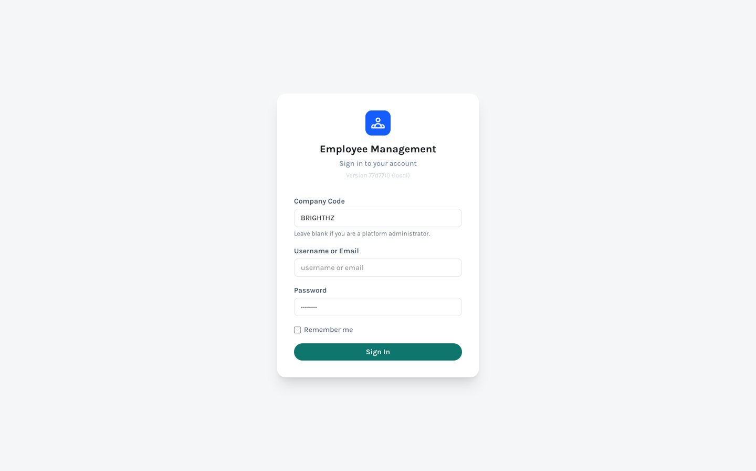
Figure 1. Sign-in screen. Leave Company Code blank to sign in as a Platform Administrator.
Once signed in, a Platform Administrator sees one area, Platform, with two tabs: Companies (every company on the platform) and System alerts (messages shown to everyone on the platform).
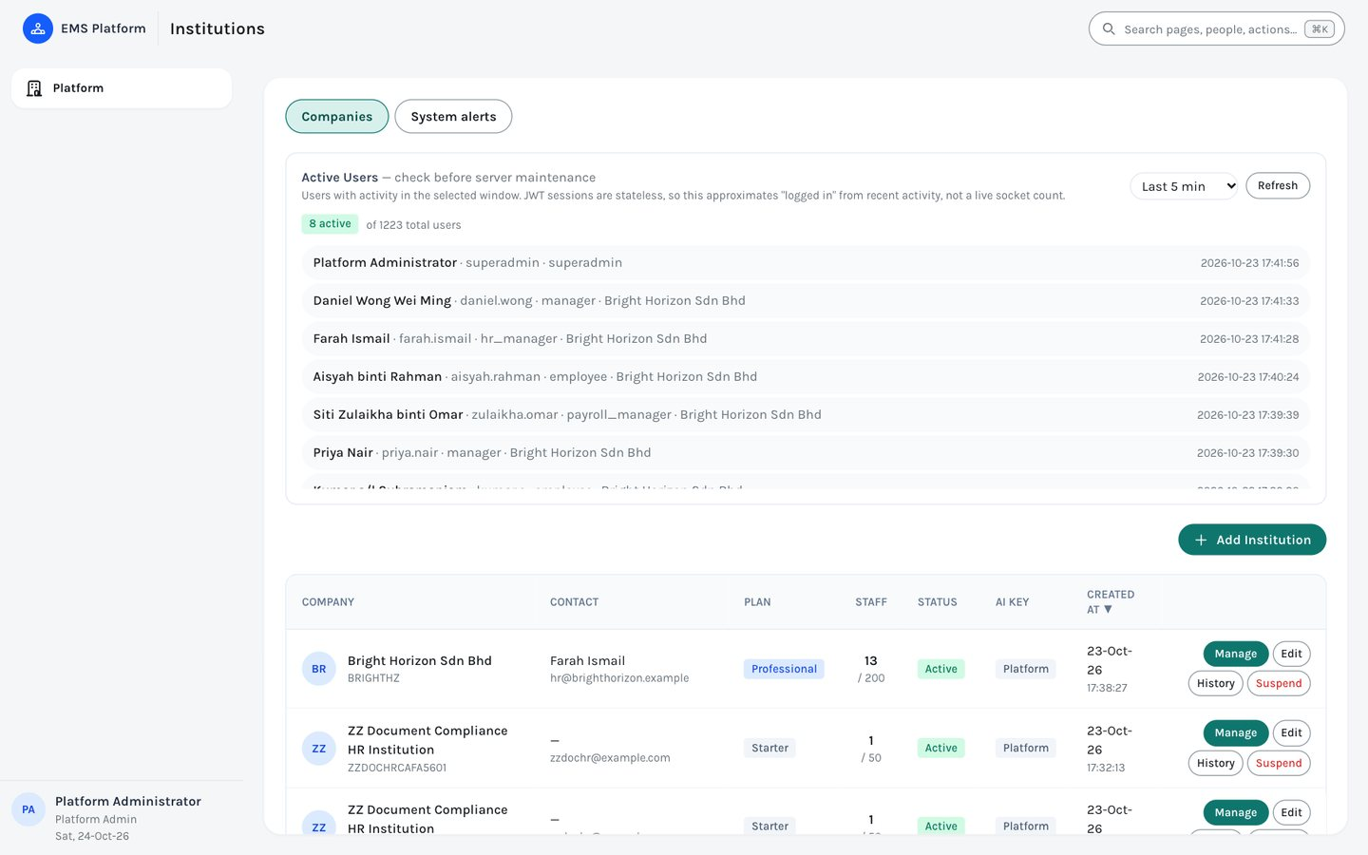
Figure 2. Platform › Companies, showing every company with its plan, staff count and status.
- Click “+ Add Institution” in the top-right corner of the list.
- Fill in the company details — name, a short unique Company Code, plan, and contact information.
- In the same form, fill in the “Initial HR Manager Account” section — this creates the very first login for the new company.
- Click “Create Institution”.
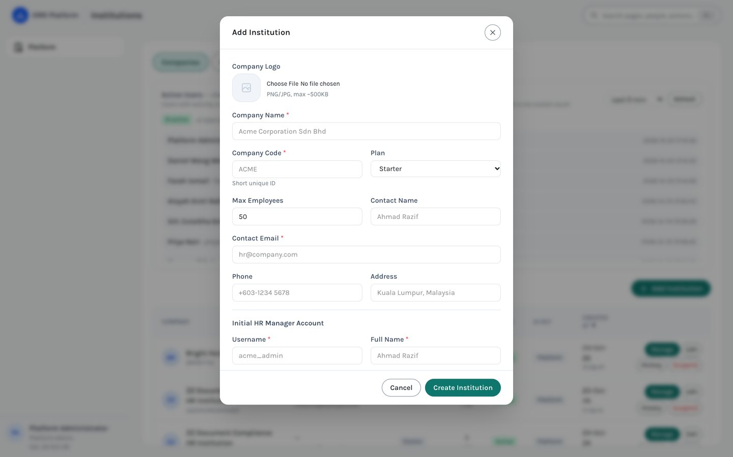
Figure 3. The Add Institution form — company details plus the initial HR Manager account, created together in one step.
Field | Description
Company Name | Full legal or trading name of the company.
Company Code | A short, unique identifier (for example BRIGHTHZ). Employees type this on the sign-in screen, so keep it short and memorable.
Plan and Max Employees | Starter, Professional or Enterprise, and the maximum number of employee records the company can hold.
Contact Name / Email / Phone / Address | Primary business contact for the account. The email is required.
Initial HR Manager — Username / Full Name / Email / Password | The login for the company’s first HR Manager. Share these with the HR contact through a secure channel.
Company Logo | Optional PNG or JPG (up to about 500 KB), shown in the top-left corner for everyone in that company.

Note: A Platform Administrator can always return to Platform › Companies later to edit a company’s details or suspend it. There is no self-service way for an HR Manager to edit their company profile, so changes to the name, logo, plan or contact details go through the Platform Administrator. To work inside a company, click Manage on its row; the top bar then shows which company you are in, with a button to leave it.

3. Step 2 — First login as HR Manager
Hand the Company Code and the HR Manager username and password to the person who will administer the account. They sign in the same way as any other user, but with the Company Code filled in this time. Sign-in accepts either the username or the email address.
After signing in, the first screen is Home. For an HR Manager, Home opens on the Today tab: quick actions to add an employee or open a requisition, four figures across the top, and “Everyone today” with the decisions waiting. On a brand-new company these are mostly empty, which is expected.
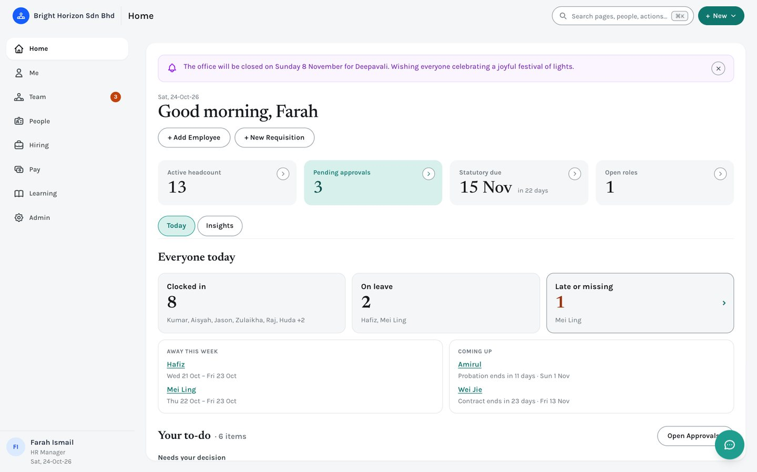
Figure 4. An HR Manager’s Home (Today tab) once the company has people in it.

4. Step 3 — Get to know the layout
The same layout is used on every screen. Take a minute to learn its five parts; the rest of this guide assumes them.
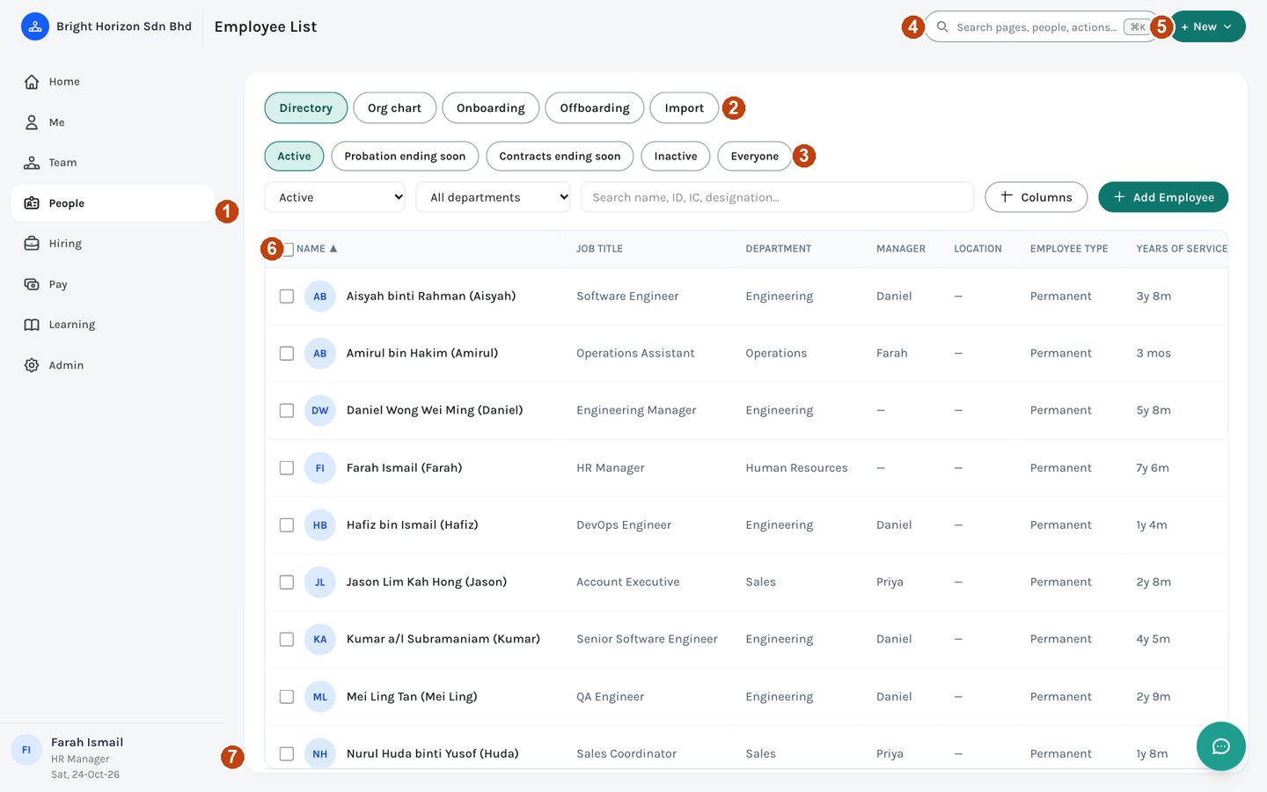
Figure 5. The layout, shown on People › Directory.
1 | The area list. Each entry is an area of EMS; the one you are in is highlighted. A red number on Team is the count of requests waiting for your decision.
2 | The tabs for the area you are in. Click a tab to move to that page. Where a tab holds several pages (for example Compensation under Pay), a second row of tabs appears underneath.
3 | Views on a list. Click one to apply it, or save your own (see People › Directory).
4 | Search and commands. Press Ctrl+K (⌘K on a Mac) or click here, then type a page, a person or an action.
5 | + New. Start something new — leave, a claim, an employee, a requisition — from anywhere. You only see what your role can create.
6 | Tick boxes on a list. Ticked rows can be exported or acted on together.
7 | Your name, role and the date. If you hold more than one role, the role switcher is here, along with Change Password, About and Sign out.

The areas and what is in them
Area | Who sees it | What is in it
Home | Everyone | Your landing page: Today (shaped by your role) and Insights (dashboards).
Me | Everyone | Overview · Profile · Leave · Time (timesheet, overtime, clock in/out) · Pay (payslips, total rewards, benefits and claims) · Growth (trainings, goals and appraisal, interviews you are scoring, the course catalog).
Team | Managers and HR; Payroll and Compensation Managers (Approvals only); anyone else while a request is waiting for them | Approvals · Requests (leave, timesheets, resignations) · Work (attendance, projects) · Performance (team reviews; HR also sees cycles and calibration).
People | Everyone (each sees their own scope) | Directory · Org chart · Onboarding · Offboarding · Import (the last three for HR).
Hiring | HR, and anyone granted recruitment access | Requisitions · Candidates · Interviews · Offers & letters.
Pay | HR Manager, Payroll Manager, Compensation Manager | Payroll runs · Compensation (nine pages) · Benefits (five pages).
Learning | HR | Courses and policies. Everyone else finds the course catalog under Me › Growth.
Admin | HR | Company · People & access · Attendance rules · Announcements & email · Integrations & AI · Audit log.
Platform | Platform Administrators | Companies · System alerts.

The sitemap
The picture below is every page in EMS: the eight areas in the left menu, the tabs inside each, and who sees each page. The colour of a tab shows who it is for. You never see a page your role cannot use, so your own menu is a subset of this map: an Employee sees three areas, a Manager four, an HR Admin seven and an HR Manager all eight.
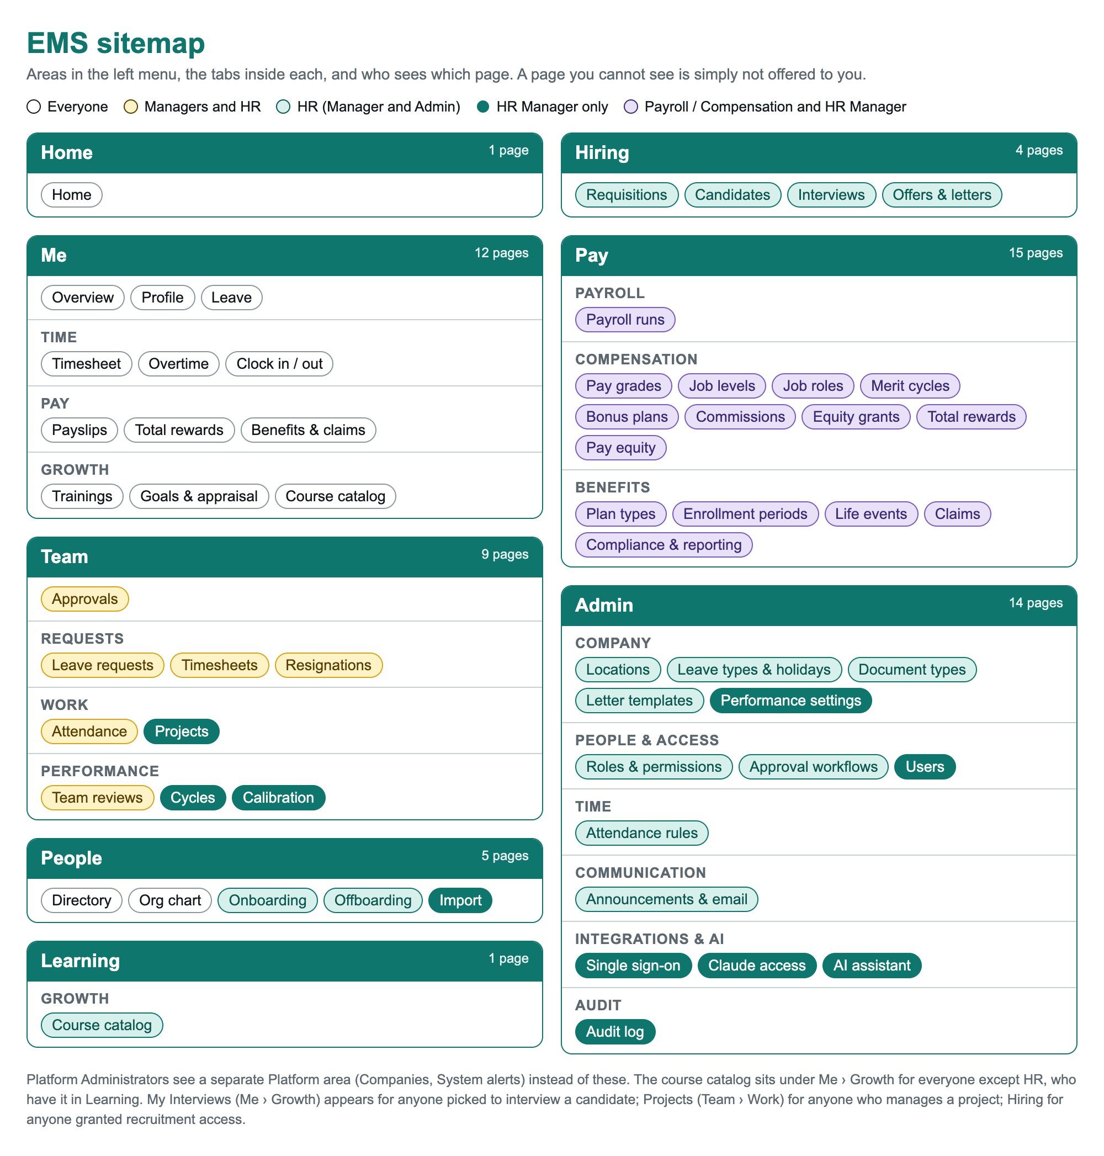
Figure 6. Every area and page in EMS, colour-coded by who sees it.
Role | Areas | Which ones
Employee | 3 | Home · Me · People (Directory and Org chart, showing only yourself and the people you are allowed to see). Team appears while a request is waiting for you.
Manager | 4 | The above, plus Team: Approvals, Leave requests, Timesheets, Resignations, Attendance and Team reviews.
Payroll Manager / Compensation Manager | 5 | Home · Me · Team (Approvals only) · People · Pay (payroll runs, compensation and benefits).
HR Admin | 7 | Home · Me · Team · People · Hiring · Learning · Admin (everything except Users, Integrations & AI, the Audit log and Performance settings, which are HR Manager only).
HR Manager | 8 | Every area above, including Pay and all of Admin.
Platform Administrator | — | A separate Platform area (Companies, System alerts) instead of these.

A page-by-page version of this map, with a column for each role, is in 18.4. A few pages appear only when they apply to you: My Interviews (Me › Growth) once you are picked to interview someone, Projects (Team › Work) if you manage a project, and Hiring if you have been granted recruitment access.

Search and the + New menu
Press Ctrl+K, type a few letters, and EMS lists matching actions, pages and people. Use the arrow keys and Enter, or click. Old names still work: typing “Stationery” finds Offers & letters, and “Holiday Manager” finds Leave types & holidays. People search shows the people you can already see: HR finds everyone, a manager finds their team, an employee finds themself.
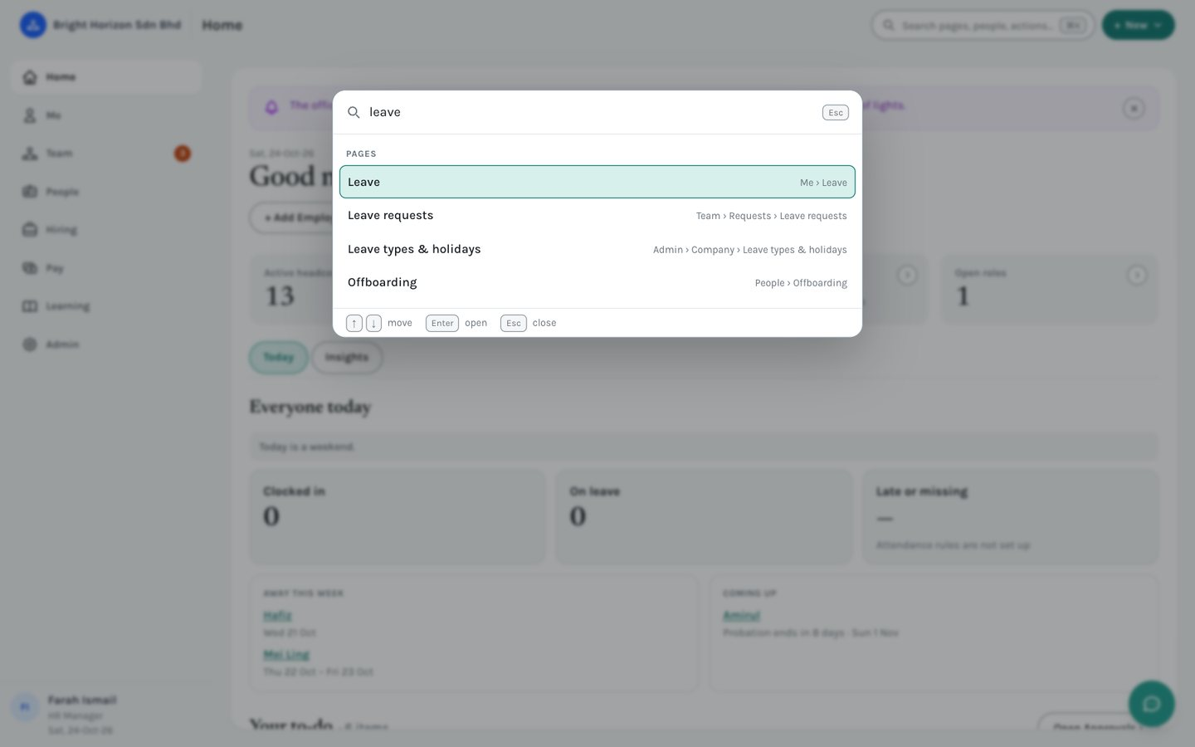
Figure 7. The search and command bar, after typing “leave”.
The + New button at the top lists the things your role can create. For an HR Manager that includes adding an employee, a job requisition, a candidate and an announcement.
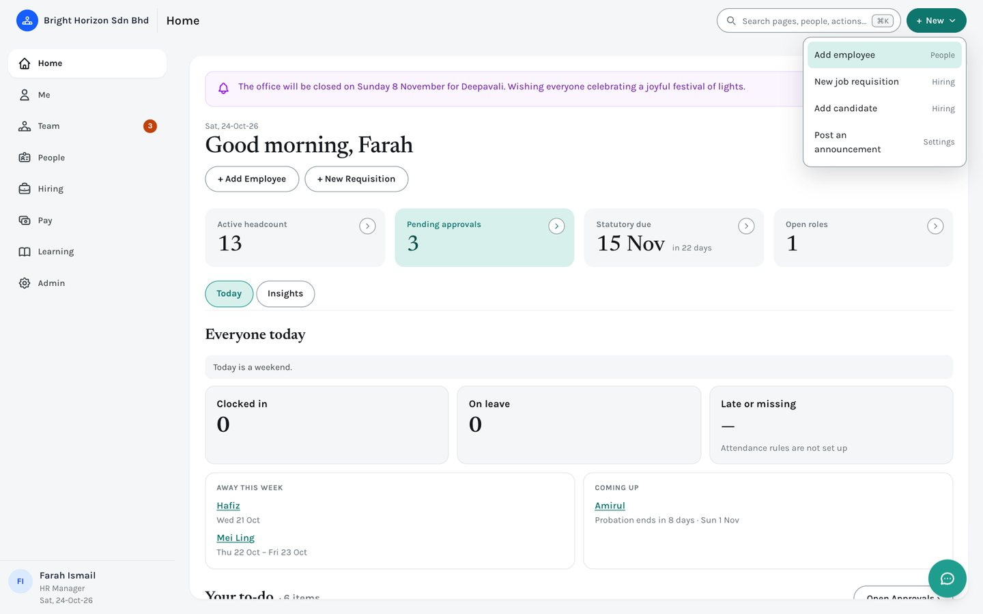
Figure 8. The + New menu for an HR Manager.
Note: On a phone the search box becomes a magnifying-glass button, and a bottom bar replaces the slide-out menu. See “Using EMS on a phone” in Part 2.

5. Step 4 — Add employees
There are two ways to bring employees into a new company: adding them one at a time, or uploading a batch from a CSV file.

5.1 Add an employee manually
Go to People › Directory and click “+ Add Employee” (or use + New › Add employee from anywhere). The form is split across three tabs — Personal Info, Employment, and Statutory & Payroll — and the Next button walks you through them in order.
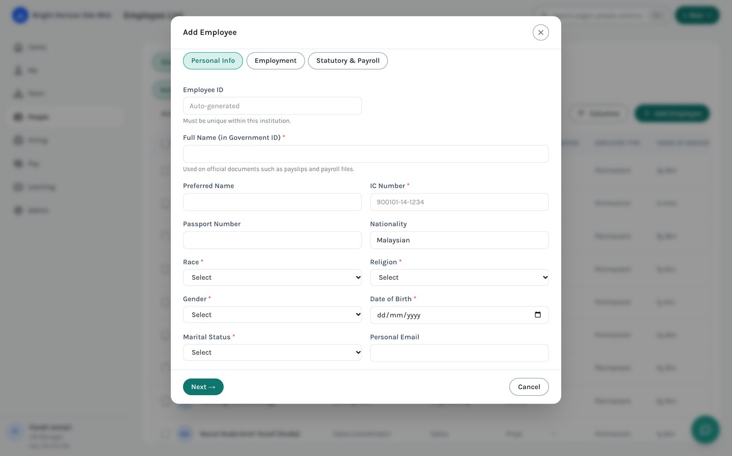
Figure 9. The Add Employee form, Personal Info tab. The Employee ID is generated automatically unless you set a custom one.
Note: Required fields are marked with a red asterisk. You can save once all three tabs are complete.

5.2 Import many employees from a CSV file
For adding many people at once, use People › Import (HR Manager only). Download the CSV template, fill in one row per employee, and upload it. Valid rows are created immediately; rows with errors are skipped and listed below the upload button so you can fix just those and upload again.
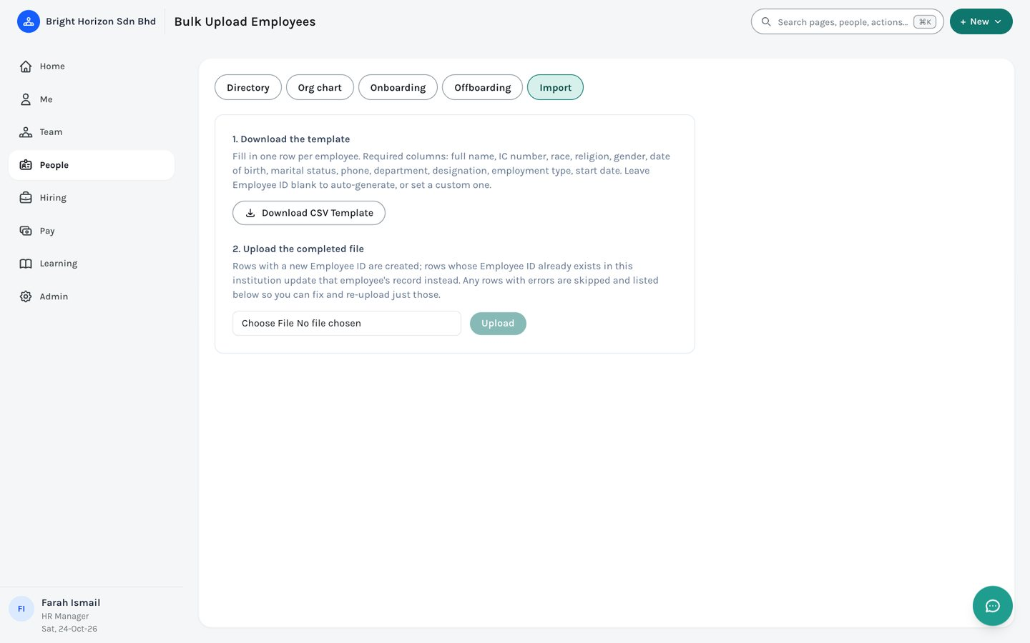
Figure 10. People › Import — download the template, fill it in, then upload.

5.3 The Directory
However they are added, everyone appears in People › Directory, searchable by name, ID, IC number or job title. The row of views above the list switches between Active people, Probation ending soon, Contracts ending soon, Inactive and Everyone; the department and status filters narrow it further. Click a row to open that person’s page.

6. Step 5 — Configure leave types and public holidays
Before employees can apply for leave, set up the company’s leave types (for example Annual, Medical, Unpaid) and its public holiday calendar. Both live on one page: Admin › Company › Leave types & holidays. It has two tabs, Holidays and Leave Types.
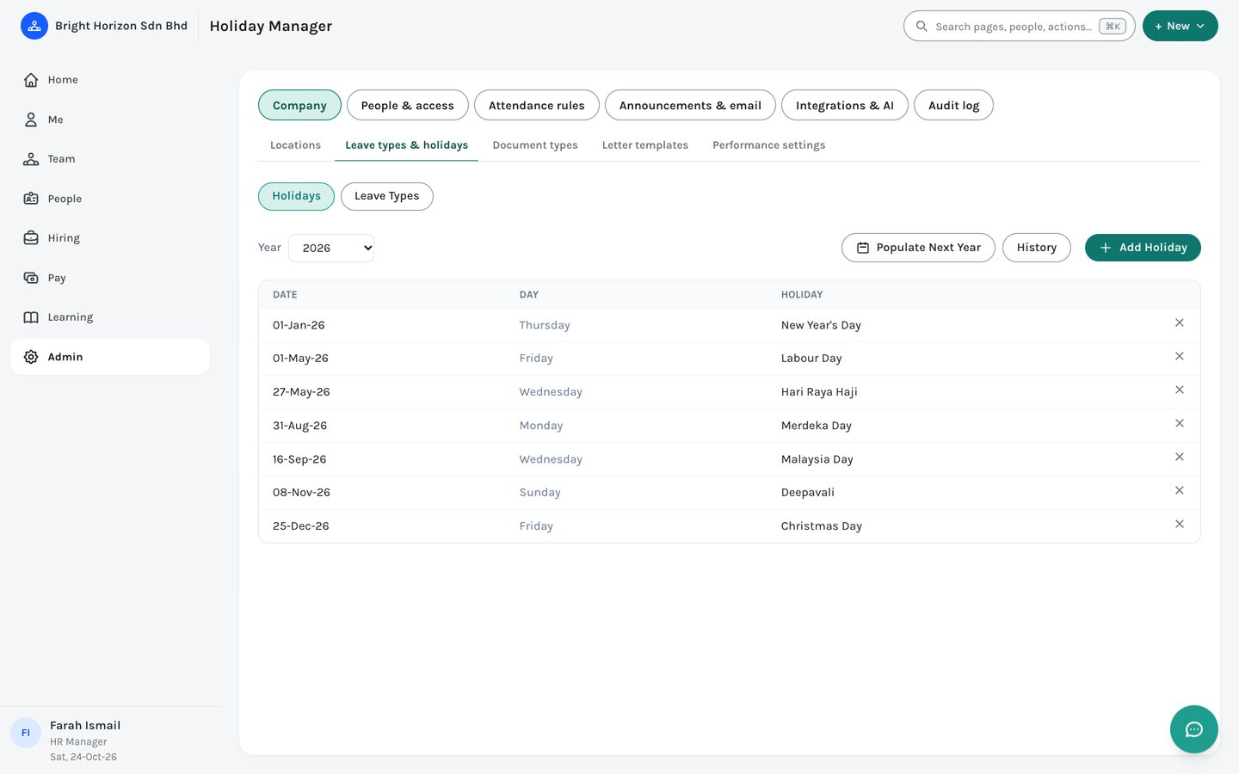
Figure 11. Admin › Company › Leave types & holidays.
- Click “+ Add Holiday” to add each public holiday for the selected year, or “Populate Next Year” to copy a year forward.
- On the Leave Types tab, add the categories your company offers, including whether each is paid, its yearly entitlement, and whether half-days are allowed.
Note: Leave balances are calculated per employee from the leave types you set up here, so it is worth doing this before employees start applying.

6.1 Limiting a leave type to the right people (Maternity, Paternity)
Some leave types are not for everyone. Maternity leave is for women; paternity leave is for married men who have been with the company long enough. Each leave type has a “Who can use this leave type” section that says who it is open to. By default every leave type is open to everyone, so nothing changes until you set a rule.
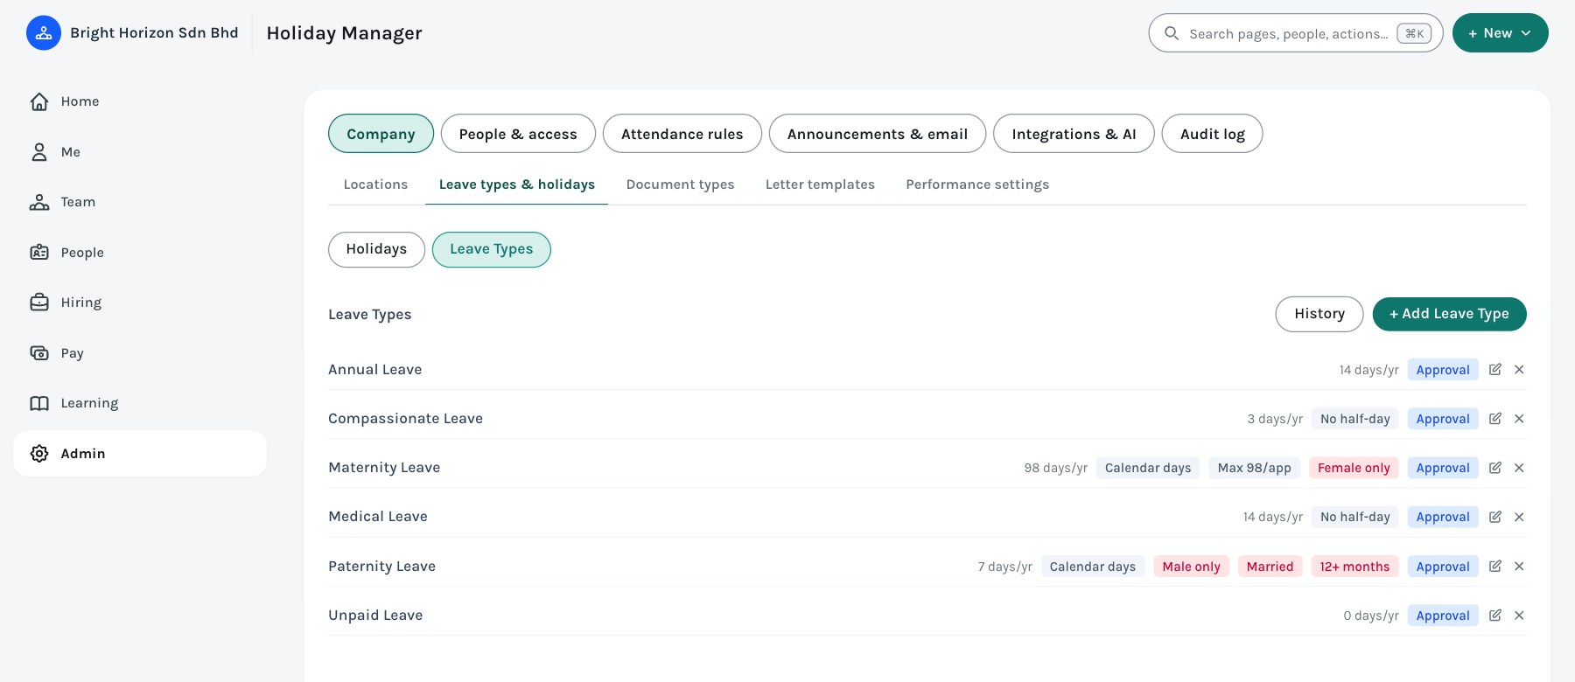
Figure 12. Admin › Company › Leave types & holidays › Leave Types, after Maternity and Paternity have been limited. The red tags show who each one is for.

Setting the rules
- Open Admin › Company › Leave types & holidays › Leave Types, and click the edit icon on the leave type (or “+ Add Leave Type” for a new one).
- Scroll to “Who can use this leave type”. Choose who it is open to: Everyone, Female staff only, or Male staff only.
- Tick “Married staff only” if it applies, and enter a minimum service in months (0 means no minimum). Service is counted from the person’s start date to the first day of the leave they are applying for.
- Check the line under the rules, for example “4 of 13 active people can use this today”, then Save.
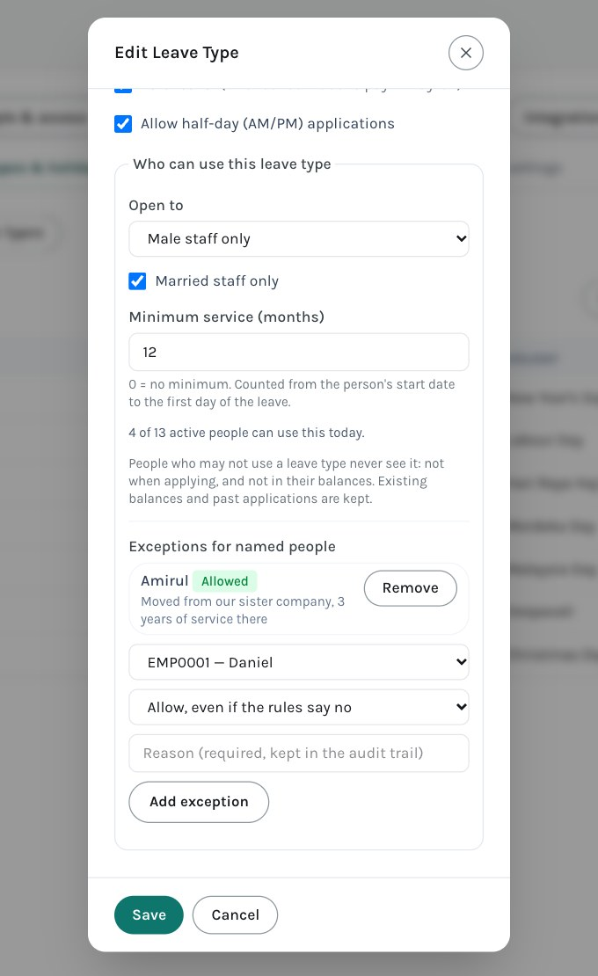
Figure 13. The “Who can use this leave type” section, set up for paternity leave, with one exception.
Leave type | Open to | Commonly used settings
Maternity Leave | Female staff only | Calendar days; 98 days entitlement; maximum 98 days per application.
Paternity Leave | Male staff only, married, minimum 12 months | Calendar days; 7 days entitlement; maximum 7 days per application.

Note: These figures follow how Malaysia’s Employment Act is generally applied. Check them against your own contracts and policy. EMS does not count how many children or births an employee has already had leave for; HR approval is where that limit is applied.

What people see
Someone who may not use a leave type never sees it: it is not in the Apply for Leave list, it has no balance card on Me › Leave, and it does not appear on Home, Me › Overview, their profile or when they ask the AI assistant or Claude about their balance. Nothing is greyed out.
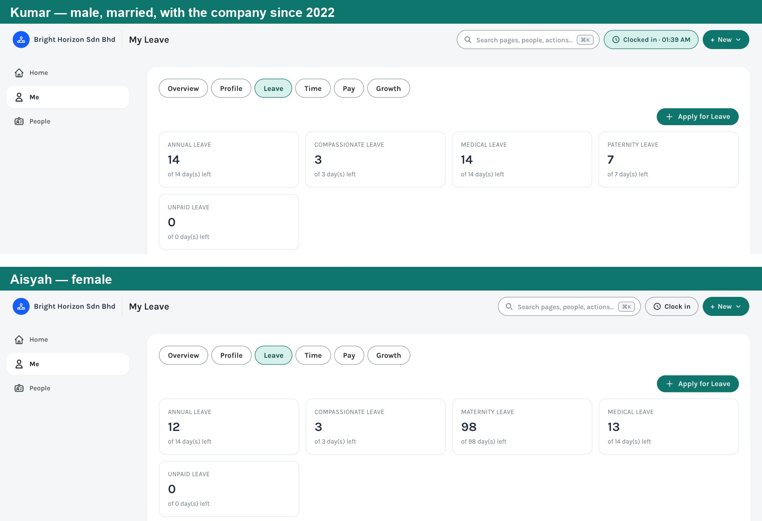
Figure 14. The same page for two people: Kumar (married, male) has Paternity Leave and Aisyah (female) has Maternity Leave. Neither sees the other’s.
- Managers and HR who apply for leave on someone’s behalf see that person’s leave types, and the list updates when they pick a different employee.
- The rules are checked again when the application is submitted, so a type cannot be used by going around the list.
- A rule that depends on information EMS does not have, such as gender or start date missing from a record, counts as “not eligible”. The preview line says how many people are left out for that reason, so you can complete their records.

Exceptions for named people
When the rules say no but HR knows better (an employee who moved over from a sister company with years of service behind them, or someone a few weeks short of the minimum), add an exception. Edit the leave type, scroll to “Exceptions for named people”, pick the employee, choose “Allow, even if the rules say no” or “Withhold, even if the rules say yes”, and type a reason. The reason is required and every exception is recorded in the audit log. Click Remove to take an exception away again.

Changing a rule later
- Balances and past applications are never deleted. If you limit a type that people already hold a balance for, they simply stop seeing it, and it comes back if you loosen the rule.
- The leave type chosen for overtime leave credit (Admin › Time) must stay open to everyone; EMS will not let you limit it, or choose a limited one.
- If other leave types draw from this type’s balance, the shared balance card stays visible for as long as at least one of them is available to the person.

7. Step 6 — Set up the reporting structure
As employees are added, use each person’s “Reports To” field (on the Employment tab) to build the reporting chain. People › Org chart draws it automatically and can be switched between a tree and a list.
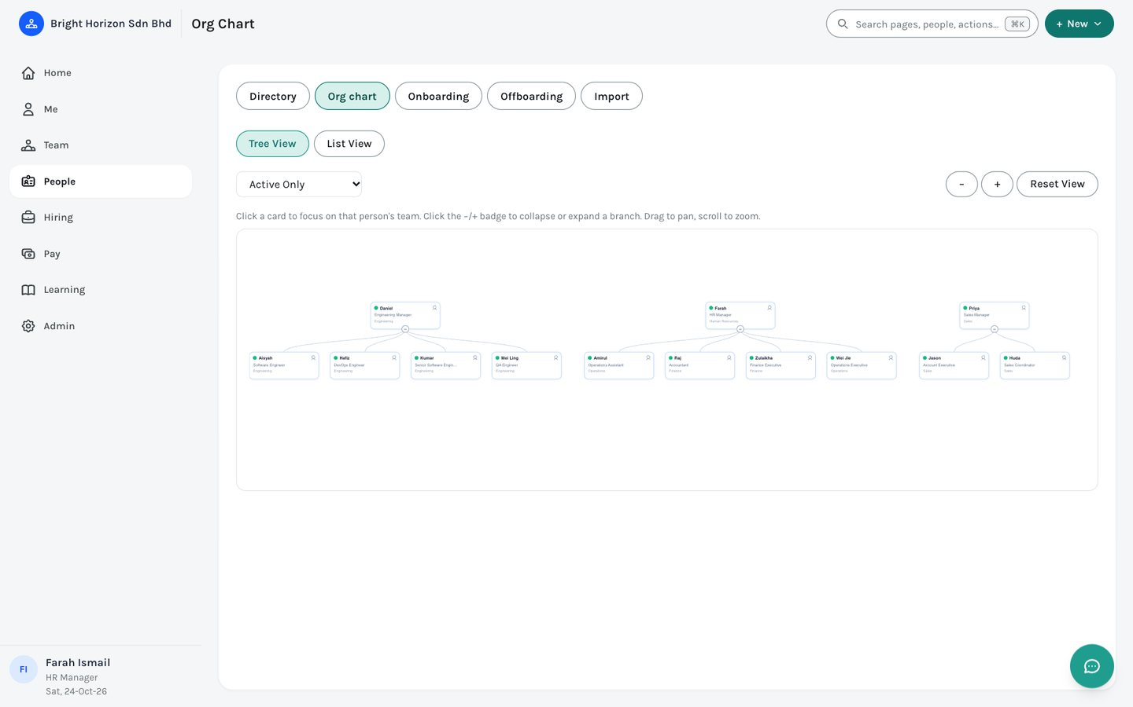
Figure 15. People › Org chart — drawn automatically from the reporting lines.
Note: The reporting chain is not only cosmetic: it decides what a manager sees (their team only), who approves a person’s leave and timesheets, and which appraisals a manager reviews.

8. Step 7 — Add staff accounts
The HR Manager account created in Step 1 is the only login at first. Add logins for the other people (managers, payroll staff, everyone who needs to sign in) from Admin › People & access › Users.
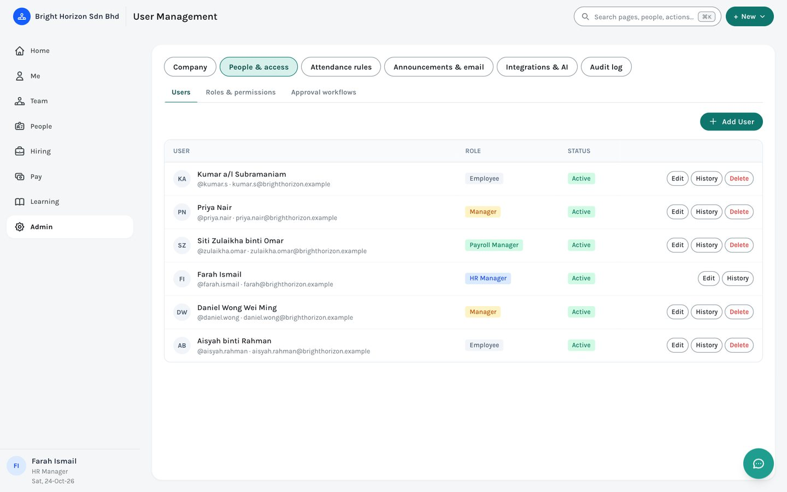
Figure 16. Admin › People & access › Users.
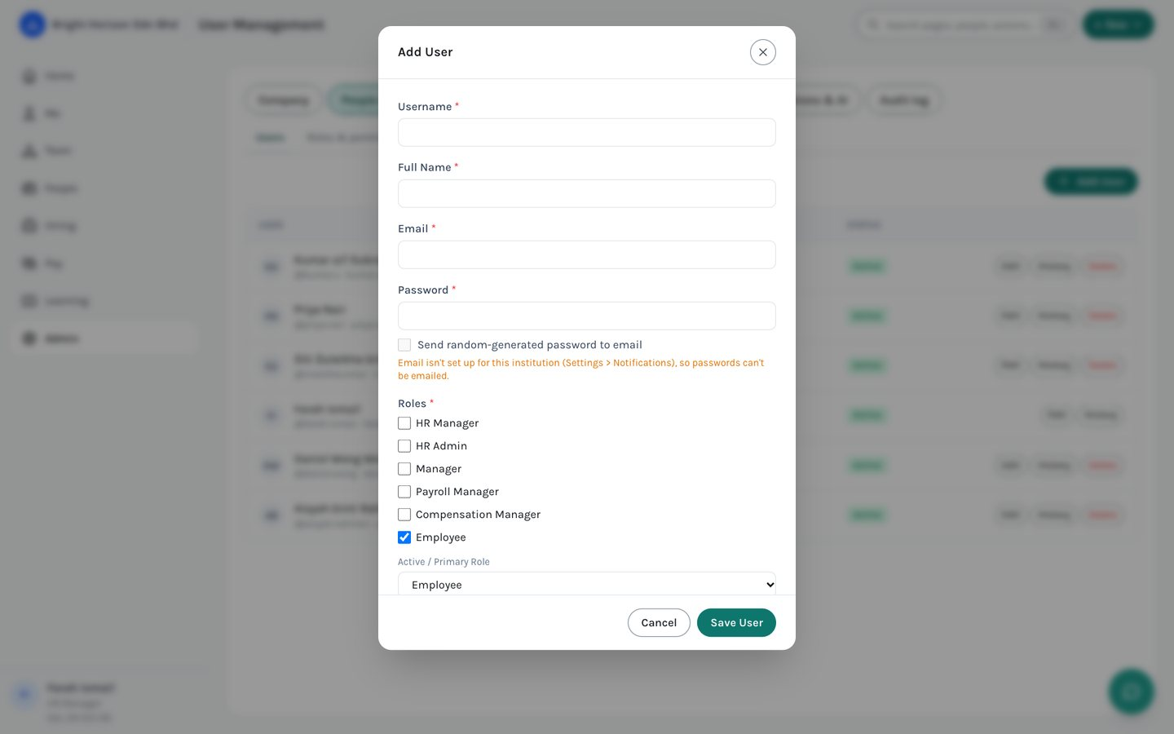
Figure 17. The Add User form. Roles are ticked; the primary role decides what the person sees first.
When creating a user, choose one or more roles. They decide what the person can see and do:
Role | What it allows
HR Manager | Full administrative access within the company — people, payroll, settings, performance, and user management.
HR Admin | Day-to-day HR work without the settings that are HR Manager only (users, single sign-on, AI and Claude access, performance settings, bulk import).
Manager | Everything scoped to their own reporting chain — approvals, team reviews, team timesheets, team attendance.
Payroll Manager | Payroll runs and payslips, and the compensation and benefits areas.
Compensation Manager | Compensation and benefits (pay grades, bonus, equity, benefit plans and claims).
Employee | Self-service only — own profile, leave, timesheet, clock-in, payslips, benefits and trainings.
Your own roles | HR can add more roles (for example “IT Infra” or “Hiring Manager”) under Admin › People & access › Roles & permissions, and then grant them chosen abilities.

- Linking a login to a person. Set the Employee ID on the login so that person also gets their own Me area, leave balance and payslips. This is optional and can be done later.
- Sending the password by email. Tick “Send random-generated password to email” and EMS creates a password nobody sees, emails it from your company’s own mailbox, and makes the person change it at first sign-in. This needs email to be set up first (Admin › Announcements & email).
- Signing in with Microsoft. If your company uses Microsoft work accounts, HR Manager can switch on single sign-on under Admin › Integrations & AI, and people then sign in with a Microsoft button. Nobody is created by signing in; their email must match an existing login.

Other settings worth a look now
Once people have logins, these Admin pages are worth reviewing before day-to-day use starts. Each is described in Part 2, chapter 16.
- Approval workflows — who approves leave, claims, timesheets and the rest (the default is the person’s manager, then HR Manager).
- Attendance rules — shifts, who must clock in, and clock-in locations. Until these exist, the “Late or missing” figure on Home says it is not set up.
- Announcements & email — company-wide banners, your email (SMTP) settings and reminder emails.
- Document types — work permits, passports and the like, with reminder windows.
Part 2 — Reference Guide
Part 1 covered the one-time setup. This part is a lasting reference for day-to-day use, organised the way the menu now is: one chapter per area. Screenshots are from a populated sample company.

9. Home
Home is the first screen after signing in and the page the Home button always returns to. It has two tabs: Today, which changes with your role, and Insights, which holds the dashboards.

9.1 Today — Employee
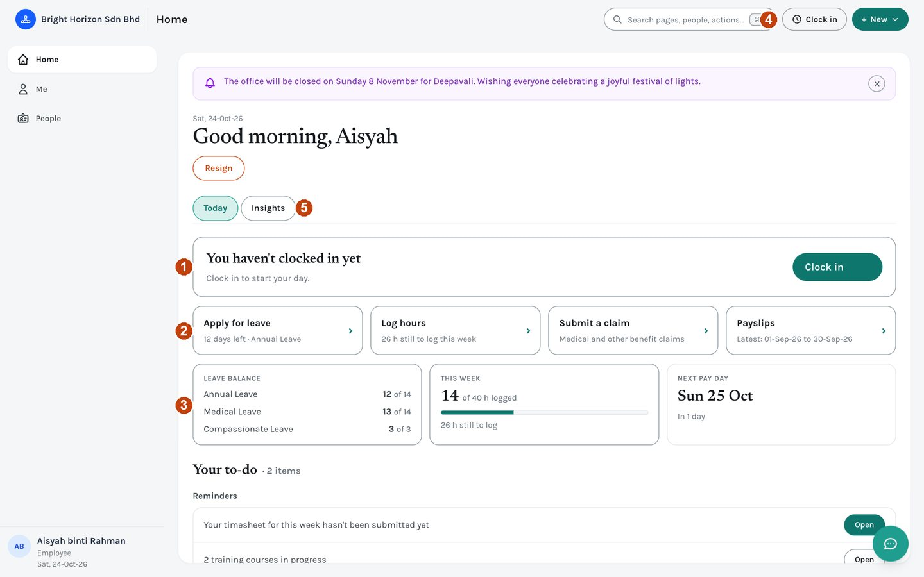
Figure 18. An Employee’s Home.
1 | The clock-in card. One big button to clock in; once you are in it says since when, and the button becomes Clock out.
2 | Four task tiles, each with a live detail: Apply for leave (days left), Log hours (hours still to log this week), Submit a claim, and Payslips (the latest).
3 | Glance cards: your leave balances, hours this week against what is expected, and the next pay day.
4 | The clock button in the top bar does the same as the clock-in card, from any page.
5 | Today and Insights. Insights holds the dashboards open to you.

Below these is your to-do list: reminders such as an unsubmitted timesheet, trainings in progress, and policies to read. Resign is a small button near the top.

9.2 Today — Manager and HR
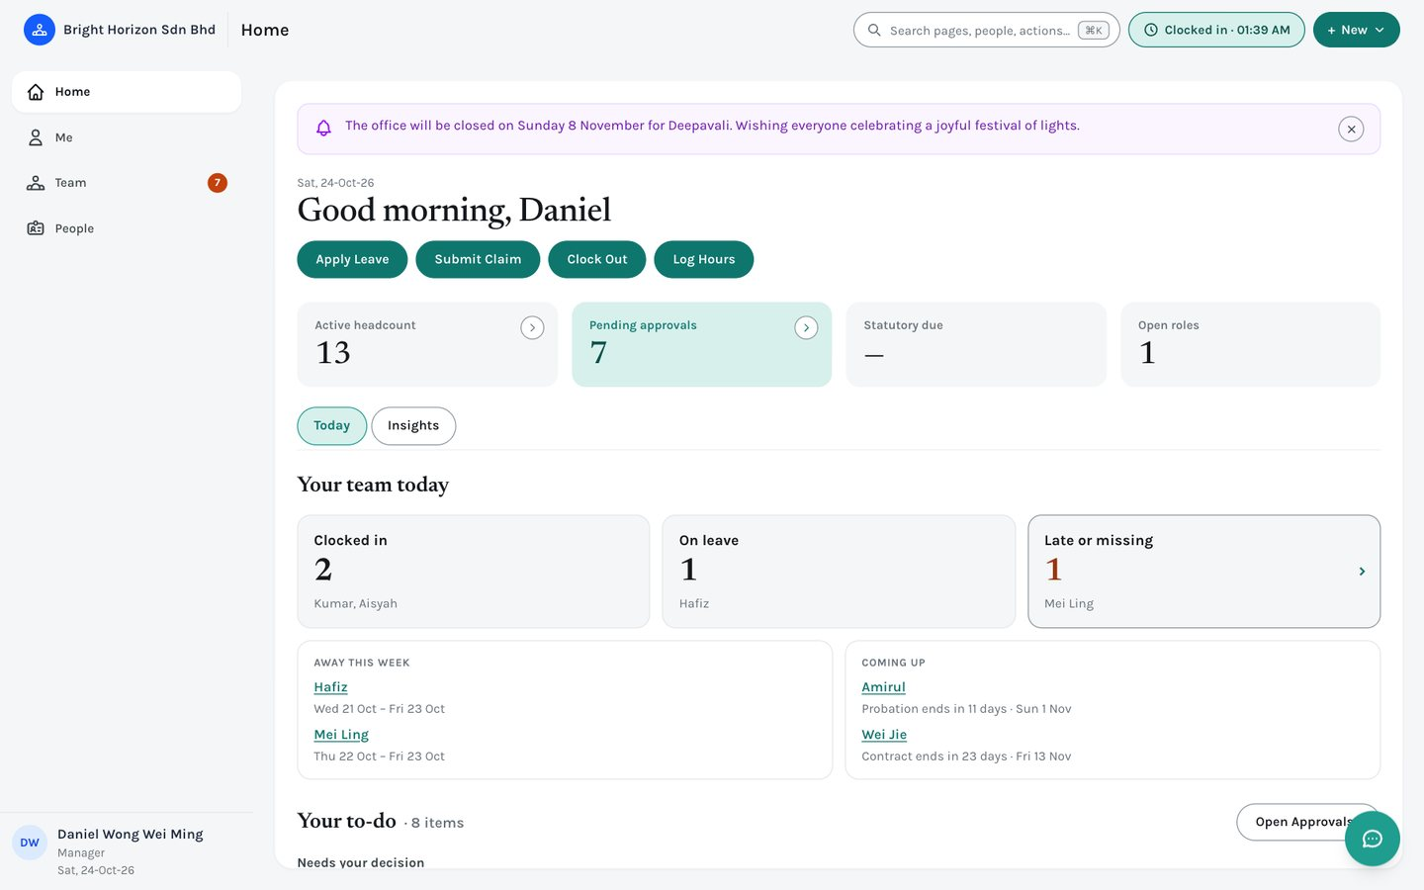
Figure 19. A Manager’s Home, with the team view and decisions.
- Quick actions. The usual personal ones (Apply Leave, Submit Claim, Clock In/Out, Log Hours); HR also gets + Add Employee and + New Requisition, and a Payroll Manager gets + New Payroll Run.
- Your team today / Everyone today. How many are clocked in, how many are on leave, and how many are late or missing. A manager sees their reporting chain (never themself); HR sees the whole company. The Late or missing figure only works once Attendance rules exist, and clicking it opens Team › Work › Attendance. Only that someone is away is shown — never what kind of leave.
- Away this week and Coming up. Who is on approved leave this week, and probation or contract end dates in the next 30 days. Click a name to open their page.
- Needs your decision. The to-do list leads with requests waiting on you. Leave and training requests can be approved or rejected right in the row; anything else has a Review button. “Open Approvals” opens the full inbox (chapter 11).
Everyone except the Employee role sees four figures across the top: Active headcount, Pending approvals, Statutory due (payroll and HR only) and Open roles. HR and Payroll Managers also get a Payroll and compliance card with pay day, the statutory remittance reminder, and documents expiring soon.

9.3 Insights
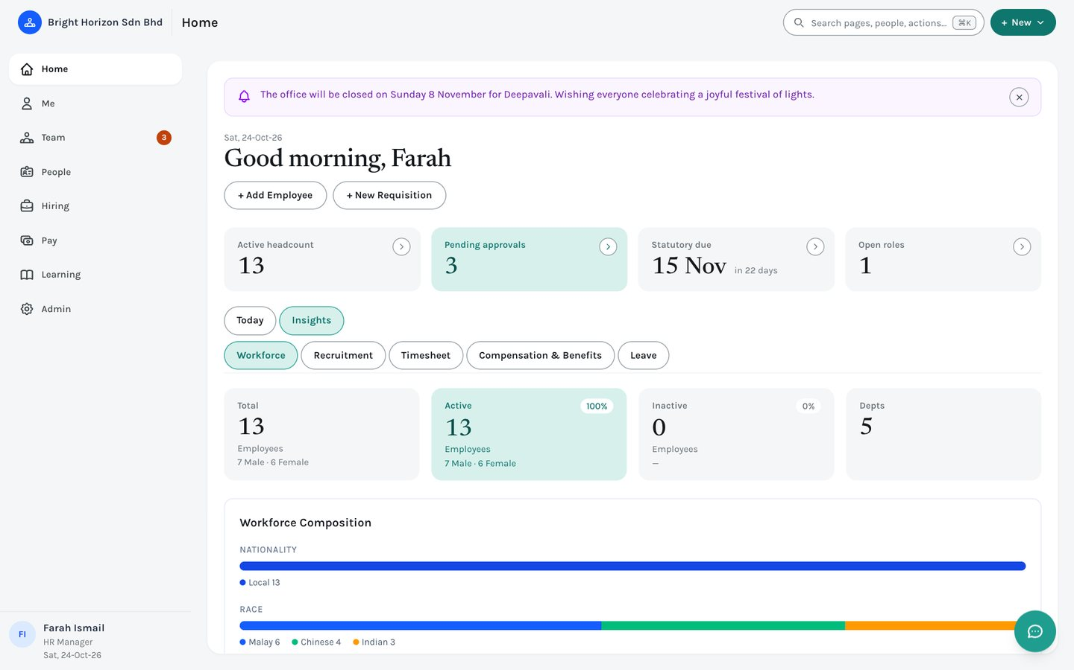
Figure 20. Home › Insights. A second row of tabs holds the dashboards your role can open.
Click Insights and a second row appears: Workforce (headcount and makeup), Recruitment (the pipeline for HR and managers; open positions for everyone else), Timesheet (project utilisation), Compensation & Benefits, and Leave (the leave calendar). Which ones you see depends on your role. EMS remembers the last one you looked at.

10. Me
Me is everything personal, for every role: your own leave, time, pay, learning and profile. Its tabs are Overview, Profile, Leave, Time, Pay and Growth; Time, Pay and Growth each have a second row.

10.1 Overview
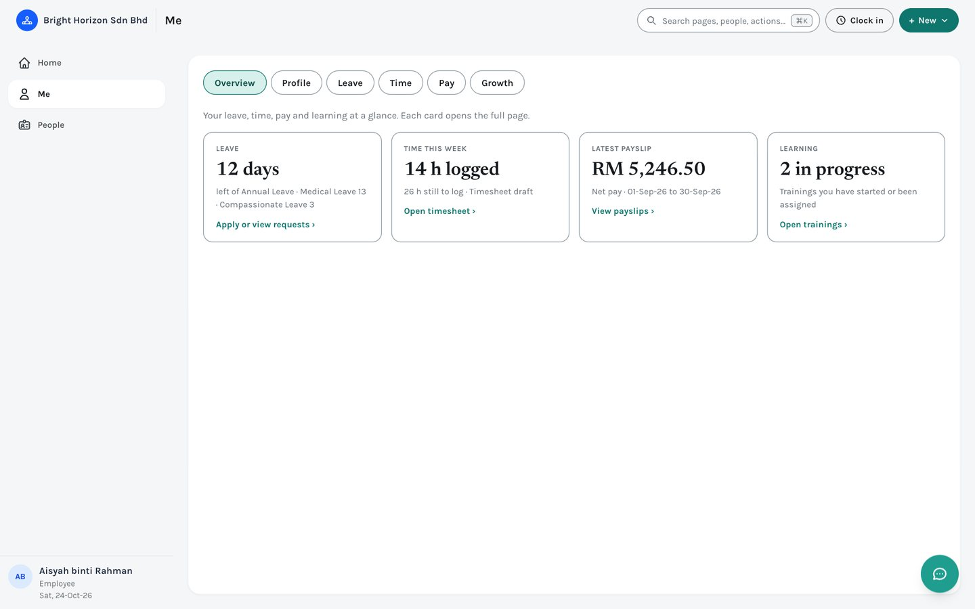
Figure 21. Me › Overview — four cards, each opening the full page.
Leave balance, time this week, your latest payslip and your learning at a glance. Click any card to open its page.

10.2 Profile
Opens your own employee page (see chapter 12.2). Employees can update certain personal contact details here; everything else is changed by HR.

10.3 Leave
Me › Leave shows your balance for each leave type, and a running history of your applications, filterable by status.
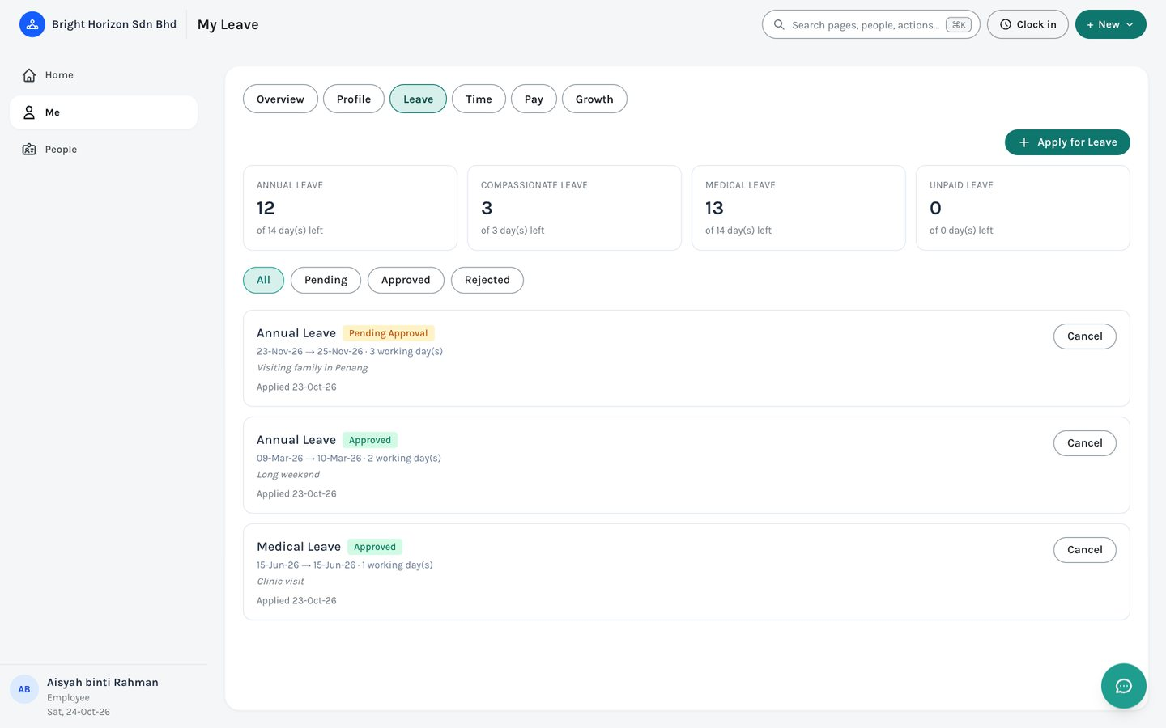
Figure 22. Me › Leave.
- Click “+ Apply for Leave” (or use Apply Leave on Home, or + New).
- Choose the leave type — your remaining balance for that type shows at once.
- Pick the start and end dates. Where the leave type allows half days, choose morning or afternoon for the first and last day.
- Add a reason or an attachment if needed, then submit. The application goes to your approver.
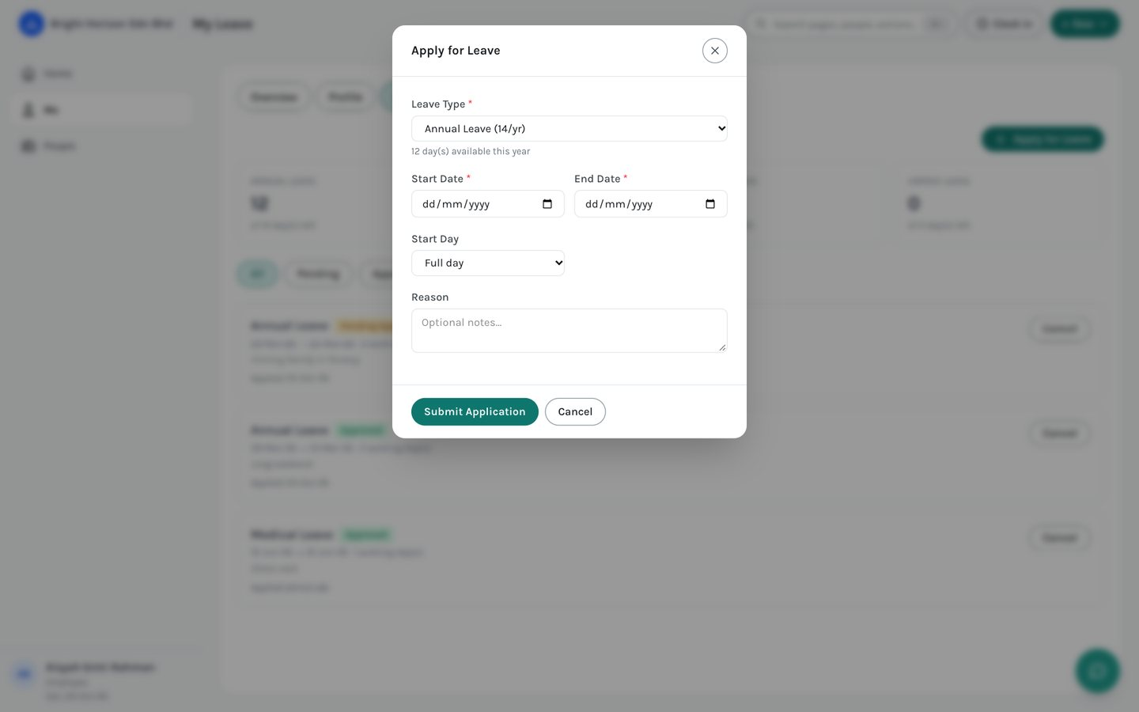
Figure 23. The Apply for Leave form.
Note: Me › Leave is always your own leave, whatever your role. Managers and HR see other people’s requests under Team › Requests › Leave requests.

Note: You only see the leave types you may use. If your company limits Maternity or Paternity leave, for example, only the people it is for see it. If you think you should have a leave type that is missing, ask HR (see 6.1).

10.4 Time: timesheet, overtime and clock in/out
Me › Time has three pages. Timesheet is where you log hours against a project and task for each day of the week and submit the week for approval. Overtime lists overtime EMS detected when you submitted, and its approval status. Clock in / out is where you clock in and out and see your attendance history.
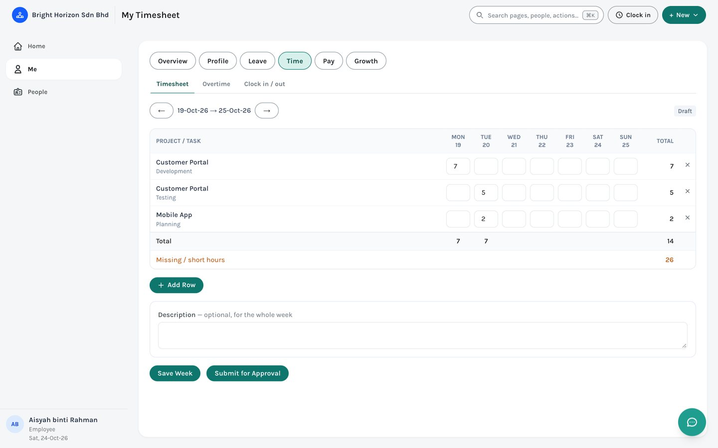
Figure 24. Me › Time › Timesheet.
You do not need to open the Clock in / out page to clock in. The clock button at the top of every page shows Clock in, or Clocked in with the time, and one click does it. Clocking out asks you to confirm. If your company uses clock-in locations, your browser asks permission to share your location the first time.
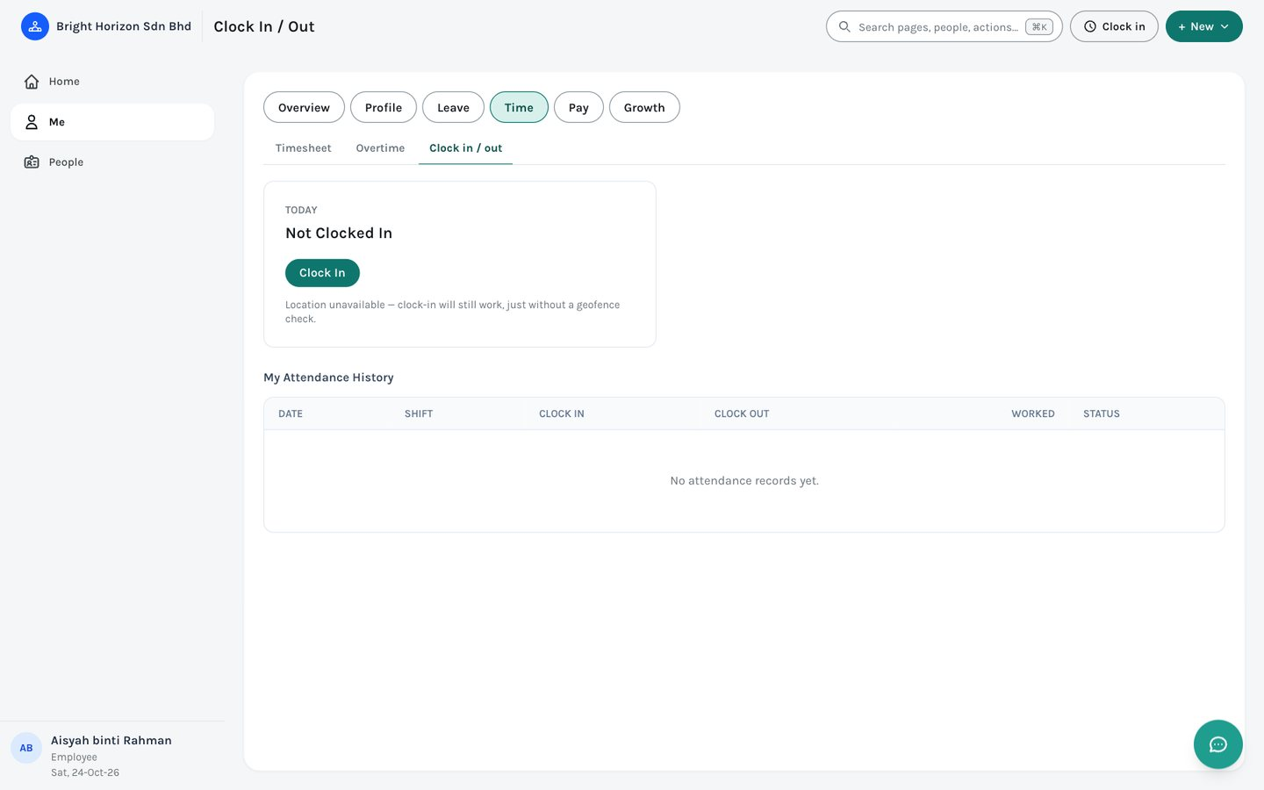
Figure 25. Me › Time › Clock in / out.
Note: A task can be marked “ALL — every employee” by HR so anyone can log hours to it, which suits company-wide activities. Weeks run Monday to Sunday.

10.5 Pay: payslips, total rewards, benefits and claims
Me › Pay lists your Payslips (one per finalised pay period, printable), your Total rewards statement, and Benefits & claims, where you see the plans you are eligible for, enrol during an open enrolment period and submit claims.
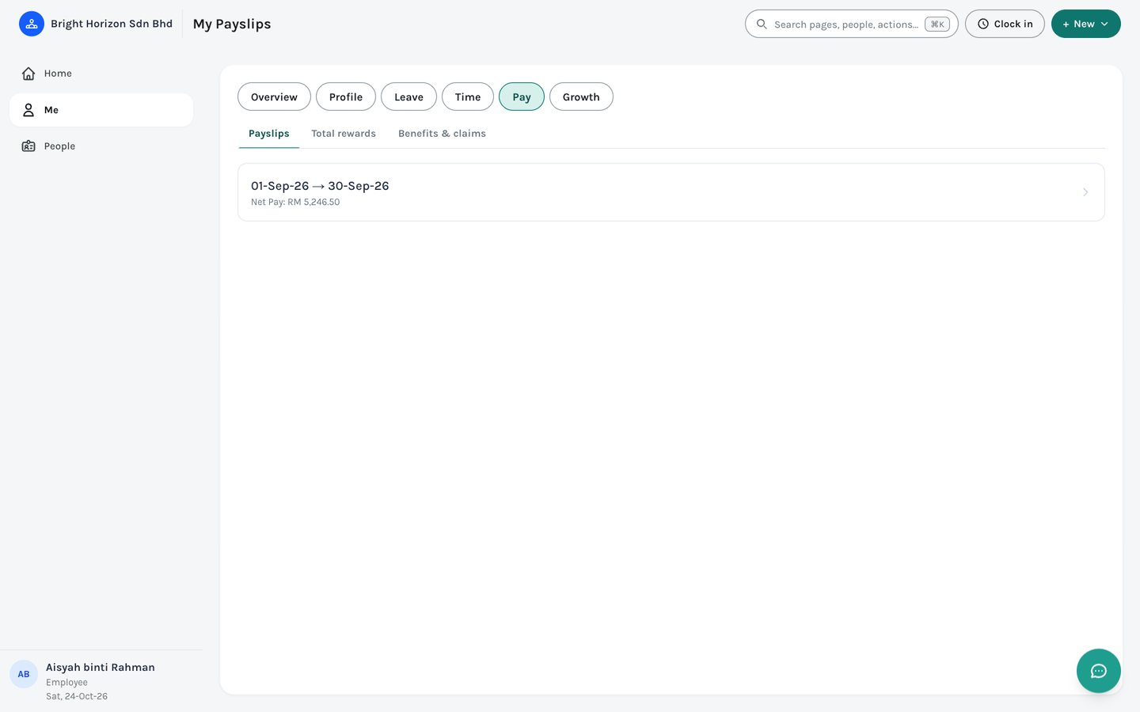
Figure 26. Me › Pay › Payslips.

10.6 Growth: trainings, goals and appraisal, interviews, courses
- Trainings — your course enrolments with progress and quiz scores, and any policies you are asked to read and acknowledge. HR and managers get a “Mine / Everyone I manage” switch here.
- Goals & appraisal — add KPI or OKR-style goals against the active performance cycle, and complete your self-review when the cycle reaches that stage.
- Interviews — appears only if HR has picked you as an interviewer. It lists your interviews, a brief about each candidate, and where you enter your score.
- Course catalog — for everyone except HR (whose catalog is in the Learning area): browse and enrol in courses.
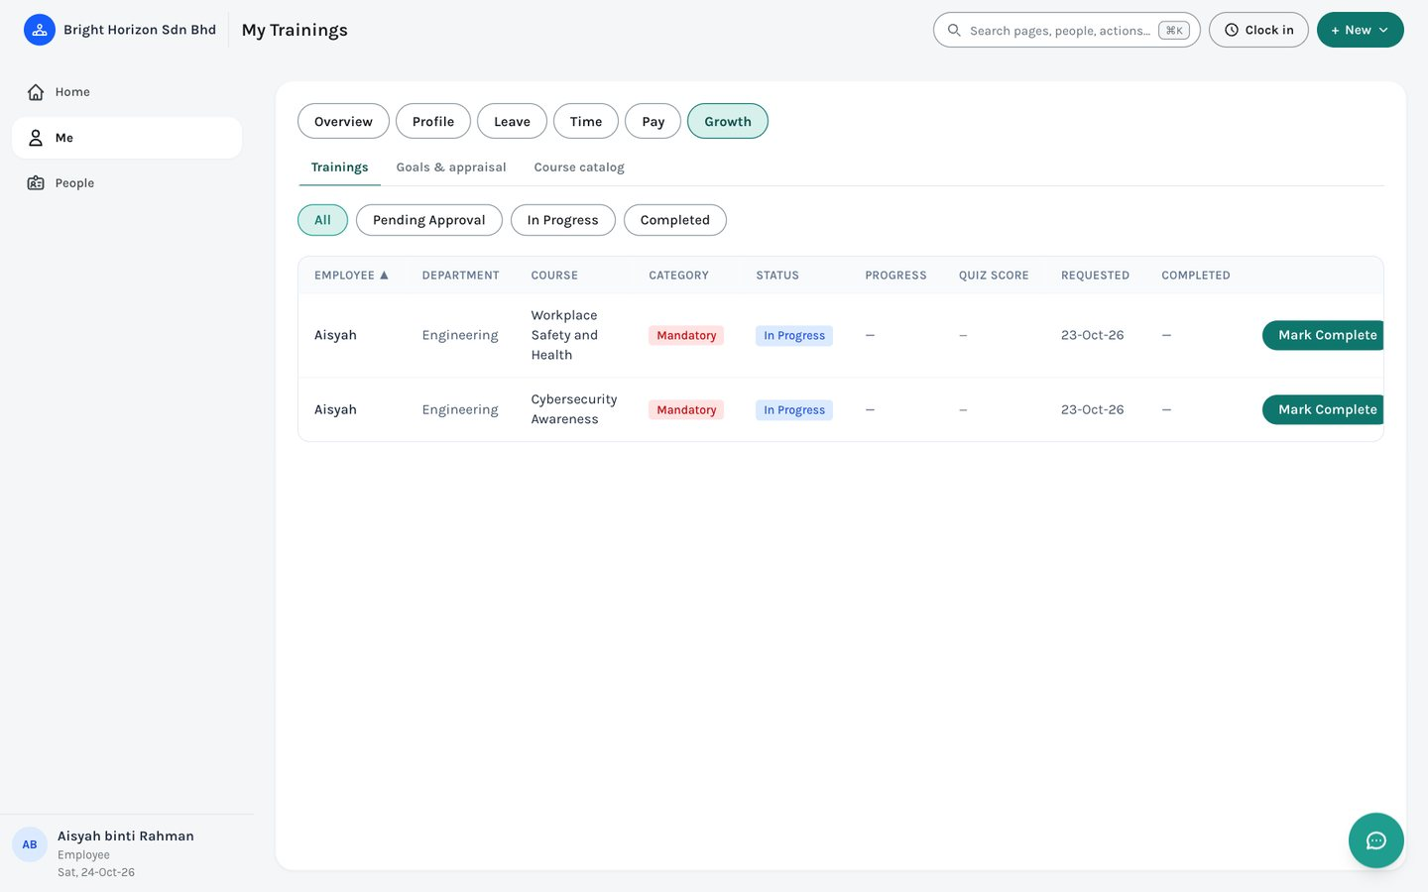
Figure 27. Me › Growth › Trainings.
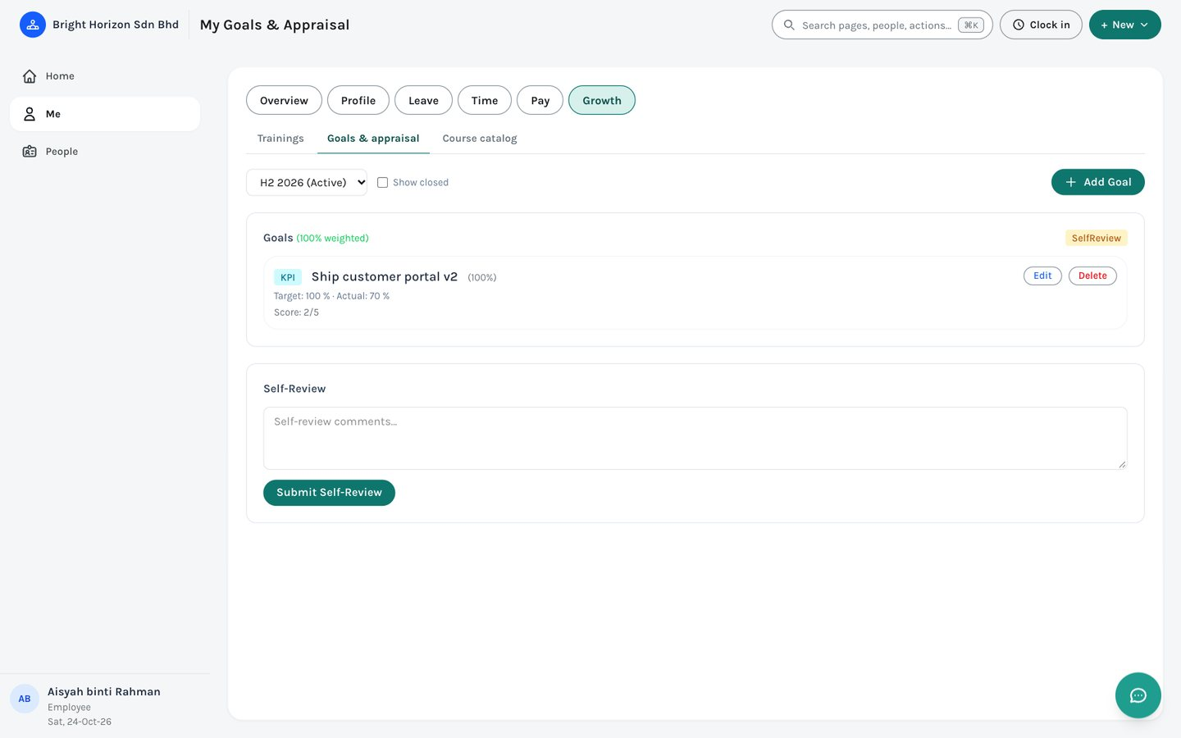
Figure 28. Me › Growth › Goals & appraisal.

11. Team
Team is for managers and HR: the requests waiting on you, and your team’s work. It has four tabs: Approvals, Requests, Work and Performance. An employee who is named as an approver sees Team while something is waiting for them.

11.1 Approvals
One inbox for everything waiting on your decision: leave, timesheets, overtime, benefit claims, job requisitions, resignations, training enrolments and improvement plans. The most overdue and longest-waiting come first.
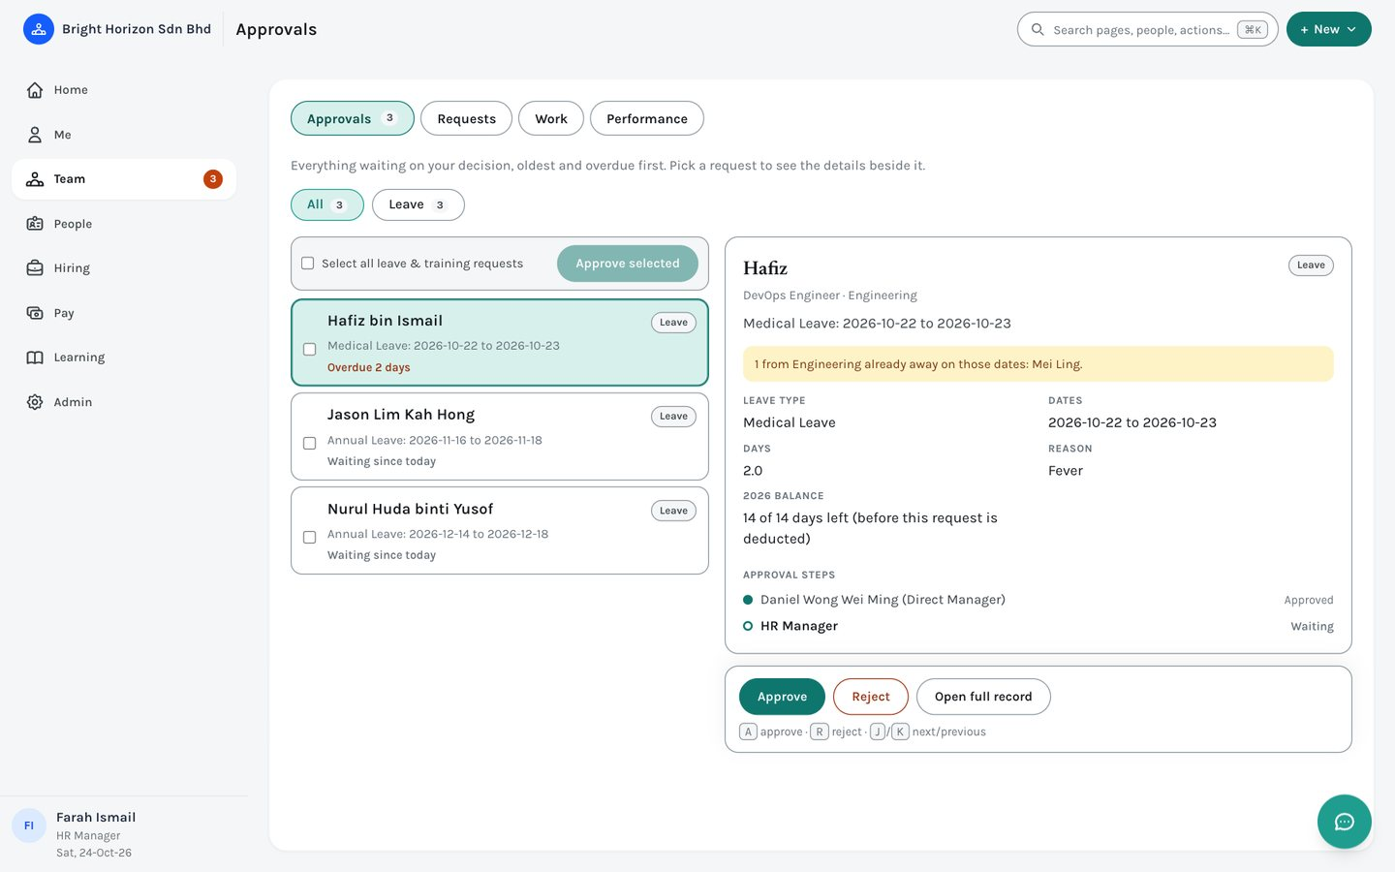
Figure 29. Team › Approvals, with a leave request selected.
- Filter by type. The chips across the top show how many of each kind are waiting.
- The details beside the request. Click a request to see its facts, any warning (for example, colleagues from the same department already away on those dates; or that approving a resignation starts offboarding), and its approval steps so you can see who has approved and who is next.
- Approve or Reject. Approve is one click. Reject asks for a reason, which is saved with the request, except for benefit claims. “Open full record” takes you to the request on its own page.
- Approve several at once. Tick leave and training requests and use “Approve selected”. Other kinds are decided one at a time, and rejecting is always one at a time because it needs a reason.
- Keyboard. J and K move down and up, A approves, R opens the reject box.
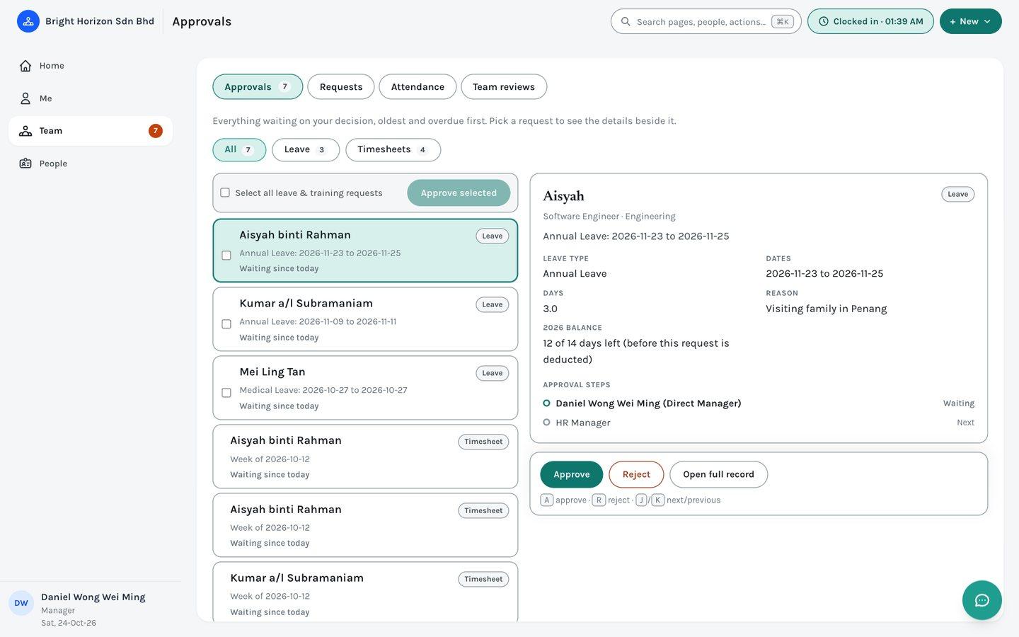
Figure 30. A Manager’s inbox: leave and timesheets from their team.
Note: You can never approve your own request, whatever your role. A decision can move a request on to the next approver rather than finishing it, and the requester is emailed either way. There is no undo, so check before you click.

11.2 Requests: leave, timesheets, resignations
The full lists, with filters, behind the inbox. Leave requests and Timesheets show everyone in your scope (a manager’s team, or the whole company for HR) with their status; Resignations lists resignation requests.
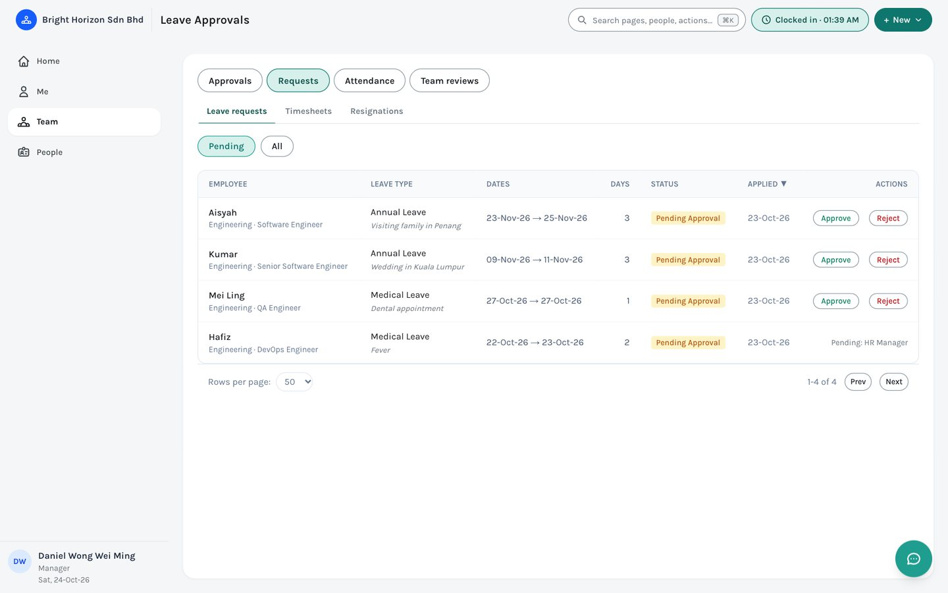
Figure 31. Team › Requests › Leave requests.
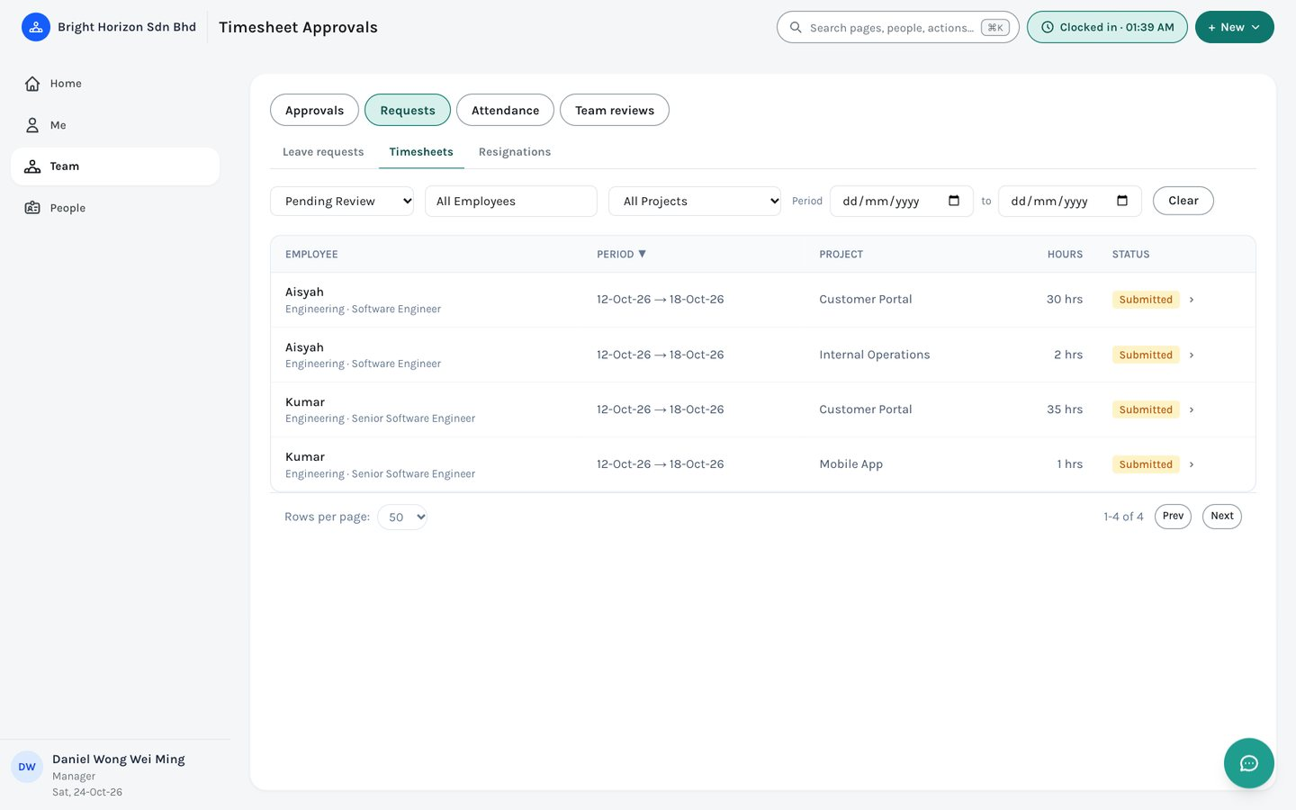
Figure 32. Team › Requests › Timesheets.

Resignations
Employees file a resignation from Home (Resign) and HR can file one for an employee from their page (More › File resignation). It records a reason, an effective date, a required last working day and an optional letter, and then follows the company’s approval chain. When it is fully approved the employee’s record is stamped with the dates and an offboarding checklist starts automatically.
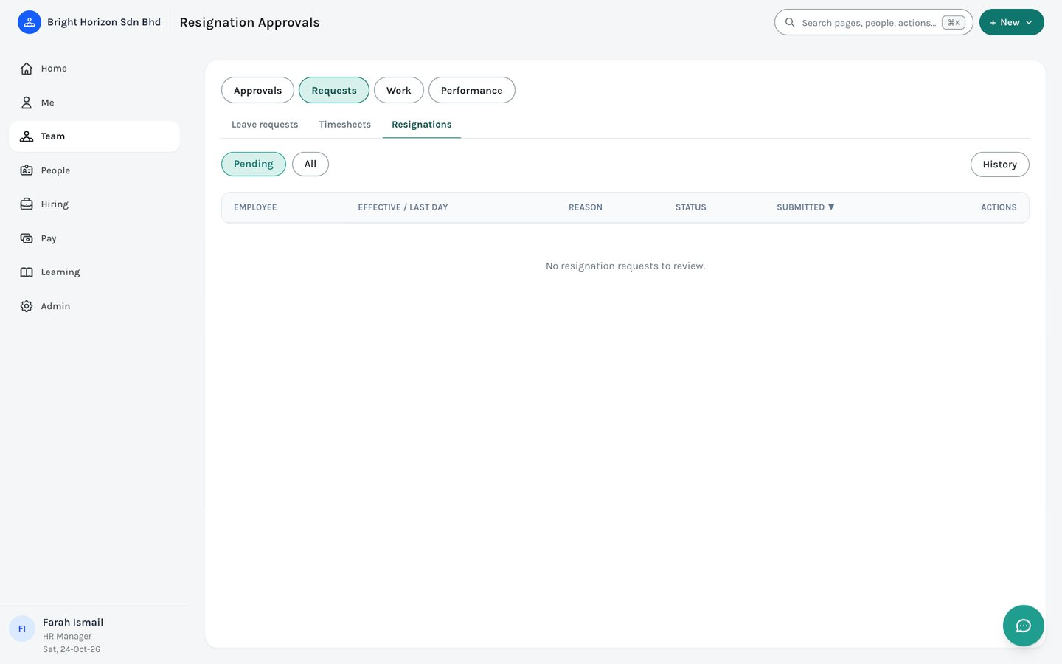
Figure 33. Team › Requests › Resignations.
Note: Filing a resignation does not change the person’s status by itself. HR still deactivates the record after the last working day.

11.3 Work: attendance and projects
- Attendance — days flagged late or absent and awaiting review. Excuse a day, confirm an absence, or reclassify it as approved leave.
- Projects — HR creates projects and tasks. A project’s listed managers see and manage the tasks of their own projects.
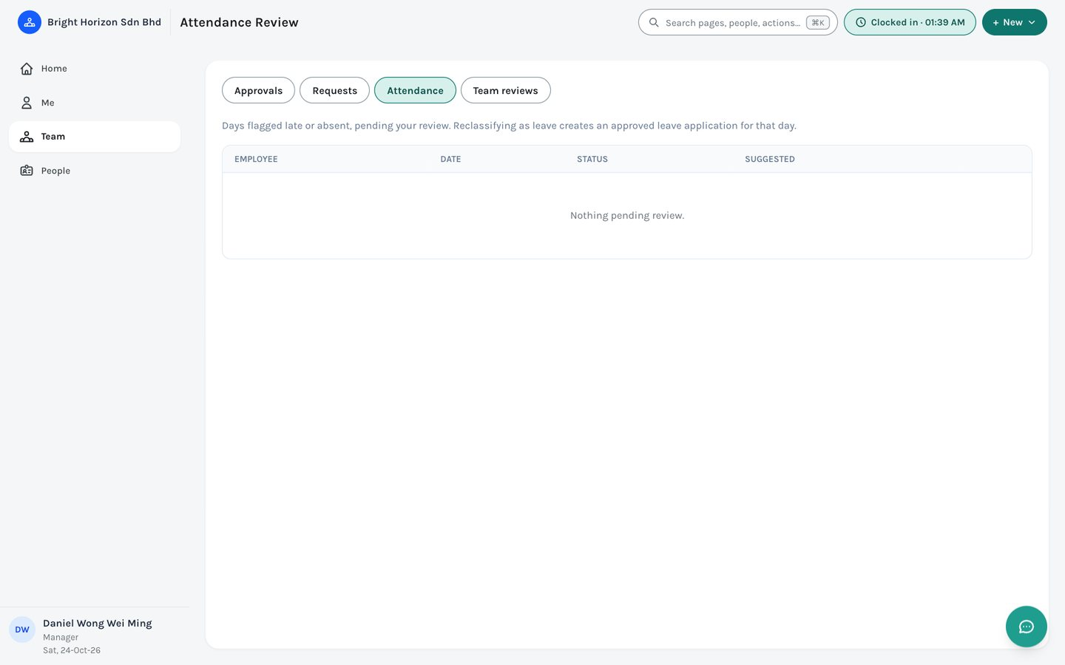
Figure 34. Team › Work › Attendance (empty when nothing needs review).

11.4 Performance
Performance runs goal-setting and appraisal through four stages: Self-Review → Manager Review → HR Calibration → Finalised.
- Team reviews (managers and HR Manager) — each report’s appraisal status; enter manager ratings once an employee has finished their self-review, and manage improvement plans.
- Cycles (HR Manager) — open a cycle such as “H2 2026”, then move it to calibration and finalise it.
- Calibration (HR Manager) — the rating distribution, and the ability to override an individual rating with a required note before finalising.
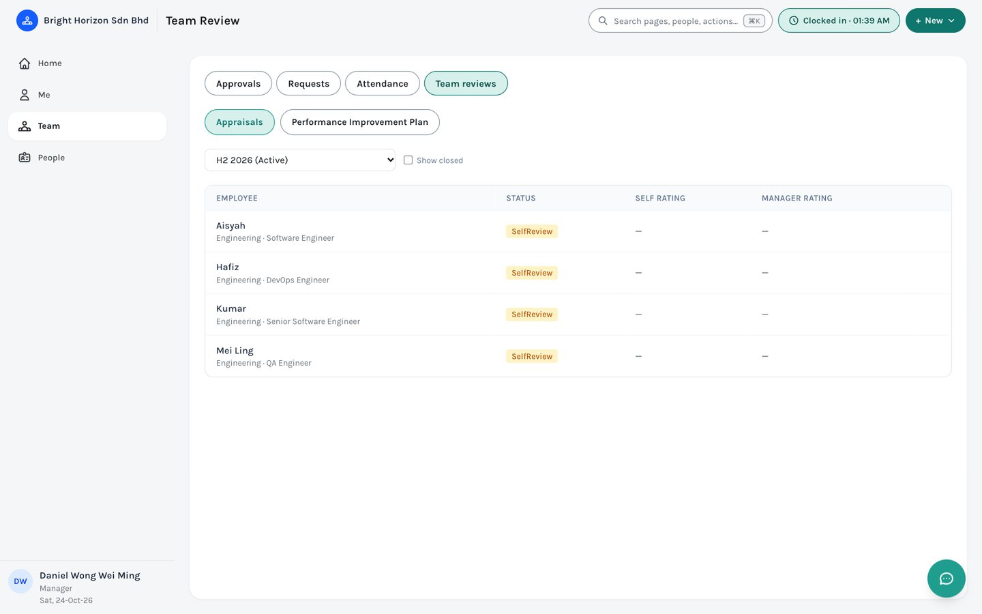
Figure 35. Team › Performance › Team reviews.
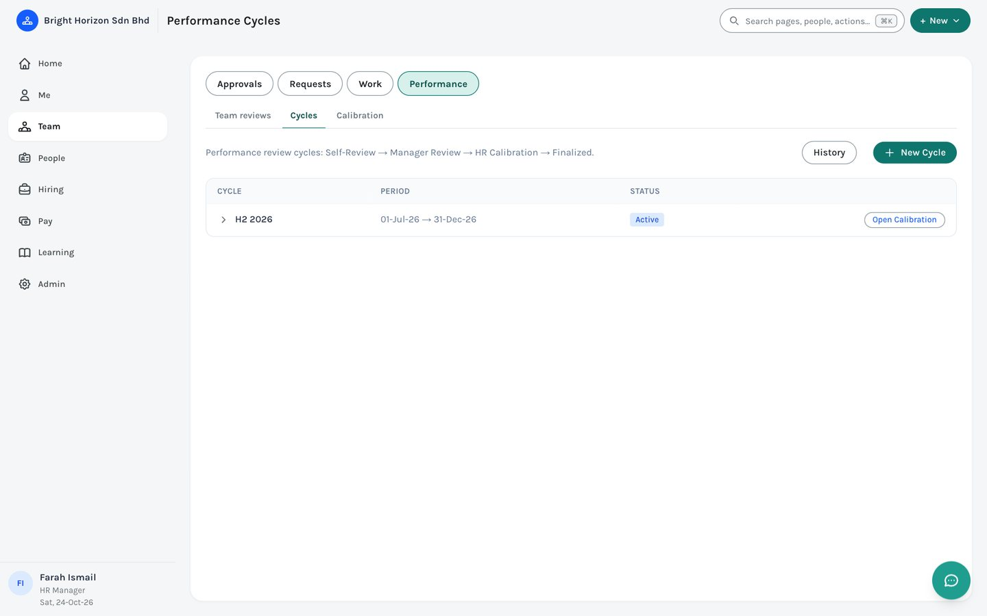
Figure 36. Team › Performance › Cycles.
Note: Closing a cycle locks every appraisal in it, and the results can feed merit increment and bonus decisions.

12. People
People holds the company directory and the employee lifecycle. Its tabs are Directory, Org chart, Onboarding, Offboarding and Import; an employee or manager sees only the first two.

12.1 Directory
The list of people in your scope: everyone for HR, your team for a manager, and only yourself for an employee. Search by name, ID, IC number or job title.
- Views. Active, Probation ending soon, Contracts ending soon, Inactive, Everyone. To keep your own, set the filters you want and click “+ Save this view”, give it a name, and it appears as a chip. The × on a saved view deletes it. Saved views live in your own browser, so they do not follow you to another computer.
- Columns. Choose which columns show. Your choice is remembered in your browser.
- Export. Tick people (or the box in the header for everyone on the page) and a bar appears with “Export to CSV”. The file contains exactly the columns currently shown.
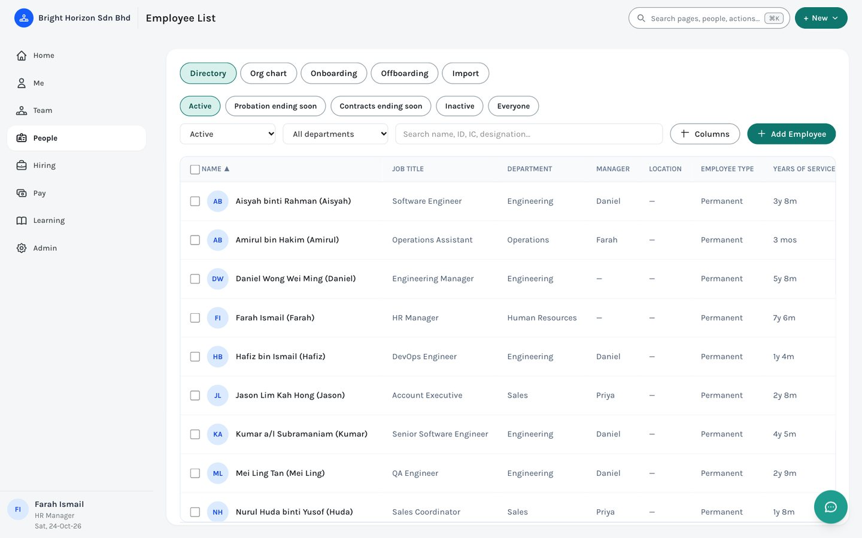
Figure 37. People › Directory.

12.2 An employee’s page
Click anyone in the Directory, the org chart, the search bar or Home to open their page. It has its own web address, so you can bookmark it or share the link (with someone who has access), and Back returns you to where you came from.
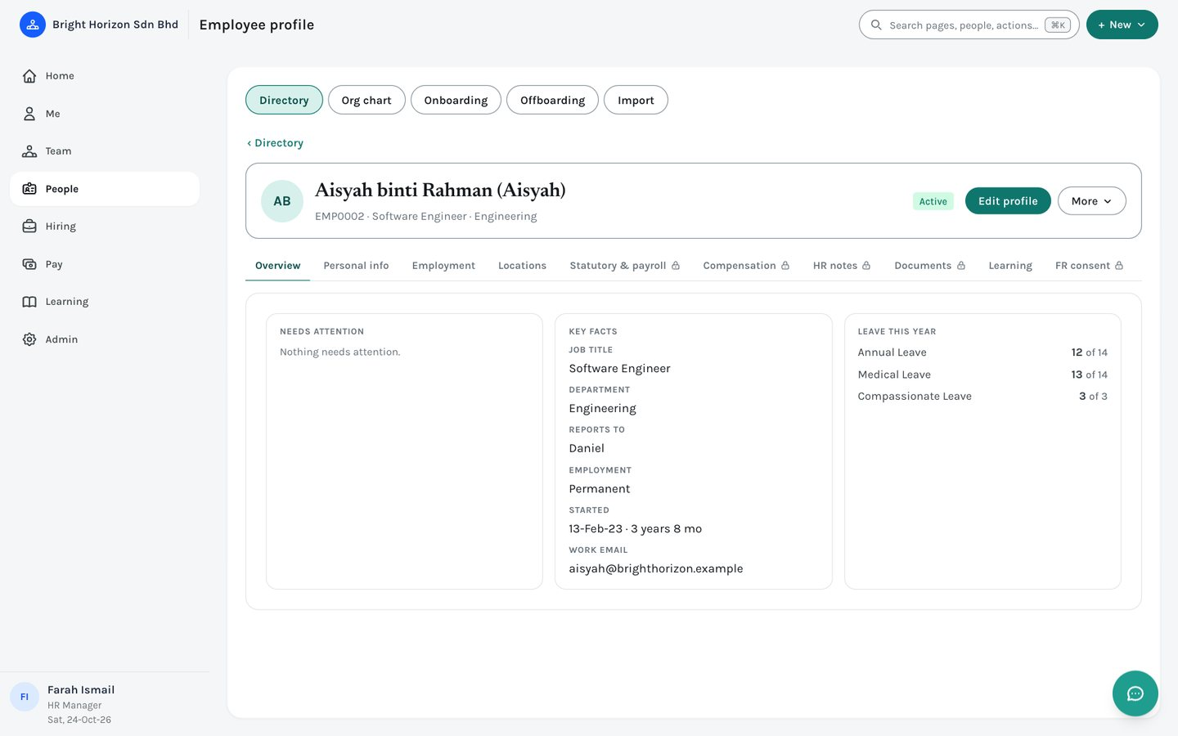
Figure 38. An employee’s page: header, tabs and the Overview tab.
- Header. Name, job and department, status, one main button — Edit profile — and a More menu.
- Overview. Key facts, “Needs attention” (probation or contract ending in the next 30 days; for HR also expiring documents and unfinished onboarding or offboarding), and leave this year.
- Tabs. Personal info · Employment · Locations · Statutory & payroll · Compensation · HR notes · Documents · Learning · FR consent. A padlock marks tabs that only HR (or, for statutory details, the person themself) can open; you only see the tabs your role allows.
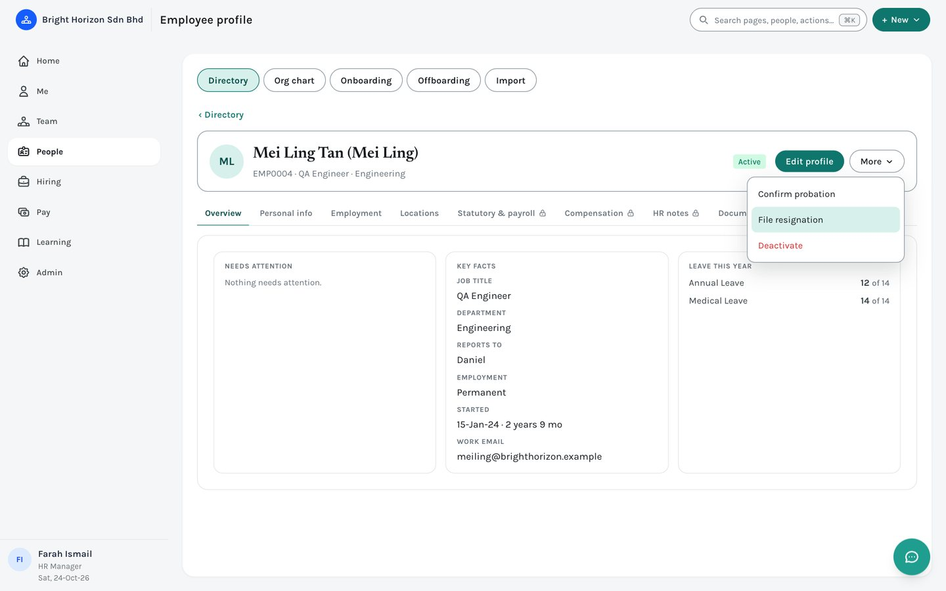
Figure 39. The More menu: confirm probation, file a resignation, or deactivate.
Note: Employees are never deleted from EMS. Use Deactivate in the More menu (HR Manager) so their leave, payroll and performance history is kept. HR notes (disciplinary, performance, warnings or commendations) are confidential to HR.

12.3 Org chart
Built from each person’s Reports To field with no separate setup. Switch between a tree and a list, and between active people only and everyone.

12.4 Onboarding and offboarding
Start a checklist for a new hire from People › Onboarding (or for a leaver from Offboarding). Checklists are built from templates, managed under “Manage Templates”, and each item is assigned to a role. Items can depend on others: an item that is waiting on an unfinished earlier step shows who it is waiting for and cannot be ticked by anyone but HR until then.
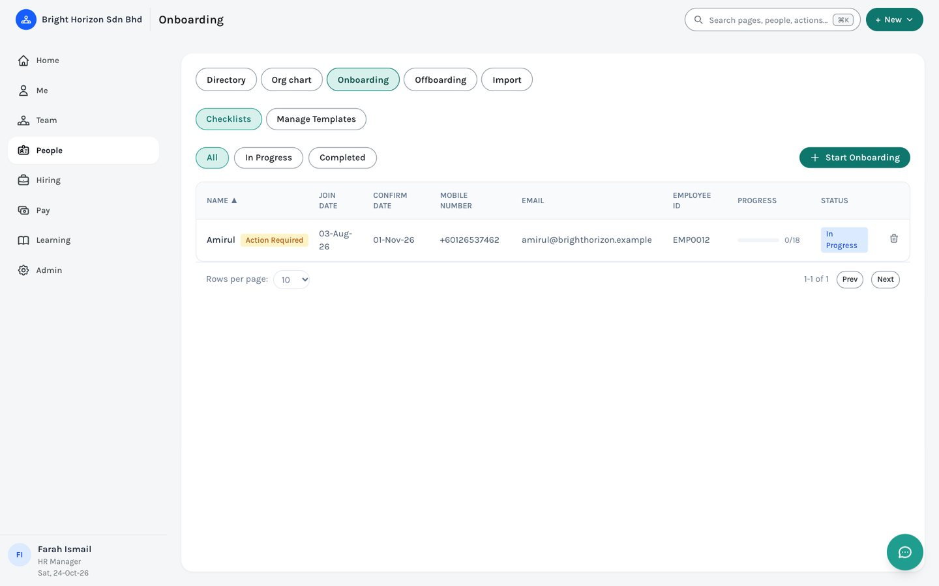
Figure 40. People › Onboarding.
Note: HR can opt a checklist into “Probation Review”, which creates Month 1, 2 and 3 review cycles for that person. Only HR can see who is on probation.

12.5 Document compliance
Track documents that expire, such as a work permit or passport. HR defines the document types under Admin › Company › Document types, each with its own reminder window, then adds documents on an employee’s Documents tab. Expiring and overdue documents appear in the employee’s Needs attention list, on Home for HR, and on the leave calendar in amber and red.

13. Hiring
The hiring pipeline runs one way: a job requisition is opened and approved, candidates are added, interviews are scheduled and scored, and a successful candidate gets an offer. Hiring is shown to HR, and to anyone HR has granted recruitment access under Roles & permissions.

13.1 Requisitions
Click “+ New Requisition”, give the title, department, headcount and salary range, and save. It starts as a Draft and moves through the approval workflow. Candidates can still be added to closed or filled requisitions so that no resume is lost.
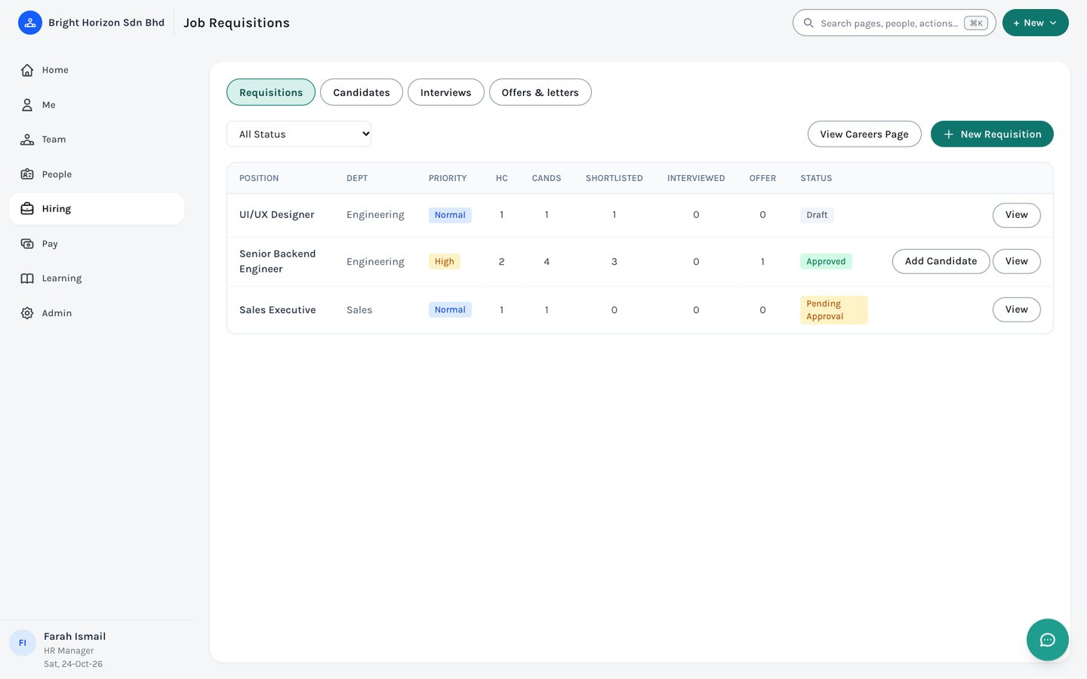
Figure 41. Hiring › Requisitions.

13.2 Candidates
One row per application: the same person can apply to several requisitions. Add Candidate lets you attach a resume (PDF or image) and click “Extract details with AI” to fill the form for you; check what it fills before saving. The stage filters and requisition-status filters narrow the list, and views such as In progress, Offers out and Hired apply a set of filters in one click.
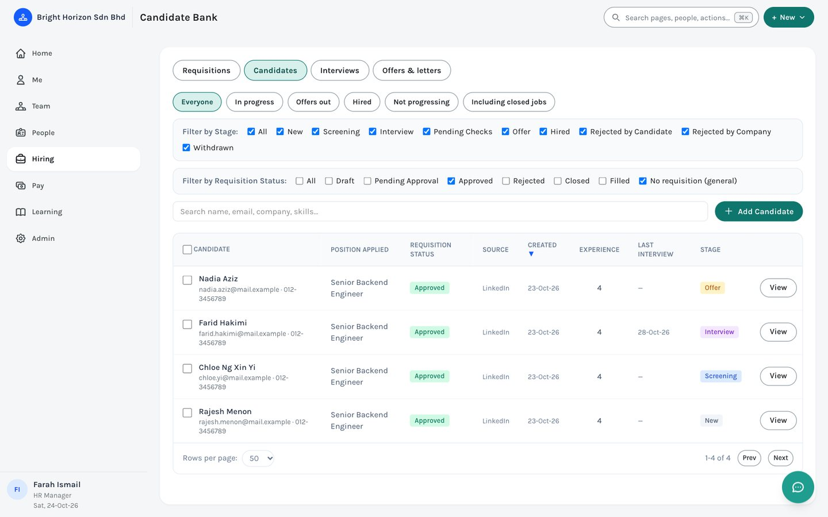
Figure 42. Hiring › Candidates.
To change the stage of several people at once, tick them. A bar appears where you choose a stage and click Move. A move EMS refuses (an invalid step, for example) is reported by name and the rest still go through.
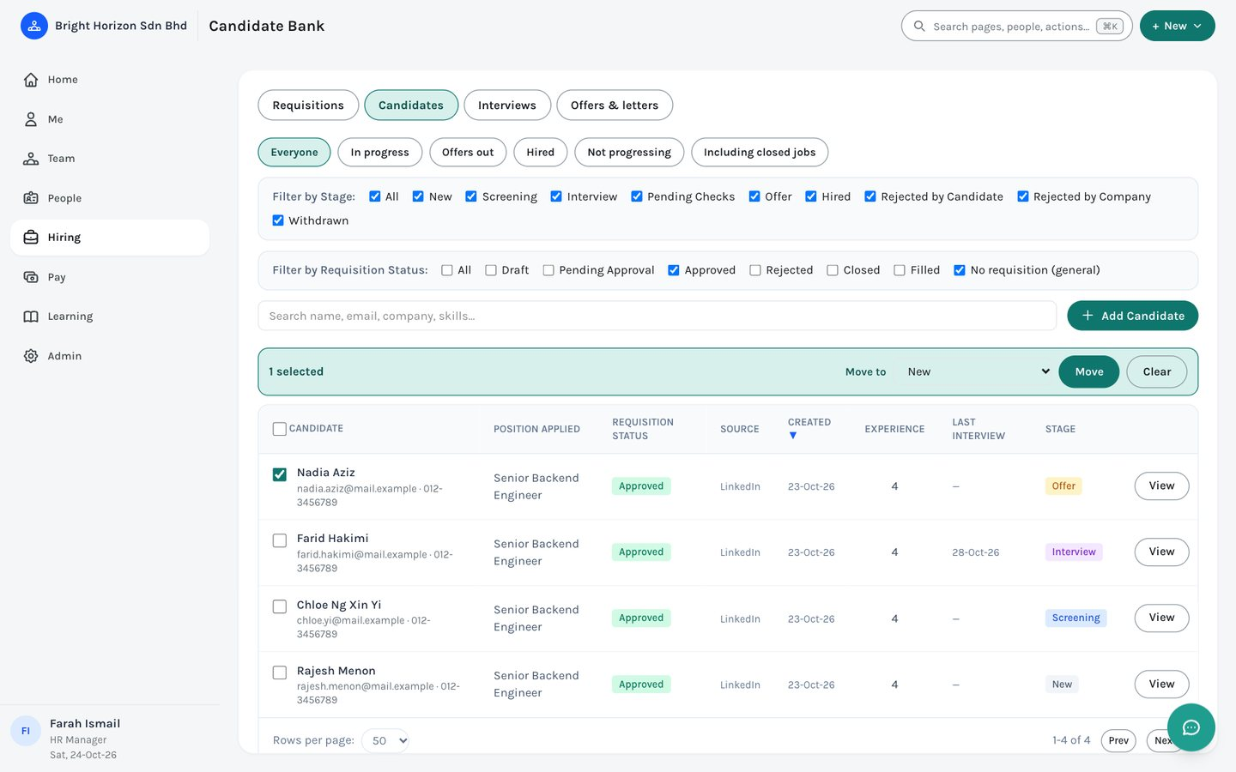
Figure 43. Candidates with one person ticked and the bulk bar showing.

13.3 Interviews and offers
Schedule an interview and pick the interviewers from the employee list. Each picked interviewer gets it on their Home to-do and scores it from Me › Growth › Interviews, seeing only the candidate’s professional background. The table shows each interviewer’s score and the average. Offers & letters generates offer, decline and confirmation letters from templates.
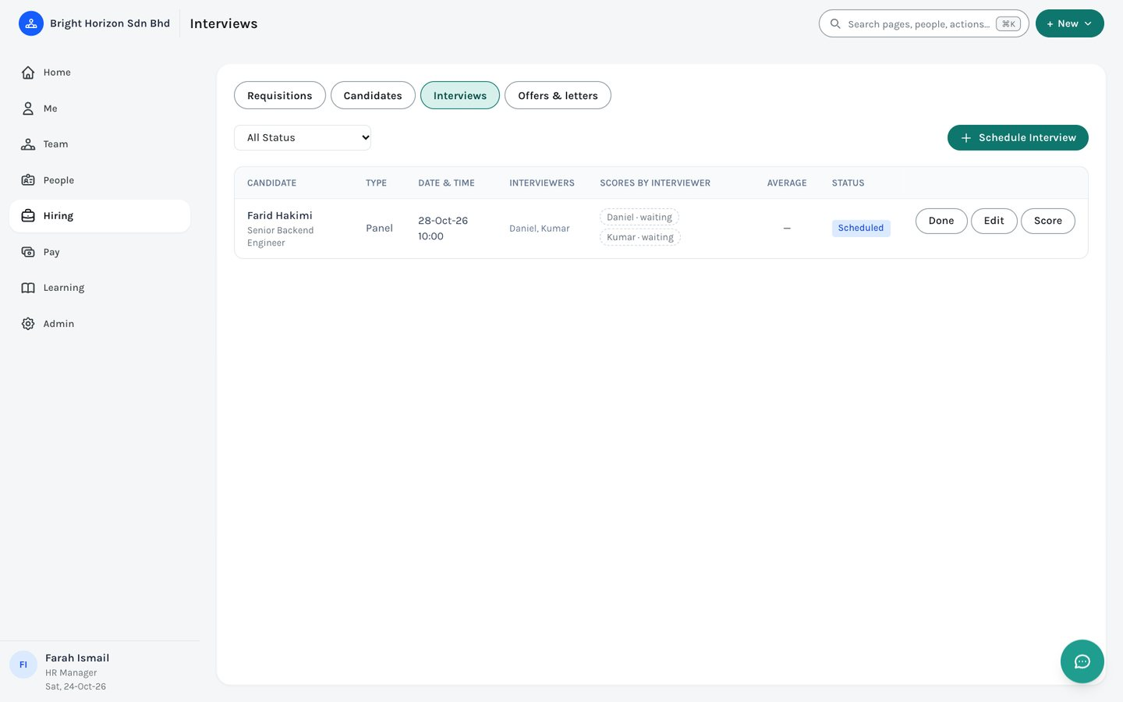
Figure 44. Hiring › Interviews, with each interviewer’s score slot.

14. Pay
Pay is for the HR Manager, Payroll Manager and Compensation Manager. Because it is large, it has a first row of three sections — Payroll runs, Compensation and Benefits — and a second row for the pages inside the last two.

14.1 Payroll runs
The Payroll Manager creates a run for a pay period and EMS works out each employee’s EPF, SOCSO, EIS and PCB from the Malaysian tables. Open a run to see the breakdown per person, then finalise it to lock the payslips. Finalised payslips appear in each employee’s Me › Pay. The HR Manager can view runs; the pay day and remittance reminder day are set on this page by the Payroll Manager.
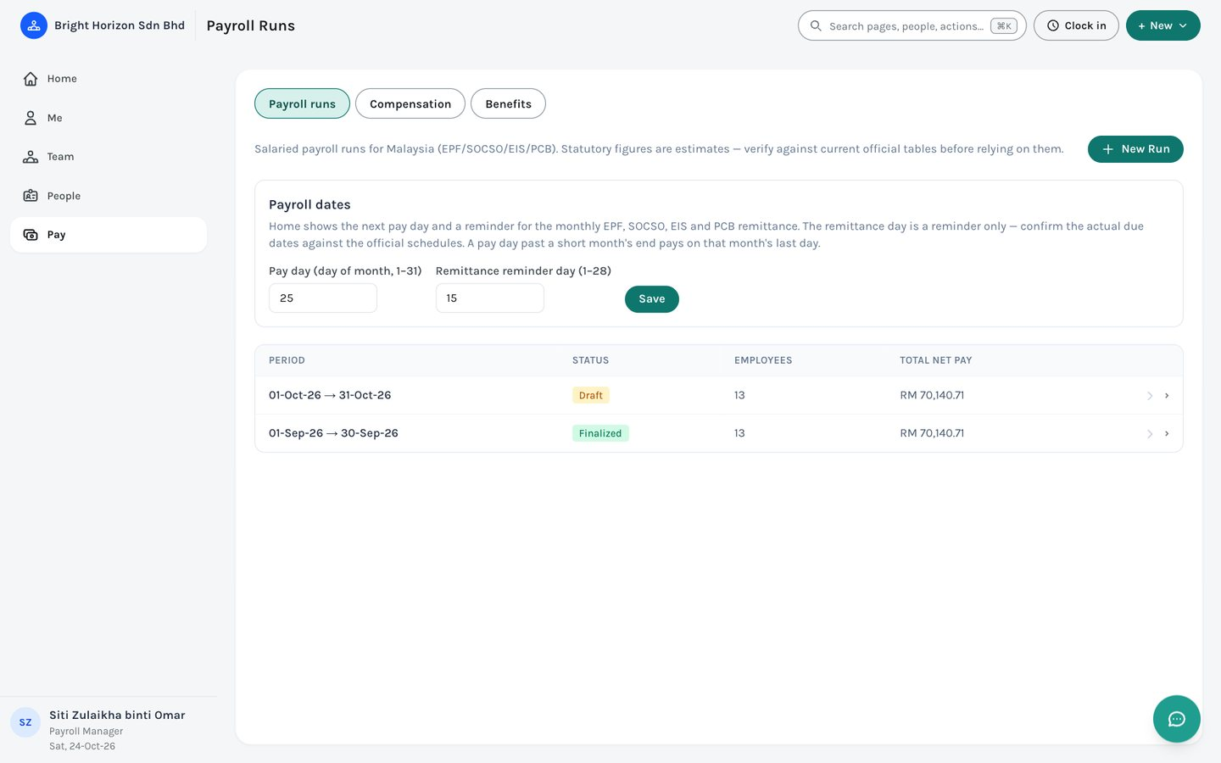
Figure 45. Pay › Payroll runs, with a finalised and a draft run.
Note: Statutory figures are estimates from built-in rate tables. Always check them against the current official EPF, SOCSO, EIS and LHDN tables before relying on them for real payroll.

14.2 Compensation
Nine pages: Pay grades, Job levels, Job roles, Merit cycles, Bonus plans, Commissions, Equity grants, Total rewards and Pay equity. Use them to define salary bands, run merit and bonus cycles, track equity, and review pay equity across the company.
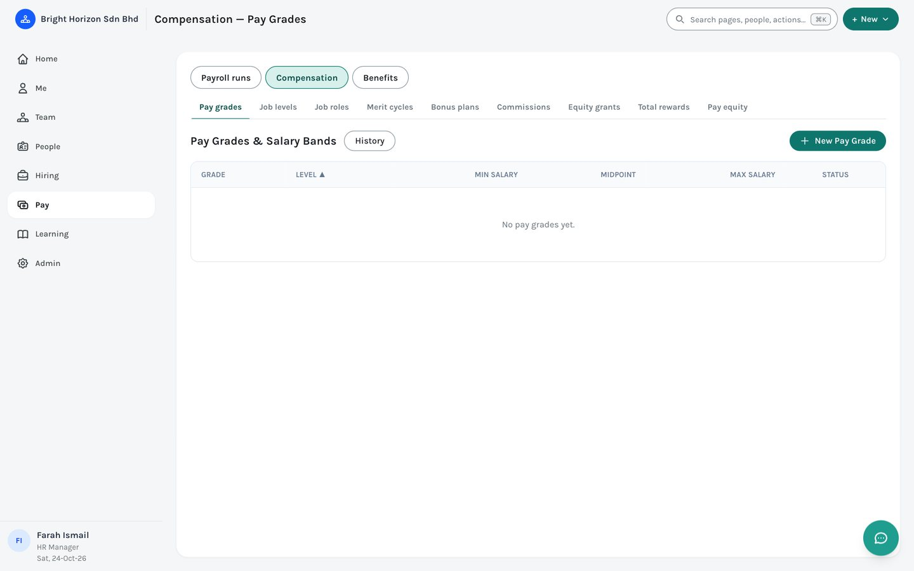
Figure 46. Pay › Compensation › Pay grades.

14.3 Benefits
Five pages: Plan types, Enrollment periods, Life events, Claims and Compliance & reporting. Define plans and who is eligible, open enrolment periods, decide life-event changes, and approve or reject claims.
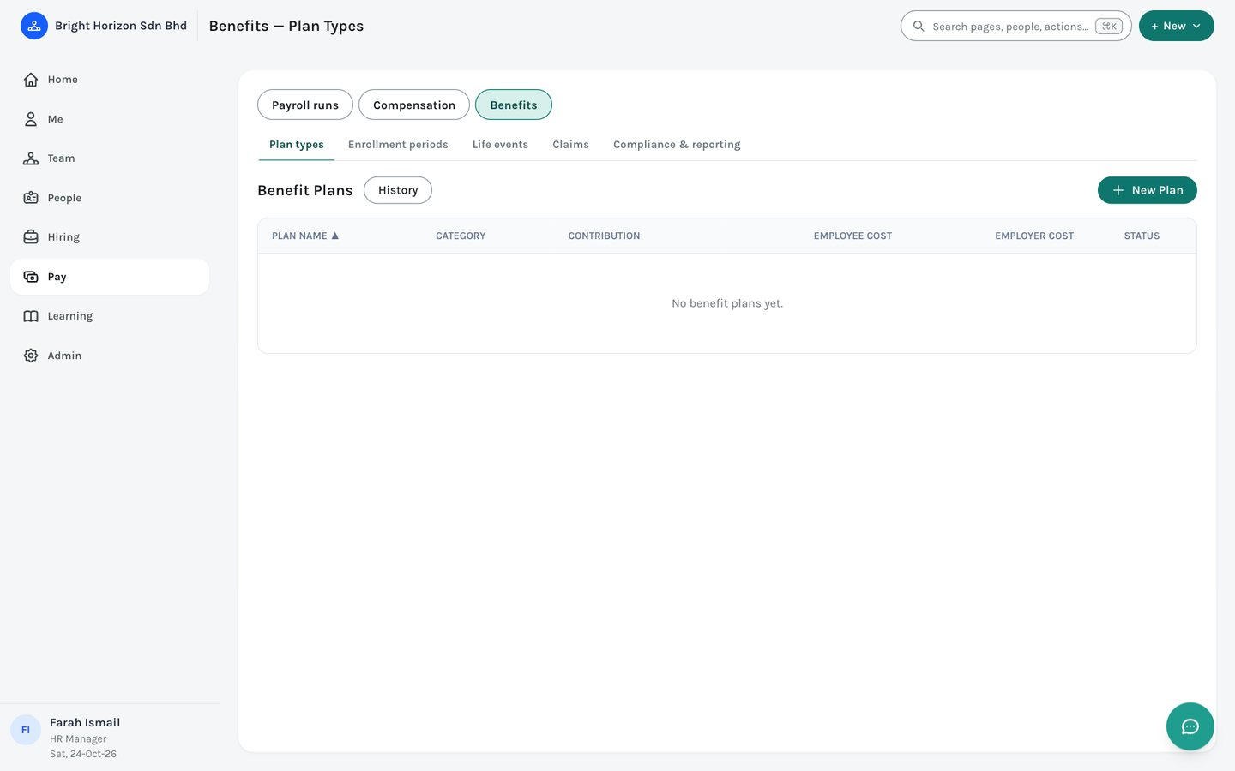
Figure 47. Pay › Benefits › Plan types.

15. Learning
HR manages courses and policies here. Everyone else browses the same catalog under Me › Growth.
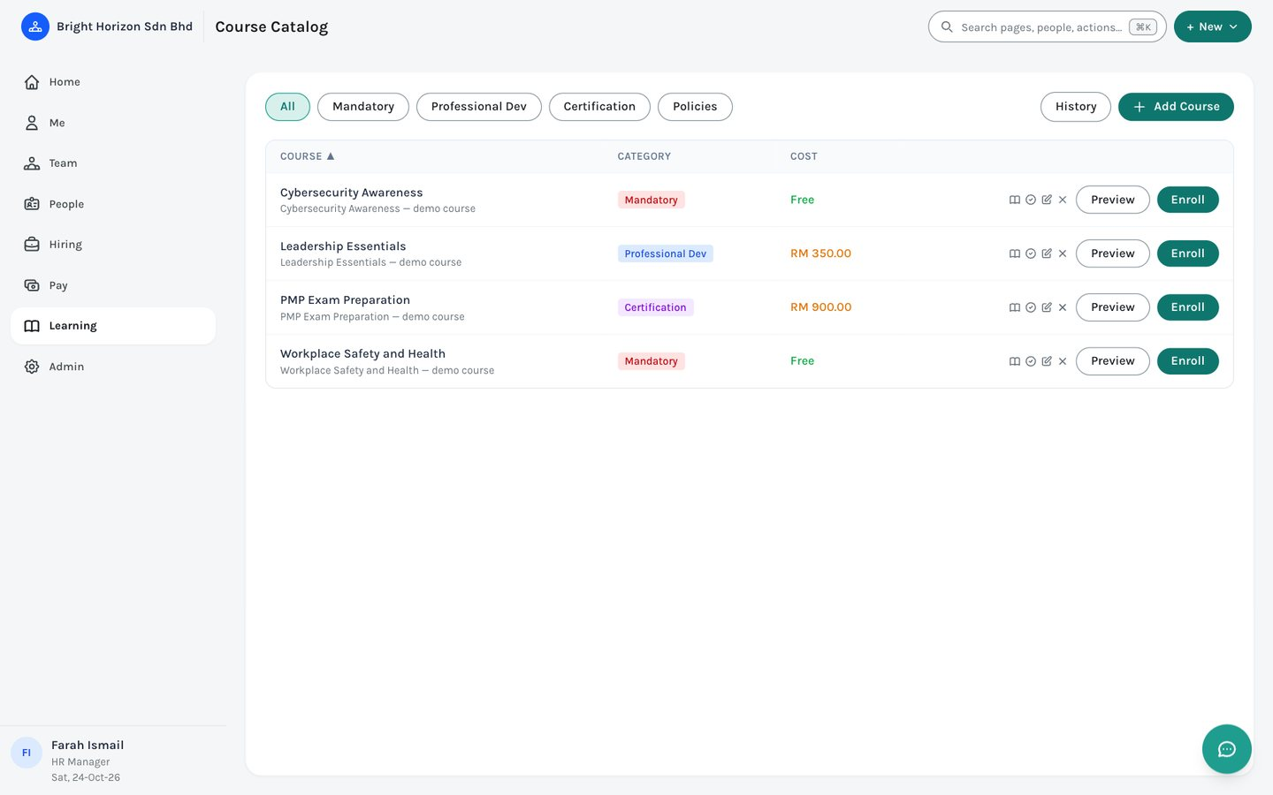
Figure 48. Learning › Course catalog. The filters include a Policies view.
- Courses. Mandatory, professional development or certification, each with a price (or free), lessons (text, video or a PDF, Word or PowerPoint document) and an optional quiz with a pass mark and attempt limit. Employees see their scores and attempts.
- Policies. HR publishes a handbook or policy as a file or a link and chooses who must read it. Each person opens it and confirms with their password (or with Microsoft). EMS records who confirmed and when; publishing a new version asks everyone again. HR tracks progress, sends reminders and exports the list.

16. Admin
Admin gathers every setting, in six groups. Most are for the HR Manager; the HR Admin sees a smaller set.
Group | What is in it
Company | Locations · Leave types & holidays · Document types · Letter templates · Performance settings.
People & access | Users · Roles & permissions · Approval workflows.
Attendance rules | Who must clock in, shifts, shift assignments and clock-in devices.
Announcements & email | Company announcements, the email (SMTP) settings, and the reminder emails.
Integrations & AI | Single sign-on (Microsoft), Claude access, and the AI assistant.
Audit log | A record of changes: employee changes, system activity and sign-in attempts.

16.1 Announcements & email
Broadcast a message that appears at the top of everyone’s Home for a set time window. On the same page, set the company timezone, the email settings and the reminder emails (overdue checklists, timesheets, holiday eve, policies).
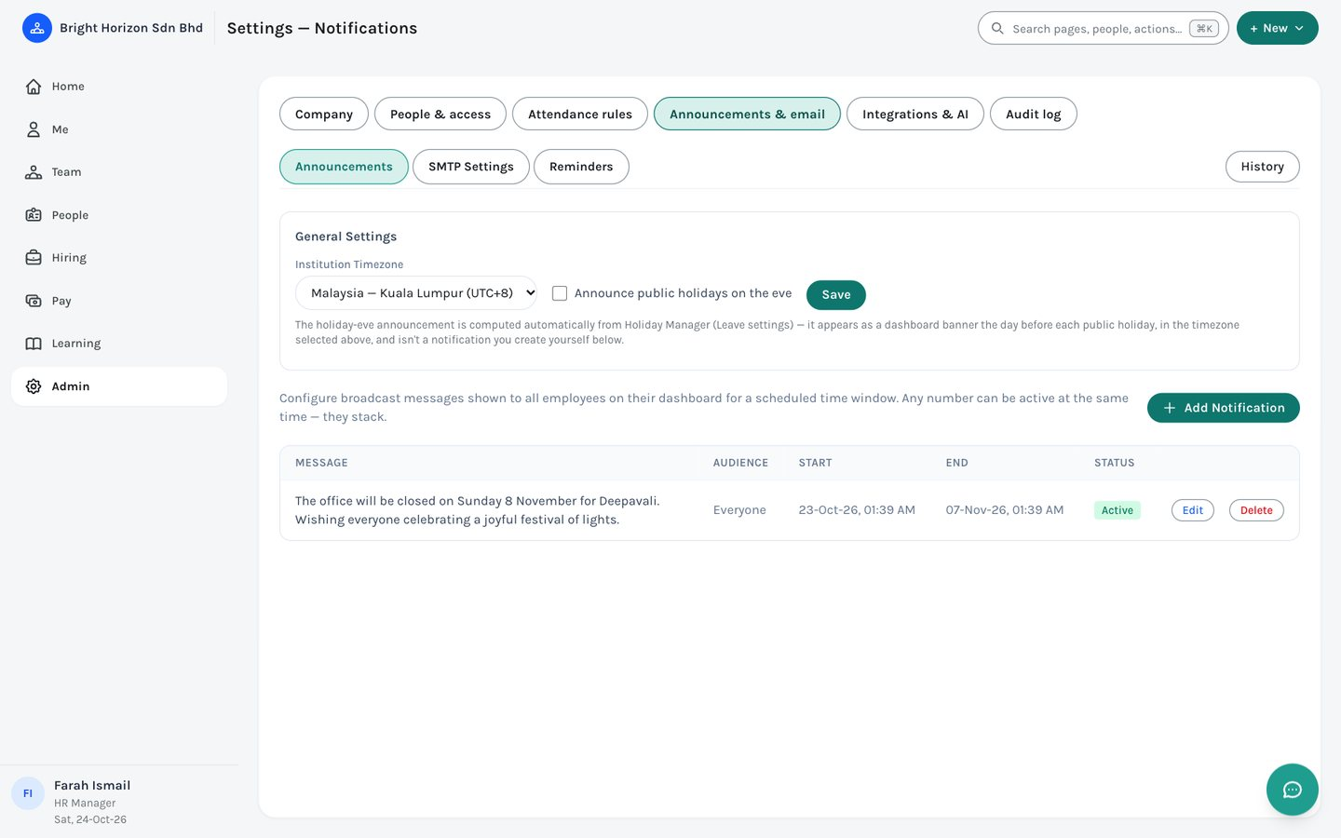
Figure 49. Admin › Announcements & email.

16.2 Roles & permissions
The six built-in roles are always available; add your own here. The Permission Matrix lists what each role can do across the modules, and for manager, employee and your own roles you can allow or withhold individual abilities for your company. The HR and payroll roles are fixed.
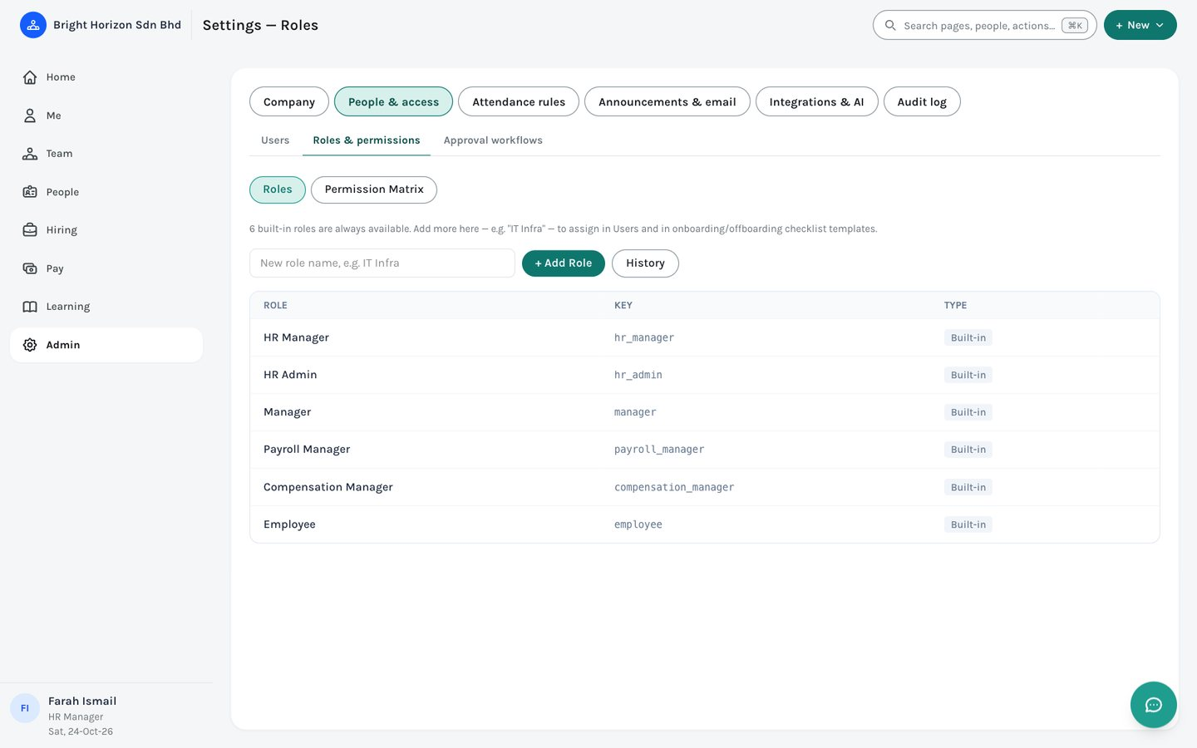
Figure 50. Admin › People & access › Roles & permissions.

16.3 Approval workflows
Decide who approves each kind of request: leave, claims, requisitions, timesheets, training, overtime, resignation and improvement plans. A workflow is a list of steps (the person’s direct manager, their skip-level manager, the HR Manager, a named person, or a project manager), with an optional alternative approver per step. Steps run in sequence, or all at once in “flat” mode.
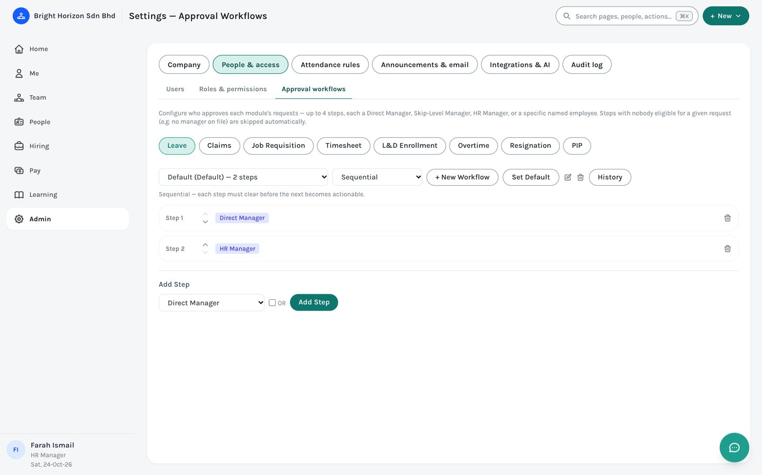
Figure 51. Admin › People & access › Approval workflows.

16.4 Attendance rules
Choose who must clock in (a department or a person), define shifts with a grace period, assign shifts, and add clock-in devices and locations. Only once a rule exists does EMS flag late and missing clock-ins.
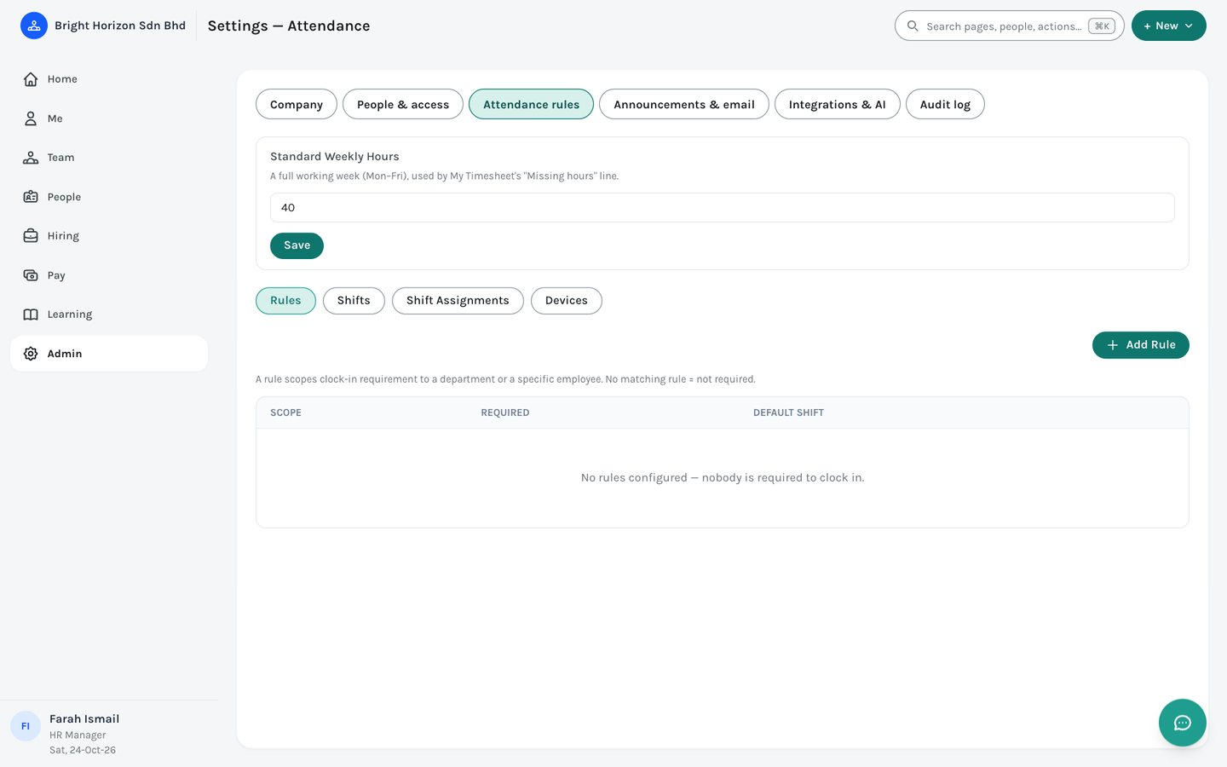
Figure 52. Admin › Attendance rules.

16.5 Document types and the audit log
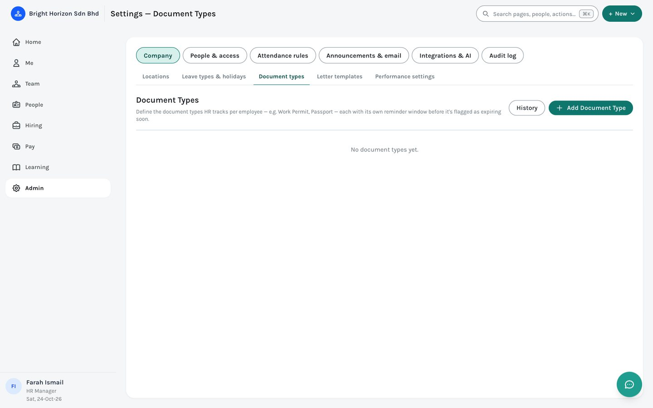
Figure 53. Admin › Company › Document types.
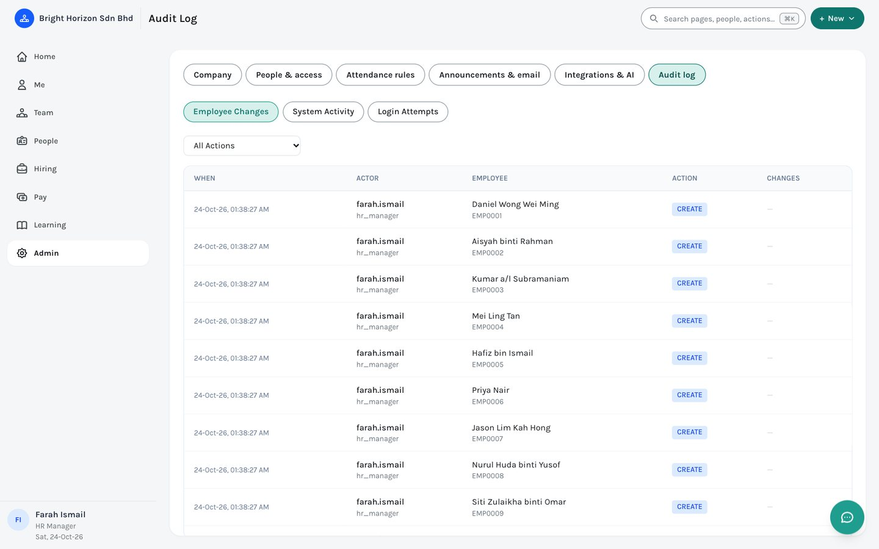
Figure 54. Admin › Audit log.
The audit log records who changed what and when across the system. It is read-only and available to the HR Manager.

16.6 Integrations & AI
- Single sign-on. Connect your company’s Microsoft (Entra ID) tenant so people can sign in with their work account. Turn it on only after a successful test sign-in. An option can require Microsoft sign-in for everyone, with a few named emergency accounts that can still use a password.
- Claude access. Lets staff connect Claude to EMS so they can clock in and out, check leave balances and hours, and (for project managers) manage tasks by chatting. Each person approves the connection themselves, it lasts 30 days before they reconnect, and HR can switch it off for the company or revoke a person.
- AI assistant. The chat helper in the corner answers questions about the signed-in person’s own data (and their team’s for managers). Here HR Manager sets the company’s API key and sees how much each person has used.

17. Using EMS on a phone
On a phone the menu becomes a bar along the bottom with your main areas (Home, Me, and Team and People where you have them). Tap More (or the menu button at the top left, when there is no More) for the full list, your account and Sign out. Search is the magnifying-glass button at the top, + New is the round plus button, and the clock button sits beside them.
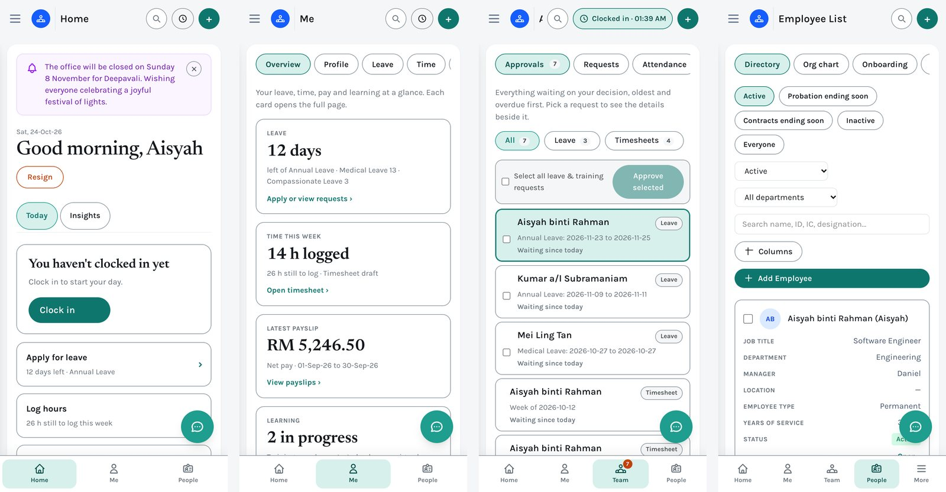
Figure 55. EMS on a phone: Home, Me, Team › Approvals and the Directory.
- Long lists — the Directory, Candidates, requests, payroll runs — show as cards, one per person or request, with the same information labelled.
- A card that opens something ends with “Open ›”.
- Approving works the same: tap a request, read the details, tap Approve or Reject.

18. Quick reference

18.1 Keyboard shortcuts
Keys | What they do
Ctrl+K or ⌘K | Open (or close) search and commands, from anywhere.
↑ ↓ and Enter, Esc | In search: move, open, and close.
J / K | On Team › Approvals: next and previous request.
A / R | On Team › Approvals: approve, or start rejecting, the selected request.
↑ ↓ and Esc | In the + New and More menus: move and close.

18.2 Questions people ask
Question | Answer
I do not see Team. | Team is for managers and HR (Payroll and Compensation Managers see its Approvals tab). If someone names you as an approver, Team appears while a request is waiting for you.
Where is everyone’s leave? I only see mine under Me. | Me is always your own. Team › Requests › Leave requests lists everyone in your scope.
I cannot see Maternity (or Paternity) leave. | Your company limits it to the people it is for, for example women for maternity, and married men with a year’s service for paternity. If you think you qualify, ask HR to check your gender, marital status and start date on your record, or to add an exception (6.1).
Why does a new father not see Paternity leave yet? | Paternity leave may need a minimum length of service. It appears on the day you reach the minimum service.
I cannot approve a request I made. | No one can approve their own request. Another approver, or a Platform Administrator, has to.
The Late or missing figure shows a dash. | No attendance rules exist yet. Add one under Admin › Attendance rules.
My saved views have disappeared. | They are stored in your browser. They will not appear on another computer or after clearing browser data.
I cannot find a page I used before. | Type its old name in search (Ctrl+K), or look it up in the table in 18.3.
How do I change my password or switch role? | Click your name at the bottom of the left menu (on a phone: More).

18.3 Where did it go? Old menu to new
Before (version 1 menu) | Now
Dashboard | Home
Employees › Employee List / Org Chart | People › Directory / Org chart
Workforce › Onboarding / Offboarding | People › Onboarding / Offboarding
Workforce › Resignation | Team › Requests › Resignations
Recruitment (Job Requisitions, Candidate Bank, Interviews, Stationery) | Hiring (Requisitions, Candidates, Interviews, Offers & letters)
L&D › Course Catalog | Learning (HR) or Me › Growth › Course catalog (everyone else)
L&D › My Trainings | Me › Growth › Trainings
Leave › My Leave | Me › Leave (your own only)
Leave › Approvals | Team › Requests › Leave requests
Settings › Holiday Manager | Admin › Company › Leave types & holidays
Timesheet › My Timesheet / My Overtime / Clock In-Out | Me › Time › Timesheet / Overtime / Clock in-out
Timesheet › Approvals | Team › Requests › Timesheets
Timesheet › Projects / Attendance Review | Team › Work › Projects / Attendance
Payroll › Payroll Runs | Pay › Payroll runs
Payroll › My Payslips / My Total Rewards / My Benefits | Me › Pay › Payslips / Total rewards / Benefits & claims
Compensation, Benefits (menus) | Pay › Compensation, Pay › Benefits
Performance › My Goals & Appraisal | Me › Growth › Goals & appraisal
Performance › Team Review / Cycles / Calibration | Team › Performance › Team reviews / Cycles / Calibration
Settings › Users / Roles / Approval Workflows | Admin › People & access
Settings › Notifications | Admin › Announcements & email
Settings › Attendance Settings | Admin › Attendance rules
Settings › Locations / Document Types / Letter Templates / Performance | Admin › Company
Settings › Bulk Upload | People › Import
Settings › Single Sign-On / Claude Access / AI Assistant | Admin › Integrations & AI
Settings › Audit Log | Admin › Audit log
Institutions / System-wide notifications (Platform Admin) | Platform › Companies / System alerts
More › Analytics / Export Builder | Removed (they were placeholders)

18.4 Page by page: who sees what
This is the sitemap in table form: every page, and which roles are offered it. A dot means the role sees the page. HR and managers still need permission for what they do on a page; a role the page lists can still be refused an action the company has restricted.
Area | Page | Employee | Manager | HR Admin | HR Manager | Payroll Mgr
Home | Home | ● | ● | ● | ● | ●
Me | Overview | ● | ● | ● | ● | ●
 | Profile | ● | ● | ● | ● | ●
 | Leave | ● | ● | ● | ● | ●
 | Time › Timesheet | ● | ● | ● | ● | ●
 | Time › Overtime | ● | ● | ● | ● | ●
 | Time › Clock in / out | ● | ● | ● | ● | ●
 | Pay › Payslips | ● | ● | ● | ● | ●
 | Pay › Total rewards | ● | ● | ● | ● | ●
 | Pay › Benefits & claims | ● | ● | ● | ● | ●
 | Growth › Trainings | ● | ● | ● | ● | ●
 | Growth › Goals & appraisal | ● | ● | ● | ● | ●
 | Growth › Course catalog | ● | ● |  |  | ●
Team | Approvals |  | ● | ● | ● | ●
 | Requests › Leave requests |  | ● | ● | ●
 | Requests › Timesheets |  | ● | ● | ●
 | Requests › Resignations |  | ● | ● | ●
 | Work › Attendance |  | ● | ● | ●
 | Work › Projects |  |  |  | ●
 | Performance › Team reviews |  | ● |  | ●
 | Performance › Cycles |  |  |  | ●
 | Performance › Calibration |  |  |  | ●
People | Directory | ● | ● | ● | ● | ●
 | Org chart | ● | ● | ● | ● | ●
 | Onboarding |  |  | ● | ●
 | Offboarding |  |  | ● | ●
 | Import |  |  |  | ●
Hiring | Requisitions |  |  | ● | ●
 | Candidates |  |  | ● | ●
 | Interviews |  |  | ● | ●
 | Offers & letters |  |  | ● | ●
Pay | Payroll › Payroll runs |  |  |  | ● | ●
 | Compensation › Pay grades |  |  |  | ● | ●
 | Compensation › Job levels |  |  |  | ● | ●
 | Compensation › Job roles |  |  |  | ● | ●
 | Compensation › Merit cycles |  |  |  | ● | ●
 | Compensation › Bonus plans |  |  |  | ● | ●
 | Compensation › Commissions |  |  |  | ● | ●
 | Compensation › Equity grants |  |  |  | ● | ●
 | Compensation › Total rewards |  |  |  | ● | ●
 | Compensation › Pay equity |  |  |  | ● | ●
 | Benefits › Plan types |  |  |  | ● | ●
 | Benefits › Enrollment periods |  |  |  | ● | ●
 | Benefits › Life events |  |  |  | ● | ●
 | Benefits › Claims |  |  |  | ● | ●
 | Benefits › Compliance & reporting |  |  |  | ● | ●
Learning | Growth › Course catalog |  |  | ● | ●
Admin | Company › Locations |  |  | ● | ●
 | Company › Leave types & holidays |  |  | ● | ●
 | Company › Document types |  |  | ● | ●
 | Company › Letter templates |  |  | ● | ●
 | Company › Performance settings |  |  |  | ●
 | People & access › Roles & permissions |  |  | ● | ●
 | People & access › Approval workflows |  |  | ● | ●
 | People & access › Users |  |  |  | ●
 | Time › Attendance rules |  |  | ● | ●
 | Communication › Announcements & email |  |  | ● | ●
 | Integrations & AI › Single sign-on |  |  |  | ●
 | Integrations & AI › Claude access |  |  |  | ●
 | Integrations & AI › AI assistant |  |  |  | ●
 | Audit › Audit log |  |  |  | ●

Compensation Managers see the same pages as Payroll Managers. Projects (Team › Work) is also offered to anyone who manages a project, My Interviews (Me › Growth) to anyone picked as an interviewer, and Hiring to anyone granted recruitment access. Course catalog is under Me › Growth for every role except HR, whose copy is in Learning.

18.5 Next steps checklist
- If you offer Maternity or Paternity leave, limit each to the right people (Admin › Company › Leave types & holidays, 6.1).
- Set up approval workflows if the default (manager, then HR Manager) does not match how your company works.
- Add attendance rules so Late or missing and the attendance review work.
- Add document types (work permit, passport) and start tracking expiries.
- Set up onboarding checklist templates before the first new hire.
- Run a payroll cycle once salaries are entered (Pay › Payroll runs).
- Post an announcement to tell everyone what changed (Admin › Announcements & email).

