BUSINESS REQUIREMENTS DOCUMENT
Partnership Pillar Platform
Multi-Pillar Digital Ecosystem Programme
Prepared for: Board of Directors & Executive Sponsors
Prepared by: IT Architecture Office
Version 0.1 – Draft for Review
August 2026

Document Control

Version History
Version | Date | Author | Description
0.1 | Aug 2026 | IT Architecture Office | Initial draft for stakeholder review

Distribution / Approval
Name / Role | Responsibility | Approval Status
Board of Directors | Strategic sponsor | Pending
Executive Sponsor – Partnership Pillar | Business owner | Pending
Head of IT | Technical governance | Pending
Architecture Review Board | Design review | Pending

Related Documents
- Solution Design Document – Partnership Pillar Platform (to follow)
- Technical Design Document – Partnership Pillar Platform (to follow)
- InsureConnect Product Design Documentation – Value-Added Services Pillar (reference only; Partnership Pillar is a distinct, independently designed solution)

Table of Contents

1. Executive Summary
The company is undertaking a multi-year programme to build four independent, API-integrated digital platforms aligned to its four business pillars: Value-Added Services, Partnership, Loyalty, and Store-Front (B2C). This document defines the business requirements for the first platform to be delivered under this programme: the Partnership Pillar Platform.
The Partnership Pillar enables the company to package insurance and non-insurance products and services from multiple third-party vendors into curated eco-systems and bundles, and to distribute those bundles commercially through partner organisations (e.g. higher learning institutions, automotive dealers, healthcare providers, travel agencies) to reach large consumer populations that the company could not economically reach on its own. In return, vendors, the company (as eco-system operator) and partners share in the commercial value generated, on a profit-share basis.
The illustrative example used throughout this document is an “Education” eco-system: a bundle of vendor offerings – transportation, student visa services, accommodation, telco SIM plans, and insurance – subscribed to by a higher learning institution (the partner) and made available to its students (the consumers).
This document defines the business context, scope, actors, domain model, commercial model, and functional requirements for a Minimum Viable Product (MVP) targeted for delivery within 6 months, covering an initial 5 eco-systems, 100 partners and 100,000 consumers in Year 1, growing 50% year-on-year. The MVP excludes actual payment settlement (handled outside the platform via exported reports) and full integration with the other three pillars (defined here at a contract/stub level only, to be completed in later phases).
Key Business Outcome
Enable the company to onboard vendors and package their offerings into eco-systems and bundles, sign up distribution partners, and support consumer-level participation (via the Store-Front pillar), while accurately tracking and reporting the profit-share due to each party – within 6 months, on a cost-effective, cloud-native foundation that can scale as the business grows.

2. Business Context & Objectives

2.1 Background
The company has identified four strategic business pillars, each representing a distinct value proposition to customers and each requiring its own dedicated platform:
Pillar | Value Proposition (Illustrative)
Value-Added Services | Insurance-adjacent services bundled with core insurance products (e.g. InsureConnect – already in delivery as a separate initiative)
Partnership (this document) | Vendor offerings packaged into eco-systems/bundles and distributed via partner organisations to consumers
Loyalty | Points-based rewards and engagement programme for consumers across the group
Store-Front (B2C) | Direct-to-consumer digital storefront, including consumer self-service, registration and purchase journeys

Each pillar will be built as an independently deployable platform, with API-based integration between pillars so that, for example, a consumer enrolled through a Partnership-pillar partner can earn Loyalty points, or be presented in the Store-Front pillar. The Partnership Pillar is the first of these four platforms to be scoped and delivered, and is being designed as a clean, standalone solution – distinct from the Value-Added Services pillar (InsureConnect).

2.2 Business Objectives
- Enable the company to rapidly onboard third-party vendors (insurance and non-insurance) and catalogue their offerings in a consistent, reusable way.
- Enable business/product teams to compose vendor offerings into eco-systems and bundles without engineering effort, supporting new go-to-market combinations (e.g. Education, Automotive, Healthcare, Travel).
- Enable distribution partners to subscribe to bundles and reach their own consumer populations under a clear, contractually-bounded scope (whole-bundle subscription).
- Provide partners with self-service visibility into their subscribed bundles, enrolled consumers and commercial performance via a partner portal.
- Accurately capture transaction-level detail – including policy-level data for insurance offerings – needed to compute profit-share due to vendors, the company and partners.
- Produce periodic, exportable transaction and profit-share reports that can drive settlement processes outside the platform in the MVP, with a clear path to an automated settlement/ledger capability in a later phase.
- Establish integration contracts (API stubs) to the Value-Added Services, Loyalty and Store-Front pillars so that those platforms can be built independently and integrated later with minimal rework.
- Deliver an MVP within 6 months on a cost-effective AWS foundation, with data residency in Malaysia, and a documented path to scale as adoption grows.

2.3 Illustrative Scenario
An “Education” eco-system is created, comprising vendor offerings for transportation, student visa processing, accommodation, telco SIM plans and travel/student insurance. Two bundles are configured from this eco-system: a “Local Student” bundle (accommodation, telco SIM, insurance) and an “International Student” bundle (all five offering types, including visa services). A higher learning institution (the partner) subscribes to the “International Student” bundle. The institution's international students (consumers) are then able to access the bundle's offerings, with each transaction tracked for profit-share purposes between the relevant vendors, the company and the institution.

3. Scope

3.1 In Scope – MVP (Target: 6 Months)
- Vendor onboarding and offering catalogue management (generic offering model – insurance and non-insurance offerings follow the same flow).
- Eco-system management, including creation of eco-systems that may hold onboarded-but-not-yet-packaged vendor offerings.
- Bundle configuration – mix-and-match of vendor offerings within an eco-system, with any vendor able to appear in multiple bundles and multiple eco-systems.
- Partner onboarding and whole-bundle subscription management, including bundle versioning and re-consent workflow when a bundle needs to change.
- Partner-facing self-service portal (view subscribed bundles, enrolled consumer counts, commission/profit-share reports).
- Consumer enrolment API (contract/stub) – actual consumer self-enrolment UX is delivered by the Store-Front pillar in a later phase.
- Transaction capture for offering redemption/purchase, including policy-level data capture for insurance offerings (premium, sum insured, policy number, etc.).
- Periodic (e.g. monthly) profit-share calculation and exportable transaction/profit-share listing reports for vendors, the company and partners.
- Internal admin functions: vendor/eco-system/bundle/partner configuration and management, profit-share rule configuration, report viewing.
- Internal sales functions: read-only visibility of vendor sign-up and partner sign-up activity/KPIs.
- Integration contracts (API/event stubs, comprehensively defined) to the Value-Added Services, Loyalty and Store-Front pillars.
- Cloud-native deployment on a new, greenfield AWS account, with data residency in Malaysia.

3.2 Out of Scope – MVP (Future Phases)
- Actual payment execution / money movement between vendors, the company and partners (settlement is handled outside the platform via exported listing/transaction reports in the MVP).
- A dedicated ledger/settlement engine platform (proposed as a possible independent future platform, consuming file exports from the Partnership Platform).
- Consumer-facing self-enrolment and purchase journeys (owned by the Store-Front / B2C pillar; only the API contract is defined here).
- Full build-out of the Value-Added Services, Loyalty and Store-Front pillar platforms themselves.
- Integration with existing internal systems (e.g. core policy administration system, CRM, ERP, payment gateway) – assumed manual/offline for MVP; automated integration is a later-version consideration.
- Mid-term (in-flight) modification of a bundle's vendor/offering composition; any change requires a new bundle version and partner re-consent.
- Multi-region / multi-country deployment beyond Malaysia data residency.

4. Actors & Personas
The Partnership Pillar Platform serves five categories of actors:
Actor | Description | Primary Interactions
Vendor | A third-party supplier of insurance or non-insurance goods/services (e.g. a telco, an insurer, an accommodation provider). Vendors offer one or more “offerings” that can be included in eco-system bundles. | Onboarded by internal Admin; offerings catalogued and made available for bundling. No direct system access assumed in MVP (managed by Admin on the vendor's behalf).
Eco-System (construct) | A curated collection/compilation of vendors and their offerings around a theme (e.g. Education, Automotive, Healthcare, Travel). Not a human actor, but a first-class business object configured by Admin. | Created and maintained by internal Admin; can exist with vendors onboarded but not yet packaged into bundles.
Partner | An organisation that subscribes to one or more eco-system bundles to make offerings available to its own consumer population (e.g. a higher learning institution, an automotive dealer group, a hospital group, a travel agency). | Onboarded by internal Admin/Sales; subscribes to whole bundles; uses the Partner Portal to view subscriptions, consumers and profit-share reports.
Consumer | An individual who benefits from a partner's bundle subscription (e.g. a student, a car buyer, a patient, a traveller). Enrolled and served primarily via the Store-Front (B2C) pillar. | Enrolment via API (owned by Store-Front pillar in later phase); represented in the Partnership Platform as enrolment/usage records for profit-share purposes.
Internal – Admin | Company staff responsible for platform configuration and operations. | Onboard vendors, eco-systems, bundles and partners; configure profit-share rules; view profit-share and transaction reports.
Internal – Sales | Company sales staff whose KPIs are measured on vendor and partner acquisition. | Read-only visibility into vendor sign-up and partner sign-up activity / KPI dashboards. No configuration access.

5. Domain Model & Key Business Concepts

5.1 Core Entities
Entity | Definition | Key Business Rules
Offering | A single good or service made available by a vendor. May be an insurance product (e.g. travel insurance) or a non-insurance product/service (e.g. SIM plan, accommodation booking). Treated generically by the platform – no differentiated flow by offering type in MVP. | Insurance offerings additionally capture policy-level data (premium, sum insured, policy number) at the point of transaction, for profit-share purposes.
Vendor | A supplier organisation that owns one or more offerings. | A vendor's offerings may appear in any number of bundles, across any number of eco-systems.
Eco-System | A themed collection/compilation of vendors and offerings (e.g. “Education”, “Automotive”, “Healthcare”, “Travel”). | An eco-system can exist with onboarded vendors/offerings but no bundles yet configured.
Bundle | A specific mix-and-match selection of vendor offerings within an eco-system, defined for a period of offering. | Composition is fixed once the bundle is offered/subscribed – no vendor/offering movement mid-term. Any change requires a new bundle version and partner re-consent, since each bundle can represent a distinct contractual obligation.
Partner | An organisation that subscribes to a bundle in order to extend its offerings to its own consumers. | A partner subscribes to a whole bundle only (no partial/cherry-picked offerings); a partner may subscribe to bundles across multiple eco-systems.
Consumer | An individual who is part of a partner's population and accesses the bundle's offerings. | Enrolled and managed primarily by the Store-Front (B2C) pillar; represented in this platform via an enrolment/usage record.
Transaction | A record of a consumer (or partner, on a consumer's behalf) using/redeeming/purchasing an offering under a subscribed bundle. | Basis for periodic profit-share computation; captures policy-level data where the offering is insurance.

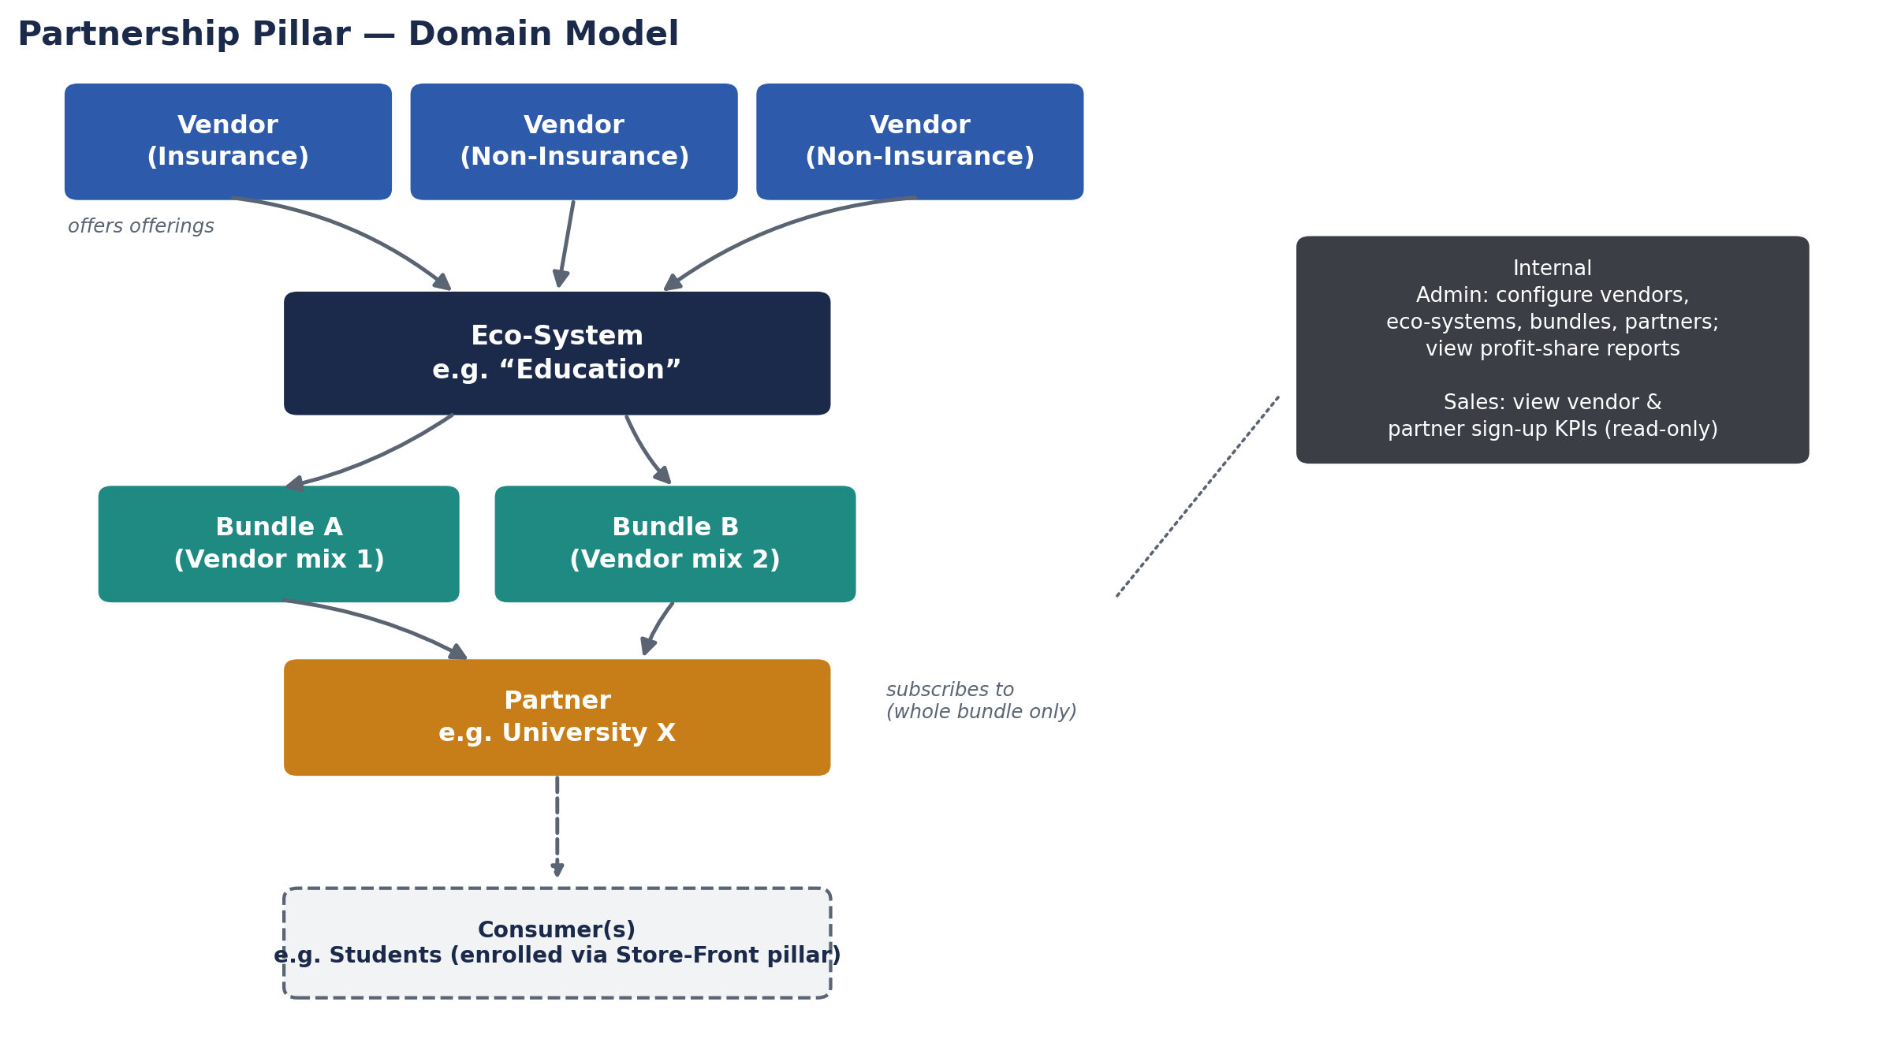
Figure 1 – Partnership Pillar domain model: Vendors offer Offerings, compiled into an Eco-System, packaged into Bundles, subscribed to by a Partner, and extended to Consumers (enrolled via the Store-Front pillar).

5.2 Key Business Rules Summary
- Offerings are generic – insurance and non-insurance offerings follow the same platform flow in MVP.
- An eco-system may hold onboarded vendors/offerings without any bundle yet defined.
- Any vendor/offering may appear in multiple bundles, and across multiple eco-systems.
- A partner subscribes to a whole bundle only; partial/cherry-picked subscriptions are not supported – a new bundle is created instead.
- A bundle's vendor/offering composition is fixed for the period it is offered; any change requires a new bundle version and partner re-consent.
- Consumer self-enrolment is owned by the Store-Front (B2C) pillar; the Partnership Platform exposes an enrolment API contract only in MVP.

6. Commercial Model – Profit Share
The Partnership Pillar's commercial model is a three-way profit share between the Vendor (supplier of the offering), the company as Eco-System Operator, and the Partner (distributor to consumers). Consumers do not participate in the profit-share directly; consumer-level incentives are handled separately through the Loyalty pillar (points), outside the scope of this document.

6.1 MVP Approach: Periodic, Reporting-Only
For MVP, profit-share is computed periodically (e.g. monthly) based on transaction listings/reports, rather than in real time at the point of transaction. No actual money movement occurs within the platform — settlement between parties is handled outside the system using the exported transaction and profit-share reports. The company has identified the possibility of a separate, independent ledger/settlement platform in a later phase, which would consume file exports from the Partnership Platform to automate settlement.
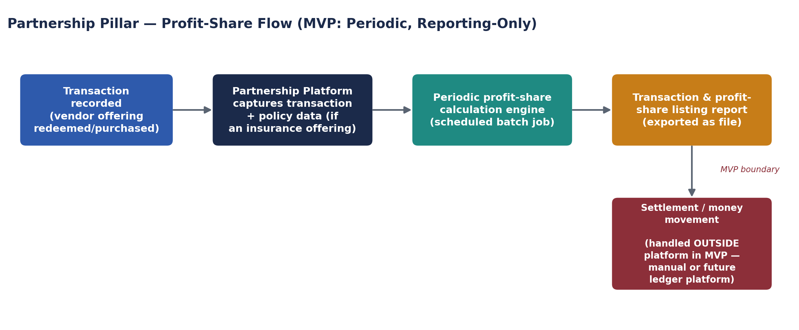
Figure 2 – MVP profit-share flow: transactions are captured, calculated periodically, and exported as reports; settlement/money movement is out of platform scope for MVP.

6.2 Data Captured for Profit-Share
- Transaction value/amount attributable to each offering redeemed or purchased.
- For insurance offerings: policy-level data, including premium, sum insured, and policy number, in addition to the transaction record.
- Vendor, eco-system, bundle and partner references, to enable correct attribution of the three-way split.

6.3 Future Direction
Later phases may introduce real-time or near-real-time profit-share calculation, automated settlement (potentially via a dedicated ledger/settlement platform), and direct payment integration. These are noted here to inform the Solution and Technical Design Documents' scalability considerations, but are explicitly out of scope for MVP.

7. Functional Requirements
Requirements are prioritised using MoSCoW (Must / Should / Could) for MVP delivery.

7.1 Vendor & Offering Management
ID | Requirement | Priority
FR-VEN-01 | Admin shall be able to onboard a new vendor, capturing company details, contact details and commercial terms. | Must
FR-VEN-02 | Admin shall be able to create one or more offerings under a vendor, marking each as insurance or non-insurance (informational tag only; no differentiated flow in MVP). | Must
FR-VEN-03 | Admin shall be able to edit, deactivate or archive a vendor or offering. | Must
FR-VEN-04 | The platform shall allow a vendor/offering to be onboarded without being assigned to any eco-system or bundle. | Must
FR-VEN-05 | Admin shall be able to search and filter vendors/offerings by eco-system, bundle, and offering type. | Should

7.2 Eco-System & Bundle Management
ID | Requirement | Priority
FR-ECO-01 | Admin shall be able to create an eco-system (e.g. Education, Automotive, Healthcare, Travel) and assign vendors/offerings to it. | Must
FR-ECO-02 | An eco-system shall be able to exist with assigned vendors/offerings but no bundles configured. | Must
FR-BUN-01 | Admin shall be able to create a bundle within an eco-system by selecting a mix-and-match set of vendor offerings. | Must
FR-BUN-02 | The same vendor/offering shall be selectable into multiple bundles, within the same or different eco-systems. | Must
FR-BUN-03 | Once a bundle is offered/subscribed, its vendor/offering composition shall be locked; changes require creating a new bundle version. | Must
FR-BUN-04 | The platform shall support a partner re-consent workflow when a new bundle version is created to replace a subscribed bundle. | Must
FR-BUN-05 | Admin shall be able to view all bundles associated with an eco-system, and all eco-systems a given vendor participates in. | Should

7.3 Partner Management & Partner Portal
ID | Requirement | Priority
FR-PTR-01 | Admin shall be able to onboard a partner organisation, capturing profile, contact and commercial terms. | Must
FR-PTR-02 | A partner shall be able to subscribe to one or more whole bundles (no partial/offering-level subscription). | Must
FR-PTR-03 | A partner shall be able to subscribe to bundles across multiple eco-systems. | Must
FR-PTR-04 | Partners shall have access to a self-service portal to view their subscribed bundles and bundle details. | Must
FR-PTR-05 | Partners shall be able to view, via the portal, a summary of their enrolled consumers (counts/aggregates, sourced from the Store-Front pillar via API). | Must
FR-PTR-06 | Partners shall be able to view, via the portal, their periodic transaction and profit-share reports. | Must
FR-PTR-07 | Partners shall receive a notification and be required to re-consent when a subscribed bundle is superseded by a new version. | Must
FR-PTR-08 | Admin shall be able to view a full history of a partner's bundle subscriptions, including past/superseded versions. | Should

7.4 Consumer Enrolment (API Contract)
ID | Requirement | Priority
FR-CON-01 | The platform shall expose an API contract for the Store-Front pillar to register a consumer against a partner's subscribed bundle. | Must
FR-CON-02 | The platform shall expose an API contract to retrieve a consumer's active bundle entitlements, for use by other pillars. | Must
FR-CON-03 | The platform shall maintain a consumer enrolment/usage record sufficient to support profit-share attribution, without owning full consumer profile management. | Must
FR-CON-04 | Full consumer self-enrolment UX/UI is explicitly out of scope for this platform (owned by Store-Front pillar). | N/A – Scope Note

7.5 Profit-Share & Reporting
ID | Requirement | Priority
FR-RPT-01 | The platform shall capture each transaction (offering redemption/purchase) with sufficient detail to support profit-share calculation. | Must
FR-RPT-02 | For insurance offerings, the platform shall additionally capture policy-level data (premium, sum insured, policy number). | Must
FR-RPT-03 | Admin shall be able to configure profit-share split rules per vendor/eco-system/bundle/partner combination. | Must
FR-RPT-04 | The platform shall run a periodic (e.g. monthly) batch process to calculate profit-share due to each vendor, the company and each partner. | Must
FR-RPT-05 | The platform shall generate an exportable transaction listing report and a profit-share summary report, per period. | Must
FR-RPT-06 | Admin shall be able to view historical profit-share reports by period, eco-system, bundle, vendor or partner. | Should
FR-RPT-07 | The platform shall NOT execute any payment or money movement in MVP; settlement is performed outside the platform using exported reports. | N/A – Scope Note

7.6 Internal Admin & Sales Functions
ID | Requirement | Priority
FR-ADM-01 | Admin shall have full configuration access to vendors, offerings, eco-systems, bundles and partners. | Must
FR-ADM-02 | Admin shall be able to onboard partners directly (in addition to any Sales-assisted sign-up). | Must
FR-ADM-03 | Admin shall have view access to all profit-share and transaction reports. | Must
FR-SAL-01 | Sales users shall have read-only visibility into partner sign-up activity, to track their own KPIs (number of partners signed). | Must
FR-SAL-02 | Sales users shall have read-only visibility into vendor sign-up activity, to track their own KPIs (number of vendors signed). | Must
FR-SAL-03 | Sales users shall NOT have access to configuration functions or profit-share commercial detail beyond their own KPI view. | Must

8. Cross-Pillar Integration Requirements
The four pillar platforms are built independently but must integrate. For MVP, the Partnership Pillar will define integration contracts (API/event stubs) as comprehensively as possible; actual point-to-point implementation with the other three platforms will be completed once those platforms exist. Full technical API definitions are detailed in the Technical Design Document – this section defines the business-level integration needs.
Pillar | Direction | Business Purpose | MVP Status
Value-Added Services  (InsureConnect) | Bi-directional (future) | Potential shared vendor/offering catalogue or cross-sell of value-added services within Partnership bundles. | Contract/stub defined; no live integration in MVP.
Loyalty | Outbound (Partnership → Loyalty) | Notify Loyalty pillar of qualifying consumer transactions so loyalty points can be accrued. | Contract/stub defined; no live integration in MVP.
Store-Front (B2C) | Bi-directional | Store-Front owns consumer self-enrolment and purchase UX; Partnership Platform provides bundle/entitlement data and receives enrolment/transaction events. | Contract/stub defined – this is the most-used integration and will be prioritised for early implementation once Store-Front exists.

9. Non-Functional Requirements (Business-Level)
Detailed technical NFRs (performance, availability targets, capacity) are addressed in the Technical Design Document. At the business level, the platform must satisfy:
- Regulatory compliance with BNM guidelines, Financial Services Act 2013 (FSA), Islamic Financial Services Act 2013 (IFSA) and the Personal Data Protection Act 2010 (PDPA), given insurance offerings and personal data are processed.
- Data residency within Malaysia.
- Auditability – full traceability of transactions and profit-share calculations for commercial and regulatory audit purposes.
- Role-based access control reflecting the distinct Admin, Sales and Partner personas defined in Section 4.
- Cost-effectiveness for MVP, with a documented path to scale as eco-system, partner and consumer volumes grow (50% YoY).
- Availability appropriate to a business-hours-plus-buffer operating model for MVP, with a path to higher availability as the platform becomes business-critical.

10. Assumptions & Constraints

10.1 Assumptions
- Integration with existing internal systems (policy admin, CRM, ERP, payment gateway) is not required for MVP; these processes remain manual.
- The Value-Added Services, Loyalty and Store-Front pillar platforms do not yet exist; integration will be validated once they are built.
- Settlement/money movement will be performed manually (or by a future independent ledger platform) using reports exported from this platform.
- A partner subscribes to a whole bundle; any need for a variant is met by creating a new bundle rather than partial subscription.
- Consumer self-enrolment UX is delivered by the Store-Front pillar; this platform only defines and exposes the enrolment API contract.

10.2 Constraints
- MVP delivery target: 6 months from project initiation.
- Greenfield AWS account; no existing landing zone to conform to.
- Data must remain in-region (Malaysia) where possible.
- Initial architecture must be cost-effective, favouring a lean MVP footprint over premature scale investment, while documenting a clear scale-up path.

11. Success Metrics / KPIs
Metric | Year 1 Target | Notes
Eco-systems live | 5 | e.g. Education, Automotive, Healthcare, Travel, +1
Partners onboarded | 100 | 50% YoY growth thereafter
Consumers enrolled | 100,000 | 50% YoY growth thereafter; enrolment via Store-Front pillar API
MVP delivery timeline | 6 months | From project initiation to production go-live
Profit-share report accuracy | 100% reconciliation with transaction listings | Periodic (e.g. monthly) report cycle
Partner portal adoption | ≥ 80% of partners actively using self-service portal within 3 months of onboarding | Reduces manual admin/sales support load

12. High-Level Roadmap

12.1 MVP (Months 1–6)
- Vendor, eco-system and bundle management; partner onboarding and whole-bundle subscription with re-consent workflow.
- Partner self-service portal.
- Consumer enrolment API contract (stub) for Store-Front pillar.
- Transaction capture (incl. insurance policy-level data) and periodic profit-share reporting (no payment execution).
- Internal Admin and Sales functions.
- Integration contracts (stubs) to Value-Added Services, Loyalty and Store-Front pillars.
- Deployment on a cost-effective, greenfield AWS foundation with Malaysia data residency.

12.2 Phase 2 (Indicative – Post-MVP)
- Live integration with Store-Front, Loyalty and Value-Added Services pillars as those platforms come online.
- Automation of settlement, potentially via a dedicated ledger/settlement platform consuming Partnership Platform exports.
- Integration with existing internal systems (policy admin, CRM, ERP, payment gateway).
- Scale-up of underlying architecture in line with volume growth (see Technical Design Document).

13. Key Risks
Risk | Impact | Mitigation (Business-Level)
Other three pillar platforms not ready in time for integration testing | Integration contracts unvalidated at MVP go-live | Define contracts comprehensively up front; use contract/stub testing; prioritise Store-Front integration first
Manual settlement process is error-prone at scale | Reconciliation disputes between vendors/partners | Strong audit trail and report accuracy from MVP; fast-track future ledger/settlement platform
Bundle re-consent friction slows partner changes | Partner dissatisfaction / delayed commercial changes | Streamlined re-consent workflow in Partner Portal; clear communication of contractual rationale
Regulatory scrutiny of insurance-related data handling | Compliance exposure under BNM/FSA/IFSA/PDPA | Legal/compliance review during SDD/TDD; data captured and retained per regulatory guidance

Appendix A: Glossary
Term | Definition
Offering | A good or service supplied by a vendor (insurance or non-insurance).
Vendor | A third-party supplier of one or more offerings.
Eco-System | A themed collection/compilation of vendors and their offerings.
Bundle | A specific mix-and-match combination of vendor offerings within an eco-system.
Partner | An organisation that subscribes to a bundle to extend it to its own consumers.
Consumer | An individual who accesses bundle offerings through a partner.
Profit-Share | The commercial split of value generated by a transaction between vendor, company (eco-system operator) and partner.
MVP | Minimum Viable Product – the initial release scope targeted for delivery within 6 months.
BNM | Bank Negara Malaysia – Malaysia's central bank and financial regulator.
FSA / IFSA | Financial Services Act 2013 / Islamic Financial Services Act 2013.
PDPA | Personal Data Protection Act 2010 (Malaysia).

