SOLUTION DESIGN DOCUMENT
Partnership Pillar Platform
Multi-Pillar Digital Ecosystem Programme
Prepared for: Architecture Review Board & Head of IT
Prepared by: IT Architecture Office
Version 0.1 – Draft for Review
August 2026

Document Control

Version History
Version | Date | Author | Description
0.1 | Aug 2026 | IT Architecture Office | Initial draft for stakeholder review

Distribution / Approval
Name / Role | Responsibility | Approval Status
Architecture Review Board | Design review & sign-off | Pending
Head of IT | Technical governance | Pending
Executive Sponsor – Partnership Pillar | Business owner | Pending

Related Documents
- Business Requirements Document – Partnership Pillar Platform (v0.1, approved baseline for this design)
- Technical Design Document – Partnership Pillar Platform (companion document, detailed technical architecture, network design and volumetrics)

Table of Contents

1. Introduction

1.1 Purpose
This Solution Design Document (SDD) translates the approved Business Requirements Document (BRD) for the Partnership Pillar Platform into a logical solution design: the application architecture, key workflows, data model overview, integration approach, delivery methodology, team/skillset plan and timeline needed to deliver the MVP within 6 months.

1.2 Scope & Relationship to Other Documents
This document assumes the business context, actors, domain model, commercial model and functional requirements defined in the BRD (v0.1) as its baseline and does not repeat them in full. Detailed technical architecture – AWS component selection, network/VPC design, security architecture, volumetrics and infrastructure implementation plan – is covered in the companion Technical Design Document (TDD).

1.3 Audience
This document is intended for the Architecture Review Board and Head of IT to review and approve the proposed solution approach before detailed technical design and build commence.

2. Solution Overview

2.1 Recap – Domain Model
As defined in the BRD: Vendors offer Offerings (insurance or non-insurance, generic flow); Offerings are compiled into Eco-Systems; Eco-Systems are packaged into Bundles (fixed composition once offered); Partners subscribe to whole Bundles; Consumers access Bundle offerings through a Partner, enrolled primarily via the Store-Front pillar. A three-way profit share (Vendor / Company / Partner) is computed periodically from captured transactions.

2.2 Solution Design Principles
- Contract-first integration – define API/event contracts to the other three pillars comprehensively now, even though live calls are deferred, so later integration requires minimal rework.
- Domain-oriented modularity – structure the solution around the bounded contexts identified in the BRD (Vendor/Offering, Eco-System/Bundle, Partner/Subscription, Transaction/Profit-Share) so that services can be split out independently as the platform scales.
- Cost-effective MVP, evolutionary architecture – favour managed AWS services and a lean footprint for MVP; document the scale-up path rather than over-building upfront (see TDD Section “Scalability & Future Evolution”).
- Security and compliance by design – role-based access control for Admin/Sales/Partner personas, data residency in Malaysia, and auditability of transactions and profit-share calculations from day one.
- Configuration over code – eco-system, bundle and profit-share rule configuration is data-driven so business/product teams can compose new go-to-market offerings without engineering changes.

3. Logical Solution Architecture
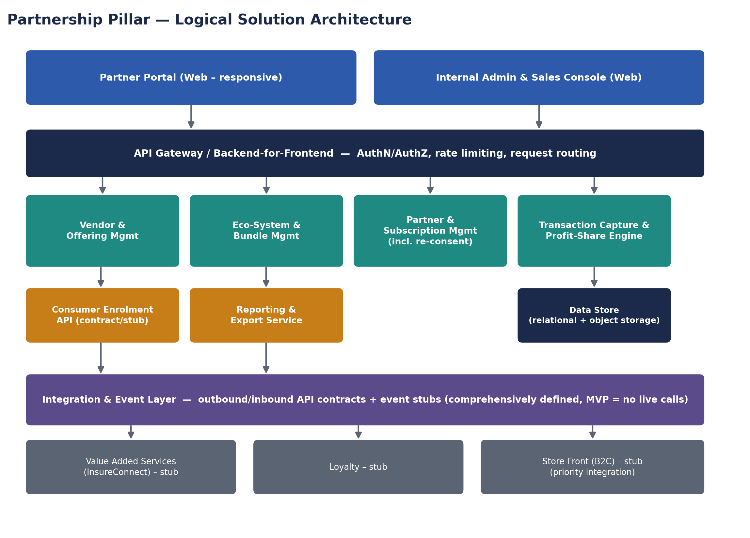
Figure 1 – Partnership Pillar logical solution architecture: channel layer, API/BFF layer, core domain modules, integration & event layer, and data store.

3.1 Component Descriptions
Component | Responsibility
Partner Portal (Web) | Self-service channel for partners to view subscribed bundles, enrolled consumer summaries, and profit-share/transaction reports; handles bundle re-consent.
Internal Admin & Sales Console (Web) | Admin: vendor/eco-system/bundle/partner configuration, profit-share rule setup, report viewing. Sales: read-only vendor and partner sign-up KPI dashboards.
API Gateway / BFF | Single entry point for both web channels; authentication/authorization, rate limiting, and request routing to backend modules.
Vendor & Offering Management | CRUD for vendors and their offerings; supports offerings existing without eco-system/bundle assignment.
Eco-System & Bundle Management | Eco-system creation; bundle composition (mix-and-match of offerings); bundle version locking and re-consent triggering.
Partner & Subscription Management | Partner onboarding; whole-bundle subscription; subscription history; re-consent workflow orchestration.
Transaction Capture & Profit-Share Engine | Captures offering redemption/purchase transactions (incl. insurance policy-level data); periodic batch calculation of profit-share splits.
Consumer Enrolment API (stub) | Contract-defined API for the Store-Front pillar to register consumers against a partner's bundle and query entitlements.
Reporting & Export Service | Generates and exports periodic transaction listing and profit-share summary reports (e.g. CSV/PDF) for Admin and Partner consumption.
Integration & Event Layer | Hosts outbound/inbound API contracts and domain events (stubs) for the Value-Added Services, Loyalty and Store-Front pillars.
Data Store | Persistent storage for core transactional/configuration data plus exported report artefacts.

3.2 Technology Direction (Indicative)
The following technology direction is proposed to guide detailed technical design in the TDD; final selection, sizing and AWS service mapping are confirmed there:
- Containerized backend services, deployed on a managed container platform for operational simplicity at MVP scale.
- A relational database as the system of record, given the structured, relationship-heavy nature of the Vendor/Eco-System/Bundle/Partner/Transaction model.
- A responsive web front-end for both the Partner Portal and the Internal Admin & Sales Console (two applications or a role-gated single application – confirmed in TDD).
- REST APIs for synchronous interactions; an event-based mechanism for asynchronous domain events and cross-pillar integration stubs.
- Scheduled batch processing for the periodic profit-share calculation job.

4. Key Solution Workflows

4.1 Vendor & Bundle Configuration
- Admin onboards a vendor and captures its offering(s), tagging each as insurance or non-insurance (informational only).
- Admin creates or selects an eco-system (e.g. “Education”) and assigns the vendor's offerings to it. The eco-system may hold unpackaged offerings indefinitely.
- Admin creates a bundle within the eco-system by selecting a mix-and-match set of offerings from any of its vendors.
- Once the bundle is published/offered, its composition is locked. Any future change to the vendor/offering mix requires Admin to create a new bundle version.

4.2 Partner Subscription & Re-consent
- Admin (or Sales-assisted sign-up, recorded by Admin) onboards a partner and captures commercial terms.
- Partner (via Admin, or self-service in the Partner Portal) subscribes to a whole bundle. Partial/offering-level subscription is not permitted.
- If Admin creates a new version of a bundle the partner is subscribed to, the platform flags the partner's subscription as pending re-consent and notifies the partner.
- The partner reviews and re-consents to the new bundle version via the Partner Portal; until re-consent, the partner's consumers continue on the prior (locked) bundle version.

4.3 Transaction Capture & Profit-Share (MVP: Periodic, Reporting-Only)
This workflow follows the profit-share flow defined in the BRD (Figure 2): a transaction is captured against a subscribed bundle's offering (with policy-level data for insurance offerings), a scheduled batch job periodically calculates the profit-share split per the configured rules, and a transaction/profit-share report is exported. No payment execution occurs within the platform in MVP.

4.4 Consumer Enrolment (API Contract)
- The Store-Front pillar calls the Consumer Enrolment API to register a consumer against a partner's active bundle subscription.
- The Partnership Platform validates the partner's subscription is active (not pending re-consent / not superseded) before accepting the enrolment.
- The platform maintains an enrolment/usage record for the consumer, sufficient for profit-share attribution, without owning full consumer profile management.
- Other pillars (e.g. Loyalty) may query the consumer's active bundle entitlements via a companion read API (contract defined, live call deferred).

5. Data Model Overview
The following is a conceptual entity list; the full logical/physical data model, storage engine and schema are detailed in the TDD.
Entity | Key Attributes (Indicative) | Relationships
Vendor | Vendor ID, name, contact, commercial terms, status | 1 Vendor → many Offerings
Offering | Offering ID, vendor ref, type tag (insurance/non-insurance), description, status | Many Offerings ↔ many Bundles (via BundleOffering)
EcoSystem | Eco-System ID, name, theme, status | 1 Eco-System → many Bundles; 1 Eco-System ↔ many Offerings (assigned, pre-bundle)
Bundle | Bundle ID, eco-system ref, version, status (draft/active/superseded), effective dates | 1 Bundle → many BundleOffering; 1 Bundle → many PartnerSubscription
BundleOffering | Bundle ref, offering ref | Junction: locks the offering mix per bundle version
Partner | Partner ID, name, contact, commercial terms, onboarded-by (Admin/Sales), status | 1 Partner → many PartnerSubscription
PartnerSubscription | Partner ref, bundle ref, status (active/pending re-consent/superseded), consent timestamp | Links Partner to a specific Bundle version
ConsumerEnrolment | Consumer reference (external ID from Store-Front), partner subscription ref, enrolment date, status | Many ConsumerEnrolment → 1 PartnerSubscription
Transaction | Transaction ID, enrolment ref, offering ref, amount, timestamp, policy data (if insurance): premium, sum insured, policy number | Many Transactions → 1 ConsumerEnrolment
ProfitShareRule | Rule ID, scope (vendor/eco-system/bundle/partner), split percentages | Applied to Transactions during batch calculation
ProfitShareReport | Report ID, period, generated date, export file reference | 1 Report → many summarised Transactions

6. Integration Approach
The Partnership Platform adopts a contract-first integration approach with the other three pillars: API and event contracts are defined and published now, even though live implementation is deferred until the counterpart platforms exist. This lets each pillar team build and test independently against agreed contracts (using mocks/stubs) and reduces integration risk once platforms are ready to connect.
Contract | Type | Direction | Purpose | MVP Status
Consumer Enrolment API | REST (sync) | Store-Front → Partnership | Register a consumer against a partner's active bundle subscription | Contract published; stub/mock implementation for testing
Consumer Entitlement Query API | REST (sync) | Store-Front / Loyalty → Partnership | Retrieve a consumer's active bundle entitlements | Contract published; stub/mock implementation
Transaction Event | Event (async) | Partnership → Loyalty | Notify qualifying transactions for loyalty point accrual | Event schema published; not yet emitted to a live consumer
Vendor/Offering Catalogue Sync (future) | REST or event | Partnership ↔ Value-Added Services | Potential shared catalogue or cross-sell in future phase | Contract sketched at a high level only; not prioritised for MVP

6.1 Versioning & Governance
- All published contracts are versioned (e.g. semantic versioning) so downstream pillar teams can build against a stable interface.
- Breaking changes to a published contract require Architecture Review Board notification, consistent with governance for a shared, multi-pillar programme.

7. Non-Functional Design Considerations
Area | MVP Design Consideration
Availability | Target ~99.5% during business hours plus buffer for MVP; multi-AZ deployment for resilience (detailed in TDD).
Performance | Partner Portal and Admin Console interactions should respond within ~2 seconds for typical operations at MVP volumes; batch profit-share job completes within an overnight window.
Scalability | Domain-oriented module boundaries allow independent scaling or future extraction into separate services as eco-system/partner/consumer volumes grow 50% YoY.
Security | Role-based access control per persona (Admin, Sales, Partner); encrypted data at rest and in transit; least-privilege access to configuration and reporting functions.
Compliance | Data residency in Malaysia; audit trail for transactions and profit-share calculations to support BNM/FSA/IFSA/PDPA obligations.
Auditability | All configuration changes (bundle versions, profit-share rules) and transaction/report generation are logged with actor and timestamp.
Cost-effectiveness | MVP architecture favours managed, consumption-based AWS services over always-on infrastructure sized for future scale (see TDD).

8. Delivery Approach

8.1 Methodology
Delivery follows an Agile Scrum approach with 2-week sprints, a single cross-functional delivery team, and a working increment demoed at the end of each sprint to the business/product stakeholder. Sprint 0 is reserved for environment setup and backlog grooming; the final sprint is reserved for hardening, UAT and go-live readiness.

8.2 Team Structure & Skillsets
Role | Indicative Count | Responsibility
Delivery Lead / Scrum Master | 1 | Sprint planning, delivery tracking, stakeholder communication, risk/impediment management.
Solution / Technical Architect | 1 | Owns solution and technical design, API contracts, architecture governance (this document + TDD).
Backend Engineers | 3–4 | Build domain modules (Vendor/Offering, Eco-System/Bundle, Partner/Subscription, Transaction/Profit-Share), APIs, batch jobs.
Frontend Engineer(s) | 2 | Build Partner Portal and Internal Admin & Sales Console.
Cloud / DevOps Engineer | 1 | AWS account setup, network/security foundation, CI/CD pipeline, environment management (with TDD as blueprint).
QA / Test Engineer | 1–2 | Test strategy, functional/regression testing, UAT support, integration contract test harnesses.
Business Analyst | 1 | Refines BRD requirements into user stories/acceptance criteria; liaises with business/product stakeholders.
Product Owner (Business) | 1 (part-time) | Prioritises backlog, accepts stories, represents partner/vendor/commercial stakeholders.
Indicative core team size: 10–12 people. Actual staffing is subject to organisational resourcing and may combine roles (e.g. Architect also acting as a Backend Engineer) for a team of this scale.

8.3 Indicative Delivery Timeline (6-Month MVP)
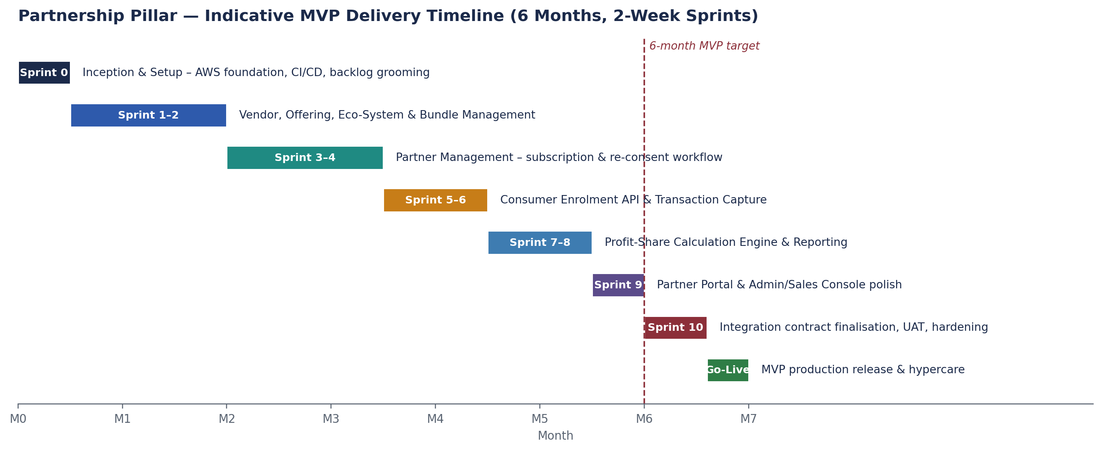
Figure 2 – Indicative MVP delivery timeline across eleven 2-week sprints (Sprint 0–10) plus go-live.
Phase | Approx. Timing | Key Deliverables
Sprint 0 | Weeks 1–2 | AWS account & landing zone, CI/CD pipeline, backlog groomed, team onboarded.
Sprint 1–2 | Weeks 3–6 | Vendor & Offering Mgmt, Eco-System & Bundle Mgmt (incl. version locking).
Sprint 3–4 | Weeks 7–10 | Partner Mgmt, whole-bundle subscription, re-consent workflow.
Sprint 5–6 | Weeks 11–14 | Consumer Enrolment API (contract + stub), Transaction capture (incl. insurance policy data).
Sprint 7–8 | Weeks 15–18 | Profit-share calculation engine (batch), transaction/profit-share reporting & export.
Sprint 9 | Weeks 19–20 | Partner Portal and Admin/Sales Console feature completion and UX polish.
Sprint 10 | Weeks 21–24 | Cross-pillar integration contract finalisation, end-to-end UAT, security/performance hardening.
Go-Live | End of Month 6–7 | MVP production release and hypercare support period.

8.4 Environments
- Development – continuous integration target for feature branches.
- SIT (System Integration Testing) – integrated backend/frontend testing, including contract/stub validation.
- UAT (User Acceptance Testing) – business/product stakeholder sign-off environment, production-like configuration.
- Production – live MVP environment (see TDD for environment-specific AWS account/network detail).

9. Assumptions, Dependencies & Delivery Risks

9.1 Assumptions
- The BRD (v0.1) functional scope is the approved baseline for this design; material scope changes will require an addendum to both BRD and SDD.
- A dedicated delivery team (Section 8.2) can be resourced/onboarded in time for Sprint 0.
- The other three pillar platforms will not be available for live integration testing within the 6-month MVP window; contract-level testing (mocks/stubs) is sufficient for MVP go-live.

9.2 Dependencies
- AWS account provisioning and any required organisational approvals (security review, budget sign-off) must complete before Sprint 0 environment setup.
- Vendor and partner commercial/legal terms (profit-share percentages, contracts) must be available in time to configure profit-share rules ahead of Sprint 7–8.

9.3 Delivery Risks
Risk | Impact | Mitigation
Team ramp-up delay (hiring/resourcing) | Slippage against 6-month target | Begin resourcing in parallel with BRD/SDD approval; prioritise Architect and DevOps roles first
Ambiguity in profit-share rule configuration requirements | Rework in Sprint 7–8 | Validate rule configuration model with business/commercial stakeholders early (Sprint 1–2)
Integration contracts change once other pillars begin design | Rework of contract/stub layer | Version contracts; treat first release as v1 with an explicit change-management process

10. Open Items for Technical Design
- Final AWS service selection, sizing and cost estimate (TDD).
- Detailed physical data model, indexing and partitioning strategy (TDD).
- Detailed API specifications (OpenAPI) for all contract/stub endpoints (TDD appendix or separate API specification artefact).
- Detailed security architecture – IAM roles, secrets management, encryption key management (TDD).
- CI/CD pipeline and Infrastructure-as-Code tooling selection (TDD).

Appendix A: Requirements Traceability (Indicative)
Maps BRD functional requirement groups to the solution components responsible for delivering them. Full requirement-by-requirement traceability will be maintained in the sprint backlog.
BRD Requirement Group | SDD Component(s)
FR-VEN-xx Vendor & Offering Management | Vendor & Offering Management module
FR-ECO-xx / FR-BUN-xx Eco-System & Bundle Management | Eco-System & Bundle Management module
FR-PTR-xx Partner Management & Portal | Partner & Subscription Management module; Partner Portal
FR-CON-xx Consumer Enrolment (API) | Consumer Enrolment API (stub); Integration & Event Layer
FR-RPT-xx Profit-Share & Reporting | Transaction Capture & Profit-Share Engine; Reporting & Export Service
FR-ADM-xx / FR-SAL-xx Internal Admin & Sales | Internal Admin & Sales Console

