TECHNICAL DESIGN DOCUMENT
Partnership Pillar Platform
Multi-Pillar Digital Ecosystem Programme
Prepared for: Delivery / Engineering / Infrastructure / Support Teams & Head of IT
Prepared by: IT Architecture Office
Version 0.1 – Draft for Review
August 2026

Document Control

Version History
Version | Date | Author | Description
0.1 | Aug 2026 | IT Architecture Office | Initial draft for stakeholder review

Distribution / Approval
Name / Role | Responsibility | Approval Status
Head of IT | Technical governance & sign-off | Pending
Engineering Lead | Implementation ownership | Pending
Infrastructure / Cloud Team | AWS build & operations | Pending
Support / Operations Team | Post-go-live operations readiness | Pending

Related Documents
- Business Requirements Document – Partnership Pillar Platform (v0.1)
- Solution Design Document – Partnership Pillar Platform (v0.1) – logical architecture, workflows and delivery plan this TDD implements

Table of Contents

1. Introduction

1.1 Purpose
This Technical Design Document (TDD) defines the detailed technical architecture, AWS network design, technical components, data architecture, security architecture, volumetrics/capacity planning, deployment approach and implementation plan for the Partnership Pillar Platform MVP. It implements the logical solution design set out in the Solution Design Document (SDD).

1.2 Scope
This document covers the technical build for MVP: a greenfield AWS account, cost-effective architecture sized for Year 1 volumes (5 eco-systems, 100 partners, 100,000 consumers, 50% YoY growth), with data residency in Malaysia. Where MVP choices favour cost/simplicity over scale, the future evolution path is documented explicitly (Section 12) rather than built upfront.

1.3 References
- Business Requirements Document – Partnership Pillar Platform (v0.1)
- Solution Design Document – Partnership Pillar Platform (v0.1)

2. Technical Architecture Overview

2.1 Architecture Style & Rationale
The MVP is built as a set of small, independently deployable services on AWS Fargate, one per bounded context identified in the SDD (Vendor & Offering, Eco-System & Bundle, Partner & Subscription, Transaction & Profit-Share). This is deliberately positioned between a single monolith and a full microservices platform:
- Each service is right-sized (minimal vCPU/memory, 1–2 tasks with modest auto-scaling) so total MVP compute cost remains low – see Section 8.4 for an indicative cost estimate.
- Clean module/service boundaries, aligned to the domain model, mean each service can be scaled, redeployed or re-platformed (e.g. to Amazon EKS) independently as volumes grow, without a disruptive re-architecture.
- If budget constraints require an even leaner MVP footprint, these four services can be deployed as a single Fargate service running a modularised codebase (a “modular monolith”) with the same internal module boundaries – a deployment-only decision that does not change the design in this document.
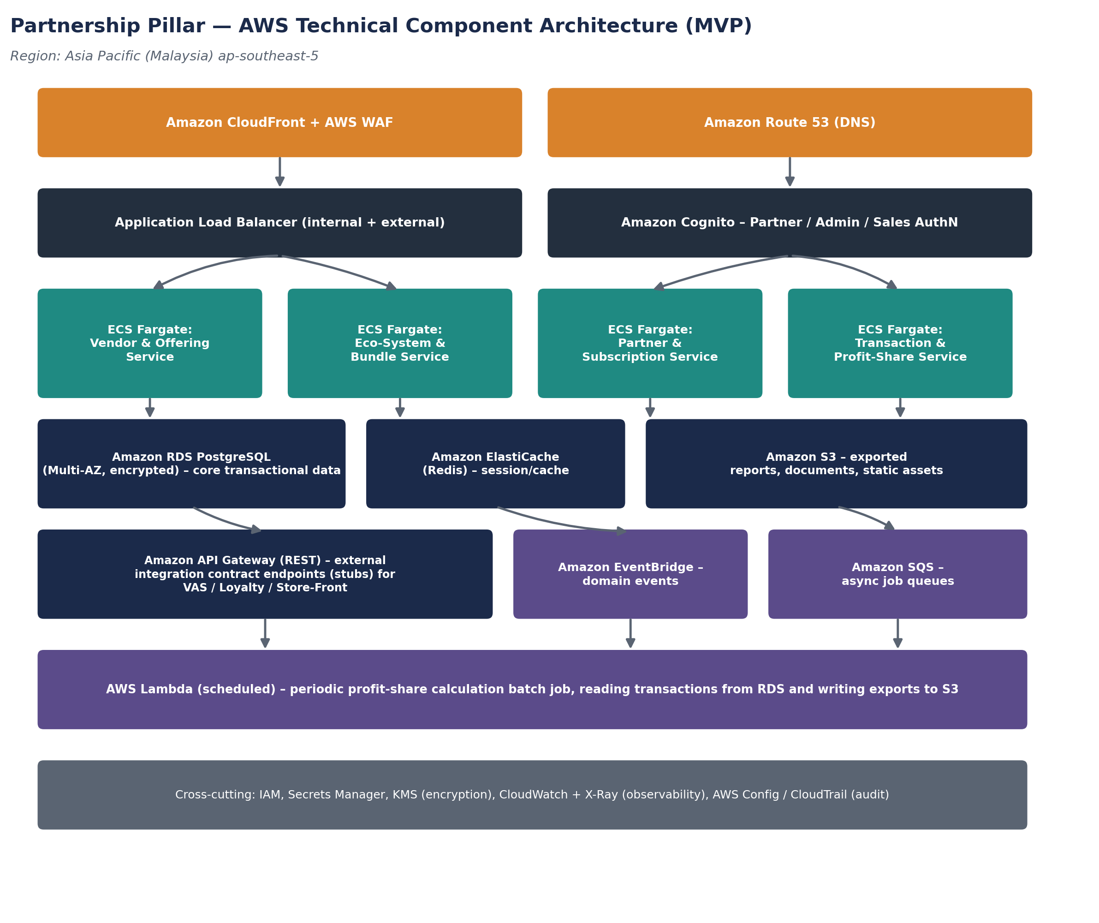
Figure 1 – AWS technical component architecture (MVP): edge/CDN, compute, data, integration/async layers, and cross-cutting concerns.

2.2 Technology Stack Summary
Layer | Technology | Rationale
Frontend (Partner Portal & Admin/Sales Console) | React (or similar modern SPA framework), served via CloudFront + S3 static hosting | Fast, low-cost static hosting; clean separation from backend APIs
API layer | REST APIs (JSON) behind Amazon API Gateway and/or Application Load Balancer | Industry-standard, well-supported tooling, straightforward contract publishing for integration stubs
Backend services | Containerized services (Node.js or Java/Spring Boot – confirmed at build start based on team skillset) on Amazon ECS Fargate | Serverless container operations (no EC2 patching); pay-for-what-you-use; fits small MVP team
Relational data store | Amazon RDS for PostgreSQL | Mature, well-understood relational engine suited to the structured Vendor/Bundle/Partner/Transaction model
Caching | Amazon ElastiCache for Redis | Session state and read-heavy lookup caching (e.g. active bundle entitlements)
Object storage | Amazon S3 | Exported reports, static assets, low-cost durable storage
Async messaging / events | Amazon EventBridge, Amazon SQS | Domain events and integration stubs to other pillars; decoupled async processing
Scheduled batch | AWS Lambda (EventBridge Scheduler trigger) | Low-cost, serverless periodic profit-share calculation job
AuthN/AuthZ | Amazon Cognito | Managed identity for Partner / Admin / Sales personas; role-based access control
Edge / delivery | Amazon CloudFront, AWS WAF, Amazon Route 53, AWS Certificate Manager | TLS termination, DDoS/web-attack protection, DNS management

3. AWS Network Architecture
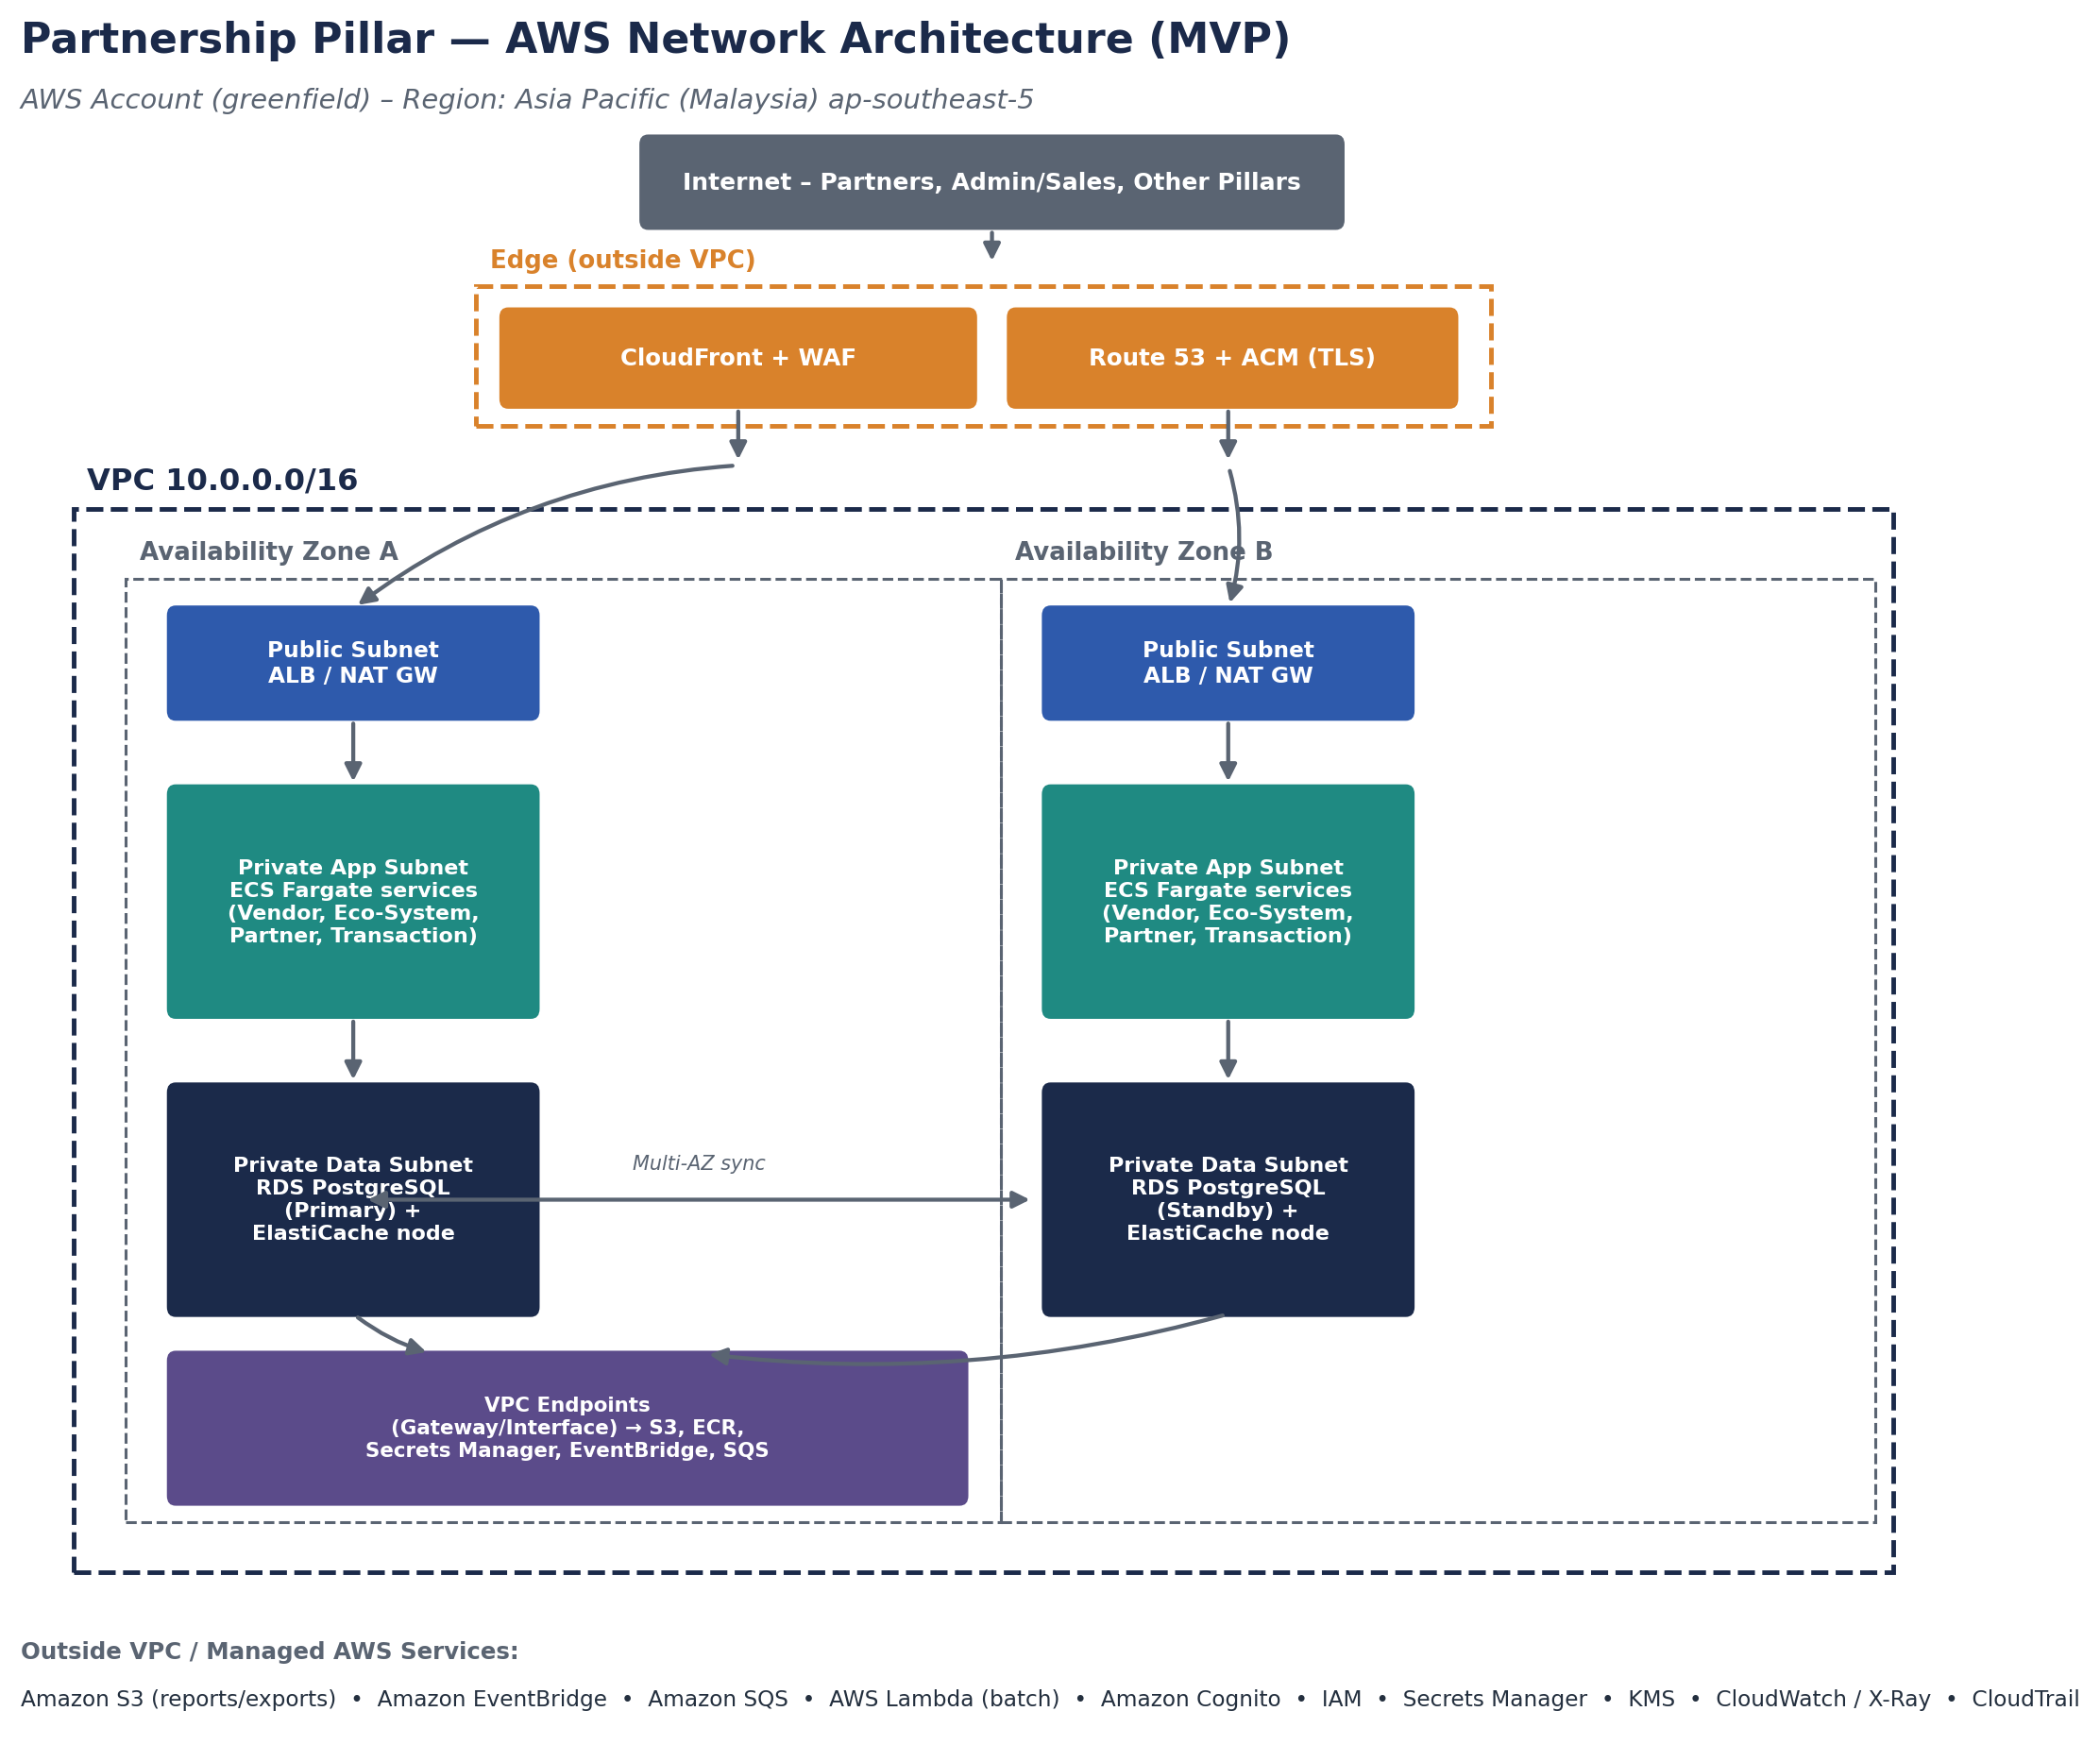
Figure 2 – AWS network architecture (MVP): 2-AZ VPC with public, private-app and private-data subnet tiers.

3.1 VPC & Subnet Design
Subnet Tier | Indicative CIDR (per AZ) | Purpose | Internet Access
Public | 10.0.0.0/24, 10.0.1.0/24 | ALB, NAT Gateway | Direct (via Internet Gateway)
Private – Application | 10.0.10.0/24, 10.0.11.0/24 | ECS Fargate tasks | Outbound only, via NAT Gateway
Private – Data | 10.0.20.0/24, 10.0.21.0/24 | RDS PostgreSQL, ElastiCache | None (VPC-internal + VPC endpoints only)
The VPC spans two Availability Zones within ap-southeast-5 for MVP resilience. A third AZ can be added ahead of scale-up (Section 12) without redesign, since the Malaysia region provides three AZs.

3.2 Security Groups & Network Controls
Control | Description
ALB Security Group | Allows inbound HTTPS (443) from CloudFront/WAF only; outbound to application security group.
Application Security Group (ECS tasks) | Allows inbound only from the ALB security group on the service port; outbound to data security group and VPC endpoints.
Data Security Group (RDS, ElastiCache) | Allows inbound only from the application security group on the DB/cache port; no direct internet exposure.
AWS WAF | Managed rule sets for common web exploits (SQLi, XSS) and rate-based rules in front of CloudFront.
VPC Endpoints | Gateway endpoint for S3; interface endpoints for Secrets Manager, EventBridge, SQS, ECR – keeps AWS-service traffic off the public internet.
Network ACLs | Default-deny baseline at the subnet level as defense-in-depth, supplementing security groups.

3.3 DNS & Certificate Management
- Amazon Route 53 hosts the public DNS zone for the Partnership Pillar's domain/subdomain.
- AWS Certificate Manager issues and auto-renews TLS certificates used at CloudFront and the ALB.

4. Technical Components Detail

4.1 Compute – Amazon ECS on Fargate
Setting | MVP Configuration
Cluster | Single ECS cluster for the Partnership Pillar platform
Services | 4 services: Vendor & Offering, Eco-System & Bundle, Partner & Subscription, Transaction & Profit-Share
Task size (each) | 0.5 vCPU / 1 GB memory (indicative starting point; tuned after load testing)
Desired task count | 1–2 tasks per service (Multi-AZ placement) for MVP
Auto-scaling | Target-tracking on CPU/memory utilisation, min 1, max 3–4 tasks per service for MVP
Deployment | Rolling deployment via ECS service update, driven by CI/CD pipeline (Section 9)

4.2 Data – Amazon RDS for PostgreSQL & ElastiCache
Setting | MVP Configuration
Engine | PostgreSQL (latest supported stable major version at build time)
Instance class | db.t4g.medium (burstable, cost-effective) as MVP starting point
Multi-AZ | Enabled for production (standby replica in second AZ) per Figure 2
Storage | General Purpose SSD (gp3), auto-scaling storage enabled, starting at 50–100 GB
Backups | Automated daily snapshots, 7–14 day retention for MVP (see Section 6.3 / 11)
Cache | ElastiCache for Redis, single small node (cache.t4g.micro/small) for session and entitlement-lookup caching

4.3 Storage – Amazon S3
- Reports bucket: exported transaction listing and profit-share reports; versioning enabled; lifecycle policy to transition older exports to lower-cost storage classes.
- Static assets bucket: frontend build artefacts served via CloudFront.
- All buckets: default encryption (SSE-KMS), block public access enabled, access via least-privilege IAM roles / VPC endpoint only.

4.4 Integration & Messaging
- Amazon API Gateway exposes the published Consumer Enrolment API and Consumer Entitlement Query API contracts (see SDD Section 6) for the Store-Front pillar, secured via API keys/OAuth2 client credentials.
- Amazon EventBridge carries domain events (e.g. TransactionRecorded) for the Loyalty pillar integration stub, on a dedicated event bus for the Partnership Pillar.
- Amazon SQS decouples slower asynchronous processing (e.g. report generation jobs) from user-facing request paths.
- AWS Lambda, triggered on a schedule via EventBridge Scheduler, runs the periodic profit-share calculation batch job, reading transactions from RDS and writing report exports to S3.

4.5 Identity & Access – Amazon Cognito
- Separate Cognito user pools (or pool groups) for Partner users and Internal (Admin/Sales) users, reflecting the BRD's persona-based access model.
- Role-based claims in the issued JWT drive authorization decisions at the API Gateway / application layer (Admin: full config access; Sales: read-only KPI; Partner: own-organisation data only).

4.6 Edge & Delivery
- Amazon CloudFront fronts both the static frontend assets and API traffic where applicable, with AWS WAF attached for managed protection rules.
- Amazon Route 53 and AWS Certificate Manager handle DNS and TLS as described in Section 3.3.

5. Data Architecture
The logical entities (Vendor, Offering, EcoSystem, Bundle, BundleOffering, Partner, PartnerSubscription, ConsumerEnrolment, Transaction, ProfitShareRule, ProfitShareReport) are defined in the SDD (Section 5). Technically, these map to a normalised PostgreSQL schema, with the BundleOffering and PartnerSubscription tables enforcing the BRD's core business rules (locked bundle composition per version; whole-bundle-only subscription) via foreign keys and application-level validation.

5.1 Encryption & Key Management
- Encryption at rest for RDS, ElastiCache (where supported) and S3 via AWS KMS customer-managed keys.
- Encryption in transit via TLS 1.2+ for all client-facing and internal service-to-service traffic.
- Secrets (database credentials, API keys) stored in AWS Secrets Manager, never in application code or environment files, with automatic rotation enabled where supported.

5.2 Backup & Retention
- RDS automated backups: daily snapshot, 7–14 day retention for MVP, extendable as compliance requirements are confirmed.
- S3 report exports: versioned, retained per a data retention policy to be confirmed with compliance/legal (informed by BNM/PDPA requirements).
- Point-in-time recovery enabled on RDS for operational recovery within the backup retention window.

6. Security Architecture

6.1 IAM & Access Control
- Least-privilege IAM roles per service (ECS task roles, Lambda execution role), scoped to only the AWS resources each component needs.
- No long-lived AWS credentials embedded in application code; ECS tasks and Lambda assume roles at runtime.
- Human access to the AWS account via federated SSO (e.g. IAM Identity Center) with MFA enforced, rather than individual IAM users, where organisationally available; otherwise individual IAM users with mandatory MFA as an MVP interim measure.

6.2 Network Security
As detailed in Section 3.2: layered security groups, private subnets for application and data tiers, WAF at the edge, and VPC endpoints to avoid unnecessary public internet exposure for AWS-service traffic.

6.3 Application Security
- Secure coding practices aligned to OWASP Top 10; dependency vulnerability scanning in the CI/CD pipeline (Section 9).
- Input validation and authorization checks enforced at the API layer for every request, including internal Admin/Sales console calls.
- Audit logging of configuration changes (bundle versions, profit-share rules) and report generation events, per BRD auditability requirement.

6.4 Compliance Mapping
Requirement | Technical Control
Data residency (Malaysia) | All compute, storage and database resources deployed in AWS Asia Pacific (Malaysia) ap-southeast-5
PDPA 2010 | Encryption at rest/in transit; least-privilege access; audit logging; data retention policy to be finalised with compliance/legal
BNM / FSA / IFSA (insurance-related data) | Policy-level data (premium, sum insured, policy number) captured and stored with the same controls as other transactional data; access restricted to Admin role and relevant reporting functions

7. Integration & API Design
This section adds technical detail to the contracts introduced in the SDD (Section 6).
Contract | Protocol / Format | AuthN | Versioning
Consumer Enrolment API | REST / JSON over HTTPS, via API Gateway | OAuth2 client credentials (Cognito) or API key | URI-versioned, e.g. /v1/enrolments
Consumer Entitlement Query API | REST / JSON over HTTPS, via API Gateway | OAuth2 client credentials (Cognito) or API key | URI-versioned, e.g. /v1/entitlements
Transaction Event | Amazon EventBridge event, JSON payload, dedicated event bus | IAM resource policy on the event bus | Event schema versioned in the payload (schemaVersion field)

Full OpenAPI specifications for each REST contract and JSON Schema definitions for each event are maintained as a separate, version-controlled API specification artefact alongside the codebase, referenced from this document rather than reproduced in full here.

7.1 Contract Testing Approach
- Consumer-driven contract tests (e.g. Pact-style) or OpenAPI-schema-validation tests run in CI to catch breaking changes to published contracts before merge.
- A mock/stub server implementing each contract is provided so other pillar teams (once they exist) can integrate against a realistic test double ahead of live connectivity.

8. Volume & Capacity Considerations

8.1 Year 1 Volume Assumptions (from BRD)
Metric | Year 1 Target | Year 2 (Indicative, +50% YoY)
Eco-systems | 5 | 7–8
Partners | 100 | 150
Consumers enrolled | 100,000 | 150,000

8.2 Estimated Transaction & Request Volumes (Indicative)
Assuming each consumer generates on average 1–2 transactions per month across their subscribed bundle's offerings, Year 1 volume is estimated at roughly 100,000–200,000 transactions per month (peak), with substantially lighter administrative/configuration traffic from the ~100 partners and internal Admin/Sales users. These are planning assumptions to validate with the business during Sprint 1–2 and to revisit after initial load testing; they are not firm SLAs.

8.3 Sizing Recommendations
- ECS Fargate: 1–2 tasks per service at MVP launch, auto-scaling to 3–4 tasks under peak load (e.g. month-end enrolment spikes), based on the volumes in Section 8.2.
- RDS PostgreSQL: db.t4g.medium is expected to comfortably handle Year 1 transaction volumes; monitor and resize (or migrate to Aurora – Section 12) as Year 2 volumes approach.
- S3: negligible cost driver at MVP scale; storage grows predictably with report export frequency and retention policy.

8.4 Indicative Monthly Cost Estimate (MVP, Order-of-Magnitude)
AWS Service Group | Indicative Monthly Cost (USD) | Notes
ECS Fargate (4 services, 1–2 tasks each) | $60 – 120 | Right-sized tasks; scales with auto-scaling activity
RDS PostgreSQL (Multi-AZ, db.t4g.medium) | $140 – 180 | Includes storage and automated backups
ElastiCache (small node) | $25 – 40
ALB, NAT Gateway, data transfer | $60 – 100 | NAT Gateway data processing is often the largest “hidden” cost – monitor closely
CloudFront + WAF | $20 – 40 | Traffic-dependent
S3, Secrets Manager, KMS, misc. | $15 – 30
API Gateway, EventBridge, SQS, Lambda | $10 – 25 | Low at MVP transaction volumes
CloudWatch, X-Ray, CloudTrail | $15 – 30 | Observability and audit logging
Estimated Total | ~$345 – 565 / month | Excludes one-off setup effort and any AWS support plan; refine after load testing

9. Deployment & DevOps

9.1 CI/CD Pipeline
- Source control: Git repository per service (or a mono-repo with per-module build paths), with mandatory pull-request review.
- Build & test: automated build, unit tests, dependency vulnerability scan, and contract tests (Section 7.1) on every pull request.
- Container image build & push to Amazon ECR on merge to the main branch.
- Deploy: automated deployment to Dev on every merge; promotion to SIT/UAT/Production via approval gates.

9.2 Infrastructure as Code
All AWS infrastructure (VPC, subnets, security groups, ECS, RDS, S3, IAM roles, etc.) is defined and version-controlled as Infrastructure as Code (e.g. Terraform or AWS CDK – tool selection confirmed with the Cloud/DevOps engineer at Sprint 0), enabling repeatable environment provisioning and peer-reviewed infrastructure changes.

9.3 Environments
Environment | Purpose | Notes
Dev | Continuous integration target for feature branches | Shared, lower-cost sizing
SIT | Integrated backend/frontend and contract/stub testing | Mirrors production topology at smaller scale
UAT | Business/product stakeholder sign-off | Production-like configuration and data shape
Production | Live MVP environment | Full Multi-AZ configuration per Section 3–4
For MVP, all environments are provisioned within the single greenfield AWS account using separate VPCs/namespaces for isolation. Migrating to a multi-account structure (one AWS account per environment via AWS Organizations) is recommended as a near-term post-MVP hardening step – see Section 12.

10. Monitoring, Logging & Observability
- Amazon CloudWatch: metrics and alarms for ECS service health, RDS performance, API Gateway error rates/latency, and Lambda batch job success/failure.
- AWS X-Ray: distributed tracing across services to diagnose latency and error root causes.
- Centralised logging: application and infrastructure logs shipped to CloudWatch Logs (with a future option to route to a dedicated log analytics tool as volume grows).
- Alerting: CloudWatch Alarms notify the Support/Operations team (e.g. via SNS to email/chat) on critical thresholds (service unhealthy, batch job failure, elevated error rates).
- AWS CloudTrail: account-level API activity logging for security and compliance audit.

11. Disaster Recovery & High Availability

11.1 Indicative Targets (MVP)
Metric | MVP Target | Notes
RTO (Recovery Time Objective) | ≤ 4 hours | Multi-AZ failover for compute/data; manual runbook-driven recovery for edge cases
RPO (Recovery Point Objective) | ≤ 24 hours (targeting nearer real-time via Multi-AZ sync) | RDS Multi-AZ provides near-zero data loss for AZ failure; cross-region DR is a future consideration

11.2 High Availability Design
- Compute (ECS Fargate) and data (RDS Multi-AZ, ElastiCache) span two Availability Zones, so a single-AZ failure does not cause an outage.
- ALB health checks automatically remove unhealthy ECS tasks from rotation; ECS automatically replaces failed tasks.

11.3 Backup & Restore
As detailed in Section 5.2: automated daily RDS backups with point-in-time recovery, and versioned S3 storage for report exports. Restore procedures are documented in an operational runbook maintained by the Infrastructure/Support team ahead of go-live.

11.4 Future Direction
Cross-region disaster recovery (e.g. a warm standby in a second AWS region) is not included in MVP given cost-effectiveness goals and the availability of three AZs within the Malaysia region; it is noted as a future consideration once the platform is business-critical (Section 12).

12. Scalability & Future Evolution
The MVP architecture intentionally favours cost-effectiveness and delivery speed within the 6-month window. The table and figure below summarise the components most likely to need evolution as eco-system, partner and consumer volumes grow (50% YoY), so that Delivery, Engineering and Infrastructure teams can plan ahead rather than be surprised by scale.
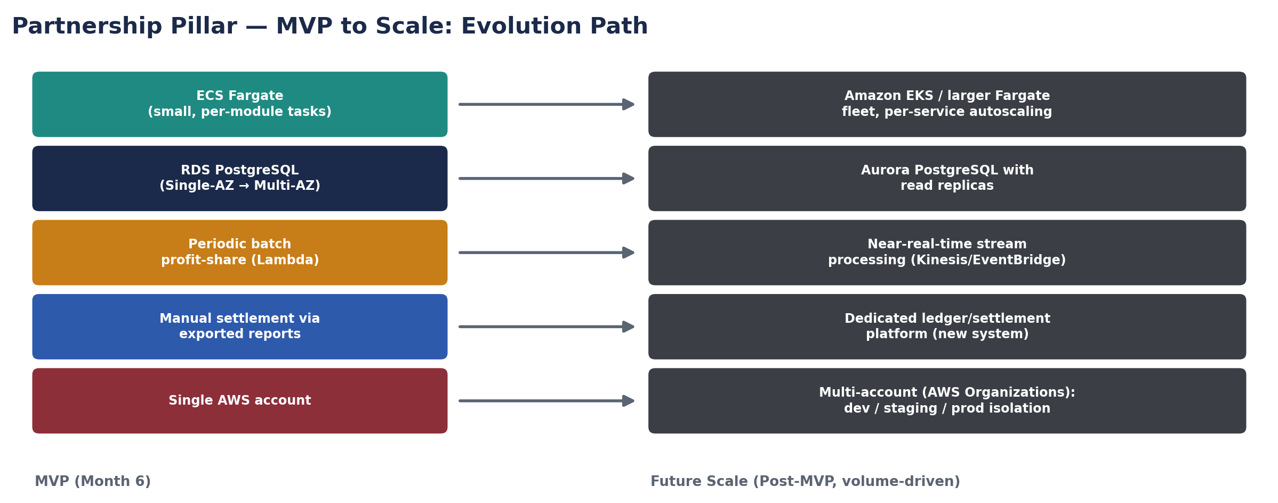
Figure 3 – Indicative MVP-to-scale evolution path for the components most sensitive to growth.
MVP Component | Trigger to Evolve | Future Direction
ECS Fargate (small, per-module tasks) | Sustained high CPU/memory utilisation or need for independent release cadence per module | Increase task counts/auto-scaling ceilings; consider Amazon EKS for finer-grained orchestration and service mesh capabilities
RDS PostgreSQL (Single instance, Multi-AZ) | Read-heavy reporting load contending with transactional writes; approaching instance class ceiling | Add read replicas; migrate to Aurora PostgreSQL for better scaling and faster failover
Periodic batch profit-share (Lambda, scheduled) | Business need for more frequent/real-time profit-share visibility | Move to near-real-time event/stream processing (e.g. Kinesis or EventBridge Pipes) alongside or instead of the batch job
Manual settlement via exported reports | Transaction/partner volumes make manual reconciliation error-prone or slow | Stand up the previously-flagged independent ledger/settlement platform, consuming Partnership Platform exports (or a direct integration)
Single AWS account (env-isolated by VPC) | Need for stronger environment isolation, blast-radius reduction, or separate billing/compliance boundaries | Migrate to a multi-account structure under AWS Organizations (separate accounts per environment)
Two-AZ deployment | Platform becomes business-critical; tighter RTO/RPO required | Extend to all three Malaysia-region AZs; evaluate cross-region DR
Cognito-based auth | Need for enterprise SSO federation with other internal systems (post-MVP internal system integration) | Federate Cognito with internal identity provider (SAML/OIDC) once internal systems integration begins

13. Implementation Timeline & Skillset
This section complements the SDD's sprint-by-sprint delivery plan (SDD Section 8.3) with the specific infrastructure/engineering tasks and skillsets needed on the technical side.
Phase | Key Technical/Infra Tasks | Skillset Needed
Sprint 0 | AWS account setup, IaC baseline (VPC/subnets/security groups), CI/CD pipeline skeleton, ECR repos, Cognito user pools | Cloud/DevOps Engineer, Solution/Technical Architect
Sprint 1–2 | Stand up Vendor/Offering and Eco-System/Bundle services on ECS Fargate; RDS schema baseline | Backend Engineers, Cloud/DevOps Engineer
Sprint 3–4 | Partner/Subscription service; Cognito role-based access wiring; Partner Portal auth integration | Backend Engineers, Frontend Engineer
Sprint 5–6 | Consumer Enrolment API + API Gateway setup; Transaction capture service; EventBridge event schema | Backend Engineers, Cloud/DevOps Engineer
Sprint 7–8 | Lambda batch profit-share job; S3 report export pipeline; CloudWatch dashboards/alarms | Backend Engineers, Cloud/DevOps Engineer
Sprint 9 | Frontend build/deploy pipeline via CloudFront/S3; UX integration across Partner Portal & Admin Console | Frontend Engineer(s)
Sprint 10 | Security hardening (WAF rules, IAM review), load testing, contract test suite finalisation, DR runbook | Cloud/DevOps Engineer, QA/Test Engineer, Solution/Technical Architect
Go-Live | Production cutover, hypercare monitoring, operational handover to Support team | Full delivery team + Support/Operations Team

14. Technical Risks
Risk | Impact | Mitigation
NAT Gateway / data transfer costs exceed estimate | Budget overrun on infrastructure cost | Monitor via Cost Explorer from Sprint 0; consider VPC endpoint expansion to reduce NAT traffic
Underestimated transaction volume at go-live | Performance degradation, auto-scaling limits reached | Load test against Section 8.2 assumptions before go-live; conservative auto-scaling ceilings with headroom
Single-region deployment | Regional AWS outage impacts availability | Accepted risk for MVP given cost-effectiveness goal and 3-AZ regional resilience; documented as a future DR consideration (Section 11.4)
IaC/CI-CD tooling learning curve for the team | Sprint 0 delays | Select tooling the Cloud/DevOps Engineer is already proficient with; keep initial IaC scope minimal and iterate

Appendix A: AWS Service Summary
Category | AWS Services Used (MVP)
Compute | Amazon ECS (Fargate), AWS Lambda
Data | Amazon RDS (PostgreSQL), Amazon ElastiCache (Redis)
Storage | Amazon S3
Networking & Edge | Amazon VPC, Application Load Balancer, Amazon CloudFront, AWS WAF, Amazon Route 53, AWS Certificate Manager
Integration & Messaging | Amazon API Gateway, Amazon EventBridge, Amazon SQS
Identity | Amazon Cognito, AWS IAM
Security | AWS KMS, AWS Secrets Manager
Observability & Audit | Amazon CloudWatch, AWS X-Ray, AWS CloudTrail, AWS Config
DevOps | Amazon ECR, Infrastructure as Code tooling (Terraform / AWS CDK)

Appendix B: Glossary
Term | Definition
ap-southeast-5 | AWS Region code for Asia Pacific (Malaysia)
ECS / Fargate | Amazon Elastic Container Service / its serverless compute engine for containers
RDS | Amazon Relational Database Service
VPC | Virtual Private Cloud – an isolated AWS network
WAF | Web Application Firewall
RTO / RPO | Recovery Time Objective / Recovery Point Objective
IaC | Infrastructure as Code
KMS | AWS Key Management Service

