





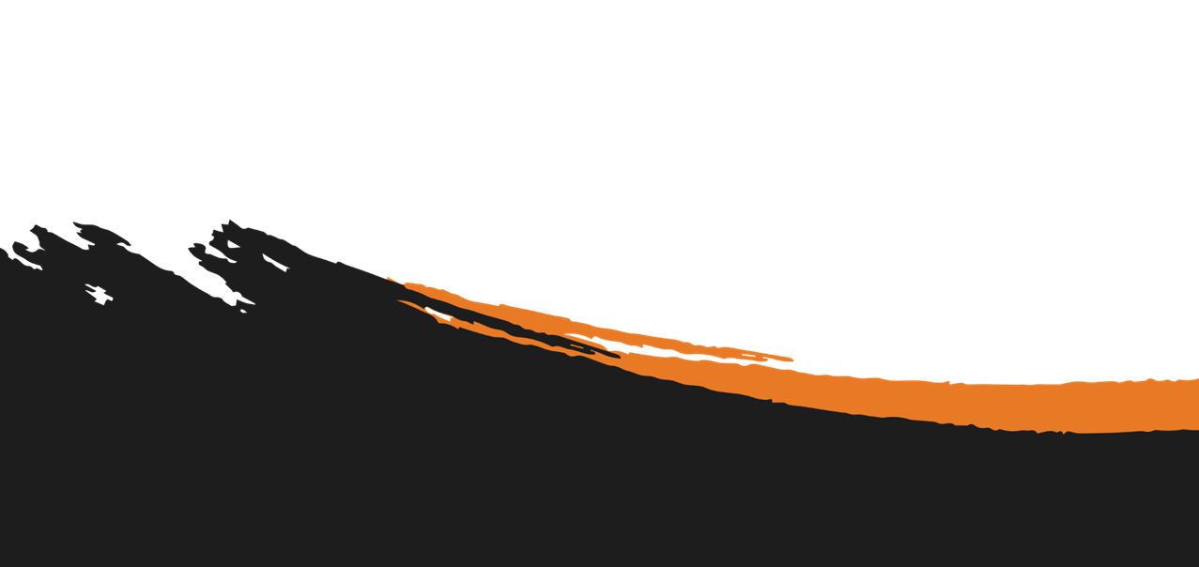
TITLE:
How to Protect Your Business Social Media Accounts From Hackers

ORIGINALLY RELEASED:
November 2026 Marketing Pack

BLOG POST

COPYRIGHT STUFF
Who the heck wrote this thing?
Copyright © - The Tech Tribe
All rights reserved.

PUBLISHER
Who’s managing and distributing this thing?
The Tech Tribe
PO Box 150
Pyrmont NSW 2009
AUSTRALIA

DISCLAIMER
We care, but you’re responsible
While all attempts have been made to verify information provided in this publication, neither the author nor the publisher assumes any responsibility for errors, omissions or contradictory interpretation of the subject matter herein. This publication is designed to provide accurate and authoritative information with regards to the subject matter covered. However, it is delivered with the understanding that the author and the publisher are not engaged in rendering legal, accounting, or other professional advice. If professional advice or other expert assistance is required, the services of a competent professional should be sought.
The purchaser or reader of this publication assumes responsibility for the use of these materials and information. Adherence to all applicable laws and regulations, including federal, state and local, governing professional licensing, business practices, advertising and any other aspects of doing business is the sole responsibility of the purchaser or reader.
The publisher assumes no responsibility or liability whatsoever on behalf of any purchaser or reader of these materials.

Contents
COPYRIGHT STUFF 1
BEFORE POSTING THE BLOG POST 3
AUTOMATIC WORDPRESS POSTING 3
THE SUGGESTED blog title 3
THE Suggested Featured Image 3
THE SUGGESTED SOCIAL MEDIA POST 4
SAMPLE SOCIAL POST 1 (LinkedIn) 4
SAMPLE SOCIAL POST 2 (FACEBOOK) 5
SAMPLE SOCIAL POST 3 (X/TWITTER) 5
THE suggested blog post email 5
The BLOG Article URL 6
THE SUGGESTED BLOG CONTENT 6
FREQUENTLY ASKED QUESTIONS 15

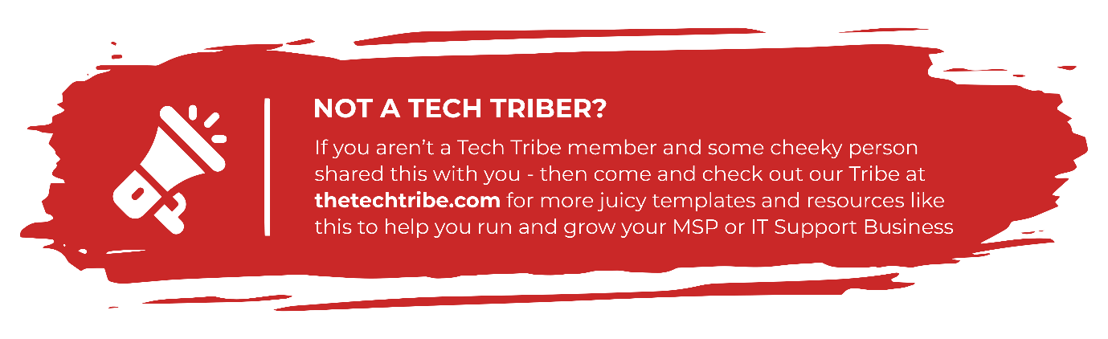

BEFORE POSTING THE BLOG POST
Before you post this Blog Post to your website, we (strongly) recommend you read through ALL the Frequently Asked Questions (FAQ) items found at:
thetechtribe.com/blog-faq
There’s a number of things that you want to make sure you do correctly to get the most out of using these blog posts and to avoid getting into potential trouble from Google.

AUTOMATIC WORDPRESS POSTING
Did you know we built you custom Wordpress Plugin that posts this entire Blog Post (including the Images) to your website completely automatically?
No? Well now you do
You can find more details here:
https://help.thetechtribe.com/support/solutions/articles/48001226562-how-do-i-use-the-tribal-wordpress-plugin-
Once you install & configure it, your 6 x monthly blog posts will be automatically loaded into your website.

THE SUGGESTED blog title
How to Protect Your Business Social Media Accounts From Hackers
Of course, you’re welcome / encouraged to update this Title. It’ll give you a much better chance of getting some real SEO Juice.

THE Suggested Featured Image
Here’s a suggestion for the Featured Image for this Blog Post. All images we offer here as Suggested Images are Royalty Free for Commercial Purposes.

IMAGE SOURCE: https://www.pexels.com/photo/smartphone-on-a-ring-light-12673790/

THE SUGGESTED SOCIAL MEDIA POST
Here are the Social Media posts that you can use to link back to your Blog Post. If you also include the URL in your social media post, it’ll link through (on most social media platforms).

SAMPLE SOCIAL POST 1 (LinkedIn)
“Your marketing manager receives a message saying your company page has broken a platform rule. The message warns that the page will be disabled unless someone submits an appeal.
The link opens a sign-in page that looks familiar. If your employee enters their details, they may be giving their username and password to a hacker.
A strong password is important, but it is only one part of protecting a business account. You also need multi-factor authentication, current recovery details, and a clear record of everyone with administrator access.
We’ve written an article to explain how business social media accounts are compromised and what you can do to protect yours.
Read it here: [BLOG_LINK]
#SocialMediaSecurity #Cybersecurity #BusinessSecurity

SAMPLE SOCIAL POST 2 (FACEBOOK)
Customers may use your social media pages to contact your business, check your latest updates, or confirm that they have found the right company.
If a hacker takes control of an account, they may post scams, contact your customers, or remove the people who normally manage the page.
We’ve written an article to explain how these accounts are compromised and the steps you can take to protect them.
Read it here: [BLOG_LINK]

SAMPLE SOCIAL POST 3 (X/TWITTER)
Business social media accounts are often managed by several people, which can make access difficult to track. We’ve written an article to explain how accounts are hacked and what to check before someone else takes control: [BLOG_LINK]

THE suggested blog post email
Here is an email copy that you can use to link back to your Blog Post.
We also add this email into the Email Templates section inside Growably (what is Growably?).
Subject: Protect your business social media accounts from hackers
Hi [First Name],
Your business social media accounts may be managed by an employee, an outside agency, or several people across your team. That works well only when you know who has access and how the accounts can be recovered.
A fake platform message, stolen password, or old administrator account could give someone else access. They may use the account to post scams, contact customers, or remove your current administrators.
We’ve written an article to explain how business social media accounts are compromised and what you can do to protect yours.
See how to protect your business social media accounts
Best,
[NAME]

The BLOG Article URL
The Source URL for you to add a link-back to AND set the rel=”canonical” tag to is:
https://thetechnologypress.com/how-to-protect-your-business-social-media-accounts-from-hackers/
The Technology Press (thetechnologypress.com) is an un-branded Content Syndication Source to help make sure you don’t get potentially penalized for duplicate site content.
You can find more details about how this works at thetechtribe.com/blog-faq

THE SUGGESTED BLOG CONTENT
As mentioned previously, if you want a chance at getting some SEO Juice, then you can also tweak / customize this article. Often only a little bit of tweaking, will be enough for Google to see this as original Content.
Two things you might consider tweaking are:
- Putting your company name throughout by using phrases like “Here at <your company name>, we believe that…”
- Mentioning your Local Geographical Area (LGA) using phrases such as “Small businesses in <LGA Name> need to make sure they have a plan in place…” etc. I’m sure you get the idea.
If you’re not worried about getting too much / any SEO Juice for the moment and just happy for your Website / Blog to have continual fresh content, then you can simply post it as is.
Simply copy the entire article using Copy / Paste from the blue box below and it will preserve all the formatting in there.
Make sure to update the H2 & H3 heading tags.
Article Summary: Treat every business social media account as a business system. Keep ownership and recovery details under company control, give each person their own access, require MFA, and remove former employees and agencies promptly. Review connected apps regularly and have a written recovery plan in case an account is compromised.
Business social media accounts often grow in bits and pieces.
One employee creates the Facebook Page. Someone else connects Instagram, and an outside agency is later given access to run advertising. Your LinkedIn Page may still be tied to the employee who set it up, while the recovery phone number for another account belongs to someone who left years ago.
Everything can continue working, so nobody has a reason to check how the accounts are set up.
That changes when an employee leaves, an agency relationship ends, or someone receives a password-reset alert they didn’t request. You may then discover that nobody knows which email address owns the account, who has full control, or how the business would recover access.
A compromised social media account can be used to publish scams, send fraudulent messages, access private conversations, or spend money through a connected advertising account. Even if the problem is fixed quickly, customers may have already seen posts or messages that appeared to come from your business.
The best time to sort out ownership and access is before any of that happens.
<H2>Make a list of every account connected to your business</H2>
Start by identifying every social media account your business owns or manages.
Include the obvious company pages, but also look for regional accounts, old campaign pages, YouTube channels, advertising accounts, and profiles created for individual locations or services.
For each account, record the platform, page or profile name, public handle, business owner, current administrators, recovery email address, recovery phone number, and any connected advertising or payment account.
You should also note which agencies, contractors, scheduling tools, or other applications can publish content or read information from the account.
This list gives you somewhere to start when an employee leaves or an account behaves unexpectedly. Without it, your IT provider may have to search old emails and ask several people just to work out who can still sign in.
Keep the list somewhere approved by your business, but don’t put passwords in the document. Passwords and recovery codes belong in a business password manager.
<H2>Keep ownership under the business’s control</H2>
An employee may have created a social media account using their personal email address or mobile phone because they were the person handling marketing at the time.

IMAGE SOURCE: https://www.pexels.com/photo/close-up-shot-of-a-smartphone-5956083/
That arrangement puts the business in a difficult position if the employee leaves, loses access to the email account, changes their phone number, or becomes unavailable.
Check that the main recovery email address belongs to the business and will continue to exist when staff change. The same applies to the phone number used for account recovery or security alerts.
Avoid relying on an email inbox that only one employee can access. A monitored business address, such as a dedicated marketing or social media administration account, gives the business more control. Protect that mailbox with MFA and restrict access to the people responsible for account recovery.
Where the platform allows it, have at least two carefully chosen people who can manage access. Keep that group small, but make sure the business isn’t dependent on one person who might be unavailable when help is needed.
Recovery codes should also be stored securely. If one employee keeps the only copy on their phone or in a personal password manager, the business may lose its backup access when that person leaves.
<H2>Give each person their own access</H2>
If several employees manage the same social media account, they shouldn’t all use one username and password.
Most major platforms provide ways to assign access without sharing the main login.
Facebook Pages can give people full control, partial control, or task access. LinkedIn assigns Page permissions to individual member profiles, and LinkedIn states that Pages don’t have separate usernames or passwords. X provides a Delegate feature that lets an owner assign administrator or contributor roles without sharing the account password. YouTube also offers channel permissions, allowing several people to manage a channel through their own Google accounts.
These features give each person their own way to sign in. You can remove one employee or agency without changing access for everyone else, and you have a better record of who performed each action.
Sharing one personal profile is especially risky. On LinkedIn, for example, profiles are meant to belong to individual people, and sharing login details can lead to account restrictions.
<H2>Match each person’s access to their work</H2>
Someone who creates posts may not need permission to add administrators, change recovery details, or manage payment methods.
Give each person the lowest level of access that still lets them do their job. Your social media manager may need to publish content and reply to messages, while an analyst may only need to view reports. An outside agency running advertisements shouldn’t automatically receive full control of the company page.
Be careful when assigning the highest level of access. Meta warns that a person with full control of a Facebook Page can give access to others, remove existing administrators, or delete the Page.
Review permissions whenever someone changes roles. An employee who moved out of marketing two years ago may still have access simply because nobody removed it..
<H2>Require MFA for everyone with access</H2>
A password can be stolen through phishing, malware, password reuse, or a fake login page. MFA adds another check before the account allows someone to sign in.
Require MFA for every employee, contractor, and agency account that can manage your business pages. This includes people who only post content because their individual account can still become a way into the business page.
Use the strongest method the platform supports. Security keys and passkeys offer strong protection against phishing because they check that the person is signing in to the correct website. An authentication app is another good option.
SMS and email codes still provide more protection than a password alone, but they can be exposed through phishing, email compromise, or attacks against a mobile phone account. CISA recommends that businesses use phishing-resistant MFA where possible.
Don’t approve an unexpected sign-in prompt. If an employee receives an MFA request when they aren’t signing in, they should reject it and report it to the person responsible for the account.
<H2>Protect the email account used for recovery</H2>
Your recovery email can be just as important as the social media password.
If an attacker gets into that mailbox, they may be able to reset the social media password, approve security changes, and intercept warnings from the platform. They may then change the recovery details and make it harder for you to regain access.
Cyber.gov.au specifically recommends protecting the email address linked to a social media account with MFA.
The mailbox should have a unique password, MFA, and a current recovery method. Your IT provider should also check for unexpected forwarding rules, unfamiliar sign-ins, and changes to recovery details if you suspect either the email or social media account has been compromised.
<H2>Watch for fake warnings and support messages</H2>
Social media administrators regularly receive messages claiming that a page has broken a rule, used copyrighted material, lost verification, or needs to confirm its identity.
Some of these messages are phishing attempts. They send the recipient to a fake login page designed to steal a password and MFA code. Others ask the recipient to add a supposed support representative as an administrator.
Treat unexpected warnings carefully, even when they include your logo, page name, or details from a recent post.
Open the platform through its normal app or website and check the account’s support or notification area there. Don’t sign in through a link sent in a direct message, comment, or unexpected email.
Never send a password, verification code, backup code, or authentication-app code to someone claiming to provide support. Legitimate support staff shouldn’t need those details.
The April 2026 guidance from the Australian Signals Directorate tells organizations not to share passwords, registration codes, or verification codes, particularly with accounts claiming to represent a platform.
<H2>Review connected apps and scheduling tools</H2>
Your social media accounts may be connected to scheduling platforms, analytics services, competition tools, customer support systems, or advertising software.
These tools can save time, but some receive permission to publish posts, read messages, view account information, or manage advertising. If the third-party service is compromised, an attacker may be able to use the access you granted without needing your social media password.
Review connected applications in each platform’s security settings. Remove tools the business no longer uses and question any connection you don’t recognize.
For the applications you keep, check what each one can access. A reporting tool may only need analytics, while a scheduling platform may need permission to publish. It shouldn’t receive broader access without a clear reason.
CISA’s guidance on social media account protection recommends limiting third-party applications, reviewing their permissions, and protecting API keys or tokens that allow tools to act on the organization’s behalf.
<H2>Remove access when someone leaves</H2>
Social media access should be part of your normal offboarding process.
When an employee or contractor leaves, remove their page roles, advertising permissions, delegated access, and access to connected tools. If they knew a shared password, change it and review active sessions.
Don’t assume that removing someone from one platform also removes their access everywhere else. An agency may have separate permissions for the company page, advertising account, scheduling tool, analytics platform, and shared file storage.
Check them one by one.
You should also confirm that recovery email addresses and phone numbers still belong to people who work for the business. An old phone number can become a problem if the number is later reassigned to someone else.
<H2>Check active sessions and security alerts</H2>
Most social platforms let you review devices or locations where the account is currently signed in.
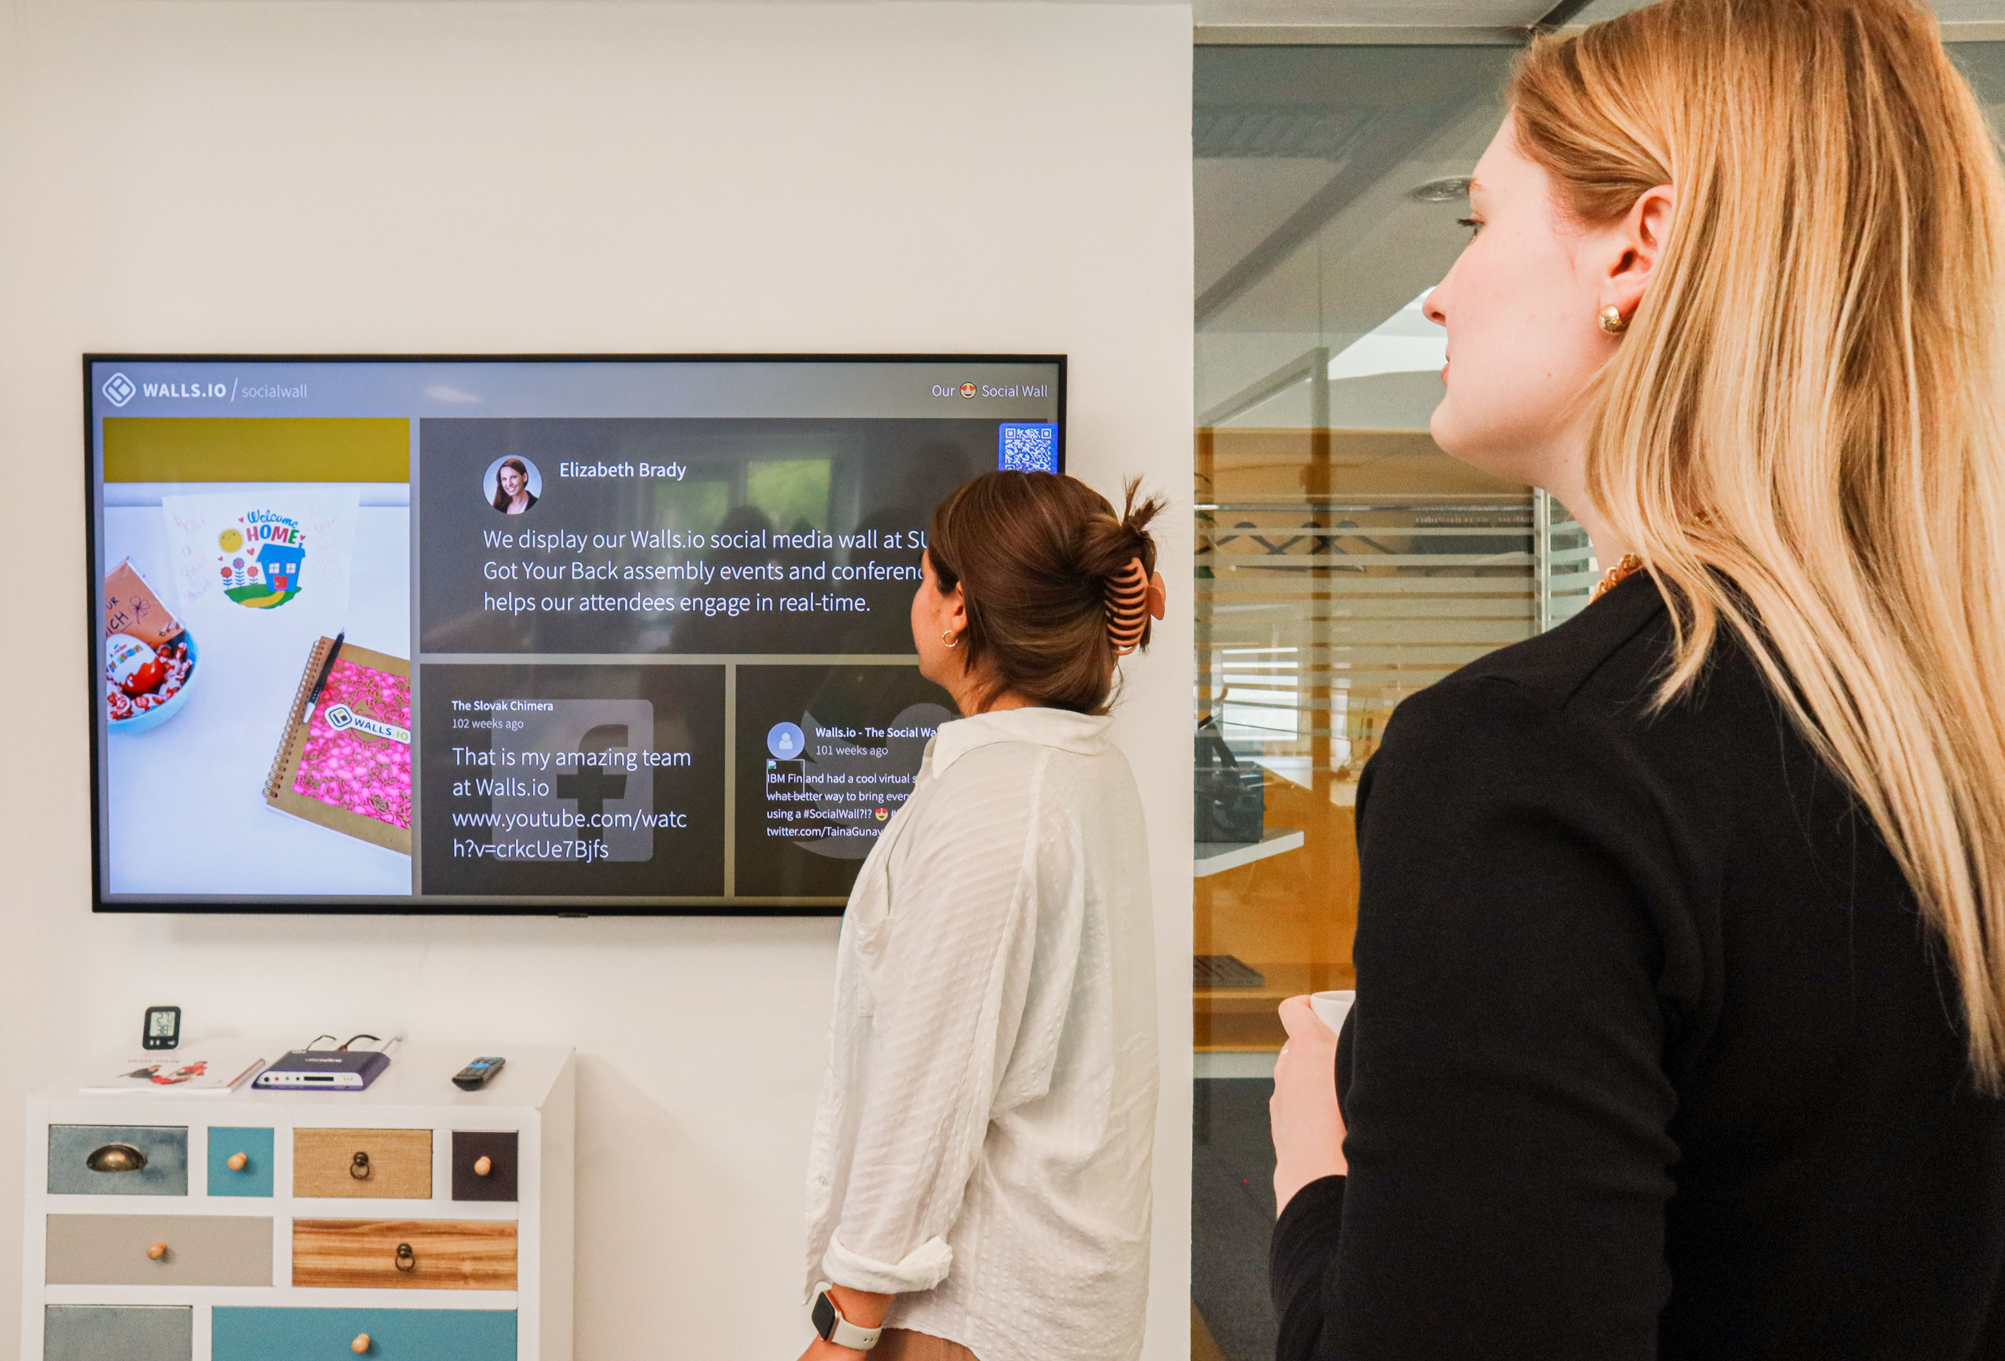
Image Source: https://www.pexels.com/photo/women-standing-in-the-office-and-looking-at-a-tv-screen-15467755/
Look for devices you don’t recognize, locations that don’t fit your team, and sessions that have remained active longer than expected. Remember that location information based on an IP address may be approximate, so an unfamiliar city doesn’t prove that an account has been hacked.
If something looks wrong, ask the relevant employee whether the session belongs to them. When it doesn’t, sign the device out, reset the affected credentials, and review recent activity.
Turn on alerts for new logins or security changes where the platform offers them. Send those alerts to an address that is monitored, rather than to an employee’s inbox that nobody checks when they’re away.
<H2>Pay attention to advertising and payment access</H2>
A compromised social account may also give an attacker access to advertising tools.
Review who can create campaigns, change spending limits, and manage payment methods. Remove cards or payment accounts that are no longer used, and turn on available alerts for spending or campaign changes.
If your platform separates page access from advertising access, review both. Removing someone from the public page doesn’t always remove them from the advertising account or business management system.
Ask whoever reviews company card statements to report unfamiliar social media charges promptly. A small charge may be the first sign that someone is testing whether an advertising account still works.
<H2>Decide what you’ll do if an account is hacked</H2>
Write down the recovery process before you need it. The plan should identify who will contact the platform, who will secure the linked email account, and who can approve a public statement if customers received fraudulent messages.
Keep links to the platform’s official recovery pages in your account register. That reduces the chance of an employee searching for help in a hurry and ending up on a fake support page.
If you believe an account has been compromised, use a trusted device to change the password and end unfamiliar sessions. Check whether the attacker added administrators, changed recovery details, or connected a new application.
Secure the linked email account as well. If you only reset the social media password while the attacker still controls the recovery mailbox, they may be able to take the account back.
Save screenshots and record the times of suspicious posts, messages, advertisements, and account changes. If fraudulent content was sent to customers, warn them through a channel you still control and tell them what they should ignore.
CISA recommends including compromised devices, unauthorized access, fraudulent posts, and exposed private communications in a social media incident response plan.
<H2>Review the setup regularly</H2>
Check social media ownership, administrators, connected apps, recovery details, and advertising permissions at least a few times a year.
Repeat the review whenever an employee changes roles, someone leaves, or you start or finish working with an outside agency. Security settings can also change as platforms add features, so include them in the review.
The goal is to make sure you can answer four questions without searching through old messages:
Who owns each account? Who can access it? How is that access protected? What will you do if the account is taken over?
If those answers are documented and current, recovering from a problem becomes much easier.
<H2>Frequently Asked Questions</H2>
<H3>Should only one person have administrator access?</H3>
Relying on one person can leave the business locked out if they’re unavailable or lose access. Keep the number of full administrators small, but make sure at least one other trusted person can help recover or manage the account.
<H3>Is an authentication app better than an SMS code?</H3>
Authentication apps are generally less exposed to SIM-swap attacks than SMS codes, while security keys and passkeys offer stronger protection against phishing. If SMS is the only MFA option available, it is still better than relying on a password alone.
<H3>Can an outside marketing agency have access?</H3>
Yes, but give the agency its own assigned access rather than sharing your main password. Limit its permissions to the work it performs and remove that access when the relationship ends.
<H3>Should we use a personal email address for account recovery?</H3>
Use an address controlled by the business wherever possible. A personal address can create recovery problems when an employee leaves or becomes unavailable.
<H3>What if the platform doesn’t support separate users?</H3>
Keep the password in a business password manager, restrict access to the smallest possible group, and change it when anyone leaves that group. Turn on MFA and document who controls the recovery methods.
<H2>Sources and Further Reading</H2>
- CISA: Social Media Account Protection
- CISA: Require Multifactor Authentication
- Australian Signals Directorate: Security Tips for Social Media and Messaging Services
- Cyber.gov.au: Secure Your Social Media
- Meta: About Facebook Page Access
- LinkedIn: Understand Admin Access for LinkedIn Pages
- X: How to Use the Delegate Feature
- YouTube: Add or Remove Access With Channel Permissions
Ask your IT provider to review who owns and manages your business social media accounts, especially if several employees or agencies have had access over the years. If you don’t have an IT provider, you can always reach out to us and we’ll help you secure them.

Article used with permission from The Technology Press.


A QUICK NOTE FROM NIGEL:
If you’re worried about being penalized by Google for Duplicate Content, make sure to read the FAQ at thetechtribe.com/blog-faq

FREQUENTLY ASKED QUESTIONS
The FAQ for this stuff will be updated regularly, so instead of us putting including a bunch of FAQs in this document, we’ll keep it updated all in one place here:

thetechtribe.com/blog-faq

THE END

