






TITLE:
Simple Backup and Recovery Plans
Every Small Business Needs

ORIGINALLY RELEASED:
July 2025 Marketing Pack

BLOG POST

COPYRIGHT STUFF
Who the heck wrote this thing?
Copyright © - The Tech Tribe
All rights reserved.

PUBLISHER
Who’s managing and distributing this thing?
The Tech Tribe
PO Box 150
Pyrmont NSW 2009
AUSTRALIA

DISCLAIMER
We care, but you’re responsible
While all attempts have been made to verify information provided in this publication, neither the author nor the publisher assumes any responsibility for errors, omissions or contradictory interpretation of the subject matter herein. This publication is designed to provide accurate and authoritative information with regards to the subject matter covered. However, it is delivered with the understanding that the author and the publisher are not engaged in rendering legal, accounting, or other professional advice. If professional advice or other expert assistance is required, the services of a competent professional should be sought.
The purchaser or reader of this publication assumes responsibility for the use of these materials and information. Adherence to all applicable laws and regulations, including federal, state and local, governing professional licensing, business practices, advertising and any other aspects of doing business is the sole responsibility of the purchaser or reader.
The publisher assumes no responsibility or liability whatsoever on behalf of any purchaser or reader of these materials.

Contents
COPYRIGHT STUFF 1
BEFORE POSTING THE BLOG POST 3
SHOUT OUT TO T.M.E. 3
AUTOMATIC WORDPRESS POSTING 3
THE SUGGESTED blog title 3
THE Suggested Featured Image 4
THE SUGGESTED SOCIAL MEDIA POST 4
SAMPLE SOCIAL POST 1 (TEXT) 5
SAMPLE SOCIAL POST 2 (TEXT) 5
SAMPLE SOCIAL POST 3 (TEXT) 5
SAMPLE SOCIAL POSTS (IMAGES) 5
THE VIDEO AND VIDEO TEXT 7
The BLOG Article URL 8
THE SUGGESTED BLOG CONTENT 8
FREQUENTLY ASKED QUESTIONS 14

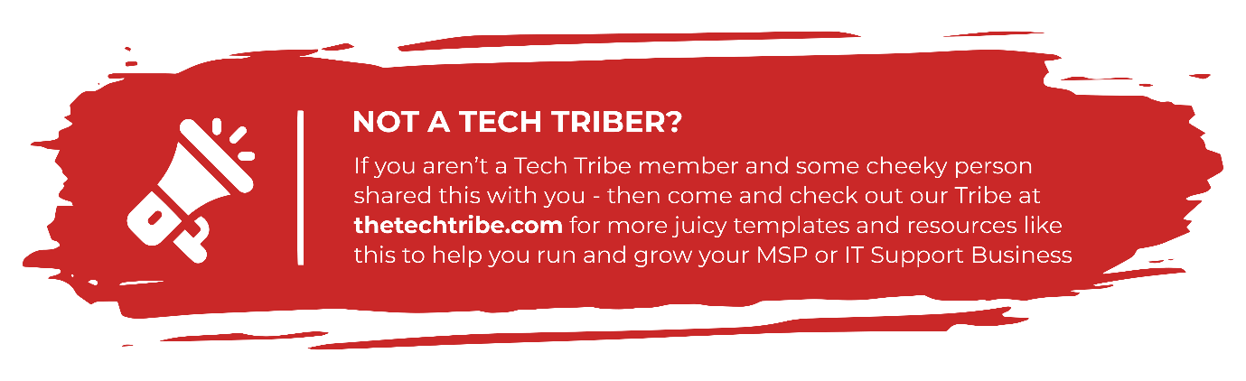

BEFORE POSTING THE BLOG POST
Before you post this Blog Post to your website, we (strongly) recommend you read through ALL the Frequently Asked Questions (FAQ) items found at:
thetechtribe.com/blog-faq
There’s a number of things that you want to make sure you do correctly to get the most out of using these blog posts and to avoid getting into potential trouble from Google.

SHOUT OUT TO T.M.E.

Matt, Ramey & their team over at Tech Marketing Engine help us put together this Blog Post content for you each month and they do a stellar job of it..
However, as you know – this content is not unique to you as other Tech Tribe members will be using it on their websites as well (more details about SEO impacts here).
If you’re looking for Unique Content to help out with SEO and to help stand out even more from the crowd– then check out T.M.E.’s Tribal Perk here.

AUTOMATIC WORDPRESS POSTING
Did you know we built you custom Wordpress Plugin that posts this entire Blog Post (including the Images) to your website completely automatically?
No? Well now you do
You can find more details here:
https://help.thetechtribe.com/support/solutions/articles/48001226562-how-do-i-use-the-tribal-wordpress-plugin-
Once you install & configure it, your 6 x monthly blog posts will be automatically loaded into your website.

THE SUGGESTED blog title
Simple Backup and Recovery Plans Every Small Business Needs
Of course, you’re welcome / encouraged to update this Title. It’ll give you a much better chance of getting some real SEO Juice.
THE Suggested Featured Image
Here’s a suggestion for the Featured Image for this Blog Post. All images we offer here as Suggested Images are Royalty Free for Commercial Purposes.
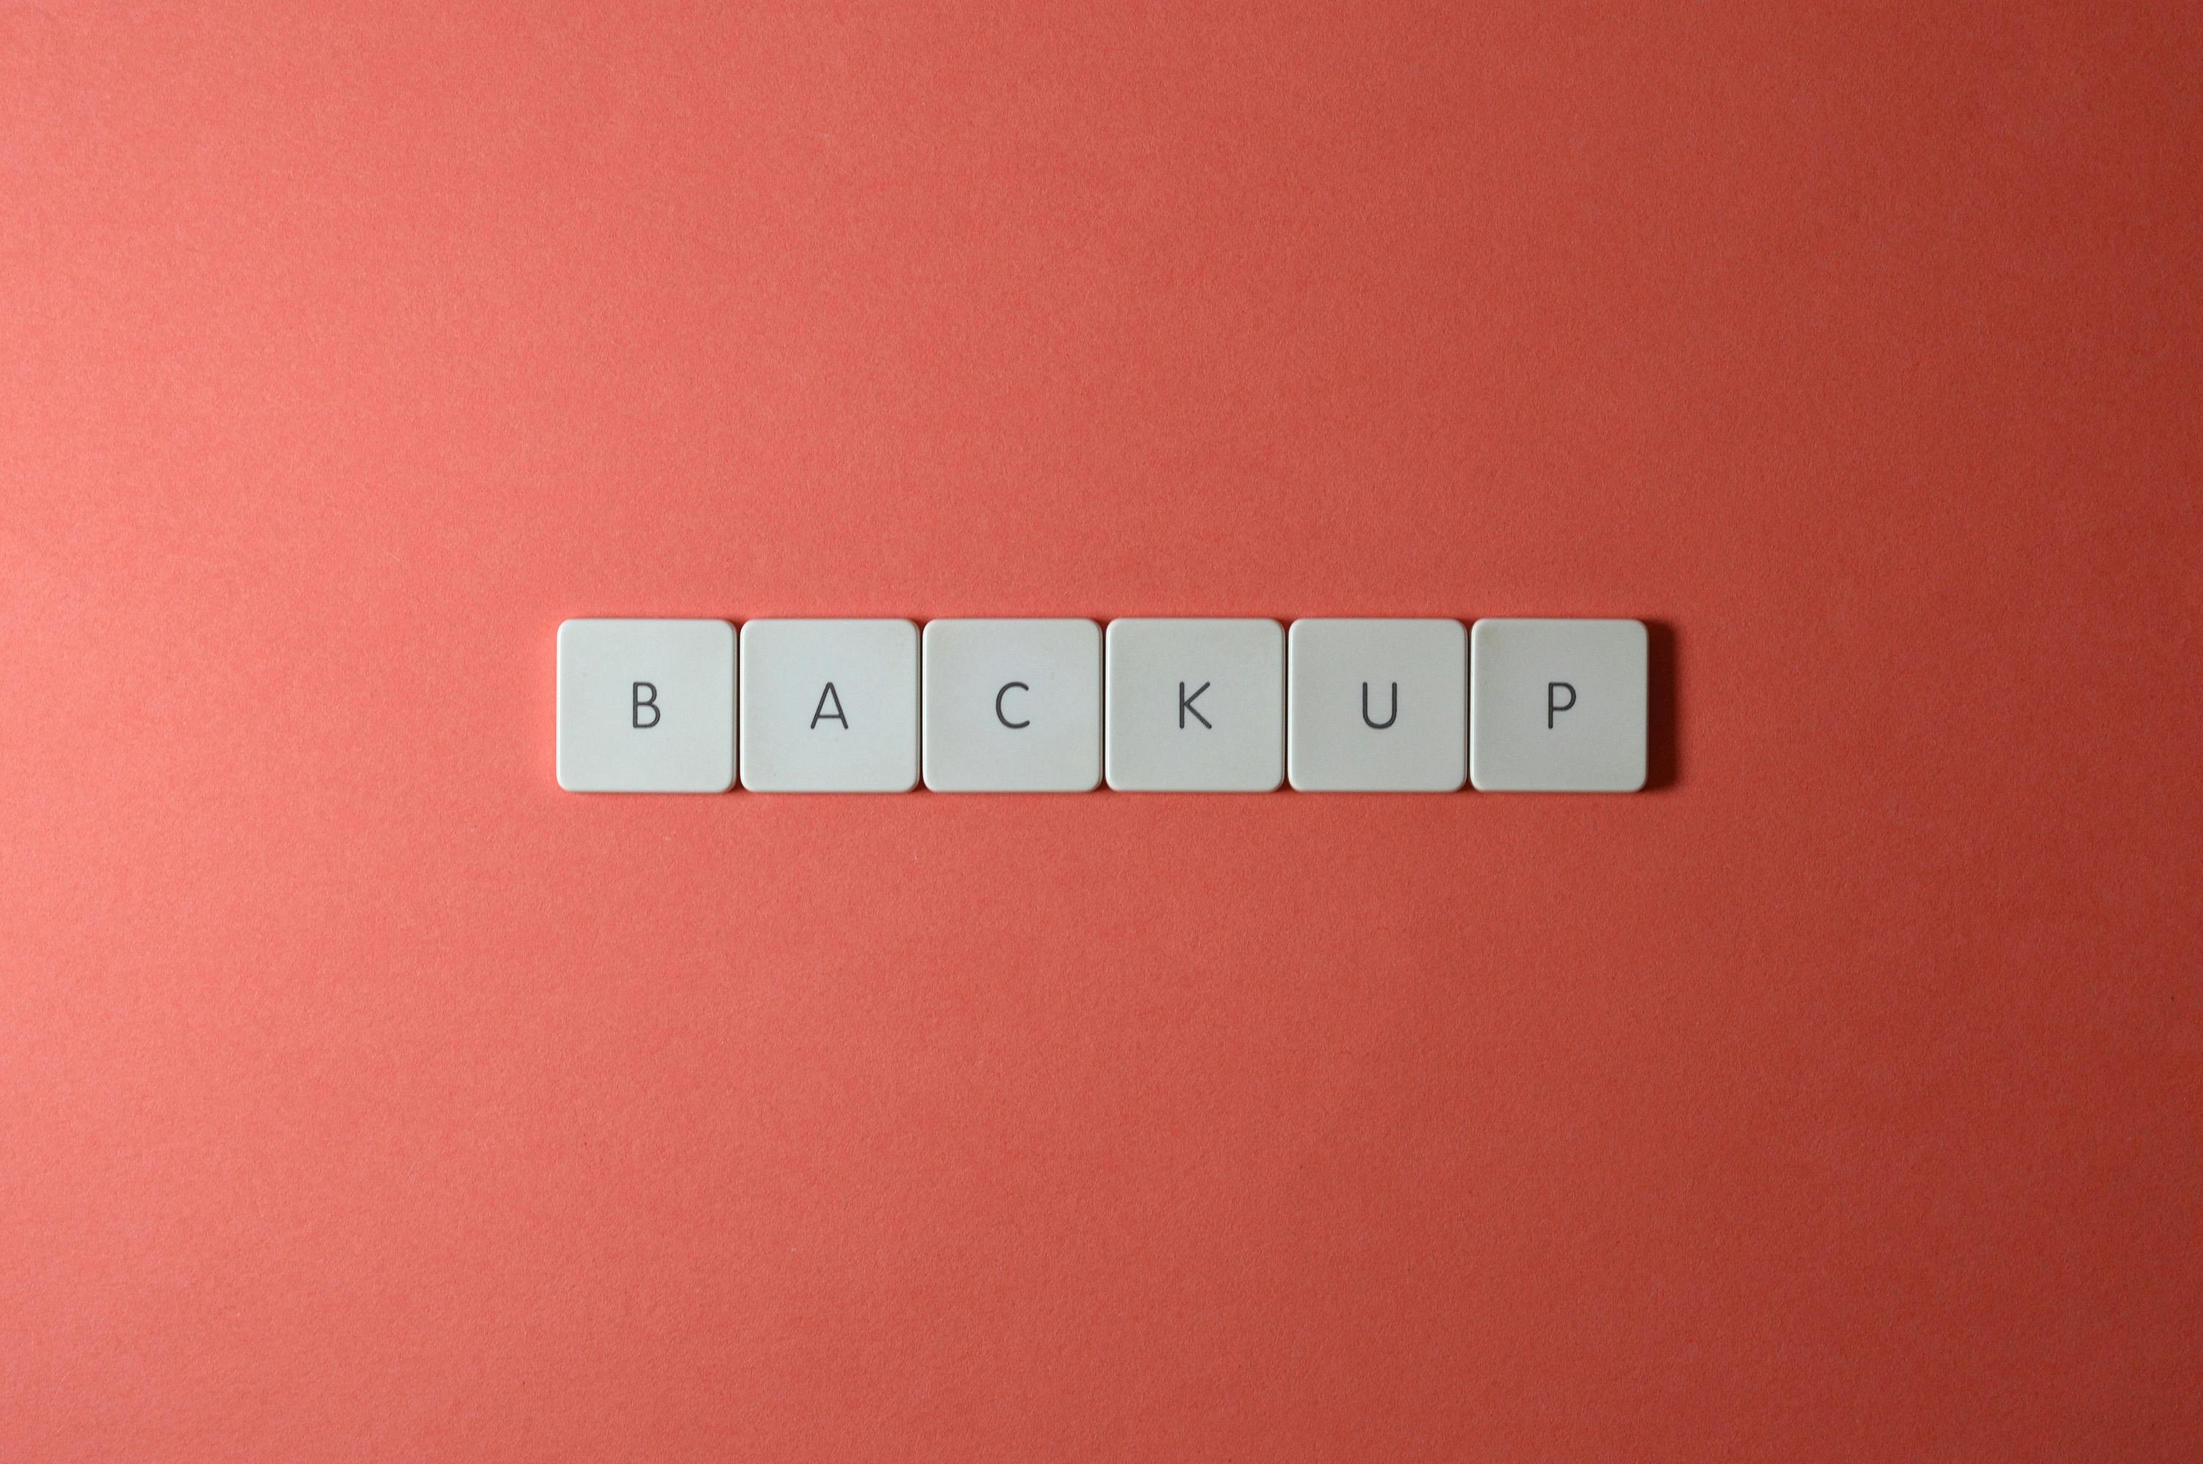
IMAGE SOURCE: https://www.pexels.com/photo/close-up-shot-of-keyboard-buttons-2882506/
THE SUGGESTED SOCIAL MEDIA POST
Here are the Social Media posts that you can use to link back to your Blog Post. If you also include the URL in your social media post, it’ll link through (on most social media platforms).

SAMPLE SOCIAL POST 1 (TEXT)
What if you lost all your data tomorrow? 😬 Don't risk it! Our blog provides simple backup and recovery plans every small business needs. Protect your lifeline!
#DataBackup #DataRecovery #SmallBusiness #DataProtection

SAMPLE SOCIAL POST 2 (TEXT)
Data loss can CRUSH your business. 💔 We're making backup and recovery easy to understand and implement. Don't wait until it's too late! Secure your future today.
#SmallBusinessTips #BackupAndRecovery #BusinessContinuity

SAMPLE SOCIAL POST 3 (TEXT)
Is your data safe? 🤔 We're sharing essential backup and recovery strategies to keep your small business running, no matter what happens. This is your business insurance for the digital age!
#SmallBusinessBackup #DataSecurity

SAMPLE SOCIAL POSTS (IMAGES)
Here are three Images that you can use (coupled with the above text or without) on your Social Media Accounts to promote / link back to this blog post on your Website.
NOTE: make sure to click on the Download the High-Rez link to get the high-rez version as Microsoft Word compresses images by default (so don’t use the Save-As Picture option).
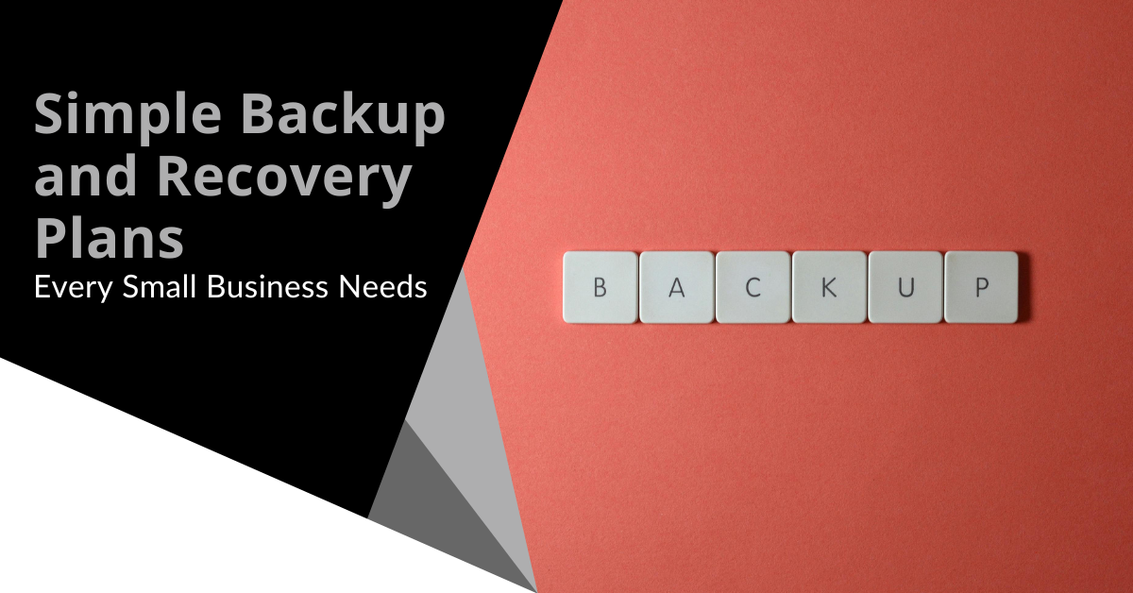 | 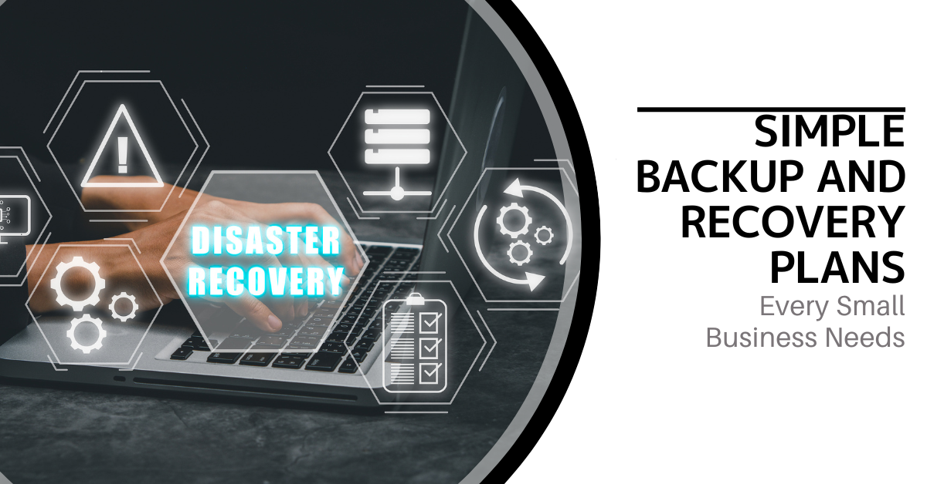 | 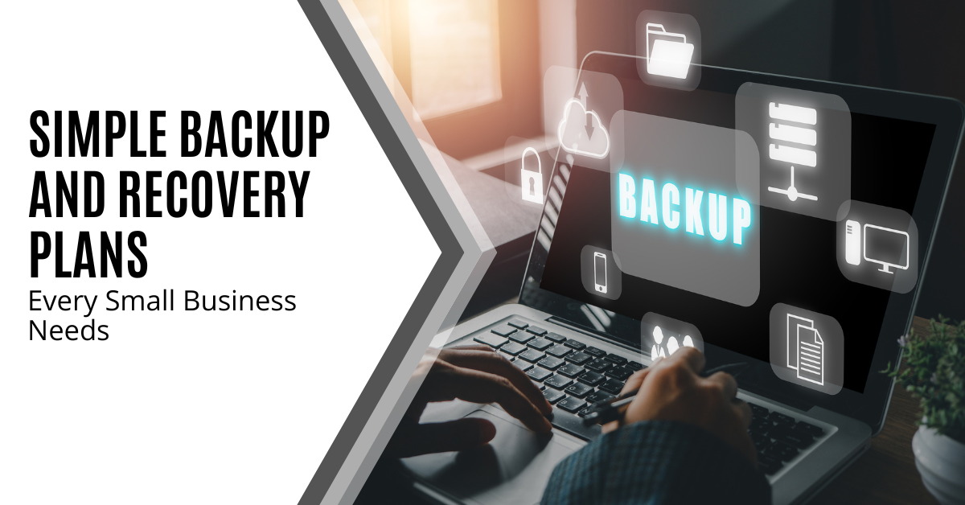
Download the High-Rez | Download the High-Rez | Download the High-Rez
THE MONTHLY EMAIL NEWSLETTER
If you’re not sending any email marketing to your prospects at all, then the very minimum you should send them could be a once-per-month wrap-up email just to keep in touch.
That email would link them to all the Blog Posts you’ve published throughout the month with a quick intro about each post so they could work out what ones they might be interested in reading.
Luckily, we write this email for you each month so you can simply copy & paste it into your Marketing CRM to send out.
We also add this email into the Email Templates section inside Growably (what is Growably?).
It looks like this:
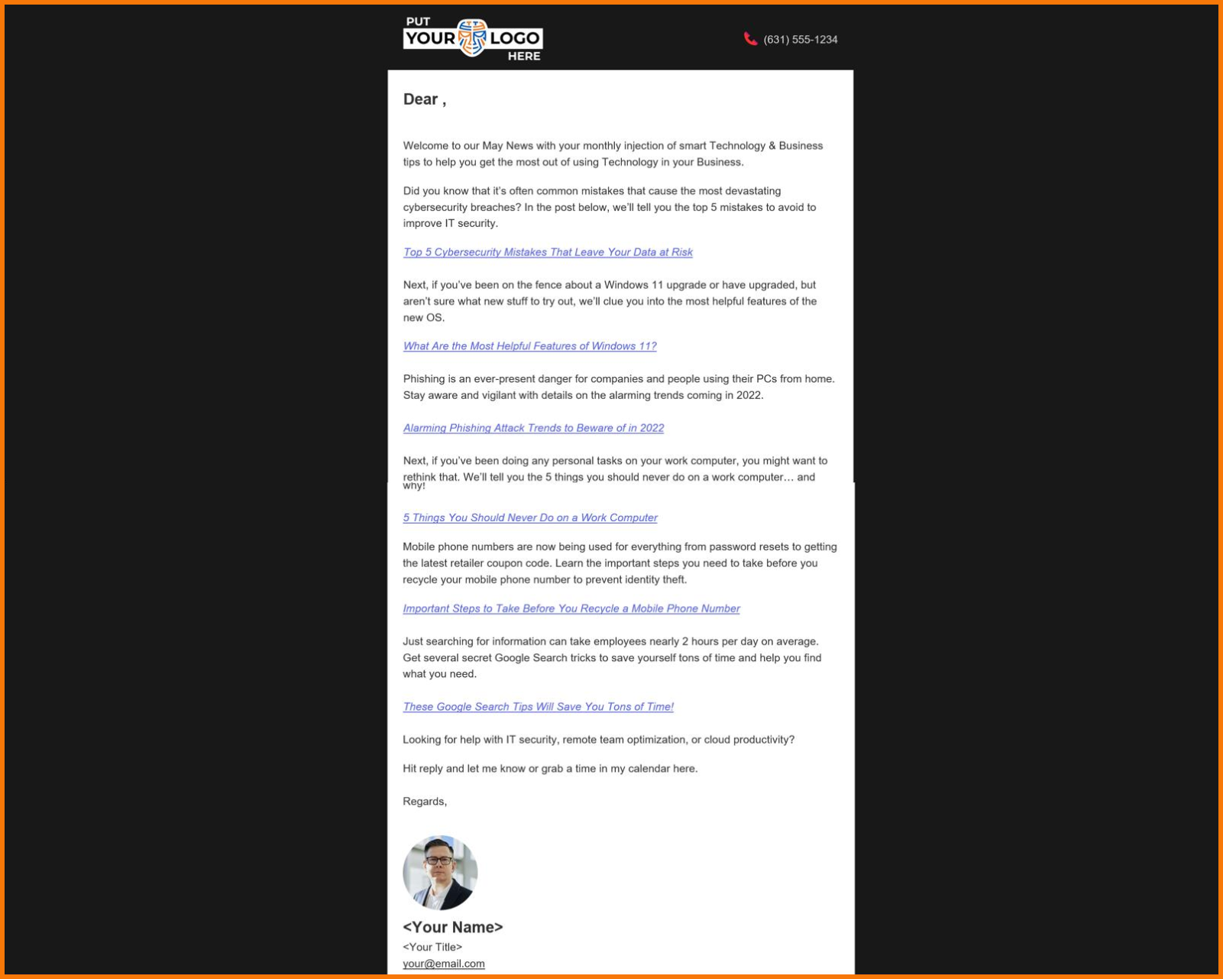

THE VIDEO AND VIDEO TEXT
We also create you a video that corresponds with this blog post that you can post across your Social Media channels.
You can download the video for this Blog Post from the Monthly Marketing Content Pack file here and you’ll find it in this folder in the ZIP file:
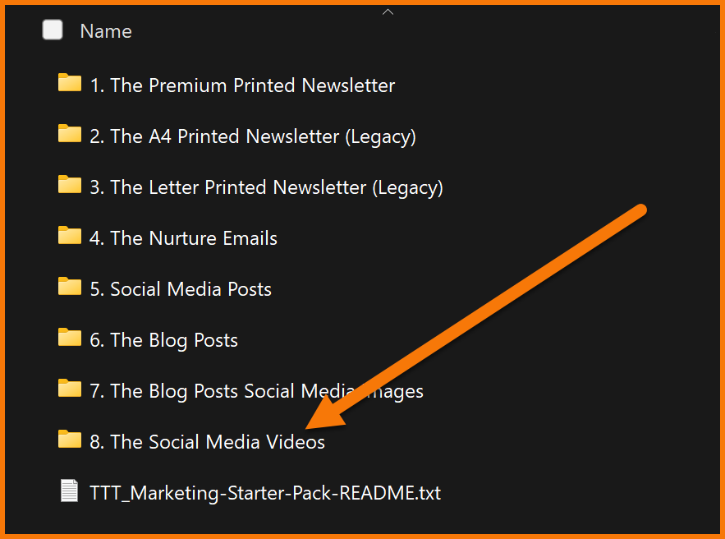
Here’s some sample text you can use to post along with the video:
US Version
Let's take a look at simple backup and recovery plans that every small business needs.
Small businesses rely heavily on data. Losing this data can be devastating.
Regular backups are crucial for recovery. Start by knowing your storage limits.
Use a cloud service for secure, off-site storage.
Automate your backup schedule to avoid any errors.
Don't forget to test your recovery plan to make sure it actually works. Trust me, you'll thank yourself later.
Keep a local backup for quick access and be sure to educate your team on data safety.
Finally, maintain multiple backup versions for better protection and implement a hybrid strategy for flexibility.
Contact us for help protecting your business from data loss.

UK Version
Let's take a look at simple backup and recovery plans that every small business needs.
Small businesses rely heavily on data. Losing this data can be devastating.
Regular backups are crucial for recovery. Start by knowing your storage limits.
Use a cloud service for secure, off-site storage.
Automate your backup schedule to avoid any errors.
Don't forget to test your recovery plan to make sure it actually works. Trust me, you'll thank yourself later.
Keep a local backup for quick access and be sure to educate your team on data safety.
Finally, maintain multiple backup versions for better protection and implement a hybrid strategy for flexibility.

The BLOG Article URL
The Source URL for you to add a link-back to AND set the rel=”canonical” tag to is:
https://thetechnologypress.com/simple-backup-and-recovery-plans-every-small-business-needs/
The Technology Press (thetechnologypress.com) is an un-branded Content Syndication Source to help make sure you don’t get potentially penalized for duplicate site content.
You can find more details about how this works at thetechtribe.com/blog-faq

THE SUGGESTED BLOG CONTENT
As mentioned previously, if you want a chance at getting some SEO Juice, then you can also tweak / customize this article. Often only a little bit of tweaking, will be enough for Google to see this as original Content.
Two things you might consider tweaking are:
- Putting your company name throughout by using phrases like “Here at <your company name>, we believe that…”
- Mentioning your Local Geographical Area (LGA) using phrases such as “Small businesses in <LGA Name> need to make sure they have a plan in place…” etc. I’m sure you get the idea.
If you’re not worried about getting too much / any SEO Juice for the moment and just happy for your Website / Blog to have continual fresh content, then you can simply post it as is.
Simply copy the entire article using Copy / Paste from the blue box below and it will preserve all the formatting in there.
Make sure to update the H2 & H3 heading tags.
What would happen if your business lost all its data tomorrow? Would you be able to recover, or would it grind your operations to a halt? Every small business runs on data, which includes customer information, financial records, communications, product files, and more. Yet data security often falls to the bottom of the to-do list.
According to the Federal Emergency Management Agency (FEMA), 40% of small businesses never reopen after a disaster, and another 25% shut down within one year. That's a staggering 65% failure rate due to a lack of preparation. Here's the good news. Protecting your data from disaster doesn't require a dedicated IT team or an enterprise budget. With the right strategy, tools, and a little foresight, you can implement a backup and recovery plan that minimizes downtime and gives you peace of mind.
In this blog post, we will discuss practical and easy-to-follow advice to help you protect your most valuable business asset: your data.
<H2>How Important Are Regular Backups?</H2>
Let's put it bluntly. If you don't have regular backups, your business is one unexpected event away from potential collapse. Whether the threat is a hard drive failure, an employee mistake, or a flood that wipes out your office, losing data can derail your business overnight.
And it's not just about catastrophic events. Everyday occurrences (like someone accidentally deleting a file or clicking on a malicious link) can result in data loss. According to TechNewsWorld, cyberattacks targeting small businesses have risen steadily in the past decade. More so, industries governed by regulatory compliance (like healthcare, finance, or legal services) face stiff penalties if they can't produce secure and reliable backups when audited.
<H2>Simple Backup and Recovery Plans</H2>
Not sure where to start with protecting your business data? Here are some simple, effective backup and recovery plans that every small business can use.
<H3>Know Your Storage Limits</H3>
It's easy to assume your backups are working until you get that dreaded alert: "Backup Failed - Storage Full." Small businesses often outgrow their storage capacity without realizing it.
To avoid data disruptions:
- Audit your storage monthly to track how quickly you're using space.
- Enable alerts so you're notified before hitting limits.
- Clean up old, duplicate, or unused files regularly.
Pro tip:
Always leave 20-30% of your backup storage free. This buffer ensures there's room for emergency backups or unexpected file growth.
<H3>Use a Cloud Service</H3>
Cloud storage has revolutionized small business data protection. These services offer affordable, flexible, and secure off-site storage that keeps your data safe, even if your physical office is compromised.
Look for cloud services that offer:
- Automatic and scheduled backups
- End-to-end encryption
- Access across all devices
- Version history and recovery tools
Popular options include Microsoft OneDrive, Google Workspace, Dropbox Business, and more robust solutions such as Acronis, Backblaze, or Carbonite.
Cloud backups are your first line of defense against local disasters and cyber threats.
<H3>Automate Your Backup Schedule</H3>
Let's face it. Manual backups are unreliable. People forget. They get busy. They make mistakes. That's why automation is key.
Set your systems to back up:
- Daily for mission-critical data
- Weekly for large system files and applications
- Monthly for archives
Bonus tip:
Run backups after business hours to avoid interfering with employee productivity. Tools like Acronis, Veeam, and Windows Backup can automate schedules seamlessly.
<H3>Test Your Recovery Plan</H3>
A backup plan is only as good as its recovery. Many businesses don't test their backups until they're in crisis, and then discover their files are incomplete or corrupted.
Run quarterly disaster recovery drills. These help you:
- Measure how fast files can be restored
- Identify gaps in your backup process
- Ensure key team members know their roles
Recovery time objectives (RTO) and recovery point objectives (RPO) are critical metrics. Your RTO is how long it takes to resume operations, while your RPO is how much data loss you can tolerate. Define and measure both during your test runs.
<H3>Keep a Local Backup for Fast Access</H3>
Cloud storage is powerful, but local storage is your speed advantage. Downloading massive files from the cloud during an outage can take time. That's where external hard drives, USBs, or NAS systems come in.
Benefits of local backups include:
- Rapid recovery times
- Secondary layer of security
- Control over physical access
Secure your drives with encryption, store them in a locked cabinet or fireproof safe, and rotate them regularly to prevent failure.
<H3>Educate Your Team</H3>
Your employees can either be your biggest risk or your strongest defense. Most data breaches happen due to human error. That's why training is crucial.
Every employee should know:
- Where and how to save data
- How to recognize phishing and malware attempts
- Who to contact during a data emergency
Hold short monthly or quarterly training sessions. Use mock phishing emails to test awareness. Keep a simple emergency checklist posted in shared areas.
Remember that empowered employees make smarter decisions and make data safer.
<H3>Keep Multiple Backup Versions</H3>
One backup is good. Multiple versions? Even better. Version control protects you from overwrites, corruption, and malicious attacks.
Here are the best practices for version control:
- Retain at least three previous versions of each file
- Use cloud services with built-in versioning (like Dropbox or OneDrive)
- Keep snapshots of your system before major updates or changes
This allows you to restore data to a known good state in case of malware, accidental changes, or corrupted files.
<H3>Monitor and Maintain Your Backups</H3>
Backup systems aren't "set it and forget it." Like any other technology, they need care and maintenance.
Establish a maintenance routine:
- Review backup logs weekly
- Check for failed or missed backups
- Update your backup software
- Replace aging hardware on schedule
Designate a "data guardian", someone responsible for oversight and reporting. Regular maintenance avoids nasty surprises when you need your backups most.
<H3>Consider a Hybrid Backup Strategy</H3>
Many small businesses find success using a hybrid backup strategy, which combines both local and cloud backups. This approach provides flexibility, redundancy, and optimized performance.
Benefits of a hybrid backup strategy:
- Fast recovery from local sources
- Off-site protection for major disasters
- Load balancing between backup sources
For instance, you could automate daily backups to the cloud while also running weekly backups to an encrypted external drive. That way, you're covered from every angle.
<H2>What to Do When Disaster Strikes</H2>
Even with the best backup plans, disasters can still happen. Whether it's a ransomware attack, an office fire, or someone accidentally deleting an entire folder of client files, the real test comes after the crisis hits. Here's how to keep a cool head and take control when your data's on the line:
<H3>Assess the Damage</H3>
Take a step back and figure out what was affected. Was it just one system? A whole server? It's crucial to quickly evaluate what data and systems have been compromised. Understanding the scope of the damage will help you prioritize your recovery efforts and focus on the most critical systems first, preventing further damage or loss.
<H3>Activate Your Recovery Plan</H3>
This is where your preparedness pays off. Use your documented recovery steps to restore your data. If you have cloud-based backups or automated systems, begin the restoration process immediately. Always start with the most crucial data and systems to minimize downtime. Your recovery plan should be detailed, guiding you through the process with minimal confusion.
<H3>Loop in Your Team</H3>
Clear communication is essential during a disaster. Notify your team about the situation, especially key departments like customer service, IT, and operations. Assign tasks to staff members, so everyone knows what needs to be done. Regular updates and transparency reduce anxiety, keep morale up, and help ensure that recovery proceeds smoothly without added stress.
<H3>Document What Happened</H3>
Once the dust settles, take time to document everything that occurred. What was the root cause? How long did the recovery take? Were there any hiccups? This post-mortem analysis is key to improving your disaster recovery strategy. By learning from the event, you can refine your processes and prevent similar issues in the future, strengthening your system's resilience.
<H3>Test the Recovery Process</H3>
It's not enough to have a recovery plan on paper; you need to verify that it works in practice. After an incident, test your recovery steps regularly to ensure that backups are functional and can be restored quickly. Simulated drills or periodic tests can help identify weak spots in your plan before a real disaster strikes, allowing you to address any issues in advance.
Disaster-proofing your data is a smart investment, as the cost of lost data (measured in lost revenue, damaged reputation, and potential regulatory fines) far outweighs the effort to prepare. To ensure your business is protected, set up both cloud and local backups, automate and test your recovery processes, educate your staff, monitor storage, and rotate hardware. With a solid backup and recovery plan in place, your business will be ready to weather any storm, from natural disasters to cyberattacks or even the occasional spilled coffee. Don't wait for a crisis to act.
Data disasters strike without warning. Is your business protected? Get custom backup solutions that ensure zero downtime, automatic security, and instant recovery. Because when disaster hits, the best backup isn't an option. It's a necessity.
Contact us now before it's too late!
Article used with permission from The Technology Press.


A QUICK NOTE FROM NIGEL:
If you’re worried about being penalized by Google for Duplicate Content, make sure to read the FAQ at thetechtribe.com/blog-faq

FREQUENTLY ASKED QUESTIONS
The FAQ for this stuff will be updated regularly, so instead of us putting including a bunch of FAQs in this document, we’ll keep it updated all in one place here:

thetechtribe.com/blog-faq

THE END

